Monomeric and dimeric complexes of pyrimidine-4,6-dicarboxylic acid with organometallic fac-[M(CO)₃]⁺ (M = Re and ^{99m}Tc) core as radiopharmaceutical probes
Janvier Mukiza^{1,2,3*}, Gratien Habarurema⁴, Jurdas Sezirahiga^{2,5}, Theonille Mukabagorora⁵, Jean Bosco Nkuranga⁴, Tite Uwambajineza², Theoneste Muyizere⁶, Olivier Blacque¹, Gervais Baziga²
¹Department of Chemistry, University of Zurich, Winterthurerstr.190, CH-8057 Zurich, Switzerland
²Rwanda Food and Drugs Authority, P.O Box:1948 Kigali, Rwanda
³School of Education, University of Rwanda-College of Education, Rwanda
⁴Department of Chemistry, University of Rwanda-College of Science and Technology, Rwanda
⁵University of Rwanda, College of Medicine and Health Sciences, Rwanda
⁶University of Chinese Academy of Sciences, 100039 Beijing, China

Table of Content for Supplementary Information
Fig. S1: UPLC chromatogram of [Re(CO)₃(OH₂)(Hpmdc)] (1) eluted using 0.1% trifluoro- acetic acid (TFA) in H₂O (solvent A) acetonitrile (solvent B)
Fig. S2. IR spectrum of [Re(CO)₃(OH₂)(Hpmdc)] (1)
Fig. S3: ¹HNMR of [Re(CO)₃(OH₂)(Hpmdc)] (1) in D₂O
Fig. S4: ¹³CNMR of [Re(CO)₃(OH₂)(Hpmdc)] (1) in CD₃OD
Fig. S5: ESI-MS spectrum representing m/z mass of [Re(CO)₃(OH₂)(Hpmdc)] (1) with 457.03 for [C₉H₆N₂O₈Re]⁺ or [1+H]⁺; 439.06 for [C₉H₄N₂O₇Re]⁺ or [1-H₂O+H]⁺; and 479.99 for [C₁₁H₇N₃O₇Re]⁺ or [1+MeCN+H-H₂O]⁺
Fig. S6: Infrared spectrum of [Re(CO)₃(OH₂)(etpmdc)] (3)
Fig. S7: ¹HNMR of [Re(CO)₃(OH₂)(etpmdc)] (3) in CD₃OD
Fig. S8: ¹³CNMR of [Re(CO)₃(OH₂)(etpmdc)] (3) in CD₃OD
Fig. S9: ESI-MS spectrum representing m/z mass of [Re(CO)₃(OH₂)(etpmdc)] (3) with 467.21 for [C₁₁H₈N₂O₇Re]⁺ or [3-H₂O+H]⁺ and 508.02 for [C₁₃H₁₁N₃O₇Re]⁺ or [3+MeCN+H-H₂O]⁺ Figure S10: UPLC chromatogram of (Et₃NH)₂[(µ-pmdc)₂(Re(CO)₃)₂] (4) eluted using 0.1% trifluoro-acetic acid (TFA) in H₂O (solvent A) acetonitrile (solvent B)
Fig. S11: IR spectrum of (Et₃NH)₂[(µ-pmdc)₂(Re(CO)₃)₂] (4)
Fig. S12: ¹HNMR of (Et₃NH)₂[(µ-pmdc)₂(Re(CO)₃)₂] (4) in D₂O
Fig. S13: ¹³CNMR of (Et₃NH)₂[(µ-pmdc)₂(Re(CO)₃)₂] (4) in D₂O
Figure S14: ESI-MS spectrum representing m/z mass of (Et₃NH)₂[(µ-pmdc)₂(Re(CO)₃)₂] (4) in negative mode with 872.91 for [C₁₈H₅N₄O₁₄Re₂]⁻ or [4+H]⁻
Fig. S15: ESI-MS spectrum representing m/z mass of (Et₃NH)₂[(µ-pmdc)₂(Re(CO)₃)₂] (4) in positive mode with 916.10 for [C₂₀H₁₀N₅O₁₄Re₂]⁺ or [4+3H+MeCN]⁺
Fig. S16: Packing diagram of 3 showing two asymmetric units and hydrogen bonds (blue dashed)

Fig. S1: UPLC chromatogram of [Re(CO)₃(OH₂)(Hpmdc)] (1) eluted using 0.1% trifluoro-acetic acid (TFA) in H₂O (solvent A) acetonitrile (solvent B)
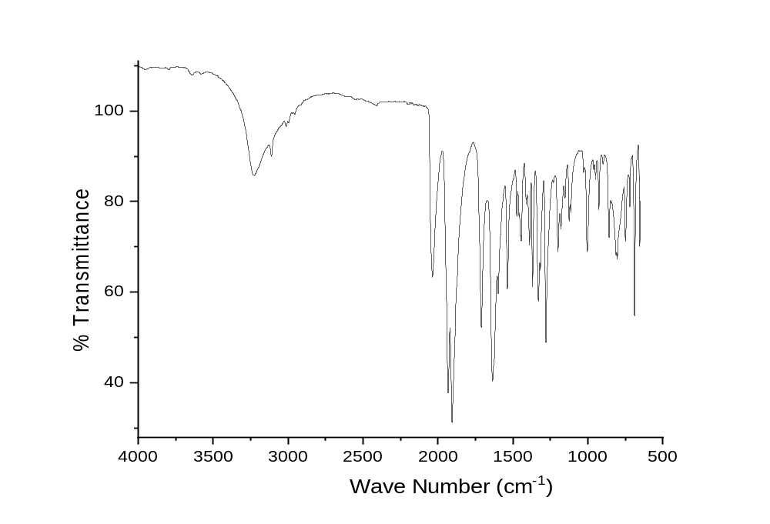
Fig. S2: IR spectrum of [Re(CO)₃(OH₂)(Hpmdc)] (1)
ѵ(C≡O) 2042, 1908, 1932; ѵ (C=O): 1712; ѵ (C=N: 1636,1599); ѵ(OH): 3225, 3110
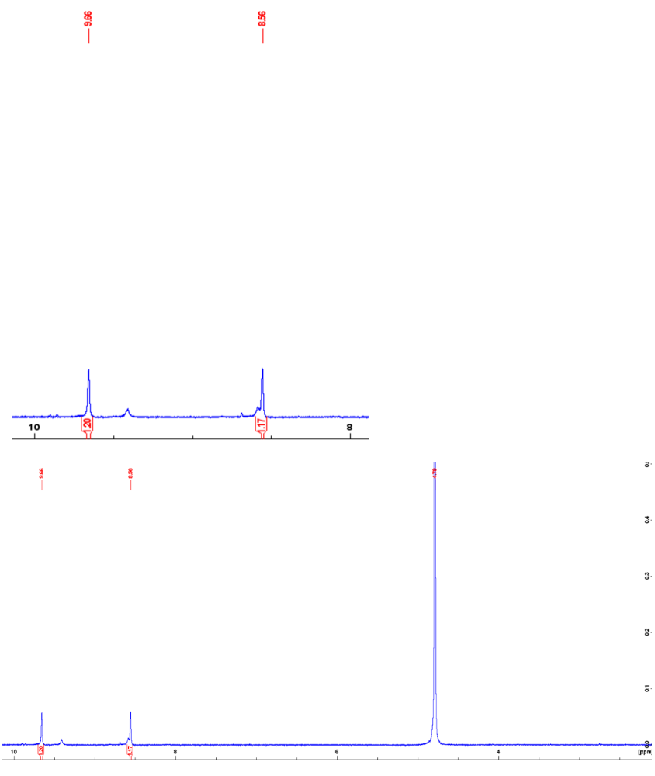
Fig. S3: ¹HNMR of [Re(CO)₃(OH₂)(Hpmdc)] (1) in D₂O
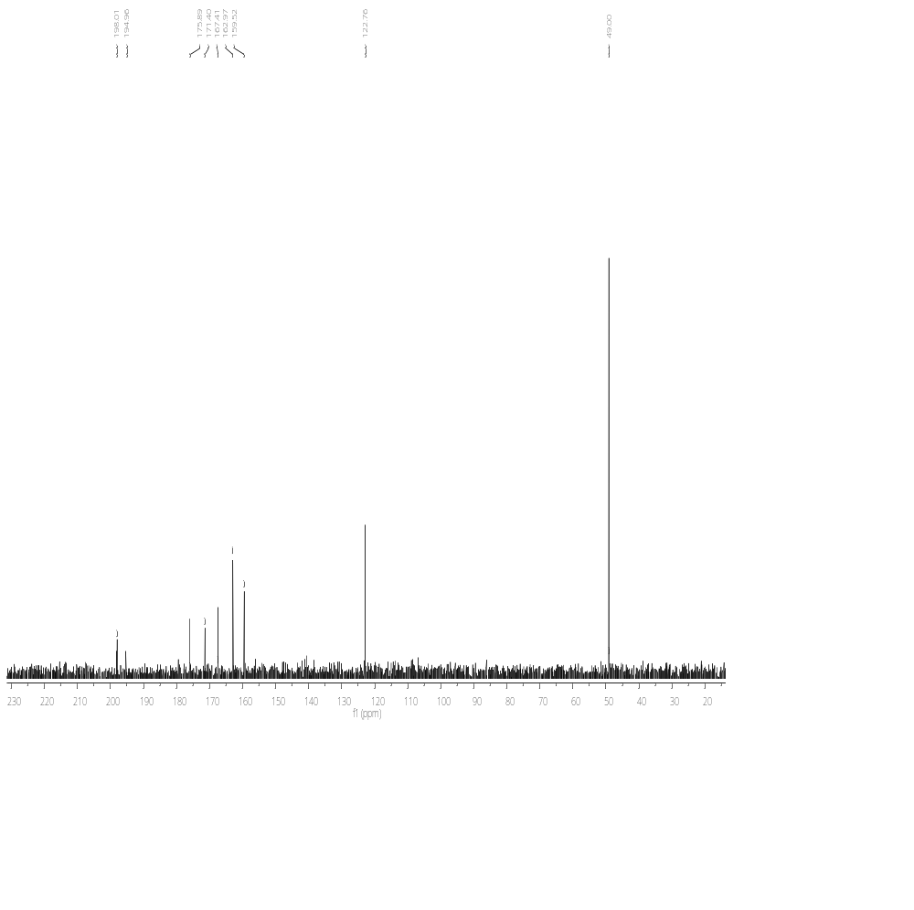 Fig. S4: ¹³CNMR of [Re(CO)₃(OH₂)(Hpmdc)] (1) in CD₃OD

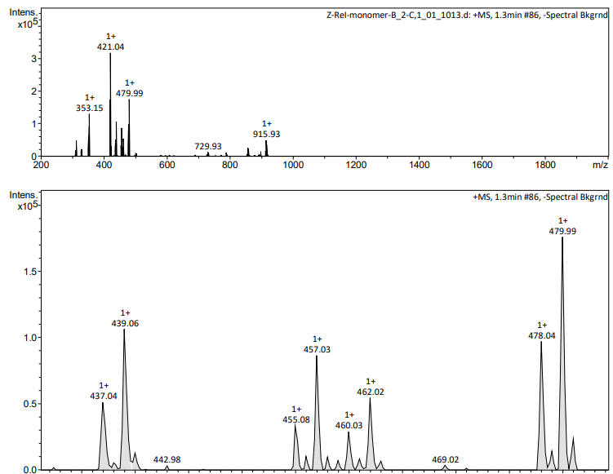
Fig. S5: ESI-MS spectrum representing m/z mass of [Re(CO)₃(OH₂)(Hpmdc)] (1) with 457.03 for [C₉H₆N₂O₈Re]⁺ or [1+H]⁺; 439.06 for [C₉H₄N₂O₇Re]⁺ or [1-H₂O+H]⁺; and 479.99 for [C₁₁H₇N₃O₇Re]⁺ or [1+MeCN+H-H₂O]⁺

Fig. S6: Infrared spectrum of [Re(CO)₃(OH₂)(etpmdc)] (3)
ѵ(C≡O) 1873, 1883, 2015; ѵ (C=O): 1689; ѵ (C=N: 1585,1581); ѵ(C-H): 3089,3091, ѵ(H-O) 3364
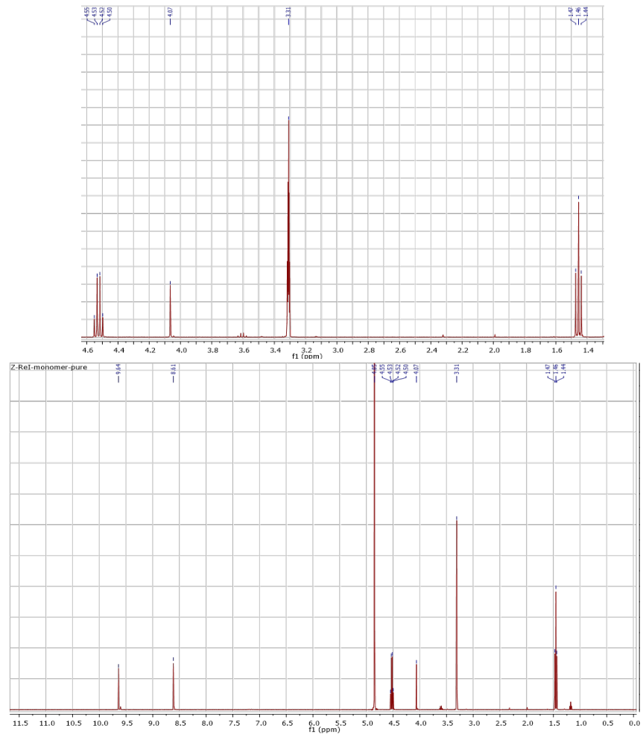
Fig. S7: ¹HNMR of [Re(CO)₃(OH₂)(etpmdc)] (3) in CD₃OD

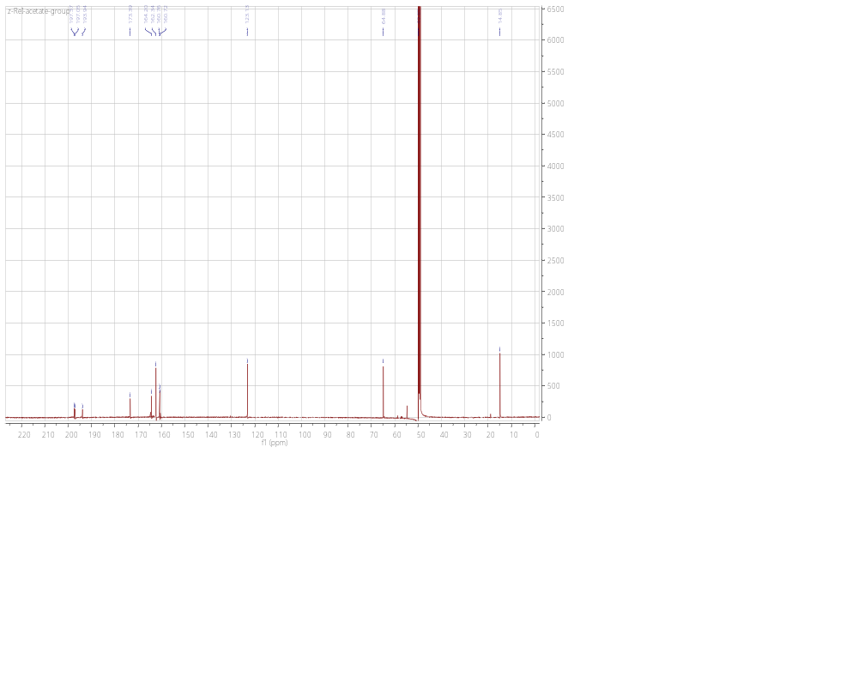
Fig. S8: ¹³CNMR of [Re(CO)₃(OH₂)(etpmdc)] (3) in CD₃OD
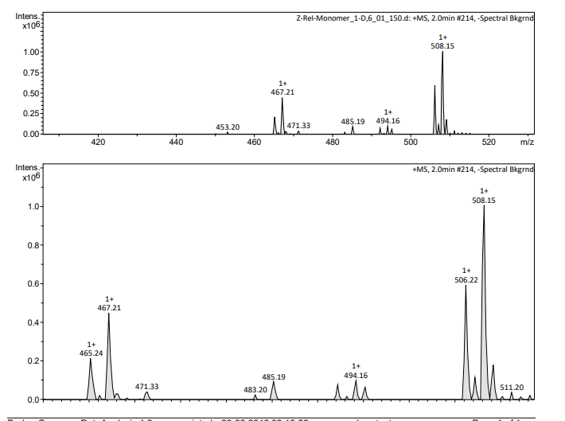
Fig. S9: ESI-MS spectrum representing m/z mass of [Re(CO)₃(OH₂)(etpmdc)] (3) with 467.21 for [C₁₁H₈N₂O₇Re]⁺ or [3-H₂O+H]⁺ and 508.02 for [C₁₃H₁₁N₃O₇Re]⁺ or [3+MeCN+H-H₂O]⁺
Fig. S10: UPLC chromatogram of (Et₃NH)₂[(µ-pmdc)₂(Re(CO)₃)₂] (4) eluted using 0.1% trifluoro-acetic acid (TFA) in H₂O (solvent A) acetonitrile (solvent B)
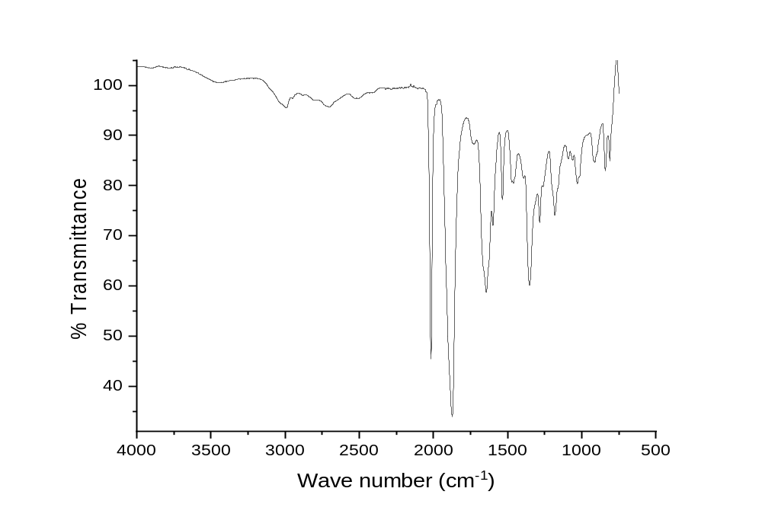
Fig. S11: IR spectrum of (Et₃NH)₂[(µ-pmdc)₂(Re(CO)₃)₂] (4)
ѵ(C≡O) 2016, 1875; ѵ (C=O): 1646; ѵ (C=N: 1599,1538); ѵ(C-H): 2988
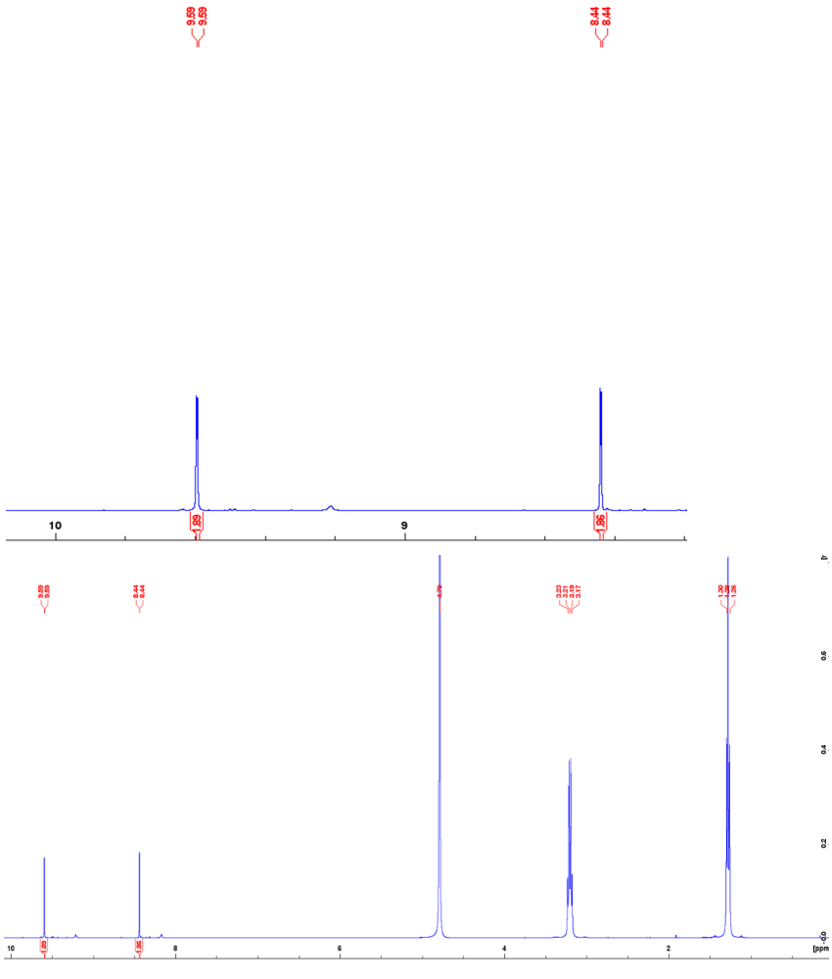
Fig. S12: ¹HNMR of (Et₃NH)₂[(µ-pmdc)₂(Re(CO)₃)₂] (4) in D₂O
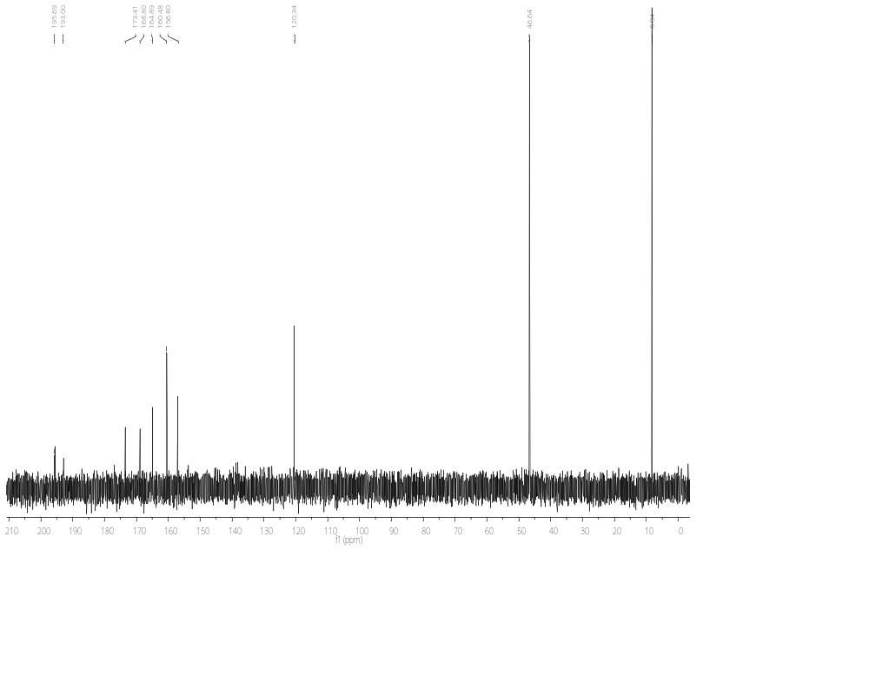Fig. S13: ¹³CNMR of (Et₃NH)₂[(µ-pmdc)₂(Re(CO)₃)₂] (4) in D₂O

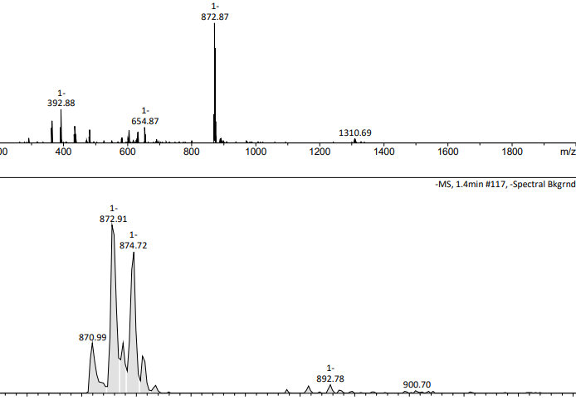
Fig. S14: ESI-MS spectrum representing m/z mass of (Et₃NH)₂[(µ-pmdc)₂(Re(CO)₃)₂] (4) in negative mode with 872.91 for [C₁₈H₅N₄O₁₄Re₂]⁻ or [3+H]⁻

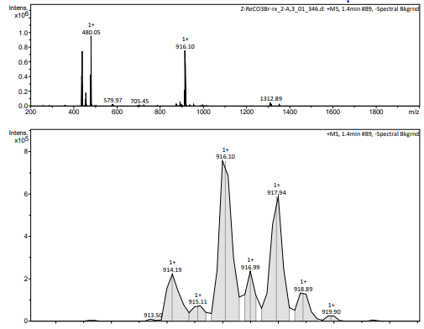
Fig. S15: ESI-MS spectrum representing m/z mass of (Et₃NH)₂[(µ-pmdc)₂(Re(CO)₃)₂] (4) in positive mode with 916.10 for [C₂₀H₁₀N₅O₁₄Re₂]⁺ or [4+3H+MeCN]⁺


Fig. S16: Packing diagram of 3 showing two asymmetric units and hydrogen bonds (blue dashed)

