Supplementary data
  - Widespread rock wall permafrost degradation in Greenland by the end of the 21st century under CMIP6 projections
Marco Marcer^{1,2}, Michele Citterio³, Thomas Ingeman-Nielsen¹
¹DTU Sustain, Bygning 115, 2800 Kgs. Lyngby, Denmark
²Arctic DTU, Siimuup Aqqutaa 32, B-1280, 3911 Sisimiut, Greenland
³GEUS Geological Survey of Greenland and Denmark, Copenhagen

S1: Rock surface temperature data
Summary of the rock surface temperature loggers used in this study. MAAT and PISR values are evaluated using the modeling approach described in the modeling section.
ID | Latitude | Longitude | Elevation [m.a.s.l.] | Start date | End date | MARST [ºC] | MAAT [ºC] | PISR  [kWhm⁻¹]
ITI-G02 | 66.99 | -52.36 | 116 | 01.07.2021 | 30.06.2022 | 1.0 | -2.3 | 1,112
ITI-G01 | 66.99 | -52.36 | 158 | 01.07.2021 | 30.06.2022 | 1.2 | -2.8 | 1,267
ITI-Bs01 | 66.99 | -52.36 | 149 | 01.07.2021 | 30.06.2022 | -1.0 | -2.7 | 921
ITI-G03 | 67.00 | -52.35 | 297 | 01.07.2021 | 30.06.2022 | 0.7 | -4.4 | 971
ITI-G04 | 67.00 | -52.34 | 364 | 01.07.2021 | 30.06.2022 | 1.0 | -4.5 | 1,395
ITI-Bs02 | 67.00 | -52.36 | 196 | 01.07.2021 | 30.06.2022 | -2.3 | -3.4 | 562
ITI-G05 | 67.01 | -52.34 | 552 | 01.07.2021 | 30.06.2022 | 0.7 | -5.1 | 1,406
ITI-G06 | 67.01 | -52.35 | 465 | 01.07.2021 | 30.06.2022 | -3.8 | -5.0 | 599
KAN-G01 | 67.08 | -50.33 | 393 | 01.08.2021 | 30.07.2022 | 0.1 | -4.0 | 1,431
KAN-G02 | 66.98 | -50.89 | 177 | 01.08.2021 | 30.07.2022 | 2.5 | -2.9 | 1,418
KAN-G03 | 67.01 | -50.67 | 146 | 01.08.2021 | 30.07.2022 | -1.6 | -2.3 | 599
KAN-G05 | 67.15 | -50.10 | 428 | 01.08.2021 | 30.07.2022 | -1.3 | -4.0 | 648
KAN-G04 | 67.14 | -50.13 | 455 | 01.08.2021 | 30.07.2022 | 0.1 | -4.4 | 1,356
KAN-G06 | 67.09 | -50.29 | 319 | 01.08.2021 | 30.07.2022 | -3.1 | -3.8 | 633
AQQ-G02 | 67.09 | -53.29 | 853 | 01.07.2021 | 30.06.2022 | -0.1 | -5.9 | 1,352
AQQ-G04 | 67.09 | -53.24 | 1,345 | 01.07.2021 | 30.06.2022 | -3.0 | -8.1 | 1,498
AQQ-G05 | 67.09 | -53.24 | 1,326 | 01.07.2021 | 30.06.2022 | -6.0 | -8.1 | 492
SIS-G01 | 66.96 | -53.66 | 289 | 01.09.2020 | 30.08.2022 | 1.7 | -3.8 | 1,394
SIS-G02 | 66.96 | -53.67 | 354 | 01.09.2020 | 30.08.2022 | -2.5 | -3.6 | 1,070
SIS-G03 | 66.96 | -53.67 | 379 | 01.09.2020 | 30.08.2022 | -0.6 | -3.6 | 1,105
SIS-G04 | 66.96 | -53.65 | 487 | 01.09.2020 | 30.08.2022 | 1.0 | -4.0 | 1,423
SIS-G05 | 66.95 | -53.69 | 83 | 01.09.2020 | 30.08.2022 | 3.1 | -2.2 | 1,292
SIS-G08 | 66.96 | -53.72 | 554 | 01.09.2020 | 30.08.2022 | 0.4 | -4.3 | 1,441
SIS-G09 | 66.96 | -53.67 | 343 | 01.10.2020 | 30.09.2022 | -2.4 | -3.4 | 672
SIS-G10 | 66.97 | -53.58 | 574 | 01.09.2021 | 30.08.2022 | -3.8 | -4.9 | 606
SIS-Bs1 | 66.96 | -53.69 | 131 | 01.09.2021 | 30.08.2022 | -0.2 | -3.4 | 820
SIS-Bs01 | 66.96 | -53.69 | 131 | 01.09.2020 | 30.08.2021 | 0.4 | -2.2 | 820
SIS-Bs02 | 66.96 | -53.70 | 150 | 01.09.2020 | 30.08.2021 | 2.5 | -2.5 | 1,378
SIS-Bs03 | 66.96 | -53.71 | 512 | 01.09.2020 | 30.08.2021 | 0.1 | -3.5 | 930
VAI-G01 | 70.27 | -52.77 | 680 | 01.05.2019 | 30.03.2022 | -1.0 | -5.2 | 1,199
VAI-G04 | 70.29 | -52.74 | 1,411 | 01.05.2019 | 30.03.2022 | -2.1 | -8.5 | 1,409
DIS-G02 | 69.83 | -52.50 | 1,000 | 01.05.2019 | 30.03.2022 | -4.1 | -6.4 | 536
VAI-G05 | 70.29 | -52.74 | 1,430 | 01.07.2019 | 30.05.2022 | -3.7 | -9.2 | 1,373
DIS-G04 | 69.83 | -52.49 | 989 | 01.05.2019 | 30.03.2022 | -4.0 | -6.3 | 533
VAI-G09 | 70.29 | -52.75 | 1,215 | 01.05.2019 | 30.03.2022 | -1.3 | -7.5 | 1,385
DIS-G08 | 69.82 | -52.52 | 1,065 | 01.07.2021 | 30.06.2022 | -5.7 | -7.6 | 981

S2: Model performance
Here described the model performance.
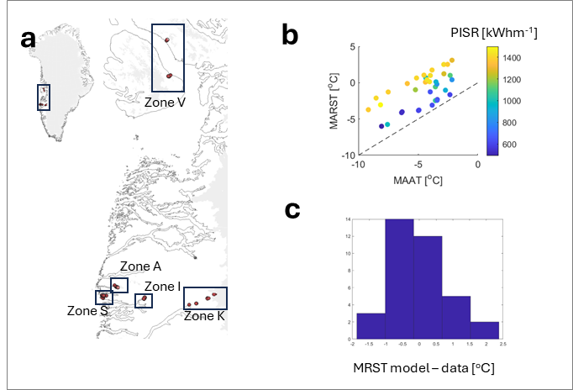
Figure S2.1: Model performance summary. In (a) the location of the loggers, organized by geographical zones used for the spatial cross validation. In (b) the relation between measured MRST, and downscaled MAAT and PISR. In (c), model residuals distribution.

Table S2.1: Model performance indicators, for training and validation of both full dataset and spatial cross validation.
Full dataset | Intercept | -1.876
Full dataset | MAAT | 0.85
Full dataset | PISR | 0.0045
Full dataset | R2 | 0.84
Full dataset | MAE [C] | 0.70
Spatial cross validation
Zone A | R2 tr | 0.87
Zone A | MAE tr [C] | 0.73
Zone A | MAE val [C] | 0.63
Zone I | R2 tr | 0.86
Zone I | MAE tr | 0.70
Zone I | MAE val | 0.72
Zone K | R2 tr | 0.84
Zone K | MAE tr [C] | 0.70
Zone K | MAE val [C] | 0.74
Zone S | R2 tr | 0.87
Zone S | MAE tr [C] | 0.67
Zone S | MAE val [C] | 0.77
Zone V | R2 tr | 0.84
Zone V | MAE tr [C] | 0.69
Zone V | MAE val [C] | 0.75

S3: ECMs pool
Model | ECS (°C)
------------------ | ----------
ACCESS-CM2 | 4.72
AWI-CM-1-1-MR | 3.16
BCC-CSM2-MR | 3.04
CAMS-CSM1-0 | 2.29
CESM2 | 5.16
CIESM | 5.68
CMCC-ESM2 | 3.57
CNRM-CM6-1 | 4.83
CNRM-ESM2-1 | 4.76
CanESM5-CanOE | 5.70
EC-Earth3-Veg-LR | 4.31
FGOALS-g3 | 2.88
FIO-ESM-2-0 | 4.31
GFDL-ESM4 | 3.93
HadGEM3-GC31-LL | 5.55
INM-CM5-0 | 1.92
KACE-1-0-G | 4.48
KIOST-ESM | 3.36
MIROC-ES2L | 2.68
MPI-ESM1-2-LR | 3.37
MRI-ESM2-0 | 3.15
NESM3 | 4.72
NorESM2-LM | 2.54
NorESM2-MM | 2.53
TaiESM1 | 4.43
UKESM1-0-LL | 2.53

S4: ECMs individual outcomes

SSP1-2.6
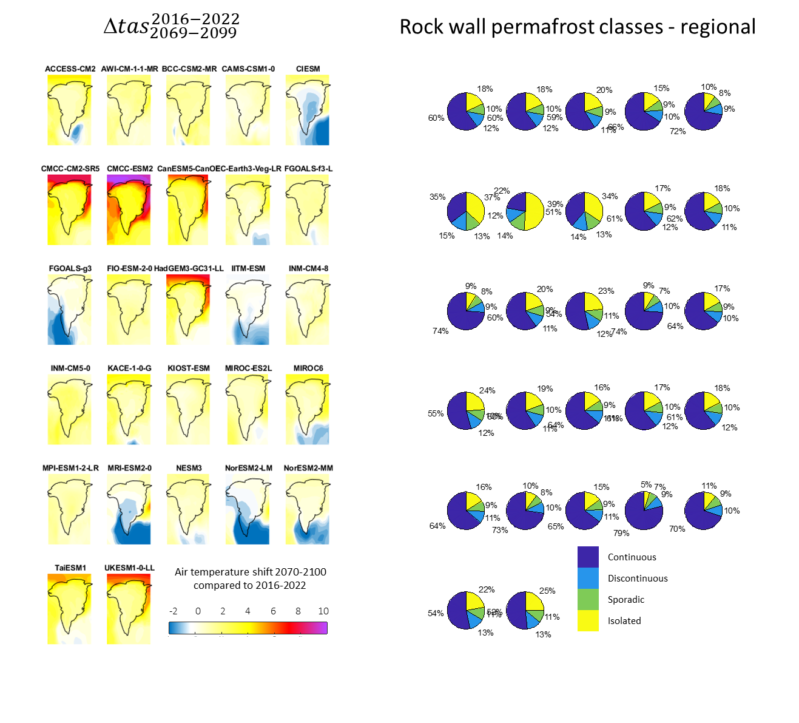

SSP2-4.5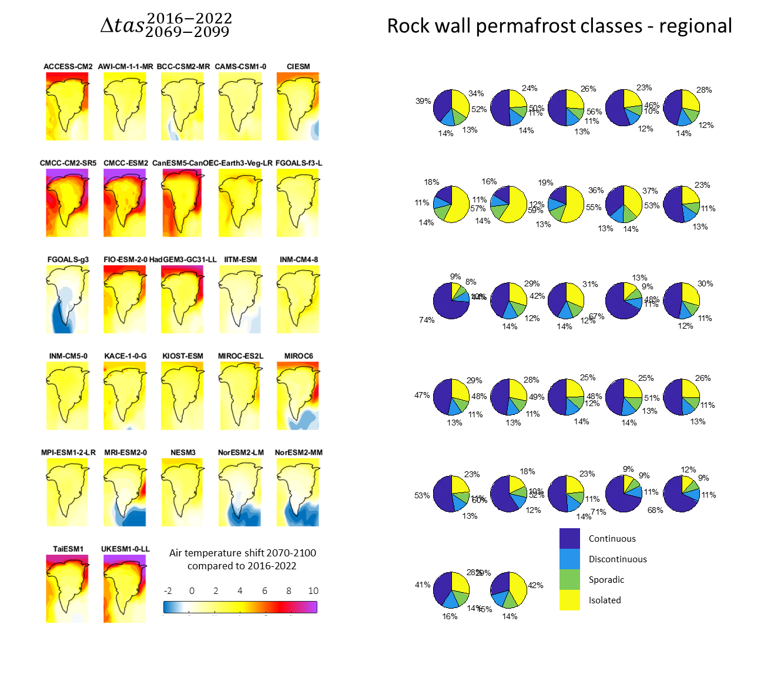

SSP5-8.5