Supplemental information
Expandable hESC-derived cardiovascular progenitor cells generate functional cardiovascular lineage cells for cardiac microtissue construction
Siamak Rezaeiani^{1,2}, Malihe Rezaee², Mojtaba Shafaghi², Mohammad Karami², Roghayeh Hamidi², Hamid Khodayari², Sadaf Vahdat³, Sara Pahlavan^{2*}, Hossein Baharvand^{2,4*}
- Department of Applied Cell Sciences, Faculty of Basic Sciences and Advanced Medical Technologies,
Royan Institute, ACECR, Tehran, Iran
- Department of Stem Cells and Developmental Biology, Cell Science Research Center, Royan Institute for Stem Cell Biology and Technology, ACECR, Tehran, Iran
- Applied Cell Sciences Division, Department of Hematology, Faculty of Medical Sciences, Tarbiat Modares University, Tehran, Iran
- Department of Developmental Biology, School of Basic Sciences and Advanced Technologies in Biology, University of Science and Culture, Tehran, Iran

*Corresponding authors:
1. Hossein Baharvand, Royan Institute, Banihashem Sq., Banihashem St., Ressalat highway, Tehran, Iran. P.O. Box: 16635-148, Tel: +98 21 22306485, Fax: +98 21 23562507, Email: h.baharvand@royan-rc.ac.ir
2. Sara Pahlavan, Royan Institute, Banihashem Sq., Banihashem St., Ressalat highway, Tehran, Iran. P.O. Box: 16635-148, Tel: +98 21 23562504, Fax: +98 21 23562507, Email: sarapahlavan@royaninstitute.org, s.pahlavan@royan-rc.ac.ir

Supplementary Methods
Generation of human embryonic stem cells-derived cardiovascular progenitor cells (hESC-CPC)
Human embryonic stem cells (hESC), Royan H6 (RH6) line (1), were expanded in adherent culture according to a previously described protocol (2). In order to prompt hESC for cardiogenic differentiation, the expansion system was changed to static suspension culture where hESC were expanded in ultra-low attachment plates (Corning,351008 as previously described (2). Briefly, 2 × 10⁵ viable cells/ml were transferred to ultra-low attachment plates for expansion. The hESC medium was comprised of DMEM/F12 (Gibco, 31331-028) supplemented with 20% knockout serum replacement (KOSR; Gibco, 10828-028), 1% nonessential amino-acids (NEAA; Gibco, 11140-035), 1% penicillin/streptomycin (Gibco, 15070-063), 1% insulin-transferrin-selenite (ITS; Gibco, 51500-056), 0.1 mM β-mercaptoethanol (Sigma-Aldrich, M7522), and freshly added 100 ng/ml basic fibroblast growth factor (bFGF) (Sigma-Aldrich, F0291). Furthermore, 10 μM of ROCKi (Sigma-Aldrich, Y0503) was added to the culture medium for the first 24 h in order to inhibit apoptosis. The medium was exchanged every day in a certain time for 5 days. The 5-day old hESC spheroids with average diameter of 175 ± 25 μm were subjected to cardiogenic differentiation. For this purpose, hESC were primarily treated with 12 μM of CHIR (Stemgent, 04-0004-10), a small molecule for induction of canonical WNT/β-catenin signaling, diluted in basal differentiation medium that consisted of RPMI 1640 (Gibco, 52400-041) supplemented with 2% B-27 without Vitamin A (Gibco, 125870-01), 2 mM L-glutamine (Gibco, 25030-024), 1% NEAA, 1% penicillin/streptomycin, and 0.1 mM β-mercaptoethanol for one day, followed by one-day culture in basal differentiation medium without CHIR. From 48 to 96 h, the cells were cultured in basal differentiation medium supplemented with a cocktail of small molecules including 5 µM IWP2 (Tocris Bioscience, 3533), as an inhibitor of WNT signaling, 5 µM SB-431542 (Cayman, 13031), as a selective antagonist of the TGF-β1 activin receptor-like kinase (ALK) receptors, and 5 µM purmorphamine (Pur) (Stemgent, 04-0009;) as an agonist of sonic hedgehog (SHH).
Culture and expansion of hESC-CPC
The 4-day old differentiated hESC-CPC spheroids were dissociated into single cells by treating with Accumax solution (Pan Biotech, P10-21250) for 3 min at 37 °C. The resulting cells were characterized with flow cytometry and immunofluorescence staining for CPC-specific markers. For hESC-CPC expansion, single CPCs were cultured at Matrigel (Sigma-Aldrich, E1270)-coated plates with specific expansion medium (CPC_{xm}) composed of a basal medium (DMEM/F12, B27 without Vitamin A, 1% N2 supplement (Gibco, 17502-001), 2 mM L-glutamine, 1% NEAA, 0.1 mM β-mercaptoethanol, and 15 mM HEPES (Gibco, 15630-080)) and fresh small molecules;100 ng/ml bFGF, 3 μM CHIR, and 0.5 μM A83-01 (Stemgent, 04-0014) as inhibitor of TGF-β1 ALK receptors. Furthermore, hESC-CPC were passaged every 72 h and expanded for 8 passages. Characterization of hESC-CPC was performed at passage 0 (P0), P4 and P8 using immunofluorescence staining against CPC-specific markers.
Freeze-thaw procedure of hESC-CPC
In order to save hESC-CPC for longer period of time, 1×10⁶ cells were dissolved in 500 μL of cold freezing medium; CryoStor®CS10 (STEMCELL, 07954), after enzymatic digestion by Accumax solution and centrifugation at 1500 rpm for 3 min. Cells were kept overnight in a −70 °C freezer following 1 h incubation at -20 °C freezer. hESC-CPCs were transferred to a liquid nitrogen tank the next day. For thawing, the frozen vials were held in a 37 °C water bath until most of the ice is thawed. Fresh CPC_{xm} that consisted of 10 μM ROCKi was added to cells after centrifugation, followed by culture on Matrigel-coated plates. After thaw, the cell viability was assessed by using Trypan Blue staining (Sigma, T111732).
Population Doubling Time (PDT) and expansion fold assay
Passages 0 (P0), 4 (P4), and 8 (P8) CPCs were seeded onto Matrigel-coated 4-well plates at a density of 4 × 10⁴ cells/cm² in CPC_{xm} medium. PDT was assessed using the method described in a previous study (3). The trypan blue exclusion method was used to determine cell counts at 2, 3, and 4 days after culturing. The following formula was utilized to calculate PDT:
N = N₀2 ^{t/T}
Where:
N = Daily cell count
N0 = Initial cell count
T = PDT
The 4 × 10 ⁴ CPCs at P0, P4, and P8 were cultured and counted after 72 h; then expansion fold was calculated.
Gene expression analysis by real-time RT-qPCR
For the molecular analysis of gene transcription, total RNA was isolated using Micro Reagent Kit (Qiagen, 74004). To prevent potential DNA contamination, a DNase1 Kit (Qiagen, 79254) was used according to the manufacturer’s instructions. First strand cDNA synthesis was carried out using 2 µg of total RNA with the Pars tous Reagent Kit (A101161), and real-time PCR was conducted using the Amplicon Kit (A325402) and Real-Time PCR machine (AB Applied Biosystems). Relative gene expression was calculated using the 2^{-ΔΔct} formula, with GAPDH serving as the housekeeping gene. The expression pattern of the genes in CPCs, CFs, CMs, SMCs, and ECs were compared with hESCs. The primer information is provided in Supplementary Table 1.
Flow Cytometry
The hESC-CPCs, which were collected from day 4 of differentiation, were dissociated into single cells using Accumax. Subsequently, cells were washed twice with PBS and fixed in 4% paraformaldehyde (PFA) for 15 min at 4°C. The cells were washed twice with washing buffer (PBS/ Tween 0.05%), permeabilized and blocked in a PBS solution containing 0.1% (vol/vol) Triton X-100 and 1% BSA, for 30 min at 4°C. The cells were incubated overnight at 4°C with the diluted primary antibody (1:50 for NKX2.5). Then, cells were washed three times with washing buffer, after which secondary antibodies (1:100 for Goat anti-rabbit, Sant Cruz, Sc-3739) were added to the cells. After 45 min of incubation at 4°C, followed by two times washing with washing buffer, the stained cells were analyzed with a flow cytometer (BD FACSCalibur (488)) and flowJo software version 2.5.1.
Immunofluorescence staining
Cells were fixed with 4% (wt/vol) paraformaldehyde (PFA) at 4 °C for 20 min, and washed twice with washing buffer (PBS/ Tween 0.05%) for 5 min. For permeabilization and blocking, cells were incubated in PBS containing 0.1% Triton X-100 and 1% BSA for 1 h at room temperature (RT). Primary antibodies diluted in the fresh permeabilization/blocking buffer (1:50 or 1:200) were added to the cells, followed by an overnight incubation at 4°C. The next day, cells were washed three times with washing buffer, each for 5 min. Secondary antibodies diluted in fresh permeabilization/blocking buffer (1:100 or 1:500) were added to the cells, after which they were incubated for 1 h at RT. The cells were subsequently washed three times with washing buffer, each for 5 min. Furthermore, the cells were incubated with DAPI (Sigma-Aldrich, D8417) (2µg/ml) for 2 min at RT for nuclear staining. For visualization, the fluorescence microscope (Olympus, IX71, Japan) was used. The primary and secondary antibodies which were used are listed in Supplementary Table 2.
Histological analysis
The microtissues were collected 7 days after co-culture for immunohistofluorescence. The microtissues were fixed with 4% (wt/vol) paraformaldehyde at 4°C for 72 h. To increase the integrity, the samples were incorporated in 2% agar gel (Sigma Aldrich, A1296). The processed microtissues were embedded in paraffin blocks and cut into 5μm-thick sections using a microtome (MicromHM325; Thermo Fisher Scientific, Waltham, MA). For immunofluorescence staining, deparaffinized and rehydrated sections were undergone antigen retrieval using Target Retrieval Solution, pH 9, (Dako, S2368) for 20 min. Subsequently, samples were blocked with 10% BSA for 1 h at 37 °C, following the permeabilization with PBS containing 0.5% Triton X100 at RT for 10 min. Then, the sections were incubated overnight with primary antibodies at 4 °C. The next day, sections were washed with washing buffer three times (15 min each) and incubated with secondary antibodies at 37 °C for 1 h. The sections were washed two times with washing buffer (7 min each) and then stained with DAPI for 2 min. The sections were imaged by a fluorescence microscope (Olympus, IX71, Japan). The antibodies which were used, are listed in Supplementary table 2.
Confocal imaging:
To evaluate the cell distribution in the microtissue, the Rhodamine Phalloidin (Invitrogene, B7474) staining was used and visualized by confocal laser scanning microscopy (CLSM; LSM800, Carl Zeiss, Germany). On day 7 of co-culture, the microtissues were rinsed twice with PBS for 5 min, fixed with 4% paraformaldehyde at 4°C for 30 min, rinsed twice with PBS/Tween, and incubated with Biotin-labeled Phalloidin (at a 1:200 ratio) for 2 h at 37°C. Subsequently, the samples were washed twice with PBS/Tween. Nuclei were stained with DAPI for 2 min at RT, and then the microtissues were observed using CLSM.

Supplementary Figures

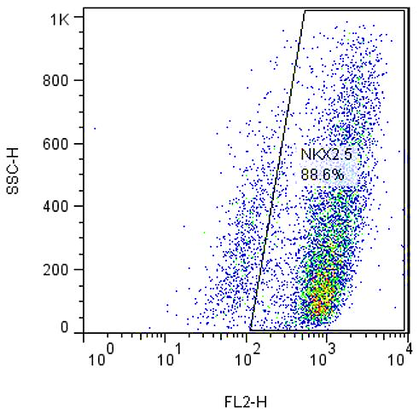
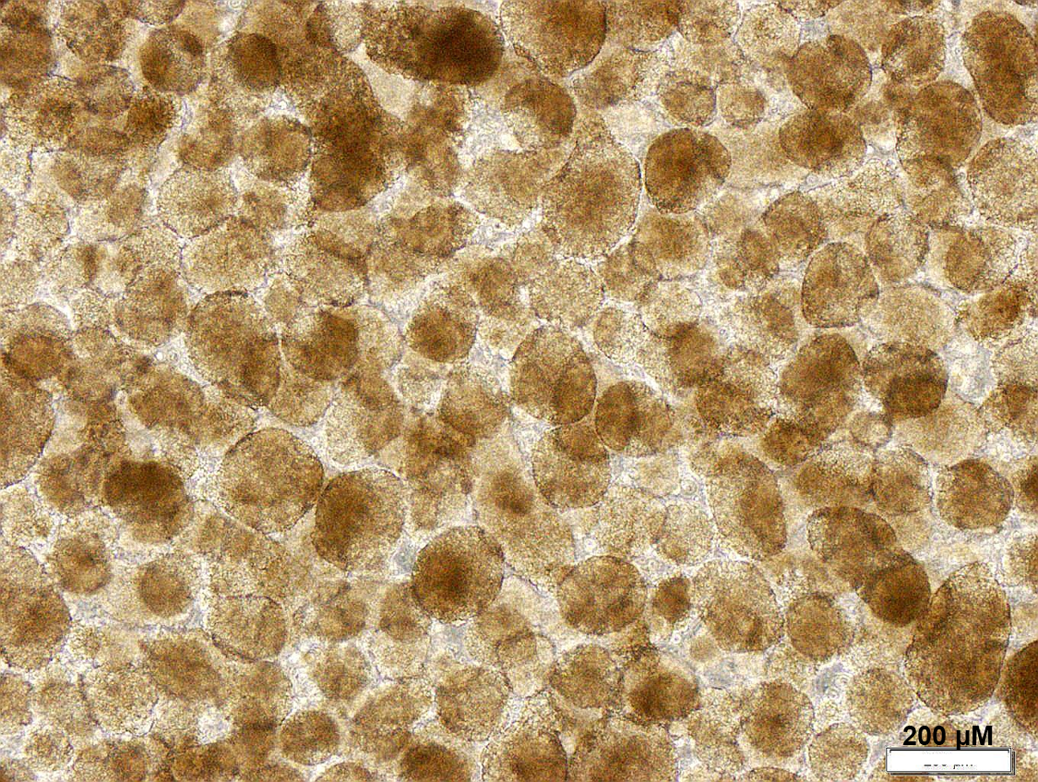
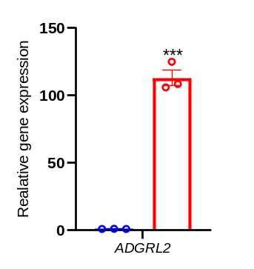
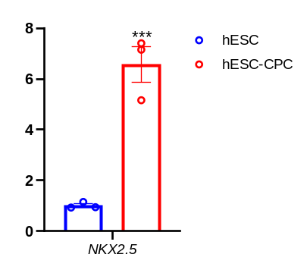
3D hESC culture
A
B
C
D
Relative gene expression vs hESC
Supplementary Figure 1: (A) Morphology of the hESC spheroids, Scale bars: 200 μm. (B) Flow cytometry analysis indicated that day-4 differentiated CPCs were 88.6% NKX2.5⁺ (C, D) Expression of NKX2.5 and ADGRL2 in day-4 differentiated CPCs compared to hESCs. All data are presented as mean ± standard error of the mean (SEM).

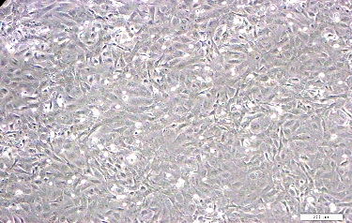
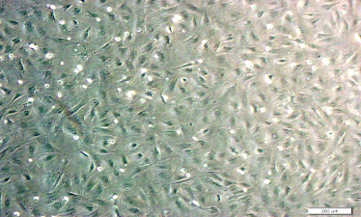
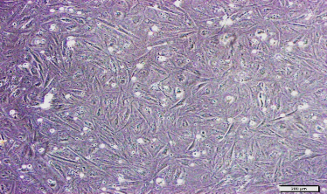
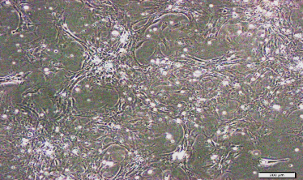
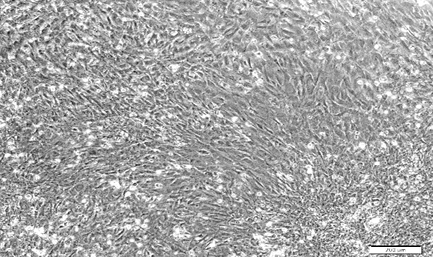
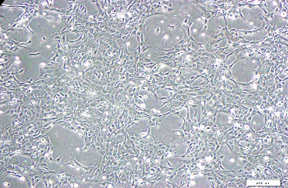
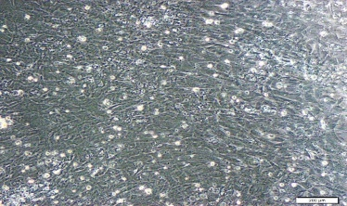
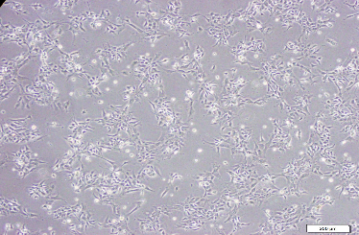
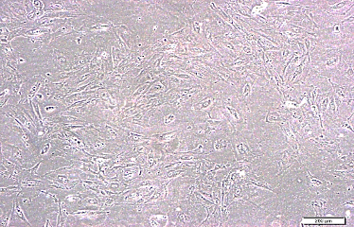
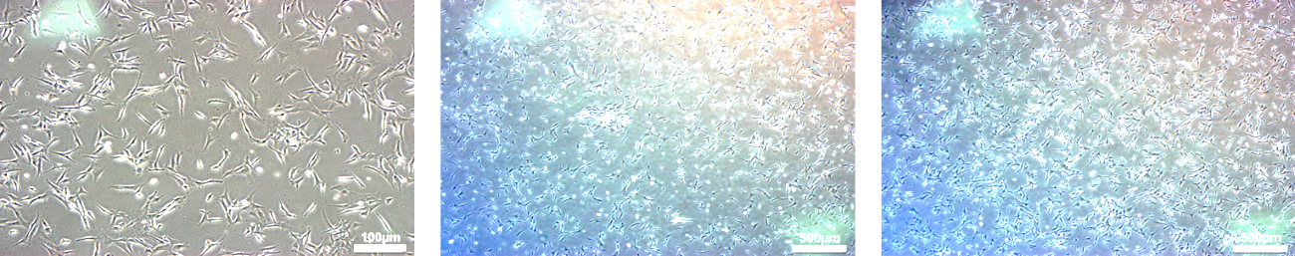
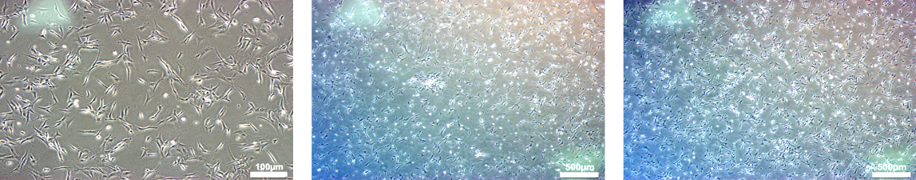
CPC-CM
P4
P8
P0
CPC-EC
CPC-SMC
CPC-CF
500 µm
Supplementary Figure 2: CPC-derived CMs, ECs, SMCs, CFs showed different morphologies compared to hESC-derived CPCs at P0, P4 and P8.

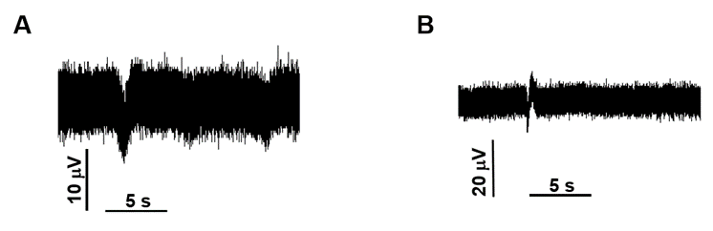

Supplementary Figure 3: Field potential recording from microtissues that included CPC(P0)-CM (A) and CPC(P8)-CM (B) as well as CPC-EC, CPC-SMC, CPC-CF.

Supplementary Tables
Supplementary Table 1. List of primers used for real-time qRT-PCR
Gene name | Primer sequence (5'-3')
NKX2.5 | F: TCTATCCACGTGCCTACAG | R: CCTCTGTCTTCTCCAGCTC
SOX17 | F: CGGTATATTACTGCAACTATCCTG | R: GGATTTCCTTAGCTCCTCCA
cTNT | F: ATGATGCATTTTGGGGGTTA | R: CAGCACCTTCCTCCTCTCAG
ISL1 | F: TACAAAGTTACCAGCCACC | R: GGAAGTTGAGAGGACATTGA
PDGFRα | F: TACACTTGCTATTACAACCACA | R: ATCCTCCACGATGACTAAAT
AFP | F: AAATGCGTTTCTCGTTGCTT | R: GCCACAGGCCAATAGTTTGT
PAX6 | F: GTCCATCTTTGCTTGGGAAA | R: TAGCCAGGTTGCGAAGAACT
MLC2v | F: CTTGGGCGAGTGAACGT | R: CTGGTCAACCTCCTCCTTG
GAPDH | F: CTCATTTCCTGGTATGACAACGA | R: CTTCCTCTTGTGCTCTTGCT

Supplementary Table 2. List of antibodies used for immunostaining
Antibody | Type | Brad | Cat no | Concentration | Cell
Rabbit anti-NKX2.5 | Primary | Sant Cruz | Sc-14033 | 1:50 | CPC
Goat anti-rabbit | Secondary | Sant Cruz | Sc-3739 | 1:100
Rabbit anti-Ki67 | Primary | Abcam | AB15580 | 1:200 | CPC
Goat anti-rabbit | Secondary | Invitrogen | A-11008 | 1:500
Mouse anti-α-SMA | Primary | Abcam | AB7817 | 1:200 | SMC
Donkey anti-mouse | Secondary | Abcam | AB150105 | 1:500
Mouse anti-vimentin | Primary | Sant Cruz | SC-6260 | 1:200 | CF & EC
Anti- CD31 | Primary | Abcam | AB28364 | 1:100 | EC
Goat anti-cTNT | Primary | Abcam | AB6423 | 1:200 | CM
Donkey anti-Goat | Secondary | Invitrogen | A-11055 | 1:500
Goat anti-NKX2.5 | Primary | R&D | AF2444 | 1:200 | CPC
Donkey anti-goat | Secondary | Abcam | AB150132 | 1:500

References:
1. Baharvand H, Ashtiani SK, Taee A, Massumi M, Valojerdi MR, Yazdi PE, et al. Generation of new human embryonic stem cell lines with diploid and triploid karyotypes. Dev Growth Differ. 2006;48(2):117-28.
2. Fonoudi H, Ansari H, Abbasalizadeh S, Larijani MR, Kiani S, Hashemizadeh S, et al. A Universal and Robust Integrated Platform for the Scalable Production of Human Cardiomyocytes From Pluripotent Stem Cells. Stem Cells Transl Med. 2015;4(12):1482-94.
3. Vahdat S, Mousavi SA, Omrani G, Gholampour M, Sotoodehnejadnematalahi F, Ghazizadeh Z, et al. Cellular and molecular characterization of human cardiac stem cells reveals key features essential for their function and safety. Stem cells and development. 2015;24(12):1390-404.
4. Hosseini M, Ayyari M, Meyfour A, Piacente S, Cerulli A, Crawford A, et al. Cardenolide-rich fraction of Pergularia tomentosa as a novel Antiangiogenic agent mainly targeting endothelial cell migration. Daru. 2020;28(2):533-43.
5. Carpentier G, Berndt S, Ferratge S, Rasband W, Cuendet M, Uzan G, et al. Angiogenesis analyzer for ImageJ—A comparative morphometric analysis of “endothelial tube formation assay” and “fibrin bead assay”. Scientific reports. 2020;10(1):11568.
6. Tian X-X, Kang J, Yan C-H, Xu K, Tao J, Yang G-T, et al. Purification and functional assessment of smooth muscle cells derived from mouse embryonic stem cells. Journal of Geriatric Cardiology: JGC. 2013;10(3):272.

