Comparative Analysis of Cysteine Protease-based Nano-formulations to Manage Callosobruchus maculatus Fabricius and Trogoderma granarium Everts in Stored Products

Supplementary Material

Table S1: Comparison of partial peptide sequence of Populus euphratica Cysteine Protease (PeuCP). with other reported plant cysteine proteases
Source | Position of first amino acid sequence | *Sequences | Identity (%) | Accession no.
Populus euphratica |  | AFQYVLR | 100.00 | This paper
Populus euphratica | 194 | AFQYIIR | 71.43 | XP_011014388.1
Ambrosia artemisiifolia | 200 | AFTYVIK | 57.14 | V5LU01
Populus alba | 194 | AFKYIKQ | 42.86 | XP_034920851.1
*Identical amino acids are underlined.

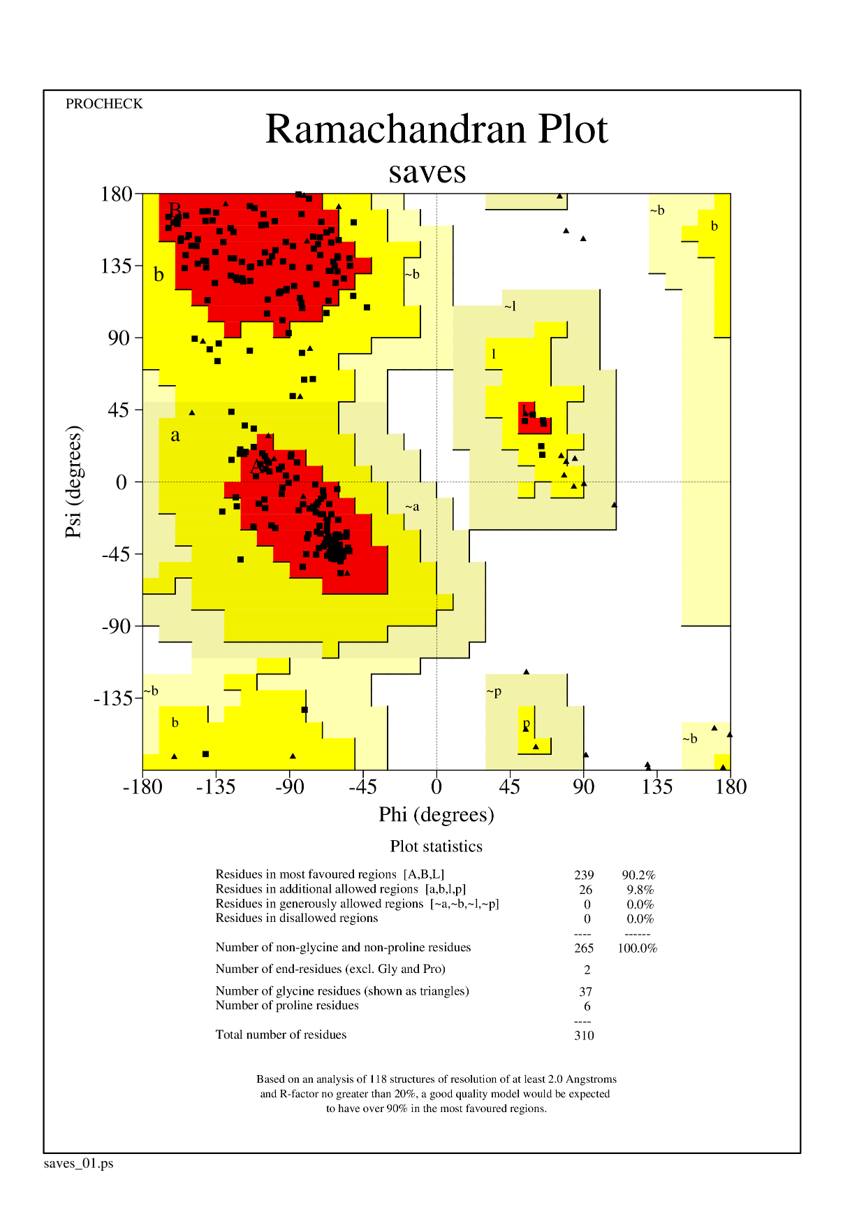

Figure S1: Ramachandran plot

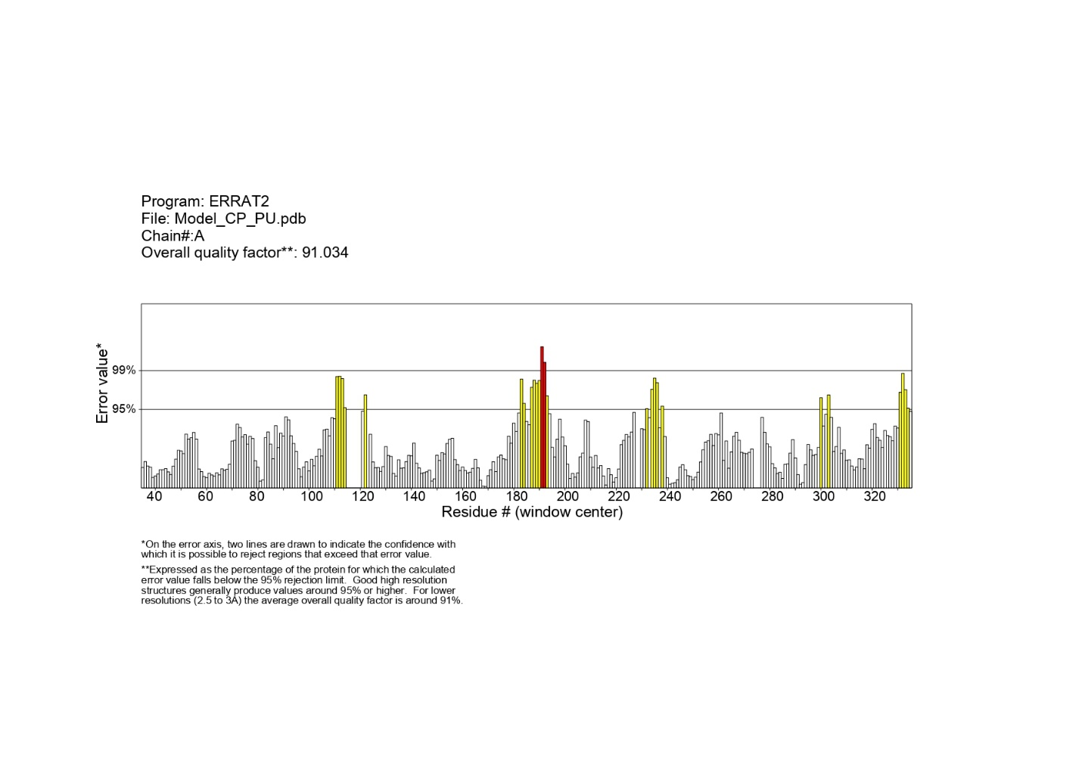

Figure S2: ERRAT

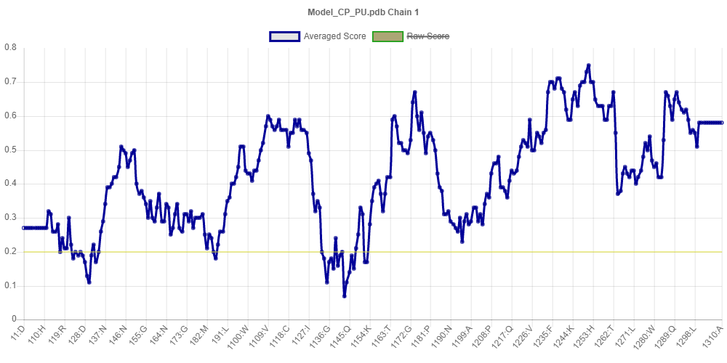

Figure S3: VERIFY₃D

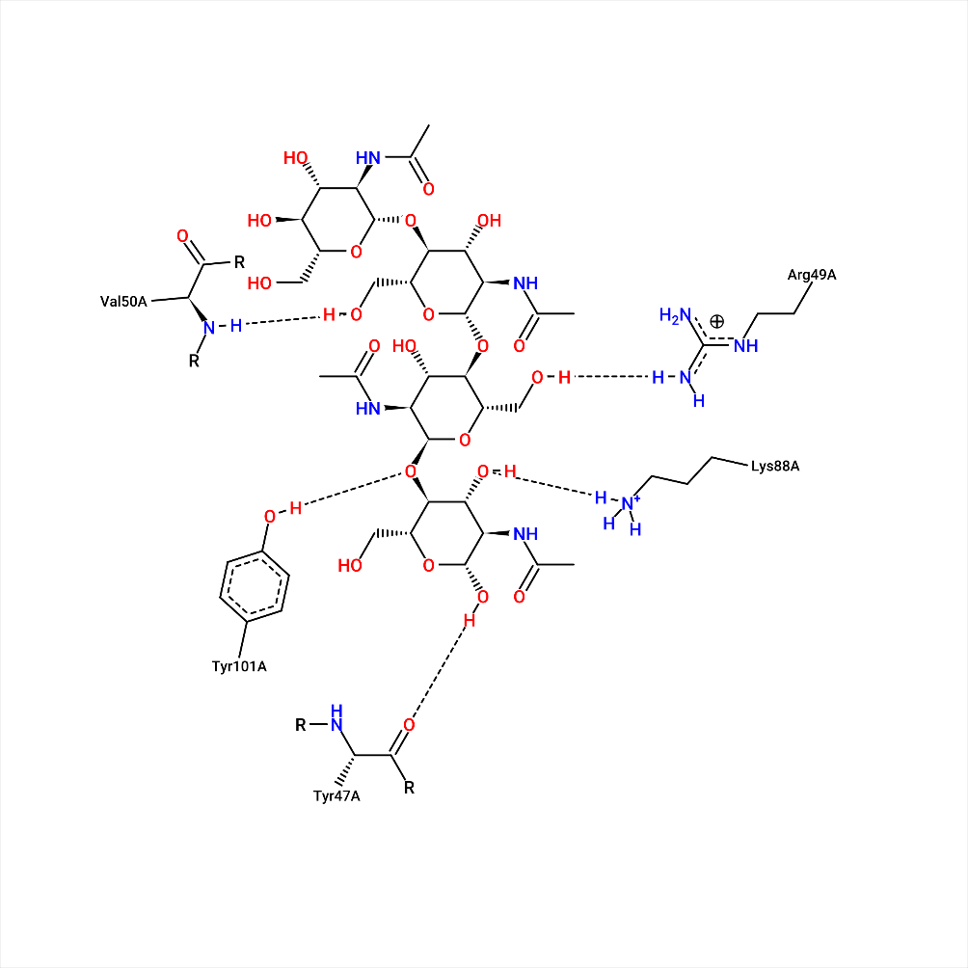

Figure S4: 2D interaction diagram (LigPlot)

Table S2: Contact toxicity of PeuCP at various concentrations against C. maculatus and T. granarium.
Protein | Insects | Hours after treatment | LC₅₀ (95% FL) (mg/L) | LC₉₀ (95% FL) (mg/L) | Slope ± S.E | χ²* |  |  |  | df** |  | ***P
Cysteine protease | Callosobruchus maculatus | 24 | 12.6 (9.52-26.8) | 25 (17.2-66.0) | 0.10±0.03 | 0.137 |  |  | 2 |  | 0.933
Cysteine protease | Callosobruchus maculatus | 48 | 7.78 (6.02-11.2) | 18.6 (13.8-35.4) | 0.11±0.03 | 0.909 |  |  | 2 |  | 0.634
Cysteine protease | Callosobruchus maculatus | 72 | 3.42 (2.16-4.47) | 17.1 (10.6-60.3) | 1.83±0.44 | 0.476 |  |  | 2 |  | 0.788
Cysteine protease | Trogoderma  granarium | 24 | 11.9 (9.25-22.4) | 23.6 (16.7-54.0) | 0.11±0.03 | 0.191 |  |  | 2 |  | 0.908
Cysteine protease | Trogoderma  granarium | 48 | 7.19 (5.98-8.38) | 14.4 (11.8-20.0) | 0.17±0.03 | 0.295 |  |  | 2 |  | 0.862
Cysteine protease | Trogoderma  granarium | 72 | 6.50 (5.10-8.24) | 14.8 (11.8-22.2) | 0.15±0.03 | 0.789 |  |  | 2 |  | 0.674
Each datum represents the mean of five replicates, each replicate set up with 10 adults (n = 50)
*Chi-square value
**Degree of freedom
***Probability value calculated by chidist formula in Microsoft Excel

Table S3: Contact toxicity of nanoparticles at various concentrations against T. granarium.
Insect | Nanoparticles | Hours after treatment | LC₅₀ (95% FL) (mg/L) | LC₉₀ (95% FL) (mg/L) | Slope ± S.E | χ²* | df** | ***P
Trogoderma granarium | Zinc Oxide | 24 | 13.7 (10.6-24.7) | 23.6 (17.0-49.4) | 0.12±0.04 | 0.079 | 2 |  | 0.961
Trogoderma granarium | Zinc Oxide | 48 | 8.44 (6.97-11.1) | 16.9 (13.3-26.2) | 0.15±0.03 | 0.197 | 2 |  | 0.906
Trogoderma granarium | Zinc Oxide | 72 | 7.84 (6.16-11.0) | 18.1 (13.6-32.4) | 0.12±0.03 | 0.611 | 2 |  | 0.736
Trogoderma granarium | Graphene | 28 | - | - |  | - | - |  | -
Trogoderma granarium | Graphene | 48 | - | - |  | - | - |  | -
Trogoderma granarium | Graphene | 72 | - | - |  | - | - |  | -
Each datum represents the mean of five replicates, each replicate set up with 10 adults (n = 50)
*Chi-square value
**Degree of freedom
***Probability value calculated by chidist formula in Microsoft Excel

Insect | Encapsulated Protein | Hours after treatment | LC₅₀ (95% FL) (mg/L) | LC₉₀ (95% FL) (mg/L) | Slope ± S.E | χ²* | df** |  | ***P
Trogoderma granarium | Zinc Oxide | 24 | 8.91 (6.17-26.3) | 78.2 (26.4-873) | 1.35±0.43 | 0.062 |  | 2 |  | 0.969
Trogoderma granarium | Zinc Oxide | 48 | 2.01 (-4.85-4.12) | 13.6 (10.1-28.5) | 0.11±0.03 | 0.334 |  | 2 |  | 0.846
Trogoderma granarium | Zinc Oxide | 72 | 2.42 (1.03-3.39) | 13.9 (8.80-55.0) | 1.68±0.46 | 0.177 |  | 2 |  | 0.915
Trogoderma granarium | Graphene | - | - | - |  | - |  | - |  | -
Trogoderma granarium | Graphene | - | - | - |  | - |  | - |  | -
Trogoderma granarium | Graphene | - | - | - |  | - |  | - |  | -
Table S4: Contact toxicity of encapsulated protein at various concentrations against T. granarium.
Each datum represents the mean of five replicates, each replicate set up with 10 adults (n = 50)
*Chi-square value
**Degree of freedom
***Probability value calculated by chidist formula in Microsoft Excel

