Supplementary Table S1: The Clinicopathological Features of patients with gastric cancer
Charastristics | The training set |  |  |  |  |  |  | The validation set
Charastristics | Patients,n(%) |  |  |  |  |  |  | Patients,n(%)
Charastristics | Patients,n(%) | Albumin(g/L) |  |  | CEA(ng/ml) |  |  | Patients,n(%) | Albumin(g/L) |  |  | CEA(ng/ml)
Charastristics | Patients,n(%) | >41.47 | ≤41.47 | P value | ≤4.77 | >4.77 | P value | Patients,n(%) | >41.47 | ≤41.47 | P value | ≤4.77 | >4.77 | P value
Sex |  |  |  | 0.287 |  |  | 0.350 |  |  |  | 0.084 |  |  | 0.681
Female | 49(29.9) | 24 | 25 |  | 38 | 11 |  | 52(31.5) | 31 | 21 |  | 45 | 7
Male | 115(70.1) | 69 | 46 |  | 81 | 34 |  | 113(68.5) | 51 | 62 |  | 95 | 18
Age (years) |  |  |  | 0.004* |  |  | 0.127 |  |  |  | <0.001* |  |  | 0.034*
≤60 | 59(36.0) | 34 | 25 |  | 47 | 12 |  | 57(34.5) | 41 | 16 |  | 53 | 4
>60 | 105(64.0) | 36 | 69 |  | 72 | 33 |  | 108(65.5) | 41 | 67 |  | 87 | 21
Tumor location |  |  |  | 0.283 |  |  | 0.108 |  |  |  | 0.520 |  |  | 0.119
Middle and lower third | 137(83.5) | 61 | 76 |  | 96 | 41 |  | 142(86.1) | 72 | 70 |  | 118 | 24
Upper third | 27(16.5) | 9 | 18 |  | 23 | 4 |  | 23(13.9) | 10 | 13 |  | 22 | 1
Differentiation |  |  |  | 0.188 |  |  | 0.779 |  |  |  | 0.173 |  |  | 0.029*
Well/Moderate | 70(42.7) | 34 | 36 |  | 50 | 20 |  | 58(35.2) | 33 | 25 |  | 54 | 4
Poor | 94(57.3) | 36 | 58 |  | 69 | 25 |  | 107(64.8) | 49 | 58 |  | 86 | 21
Diameter of lesion (cm) |  |  |  | <0.001* |  |  | <0.001* |  |  |  | 0.005* |  |  | 0.001*
≤4 | 97(59.1) | 54 | 43 |  | 82 | 15 |  | 101(61.2) | 59 | 42 |  | 93 | 8
>4 | 67(40.1) | 16 | 51 |  | 37 | 30 |  | 64(38.8) | 23 | 41 |  | 47 | 17
Cancer embolism |  |  |  | 0.334 |  |  | 0.021* |  |  |  | 0.097 |  |  | 0.003*
None | 75(45.7) | 35 | 40 |  | 61 | 14 |  | 64(38.8) | 37 | 27 |  | 61 | 63
Yes | 89(54.3) | 35 | 54 |  | 58 | 31 |  | 101(61.2) | 45 | 56 |  | 79 | 22
Never invasion |  |  |  | 0.112 |  |  | 0.040* |  |  |  | 0.014* |  |  | 0.540
None | 63(38.4) | 22 | 41 |  | 40 | 23 |  | 95(57.6) | 55 | 40 |  | 82 | 13
Yes | 101(61.6) | 48 | 53 |  | 79 | 22 |  | 70(42.4) | 27 | 43 |  | 58 | 12
pTNM |  |  |  | 0.001* |  |  | <0.001* |  |  |  | 0.004* |  |  | 0.001*
I-II | 73(44.5) | 42 | 31 |  | 67 | 6 |  | 76(46.1) | 47 | 29 |  | 72 | 4
III-IV | 91(55.5) | 28 | 63 |  | 52 | 39 |  | 89(53.9) | 35 | 54 |  | 68 | 21
Depth of invasion |  |  |  | 0.090 |  |  | <0.001* |  |  |  | 0.001* |  |  | 0.001*
T1-T2 | 56(34.1) | 29 | 27 |  | 52 | 4 |  | 63(38.2) | 42 | 21 |  | 61 | 2
T3-T4 | 108(65.9) | 41 | 67 |  | 67 | 41 |  | 102(61.8) | 40 | 62 |  | 79 | 23
LN metastasis |  |  |  | 0.005* |  |  | <0.001* |  |  |  | 0.015* |  |  | 0.001*
N0 | 62(37.8) | 35 | 27 |  | 55 | 7 |  | 69(41.8) | 42 | 27 |  | 66 | 3
N1/N1/N2 | 102(62.2) | 35 | 67 |  | 64 | 38 |  | 96(58.2) | 40 | 56 |  | 74 | 22
Survival status |  |  |  | <0.001* |  |  | 0.001* |  |  |  | <0.001* |  |  | <0.001*
Survival | 76(46.3) | 45 | 31 |  | 65 | 11 |  | 100(60.6) | 65 | 35 |  | 94 | 6
Death | 88(53.7) | 25 | 63 |  | 54 | 34 |  | 65(39.4) | 17 | 48 |  | 46 | 19

Supplementary Table S2: The Clinicopathological Characteristics Stratified by the ALB-CEA Score
Characteristics | The training set |  |  |  | The validation set
Characteristics | ALB-CEA | ALB-CEA | ALB-CEA | P value | ALB-CEA | ALB-CEA | ALB-CEA | P value
Characteristics | 0 | 1 | 2 |  | 0 | 1 | 2
Sex |  |  |  | 0.358 |  |  |  | 0.179
Female | 21 | 20 | 8 |  | 30 | 16 | 6
Male | 36 | 55 | 24 |  | 48 | 50 | 15
Age (years) |  |  |  | 0.011* |  |  |  | <0.001*
≤60 | 27 | 27 | 5 |  | 41 | 12 | 4
>60 | 30 | 48 | 27 |  | 37 | 54 | 17
Tumor location |  |  |  | 0.258 |  |  |  | 0.280
Middle and lower third | 49 | 59 | 29 |  | 68 | 54 | 20
Upper third | 8 | 16 | 3 |  | 10 | 12 | 1
Differentiation |  |  |  | 0.675 |  |  |  | 0.107
Well/Moderate | 27 | 30 | 13 |  | 33 | 21 | 4
Poor | 30 | 45 | 19 |  | 45 | 45 | 17
Diameter of lesion (cm) |  |  |  | <0.001* |  |  |  | <0.001*
≤4 | 48 | 40 | 9 |  | 52 | 40 | 9
>4 | 9 | 35 | 23 |  | 14 | 35 | 15
Cancer embolism |  |  |  | 0.109 |  |  |  | 0.019*
None | 31 | 34 | 10 |  | 37 | 24 | 3
Yes | 26 | 41 | 22 |  | 41 | 42 | 18
Never invasion |  |  |  | 0.052 |  |  |  | 0.080
None | 42 | 43 | 16 |  | 52 | 33 | 10
Yes | 15 | 32 | 16 |  | 26 | 33 | 11
pTNM |  |  |  | <0.001* |  |  |  | 0.001*
I-II | 40 | 29 | 4 |  | 47 | 25 | 4
III-IV | 17 | 46 | 28 |  | 31 | 41 | 17
Depth of invasion |  |  |  | 0.001* |  |  |  | <0.001*
T1-T2 | 28 | 25 | 3 |  | 42 | 19 | 2
T3-T4 | 29 | 50 | 29 |  | 36 | 47 | 19
LN metastasis |  |  |  | <0.001* |  |  |  | 0.002*
N0 | 32 | 26 | 4 |  | 42 | 24 | 3
N1/N1/N2 | 25 | 49 | 28 |  | 36 | 42 | 18
Survival status |  |  |  | <0.001* |  |  |  | <0.001*
Survival | 39 | 32 | 5 |  | 62 | 35 | 3
Death | 18 | 43 | 27 |  | 16 | 21 | 18

Supplementary Table S3: Comparison of prediction performance of three assessment methods
Model | The training set |  |  | The validation set
Model | C-index (95%CI) | AUC (95%CI) | AIC | C-index (95%CI) | AUC (95%CI) | AIC
ALB-CEA | 0.743(0.658-0.829) | 0.703(0.623-0.782) | 207 | 0.825(0.736-0.914) | 0.776(0.703-0.848) | 180
CEA | 0.621(0.556-0.685) | 0.621(0.535-0.706) | 218 | 0.616(0.556-0.676) | 0.616(0.525-0.707) | 209
ALB | 0.654(0.581-0.727) | 0.654(0.569-0.739) | 214 | 0.694(0.623-0.765) | 0.694(0.612-0.777) | 201

Supplementary Fig. S1: Kaplan-Meier survival curves for OS according to CEA and ALB in patients with gastric cancer (the training set, A; the validation set, B).
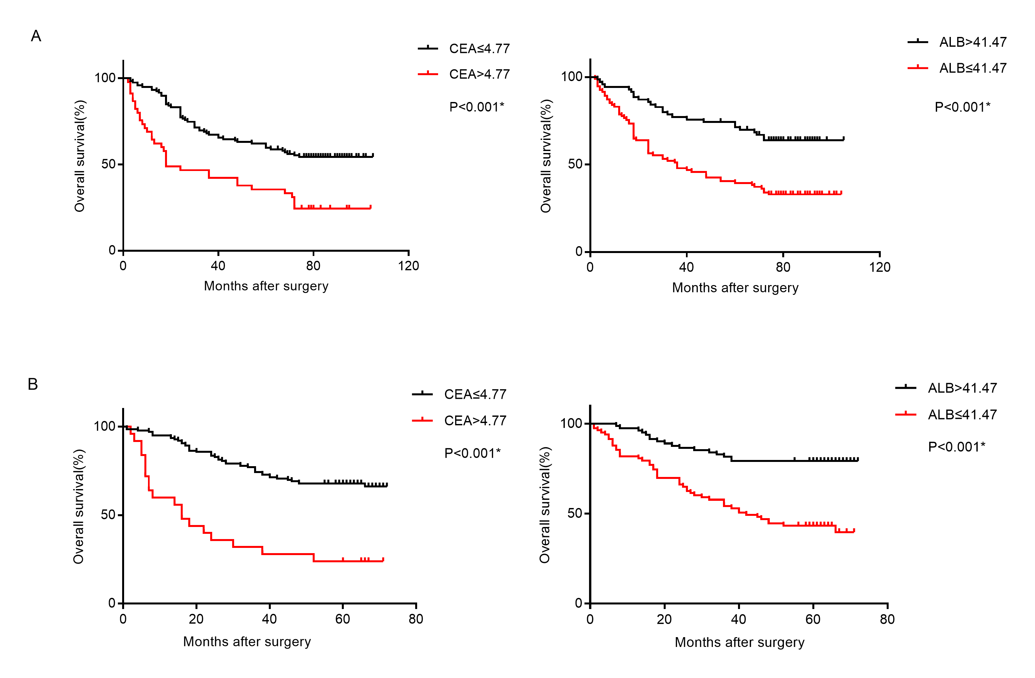
Abbreviations: OS: overall survival; CEA: carcinoembryonic antigen; ALB: albumin.

