Discover Psychology

Supplementary material for “A state-transition-free, delayed-feedback task elicited heterogeneous human responses” by Satoshi Hirata, Yutaro Sato, Hika Kuroshima, Yutaka Sakai

Correspondence:
Satoshi Hirata
Wildlife Research Center
Kyoto University
2-24 Tanaka Sekiden-cho
Sakyo, Kyoto
606-8203 Japan
Tel: 075-771-4398
Fax: 075-771-4394
Email: hirata.satoshi.8z@kyoto-u.ac.jp

1. Supplementary background
Our task was a modification of that used by Sato et al. (2023) with chimpanzees [S1]. In addition to what we described in the Introduction in the main text, there was another confounding factor in Sato et al.’s (2023) task. In their task, rewards for redundant choices of stimulus B, which was associated with a delayed reward (Fig. 1 of the main text), were omitted, to limit the number of available rewards to one or zero per trial, thus avoiding any additional cognitive load of discriminating reward quantity. This reward-exclusion when stimulus B was chosen on multiple trials before stimuli B and C were presented might have resulted in degradation of the relative value of B due to its reduced contingency with reward. That is, in an overall session, the number of rewards for choosing stimulus B was smaller than the number of times B was chosen, whereas every choice of stimulus A was rewarded. This reduced reward value might explain why three chimpanzees did not learn to choose B.
A possible solution is to control the trial sequence so that choice of stimulus and delayed reward have a one-to-one correspondence. In the task used in the present study, the three trial types are equally presented in each session (Fig. S2). The number of C choices, associated with delayed reward, and the number of rewards per session are equal, except that the last selection of C in a session sometimes goes unrewarded due to the quasi-random structure of the trials (if the last C vs D trial follows the last E vs F trial).

2. Supplementary methods

Instructions given to the participants
Prior to the task, the following instructions were given to the participant on a printed document and read out by the experimenter: “This is an experimental task using a touch panel. The duration of the experiment is approximately 30 minutes. When you touch the start button (green rectangle) on the screen, two types of images are displayed. When you touch one of them, a screen will appear showing your score, with or without a point being added accordingly. You are required to repeat such two choice trials multiple times. The scores are hypothetical, and you will not be disadvantaged in any way by your score. Please do not take notes and try to spend as little time as possible to make your choice. Please maximize your score as much as possible. You may take breaks during the course of the experiment. After the prescribed number of trials, you will be asked to write your comments on the experiment on a separate form. Participation in the experiment is based on your free will. Even after agreeing to participate in the experiment, the experiment can be terminated at any time for any reason”.
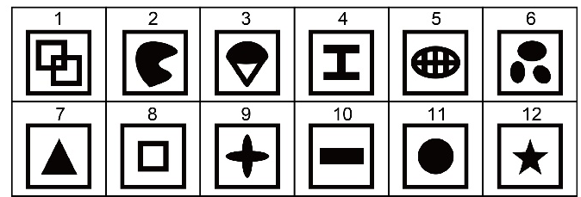
Fig. S1. The visual stimuli prepared for the test. Six of these (stimuli 1–6 or 7–12) were used for each participant.

Table S1. The assignment of the visual stimuli in the four groups. The numbers in the table refer to stimuli shown in the Fig. S1.
Group (N of participants) | Combination of role and stimulus
Group (N of participants) | A | B | C | D | E | F
Group 1 (N = 10) | 1 | 2 | 3 | 4 | 5 | 6
Group 2 (N = 10) | 2 | 1 | 4 | 3 | 6 | 5
Group 3 (N = 10) | 7 | 8 | 9 | 10 | 11 | 12
Group 4 (N = 10) | 8 | 7 | 10 | 9 | 12 | 11

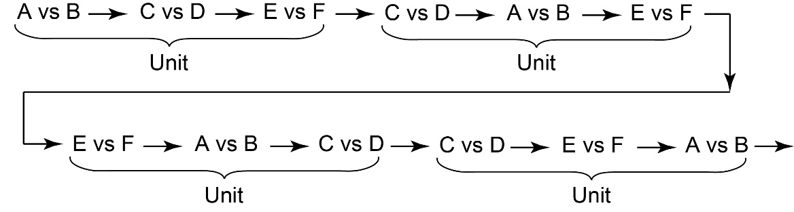
Fig. S2. An example of the sequence of trials consisting of units containing three trials (A vs B/C vs D/E vs F).

3. Supplementary results and discussion

3-1. Consideration on possible confounding factors
To assess whether participants who showed full or partial understanding in their written report might have been favored by the computer-generated sequence of trials using a random function, we checked the lag between the choice of C and the later E vs F trial when the reward was for the choice of C. We assume that a shorter lag would facilitate understanding the link between the choice and the reward. Over all 40 participants, the mean trial lag (e.g., choice of C rewarded in the immediate subsequent trial (which should be E vs F): lag is 1 trial) was 2.99 (range = 2.67–3.38), and the median was 3. For the participant who showed full correct understanding in the written report, the mean was 2.8 and the median was 3. The means for the four participants who showed partial understanding in their written report were 2.91, 2.93, 3.10, and 3.13, respectively, with a median of 3. In sum, the extent of delay from the C-choice to the reward did not differ consistently between those who had either correct or partial understanding and those who did not. Hence, it is unlikely that the trial sequence was easier for those participants who showed full or partial understanding in their written report.
We also addressed the issue of whether response time might have affected performance. Mean latencies to choose a stimulus were 1.29 s overall, and 1.04 s, 1.08 s, 1.22 s, 1.29 s, and 1.48 s in the one participant with full correct understanding and the four with partial understanding, respectively. Focusing on C vs D trials, mean latencies were 1.32 s overall, and 1.32 s, 1.12 s, 1.19 s, 1.54 s, and 1.97 s for the participant with full correct understanding and the four with partial understanding, respectively. Therefore, response latency was not markedly different between these two groups of participants.
We terminated the test if a participant chose C in ≥8/10 trials in two consecutive bins containing 10 C vs D trials so that we could enquire about their understanding in a written report immediately after the bias for C was established, not after over-training. Although the criterion of ≥8/10 trials in two consecutive bins was arbitrary, it was apt for our purpose. The one participant with full correct understanding and four participants with partial understanding all met this criterion, which we therefore conclude to be a necessary condition for explicit understanding of the task.
Although most participants did not learn to choose C for delayed reward, it is possible that they would learn to do so with more trials; our maximum number of trials (501) was set with consideration of participants’ time restraints. Another possibility is that if tangible rewards were available (e.g., exchanged for money or vouchers), their performance might change. It should be noted that the failure of some participants to learn to choose C cannot be simply accounted for by their learning ability. We categorized participants according to their percent correct in A vs B trials above the median score for all participants (98.1%). Using scores in A vs B trials as an index of learning ability, no consistent relationship between performance in A vs B trials and in C vs D was found. Without conducting a complementary assessment of learning ability we cannot draw strong conclusions, but all participants were either students or postdoctoral researchers at Kyoto University, indicating above-average learning ability. As in Zentall et al.’s (2023) [S2] study with the 1-back task, attempts to explicitly understand the task structure might actually have interfered with some participants’ ability to learn [S3]. Future research is needed to uncover factors underlying individual differences in our task. Rather than analyzing choices in the present task alone, presenting a set of different tasks might be advantageous.
Any bias for D is difficult to explain in terms of learning by reward. It may be due to chance, or it may reflect individual characteristics such as perseverance: repeating the same choice. An additional factor might be preference for a specific geometric figure (e.g., based on its perceived aesthetical value). We can reject possible explanations based on low motivation or lack of learning ability, as all participants learned to choose A in A vs B trials and their performances were consistent throughout the session.

3-2. Concordance between bias for E of D and immediate rewards
Although not described the main text, we examined the consistency of the bias in E vs F and the proportion of rewards immediately after E vs F. Of 26 participants who showed a significant bias for E or F, 19 showed consistency, gaining a higher proportion of apparent immediate rewards after choosing their preferred stimulus. In contrast, the remaining 7 participants obtained a higher proportion of apparent immediate rewards by choosing the less preferred visual stimulus. Therefore, some participants’ preference for E or F might be due to it being followed by more apparent reward, but this does not apply to all of the participants who showed bias for E or F.

3-3. Possible reasons for task difficulties
Results of studies that used a two-step task have shown that reinforcement learning algorithms with eligibility trace can explain the performances of humans and some nonhuman animals [S4–S7]. Participants generally manifested some level of understanding, either explicit or implicit, about the link between a choice and a delayed outcome. However, in the present study relatively few participants showed understanding of delayed outcome. One factor in this difference may be in the structure of the tasks used. In the two-step task, the two steps were repeated multiple times. First, the lag between the choice and the outcome was always one step. In contrast, the lag between the choice and reward varied in our task, from 1 to 5 trials, with a mean of 3 trials. A longer delay should make detecting the link more difficult. Thus, our task can be considered more difficult than the two-step task. Second, in the two-step task the order of the two steps was always the same, and the choice in the first step determined the structure of the outcome of the second step. The participant might therefore form an understanding of the sequence of steps, facilitating development of a sensitivity to the link between an action and the outcome in the next step. In contrast, in our task the order of ttrials was quasi-random, with the next trial type independent of the choice in the current trial. Moreover, as shown in Figure S2, the trial sequence sometimes contained a series of trials in which the reward in E vs F was determined by the participant’s choice in the second-most recent trial of C vs D, not the most recent. We intentionally made it difficult for participants to explicitly detect the true structure of the task as we sought to facilitate a solution based on implicit understanding, involving bridging the memory trace of the history of past action to the current outcome. To gain further insights about the ability to link actions and delayed outcomes, more tasks with different structures should be developed.

4. Supplementary references
[S1] Sato Y, Sakai Y, Hirata S. State-transition-free reinforcement learning in chimpanzees (Pan troglodytes). Learn Behav. 2023;51:413–27. https://doi.org/10.3758/s13420-023-00591-3
[S2] Zentall TR, Mueller PM, Peng DN. 1-Back reinforcement symbolic-matching by humans: How do they learn it? Learn Behav. 2023;51(3):274–80. https://doi.org/10.3758/s13420-022-00558-w
[S3] Peng DN, Zentall TR. Implicit learning of the one-back reinforcement matching-mismatching task by pigeons. Curr Biol. 2023;33(12):2582–5. e2. https://doi.org/10.1016/j.cub.2023.05.045
[S4] Akam T, Costa R, Dayan P. Simple plans or sophisticated habits? state, transition and learning interactions in the two-step task. PLoS Comp Biol. 2015;11(12):1–25. https://doi.org/10.1371/journal.pcbi.1004648
[S5] Daw ND, Gershman SJ, Seymour B, Dayan P, Dolan RJ. Model-based influences on humans’ choices and striatal prediction errors. Neuron. 2011;69(6):1204–15. https://doi.org/10.1016/j.neuron.2011.02.027
[S6] Miranda B, Nishantha Malalasekera WM, Behrens TE, Dayan P, Kennerley SW. Combined model-free and model-sensitive reinforcement learning in non-human primates. PLoS Comp Biol. 2020;16(6):1–25. https://doi.org/10.1371/journal.pcbi.1007944
[S7] Walsh MM, Anderson JR. Learning from delayed feedback: Neural responses in temporal credit assignment. Cogn Affect Behav Neurosci. 2011;11(2):131–43. https://doi.org/10.3758/s13415-011-0027-0

