Supplementary material

Homologous relationship between FabG involved in fatty acid biosynthesis and SDR on chromosome II in the multi-chromosome pathogen Vibrio anguillarum

Dong-Gyun Kim^{a,1}, So Young Park^{b,1}, S. M. Rafquzzaman^{c} and Jong Min Lee^{b,*}

ª Biotechnology Research Division, National Institute of Fisheries Science, Busan, Republic of Korea
^{b} Department of Biotechnology, Pukyong National University, Busan, 48513, Republic of Korea
^{c} Department of Fisheries Biology and Aquatic Environment, BSMRAU, Gazipur, Bangladesh

* Corresponding author
Jong Min Lee
E-mail: jmlee84@pknu.ac.kr
Tel.: +82-51-629-5865
Fax: +82-51-629-5863

¹ These authors contributed equally to this work

Table S1. Bacterial strains and plasmid used in this study
Strains or plasmid | Relevant characteristic(s) or genotype | Sources or Reference
Strains
Vibrio anguillarum | NB10 (Serotype O1) | [23]
E. coli DH5α | F⁻ endA1 glnV44 thi-1 recA1 relA1 gyrA96 deoR nupG Φ80dlacZΔM15 Δ(lacZYA-argF)U169, hsdR17(r_{K}⁻ m_{K}⁺), λ– | Laboratory collection
E. coli BL21 (DE3) | F– ompT gal dcm lon hsdS_{B}(r_{B}⁻ m_{B}⁻) λ(DE3 lacI lacUV5-T7 gene1 ind1 sam7 nin5 | Laboratory collection
Plasmid
pET-22b(+) | Expression vector; Ap^{r 1}, T7 promoter, six His-tag coding sequence | Novagen co.
¹ Ap^{r}, ampicillin resistant

Table S2. Primers used in this work.
Primer | Sequence (5'→3') | bp
VaFabG up | GGCC CATATG ATG AAC CTA GAA GGC AAA ATT | 31
VaFabG rp | GGCC CTCGAG TAC CAT GTA CAT CCC GCC ATT | 31
VaSDR up | GGCC CATATG ATG AAT GGT TTA ACC CAT AAA | 31
VaSDR rp | GGCC CTCGAG AAC GAT TTT AGG TTG GCC GTC | 31
Bolds indicates restriction enzyme sites. CATATG; NdeI, CTCGAG; XhoI.

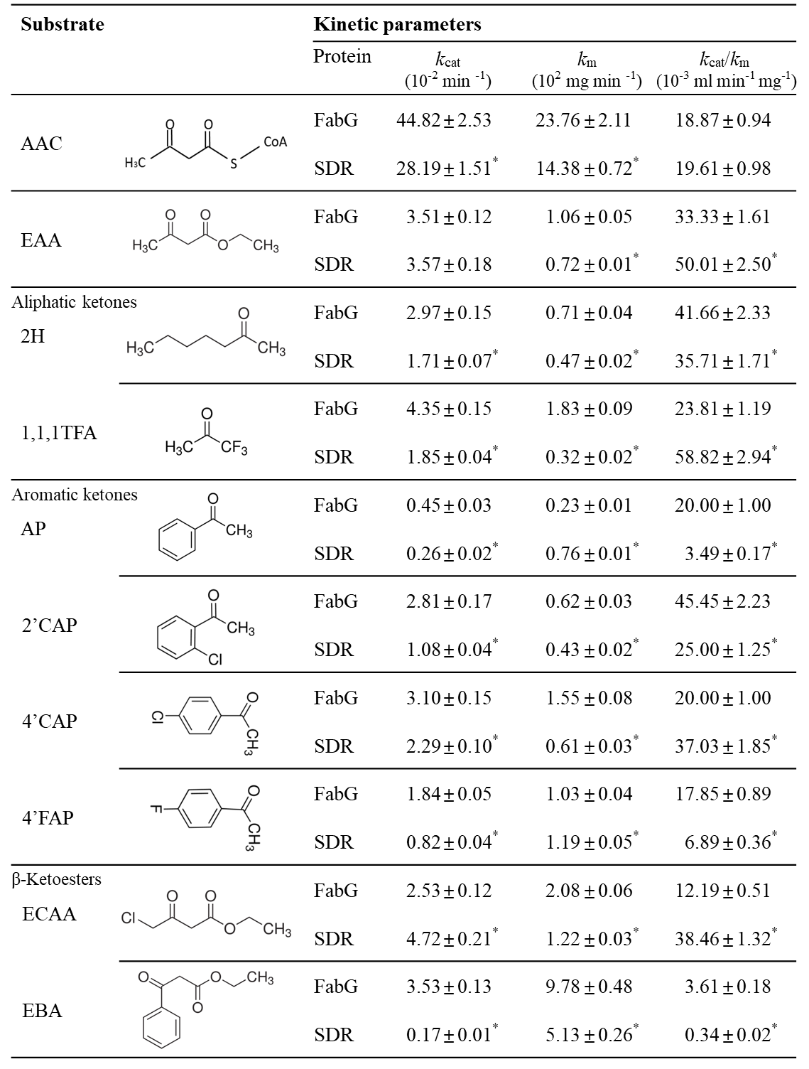
Figure S1. the numerical values of kinetic parameters of recombinant FabG-1b and SDR for the 10 tested substrates.

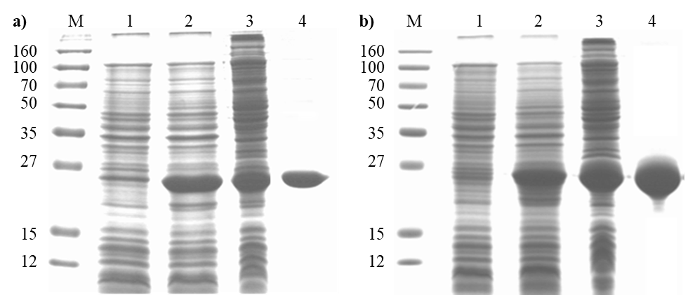Figure S2. SDS-PAGE analysis of recombinant protein expression during purification steps. a) FabG-1b and b) SDR. Lane M, molecular weight marker; Lane 1, crude cell extract without IPTG induction; Lane 2, cells extract after IPTG induction for 4 h; Lane 3, soluble proteins; and Lane 4, purified protein from a Ni-NTA His-tag affinity chromatography.

