Table 1: Yield and distribution of DC observed through manual scoring, following ex vivo irradiation of blood samples, within the dose range of 0–5 Gy, using ⁶⁰Co-γ-rays. All datasets exhibited compliance with the Poisson distribution (PD, u values falling within the range of ±1.96). D0, D1, D2, D3, D4, D5, and D6 represents, metaphases with 0, 1, 2, 3, 4, 5, and 6 DC, respectively.
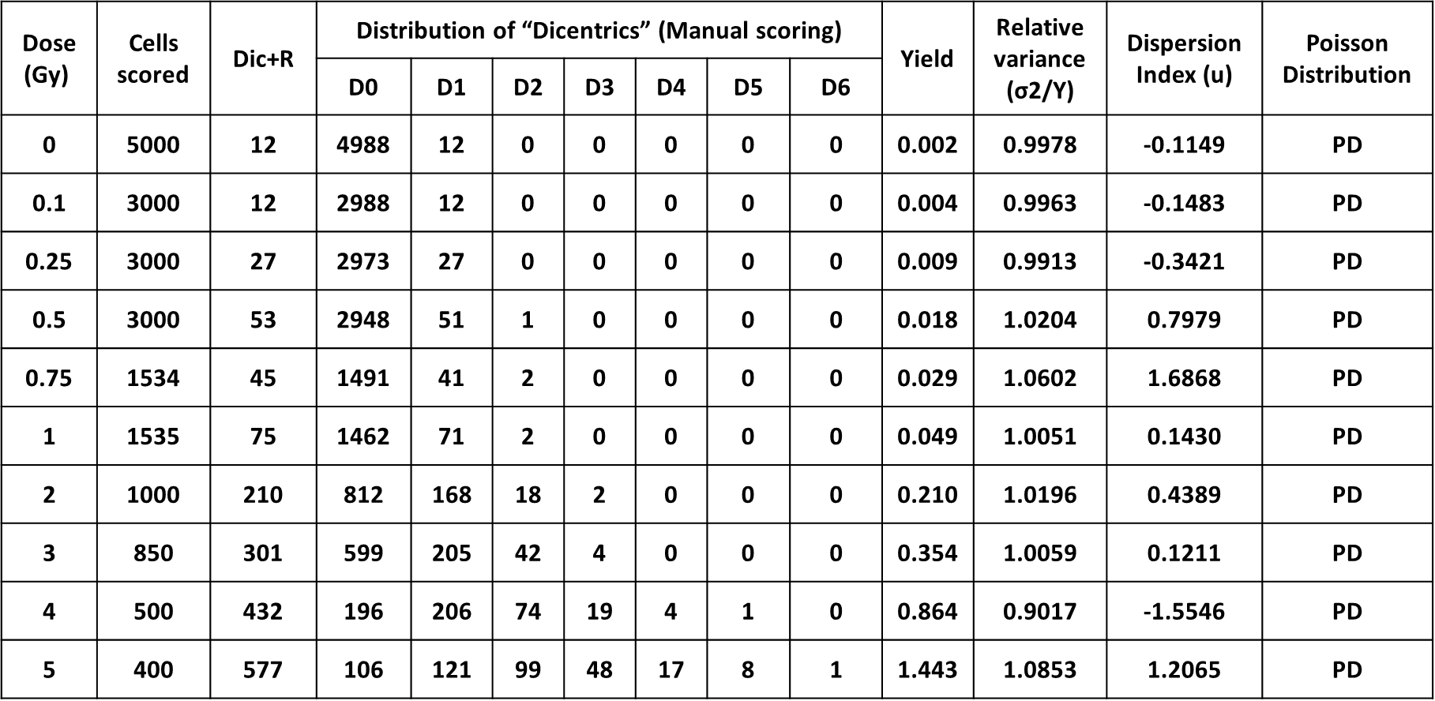

Table 2: Yield and distribution of ⁶⁰Co-γ-ray induced DC aberrations, scored in automated mode, following ex vivo irradiation within the dose range of 0–5 Gy. All sets of pooled data demonstrated agreement with the Poisson distribution (PD, u values within the range of ±1.96). D0, D1, D2, D3, D4 and D5, represent metaphases with 0, 1, 2, 3, 4, and 5 DC cells⁻¹, respectively.
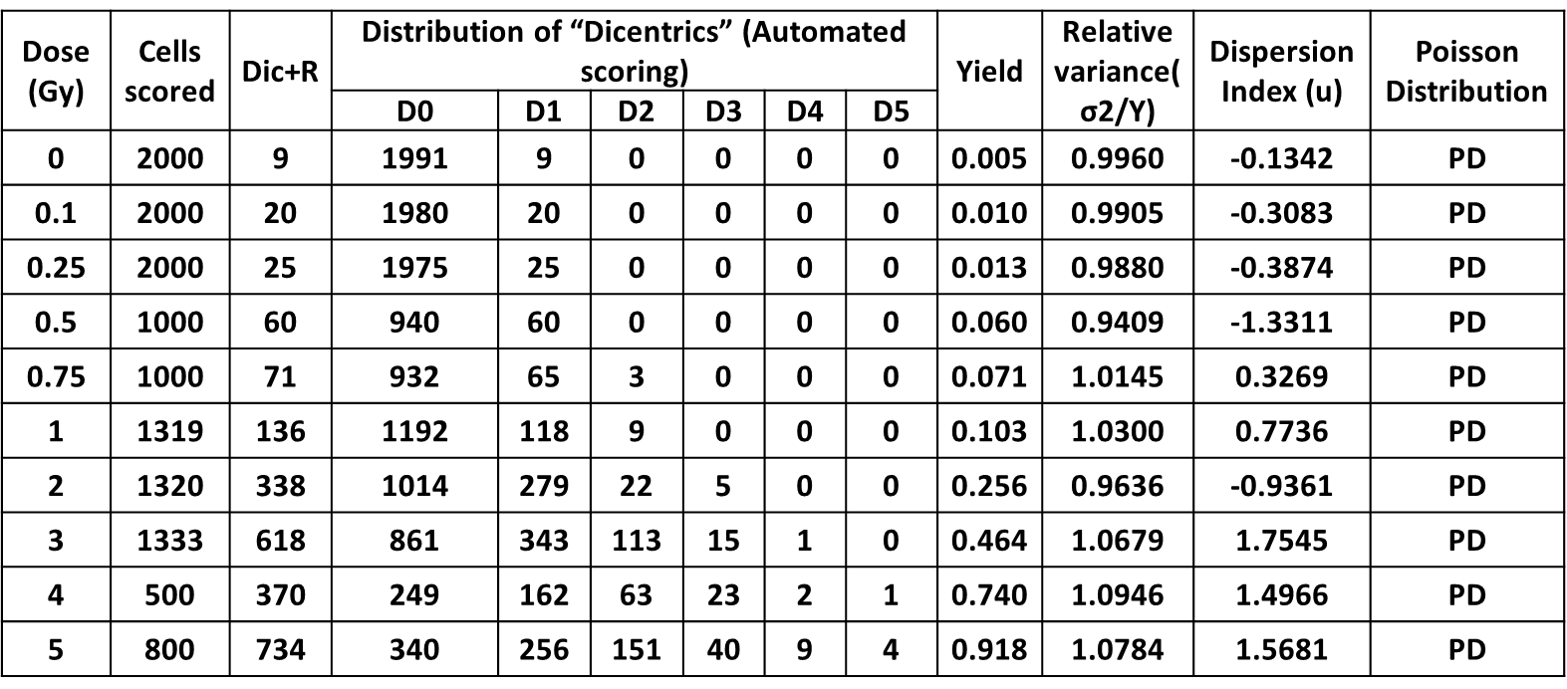

Table 3: Yield and distribution of MN induced by ⁶⁰Co-γ-ray, scored in manual mode, following ex vivo irradiation within the dose range of 0-5 Gy. All datasets (10 dose points) exhibited over-dispersion (OD, with u values exceeding ± 1.96 for all dose points). The columns labeled as D0, D1, D2, D3, D4, D5 and D6, represents metaphases with 0, 1, 2, 3, 4, 5 and 6 MN cell⁻¹, respectively.
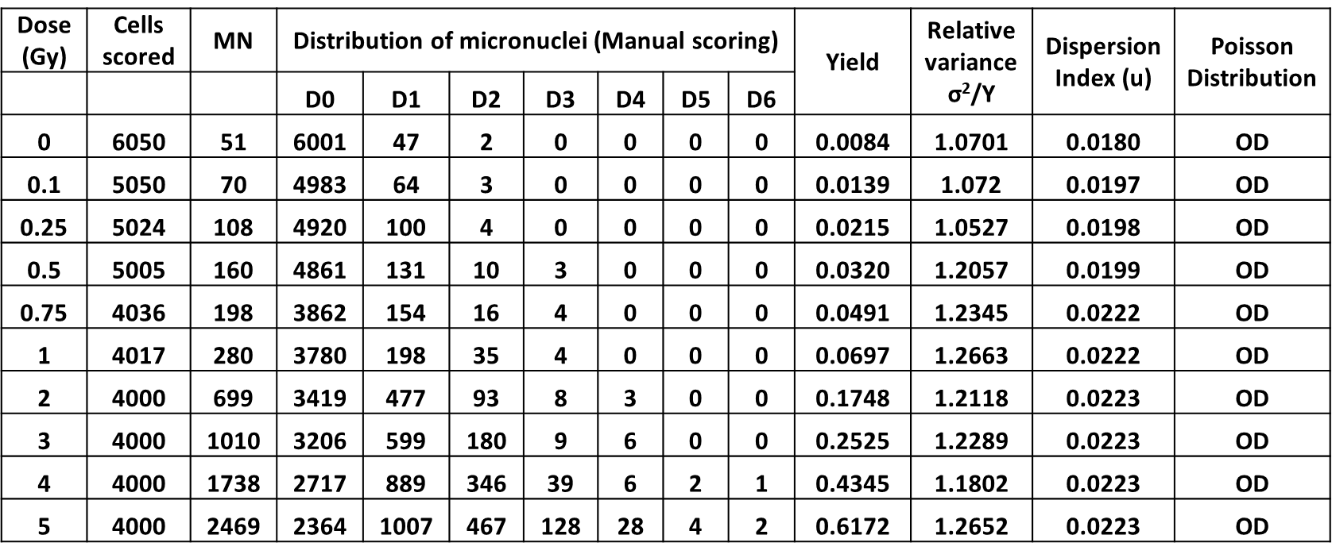
Table 4: Yield and distribution of MN induced by ⁶⁰Co-γ-ray, following ex vivo irradiation within the dose range of 0-5 Gy, with scoring of MN conducted in automated mode. The columns labeled as D0, D1, D2, D3, D4 and D5 represent binucleated cells with 0, 1, 2, 3, 4 and 5 MN cell⁻¹, respectively. OD and UD, represents Over and Under Dispersion, respectively.
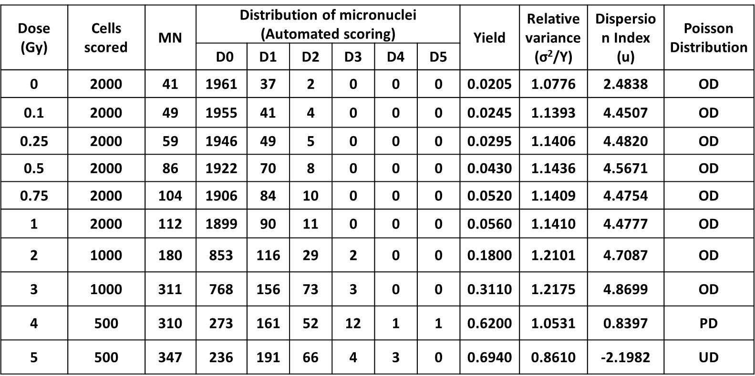

Table 5: Values of the coefficients (α and β) generated for DC and MN, derived from fitting the pooled data obtained from all three volunteers using both manual and automated scoring methods.
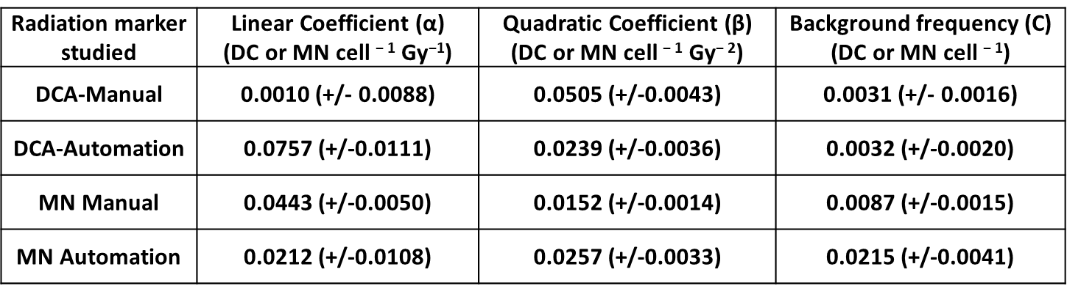
Table 6: Statistical parameters, viz., degrees of freedom (df), p-values for goodness of fit, and correlation coefficients (r) for DC and MN, obtained from fitting the pooled data of three volunteers, using both manual and automated scoring methods.
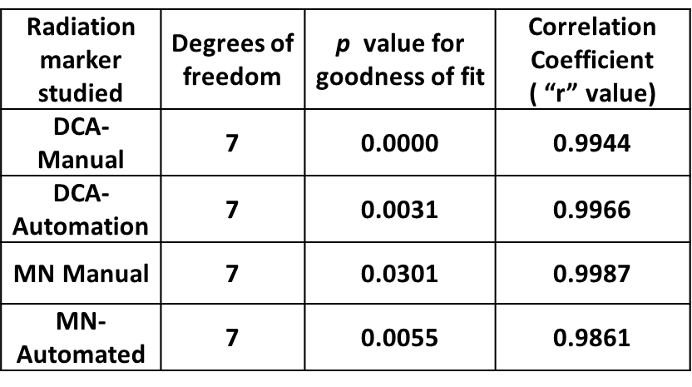

Table 7: Validation of established dose-response curves by estimating the doses of 8 dose blinded samples using DC via both manual and automated scoring, with 4 blinded dose points each.
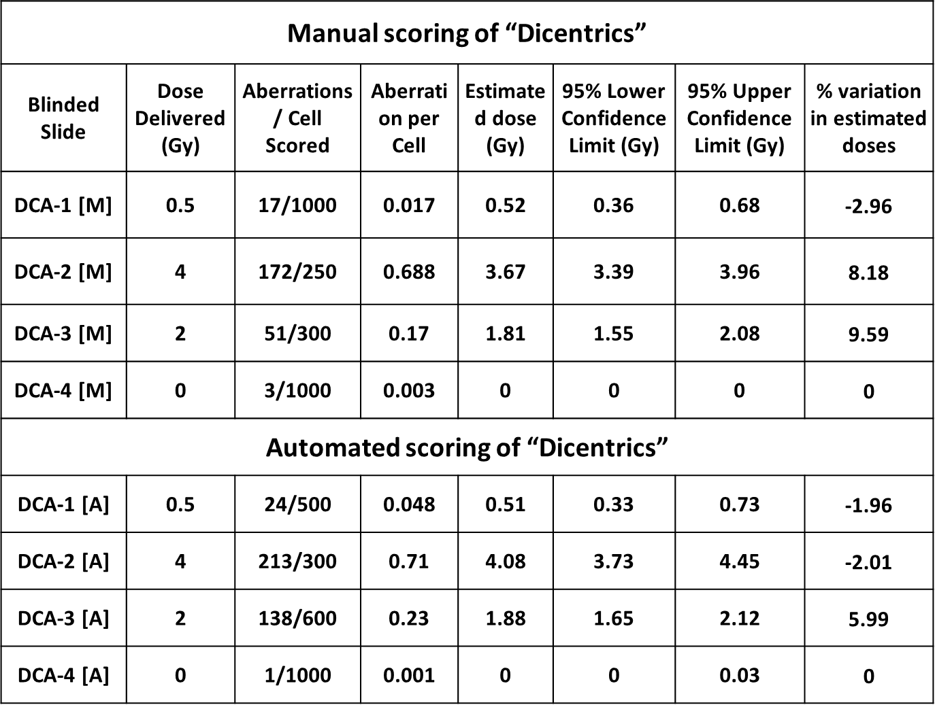

Table 8: Validation of established dose-response curves by estimating the doses of 8 dose blinded samples using MN via both manual and automated scoring, with 4 blinded dose points each.
