Table S1 MIQE checklist for RT-qPCR experiments
Experimental design
Definition of experimental and control groups | ND
Number within each group | 62 symptomatic peony leaves
Assay carried out by the core or investigator’s laboratory? | Investigator laboratory
Sample
Description | Fresh leaves
Volume/mass of sample processed | 50 mg
Microdissection or macrodissection | N/A
Processing procedure | Refrigerated at 4 ℃ upon arrival to laboratory usually in less than 6 hours
If frozen, how and how quickly? | N/A
If fixed, with what and how quickly? | N/A
Sample storage conditions and duration | Refrigerated at 4 ℃ until RNA isolation (usually less than 3 days), then frozen at -70 ℃
Nucleic acid extraction
Procedure and/or instrumentation | (see Materials and methods)
Name of kit and details of any modifications | Plant RNA Mini Kit (Onsol, South Korea)
Source of additional reagents used | None
Details of DNase or RNase treatment | On-column DNase treatment (DNase I, Onsol)
Contamination assessment | ND
Nucleic acid quantification | Spectrophotometric measurement
Instrument and method | Epoch Microplate Spectrophotometer (BioTek, United States)
Purity (A₂₆₀/A₂₈₀) | Average: 2.225
Yield | Average: 63.413
RNA integrity: method/instrument | ND
RIN/RQI or C_{q} of 3’ and 5’ transcripts | ND
Electrophoresis traces | ND
Inhibition testing | ND
Reverse transcription
Complete reaction conditions | RT-qPCR (see Materials and methods)
Amount of RNA and reaction volume | Varies (serially diluted RNA of 1 ng/µl stock)
Priming oligonucleotide and concentration | CNSV (F): CAAAGTGTGGGAGAGGAGCTAC  CNSV (R): GGGCAAGAACAAGTCCAAATC  LycMoV (F): TGCGTGCGTTACTTCAACC  LycMoV (R): AGGATAGCCAGAGGAATACCC
Reverse transcriptase and concentration | TOPscript reverse transcriptase
Temperature and time | 50 ℃ for 30 minutes
Manufacturer of reagents and catalogue numbers | Enzynomics, South Korea / Cat. RT002
C_{q}s with and without reverse transcription | ND
Storage conditions of cDNA | N/A
qPCR target information
Gene symbol | CP for CNSV and Pro-C for LycMoV
Sequence accession number | CNSV: LC785683  LycMoV: LC785521
Location of amplicon | CNSV: 461 – 562 (LC785683)  LycMoV: 137 – 248 (LC785521)
Amplicon length | CNSV: 102 bp  LycMoV: 112 bp
In silico specificity screen | ND
Pseudogenes, retropseudogenes, or homologs? | ND
Sequence alignment | Supplementary figure SF1
Secondary structure analysis of amplicon | ND
Location of each primer by exon or intron | ND
What splice variants are targeted? | ND
qPCR oligonucleotides
Primer sequences | CNSV (F): CAAAGTGTGGGAGAGGAGCTAC  CNSV (R): GGGCAAGAACAAGTCCAAATC  LycMoV (F): TGCGTGCGTTACTTCAACC  LycMoV (R): AGGATAGCCAGAGGAATACCC
RTPrimer DB identification number | N/A
Probe sequences | CNSV (P): FAM-ACCAAGTCCAGTTCTCTCGTATCCCT-BHQ1  LycMoV (P): Cy5-TGCTCCACAATTGCCTTCAATCCC-BHQ3
Location and identity of any modifications | CNSV (P): FAM at 5’ end, BHQ1 at 3’ end  LycMoV (P): Cy5 at 5’ end, BHQ3 at 3’ end
Manufacturer of oligonucleotides | Cosmogenetech (Seoul, South Korea)  (http://www.cosmogenetech.com/)
Purification method | Probe: HPLC  Primer: OPC
qPCR protocol
Complete reaction conditions | RT-qPCR (see Materials and methods)
Reaction volume and amount of cDNA/DNA | Reaction volume: 20 µl  Amount of RNA: Varies (serially diluted RNA of 1 ng/µl stock)
Primer, probe, Mg²⁺, and dNTP concentrations | Primer: 5 pmol/µl  Probe: 4 pmol/µl  Mg²⁺: Kit  dNTP: Kit
Polymerase identity and concentration | Chemically modified HOT-start taq polymerase
Buffer/kit identity and manufacturer | TOPreal™ Multi-Probe RT-qPCR kit, Cat. RT431S, Enzynomics, South Korea
Exact chemical composition of the buffer | N/A
Additives | No
Manufacturer of plates/tubes and catalog number | Plate: Bio-Rad, United States, MLL9601  Tube: Bio-Rad, United States, TCS0803  Cap: Bio-Rad, United States, TLS0801
Complete thermocycling parameters | 50 ℃ for 30 minutes, 40 cycles of 95 ℃ for 5 sec and 57 ℃ for 30 sec
Reaction setup | Manual
Manufacturer of qPCR instrument | Bio-Rad, United States
qPCR validation
Evidence of optimization | Supplementary table ST2 and ST3
Specificity | Supplementary figure SF2
For SYBR Green I, C_{q} of the NTC | N/A
Calibration curves with slope and y intercept | Fig. 4 (See Results: Application of duplex probe-based RT-qPCR)  CNSV: y-int = 27.514  LycMoV: y-int = 28.622
PCR efficiency calculated from slope | N/A
CIs for PCR efficiency or SE | ND
r² of calibration curve | CNSV: r² = 0.996  LycMoV: r² = 1
Linear dynamic range | ND
C_{q} variation at LOD | ND
CIs throughout range | ND
Evidence for LOD | Fig. 4 (See Results: Application of duplex probe-based RT-qPCR)
If multiplex, efficiency and LOD of each assay | CNSV: efficiency = 91.5%, LOD = 10⁻³ ng/µl  LycMoV: efficiency = 91.7%, LOD = 10⁻³ ng/µl
Data analysis
qPCR analysis program | Bio-Rad CFX Maestro
Method of C_{q} determination | Single threshold
Outlier identification and disposition | ND
Results for NTCs | >40 cycles
Justification of number and choice of reference genes | N/A
Description of normalization method | N/A
Number and concordance of biological replicates | ND
Number and stage of technical replicates | ND
Repeatability | ND
Reproducibility | ND
Power analysis | ND
Statistical methods for results significance | ND
Software | Bio-Rad CFX Maestro 2.3 (Ver: 5.3.022.1030)
C_{q} or raw data submission with RDML | ND
N/A = Not available
ND = Not done
Table S2 Optimization of the primer concentration for the duplex probe-based qPCR for the detection of cycas necrotic stunt virus and lychnis mottle virus
The tested primer concentrations were 10 pmol/µl, 5 pmol/µl, and 1 pmol/µl. The tested probe concentrations were 4 pmol/µl, 2 pmol/µl, and 1 pmol/µl. The standard curve had 5 magnitudes ranging from 1 ng/µl to 10⁻⁴ ng/ µl. These experiments were conducted in the CFX Opus 96 Real-Time PCR systems (Bio-Rad, United States).

Primer conc. (pmol/µl) | Probe conc. (pmol/µl) | Ct value |  |  |  |  |  |  |  |  |  | Highest RFU
Primer conc. (pmol/µl) | Probe conc. (pmol/µl) | 1 ng/µl |  | 10⁻¹ ng/µl |  | 10⁻² ng/µl |  | 10⁻³ ng/µl |  | 10⁻⁴ ng/µl
Primer conc. (pmol/µl) | Probe conc. (pmol/µl) | CNSV | LycMoV | CNSV | LycMoV | CNSV | LycMoV | CNSV | LycMoV | CNSV | LycMoV | CNSV | LycMoV
10 | 4 | 12.60 | 17.35 | 16.66 | 20.76 | 21.50 | 25.30 | 26.84 | 30.45 | 30.69 | 34.07 | 674 | 960
10 | 2 | 13.34 | 16.14 | 17.17 | 19.83 | 22.19 | 24.54 | 27.53 | 29.70 | 31.09 | 32.98 | 562 | 643
10 | 1 | 12.18 | 14.16 | 16.32 | 18.20 | 21.24 | 23.03 | 26.61 | 27.99 | 30.00 | 31.88 | 362 | 157
5 | 4 | 13.37 | 16.34 | 17.22 | 19.86 | 22.05 | 24.50 | 27.53 | 29.75 | 31.12 | 32.98 | 804 | 956
5 | 2 | 12.99 | 16.11 | 17.10 | 19.81 | 22.07 | 24.42 | 27.35 | 29.19 | 31.01 | 32.44 | 534 | 621
5 | 1 | 12.40 | 15.44 | 16.46 | 19.10 | 21.38 | 24.10 | 25.71 | 28.24 | 30.45 | 32.17 | 214 | 171
1 | 1 | 11.98 | 14.47 | 16.69 | 19.16 | 21.87 | 23.43 | 27.46 | 27.10 | 31.73 | 32.34 | 207 | 151
Table S3 Optimization of the annealing temperature for the duplex probe-based qPCR for the detection of cycas necrotic stunt virus and lychnis mottle virus
Primer : probe concentration (pmol/µl) | Temperature | Ct value |  |  |  |  |  |  |  |  |  | Highest RFU
Primer : probe concentration (pmol/µl) | Temperature | 1 ng/µl |  | 10⁻¹ ng/µl |  | 10⁻² ng/µl |  | 10⁻³ ng/µl |  | 10⁻⁴ ng/µl
Primer : probe concentration (pmol/µl) | Temperature | CNSV | LycMoV | CNSV | LycMoV | CNSV | LycMoV | CNSV | LycMoV | CNSV | LycMoV | CNSV | LycMoV
5 : 4 | 63 ℃ | 11.20 | 15.14 | 15.70 | 18.50 | 21.14 | 23.96 | 26.19 | 29.24 | 28.50 | 31.33 | 682 | 650
5 : 4 | 61 ℃ | 12.11 | 15.83 | 16.18 | 19.23 | 22.35 | 24.88 | 26.64 | 29.27 | 29.64 | 32.20 | 770 | 760
5 : 4 | 59 ℃ | 13.31 | 16.06 | 17.22 | 19.75 | 23.08 | 25.36 | 27.96 | 30.21 | 31.16 | 33.00 | 884 | 895
5 : 4 | 57 ℃ | 12.86 | 16.59 | 17.01 | 20.21 | 22.72 | 25.74 | 27.98 | 30.69 | 31.09 | 33.21 | 965 | 1042
5 : 4 | 55 ℃ | 13.37 | 16.34 | 17.22 | 19.86 | 22.05 | 24.50 | 27.53 | 29.75 | 31.12 | 32.98 | 804 | 956
5 : 4 | 53 ℃ | 13.19 | 18.29 | 18.32 | 21.18 | 24.26 | 26.93 | 29.41 | 31.96 | 32.49 | 34.50 | 922 | 1113

The tested annealing temperature were 63 ℃, 61 ℃, 59 ℃, 57 ℃, 55 ℃, and 53 ℃. The standard curve has 5 magnitudes ranging from 1 ng/µl to 10⁻⁴ ng/ µl. These experiments were conducted in the CFX Opus 96 Real-Time PCR systems (Bio-Rad, United States).
Table S4 Detection limit of the duplex probe-based qPCR for the detection of cycas necrotic stunt virus and lychnis mottle virus

Optimized conditions | Quantity (ng/µl) | Target | Ct value | RFU
Primer conc. = 5 pmol/µl  Probe conc. = 4 pmol/µl  Temperature = 57 ℃ | 1 | CNSV | 12.45 | 454
 | 1 | LycMoV | 13.49 | 175
 | 10⁻¹ | CNSV | 15.91 | 634
 | 10⁻¹ | LycMoV | 16.74 | 218
 | 10⁻² | CNSV | 20.76 | 703
 | 10⁻² | LycMoV | 20.87 | 260
 | 10⁻³ | CNSV | 25.28 | 667
 | 10⁻³ | LycMoV | 24.20 | 237
 | 10⁻⁴ | CNSV | 30.32 | 692
 | 10⁻⁴ | LycMoV | 28.59 | 246
 | 10⁻⁵ | CNSV | 34.60 | 443
 | 10⁻⁵ | LycMoV | 32.23 | 224
 | 10⁻⁶ | CNSV | 39.86 | 55.0
 | 10⁻⁶ | LycMoV | 38.30 | 26.0
 | 10⁻⁷ | CNSV | N/A | 48.7
 | 10⁻⁷ | LycMoV | N/A | 0.290
The optimized primer concentration was 5 pmol/µl and the optimized probe concentration was 4 pmol/µl for both target viruses. The optimized annealing temperature was 57 ℃. The lowest detectable concentration for this optimized condition was 10⁻⁶ ng/µl. These experiments were conducted in the CFX Opus 96 Real-Time PCR systems (Bio-Rad, United States).

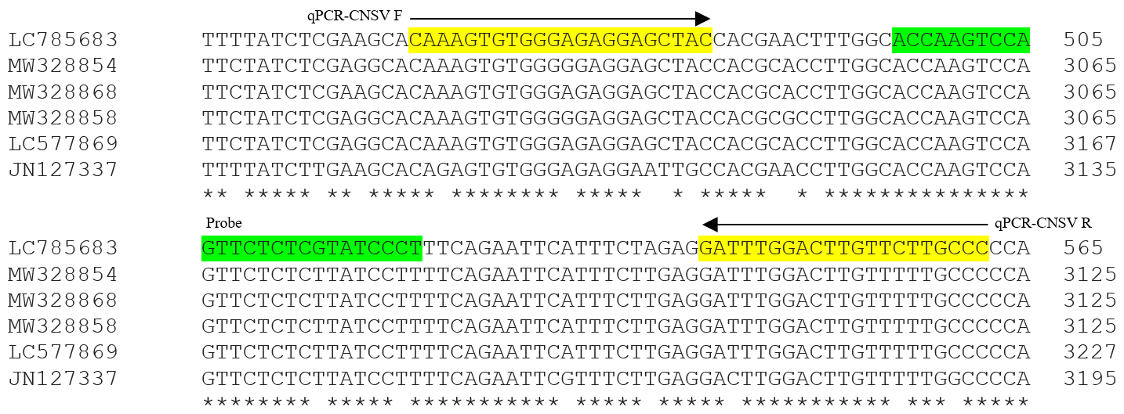
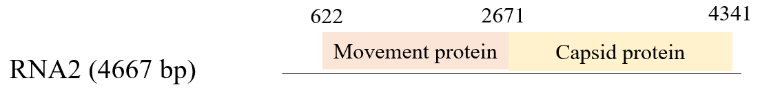
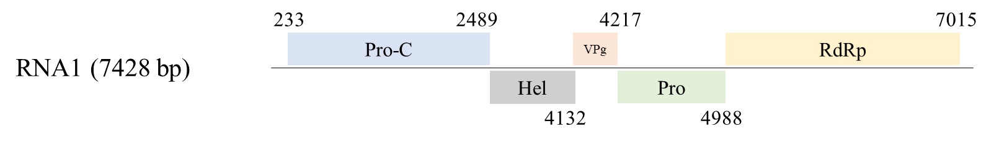
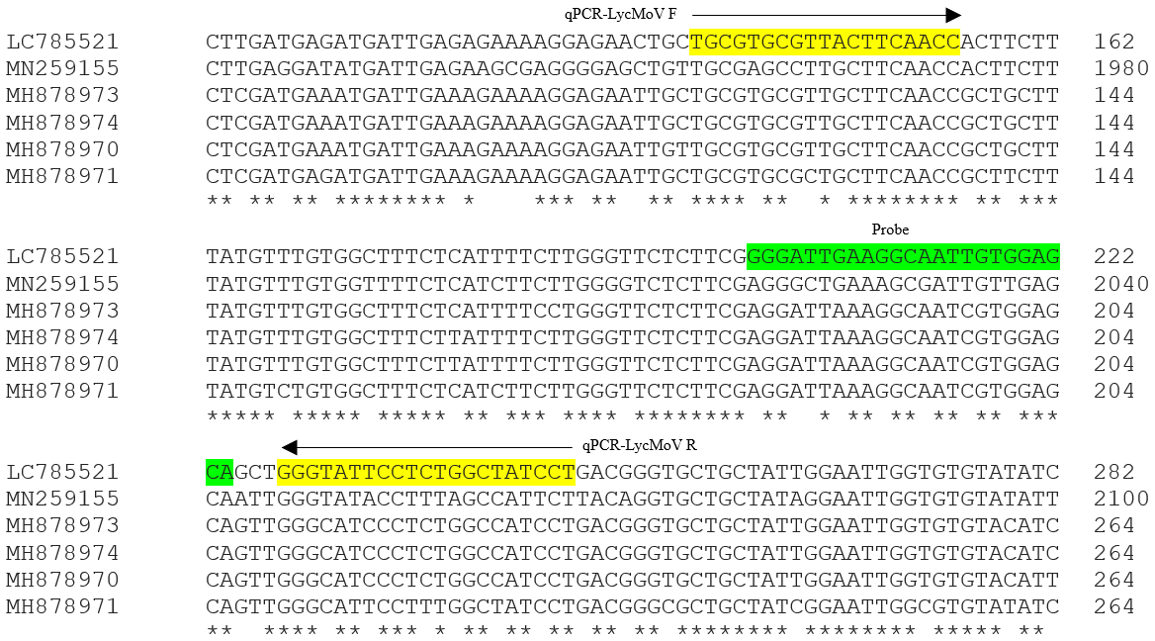
a
b
Fig S1 qPCR Primer and probe location for the detection of CNSV (a) and LycMoV (b)

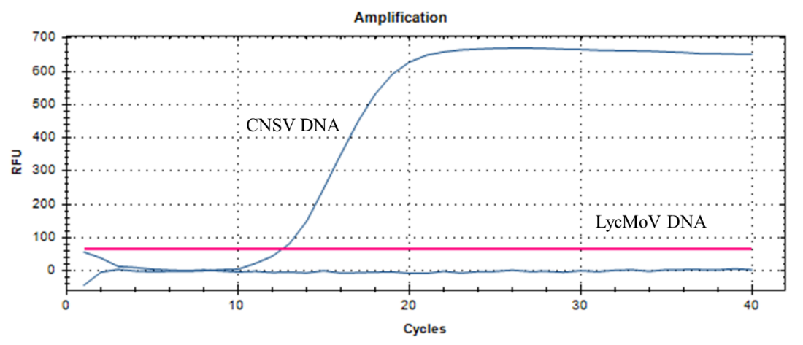
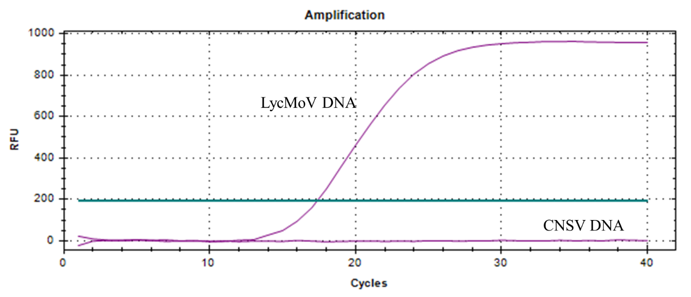
Fig S2 Primer and probe specificity of RT-qPCR primers and probes for probe-based RT-qPCR experiments. (a) CNSV primers and probe were used to amplify artificially made mixture of CNSV and LycMoV plasmid DNA. (b) LycMoV primers and probe were used to amplify artificially made mixture of CNSV and LycMoV plasmid DNA. The primer concentration was 10 pmol/µl, the probe concentration was 4 pmol/µl, and the annealing and elongation temperature was 55 ℃. These experiments were conducted in CFX Opus 96 Real-Time PCR systems (Bio-Rad, United States)

a
b

