Table S1: Selected herbal compounds for the study
Serial number | Compounds | Structure | Molecular formula
1 | Xanthohumol | 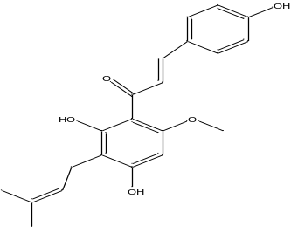 | C21H22O5
2 | Desmethylxanthohumol | 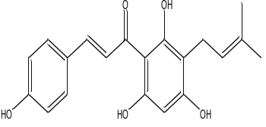 | C20H20O5
3 | Lupulone | 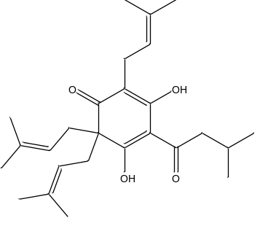 | C26H38O4
4 | Plumbagin | 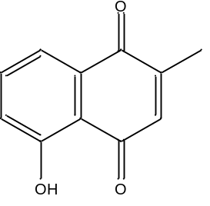 | C11H8O3
5 | Divaricatic acid | 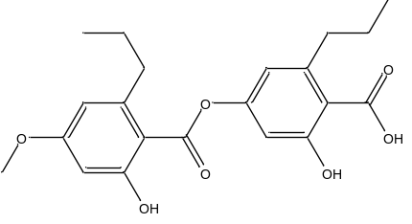 | C21H24O7
6 | Reserpine | 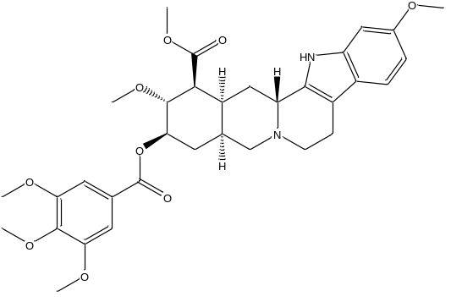 | C33H40N2O9
7 | Quinine | 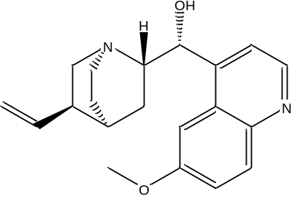 | C20H24N2O2
8 | Piperine | 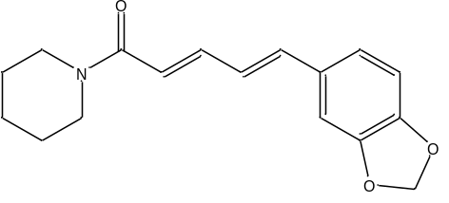 | C17H19NO3
9 | Harmaline | 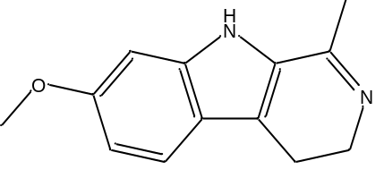 | C13H14N2O
10 | Ursolic acid | 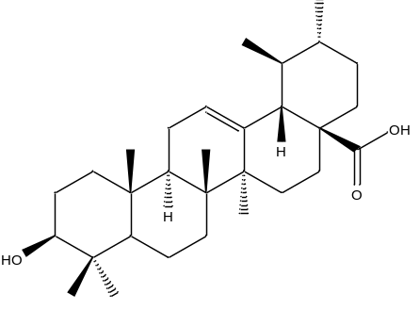 | C30H48O3
11 | Oleanolic acid | 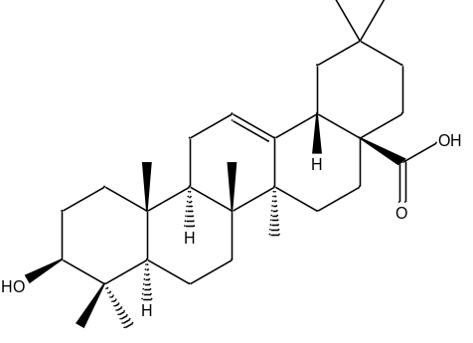 | C30H48O3
12 | Isoliquiritigenin | 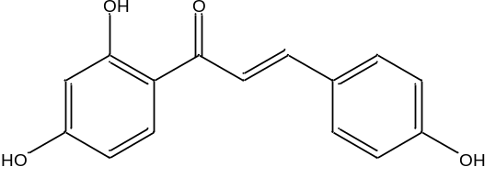 | C15H12O4
13 | Liquiritigenin | 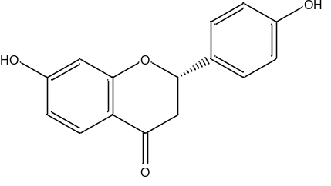 | C15H12O4
14 | Curcumin | 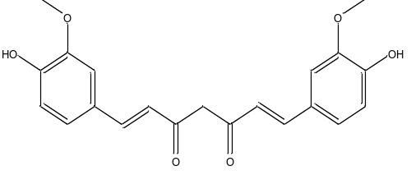 | C21H20O6
15 | Carnosic acid | 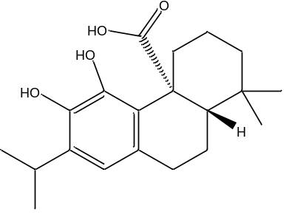 | C20H28O4
16 | Magnolol | 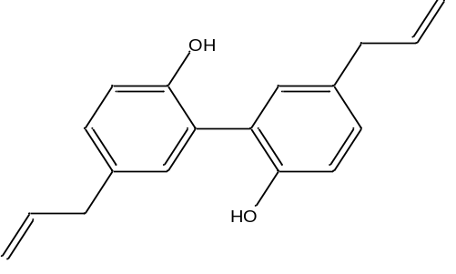 | C18H18O2
17 | Honokiol | 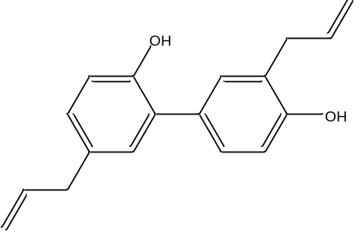 | C18H18O2
18 | Silibinin | 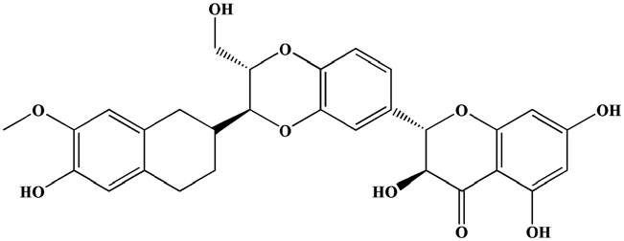 | C25H22O10
19 | Resveratrol | 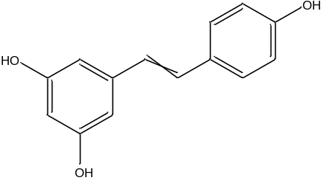 | C14H12O3
20 | 6 methoxydihydrosanguinarine | 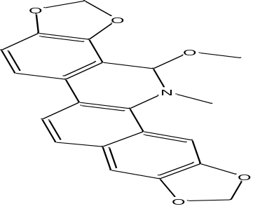 | C21H17NO5
21 | 1,8 cineol | 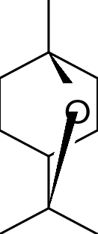 | C10H18O
21 | Brazilin | 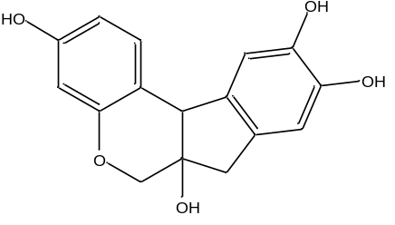 | C16H14O5
22 | Phloretin | 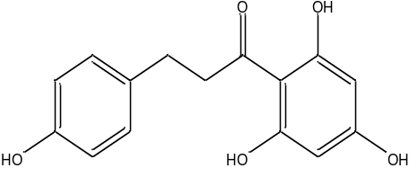 | C15H14O5
23 | Sophoraflavanone G | 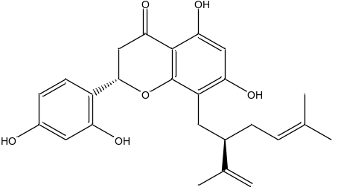 | C25H28O6
24 | Diosmetin | 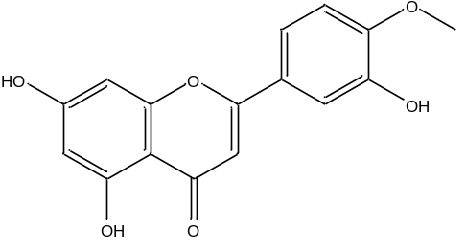 | C16H12O6
25 | Artonin E | 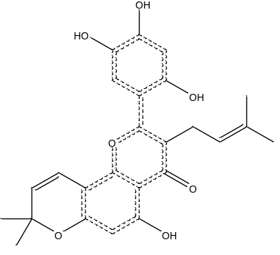 | C25H24O7
26 | Ellagitannins | 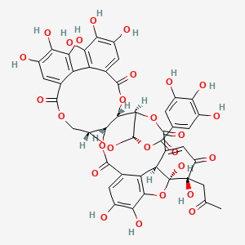 | C44H32O27
27 | alpha-Lapachone | 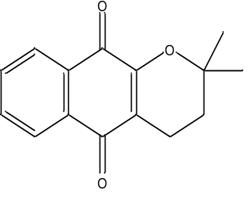 | C15H14O3
28 | Artocarpin | 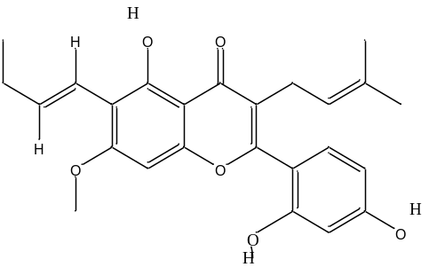 | C26H28O6
29 | Juncusol | 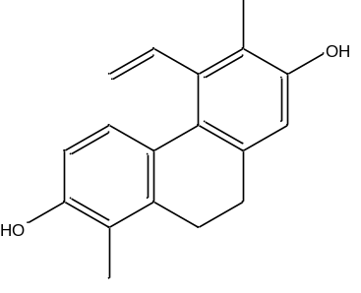 | C18H18O2
30 | Sanguisorbigenin | 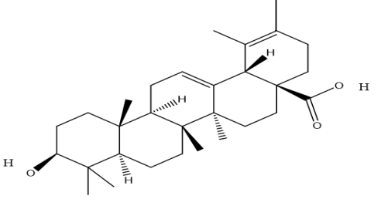 | C30H46O3
31 | Oleic acid | 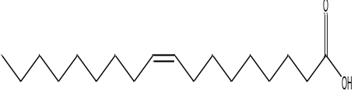 | C18H34O2
32 | Alpha-Mangostin | 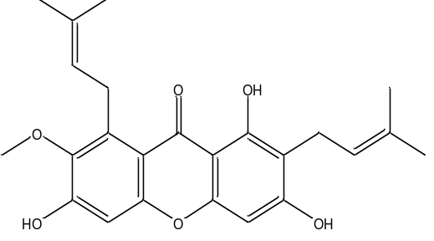 | C24H26O6
33 | Lawsone | 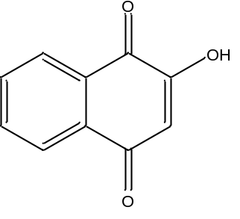 | C10H6O3
34 | 4-Phenylcoumarin | 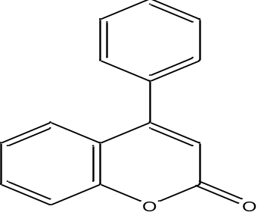 | C15H10O2
35 | Sorocenol G | 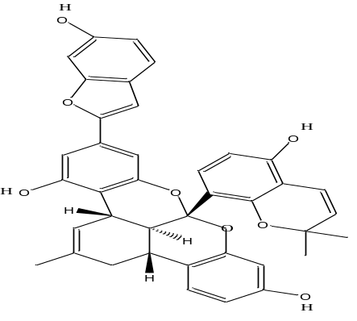 | C39H32O8
36 | Sorocenol H | 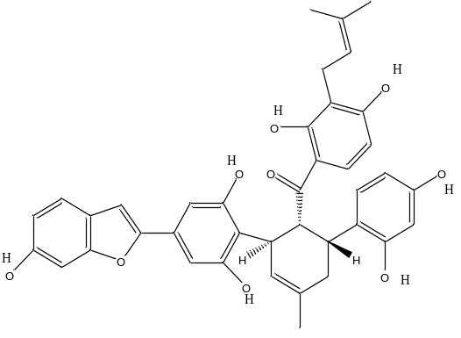 | C39H36O9
37 | Rhein | 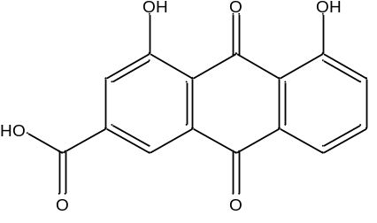 | C15H8O6
38 | Chalcomoracin | 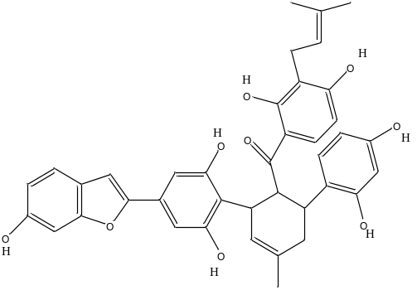 | C39H36O9
39 | Luteolin | 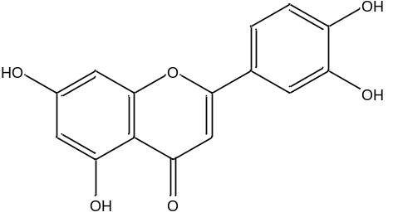 | C15H10O6
40 | Oxyresveratrol | 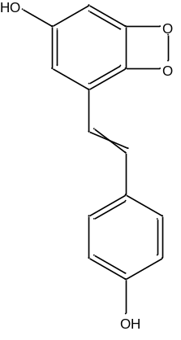 | C14H12O4
41 | Isopimaric acid | 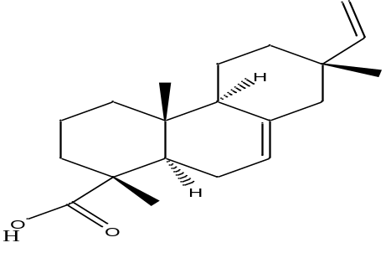 | C20H30O2
42 | Fremontone | 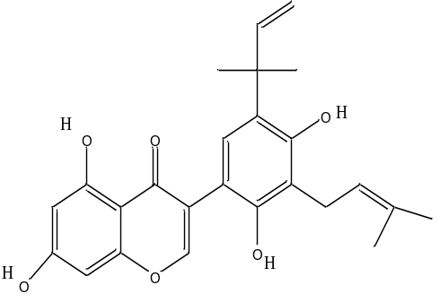 | C25H26O6
43 | Naphthalene | 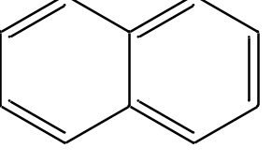 | C10H8
45 | Anthraquinone | 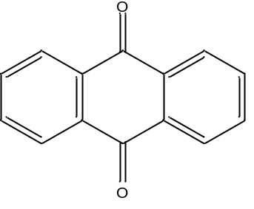 | C14H8O2
46 | Allicin | 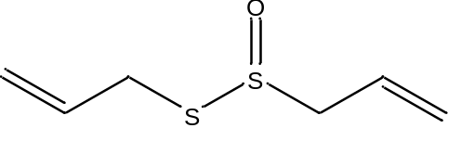 | C6H10OS2
47 | Chelerythrine | 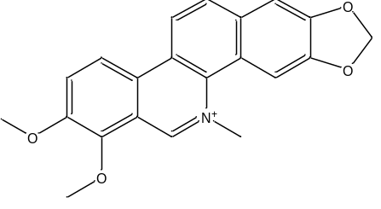 | C21H18NO4+
48 | Rosamarinic acid | 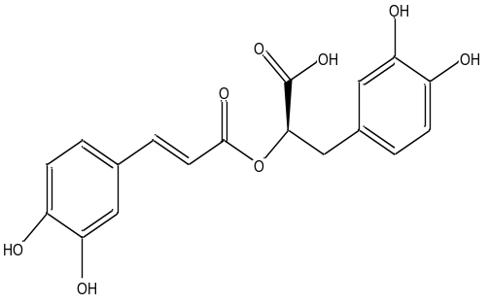 | C18H16O8
49 | Berberine | 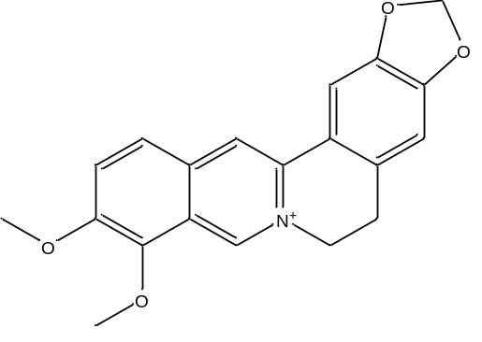 | C20H18NO4+
50 | Theanensin A | 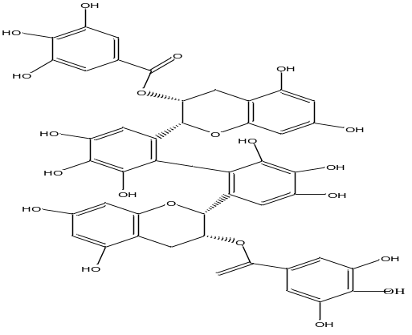 | C44H34O22
51 | Rhodomyrtone | 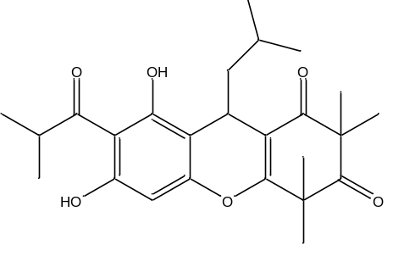 | C26H34O6
52 | Galangin | 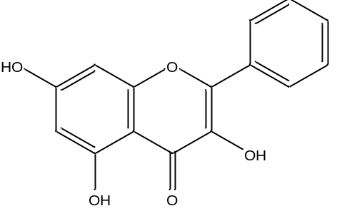 | C15H10O5
53 | Arborine | 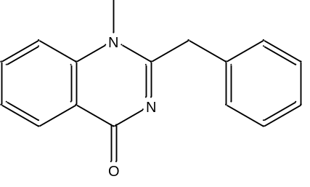 | C16H14N2O
54 | Ethyl gallate | 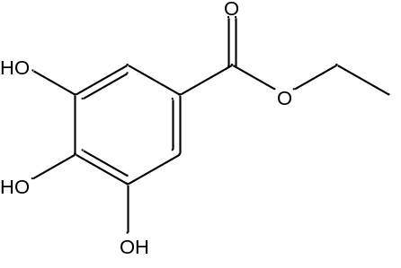 | C9H10O5
55 | Diosmetin | 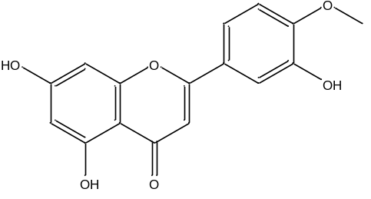 | C16H12O6
56 | Galangin |  | C15H10O5
57 | Stigmasterol |  | C₂₉H₄₈O
58 | Mansonone F |  | C₁₅H₁₂O₃
59 | Juncuenin A |  | C₁₈H₁₈O
60 | dimethoxymethylbenzene |  | C₉H₁₂O₂

Table S 2. MRSA-relatedd bacterial targets with resolution value in PDB

S. no | Targets | Resolution  (Å) | Description | PDB ID
 | blaI | 2.70 | Penicillinase repressor | 1XSD
 | blaR1 | 1.8 | Beta-lactam sensor | 1XA1
 | mecR1 | 1.59 | Beta-lactam sensing transmembrane protein | 6O9S
 | femA | 2.1 | factor essential for expression of methicillin resistance | 1LRZ
 | CapF | 2.45 | Bifunctional mettaloenzyme, respoinsible for the formation of capsular polysaccharide, a mucous layer on the surface of bacterium that facilitates immune evasion and infection. | 3ST7
 | mecA | 1.8 | encodes an alternative penicillin-binding protein, PBP 2a. | 1VQQ
 | fosB | 1.42 | fosfomycin-inactivating enzyme in MRSA | 4NAY
 | RepA | 2.6003 | Replication initiator of staphylococcal multiresistance plasmid replication. | 4PTA
 | folA | 1.48 | Dihydrofolate reductase structural gene that catalyzes the reduction of dihydrofolate to tetrahydrofolate, which is an important intermediate in the biosynthesis of proteins and nucleic acids. | 2W9H
 | norA | 3.16 | NorA is a multidrug efflux pump in Staphylococcus aureus that conferring resistance to antibiotics. | 7LO8
 | clfB | 1.917 | Clumping factor B (ClfB), a surface protein expressed by S. aureus is shown to promote skin abscess formation by binding to the host protein. | 4F27

Table S3. Docking score of the selected herbal compounds with the selected MRSA-related bacterial targets
Serial no | Compounds | blaI | blaR1 | mecR1 | femA | capF | mecA | fosB | repA | folA | norA | clfb
 | Reference Ligand | - | - | -6.282 | - | - | - | - | - | -7.996 | - | -
- 1 | Baicalin | -6.887 | -5.030 | -5.049 | -7.485 | -6.304 | -6.650 | -4.758 | -4.082 | -8.578 | -8.252 | -5.722
- 2 | Theasinensin A | -6.376 | -6.329 | -4.398 | -11.322 | -7.344 | -7.891 | - | -5.206 | - | -10.061 | -8.148
- 3 | Rosmarinic acid | -6.034 | -6.643 | -5.929 | -7.088 | -5.843 | -6.886 | -5.438 | -4.655 | - | -7.805 | -5.765
- 4 | Artonin E | -5.985 | -4.695 | -3.538 | -6.578 | -5.565 | -5.510 | -5.215 | -5.040 | -7.560 | -6.813 | -5.602
- 5 | Luteolin | -5.869 | -6.848 | -5.838 | -6.362 | -5.724 | -7.299 | -5.000 | -5.333 | -8.912 | -7.658 | -6.937
- 6 | Curcumin | -5.828 | -5.358 | -5.593 | -6.119 | -5.698 | -5.223 | -4.833 | -5.871 | -7.486 | -7.631 | -5.304
- 7 | Diosmetin | -5.548 | -6.445 | -5.267 | -5.449 | -6.356 | -7.250 | -5.720 | -4.200 | -8.353 | -7.713 | -6.403
- 8 | Ethyl gallate | -5.530 | -4.813 | -5.043 | -4.416 | -5.447 | -5.399 | -4.495 | -4.123 | -6.420 | -4.175 | -4.466
- 9 | Brazilin | -5.317 | -5.516 | -5.251 | -6.748 | -6.359 | -6.005 | -5.947 | -5.546 | -9.140 | -5.801 | -5.180
- 10 | Chrysoeriol | -4.966 | -6.577 | -5.785 | -5.286 | -5.577 | -7.437 | -4.242 | -5.270 | -8.711 | -7.886 | -6.171
- 11 | Phloretin | -4.761 | -5.761 | -6.013 | -5.552 | -5.800 | -7.694 | -5.261 | -6.167 | -7.814 | -7.129 | -5.713
- 12 | Isoliquiritigenin | -4.556 | -6.462 | -5.002 | -4.938 | -5.787 | -6.276 | -5.413 | -5.807 | -7.828 | -5.881 | -6.011
- 13 | Resveratrol | -4.546 | -5.981 | -5.928 | -5.036 | -6.423 | -7.109 | -5.806 | -5.875 | - | -7.501 | -5.757
- 14 | Liquiritigenin | -4.491 | -6.292 | -5.883 | -5.170 | -5.776 | -7.076 | -5.474 | -5.681 | -9.311 | -7.415 | -6.117
- 15 | Galangin | -4.477 | -6.495 | -5.513 | -5.000 | -6.642 | -6.592 | -4.504 | -4.718 | -7.643 | -7.128 | -5.928
- 16 | Divaricatic acid | -4.339 | -4.708 | -5.915 | -5.699 | -5.285 | -5.686 | -4.731 | -3.505 | -6.584 | -6.734 | -4.388
- 17 | Carnosic acid | -4.297 | -3.681 | -3.182 | -4.019 | -3.768 | -4.173 | -4.890 | -3.661 | - | - | -3.633
- 18 | Plumbagin | -4.143 | -6.479 | -5.776 | -4.108 | -6.404 | -5.543 | -4.768 | -4.898 | -6.454 | -6.288 | -4.791
- 19 | Ursolic acid | -4.087 | -1.969 | -3.394 | -4.158 | - | -4.879 | -3.403 | -2.503 | -5.451 | -5.564 | -3.883
- 20 | Fremontone | -4.042 | -7.295 | -5.549 | -5.741 | -6.313 | -5.170 | -4.408 | -4.429 | -7.037 | -5.966 | -4.388
- 21 | Lawsone | -4.011 | -6.425 | -6.061 | -3.546 | -5.355 | -5.500 | -4.875 | -4.869 | -7.051 | -6.967 | -6.090
- 22 | Rhein | -3.878 | -6.869 | -5.989 | -4.377 | -6.188 | -5.887 | -4.527 | -5.772 | -8.251 | -7.583 | -6.932
- 23 | Chalcomoracin | -3.626 | -6.499 | -4.190 | -5.093 | -6.052 | -5.886 | - | -5.240 | -6.075 | -9.166 | -5.361
- 24 | Juncuenin A | -3.538 | -5.737 | -5.221 | -3.903 | -5.113 | -6.035 | -4.422 | -4.182 | -7.958 | -7.006 | -4.970
- 25 | Artocarpin | -3.153 | -4.606 | -4.269 | -4.964 | -5.164 | -4.699 | -3.910 | -4.542 | -6.426 | -6.406 | -5.115
- 26 | Desmethylxanthohumol | -3.136 | -5.997 | -6.134 | -5.221 | -4.663 | -6.453 | -6.511 | -6.128 | -8.506 | -7.616 | -5.173
- 27 | Arborine | -3.116 | -5.415 | -4.660 | -2.479 | -5.377 | -5.436 | -5.120 | -4.621 | -7.470 | -6.620 | -4.111
- 28 | Juncusol | -3.077 | -5.921 | -5.055 | -4.527 | -5.261 | -5.347 | -4.803 | -5.014 | -7.986 | -7.254 | -4.965
- 29 | Xanthohumol | -3.005 | -5.440 | -5.132 | -5.306 | -5.120 | -6.535 | -5.018 | -6.906 | -9.055 | -7.545 | -5.466
- 30 | Alpha-Mangostin | -3.002 | -4.627 | -4.823 | -5.574 | -6.332 | -4.679 | -3.503 | -3.885 | -7.305 | -6.201 | -4.554
- 31 | Alpha-Lapachone | -2.854 | -5.925 | -5.638 | -3.352 | -5.192 | -5.922 | -5.259 | -4.734 | -7.616 | -6.020 | -5.103
- 32 | 4-Phenylcoumarin | -2.820 | -5.616 | -5.105 | -3.970 | -5.338 | -4.678 | -5.721 | -4.613 | -7.769 | -6.334 | -4.632
- 33 | Harmaline | -2.818 | -5.903 | -6.253 | -3.790 | -5.855 | -5.587 | -6.176 | -5.619 | -6.293 | -6.014 | -6.457
- 34 | Honokiol | -2.683 | -5.205 | -4.600 | -3.536 | -5.975 | -4.880 | -5.552 | -4.320 | -7.140 | -6.104 | -4.653
- 35 | Piperine | -2.600 | -4.777 | - | -3.410 | -5.117 | -5.338 | -5.692 | -4.421 | -5.812 | -6.462 | -6.099
- 36 | Dimethoxymethylbenzene | -2.505 | -5.328 | -5.581 | -3.168 | -4.125 | -4.870 | -5.625 | -5.041 | -5.861 | -5.550 | -5.001
- 37 | Rhodomyrtone | -2.471 | -5.571 | -4.132 | -3.418 | -4.951 | -5.109 | -3.746 | -4.647 | -7.156 | -5.390 | -4.289
- 38 | Isopimaric acid | -2.471 | - | -4.096 | -4.670 | -4.831 | -5.642 | -4.838 | -3.818 | -7.183 | -4.827 | -4.932
- 39 | Lupulone | -2.424 | -4.735 | -2.519 | -3.582 | -3.792 | -3.161 | -4.662 | -2.690 | -5.719 | -3.850 | -4.220
- 40 | Sanguisorbigenin | -2.018 | - | -2.452 | -4.393 | -4.403 | -4.969 | -2.726 | -2.423 | -4.150 | - | -3.974
- 41 | Berberine | -1.946 | -5.481 | -4.591 | -3.375 | -5.173 | -4.195 | -3.276 | -4.174 | -7.823 | -5.965 | -4.989
- 42 | 1,8 Cineol | -1.907 | -4.006 | -4.031 | -2.290 | -3.970 | -4.934 | - | -3.773 | -5.372 | -5.282 | -4.489
- 43 | Anthraquinone | -1.792 | -5.874 | -5.059 | -3.916 | -5.362 | -4.830 | -4.751 | -4.602 | -7.222 | -6.367 | -5.035
- 44 | Allicin | -1.599 | -2.937 | -2.398 | -1.974 | -1.671 | -3.162 | -2.461 | 2.584 | -3.535 | -2.460 | -2.725
- 45 | Chelerythrine | -1.289 | -5.837 | -4.488 | -2.595 | -4.465 | -5.467 | - | -3.406 | -7.332 | -7.451 | -4.913
- 46 | 6-Methoxydihydrosanguinarine | -0.074 | -4.652 | -4.425 | -3.605 | -4.205 | -5.361 | -2.745 | -3.528 | -6.827 | -7.272 | -4.374
- 47 | Oleic acid | - | -0.646 | -0.339 | -2.438 | 0.273 | 0.703 | -0.005 | 0.913 | -1.403 | -0.335 | 0.236
- 48 | Oleanolic acid | - | -2.738 | -3.179 | -4.173 | -4.272 | -4.728 | -3.797 | -2.271 | -5.000 | -5.027 | -4.050
- 49 | Silibinin | - | -3.812 | -5.637 | -5.034 | -5.104 | -5.937 | -3.976 | -4.231 | -6.272 | -6.218 | -5.595
- 50 | Stigmasterol | - | -2.937 | -2.315 | -3.150 | -3.452 | -6.269 | - | -2.651 | -5.778 | -4.431 | -3.237
- 51 | Carnosic acid | - | -3.681 | -3.182 | -4.019 | -3.768 | -4.173 | -4.896 | -3.661 | - | - | -3.633
- 52 | Quinine | - | -4.638 | -4.115 | -3.839 | -5.771 | -4.417 | -5.955 | -3.527 | -8.408 | -5.036 | -3.653
- 53 | Magnolol | - | -4.765 | -4.596 | -4.659 | -5.788 | -5.343 | -5.740 | -3.594 | -7.023 | -6.286 | -4.026
- 54 | Sorocenol G | - | -4.978 | -4.196 | -5.132 | -5.610 | -5.203 | - | - | -6.027 | -6.165 | -5.011
- 55 | Naphthalene | - | -5.372 | -4.754 | -2.851 | -4.196 | -4.848 | -4.596 | -4.499 | -5.544 | -5.536 | -4.780
- 56 | Sophoraflavanone G | - | -5.595 | -4.294 | -5.899 | -5.399 | -7.257 | -4.890 | -4.436 | -8.811 | -5.796 | -5.309
- 57 | Sorocenol H | - | -5.804 | -4.701 | -7.548 | -4.604 | -6.782 | - | -5.198 | -5.848 | - | -6.264
- 58 | Mansonone F | - | -6.011 | -5.754 | -2.747 | -5.052 | -5.011 | -3.731 | - | -7.471 | -6.482 | -4.812
- 59 | Oxyresveratrol | - | -6.050 | -5.820 | -4.992 | -7.152 | -6.985 | -5.867 | -6.644 | -9.154 | -7.539 | -6.494
- 60 | Reserpine |  |  | -2.143 | 3.337 | -3.213 | -3.817 | - | -2.434 | - | -6.292 | -1.866

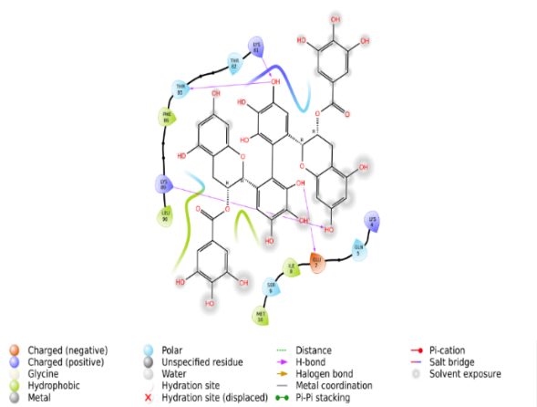
- Theasinensin A
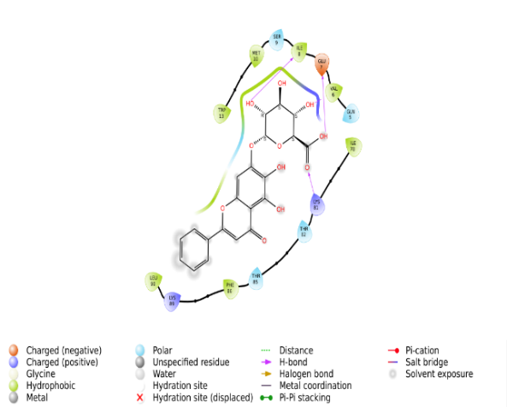
- Baicalin
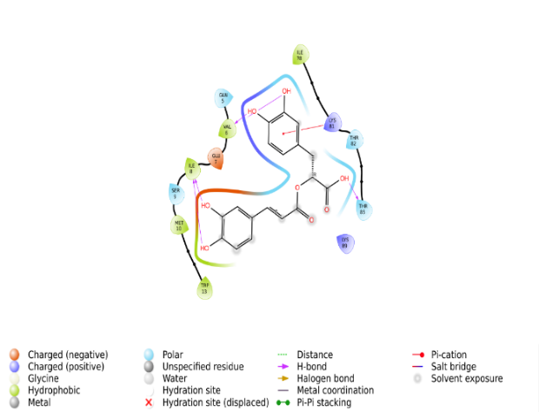
- Rosmarinic acid
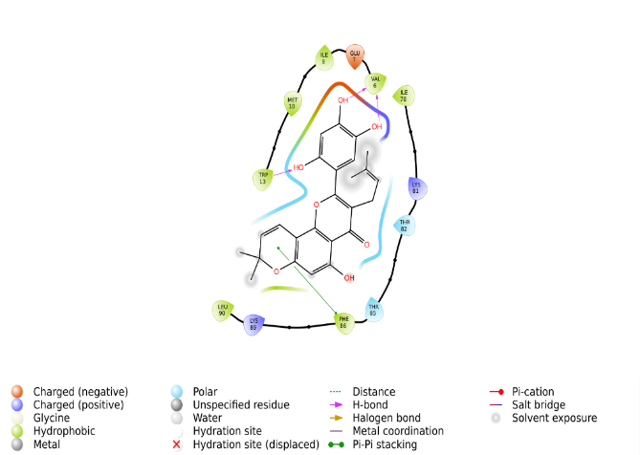
- Artonin E
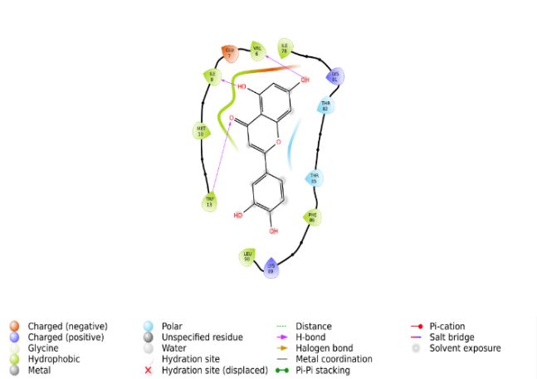
- Luteolin
Figure S4. Interaction of (a) Theasinensin A, (b) Baicalin, (c) Rosmarinic acid, (d) Artonin E and (e) Luteolin with blaI
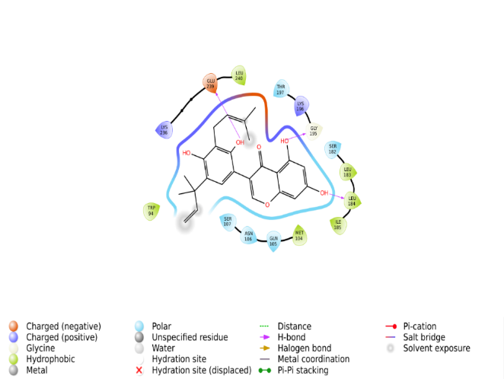
- Fremontone
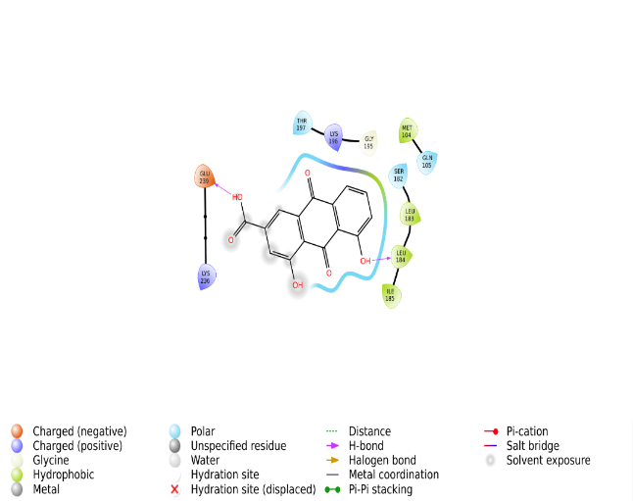
- Rhein
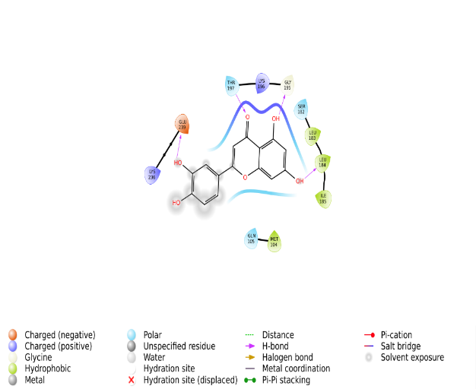
- Luteolin
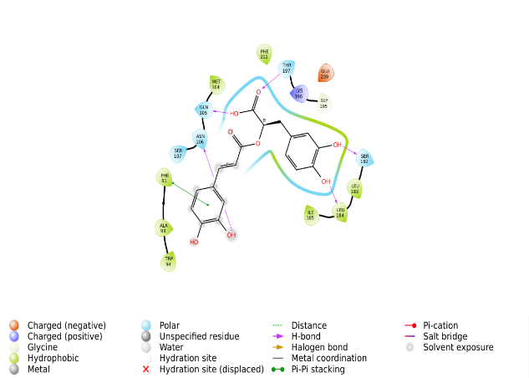
- Rosmarinic acid
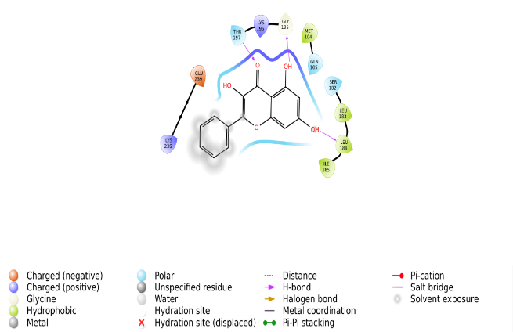
- Galangin

Figure S5. Interaction of (a) Fremontone, (b) Rhein, (c) Luteolin, (d) Rosmarinic acid and (e) Galangin with blaR1
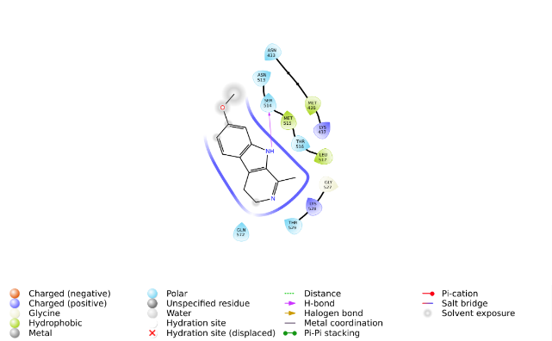
- Harmaline
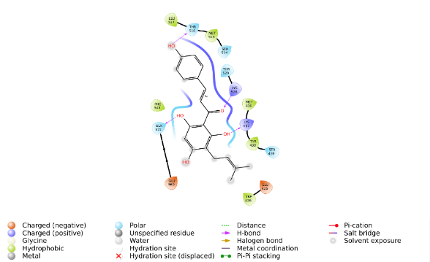
- Desmethylxanthohumol
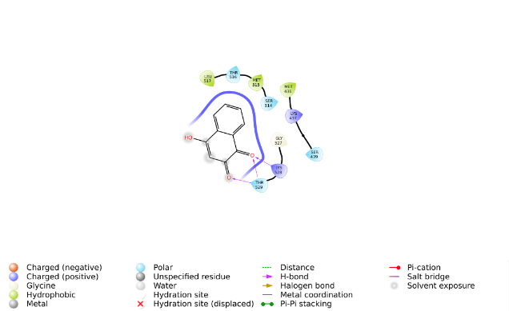
- Lawsone
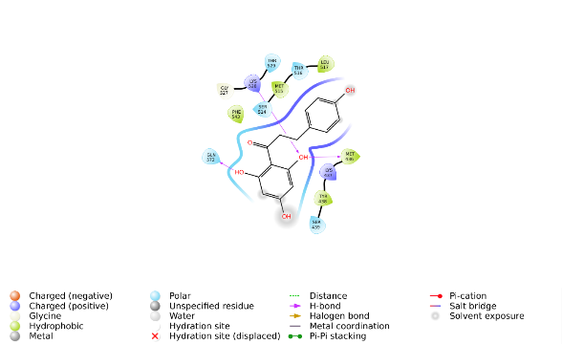
- Phloretin
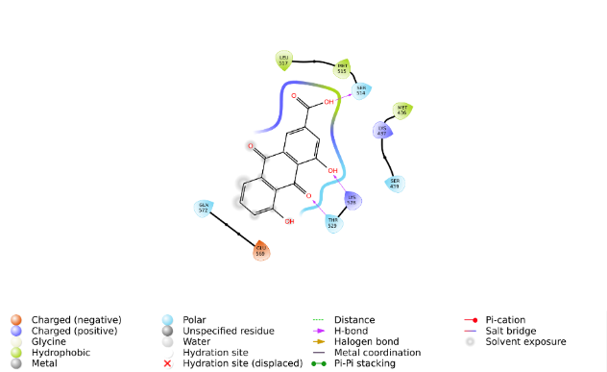
- Rhein
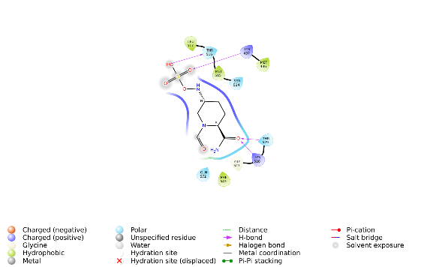
- Internal ligand

Figure S6. Interaction of (a) Harmaline, (b) Desmethylxanthohumol, (c) Lawsone, (d) Phloretin, (e) Rhein and (f) Internal ligand
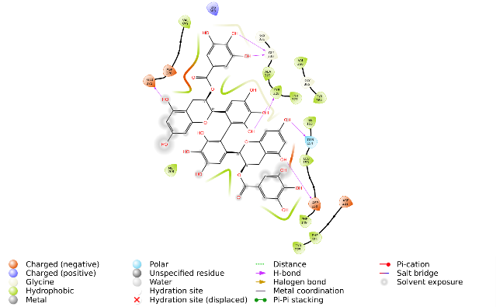
- Theasinensin A
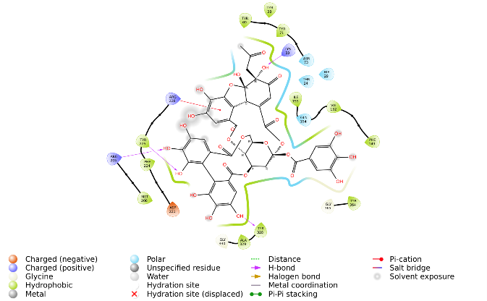
- Ellagitannin
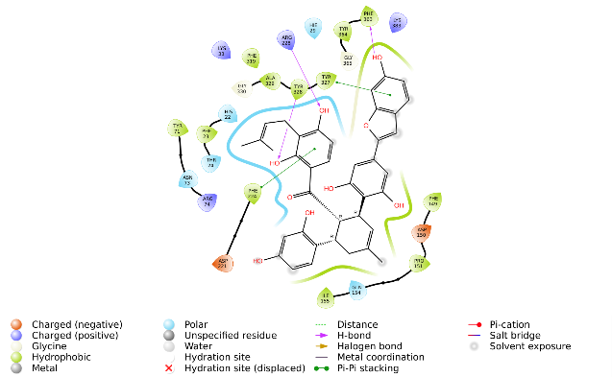
- Sorocenol H
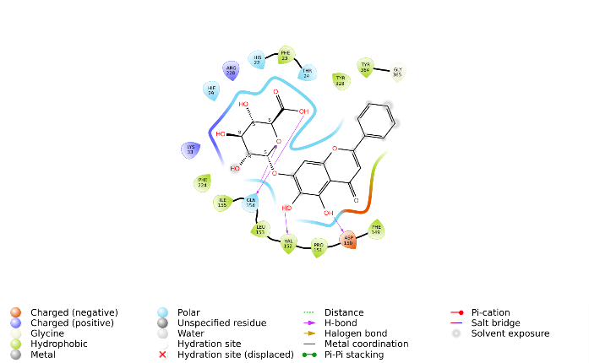
- Baicalin
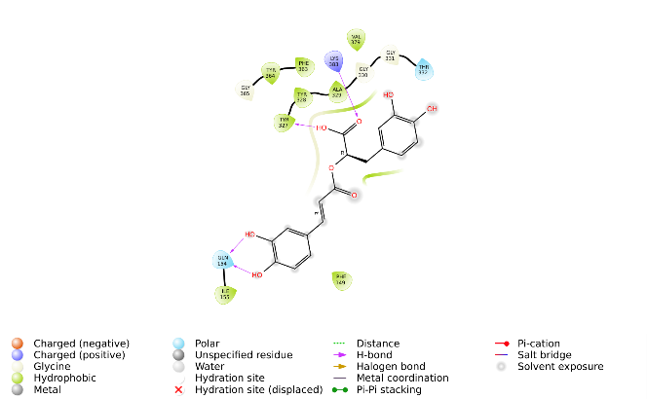
- Rosmarinic acid
Figure S7. Interaction of (a) Theasinensin A, (b) Ellagitannin, (c) Sorocenol H, (d) Baicalin, (e) Rosmarinic acid with femA
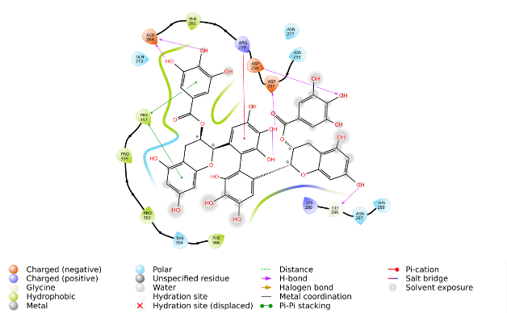
- Theasinensin A
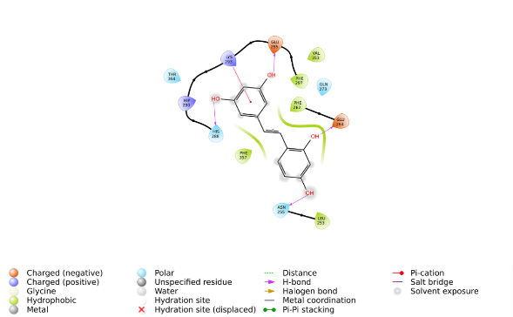
- Oxyresveratrol
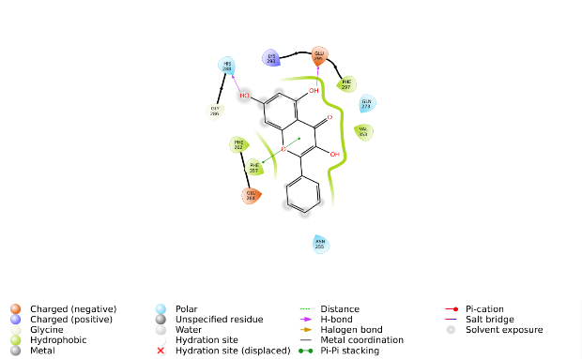
- Galangin
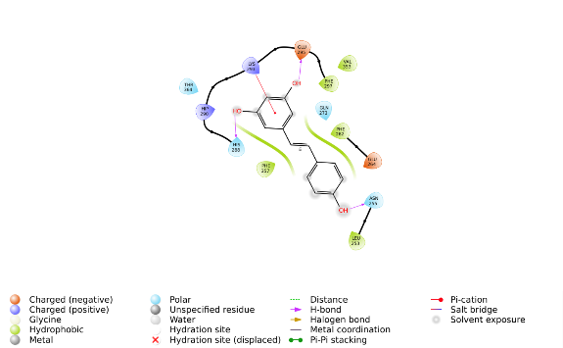
- Resveratrol
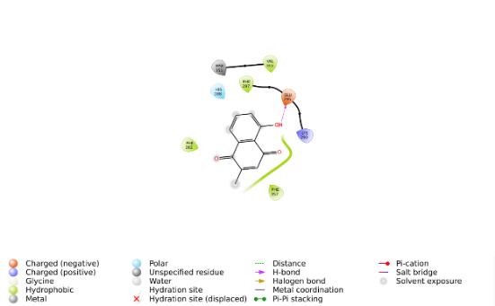
- Plumbagin

Figure S8. Interaction of (a) Theasinensin A, (b) Oxyresveratrol, (c) Galangin, (d) Resveratrol and (e) Plumbagin with capF
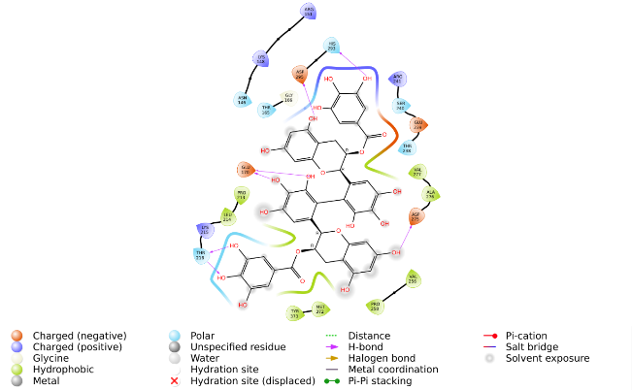
- Theasinensin A
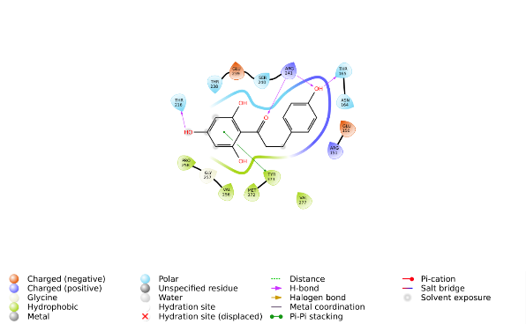
- Phloretin
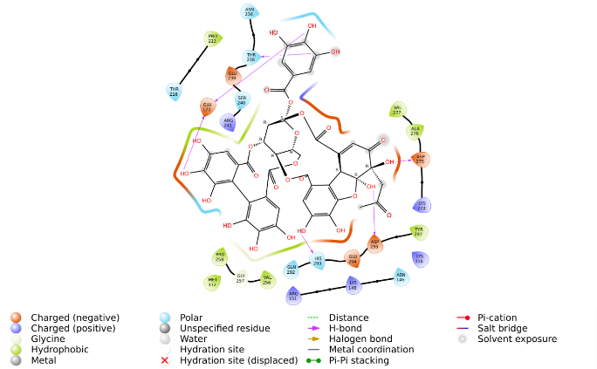
- Ellagitannin
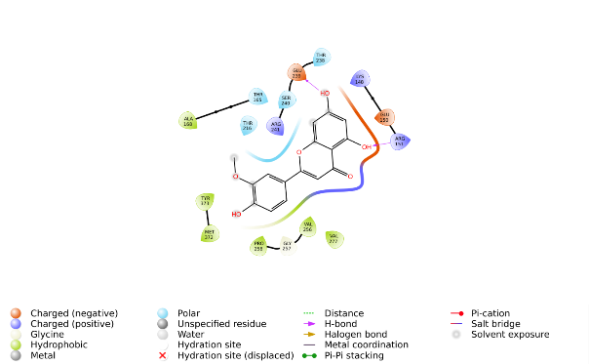
- Chrysoeriol
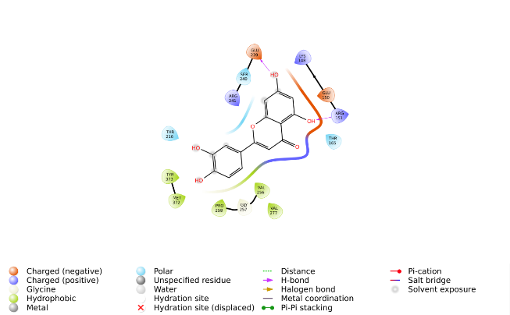
- Luteolin

Figure S9. Interaction of (a) Theasinensin A, (b) Phloretin, (c) Ellagitannin, (d) Chrysoeriol and (e) Luteolin with mecA

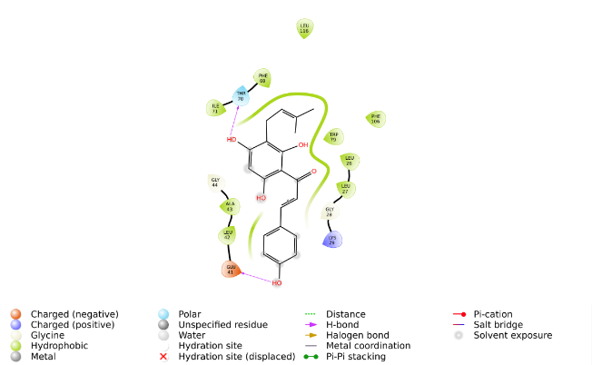
- Desmethylxanthohumol
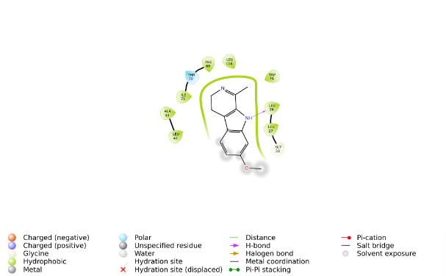
- Harmaline
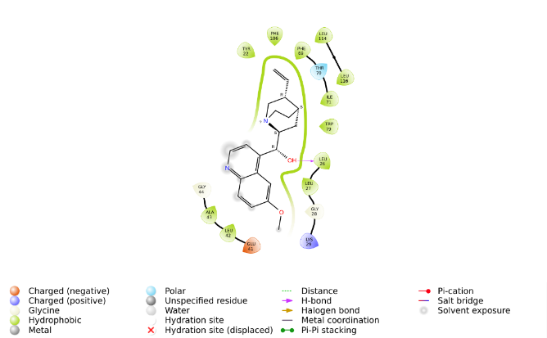
- Quinine
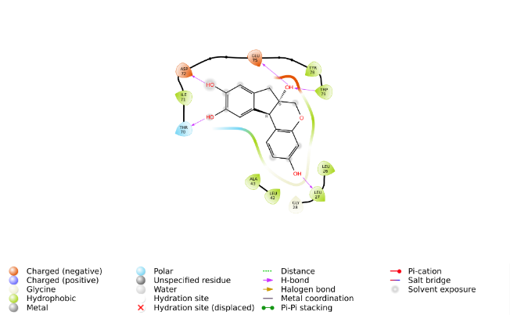
- Brazilin
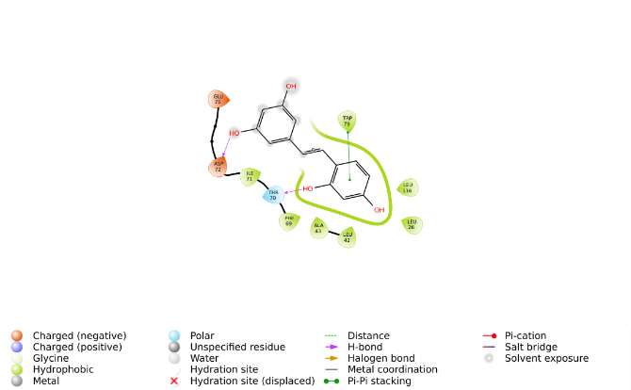
- Oxyresveratrol
Figure S10. Interaction of (a) Desmethylxanthohumol, (b) Harmaline, (c) Quinine, (d) Brazilin and (e) Oxyresveratrol with fosB
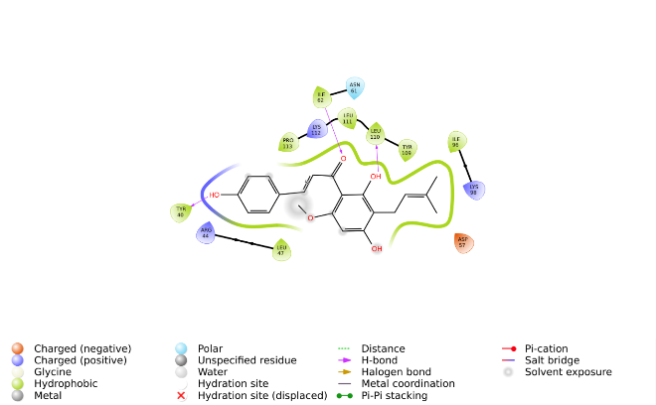
- Xanthohumol
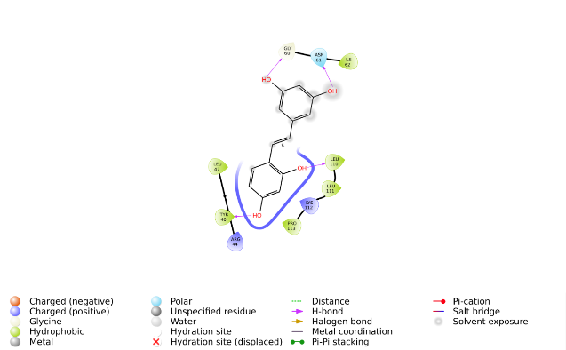
- Oxyresveratrol
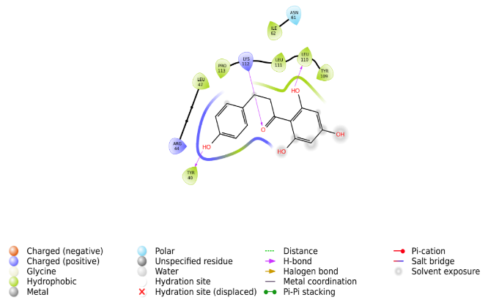
- Phloretin
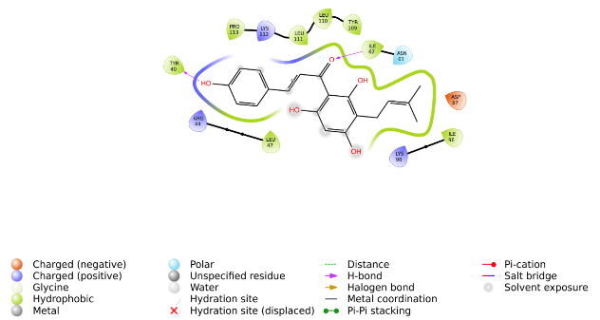
- Desmethylxanthohumol
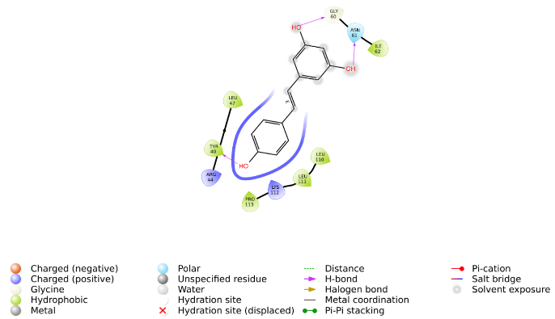
- Resveratrol
Figure S11. Interaction of (a) Xanthohumol, (b) Oxyresveratrol, (c) Phloretin, (d) Desmethylhumol and (e) Resveratrol with repA
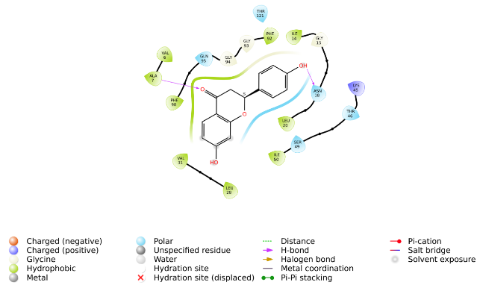
- Liquiritigenin
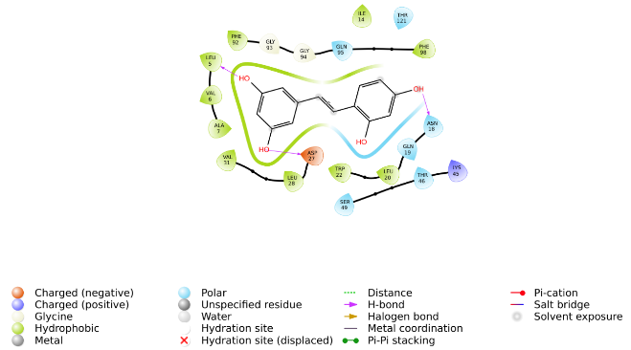
- Oxyresveratrol
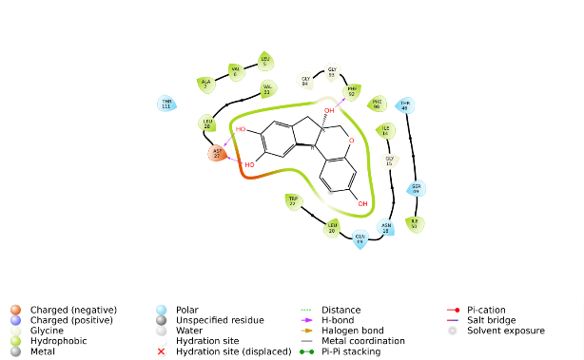
- Brazilin
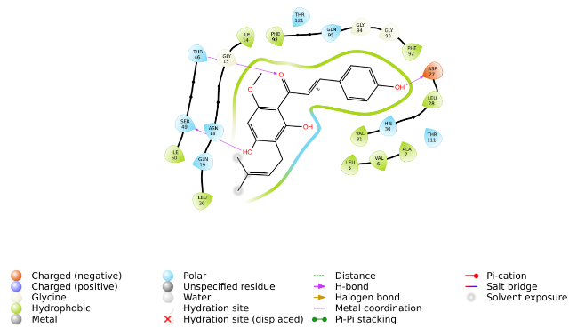
- Xanthohumol
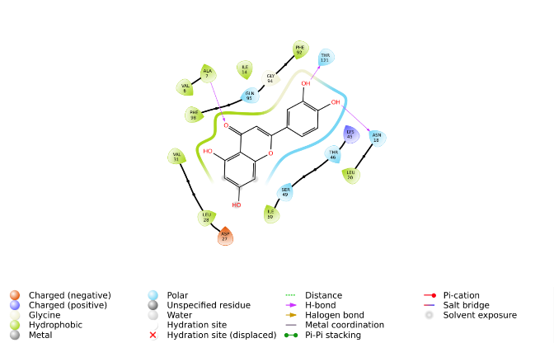
- Luteolin
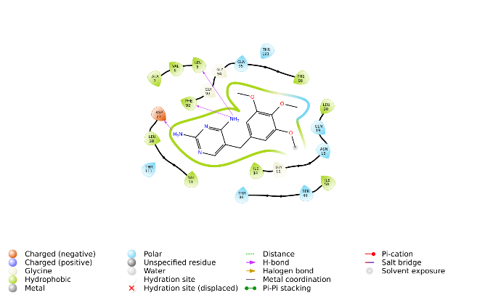
- Internal ligand
Figure S12. Interaction of (a) Liquiritigenin, (b) Oxyresveratrol, (c) Brazilin, (d) Xanthohumol, (e) Luteolin and (f) Internal ligand
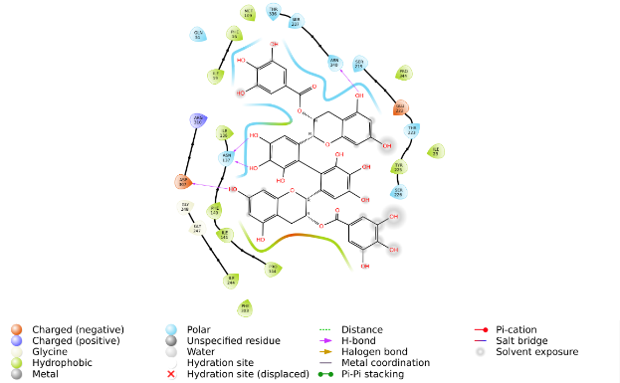
- Theasinensin A
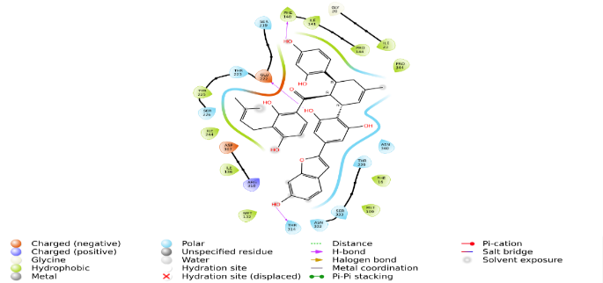
- Sorocenol H
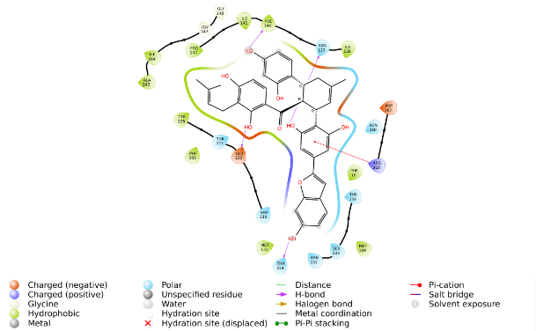
- Chalcomoracin
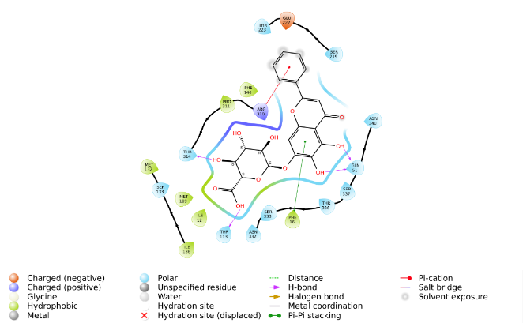
- Baicalin
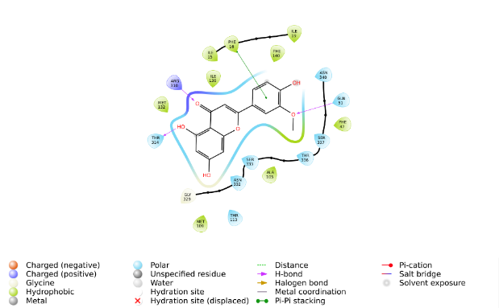
- Chrysoeriol
Figure S12. Interaction of (a) Theasinensin A, (b) Sorocenol H, (c) Chalcomoracin, (d) Baicalin and (e) Chrysoeriol with norA
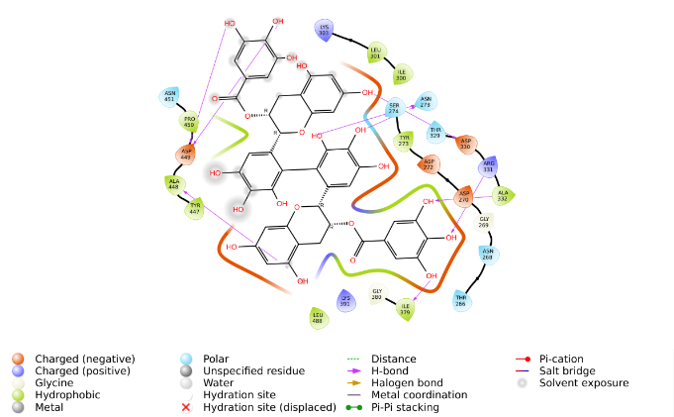
- Theasinensin A
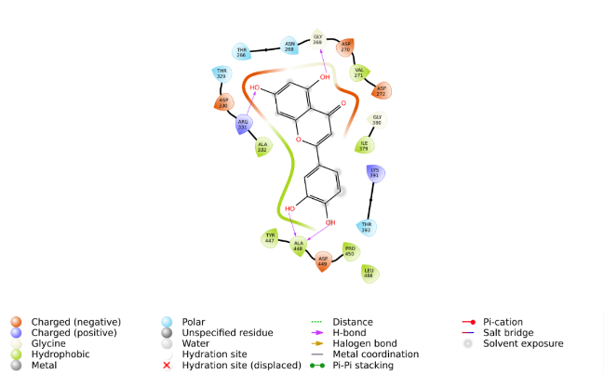
- Luteolin
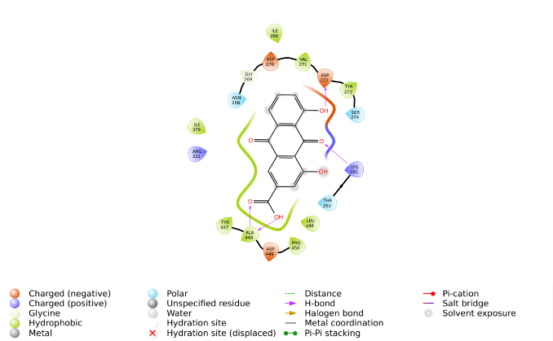
- Rhein
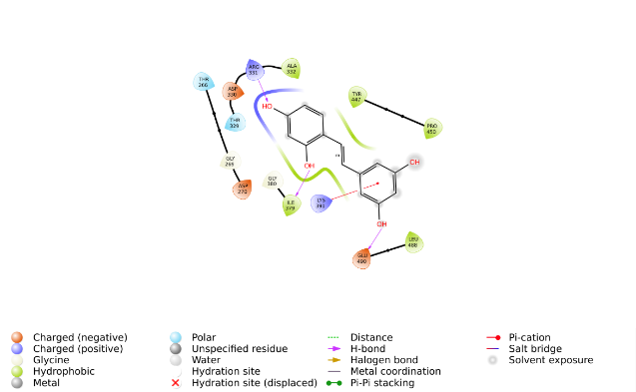
- Oxyresveratrol
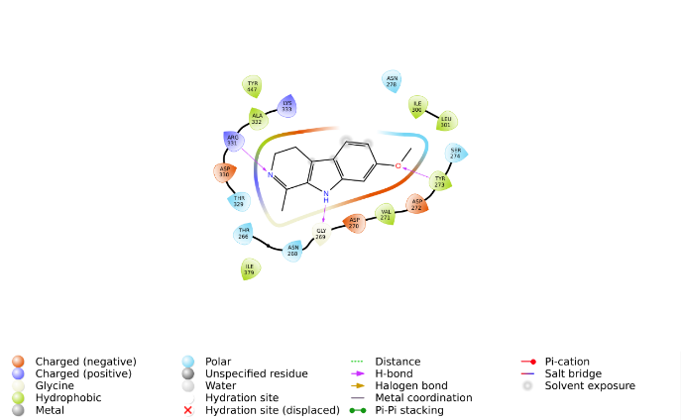
- Harmaline
Figure S13. Interaction of (a) Theasinensin A, (b) Luteolin, (c) Rhein, (d) Oxyresveratrol and (e) Harmaline with Clfb

Table S14. Compounds with docking score of ≥6.50
Serial no | Compounds | blaI | blaR1 | femA | capF | mecA | fosB | repA | folA | norA | clfb
 | Internal Ligand | No internal ligand | No internal ligand | No internal ligand | No internal ligand | No internal ligand | No internal ligand | No internal ligand | -7.996 | No internal ligand | No internal ligand
- 1 | Baicalin | -6.887 | - | -7.485 | - | -6.650 | - | - | -8.578 | -8.252 | -
- 2 | Theasinensin A | - | - | -11.322 | -7.344 | -7.891 | Not docked | - | Not docked | -10.061 | -8.148
- 3 | Rosmarinic acid | - | -6.643 | -7.088 | - | -6.886 | - | - | Not docked | -7.805 | -
- 4 | Artonin E | - | - | - | - | - | - | - | -7.560 | -6.813 | -
- 5 | Luteolin | - | -6.848 | - | - | -7.299 | - | - | -8.912 | -7.658 | -6.937
- 6 | Curcumin | - | - | - | - | - | - | - | -7.486 | -7.631 | -
- 7 | Diosmetin | - | - | - | - | -7.250 | - | - | -8.353 | -7.713 | -
- 9 | Brazilin | - | - | - | - | - | - | - | -9.140 | - | -
- 10 | Chrysoeriol | - | -6.577 | - | - | -7.437 | - | - | -8.711 | -7.886 | -
- 11 | Phloretin | - | - | - | - | -7.694 | - | - | -7.814 | -7.129 | -
- 12 | Isoliquiritigenin | - | - | - | - | - | - | - | -7.828 | - | -
- 13 | Resveratrol | - | - | - | - | -7.109 | - | - | Not docked | -7.501 | -
- 14 | Liquiritigenin | - | - | - | - | -7.076 | - | - | -9.311 | -7.415 | -
- 15 | Galangin | - | - | - | - | -6.592 | - | - | -7.643 | -7.128 | -
- 16 | Divaricatic acid | - | - | - | - | - | - | - | 6.584 | -6.734 | -
- 20 | Fremontone | - | - | - | - | - | - | - | -7.037 | - | -
- 21 | Lawsone | - | - | - | - | - | - | - | -7.051 | -6.967 | -
- 22 | Rhein | - | -6.869 | - | - | - | - | - | -8.251 | -7.583 | -6.932
- 23 | Chalcomoracin | - | - | - | - | - | Not docked | - | - | -9.166 | -
- 24 | Juncuenin A | - | - | - | - | - | - | - | -7.958 | -7.006 | -
- 26 | Desmethylxanthohumol | - | - | - | - | - | -6.128 | - | -8.506 | -7.616 | -
- 27 | Arborine | - | - | - | - | - | - | - | -7.470 | -6.620 | -
- 28 | Juncusol | - | - | - | - | - | - | - | -7.986 | -7.254 | -
- 29 | Xanthohumol | - | - | -6.500 | - | -6.535 | - | -6.906 | -9.055 | -7.545 | -
- 30 | Alpha-Mangostin | - | - | - | - | - | - | - | -7.305 | - | -
- 31 | Alpha-Lapachone | - | - | - | - | - | - | - | -7.616 | - | -
- 32 | 4-Phenylcoumarin | - | - | - | - | - | - | - | -7.769 | - | -
- 34 | Honokiol | - | - | - | - | - | - | - | -7.140 | - | -
- 37 | Rhodomyrtone | - | - | - | - | - | - | - | -7.156 | - | -
- 38 | Isopimaric acid | - | - | - | - | - | - | - | -7.183 | - | -
- 41 | Berberine | - | - | - | - | - | - | - | -7.823 | - | -
- 43 | Anthraquinone | - | - | - | - | - | - | - | -7.222 | - | -
- 45 | Chelerythrine | - | - | - | - | - | Not docked | - | -7.332 | -7.451 | -
- 46 | 6-Methoxydihydrosanguinarine | - | - | - | - | - | - | - | -6.827 | -7.272 | -
- 52 | Quinine | - | - | - | - | - | - | - | -8.408 | - | -
- 53 | Magnolol | - | - | - | - | - | - | - | -7.023 | - | -
- 56 | Sophoraflavanone G | - | - | - | Not docked | -7.257 | - | - | -8.811 | - | -
- 57 | Sorocenol H | - | - | -7.548 | - | -6.782 | Not docked | - | - | Not docked | -
- 58 | Mansonone F | - | - | - | - | - | - | Not docked | -7.471 | - | -
- 59 | Oxyresveratrol | - | - | - | -7.152 | -6.985 | - | -6.644 | -9.154 | -7.539 | -

