Enhancing Cycling Stability in NaǁZn liquid metal batteries with Fe-Based Foam Negative Current Collectors
Fang Zhangª, Junli Xu^{b*}, Zhaoshun Liuª, Duo Wangª, Lingyu Kongª, Ziyang Lvª, Mouhamadou Aziz Diopª, Aimin Liuª, Zhongning Shi^{a*}

ª Key Laboratory for Ecological Metallurgy of Multimetallic Mineral (Ministry of Education), Northeastern University, Shenyang 110819, China
^{b} College of Sciences, Northeastern University, Shenyang 110819, China

* Corresponding authors
E-mail: jlxu@mail.neu.edu.cn (J. Xu)
E-mail: znshi@mail.neu.edu.cn (Z. Shi).

Fig. S1 Optical surface profiling (OSP) images of (a-d) fresh and cycled Ni-Fe foam and (e-h) fresh and cycled Fe foam, respectively.
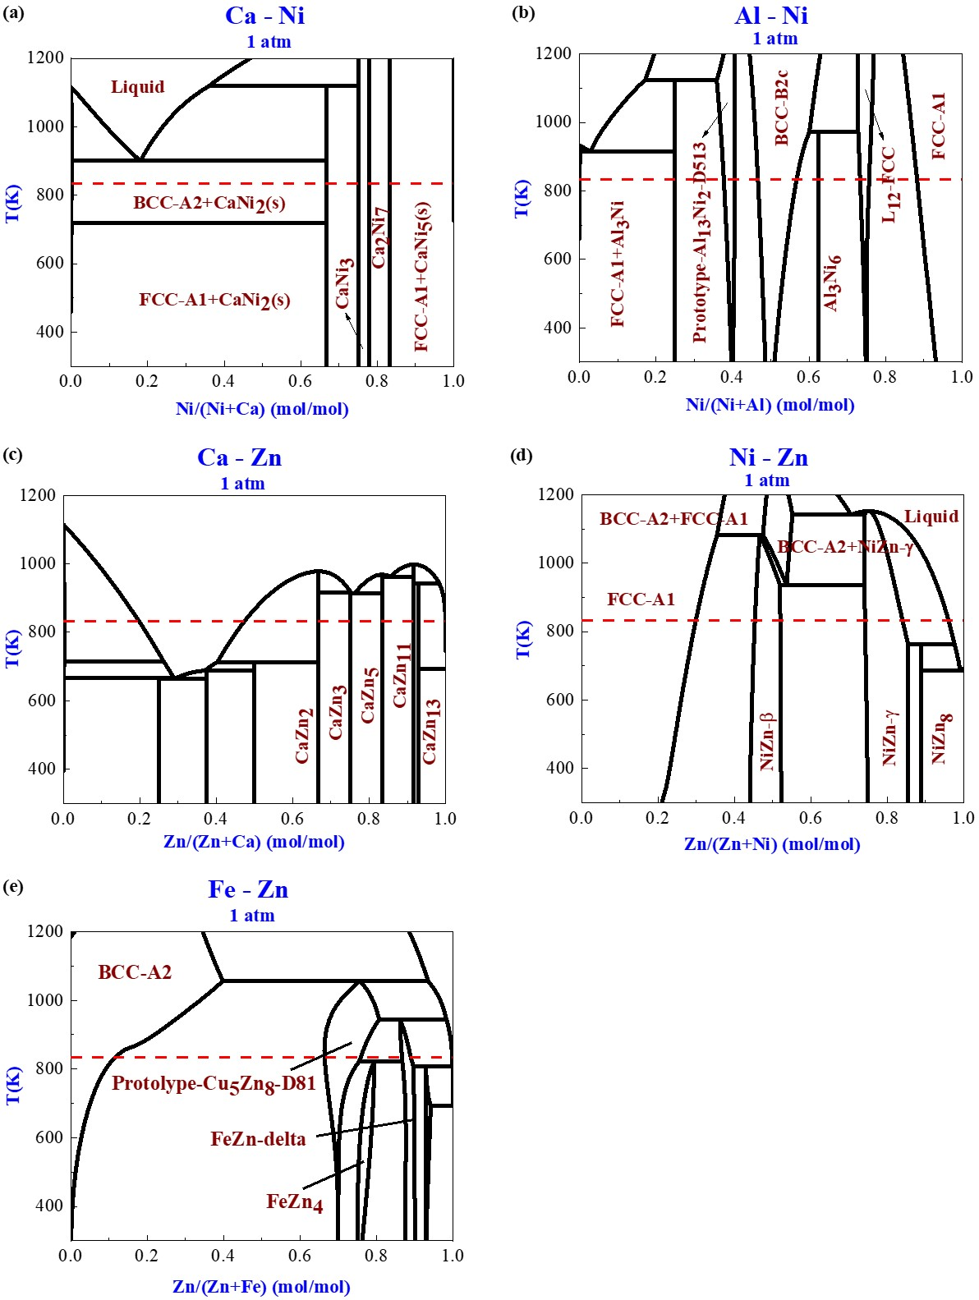
Fig. S2 Binary alloy phase diagram of Ca-Ni, Al-Ni, Ca-Zn, Ni-Zn, and Fe-Zn system.

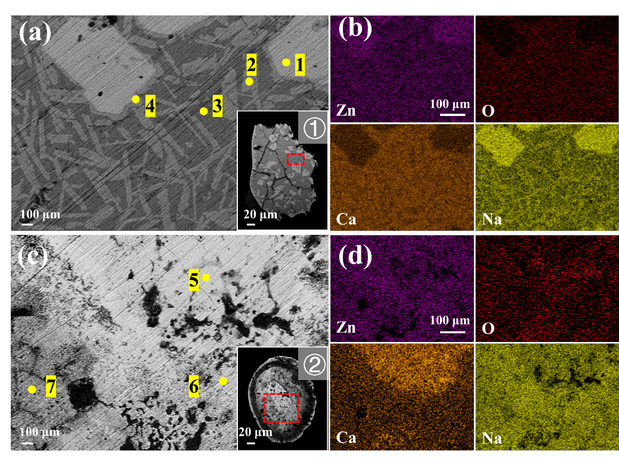
Fig. S3 SEM-EDS images of the alloys (a, b) ① and (c, d) ② in the Ni-Fe foam skeleton.

Table S1 Elemental composition by EDS in the cross-section of negative electrode products from Na/NFǁZn LMB

At% | 1 | 2 | 3 | 4 | 5 | 6 | 7
Na | 22.72 | 14.95 | 10.43 | 11.80 | 22.11 | 37.17 | 35.82
Ca | 18.42 | 23.95 | 20.53 | 25.60 | 20.51 | 8.99 | 8.61
Zn | 30.90 | 20.18 | 10.69 | 23.03 | 35.58 | 42.46 | 40.46
O | 27.95 | 40.92 | 58.35 | 39.57 | 21.80 | 11.38 | 15.12

