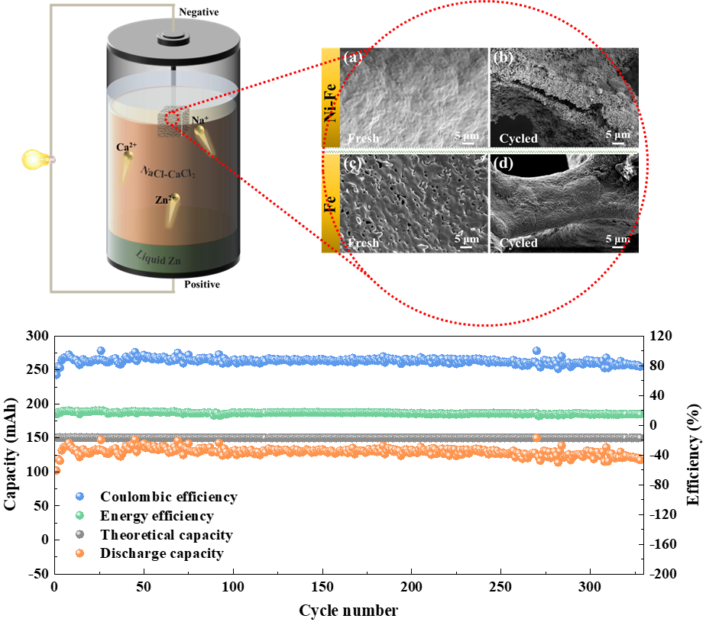
The dense structure of Fe-Zn alloy on the surface of Fe foam enhances the corrosion resistance of current collector, significantly boosting the discharge capacity and cycle stability of NaⅡZn liquid metal battery.

