Supplementary Information
Deterministic Inverse Design of Lithography-Free, Wavelength-Selective Tamm Plasmon Thermal Emitters
Mingze He^{1†}, J. Ryan Nolen^{2†}, Josh Nordlander³, Angela Cleri³, Nathan S. Mcllwaine³, Thomas G. Folland^{1, 4}, Yucheng Tang⁵, Bennett A. Landman⁵, Jon-Paul Maria³, Joshua D. Caldwell^{1, 5*}
1. Department of Mechanical Engineering, Vanderbilt University, Nashville, Tennessee, USA
2. Interdisciplinary Materials Science Program, Vanderbilt University, Nashville, Tennessee, USA
3. Department of Materials Science and Engineering, The Pennsylvania State University, University Park, Pennsylvania, USA
4. Department of Physics and Astronomy, The University of Iowa, Iowa City, Iowa, USA
5. Department of Electrical Engineering and Computer Science, Vanderbilt University, Nashville Tennessee, USA

† denotes equal contributions
* email: josh.caldwell@vanderbilt.edu
Section 1. Dielectric function fitting of Ge and AlOx
The dielectric functions of Ge and AlO_{x} were extracted using IR-VASE ellipsometry measurements. The fitting was performed with WVase software from J.A. Woolam, Inc¹.
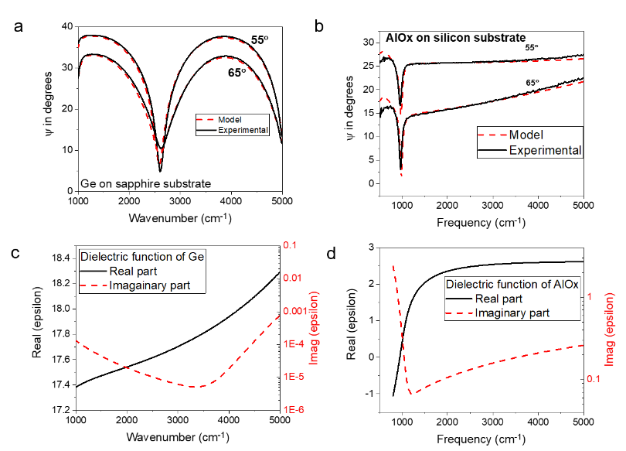
Fig. S1. Dielectric function fitting of Ge and AlO_{x}. Ellipsometry measurements of Ge on sapphire (a) and AlO_{x} on silicon (b). Fitted dielectric function of Ge (c) and AlO_{x} (d).
Based on the literature, we assume the thermal expansion of each of the constituents can be ignored (below 0.1%) below 300 °C.² The permittivity of Ge at 150 °C is modeled based on measurements at high temperature by varying the high-frequency permittivity. We determined that at 150 °C the high-frequency permittivity is 0.5 higher than at room-temperature (Fig. S2), in agreement with the literature³.
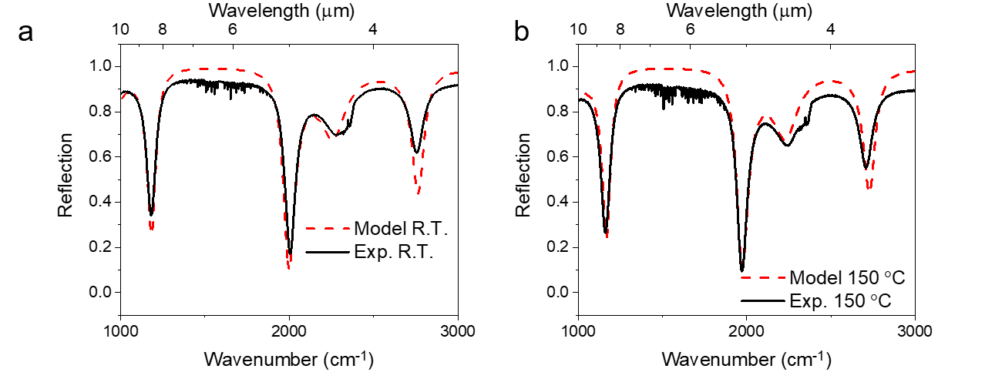
Fig. S2. Reflectance at two temperatures. (a) room temperature; (b) 150 °C
Section 2. Sample thickness
The layer thicknesses of as-grown samples are characterized by cross-sectional SEM (XSEM). The designed and as-grown layer thickness are tabulated in Table. S1, and the carrier densities ($N_{d}$) of CdO are also listed. One exemplary XSEM of the 7-layer sample (Fig. 2a) is provided in Fig. S3.
Table S1. Layer thickness of samples. Units of thickness are in nanometers.
 | 7 layer (Fig. 2a)  High-Q MWIR |  | 3 layer Fig. (2d)  LWIR |  | 3 layer (Fig. 2c)  CO₂ NDIR |  | 5 layer (Fig. 2d)  CO₂+SO₂ NDIR
 | Designed | As-grown | Designed | As-grown | Designed | As-grown | Designed | As-grown
Ge | 264 | 228 | Air |  | Air |  | Air
AlO_{x} | 356 | 540
Ge | 671 | 755 |  |  |  |  | 389 | 468
AlO_{x} | 293 | 200 |  |  |  |  | 797 | 290
Ge | 598 | 627 | 499 | 540 | 270 | 250 | 494 | 450
AlO_{x} | 178 | 198 | 829 | 440 | 430 | 590 | 310 | 268
Ge | 304 | 208 | 315 | 400 | 656 | 641 | 494 | 644
CdO $N_{d}$ (cm⁻³) | 3.5e+20 |  | 0.7e+20 |  | 3.6e+20 |  | 3.6e+20

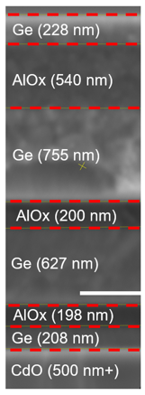
Fig. S3. XSEM image of the 7-layer sample in Fig. 2a. The scale bar is 500 nm.
Section 3. More demonstrations of inversely designed TPP-WS-EMs
We have demonstrated TPP-WS-EMs matching NO and the nerve agent simulant dimethyl methyl phosphonate (DMMP) in the main text. Here, more examples are provided in Fig. S4. Note that since the absorption spectra of O₃, CH₄ and NH₃ feature slopes or numerous sharp peaks, direct matching to the absorption spectra cannot be performed exactly. Instead, we use envelope spectra to cover those chemical spectra, and then employ these envelope spectra as the target.
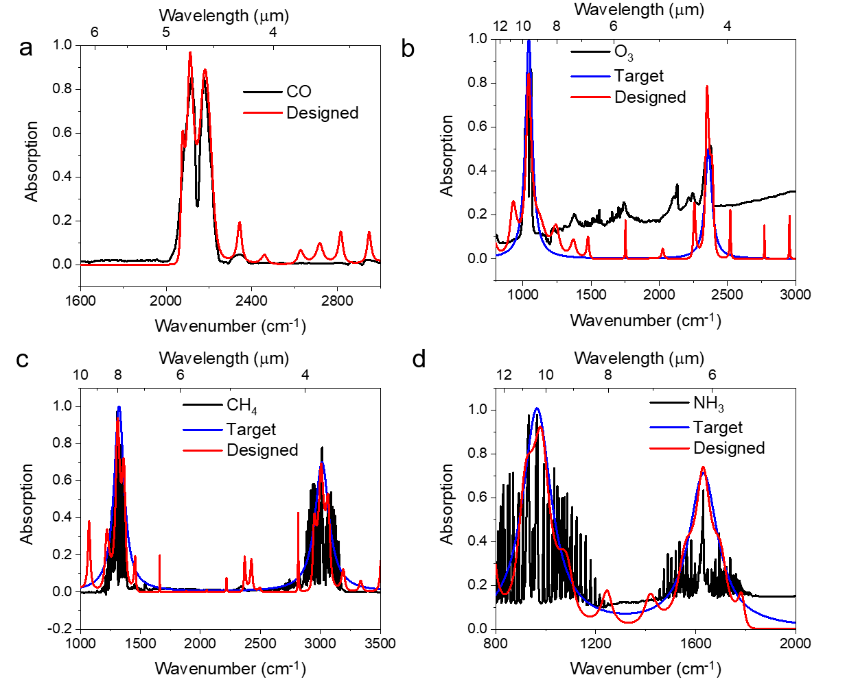
Fig. S4. More demonstrations of ID-TPP-EMs. (a) Matching CO. (b-d) Matching the envelope spectra of O₃, CH₄, and NH_{4,} respectively
Section 4. The superiority of SGD in TPP-WS-EM designs
In the optimization process, each frequency (wavelength) point is considered as an individual sample, and the absorption at that frequency is compared with the target value. Within the canonical gradient descent (GD) method, the difference across the entire data distribution is calculated and summed together to find the gradient, and all parameters are evaluated with the same computational complexity. With stochastic gradient descent (SGD), in each iteration, only a subsample of data points is used to find the gradient and update the vector representing the thickness and carrier concentration. The selected portion is randomly chosen from the entire collection of data points, so the algorithm is known as “stochastic” gradient descent, (SGD)⁴⁻⁷. The specific version we employed here is adaptive moment estimation (Adam) optimization⁷. Exemplary code is published on our group website⁸. In deep learning, SGD is considered to outperform GD and avoid poor local minimums⁴⁻⁷, with theoretical studies proving it⁴⁻⁷.
Here, to demonstrate that the SGD provides a better optimization than GD, we performed a series of optimizations on the same target: matching DMMP nerve agent and evaluating the performance based on mean-squared difference error (MSE). With SGD, the overall error is significantly lower than the optimization performed with GD. Within 20 optimization runs, the lowest error with SGD is ~40, while this value is ~70 for GD (Fig. S5a). To visualize the arbitrary unit “error”, we plot the designed spectra with different errors against the target spectra (Fig. S5b-d). While the main features are matched for errors below 100 (Fig. S5b), designs with higher errors lose one or several of the main absorption peaks.
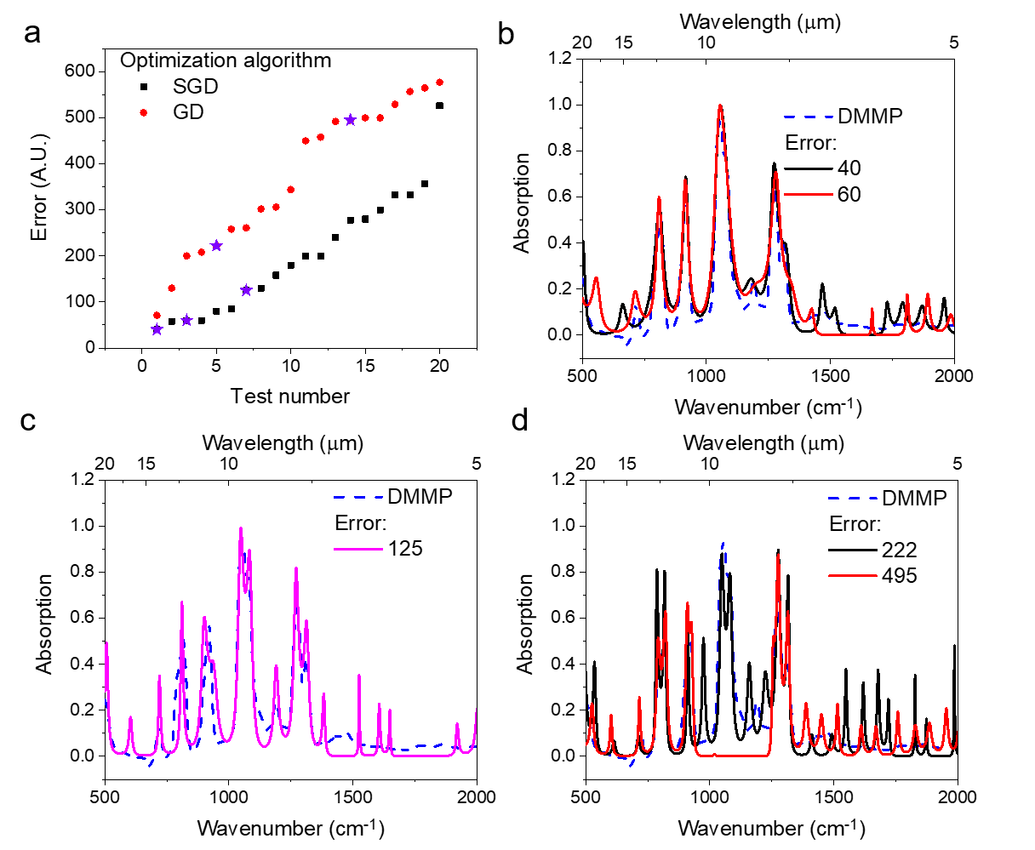
Fig. S5. The comparison of SGD and GD. (a) Error of optimized structure in 20 runs, performed with SGD and GD, respectively. Stars are the points used in panel b-d. (b-d) Designed spectra featuring different errors.
Section 5. Tamm with Gold and CdO optimization
We performed the SGD-based inverse design for the same constraints on the total number of dielectric layers (29 layers) for both CdO and gold as bottom layer. Both optimizations were performed 20 times to ensure that a local minimum is not reported. The errors are shown in Fig. S6. The structures with the lowest error are reported in Fig. 4a.
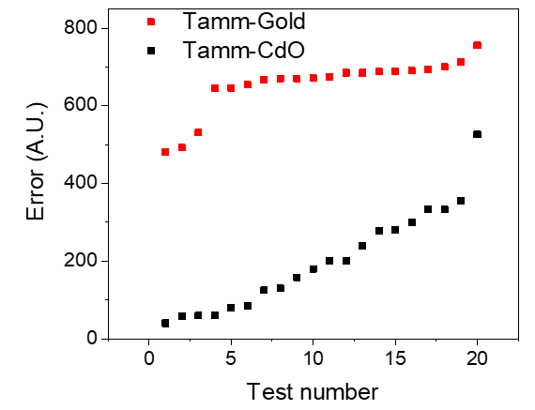
Fig. S6. The comparison between Gold and CdO supported Tamm.
Section 6. NDIR working principles
Conventional NDIR sensors consist of a gas cell containing a broadband emitter and broadband detector integrated with a narrow bandpass filter that is transmissive at the vibrational frequency of the analyte of interest (SI, Fig. S7a). The presence of the gas of interest within the cell results in a drop in the detected transmission, with the difference in amplitude being related to the molecular concentration in accordance with Beer’s Law. Due to the simple design and small footprint, these sensors are commonly implemented in industrial settings, however, they suffer from inherent inefficiencies since off-resonant emission from the broadband emitter is not used and must be filtered. Therefore, there has been significant interest in improving the design and expanding the functionality of NDIR sensors by combining the functionality of the emitter and bandpass filter into a single device. Such filterless NDIR devices are comprised of (1) WS-EM, (2) the gas cell, and (3) a broadband detector, such as a thermopile, as shown in Fig. S7b. The emission frequency of WS-EM is normally centered at the absorption frequency of the gas of interest with a sufficiently high Q-factor so as to eliminate false-negatives from other gases that may be present. There are normally two detectors, one is shown in Fig. S7, and the other is to measure the power with reference gas, e.g., nitrogen, so that the power difference can be acquired.
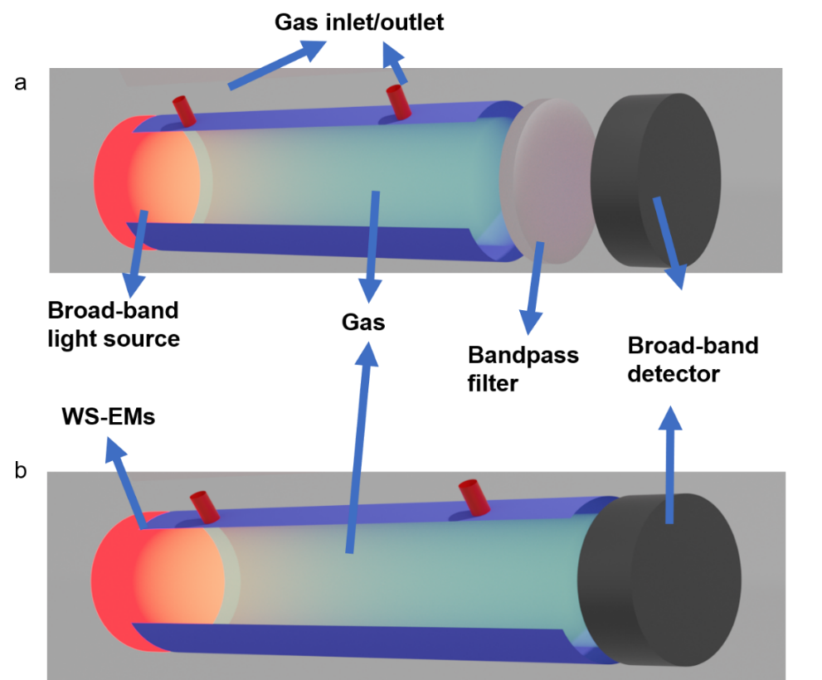
Fig. S7. Schematic of NDIR of (a) broadband light source with filter and (b) filterless NDIR enabled by WS-EM
Section 7. Emitted power matching N₂O absorption spectrum
Since the emitted power is determined both by the emissivity and the temperature of the object, we designed a TPP-WS-EM working at 250 °C for N₂O NDIR sensing. Firstly, we determine the working temperature to be 250 °C, with the temperature adjusted according to the specific product. Then the target emissivity spectrum becomes:
$Target emissivity=normalize (\frac{N_{2}O absorption spectra}{black body emission at 250 °C})$ Eq. (1)
Here, the normalization is performed to make sure the highest emissivity is unity. We also remove the background absorption of N₂O.
As such, the emissivity is adjusted to the specific working temperature, as shown in Fig. S8.
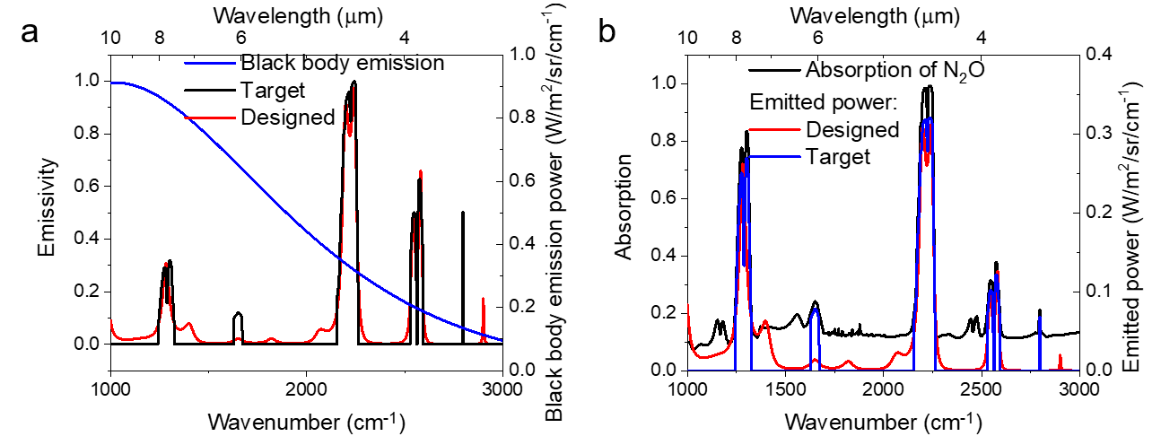
Fig. S8. Adjust the target to a specific working temperature. (a) Target emissivity and blackbody emission power spectrum; (b) target and designed emitter power.
Section 8. Designed structures
Here, we provide the parameters of the designed structures in Fig. 3, Fig. 4 and SI. All of our designs consisted of a 29-layer DBR on top of a CdO bilayer with Ge as the first and last layers in the DBR. The CdO carrier concentration is constrained between 0.2 and 12.0 e+20 cm⁻³, which is the range that has been demonstrated in literature^{9,10}. A model published by our groups is used to calculate the dielectric function of CdO⁹ as a function of carrier density, and the corresponding MATLAB code is published on our group website⁸. The dielectric function of Ge¹¹ and ZnSe¹² are considered as constants over the entire frequency range: 16+ 0i and 5.0625 +0i, respectively. The substrate is fixed to CdO with the carrier concentration of 12.0x10²⁰ cm⁻³ (plasma frequency=7800 cm⁻¹), so that we ensure there is no transmission. The units are all in nanometers.
Hyper-high-Q in Fig. 3a:
[705 681 543 854 787 872 1073 1415 1491 1120 1133 1902 1702 2396 2563 2146 2051 2066 2447 2630 2141 1979 2351 2430 1945 2291 2308 2460 1920 2500 ($N_{d}$ =1.02×10²⁰ cm⁻³)]
Multi-peak in Fig. 3b:
[4 586 689 1 622 167 166 355 195 228 214 301 184 310 259 251 202 370 270 213 196 540 561 501 343 683 698 697 177 1213 ($N_{d}$ =1.86×10²⁰ cm⁻³)]
LWIR to telecommunication in Fig. 3c:
[476 345 258 261 455 399 297 176 458 447 355 407 286 467 433 332 447 316 286 360 395 250 283 290 366 326 454 307 437 324 ($N_{d}$ =6.3×10²⁰ cm⁻³)]
Emissivity matching NO in Fig. 3d:
[64 1401 588 169 278 1047 543 636 676 736 260 619 681 448 1050 374 752 695 768 742 698 977 330 1286 922 1116 831 557 93 565 564 ($N_{d}$ =0.23×10²⁰ cm⁻³)]
Matching DMMP nerve agent in Fig. 4a with CdO:
[19 1385 270 411 770 351 603 111 553 759 583 206 480 213 876 457 1095 289 459 754 224 359 722 491 200 1009 898 1364 140 1713 ($N_{d}$ =0.29×10²⁰ cm⁻³)]
Matching DMMP nerve agent in Fig. 4a with gold (substrate is gold):
[244 394 402 314 300 421 359 404 324 284 434 591 495 374 250 396 334 454 293 275 444 369 347 474 437 491 106 442 574]
Matching CO in Fig. S4a:
[532 369 481 416 429 403 492 354 481 456 488 426 436 343 464 365 509 342 451 399 516 453 461 362 301 502 710 540 150 631 ($N_{d}$ =0.9×10²⁰ cm⁻³)]
Matching O₃ envelope in Fig. S4b:
[120 585 646 433 167 229 228 379 436 410 427 490 439 441 362 445 465 528 245 343 371 174 267 676 582 511 365 147 213 1313 ($N_{d}$ =1.4×10²⁰ cm⁻³)]
Matching CH₄ envelope in Fig. S4c:
[379 287 418 720 310 514 611 312 375 443 522 443 372 394 590 236 408 432 245 278 454 467 460 649 196 141 357 497 415 1116 ($N_{d}$ =2.1×10²⁰ cm⁻³)]
Matching NH₃ envelope in Fig. S4d:
[47 698 472 96 440 640 235 301 482 301 349 400 380 274 421 381 323 365 399 254 439 174 567 739 626 578 100 384 401 1582 ($N_{d}$ =0.48×10²⁰ cm⁻³)]
Emitted power matching N₂O in Fig. S8:
[92 460 759 414 98 275 726 355 174 416 305 209 191 397 63 90 200 97 144 191 148 484 440 442 363 507 358 450 134 40 ($N_{d}$ =3.19×10²⁰ cm⁻³)]
Section 9. Highly customized error for special designs
In the main text, we mentioned that the error is written in a combination of mean-squared error (MSE, the first term) and mean absolute error (MAE, the second term) terms:
$error=mean\left\{ratio1∙{\left(\vec{DS}-\vec{TS}\right)}^{2}+ratio2∙\left|\left(\vec{DS}-\vec{TS}\right)\right|\right\}$ Eq. (2)
While the MSE regulates the algorithm to focus on spectral ranges where the difference between DS and TS is greatest, MAE treats every frequency point equally important. If the target is a spectrum that can be matched perfectly, e.g., a single peak design over a narrow frequency range, the hyperparameter choice does not matter. Yet, when the design cannot be accomplished well, e.g., matching a complicated spectrum of a chemical, if one cares more about the overall matching (such as baseline) than the peak matching, the MAE should have a larger component than MSE. Here, we use the design details in Fig. 3c as an example to show the technique of weighed sampling. Since we are optimizing the TPP-WS-EM based on the frequency points, we can artificially make some frequency range more/less important by sampling it densely/sparsely, and we can also artificially ignore certain frequency ranges. For example, for free-space communications, the performance of WS-EM in the water absorption band can be ignored since the energy will be attenuated through space propagation. However, for NDIR sensing, the emission in the water absorption band is required to be minimal so that the signal will not be influenced by humidity.
In the case presented in Fig. 3c, only three discrete frequency ranges are optimized: LWIR (1100-1300 cm⁻¹), MWIR (2600- 2800 cm⁻¹) and telecommunications (1.5-1.6 µm) bands, so that a single TPP-WS-EM working at such a dramatically wide frequency range can be realized. The spectrum of this device in full range is shown in Fig. S9. In a commercially designed scenario, such a technique can be used to specifically optimize the frequency ranges where band-pass filters are not available or are cost-prohibitive.
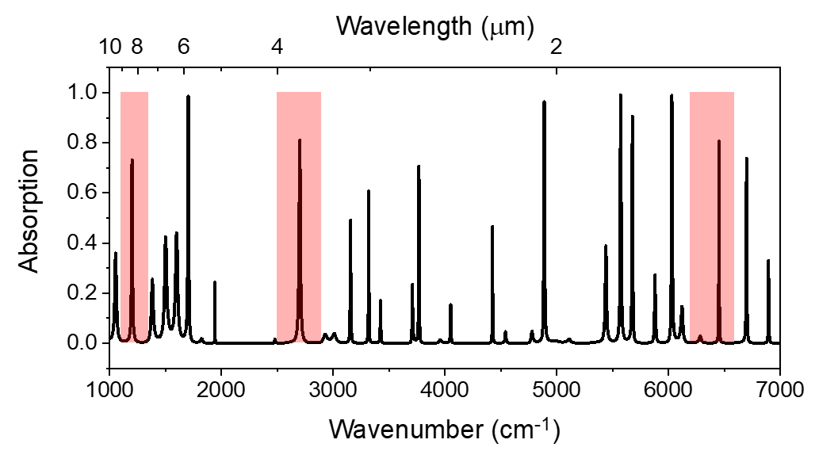
Fig. S9. Spectrum in full range, same structure in Fig. 3c. Semi-transparent boxes are the frequency ranges shown in Fig. 3c.
Still in the case presented in Fig. 3c, we assume that the performance in the telecommunications band is more important than in the LWIR, so we sample the former more densely: one frequency point every 0.5 cm⁻¹ in the telecommunications band, while only every 2 cm⁻¹ in the LWIR and MWIR. This is of extreme importance, since trade-offs are unavoidable for a product design, and our algorithm quantifies this trade-off to “prioritize” certain ranges, as dictated by human intervention.
Section 10. Rationales of target spectrum in Fig. 2d
In Fig. 2d, we also demonstrated a TPP-WS-EM for dual-gas sensing. The target is to match absorption features of SO₂ and CO₂ absorption simultaneously. In order to determine a target spectrum to design this device, we take the absorption spectra of SO₂ and CO₂ from National Institute of Standards and Technology (NIST), then we use an envelope spectrum to cover the two main absorption peaks of SO₂ and CO₂. Because numerous gases possess absorption bands in the 1000-1500 cm⁻¹, such as CH₄, and the thermal emission leads to more energy in the lower frequency range, the target spectrum at 1380 cm⁻¹ is set to be sharper (20 cm⁻¹ FWHM) to reduce the energy emitted to compensate. The FWHM at 2360 cm⁻¹, which is the absorption peak of CO₂, is set to be larger (50 cm⁻¹) to compensate for the low emitted power dictated by Plancks’ Law. The frequency range is set between 1000 cm⁻¹ and 2500 cm⁻¹. We do not try to match below 1000 cm⁻¹ as the loss of AlO_{x} is hard to predict, especially at elevated temperatures. The high frequency is set to be 2500 cm⁻¹ because the emitted power drops significantly above it, as dictated by Planck’s Law, and thus emission at higher frequencies can be considered negligible.
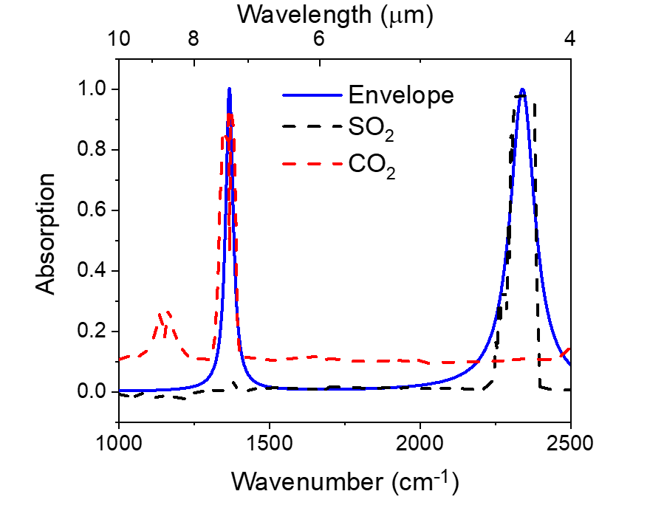
Fig. S10. Target spectrum for SO₂ and CO₂ dual gas sensing.
Section 11. Differentiating CO₂ and SO₂ with a single TPP-WS-EM by linear regression
As the emitted power is influenced by the working temperature, such a difference can be used to find the concentration of CO₂ and SO₂ by linear regression. The absorbed power of one gas, can be described as follows:
$\vec{Emitted power of EM}=\vec{Emitted power of black body }⊗\vec{Emissivity of EM}$ Eq. (3)
$\vec{Absorbed power }=\vec{Emitted power of EM }⊗\vec{absorption spectrum of gas} ∙absorption strength$ Eq. (4)
Where $⊗$ stands for elementwise multiplication. The actual gas concentration in ppm can be derived from scalar $absorption strength$ with Beer-Lambert law. Assuming all the spectra are discretized from 1000 cm⁻¹ to 2500 cm⁻¹ into $N$ frequency points, then each spectrum can be written as a $\left[N×1\right]$ vector. Assuming we have $m$ different temperatures, then the emitted power of the TPP-WS-EM at $m$ temperatures in can be written in a matrix of$\left[N×m\right]$, i.e., $\left[Emitted power\right],$ of which the rank of the matrix is $m$, because the $\vec{Emitted power of black body }$ is linearly independent at different temperatures.
When we have multiple gas types (CO₂ and SO₂ here for example), the absorption spectra will be expanded to matrixes, with different rows representing different gas types. As such, we have two unknown variables$\left[1×2\right]$, i.e., $\vec{absorption strength },$ representing the concentration of CO₂ and SO₂ respectively. Then the power change read by the detector is:
$(\left[\vec{absorption strength }\right]×\left[absorption spectra of {CO}_{2} and {SO}_{2}\right])×\left[Emitted power of EM\right]=\vec{power change at m temperatures concentration }$ Eq. (5)
where $\left[absorption spectra of {CO}_{2} and {SO}_{2}\right]$ is a matrix of $\left[2×N\right]$ representing the absorption of CO₂ and SO₂ respectively, and $×$ stands for matrix multiplication. In Eq. (5),$\left[absorption spectra of {CO}_{2} and {SO}_{2}\right]$ is pre-calibrated, [Emitted power of EM] is measured power of WS-EM before the WS-EM is assembled in the NDIR, and $\vec{power change at m temperatures concentration }$ is the reading of detector. Thus, we can use a simple non-negative linear regression solution to find the vector of $\vec{absorption strength }$, and thus the gas concentrations in ppm. Non-negative linear regression can be performed by many scientific programming interfaces, such as SciPy (https://www.scipy.org/).
Example of differentiating CO₂ and SO₂ with our TPP-WS-EM in Fig. 2d
In the case of differentiating CO₂ and SO₂ with the emitter in Fig. 2d, we can simplify the system by only considering two isolated frequency points: 1380 and 2360 cm⁻¹, as they are the only two emission peaks of our TPP-WS-EM. As such, the emissivity vector is: [0.6 1.0]. At 100, 150, 200, 250 °C, the emitted powers (W/m²/sr/cm⁻¹) of black body are:
$$\left[\begin{matrix}0.175 & 0.327 \\ 0.020 & 0.059\end{matrix} \begin{matrix}0.538 & 0.808 \\ 0.136 & 0.269\end{matrix}\right]$$
As such, the emitted power (W/m²/sr/cm⁻¹) of our TPP-WS-EM is:
$$\left[\begin{matrix}0.105 & 0.196 \\ 0.02 & 0.059\end{matrix} \begin{matrix}0.323 & 0.485 \\ 0.136 & 0.269\end{matrix}\right]$$
Assuming the concentration of SO₂ and CO₂ are leading to a and b absorption respectively, then the power change (W/m²/sr/cm⁻¹) matrix is:
$$\left[\begin{matrix}0.105a+0.02b+noise1 & 0.196a+0.059b+noise2\end{matrix} \begin{matrix}0.323a+0.136b+noise3 & 0.485a+0.269b+noise4\end{matrix}\right]$$
which are the readings of the detector at four temperatures. From there, both the absorption caused by SO₂ and CO₂ can be calculated, and therefore the corresponding concentrations extracted dynamically.
Why WS-EM instead of blackbody emitters?
With the previous discussions, it appears that one could do the aforementioned calculations with any emitters, even a blackbody, which is true when there are no noise and only CO₂ and SO₂ are present. Here we will discuss the benefits of WS-EMs over a blackbody emitter, specifically in the improved signal-noise-ratio (SNR) and selectivity.
With the aforementioned calculations for the TPP-WS-EM in Fig. 4d, at 100, 150, 200, 250 °C, the power change ratio by integrating the whole spectral range assuming a and b absorption intensity of SO₂ and CO₂ respectively is:
$$[\begin{matrix}0.316a+0.06b & 0.307a+0.09b\end{matrix} \begin{matrix}0.295a+0.12b & 0.284a+0.144b\end{matrix}]$$
For a blackbody emitter, the corresponding power change ratio is:
$$[\begin{matrix}0.039a+0.007b & 0.038a+0.011b\end{matrix} \begin{matrix}0.037a+0.015b & 0.035a+0.018b\end{matrix}]$$
Because the power change ratio is normally dictating the SNR, the signal difference is ten-fold higher with our TPP-WS-EM compared with a blackbody emitter. More importantly, other gases such as water vapor will be present in the environment, and thus, with a blackbody emitter, changes in the humidity will lead to corresponding power changes, which results in false-positives. Yet, since our TPP-WS-EM does not emit power in the water absorption band, the selectivities are improved.
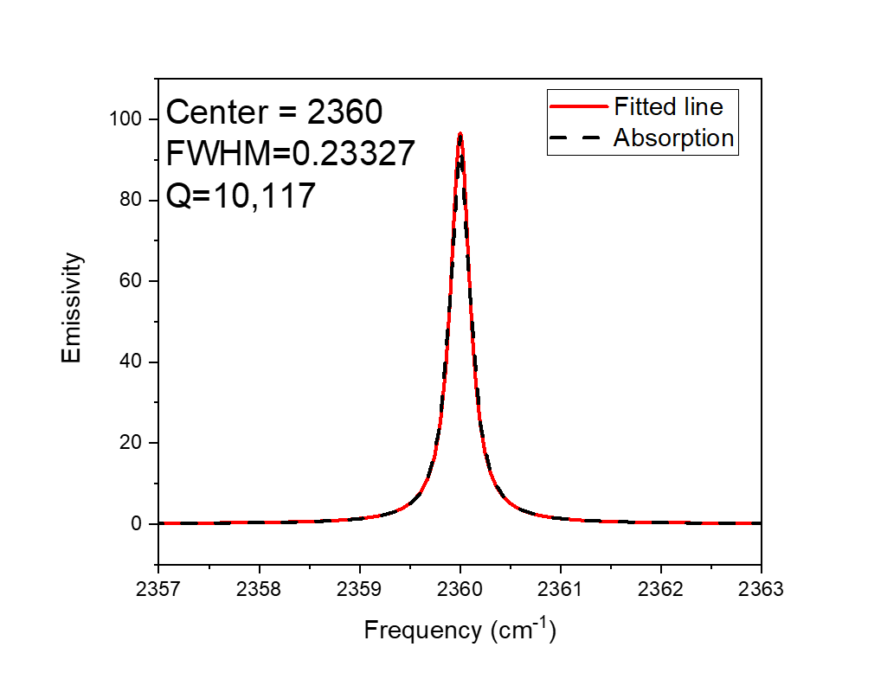
Fig. S11. Linewidth of the highest Q-factor spectra. Fitting was performed with OriginLab software with Lorentz fitting. Center and FWHM are given by the software.
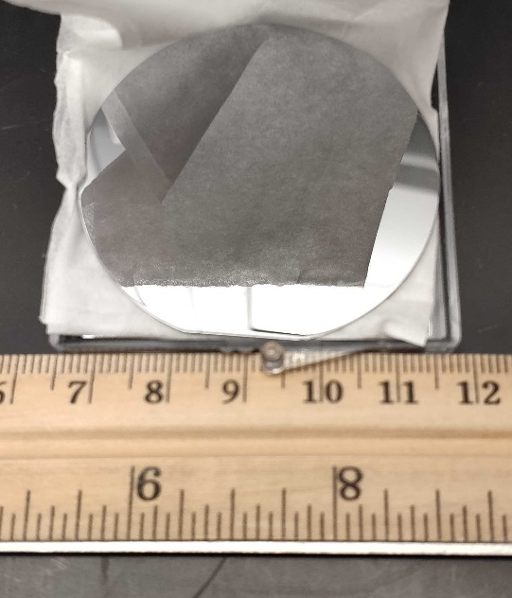
Fig. S12. A photo of our wafer-scale TPP-WS-EM. The substrate is a 2-inch sapphire wafer.

References

1 https://www.jawoollam.com/ellipsometry-software/wvase.
2 Kagaya, H. M. & Soma, T. Temperature dependence of the linear thermal expansion coefficient for Si and Ge. physica status solidi (b) 129, K5-K8 (1985).
3 Li, H. H. Refractive index of silicon and germanium and its wavelength and temperature derivatives. Journal of Physical and Chemical Reference Data 9, 561-658 (1980).
4 Robbins, H. & Monro, S. A stochastic approximation method. The annals of mathematical statistics, 400-407 (1951).
5 Bordes, A., Bottou, L. & Gallinari, P. SGD-QN: Careful quasi-Newton stochastic gradient descent. Journal of Machine Learning Research 10, 1737-1754 (2009).
6 Sohl-Dickstein, J., Poole, B. & Ganguli, S. 604-612 (PMLR).
7 Kingma, D. P. & Ba, J. Adam: A method for stochastic optimization. arXiv preprint arXiv:1412.6980 (2014).
8 https://my.vanderbilt.edu/caldwellgroup/.
9 Nolen, J. R. et al. Ultraviolet to far-infrared dielectric function of n-doped cadmium oxide thin films. Physical Review Materials 4, 025202 (2020).
10 Liu, C. P. et al. Effects of free carriers on the optical properties of doped CdO for full-spectrum photovoltaics. Physical Review Applied 6, 064018 (2016).
11 Burnett, J. H., Kaplan, S. G., Stover, E. & Phenis, A. 99740X (International Society for Optics and Photonics).
12 Gao, W. 72832L (International Society for Optics and Photonics).

