Supplementary Information

Raw data for CW_{bias}
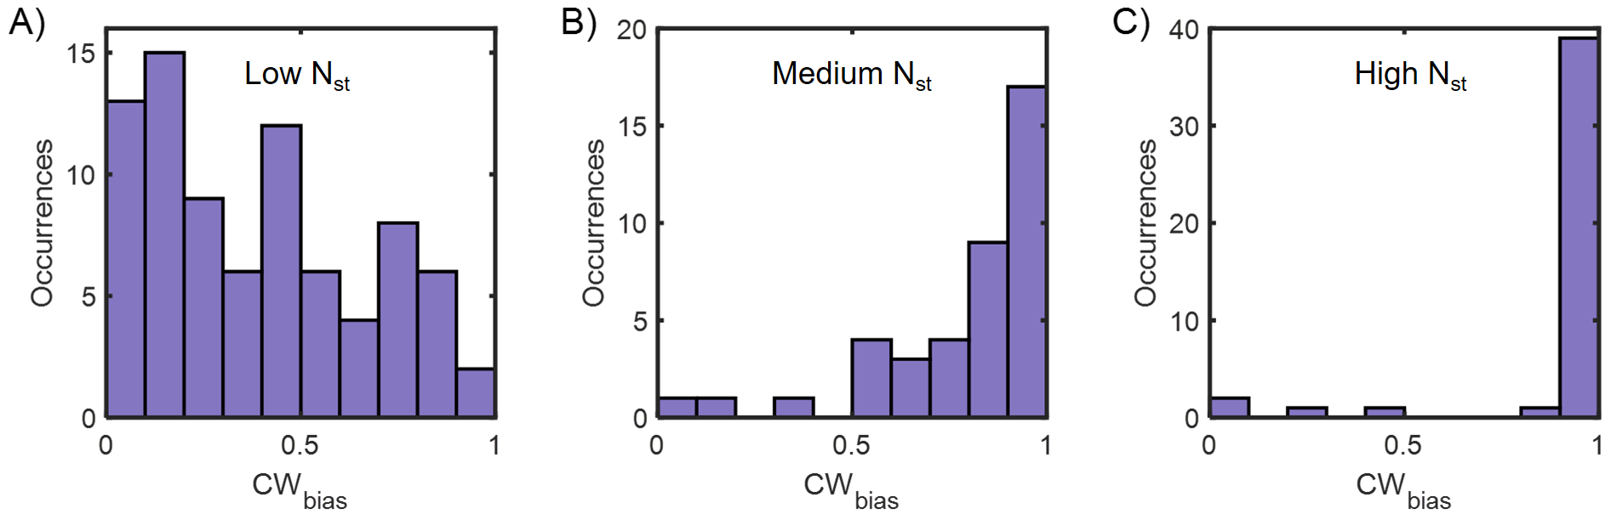
Figure S1. Raw data for Fig. 2B: CW_{bias} histograms for the populations with A) low, B) medium, and C) high N_{st}.

Predicting CW_{bias} versus [CheY-P] relationship from CW_{bias} distributions
The random variables $B$and $C$ represent the variability in CW_{bias} and [CheY-P] in a cell population, respectively. The random variable $C$ (CheY-P level) is assumed to be normally distributed with a mean $μ$ and standard deviation $σ$. The bias $B$ at each $C$ is calculated from the Hill function:
 | $$B=\frac{C^{h}}{C^{h}+K_{D}^{h}}$$ | Equation 1
where h and $K_{D}$represent the Hill coefficient and the dissociation constant, respectively. We derive the probability density for the bias from the following expression (Lele et al, Sci Adv, 2016):
$$P\left(B\right)=f\left(ϕ\right)\frac{dϕ}{dB}$$

where,
$$ϕ\left(B\right)=C=K_{D}{\left(\frac{B}{1-B}\right)}^{\frac{1}{h}}=K_{D}{\left(\frac{1}{B}-1\right)}^{-\frac{1}{h}}$$
and $f(ϕ)$ is the Gaussian function that describes the [CheY-P] distribution.
The expression for the CW_{bias} distribution is:
 | $$P\left(B\right)=\frac{K_{D}}{hB^{2}σ\sqrt{2π}}{\left(\frac{1}{B}-1\right)}^{-\frac{1}{h}-1}\exp\left(-\frac{1}{2}\frac{{\left(K_{D}{\left(\frac{1}{B}-1\right)}^{-\frac{1}{h}}-μ\right)}^{2}}{σ^{2}}\right)$$ | Equation 2
We assumed h = 10 and $K_{D}$=3.1 μM for motors with a full complement of stator units (high torque group) based on an earlier work (Cluzel et al, Science, 2000). This is a reasonable assumption as the measurements of Cluzel and co-workers were performed at high loads where the stator carries a full complement of stator units. We used a nonlinear least-square approach to fit equation 2 to the CW_{bias} distribution in the high torque group. This yielded $μ=5.3±0.5$ μM for the ΔcheRcheBcheZ cells. For the medium and low torque groups, we assumed that the $μ$ and $σ$ remained fixed while $K_{D}$ was a free parameter. The fitted values of $K_{D}$ for the different groups are shown below. The fits to the CW_{bias} distributions are indicated in the plots.
Table S1. Nonlinear least-square fitting to probability densities shown in Fig 2B. For the high N_{st} group, $μ$ was considered a free parameter whereas for the other groups, $K_{D}$ was a free parameter.
High N_{st} | Medium N_{st} | Low N_{st}
$K_{D}=3.1$ μM | $K_{D}=4.5 ± 0.0$ μM | $K_{D}=5.6 ± 0.0$ μM
The nature of $K_{D}$’s dependence on torque did not change when we assumed different values for $μ$ and $σ$ .

Estimation of CW_{bias} at varying viscous loads
The CW_{bias} was calculated from CCW-to-CW ($k_{CCW→CW}$) and CW-to-CCW ($k_{CW→CCW}$) switching rates from previous works^{38,39} :
$$CW_{bias}=\frac{k_{CCW→CW}}{k_{CCW→CW}+k_{CW→CCW}}$$

Strains and Plasmids
Plasmid | Plasmid No. | Resistance | Cloning Sites
pBAD34-motAmotB | pPL39 | Chloramphenicol | KpnI & SalI
pTrc99A-eyfp-cheY | pPL29 | Ampicillin | KpnI & XbaI

Strain name | Lab Strain # | Genotype | Plasmid
MotAB+, Fig 1B | PL240 | fliCst ΔcheRcheBcheYcheZ | pTrc99A-eYFP-cheY
ΔmotAB, Fig 1B | PL239 | fliCst ΔcheRcheBcheYcheZ, ΔmotAmotB | pTrc99A-eYFP-cheY
ΔmotAB/p(empty), Fig 1C | PL349 | fliCst ΔcheRcheBcheYcheZ, ΔmotAmotB | pTrc99A-eYFP-cheY, pBAD34
ΔmotAB/p(MotAB), Fig 1C | PL350 | fliCst ΔcheRcheBcheYcheZ, ΔmotAmotB | pTrc99A-eYFP-cheY, pBAD34-motAmotB
MotAB+, Fig 1D | PL233 | fliCst fliM-eYFP(A206K)-fliM ΔcheY
ΔmotAB, Fig 1D | PL333 | fliCst fliM-eYFP(A206K)-fliM ΔmotAmotB ΔcheY
ΔcheRcheBcheZ, Fig 2A, B | PL254 | fliCst ΔcheRcheBcheZ ΔmotAmotB | pBAD34-motAmotB
ΔcheRcheB, Fig 2E | PL138 | fliCst ΔcheRcheB

Optical Trapping and TIRF Setup
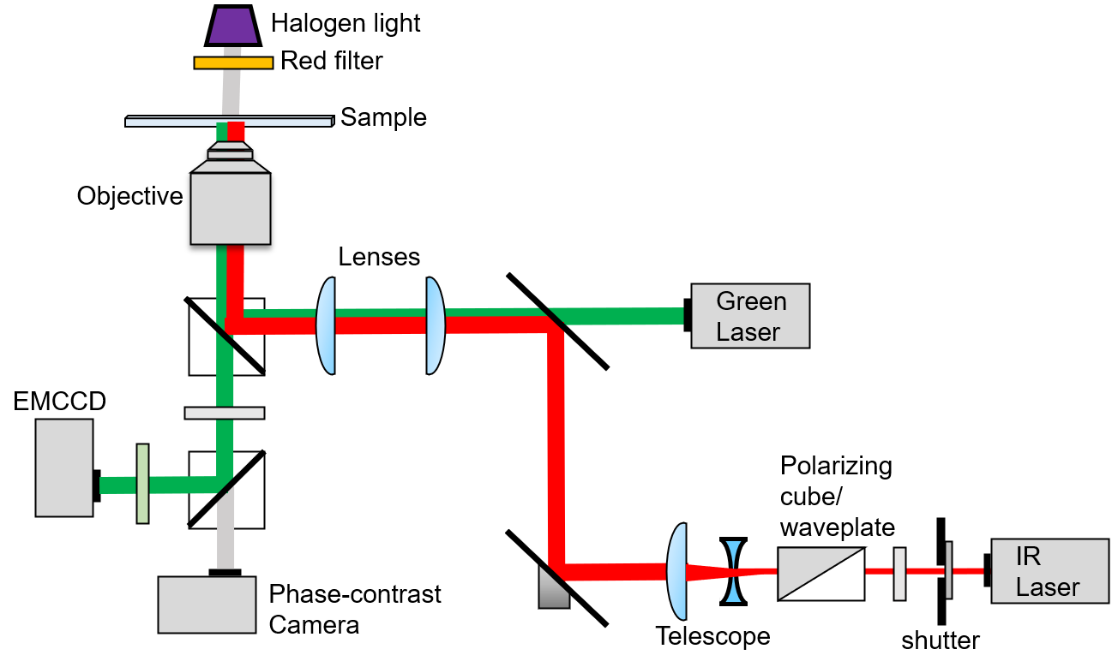
Figure S2. Setup for combined optical trapping (red laser) and TIRF illumination (green).

Point of tether in tethered cells
Figure S3. The red trajectory shows the movements of the center-of-mass of a tethered cell. The center-of-mass was obtained from each image by fitting an ellipse to the cell. The tether point (motor location) coincides with the center of a circular fit to the trajectory.

