URBAN DEVELOPMENT GROWTH STRATEGIES AND SOCIETAL WELL-BEING

SUPPLEMENTARY MATERIAL

From coding text to Causal Mapping
The written text of each urban development plan was coded by identifying the variables from the raw data following the method described by Kim and Andersen¹. Quotes from the text were highlighted using computer-aided qualitative data analysis software (CAQDAS) to track the raw data throughout the procedure and to maintain consistency between the causal maps and the raw text data^{2,3}. The raw data grounding each variable and causal relationship was recorded using CAQDAS. After coding the first urban report, we used the variables identified from that report as the starting point for coding subsequent reports.
Whenever possible, we maintained the variable names as they appeared in the urban reports. However, in some instances, we revised variable names using more operational terminology⁴ to improve the clarity and logic of the causal maps. For instance, the following quotations appear in the 2018 plan:
Greater Sydney is already an outstanding global city with a reputation for livability and cultural diversity that attracts international investment and appeals to visitors.⁵

The population of Greater Sydney is 4.7 million and is projected to grow by 1.7 million people by 2036. This growth is driven by the natural increase of the existing population, and domestic and international migration.⁵

From these quotes, we identify the variables Greater Sydney Population; Natural Increase and Migration. Greater Sydney Population covers all variables related to population, such as migration and natural increase. The main argument from the above quotations is that Greater Sydney's population is projected to continue increasing by attracting migration and also from natural births of the existing population. From this causal argument, it can be inferred that Greater Sydney's attractiveness drives population growth in the coming years. Policymakers assumed that net birth and net migration would be positive because enough current residents and also potential migrants prefer to live in Greater Sydney rather than other cities. Therefore, we identify one additional variable from these quotes: Attractiveness of the City to Residents. The Attractiveness of the City to Residents refers to the urban conditions that people analyze before deciding whether to move to Greater Sydney (immigrate), grow their family (natural change), or leave Greater Sydney (emigration). Focusing on these variables defines the boundary of the causal map.
Once we identified the variables, we next identified the causal relationships among the variables. We use keywords in the raw text data, such as boost, improve, decrease, rise, and increase, to identify and define causal relationships between two variables. In the absence of keywords, the context of the discussion is crucial to identify relationships between variables⁶. For instance, from the first quotation above, although it is not mentioned explicitly, we could infer that migration increases because of Greater Sydney’s attractiveness. The top right of the diagram in Figure 6 shows this causal relationship: the Attractiveness of the City to Residents increases the Greater Sydney Population.
We build the causal map using the variables and causal relationships identified from coding the text. The raw data grounding each causal relationship identified between two variables is recorded using a CAQDAS^{2,3}. Importantly, each relationship comes from separate fragments of text within each urban report rather than the analysis of a continuous paragraph. The resulting causal maps reveal cause-effect chains contained within the text, including a number of reinforcing and balancing feedback loops. The feedback loops result from combining causal relationships coded from different text fragments found throughout the reports. For instance, the causal relationship between two variables may come from pages 6 and 47 in the 2018 plan, while other causal relationships that close the loop come from pages 80 and 85.
The following quotations from the 2018 urban development report (Greater Sydney Commission, 2018) and Figure 1 illustrate the construction of a causal map and exemplify how a feedback loop emerges from different text fragments.
A 30-minute city is where most people can travel to their nearest metropolitan centre or cluster by public transport within 30 minutes; and where everyone can travel to their nearest strategic centre by public transport seven days a week to access jobs, shops and services. This […] will make Greater Sydney a more attractive place for […] skilled workers.⁵

As the population grows, the challenges of [transport]congestion and unreliability of journeys will spread to larger areas of the [transport] network and will increase in locations that already experience these constraints.⁵

As Sydney transitions to a metropolis of three cities, convenient and reliable access for customers by public transport to their nearest centre is increasingly important for […] reducing the time people spend travelling, increasing people’s access to jobs and business’ access to workers.⁵

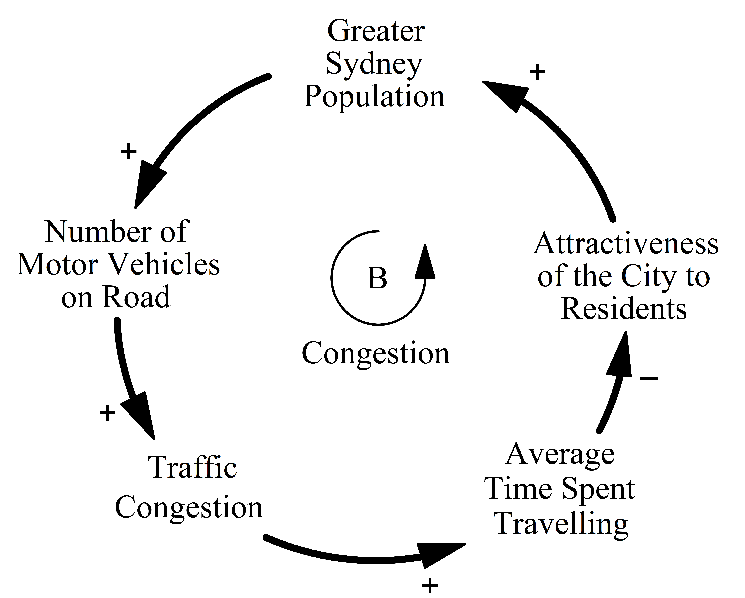
Figure 1. Causal map
Arrows indicate the direction of causality. Signs at arrowheads ('+' or '-') indicate the polarity of the relationship. A '+' sign denotes that an increase in the independent variable (Greater Sydney Population) causes the dependent variable (Number of Motor Vehicles on Road) to rise above what it would have been, ceteris paribus (and a decrease causes a decrease). A '-' denotes that an increase in the independent variable causes the dependent variable to decrease beyond what it would have been. Formally, a “+” is X→ + Y ⇔ ∂Y/∂X > 0 and “-” is X→ - Y⇔ ∂Y/∂X < 0. The “B” loop label indicates this is a balancing (or negative) feedback loop⁴.

From these quotes, the following variables are identified: Number of Motor Vehicles on Road, Traffic Congestion, Average Time Spent Travelling, Greater Sydney Population, and Attractiveness of the City to Residents. The main point from the first quotation is that policymakers highlight that a 30-minute city reduces the average travel time needed to reach an activity, increasing the attractiveness of the city. In the second quotation, population growth increases traffic congestion with implications on time travelling on roads throughout Greater Sydney. Although the Number of Motor Vehicles on Road variable is implicit in the quotations, this variable can be inferred. Population growth affects traffic congestion because more people living in the city leads to a greater number of cars on the road to travel within the city. Also, the causal relationship between Traffic Congestion and the Average time spent travelling is implicit but inferred as time spent travelling is the immediate effect of congestion. The third quotation shows a negative relationship between time spent travelling and access to jobs. From the first quotation, the greater the access to jobs, the greater the Attractiveness of the City to Residents. Omitting intermediate variables (access to jobs and workers), we infer that the Average time spent travelling causes a negative Attractiveness of the City to Residents variable.
Combining the above causal relationships results in a balancing (or negative) feedback loop. A balancing loop produces goal-seeking, self-correcting dynamic behavior in the system. An increase in the Greater Sydney population increases the number of motor vehicles on the road and the traffic congestion in the city. Greater traffic congestion increases the average time spent travelling. If the time spent travelling to access jobs, shops and services increases, the attractiveness of the city decreases, reducing the growth of the Greater Sydney population in the future and closing the Congestion balancing loop (B).

BIBLIOGRAPHY
1 Kim, H. & Andersen, D. F. Building confidence in causal maps generated from purposive text data: mapping transcripts of the Federal Reserve. System Dynamics Review 28, 311-328, doi:10.1002/sdr.1480 (2012).
2 Yearworth, M. & White, L. The uses of qualitative data in multimethodology: Developing causal loop diagrams during the coding process. European Journal of Operational Research 231, 151-161, doi:10.1016/j.ejor.2013.05.002 (2013).
3 Eker, S. & Zimmermann, N. Using Textual Data in System Dynamics Model Conceptualization. Systems 4, 28, doi:10.3390/systems4030028 (2016).
4 Sterman, J. D. Business Dynamics: Systems Thinking and Modeling for a Complex World. 1008 (McGraw-Hill Education, 2000).
5 Greater Sydney Commission. Greater Sydney Regional Plan. A Metropolis of Three Cities - Connecting people. (Greater Sydney Commission, 2018).
6 Strauss, A. & Corbin, J. Basics of qualitative research techniques. (Citeseer, 1998).

