Supplementary Material

Figure 1s - PCR product resolved by electrophoresis on a standard 4.5% agarose gel. Column 1: Molecular size marker (Ladder 100bp – Ludwig Biotec). Column 2: Positive control PgD1 gene. Column 3: PCR amplification of colony 1. Column 4: PCR amplification of colony 2. Column 5: PCR amplification of colony 3. Column 6: PCR amplification of colony 4. Column 7: PCR amplification of colony 5. Column 8: PCR amplification of colony 6. Column 9: PCR amplification of colony 7. Column 10: PCR amplification of colony 8. Column 11: Negative control.
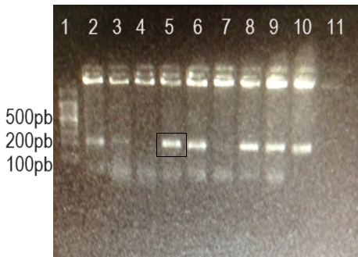

Figure 2s - PCR product resolved by electrophoresis on a standard 4.5% agarose gel using pGEM::Def3 plasmid DNA as template. In Column 1: Molecular size marker (Ladder 100bp – Ludwig Biotec). Column 2: PCR amplification of colony 3 of the pGEM::Def recombinant gene. Column 3: control (-)
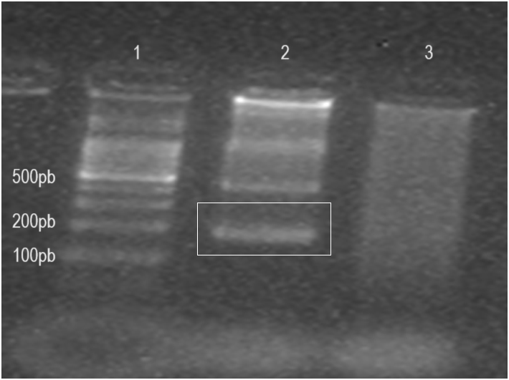
Figure 3s - PCR product resolved by standard agarose gel electrophoresis 4.5% of pET30a(+)::Def recombinant clones. Column1: Molecular size marker (Ladder 100bp – Ludwig Biotec). Column 2: PCR amplification of colony 1 of the recombinant gene pET30a(+)::Def. Column 3: PCR amplification of colony 2 of the pET30a(+)::Def recombinant gene. Column 4: PCR amplification of colony 3 of the pET30a(+)::Def recombinant gene. Column 5: Control (+) PgD1 gene. Column 6: control (-).
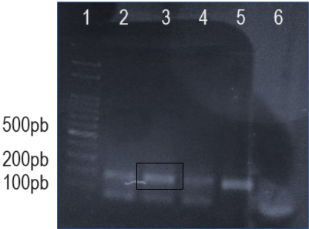
Figure 4s – Western Blot result demonstrating the presence of the Defensin PgD1 protein with a histidine tail measuring approximately 14kDa. In Column 1: Thermo-scientific marker; Column 2: pET30a(+) without insert; Column 3: Expression supernatant. Columns 4: first elution step Continuous flow; Column 5: elution with 40mM imidazole wash buffer; Lane 6: elution with 80mM imidazole wash buffer; Lane 7: pET30a(+)Def2 after elution with 300 mM imidazole.
