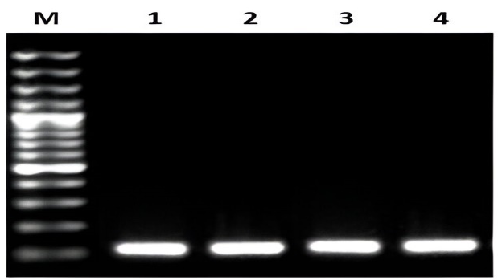
Figure S1: Ethidium bromide stained 1.5 % agarose gel representing the PCR amplified 16S rDNA gene of approximately 138 bp. Complete map of ladder shown at right side of image (M: marker, lane and T1-T4 tested isolates).

Figure S2: Ethidium bromide stained 1.5 % agarose gel representing the PCR amplified vacA gene of approximately 190 bp. Complete map of ladder shown at right side of image.

