Removal, mechanistic and kinetic studies of Cr(VI), Cd(II) and Pb(II) cations using Fe₃O₄ functionalized Schiff base chelating ligands
George S. Nyamato¹*, Ian T. Kabogo¹, Siphosethu Maqinana², Rene Bachmann³, Markus Schmitz³, Joanne Ogunah¹, Wolfgang Kleist³, Stephen O. Ojwach²,
¹Department of Physical Sciences, University of Embu, P.O Box 6-60100, Embu, Kenya
²School of Chemistry and Physics, University of KwaZulu-Natal, Pietermaritzburg Campus, Private Bag X01, Scottsville, 3209, South Africa
³Fachbereich Chemie, RPTU Kaiserslautern-Landau, Erwin-Schrödinger-Str. 54, 67663, Kaiserslautern, Germany

SUPPLEMENTARY MATERIALS
TABLE OF CONTENTS
1. Synthesis and characterization of chelating Schiff base ligands and their immobilization onto Fe₃O₄ MNPs 1
1.1 Preparation of Fe₃O₄ MNPs 1
1.2 Synthesis of functionalized Schiff base ligands 2
1.2.1 (E)-2-(3,3-dimethoxy-2-oxa-7,10-diaza-3-silaundec-10-en-11-yl)phenol (L1) 2
1.2.2 (E)-N-(2-((pyridine-2ylmethylene)amino)ethyl)-3-(Trimethoxysilyl)propan-1-amine (L2) 2
1.2.3 (E)-N-(2-((thiophen-2-ylmethylene)amino)ethyl)-3-(Trimethoxysilyl)propan-1-amine (L3) 3
2. Statistical parameters and removal efficiencies for the respective metal cations 9

1. Synthesis and characterization of chelating Schiff base ligands and their immobilization onto Fe₃O₄ MNPs

1.1 Preparation of Fe₃O₄ MNPs
The MNPs were prepared using co-precipitation method. About 1.50 g of ferrous chloride (Fe²⁺) was dissolved in 100 mL deionized water at a temperature of 85℃ under nitrogen atmosphere. After dissolving, 3.00 g of ferric chloride (Fe³⁺) was added to the mixture and a red-brown color was observed. Overall, the molar ratio attained of Fe³⁺ to Fe²⁺ was 2:1. After one hour, about 15 mL of 25% ammonium hydroxide (NH₄OH) was rapidly added into the mixture and stirred vigorously, immediately forming a black precipitate which indicated the nucleation of Fe₃O₄. The mixture was then left to stir for about 1 h after which it was filtered, and the residue washed three times with deionized water and ethanol. The residue was then dried under vacuum for 8 h at 65℃.

1.2 Synthesis of functionalized Schiff base ligands

1.2.1 (E)-2-(3,3-dimethoxy-2-oxa-7,10-diaza-3-silaundec-10-en-11-yl)phenol (L1)
To a methanol solution of salicylaldehyde (0.50 mL, 4.70 mmol), AEAPTMS (1 mL, 4.60 mmol) was added dropwise. The reaction mixture was refluxed for 24 h at 65℃ after which methanol was removed by evaporation in vacuum to yield L1 as a yellow oily liquid. Yield: 1.46 g (97%). ¹H NMR (400 MHz, CDCl₃): δ_{H} 0.60 (s, 2H, Si-CH₂); 1.56 (s, 3H, CH₂, C-NH), 2.61 (s, 4H, (CH₂)₂), 2.89 (s, 2H, CH₂), 3.55-3.42 (m, 9H, ³J_{HH}=6.32 Hz, O-CH₃), 6.84 (s, 1H, Ph), 6.92 (d, 1H, ³J_{HH}=3.16 Hz, Ph), 7.21 (d, 1H, ³J_{HH}=2.68Hz, Ph), 7.28 (d, 1H, ³J_{HH}=3.44Hz, Ph), 8.35 (s, 1H, C=NH). ¹³C NMR (100 MHz, CDCl₃,): δ 10.16, 23.29, 50.26, 52.43, 59.58, 116.95, 118.60, 131.29, 132.24, 161.11, 165.99. FT-IR (cm⁻¹): υ_{(N-H)}=3392, υ_{(O-H)}=3290, υ_{(C=N)}=1625, υ_{(Si-O)}=744.
Compounds L2 and L3 were prepared following the same procedure as described for compound L1, using the appropriate reagents.

1.2.2 (E)-N-(2-((pyridine-2ylmethylene)amino)ethyl)-3-(Trimethoxysilyl)propan-1-amine (L2)
Compound 2-pyridine-carboxaldehyde (0.50 mL, 5.30 mmol) was reacted with AEAPTMS (1 mL, 4.60 mmol) and isolated as a dark orange oily liquid. Yield 1.43 g (95%). ¹H NMR (400 MHz, CDCl₃): δ_{H} 0.36 (m, 2H, ³J_{HH}=4.12 Hz, CH₂), 1.29 (s, 3H, CH₂, NH), 2.08 (t, 2H, ³J_{HH}=3.46Hz), 2.29 (q, 2H, ³J_{HH}=5.72 Hz, CH₂), 2.94 (t, 2H, ³J_{HH}=2.68Hz, CH₂), 3.16 (s, 9H, O-CH₃), 7.06 (s, 1H, Py), 7.26 (s, 1H, Py), 7.51 (t, 2H, ³J_{HH}=7.43 Hz, Py), 8.39 (s, 1H, NH). ¹³C NMR (100 MHz, CDCl₃,): δ 10.02, 22.04, 49.58, 52.56, 55.66, 122.72, 123.29, 136.63, 149.32, 153.92, 159.01. FT-IR (cm⁻¹): υ_{(N-H)}=3300, υ_{(C=N)}= 1650, υ_{(Si-O)}=764.

1.2.3 (E)-N-(2-((thiophen-2-ylmethylene)amino)ethyl)-3-(Trimethoxysilyl)propan-1-amine (L3)
Compound 2-thiophene-carboxaldehyde (0.50 mL, 5.30 mmol) was reacted with AEAPTMS (1 mL, 4.60 mmol) and a dark brown oily liquid was obtained. Yield 0.99 g (66%). ¹H NMR (400 MHz, CDCl₃): δ_{H} 0.58 (s, 2H, CH₂), 1.55 (s, 3H, CH₂, NH), 2.61 (s, 2H, CH₂), 2.88 (s, 2H, CH₂), 3.24 (s, 2H, CH₂), 3.42 (m, 9H, ³J_{HH}=3.24 Hz, O-CH₃), 6.93 (s, 1H, Th), 7.04 (s, 1H, Th), 7.36 (s, 1H, Th), 8.38 (s, 1H, NH). ¹³C NMR (100 MHz, CDCl₃,): δ 9.51, 23.01, 50.30, 52.37, 55.69, 127.39, 128.95, 130.64, 142.19, 155.55. FT-IR (cm⁻¹): υ_{(N-H)}=3312, υ_{(C=N)}= 1631, υ_{(O-Si)}=744.

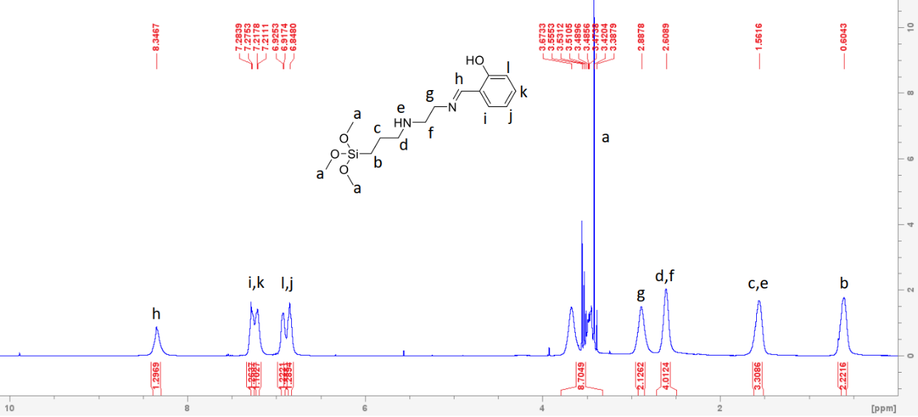
Fig. S1: ¹H-NMR for L1 showing the imine proton at 8.34 ppm

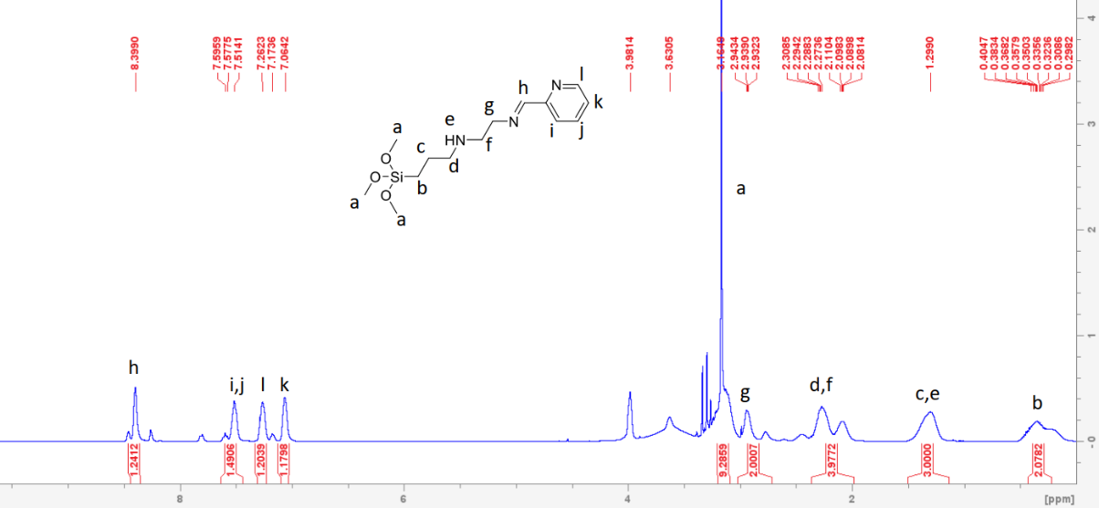
Fig. S2: ¹H-NMR for L2 showing the imine proton at 8.39 ppm

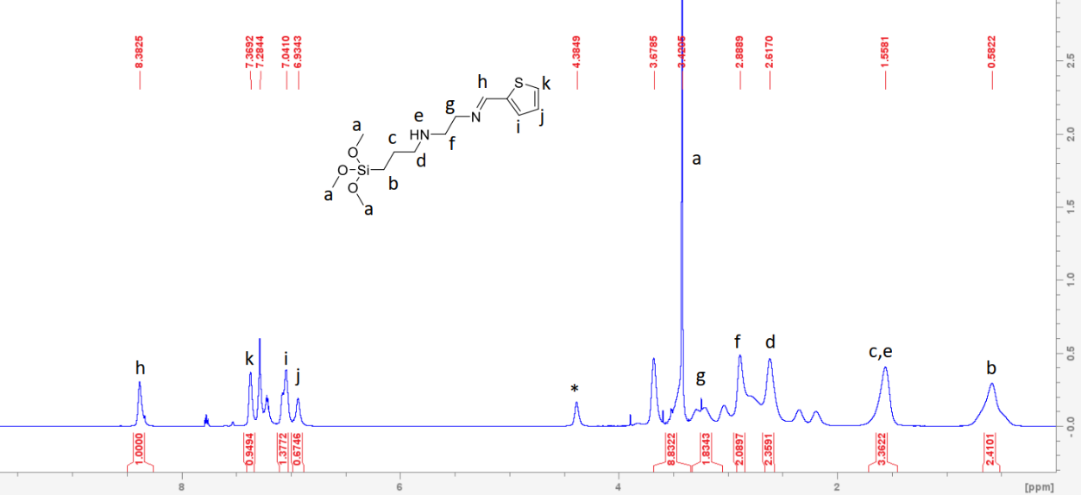
Fig. S3: ¹H-NMR for L3 showing the imine proton 8.38 ppm

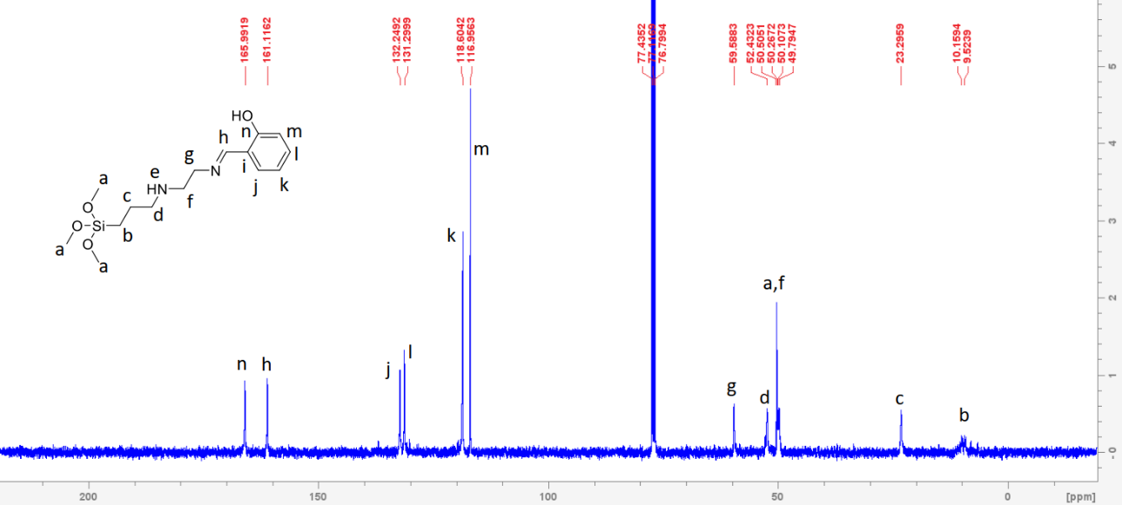
Fig. S4: ¹³C-NMR for L1 showing the C=N carbon at 161 ppm

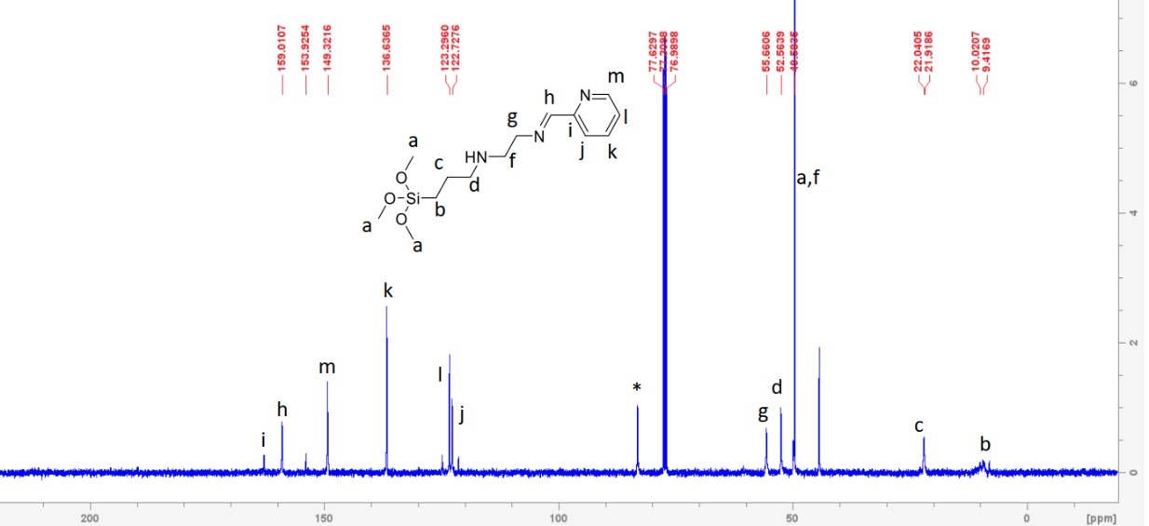
Fig. S5: ¹³C-NMR for L2 showing the C=N carbon at 153 ppm

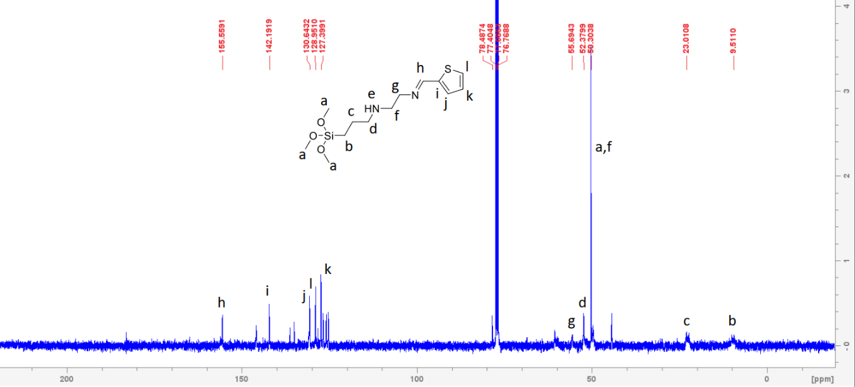
Fig. S6: ¹³C-NMR for L3 showing the C=N carbon at 155 ppm

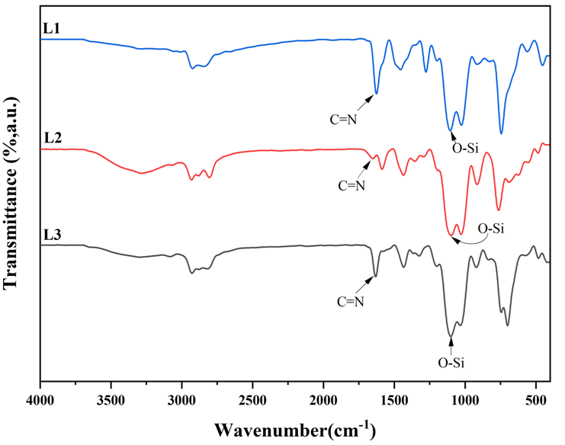
Fig. S7: FT-IR spectra of the Schiff base chelating ligands, L1-L3, showing vibrational frequencies for O-Si signals between 1087-1104 cm⁻¹ after which there was the appearance of Fe-O signals between 540-560 cm⁻¹ upon immobilization of the ligands on MNPs
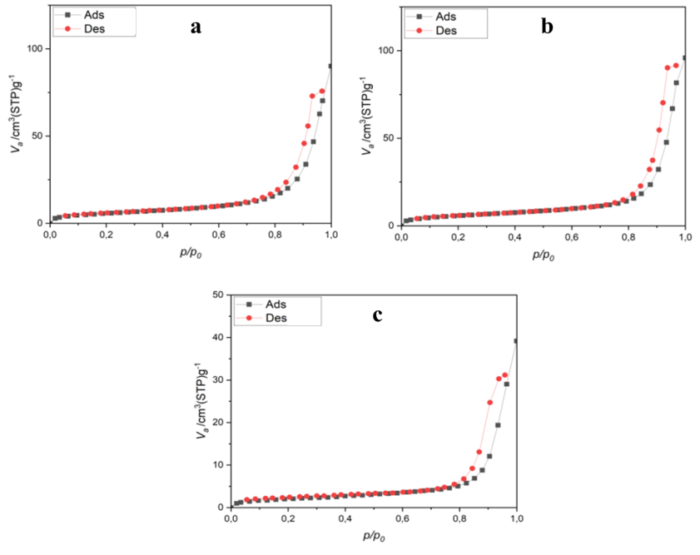
Fig. S8: N₂ adsorption-desorption isotherms for L1@Fe₃O₄-L3@Fe₃O₄, a-c respectively

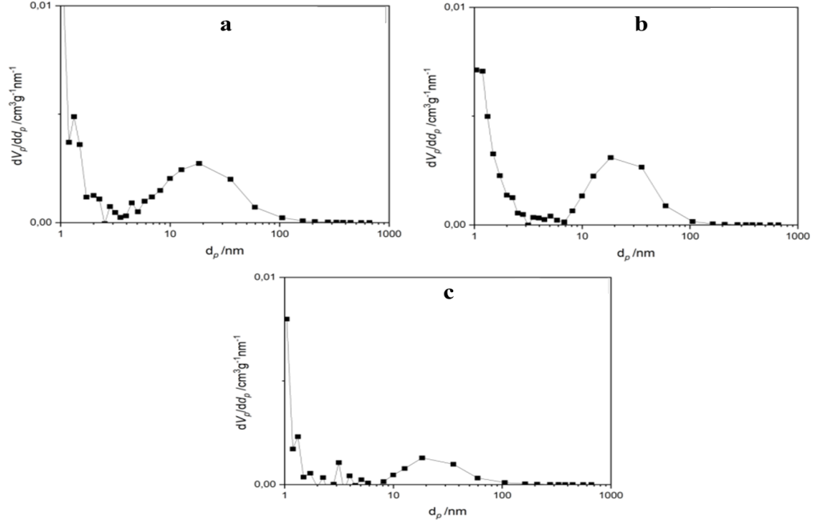
Fig. S9: Pore-size distribution (according to BJH) for L1@Fe₃O₄-L3@Fe₃O₄, a-c respectively
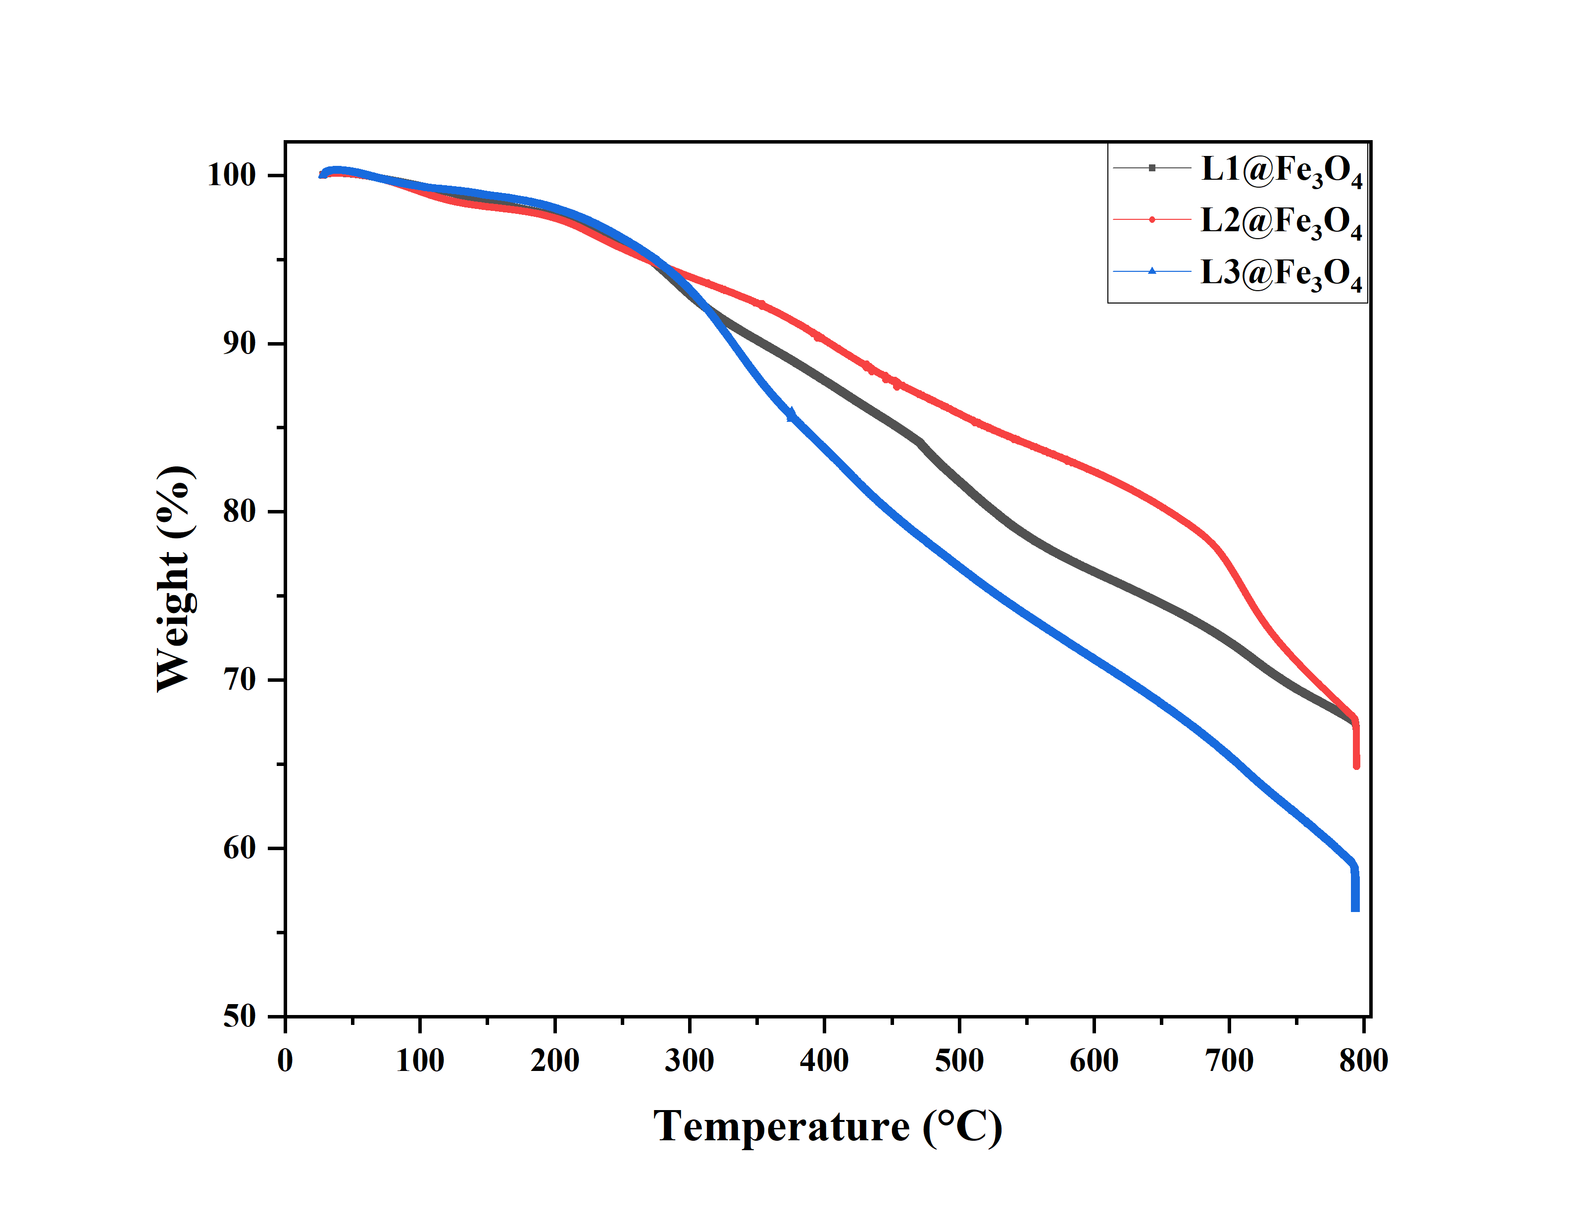
Fig. S10: TGA plots showing the decomposition patterns for L1@Fe₃O₄-L3@Fe₃O₄
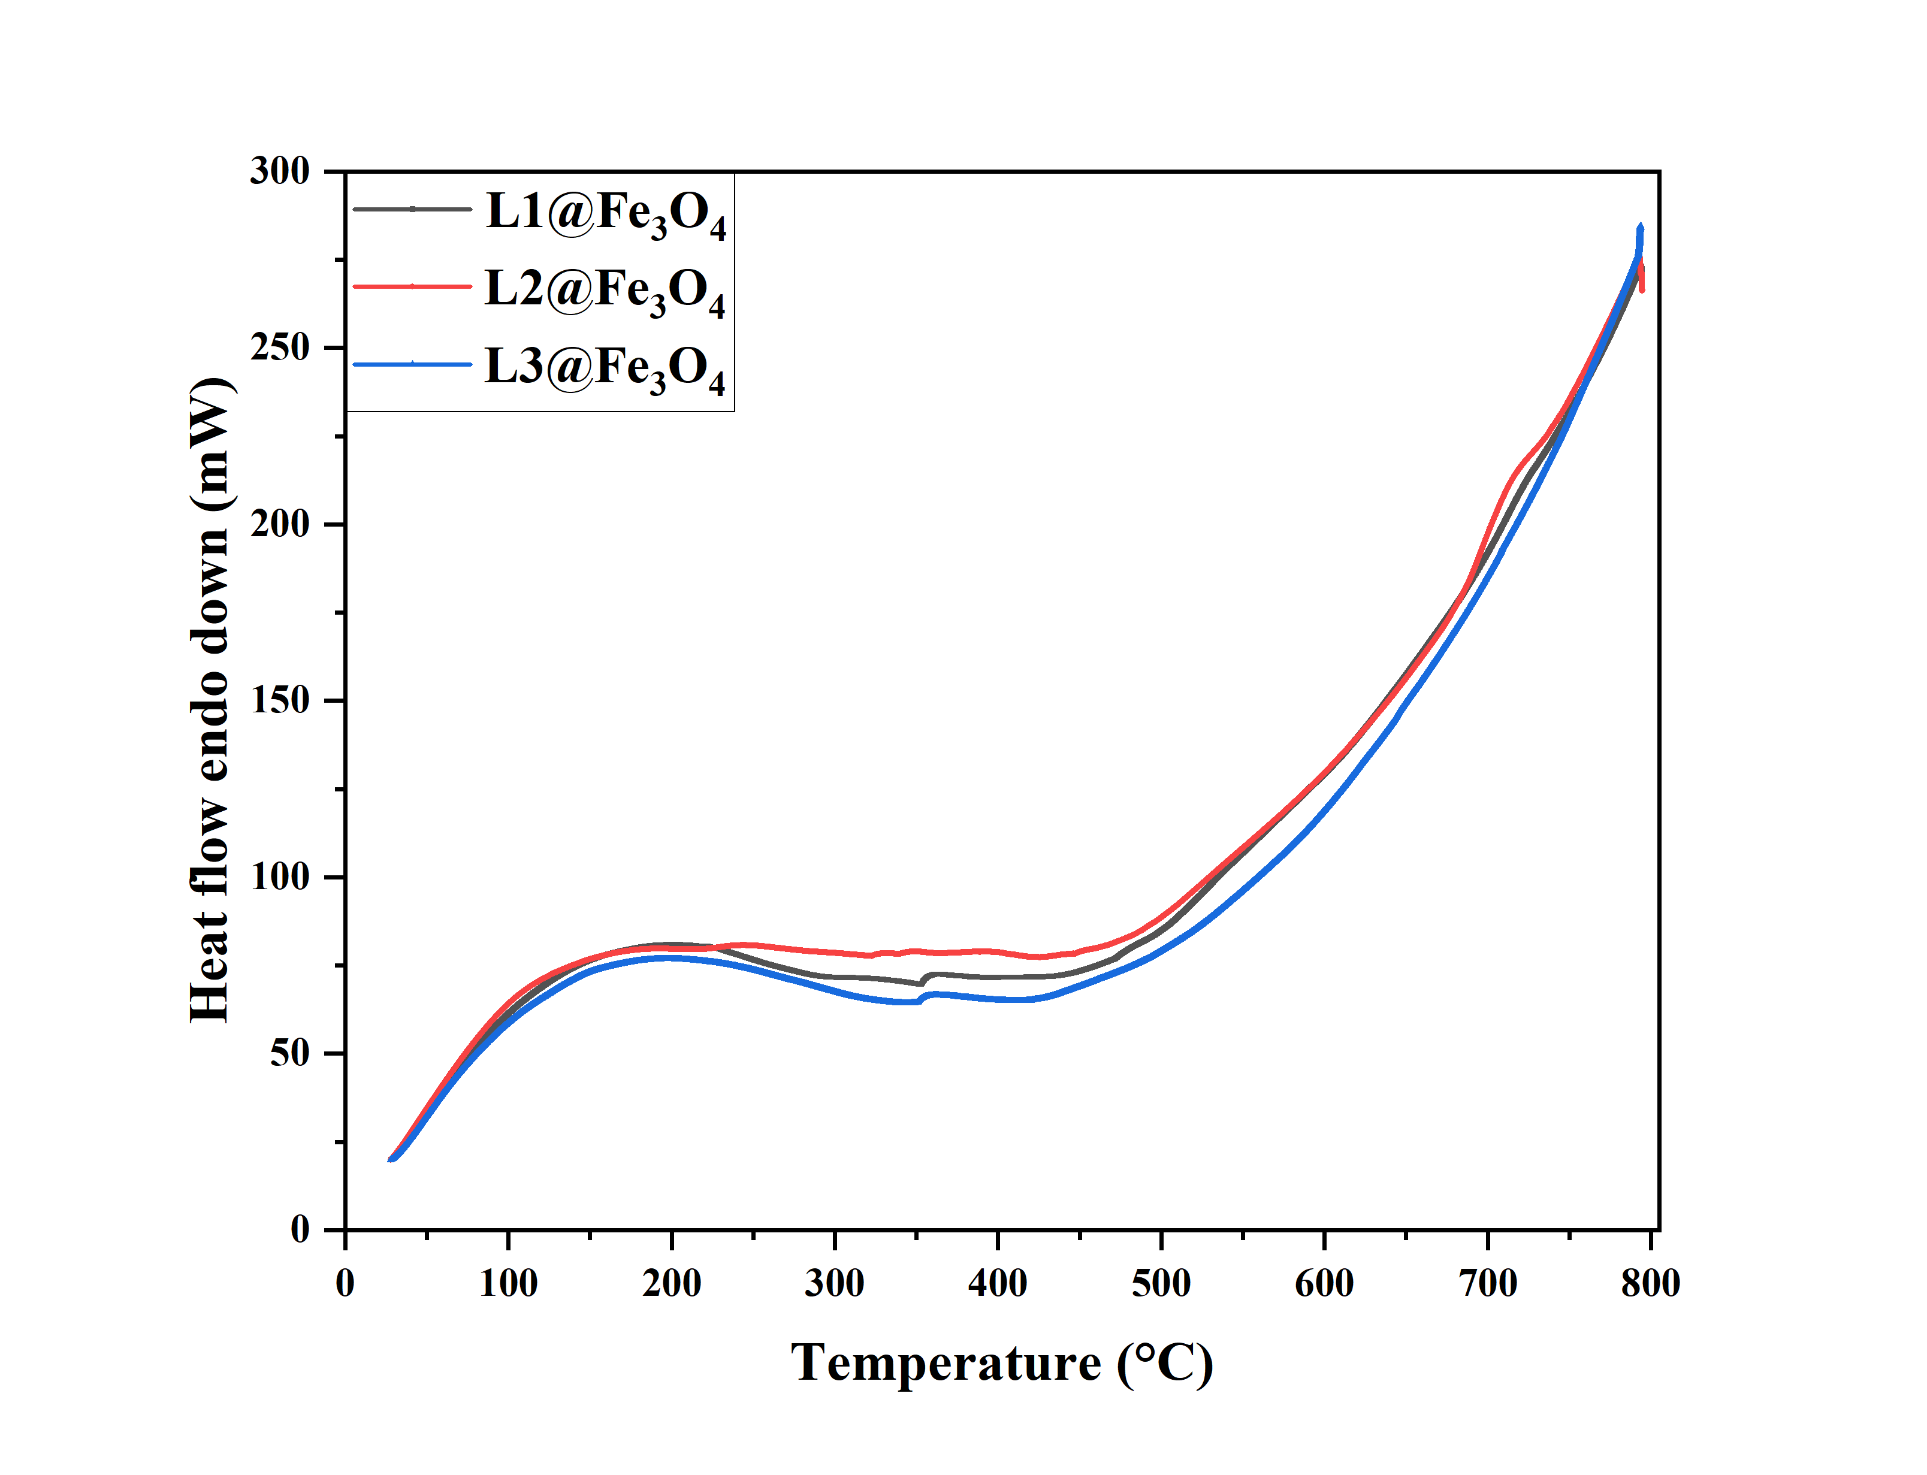
Fig. S11: DSC plots showing the decomposition patterns for L1@Fe₃O₄-L3@Fe₃O₄
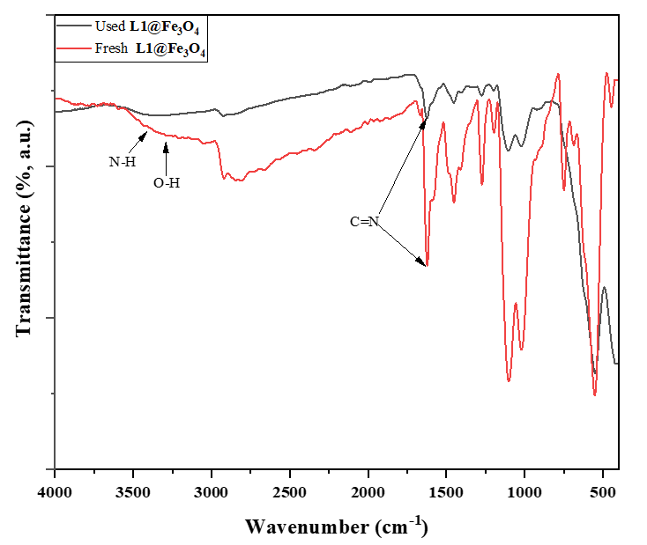
Fig. S12: Stacked FTIR spectra of fresh and used L1@Fe₃O₄ adsorbent showing the υ_{(C=N)} at 1666 and 1624 cm⁻¹, respectively, and disappearance of O-H and N-H peaks at 3290 and 3394 cm⁻¹, respectively, in the used adsorbent due to deprotonation upon complexation
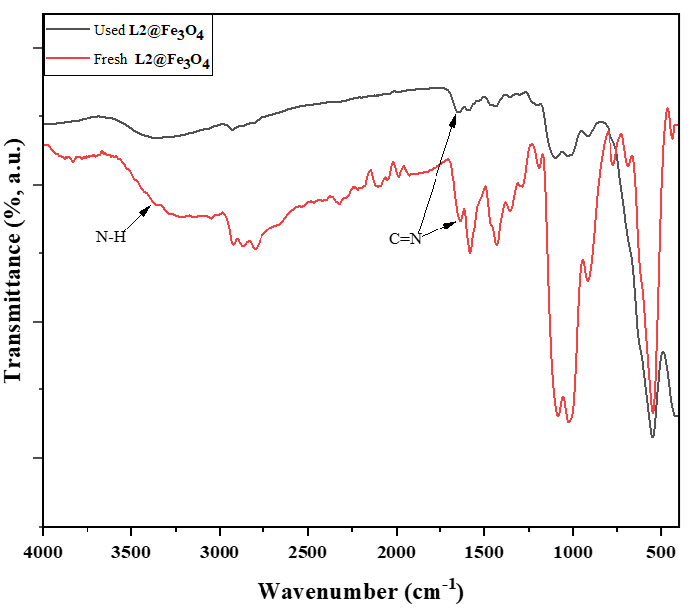
Fig. S13: Stacked FT-IR spectra of fresh and used L2@Fe₃O₄ adsorbent showing the υ_{(C=N)} at 1634 and 1643 cm⁻¹, respectively, and disappearance of N-H peak at 3384 cm⁻¹ in the used adsorbent due to deprotonation upon complexation
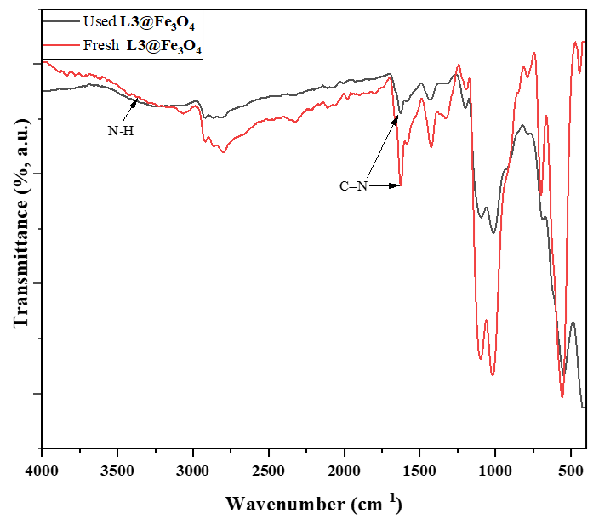
Fig. S14: Stacked FTIR spectra of the fresh and used L3@Fe₃O₄ adsorbent showing υ_{(C=N)} at 1625 and 1632 cm⁻¹, respectively, and disappearance of N-H peak at 3382 cm⁻¹ in the used adsorbent due to deprotonation upon complexation

2. Statistical parameters and removal efficiencies for the respective metal cations
Table S1: Adsorption parameters for the removal of Cr(VI) cations on L1@Fe₃O₄
Entry | C_{o}  (mg/L) | C_{e}  (mg/L) | q_{e} | 1/C_{e} | 1/q_{e} | Log C_{e} | Log q_{e} | ln C_{e}
1 | 20 | 6.4 | 20.4 | 0.156 | 0.049 | 1.856 | 1.31 | 1.856
2 | 30 | 13 | 25.5 | 0.077 | 0.039 | 2.565 | 1.407 | 2.565
3 | 40 | 21.25 | 28.13 | 0.047 | 0.036 | 3.056 | 1.449 | 3.056
4 | 50 | 31.1 | 28.35 | 0.032 | 0.035 | 3.437 | 1.452 | 3.437
5 | 60 | 39.79 | 30.32 | 0.025 | 0.033 | 3.684 | 1.482 | 3.684

Table S2: Adsorption parameters for the removal of Cd(II) cations on L1@Fe₃O₄
Entry | C_{o}  (mg/L) | C_{e}  (mg/L) | q_{e} | 1/C_{e} | 1/q_{e} | Log C_{e} | Log q_{e} | ln C_{e}
1 | 20 | 10.76 | 13.86 | 0.093 | 0.072 | 1.032 | 1.142 | 2.376
2 | 30 | 17.36 | 18.96 | 0.058 | 0.053 | 1.24 | 1.278 | 2.854
3 | 40 | 24.34 | 23.49 | 0.041 | 0.043 | 1.386 | 1.371 | 3.192
4 | 50 | 33.15 | 25.28 | 0.0302 | 0.04 | 1.52 | 1.403 | 3.501
5 | 60 | 42.35 | 26.48 | 0.024 | 0.038 | 1.627 | 1.423 | 3.746
Table S3: Adsorption parameters for the removal of Pb(II) cations on L1@Fe₃O₄
Entry | C_{o}  (mg/L) | C_{e}  (mg/L) | q_{e} | 1/C_{e} | 1/q_{e} | Log C_{e} | Log q_{e} | ln C_{e}
1 | 100 | 1.53 | 147.705 | 0.654 | 0.007 | 0.185 | 2.17 | 0.425
2 | 200 | 7.49 | 288.765 | 0.134 | 0.003 | 0.874 | 2.461 | 2.014
3 | 300 | 27.5 | 408.825 | 0.036 | 0.002 | 1.439 | 2.612 | 3.312
4 | 400 | 108.9 | 436.665 | 0.009 | 0.002 | 2.037 | 2.64 | 4.690
5 | 500 | 175.9 | 486.06 | 0.006 | 0.002 | 2.245 | 2.687 | 5.170

Table S4: % Removal efficiencies by variation of pH
Entry | pH | Metal cation / % Extraction efficiency
Entry | pH | Cr(VI) | Pb(II) | Cd(II)
1 | 1 | 38 | 19 | 25
2 | 3 | 68 | 47 | 46
3 | 5 | 55 | 83 | 45
4 | 7 | 45 | 98 | 41
5 | 9 | 42 | 99 | 36
Reaction conditions: contact time 24 hrs, adsorbent dose 10 mg, initial metal concentration 20 ppm (Cr(VI), Cd(II)), 100 ppm (Pb(II)) using L1@Fe₃O₄.
Table S5: % Removal efficiencies by variation of initial metal concentration
Entry | Initial metal concentration (ppm) | Metal cation / % Removal efficiency
Entry | Initial metal concentration (ppm) | Cr(VI) | Cd(II) | Pb(II)
1 | 20 | 68 | 46 | NR
2 | 30 | 57 | 42 | NR
3 | 40 | 47 | 39 | NR
4 | 50 | 38 | 34 | NR
5 | 60 | 34 | 29 | NR
6 | 100 | NR |  | 98
7 | 200 |  |  | 96
8 | 300 |  |  | 91
9 | 400 |  |  | 79
10 | 500 |  |  | 65
Reaction conditions: contact time 24 hrs, adsorbent dose 10 mg, pH 3 (Cr(VI), Cd(II)) , pH 9 ( Pb(II)) using L1@Fe₃O₄. NR- Not reported.

Table S6: % Removal efficiencies by contact time variation
Entry | Contact time (hrs) | Metal cation / % Removal efficiency
Entry | Contact time (hrs) | Cr(VI) | Pb(II) | Cd(II)
1 | 1 | 27 | 86 | 16
2 | 6 | 53 | 92 | 36
3 | 12 | 64 | 96 | 42
4 | 18 | 68 | 98 | 46
5 | 24 | 68 | 98 | 46
Reaction conditions: initial metal concentration 20 ppm (Cr(VI), Cd(II)), 100 ppm (Pb(II)), adsorbent dose 10 mg, pH 3 (Cr(VI), Cd(II)) , pH 9 ( Pb(II)) using L1@Fe₃O₄.
Table S7: Kinetic models and other statistical parameters of adsorption using L1@Fe₃O₄
 | Kinetic model | Parameters | Metal ions solution
Entry | Kinetic model | Parameters | Cr(VI)  (20ppm) | Cd(II)  (20ppm) | Pb(II)  (100ppm)
1 | Pseudo-first-order equation | K₁ (min⁻ ¹) | 0.0118 | 0.0231 | 0.0951
 | Pseudo-first-order equation | q_{e} exp (mg/g) | 23.565 | 20.685 | 147.705
 | Pseudo-first-order equation | q_{e} cal (mg/g) | 19.539 | 13.396 | 144.233
 | Pseudo-first-order equation | R² | 0.9321 | 0.9870 | 0.9969
 | Pseudo-second-order equation | K₂ (g mg⁻ ¹ min⁻ ¹) | 0.0377 | 0.0351 | 0.0349
 | Pseudo-second-order equation | q_{e}, exp (mg/g) | 23.565 | 20.685 | 147.705
2 | Pseudo-second-order equation | q_{e}, cal (mg/g) | 21.222 | 14.533 | 148.148
 | Pseudo-second-order equation | h (mg g⁻ ¹ min⁻ ¹) | 18.853 | 10.560 | 763.358
 | Pseudo-second-order equation | R² | 0.9950 | 0.9940 | 0.9997
3 | Elovich equation | α (mg/g min) | 28.333 | 12.886 | 1.25E10
 | Elovich equation | β (g/mg) | 0.240 | 0.317 | 0.1666
 | Elovich equation | R² | 0.9946 | 0.9937 | 0.9995
4 | Intraparticle diffusion | K_{diff} (mg/g min^{1/2}) | 4.149 | 2.880 | 63.752
 | Intraparticle diffusion | C | 2.875 | 1.571 | 25.285
 | Intraparticle diffusion | R² | 0.9126 | 0.9282 | 0.8294
Table S8: R_{L} values for the adsorption of metal cations based on Langmuir isotherm using L1@Fe₃O₄
Entry | Metal cation/R_{L} value
Entry | Initial conc. (mg L⁻¹) | Cr(VI) | Cd(II) | Initial conc. (mg L⁻¹) | Pb(II)
1 | 20 | 0.162 | 0.516 | 100 | 0.031
2 | 30 | 0.114 | 0.415 | 200 | 0.016
3 | 40 | 0.088 | 0.347 | 300 | 0.010
4 | 50 | 0.072 | 0.299 | 400 | 0.008
5 | 60 | 0.061 | 0.262 | 500 | 0.006

Table S9: Isotherm models and other statistical parameters of adsorption using L1@Fe₃O₄
Entry | Isotherm Model |  | Cr(VI) ion |  | Cd(II) ion |  | Pb(II) ion
Entry |  |  | Parameter | R² | Parameter | R² | Parameter | R²
1 | Langmuir | Linear | q_{m}=32.840  K_{L}=0.2581 | 0.9903 | q_{m}=41.771  K_{L}=0.0469 | 0.9881 | q_{m}=450.450  K_{L}=0.3153 | 0.9911
1 | Langmuir | Non-linear | q_{m}=32.762  K_{L}=0.2619 | 0.9824 | q_{m}=36.619  K_{L}=0.0561 | 0.9775 | q_{m}=472.245  K_{L}=0.2426 | 0.9785
2 | Freundlich | Linear | K_{F}=14.420  n=4.860 | 0.940 | K_{F}=4.672  n=2.0820 | 0.9482 | K_{F}=156.070  n=4.233 | 0.9042
2 | Freundlich | Non-linear | Kfr =14.869  nfr =5.106 | 0.9371 | Kfr =5.372  nfr =2.285 | 0.9389 | Kfr =184.109  nfr =5.181 | 0.9038
3 | Redlich-Peterson | Linear | α_{R}=0.069  β=0.794 | 0.9957 | α_{R}=0.214  β=0.520 | 0.9775 | α_{R}=0.0064  β=0.764 | 0.9899
3 | Redlich-Peterson | Non-linear | K_{R}=8.583  α_{R}=0.087  β=3.021 | 0.9823 | K_{R}=2.166  α_{R}=0.040  β=1.398 | 0.9775 | K_{R}=114.6  α_{R}=0.0018  β=1.384 | 0.9785
4 | Temkin | Linear | A=9.407  B=5.142 | 0.9559 | A=0.426  B=9.478 | 0.9722 | A=7.745  B=68.404 | 0.9594
4 | Temkin | Non-linear | A=9.407  B=5.141 | 0.9552 | A=0.425  B=9.478 | 0.9720 | A=7.744  B=68.403 | 0.9593

