Title: The causal relationship between smoking behaviors and rosacea and Acne: Evidence from a Mendelian randomization
Running Title: Smoking and skin disorders

Figure S1: Comparison of the causal estimates from the various Mendelian randomization methods and scatter plot of the potential effects of smoking behaviours SNPs on Acne and Rosacea 2
Figure S2: Leave-one-out plot to assess if a single variant is driving the association between smoking behaviours and Acne and Rosacea 8
Figure S3: Forest plot of variant-specific inverse variance estimates for a causal association between smoking behaviors and Acne and Rosacea 10
Figure S4. Funnel plot of a causal association between smoking behaviours and Acne and Rosacea 12

Figure S1: Comparison of the causal estimates from the various Mendelian randomization methods and scatter plot of the potential effects of smoking behaviours SNPs on Acne and Rosaceanas

The following figures show the several Mendelian randomization methods, including Simple median, Weighted median, Penalized weighted median, Inverse variance weighted, Penalized Inverse variance weighted, Robust inverse variance weighted, Penalized robust inverse variance weighted, MR-Egger, Penalized MR-Egger, Robust MR-Egger, Penalized robust MR-Egger, Maximum likelihood estimate, and Mode-based method.
Acne
- Smoking initiation
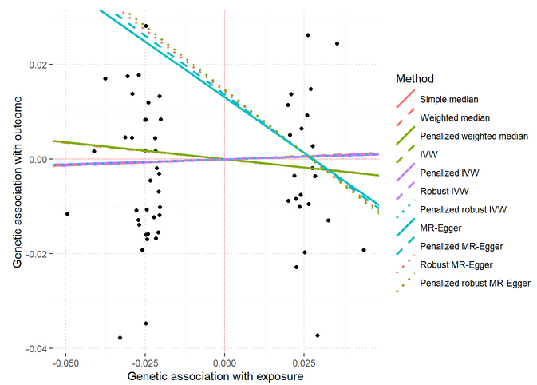

The subsequent diagram presents a scatter plot illustrating a genetic correlation. The x-axis represents the genetic association with the exposure variable (smoking initiation), while the y-axis represents the genetic association with the outcome variable (Acne). The straight line in the plot corresponds to the Inverse Variance Weighted method. Notably, the slope of this line is positive.

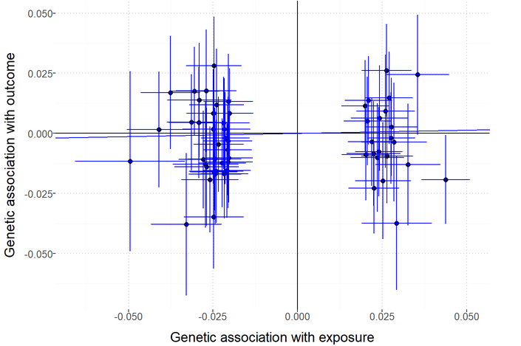

- Lifetime smoking
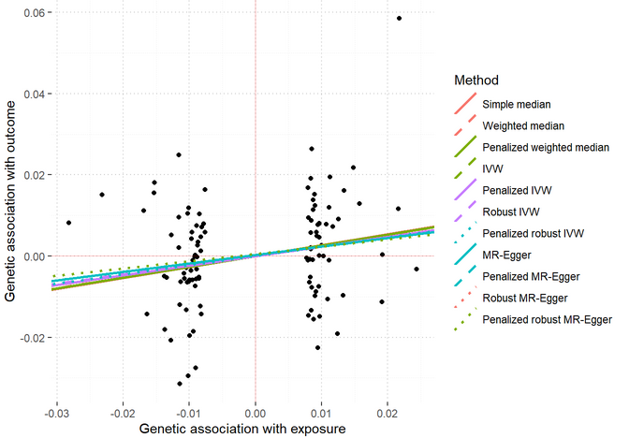

The subsequent diagram presents a scatter plot illustrating a genetic correlation. The x-axis represents the genetic association with the exposure variable (lifetime smoking), while the y-axis represents the genetic association with the outcome variable (Acne). The straight line in the plot corresponds to the Inverse Variance Weighted method. Notably, the slope of this line is positive.

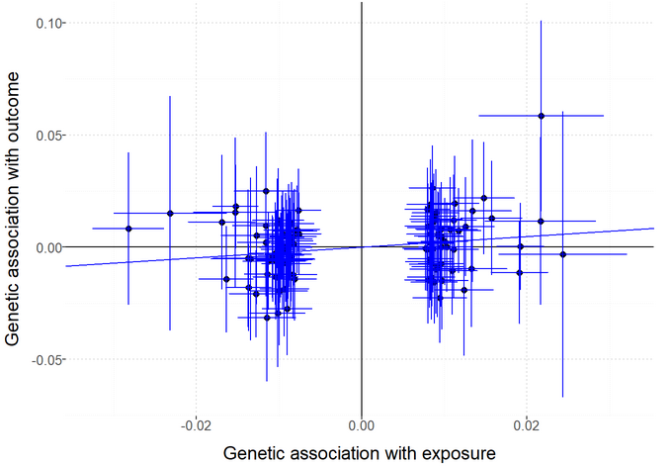
Rosaceanas
- Smoking initiation
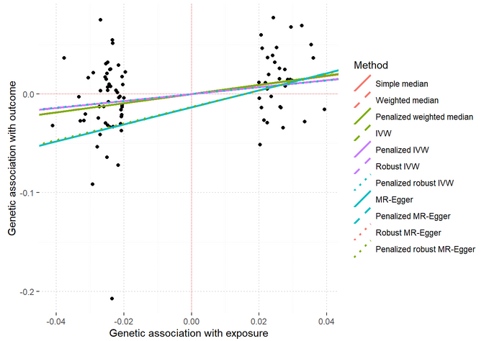

The subsequent diagram presents a scatter plot illustrating a genetic correlation. The x-axis represents the genetic association with the exposure variable (smoking initiation), while the y-axis represents the genetic association with the outcome variable (Rosaceanas). The straight line in the plot corresponds to the Inverse Variance Weighted method. Notably, the slope of this line is positive.

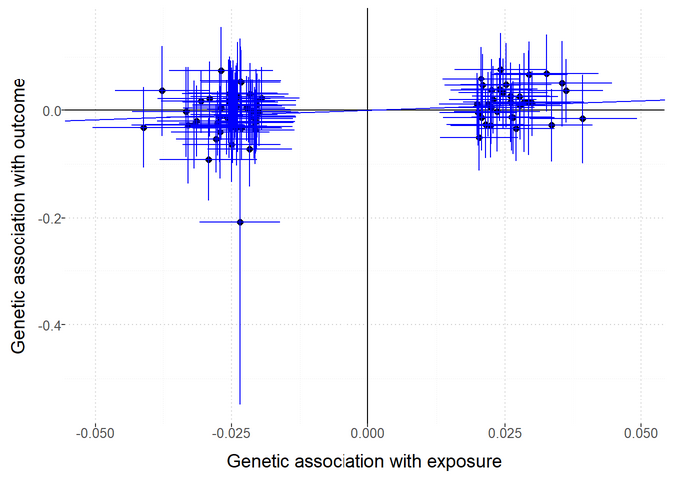
- Lifetime smoking
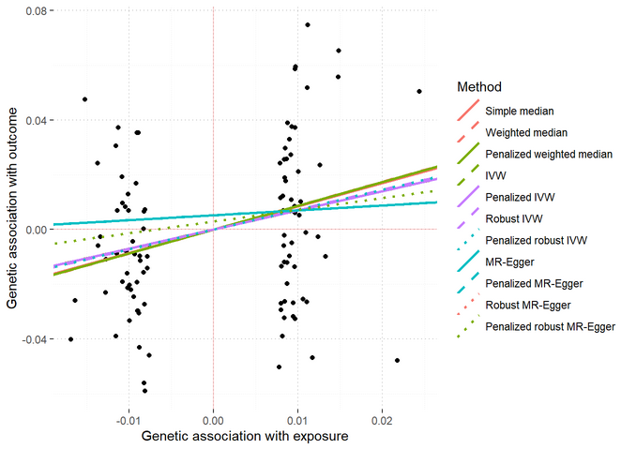

The subsequent diagram presents a scatter plot illustrating a genetic correlation. The x-axis represents the genetic association with the exposure variable (lifetime smoking), while the y-axis represents the genetic association with the outcome variable (Rosaceanas). The straight line in the plot corresponds to the Inverse Variance Weighted method. Notably, the slope of this line is positive.

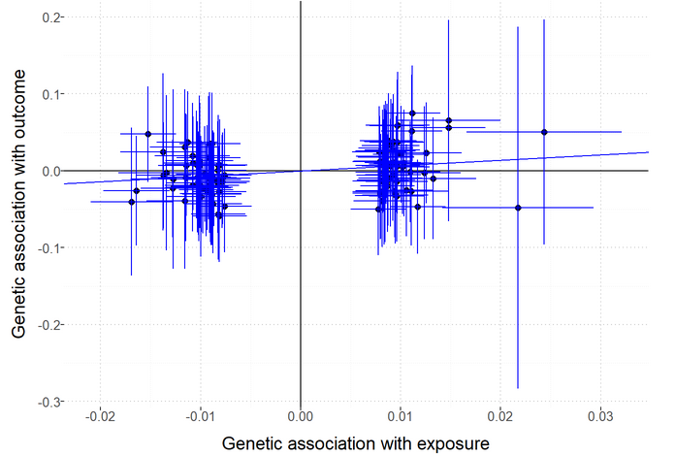

Figure S2: Leave-one-out plot to assess if a single variant is driving the association between smoking behaviours and Acne and Rosaceanas

Acne
- Smoking initiation
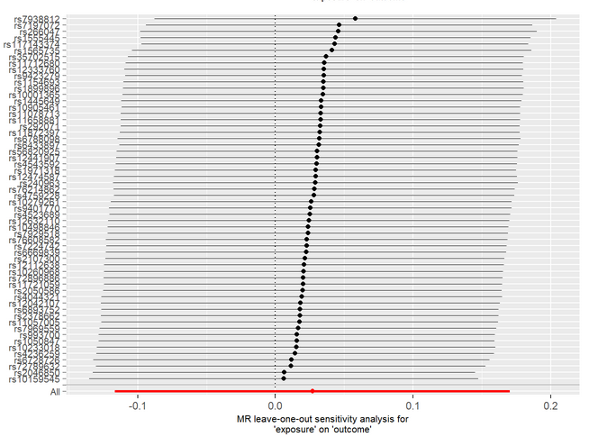
- Lifetime smoking
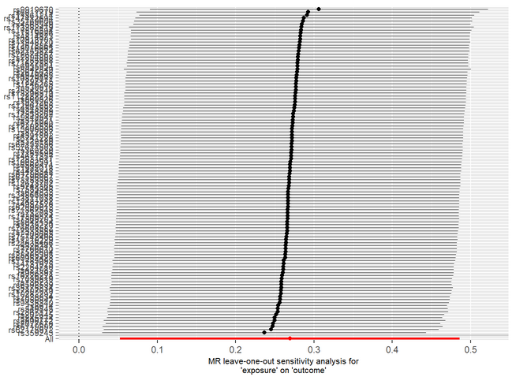
Rosaceanas

- Smoking initiation
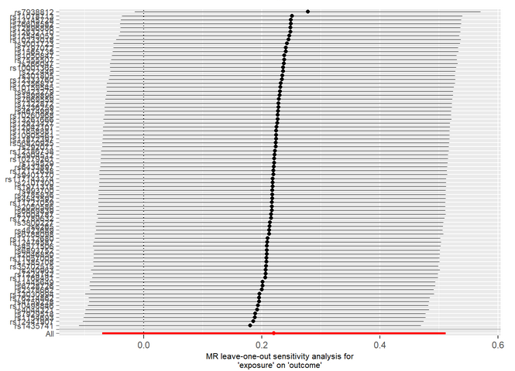
- Lifetime smoking

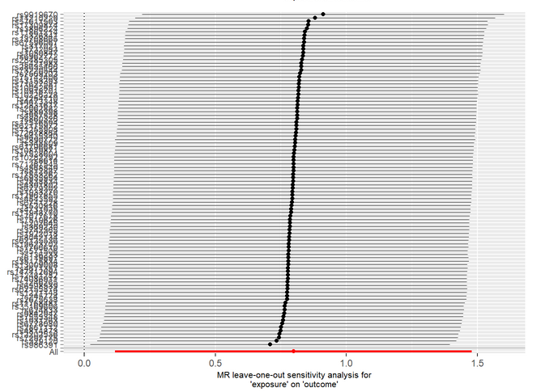

Figure S3: Forest plot of variant-specific inverse variance estimates for a causal association between smoking behaviors and Acne and Rosaceanas

Acne
- Smoking initiation
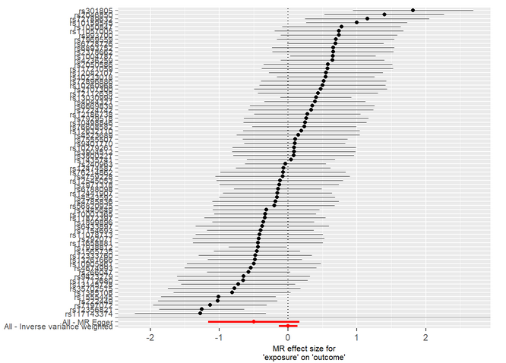

- Lifetime smoking
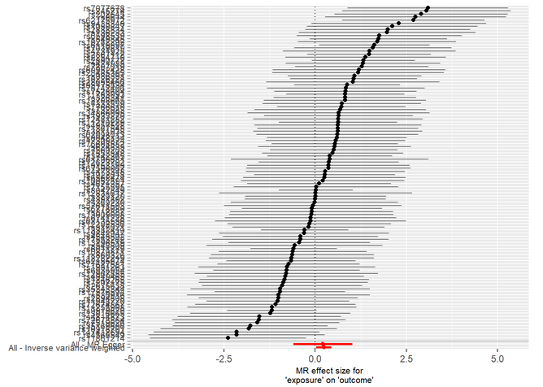
Rosaceanas
- Smoking initiation
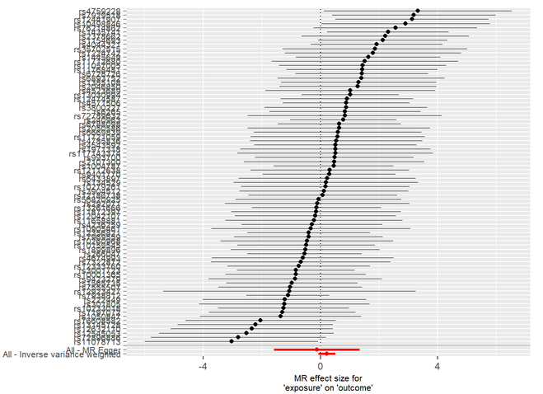

- Lifetime smoking

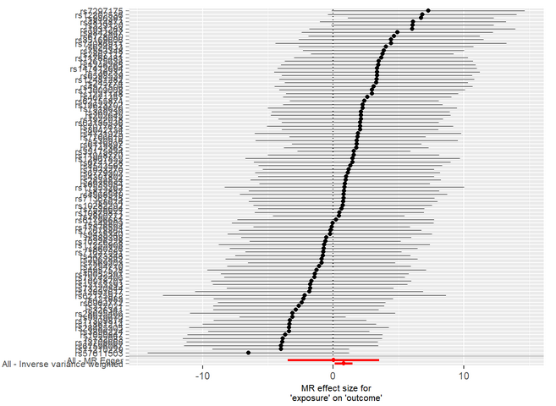

Figure S4. Funnel plot of a causal association between smoking behaviours and Acne and Rosaceanas

Acne
- Smoking initiation
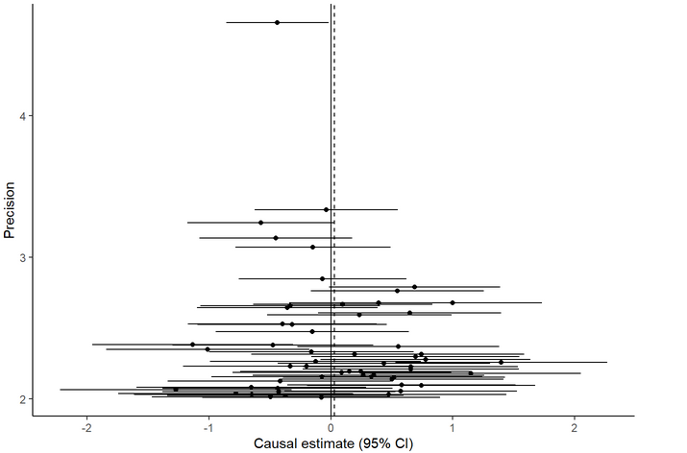
B) Lifetime smoking
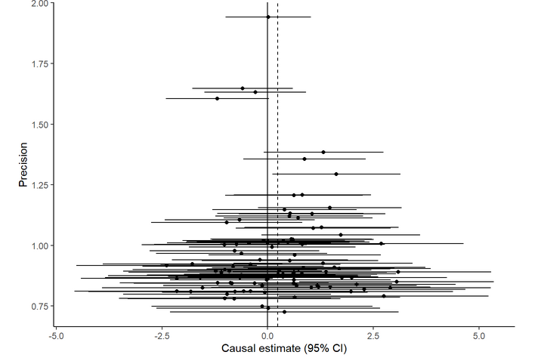

Rosaceanas
- Smoking initiation
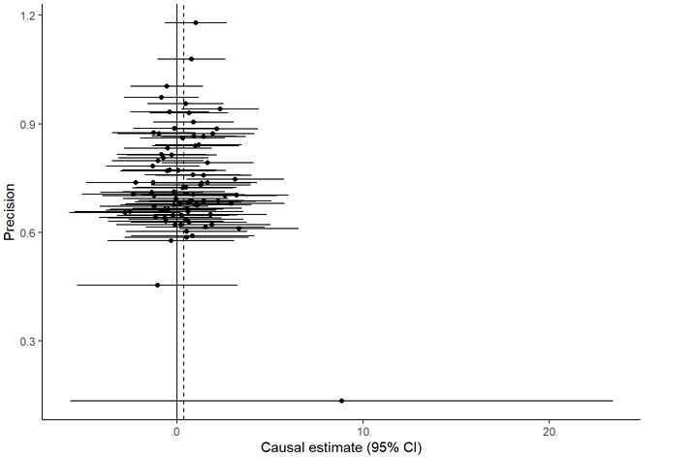

- Lifetime smoking

