Characterisation of materials properties and defects in structure fabricated via additive friction stir deposition

Author identifiers removed for double anonymised peer review (per submission instructions)

Supplementary information 1

Supplementary Table 1. A summary of the XCT scanning parameters
Part identifier | Voxel size (µm³) | Voltage (kV) | Current (µA) | Integration time (ms) | Number of projections | Number of images averaged/projection
B1 | 24.986 | 100 | 90 | 1000 | 1000 | 3
B2 | 30.06 | 100 | 90 | 1000 | 1000 | 3
T1+B3 | 30.87 | 100 | 90 | 1000 | 1000 | 3
T2+B4 | 30.06 | 100 | 90 | 1000 | 1000 | 3
T3+B5 | 30.06 | 100 | 90 | 1000 | 1000 | 3
T4+b6 | 30.06 | 100 | 90 | 1000 | 1000 | 3

Supplementary information 2
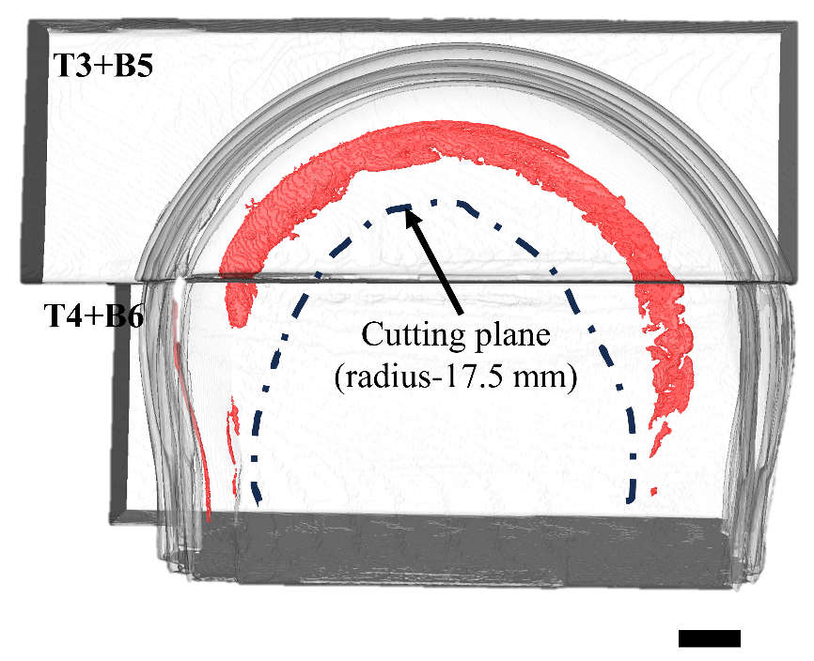

Supplementary Figure S1. Virtual machining analysis for section B5+T3 and B6+T4 (sections stitched) along the length. Scale bar corresponds to 5 mm.

