Supporting Information for

Constructing Monolayer Model Catalysts to Uncover the Distance Effect on CO₂ Electroreduction towards Multi-Carbon Products

Hengpan Yang, Shangzhao Feng, Xianguang Liu, Yan Kong, Binhua Chen, Qi Hu, Zhi Chen*, and Chuanxin He*
College of Chemistry and Environmental Engineering, Shenzhen University, Shenzhen, Guangdong, 518060, China

* Corresponding Authers: Dr. Zhi Chen (Email: zhi.chen@szu.edu.cn)
Prof. Chuanxin He (Email: hecx@szu.edu.cn)

Contents:
Supplementary Figures 1 to 16

- Materials and Characterizations
All reagents were used as received.
Linear sweep voltammograms (LSV) and potentiostatic electrolysis were performed using a CHI 660C electrochemical Station (Shanghai Chenhua Instruments Company). Liquid phase products were resolved by ¹H-NMR spectra recorded on an Ascend 400 (500 MHz, Bruker, Germany) spectrometer. Gas phase products were resolved by a Gas Chromatography (GC-2014, Shimadzu) and a differential electrochemical mass spectrometry (QAS 100, Linglu Instruments). The morphologies were observed by a field emission scanning electron microscope (FE-SEM, FEI JEOL-7800F). All STM measurements were performed with an ultra-high-vacuum low temperature scanning probe microscope (LT-STM-AFM-BO, CreaTec) at 77 K and a base pressure around 2 × 10⁻¹⁰ mbar. STM images were recorded in constant current mode, and were analyzed using WSxM¹.[Rev. Sci. Instrum., 2007, 78 , 013705]

- Synthesis, CO₂ Reduction and DFT Calculation
  - Constructing monolayer model catalysts on Au(111) surface
Tungsten wire (Alfa Aesar, 0.30 mm in diameter) was electrochemically etched (2.0 M NaOH, 4.0 V DC) to prepare the STM tips. The Au(111) single crystal prepared by the Clavilier method was used as working electrode². [J. Electroanal. Chem., 107(1980) 205-209] The Au(111) electrode was annealed in a hydrogen-oxygen flame before each experiment. The Au(111) single crystal substrate was cleaned via cycles of Ar⁺ sputtering and annealing up to 500 °C. The molecular precursors 1a and 2a were deposited by organic molecular beam epitaxy at a sublimation temperature of 170 °C and 200 °C onto the substrates held at room temperature, respectively.
Taking 1a as an example, 1a firstly was synthesized through literature and utilized as the precursor molecules³[ChemSusChem 2019, 12, 3737-3741]. It was deposited by organic molecular beam epitaxy at a sublimation temperature of 170 °C onto the freshly cleared Au(111) substrates held at room temperature. These independent 1a molecules would form 1a monolayer on Au(111) substrate through self-assembly procedure. Annealing the self-assembly 1a monolayer on Au(111) at 250 °C would trigger a chemical reaction towards 1b monolayer with a two-dimensional nanostructure.
  - CO₂ Reduction Procedure
Au(111) single crystal substrate deposited with molecular monolayers were directed used as working electrode for CO₂ reduction. Electrolysis and LSVs was performed in a in conventional H-type electrochemical cell separated by Nafion®117 membrane between cathode and anode, consisted of Pt foil as the counter electrode and an Ag/AgCl as reference electrode in CO₂ or N₂-saturated 0.1 M KHCO₃ solution.
As contrast, a specific volume of the 1a catalyst ink was then drop-casted on carbon paper electrode to achieve an approximately 1 mg cm⁻² loading amount and then dried at room temperature. This carbon paper would be utilized as the cathode for CO₂ electro-reduction. The catalyst ink was prepared via the following steps: specific amount catalyst powder was added into a mixture solution of 110 µL of Nafion solution (5 wt%, Dupond) and 890 µL of ethanol. The mixed solution was sonicated for 30 min to form a homogeneous catalyst ink.
All potentials in this paper were converted to reversible hydrogen electrode (RHE) by the following Nernst equation:
E(RHE) = E(Ag/AgCl) + 0.199 + 0.059 × pH
The electrolyzer outlet was vented directly into the gas-sampling loop of the gas chromatograph (GC-2014) equipped with a flame ionization detector (FID) and a thermal conductivity detector (TCD). The Faradaic efficiency of CO (or H₂) was calculated with the equation:
FE = n_{CO} × F × m_{CO} × V_{m} / I
Where n_{CO} is the number of electrons exchanged, F = 96,485 C/mol, m_{CO} is the mole fraction of CO in the gaseous mixture analysed, V_{m} is the molar flow rate in mol/s, and I is the total current in A. The molar flow rate is derived from the volume flow rate V by the relation V_{m} = pV/RT. p is the atmospheric pressure in Pa, R is 8.314 J/mol K, and T is the temperature in K.

  - DFT Calculations
All the first-principles spin-polarized calculations were performed by using the Vienna ab initio Simulation Program (VASP)^{4,5}. The generalized gradient approximation (GGA) in the Perdew-Burke-Ernzerhof (PBE) form and a cutoff energy of 500 eV for planewave basis set were adopted⁶. A 2 × 2 × 1 Monkhorst-Pack⁷ k grid was used for sampling the Brillouin zones at structure calculation. The ion-electron interactions were described by the projector augmented wave (PAW) method⁸. The convergence criteria of structure optimization were choose as the maximum force on each atom less than 0.03 eV/Å with an energy change less than 1 × 10⁻⁵ eV. To calculate the kinetic energy barrier of chemical reactions, the climbing image nudged elastic band (CI-NEB) method was used to search for the transition states⁹.

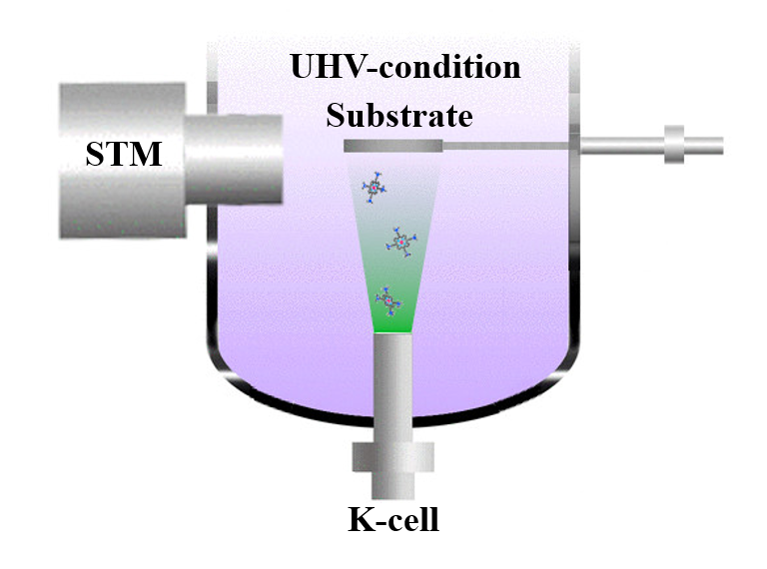
Supplementary Fig. 1 | The scheme of OMBE system. The vacuum is better than 3 × 10⁻⁸ mbar.

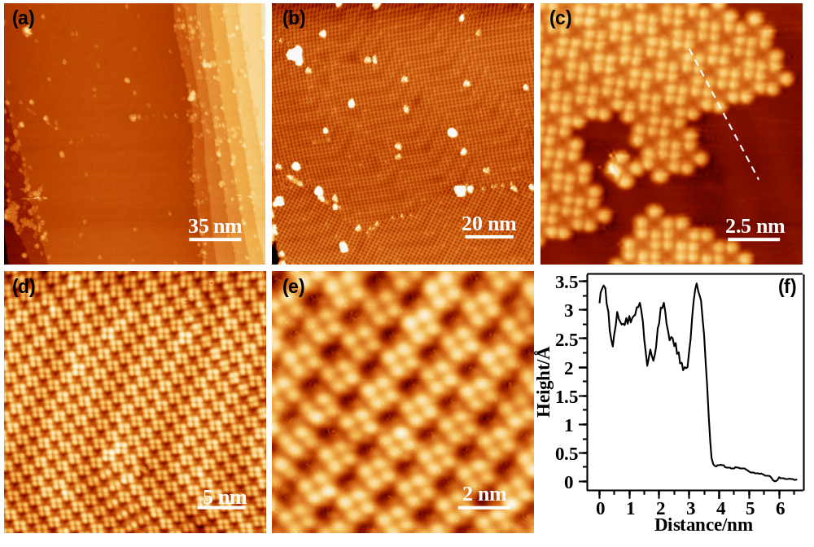
Supplementary Fig. 2 | STM images of self-assembly of 1a. (a-e) STM images of self-assembly of 1a on Au(111); (f) Height profile of white dashed line in (c).

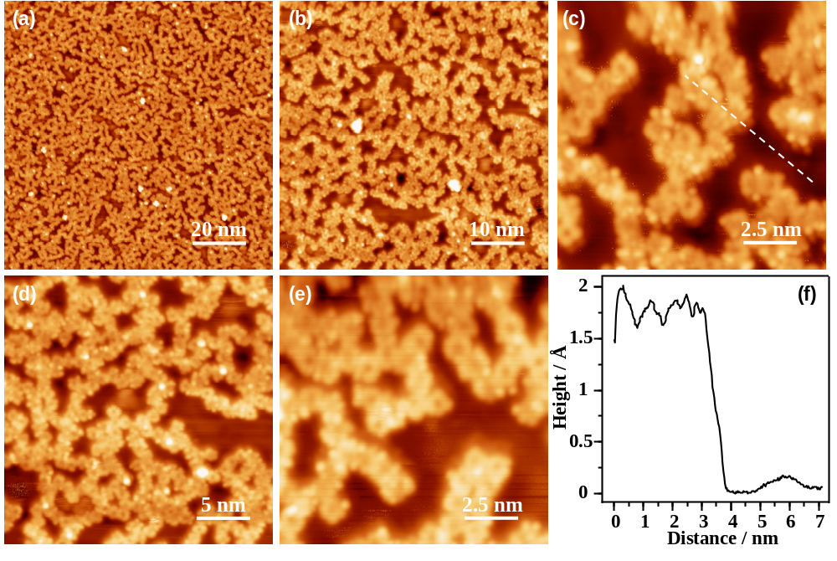
Supplementary Fig. 3 | STM images of polymer products of 1b. (a-e) STM images of polymer products of 1b on Au(111) after thermal annealing at 250 °C for 30 mins; (f) Height profile of white dashed line in (c).

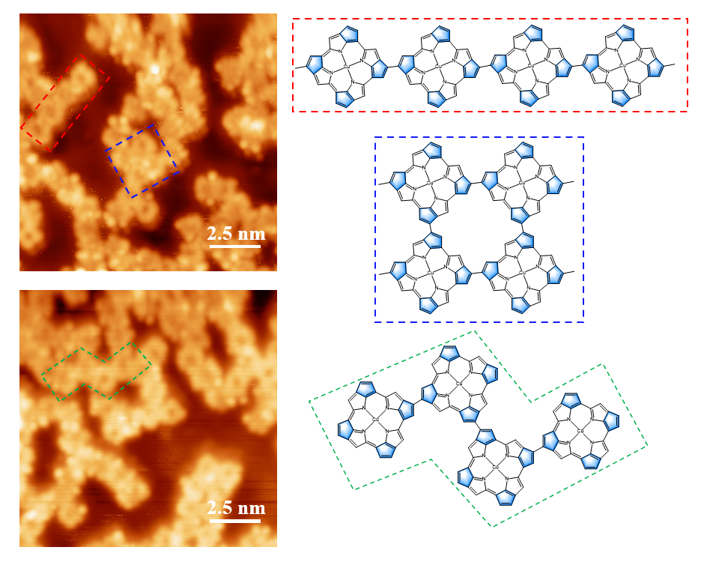
Supplementary Fig. 4 | Different fragments in polymer products of 1b on Au(111). The red dashed box shows the linear product; the blue box shows the square product; the green box shows the zigzag shape product.
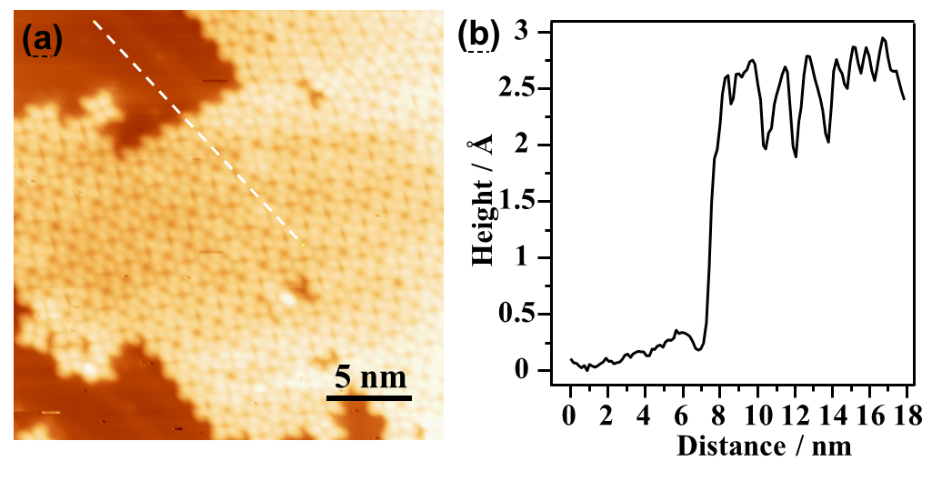
Supplementary Fig. 5 | STM image of self-assembly of 2a. (a) STM image of self-assembly of 2a on Au(111); (b) Height profile of white dashed line in (a).

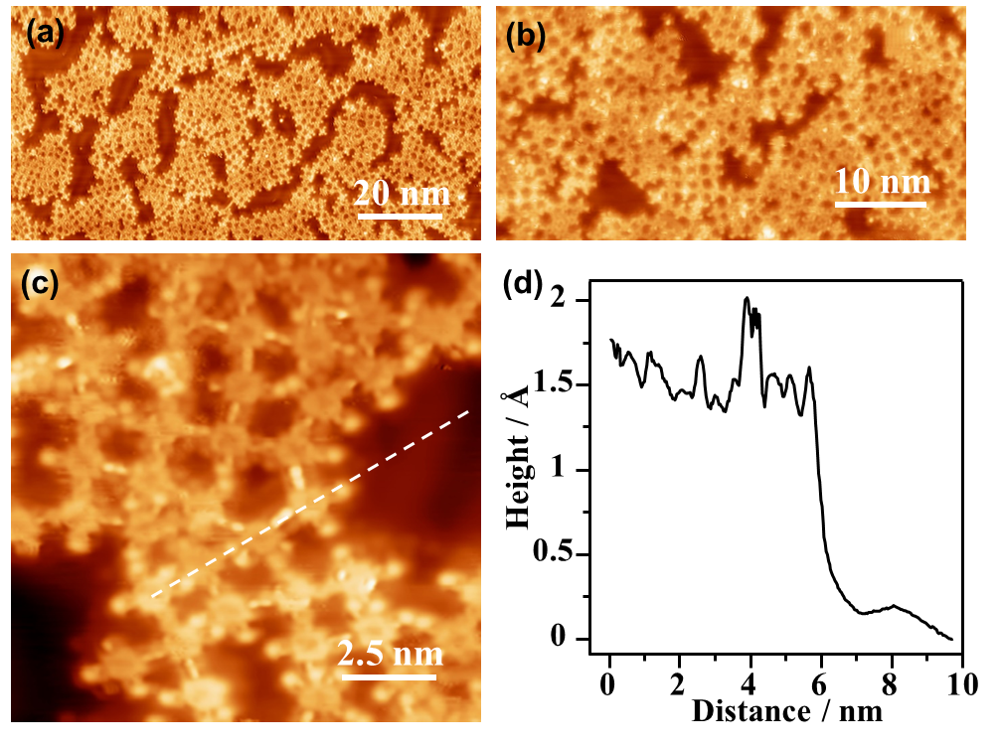
Supplementary Fig. 6 | STM images of polymer products of 2b. (a-c) STM images of polymer products of 2b on Au(111) after thermal annealing at 250 °C for 30 mins; (d) Height profile of white dashed line in (c), showing an average height of 0.15 ± 0.01 nm.
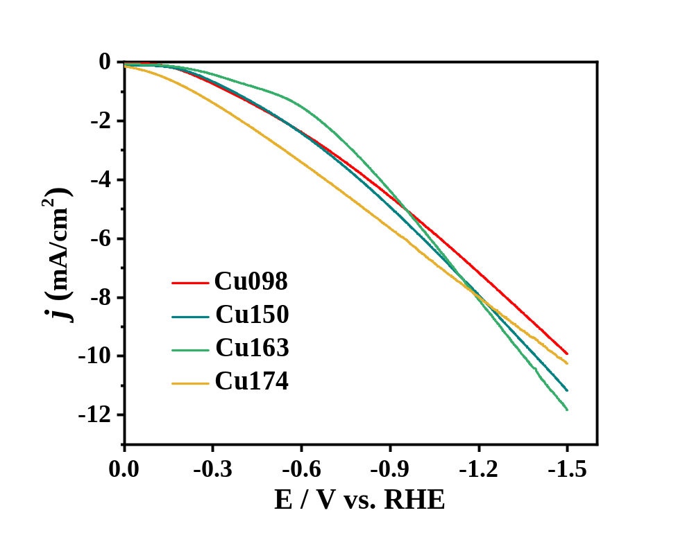
Supplementary Fig. 7 | LSV curves recorded on Cu098, Cu150, Cu163 and Cu174 samples. The electrocatalysis experiments were performed in CO₂-saturated 0.1 M KHCO₃ solution in H-type cell.

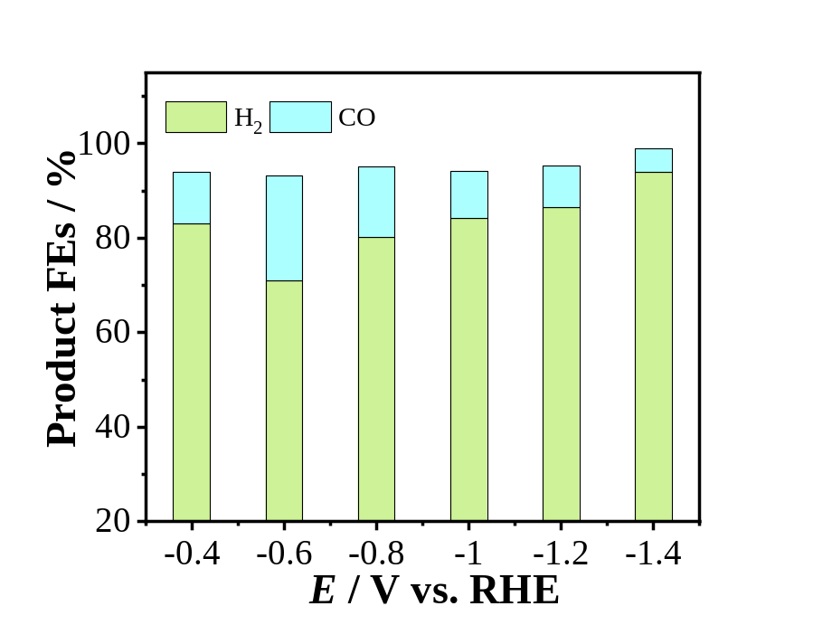
Supplementary Fig. 8 | Faradaic efficiencies of CO and H₂ using Au(111) electrode. The electrocatalysis experiments were performed from −0.4 V_{RHE} to −1.4 V_{RHE} applied potentials in CO₂-saturated 0.1 M KHCO₃ solution.

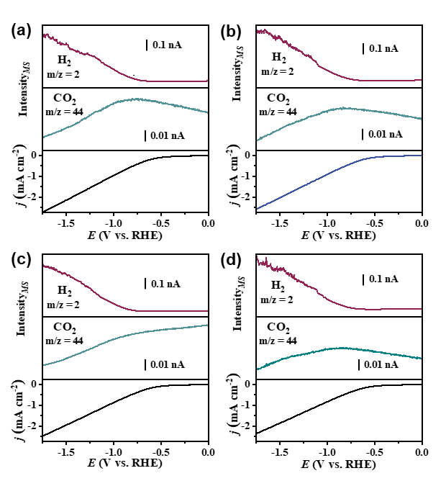
Supplementary Fig. 9 | In situ DEMS measurements of different catalysis. in situ DEMS measurements of (a) Cu098, (b) Cu150, (c) Cu163 and (d) Cu174 catalyst, ionic currents (up) of H₂ (m/z = 2) and CO₂ (m/z = 44), and the faradaic current densities (down) conducted in CO₂-saturated 0.1 M KHCO₃ with negatively going potential sweep from 0 to −1.75 V_{RHE} at 1 mV s⁻¹.

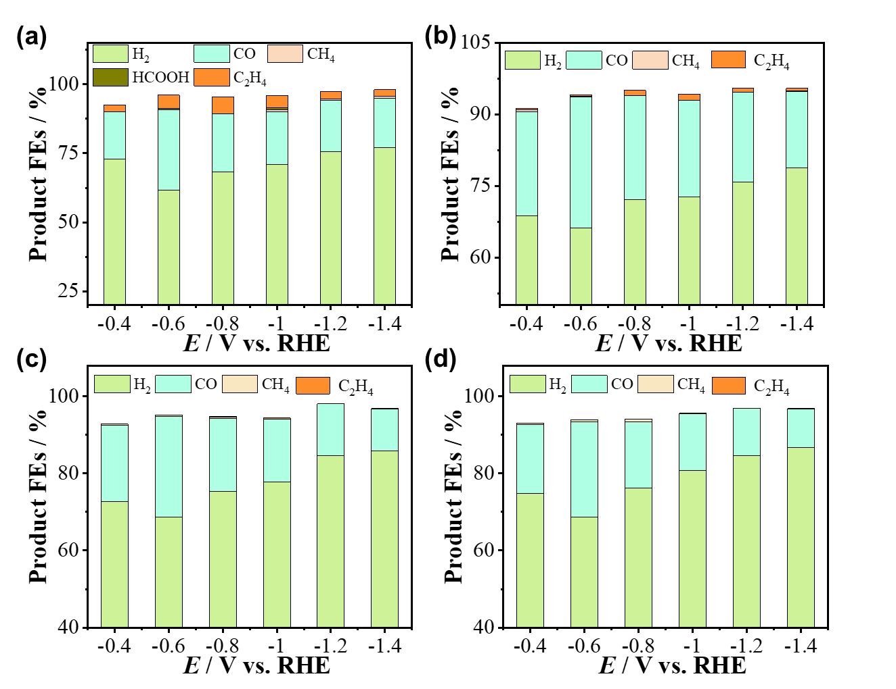
Supplementary Fig. 10 | Faradaic efficiencies of reduction products using different catalysis. Faradaic efficiencies of reduction products using (a) Cu098, (b) Cu150, (c) Cu163 and (d) Cu174 catalyst from −0.4 V_{RHE} to −1.4 V_{RHE} applied potentials in CO₂-saturated 0.1 M KHCO₃ solution.

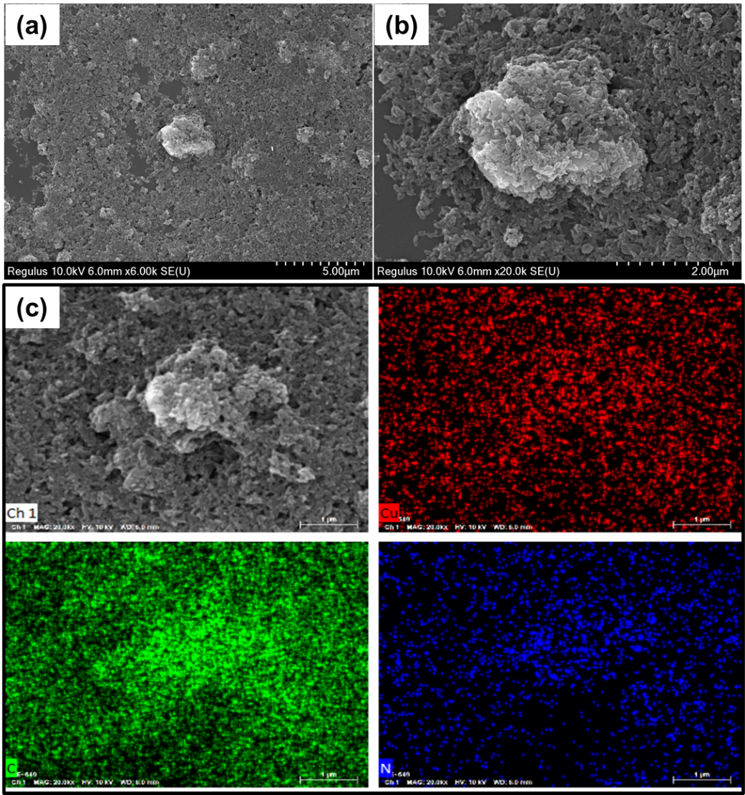
Supplementary Fig. 11 | SEM and EDX mapping images. (a-b) SEM and (c) EDX mapping images of drop-casting monomeric 1a on the Au(111) substrate.

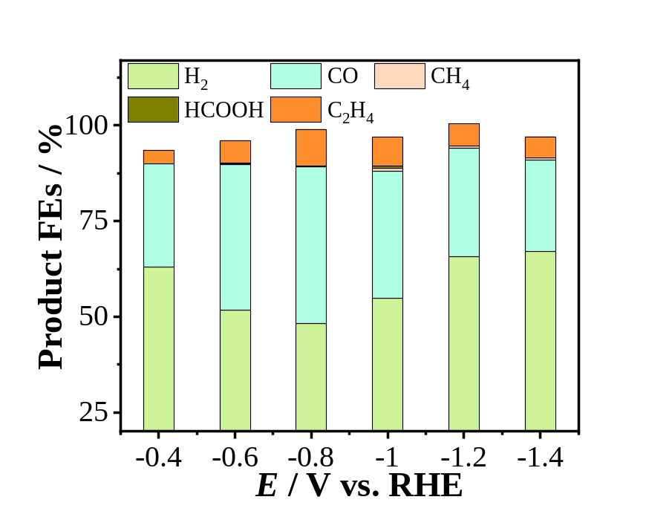
Supplementary Fig. 12 | Faradaic efficiencies of reduction products using drop-casting monomeric 1a. The Au(111) was used as substrate, and the electrocatalysis experiments were performed from −0.4 V_{RHE} to −1.4 V_{RHE} applied potentials in CO₂-saturated 0.1 M KHCO₃ solution.

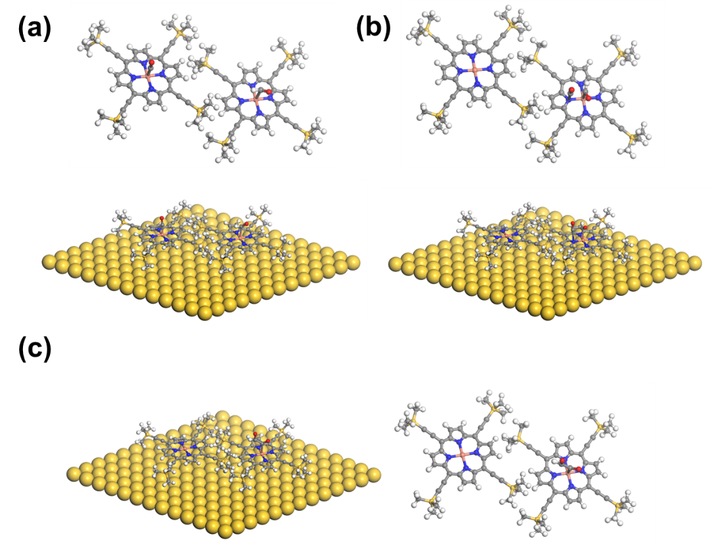
Supplementary Fig. 13 | DFT-calculated reaction path using 1a as catalysis on Au(111). DFT-calculated reaction path for the CO₂RR process of the CO and CHO with the catalyst of porphyrin 1a, shown in side and top views of the (a) initial state, the (b) transition states, and the (c) final state.

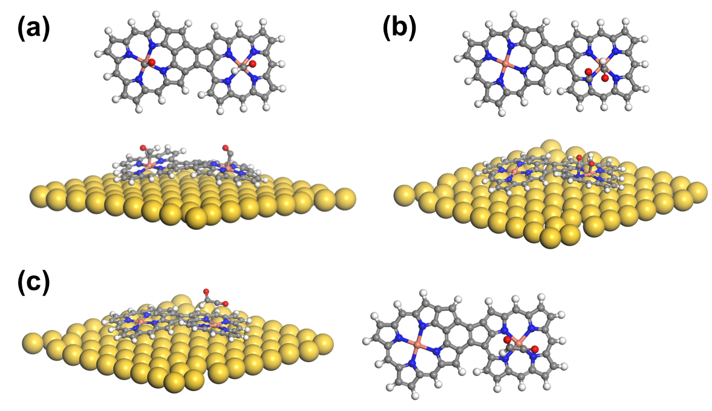
Supplementary Fig. 14 | DFT-calculated reaction path using 1b as catalysis on Au(111). DFT-calculated reaction path for the CO₂RR process of the CO and CHO with the catalyst of porphyrin dimer of 1b, shown in side and top views of the (a) initial state, the (b) transition states, and the (c) final state.

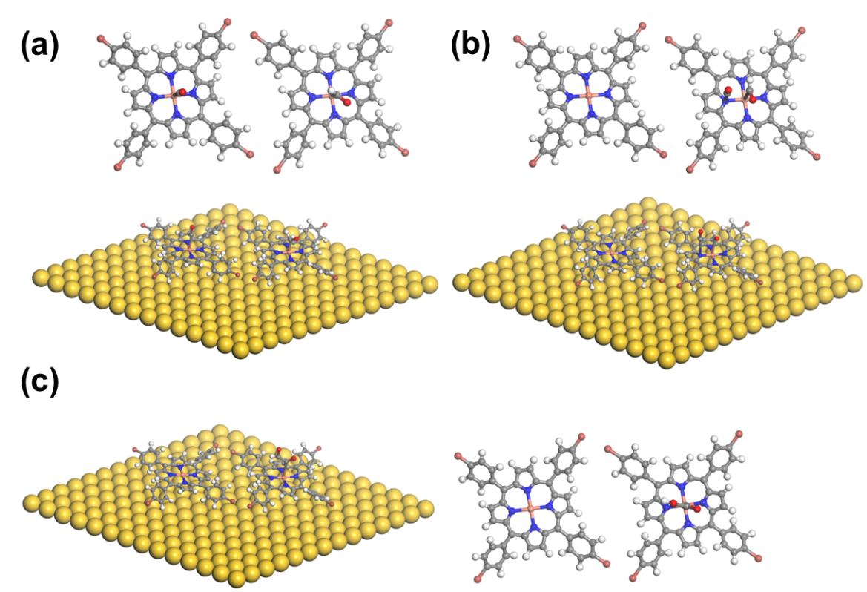
Supplementary Fig. 15 | DFT-calculated reaction path using 2a as catalysis on Au(111). DFT-calculated reaction path for the CO₂RR process of the CO and CHO with the catalyst of porphyrin 2a, shown in side and top views of the (a) initial state, the (b) transition states, and the (c) final state.

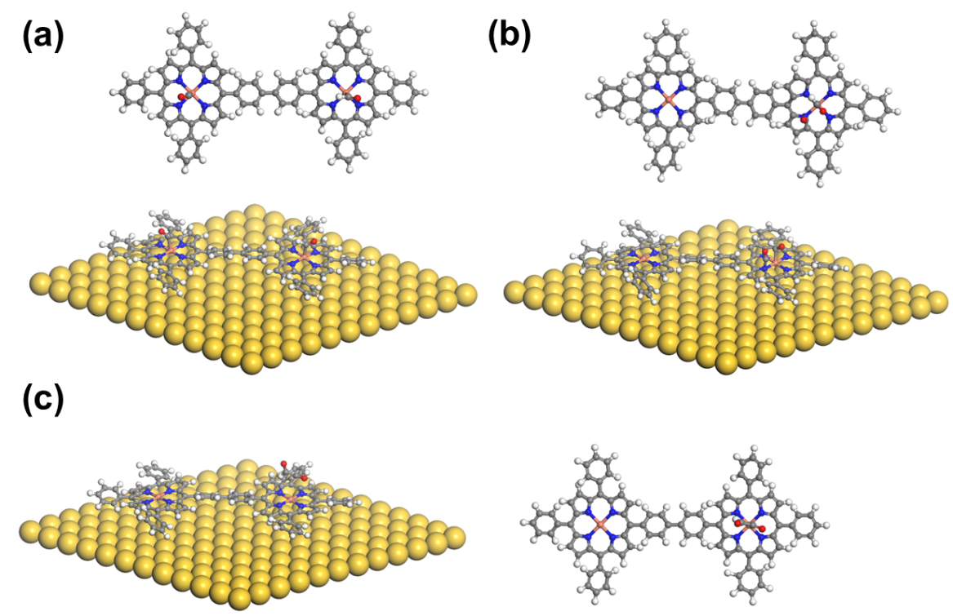
Supplementary Fig. 16 | DFT-calculated reaction path using 2b as catalysis on Au(111). DFT-calculated reaction path for the CO₂RR process of the CO and CHO with the catalyst of porphyrin dimer of 2b, shown in side and top views of the (a) initial state, the (b) transition states, and the (c) final state.

Supplementary References
1. Horcas, I. et al. WSXM: A software for scanning probe microscopy and a tool for nanotechnology. Rev. Sci. Instrum. 78, 013705 (2007).
2. Clavilier, J., Faure, R., Guinet, G. & Durand, R. Preparation of monocrystalline Pt microelectrodes and electrochemical study of the plane surfaces cut in the direction of the {111} and {110} planes. J. Electroanal. Chem. Interfacial Electrochem. 107, 205–209 (1980).
3. Chen, Z. et al. A lithium-free energy-storage device based on an alkyne-substituted-porphyrin complex. ChemSusChem 12, 3737–3741 (2019).
4. Kresse, G. & Furthmüller, J. Efficiency of ab initio total energy calculations for metals and semiconductors using a plane-wave basis set. Comput. Mater. Sci. 1, 15–50 (1996).
5. Kresse, G. & Furthmüller, J. Efficiency iterative schemes for ab initio total-energy calculations using a plane-wave basis set. Phys. Rev. B. 16, 11169-11186 (1996).
6. Perdew, J. P., Burke, K. & Ernzerhof, M. Generalized gradient approximation made simple. Phys. Rev. Lett. 18, 3865–3868 (1996).
7. Monkhorst, H. J. & Pack, J. D., Special point for Brillouin-zone integrations. Phys. Rev. B. 13 5188–5192 (1976).
8. Blöchl, P. E. Projector augmented-wave method. Phys. Rev. B. 50, 17953–17979 (1994).
9. Henkelman, G., Uberuaga, B. P. & Jónsson, H. A climbing image nudged elastic band method for finding saddle points and minimum energy paths. J. Chem. Phys. 113, 9901–9904 (2000).

