Supplementary Materials
Adaptive potential and genomic vulnerability of keystone forest tree species to climate change: a case study in Scots pine
Table S1 Location of the investigated populations of Pinus sylvestris.
Acr. | Pop # | Location | N | Lat. | Long. | Acr. | Pop # | Location | N | Lat. | Long.
POL1 | 1 | Poland, Chojnik | 10 | 50.83 | 15.63 | FIN3 | 21 | Finalnd, nr Rovaniemi | 109 | 66.57 | 26.21
POL2 | 2 | Poland, Szczeliniec | 23 | 50.43 | 16.23 | FIN4 | 22 | Finland, nr Kielajoki | 14 | 69.65 | 29.07
POL3 | 3 | Poland, Pusta Wielka | 9 | 49.40 | 20.82 | FIN5 | 23 | Finland, Utraslahti | 10 | 61.66 | 29.30
POL4 | 4 | Poland, Koryciska Wielkie | 10 | 49.27 | 19.83 | FIN6 | 24 | Finland, Punkaharju | 10 | 61.76 | 29.39
POL5 | 5 | Poland, Pieniński National Park | 11 | 49.42 | 20.36 | FIN7 | 25 | Finland, Savonlinna | 10 | 61.84 | 28.96
POL6 | 6 | Poland, Tarnawa | 9 | 49.10 | 22.49 | FIN8 | 26 | Finland, Rovaniemi ACHA | 10 | 66.60 | 26.12
POL7 | 7 | Poland, Woziwoda | 10 | 53.67 | 17.91 | FIN9 | 27 | Finland, Ivalontie | 10 | 67.71 | 27.02
POL8 | 8 | Poland, Hajnówka | 8 | 52.74 | 23.58 | FIN10 | 28 | Finland, nr Palonoja | 10 | 68.15 | 27.10
POL9 | 9 | Poland, Liski reserve | 11 | 51.95 | 22.82 | FIN11 | 29 | Finland, nr Ahmaniemi | 10 | 63.03 | 27.15
POL10 | 10 | Poland, Miłomłyn | 5 | 53.75 | 19.83 | FIN12 | 30 | Finland, Utsjoki | 10 | 69.70 | 27.08
POL11 | 11 | Poland, Tabórz reserve | 9 | 53.77 | 20.04 | FIN13 | 31 | Finland. Usjoentie | 10 | 69.88 | 27.00
POL12 | 12 | Poland, Niknąca Łąka | 10 | 50.47 | 16.39 | FIN14 | 32 | Finland, Kamaen | 10 | 69.34 | 27.22
POL13 | 13 | Poland, Głowa Króla | 10 | 50.48 | 16.38 | FIN15 | 33 | Finland, nr Tuuruniemi | 9 | 69.17 | 27.22
POL14 | 14 | Poland, Skalniak | 11 | 50.47 | 16.30 | FIN16 | 34 | Finland, Salla Reindeer Park | 9 | 66.74 | 28.82
POL15 | 15 | Poland, Błędne Skały | 12 | 50.48 | 16.29 | FIN17 | 35 | Finland, nr Kaarti | 11 | 66.66 | 29.06
LTU | 16 | Lithuania, Čepkeliai | 20 | 54.02 | 24.55 | FIN18 | 36 | Finland, nr Raatepuro | 10 | 65.81 | 29.24
LVA | 17 | Latvia, Dunezers Lake | 10 | 57.15 | 24.35 | FIN19 | 37 | Finland, nr Ahola | 10 | 65.44 | 29.03
EST | 18 | Estonia, Vardi | 10 | 58.98 | 24.48 | FIN20 | 38 | Finland nr Hietakylä | 10 | 64.83 | 28.90
FIN1 | 19 | Finland, Joutsa | 20 | 61.74 | 26.14 | FIN21 | 39 | Finland, Kuopio-Helsinki | 10 | 61.45 | 26.69
FIN2 | 20 | Finland, nr Temmes | 20 | 64.69 | 25.71-
-Acr. – acronym for the population; Pop # - ordering number N – number of samples analysed, Lat. – latitude (N), Long. – longitude (E)

Table S2 Basic summary statistic for Pinus sylvestris populations in the studied transect.
Acr. | Pop # | group | He | Ho | Fis | Acr. | Pop # | group | He | Ho | Fis
POL1 | 1 | S | 0.3155 | 0.3147 | -0.0044 | FIN3 | 21 | N | 0.3126 | 0.3143 | -0.0087
POL2 | 2 | S | 0.3088 | 0.3119 | -0.0104 | FIN4 | 22 | N | 0.3126 | 0.3219 | -0.0260
POL3 | 3 | S | 0.3112 | 0.3128 | -0.0093 | FIN5 | 23 | N | 0.3130 | 0.3140 | -0.0079
POL4 | 4 | S | 0.3058 | 0.3108 | -0.0196 | FIN6 | 24 | N | 0.3137 | 0.3136 | -0.0058
POL5 | 5 | S | 0.3134 | 0.3191 | -0.0212 | FIN7 | 25 | N | 0.3107 | 0.3122 | -0.0097
POL6 | 6 | S | 0.3058 | 0.3158 | -0.0339 | FIN8 | 26 | N | 0.3131 | 0.3158 | -0.0114
POL7 | 7 | S | 0.3160 | 0.3198 | -0.0151 | FIN9 | 27 | N | 0.3124 | 0.3148 | -0.0111
POL8 | 8 | S | 0.3088 | 0.3133 | -0.0174 | FIN10 | 28 | N | 0.3116 | 0.3127 | -0.0084
POL9 | 9 | S | 0.3149 | 0.3157 | -0.0086 | FIN11 | 29 | N | 0.3077 | 0.3110 | -0.0130
POL10 | 10 | S | 0.3134 | 0.3195 | -0.0311 | FIN12 | 30 | N | 0.3112 | 0.3141 | -0.0125
POL11 | 11 | S | 0.3098 | 0.3129 | -0.0122 | FIN13 | 31 | N | 0.3051 | 0.3132 | -0.0235
POL12 | 12 | S | 0.3137 | 0.3192 | -0.0182 | FIN14 | 32 | N | 0.3115 | 0.3152 | -0.0145
POL13 | 13 | S | 0.3130 | 0.3159 | -0.0140 | FIN15 | 33 | N | 0.3099 | 0.3136 | -0.0158
POL14 | 14 | S | 0.3059 | 0.3117 | -0.0206 | FIN16 | 34 | N | 0.3157 | 0.3156 | -0.0077
POL15 | 15 | S | 0.3102 | 0.3124 | -0.0108 | FIN17 | 35 | N | 0.3131 | 0.3185 | -0.0191
LTU | 16 | M | 0.3143 | 0.3168 | -0.0100 | FIN18 | 36 | N | 0.3074 | 0.3139 | -0.0224
LVA | 17 | M | 0.3169 | 0.3178 | -0.0082 | FIN19 | 37 | N | 0.3127 | 0.3155 | -0.0129
EST | 18 | M | 0.3145 | 0.3183 | -0.0165 | FIN20 | 38 | N | 0.3090 | 0.3174 | -0.0264
FIN1 | 19 | N | 0.3148 | 0.3139 | -0.0009 | FIN21 | 39 | N | 0.3066 | 0.3117 | -0.0185
FIN2 | 20 | N | 0.3136 | 0.3116 | 0.0011
Acr. – acronym for the population; Pop # - ordering number; He – Expected heterozygosity, Ho – Observed heterozygosity; Fis – Inbreeding coefficient

Table S3. List of 25 environmental variables used for RDA analysis.
Variable | Abbreviation | Source | Mean (range)
Annual mean temperature (°C) | mean_temp | Worldclim¹ | 3.20 (-1.9–7.4)
Mean diurnal range (Mean of monthly (max temp - min temp)) (°C) | mean_dr | Worldclim¹ | 8.03 (6.3-9.5)
Isothermality (×100) | isoterm | Worldclim¹ | 2.46 (2.1-3)
Temperature seasonality (standard deviation ×100) (°C) | temp_s | Worldclim¹ | 837.93 (676.2-996.3)
Max temperature of warmest month (°C) | max_t_warm | Worldclim¹ | 19.95 (14.6-24)
Min temperature of coldest month (°C) | min_t_cold | Worldclim¹ | -12.19 (-20- -6.6)
Temperature annual range (°C) | temp_ar | Worldclim¹ | 32.15 ( 26.6-38.3)
Mean temperature of wettest quarter (°C) | mean_t_wet | Worldclim¹ | 13.52 (9.2-17.7)
Mean temperature of driest quarter (°C) | mean_t_dry | Worldclim¹ | -4.41 (-9.5-2)
Mean temperature of warmest quarter (°C) | mean_t_warm | Worldclim¹ | 15.32 (8.8- 19.65)
Mean temperature of coldest quarter (°C) | mean_t_cold | Worldclim¹ | -7.64 (-14.6- -2.5)
Annual precipitation (mm) | perc | Worldclim¹ | 623.38 (407-1134)
Precipitation of wettest month (mm) | perc_wet_m | Worldclim¹ | 84.51 (64-172)
Precipitation of driest month (mm) | perc_dry_m | Worldclim¹ | 30.13 (17-54)
Precipitation seasonality (coefficient of variation) (mm) | perc_s | Worldclim¹ | 34.79 (28-46)
Pprecipitation of wettest quarter (mm) | perc_wet_q | Worldclim¹ | 234.08 (165-457)
Precipitation of driest quarter (mm) | perc_dry_q | Worldclim¹ | 96.46 (55-170)
Precipitation of warmest quarter (mm) | perc_warm | Worldclim¹ | 230.54 (165-457)
Precipitation of coldest quarter (mm) | perc_cold | Worldclim¹ | 110.28 (63-180)
Growing degree days heat sum above 5°C | gdd | Climatrends R package² | 1501.48 (692.3-2251.1)
Top soil pH | ph | Soil ph in Europe³ | 4.85 (3.3-6.2)
Organic carbon content (g kg⁻¹) | carbon | LUCAS 2018 TOPSOIL data⁴ | 65.64 (18.17-93.25)
Annual mean UV-B (J/m²/day) | ubv | A global UV-B radiation dataset for macroecological studies⁵ | 973.96 (691.50-986.40)
Number of days receiving ≥0.1 mm precipitation (days) | wet | CR UTS v. 4.07⁶ | 20.70 (18.1-24.09)
Number of frost days (days) | frs | CR UTS v. 4.07⁶ | 28.66 (25.03-31)
¹ Worldclim - Fick, S.E. and R.J. Hijmans, 2017. Worldclim 2: New 1-km spatial resolution climate surfaces for global land areas. International Journal of Climatology;
² Climatrends R package - Kauê de Sousa, Jacob van Etten and Svein Ø. Solberg (2020). climatrends: Climate Variability Indices for Ecological Modelling. R package version 0.5. https://CRAN.R-project.org/package=climatrends
³ Soil ph in Europe - 'Map of Soil pH in Europe', Land Resources Management Unit, Institute for Environment & Sustainability, European Commission â€“ Joint Research Centre, 2010
⁴ LUCAS 2018 TOPSOIL data - Orgiazzi, A., Ballabio, C., Panagos, P., Jones, A., Fernández-Ugalde, O. 2018. LUCAS Soil, the largest expandable soil dataset for Europe: A review. European Journal of Soil Science, 69(1): 140-153. https://doi.org/10.1111/ejss.12499
⁵ A global UV-B radiation dataset for macroecological studies - Beckmann M., Václavík T., Manceur A.M., Šprtová L., von Wehrden H., Welk E., Cord A.F. (2014) glUV: A global UV-B radiation dataset for macroecological studies, Methods in Ecology and Evolution, 5: 372–383. doi: 10.1111/2041-210X.12168
⁶ CRUTS v. 4.07 - Harris, I., Osborn, T.J., Jones, P. et al. Version 4 of the CRU TS monthly high-resolution gridded multivariate climate dataset. Sci Data 7, 109 (2020). https://doi.org/10.1038/s41597-020-0453-3
Table S4. Redundancy analysis (RDA) to partition among population genetic variation (F) in Pinus sylvestris into environment (env.), geography (geog.) and their combined effects, shown in the table as measured by adjusted R². The proportions of the variation that were exclusively attributed to environment or geography are highlighted in light grey. The individual fractions of the variation that were confounded between various combinations of these two components are highlighted in dark grey.
 | All (6995) SNPs |  | OUTFLANK and pcadapt outlier (16) SNPs^{b} |  | PAV (6) SNPs^{c}
Combined fractionsª | R² | p (>F)^{d} | R² | p (>F)^{c} | R² | p (>F)^{c}
F~env. | 0.038 | 0.001 *** | 0.171 | 0.001 *** | 0.460 | 0.001 ***
F~geog. | 0.113 | 0.001 *** | 0.330 | 0.001 *** | 0.636 | 0.001 ***
Individual fractionsª
F~env. | geog. | 0.001 | 0.475^{ns} | 0.011 | 0.308 | 0.050 | 0.037 *
F~geog. | env. | 0.063 | 0.002 ** | 0.170 | 0.004 ** | 0.106 | 0.003 **
F~clim.. + geog. | 0.114 | 0.001 *** | 0.341 | 0.001 *** | 0.686 | 0.001 ***
Total explained^{e} | 0.178 |  | 0.522 |  | 0.842
Total confounded^{e} | 0.114 |  | 0.341 |  | 0.686
Total unexplained | 0.822 |  | 0.478 |  | 0.158
Total | 1.000 |  | 1.000
ªF = Independent matrix of population alleles frequencies; RDA tests are of the form: F~dependent matrices | covariate matrices. env. = environment (eight climatic variables); geog. = geography (10 dbMem variables).^{b}Subsets of SNPs detected by two genetic outlier tests (OUTFLANK and pcadapt. ^{c} Subset of SNPs detected by all three outlier methods.The number of SNPs for each subset is given in parentheses.
^{d}; * = p < 0.05; ** = p < 0.01; *** = p < 0.001. Significance of confounded fractions between climate, geography, or north-south ancestry (dark grey rows) was not tested.
^{e}Total explained = total adjusted R² of individual fractions (light grey + dark grey rows). Total confounded = Total of individual fractions confounded between climate, geography (dark grey rows).

Figure S1. Ordination of 39 Scots pine populations in environmental space. Light grey dots: global Scots pine distribution (distribution based on EU forest database and associated climate data based on Wordclim). Dark grey dots: distribution of Scots pine in the whole studied transect. The populations used in this study are denoted as bigger points, colour-coded according to Fig. 2. Population numbers match those in Table S1.
Figure S2. Heat map of pairwise F_{ST} values between analysed populations of Scots pine calculated using SNP data.
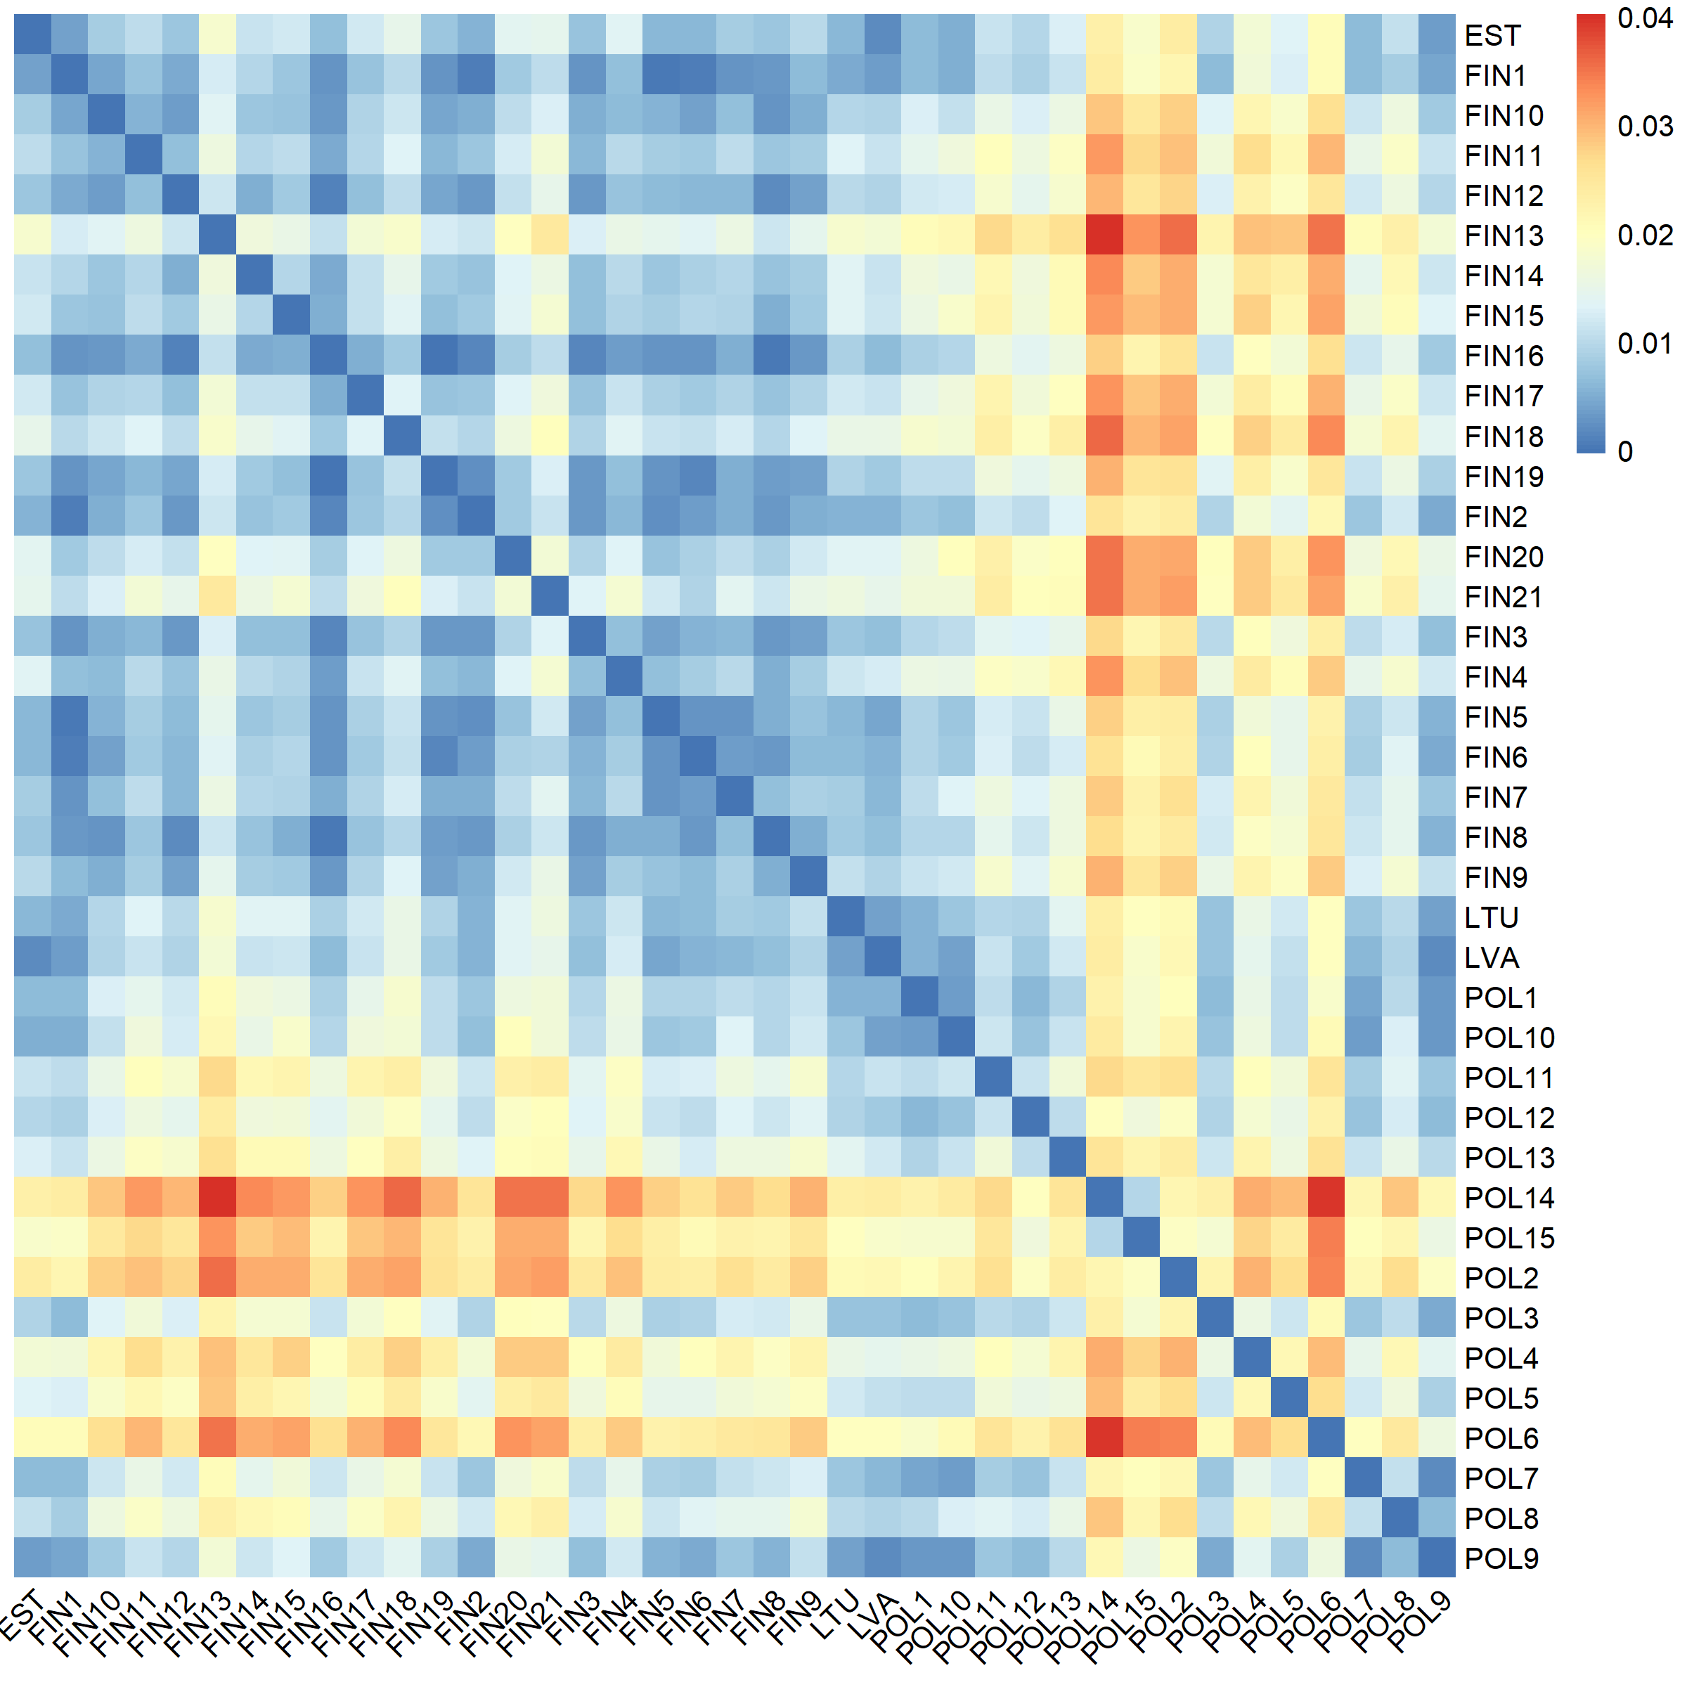
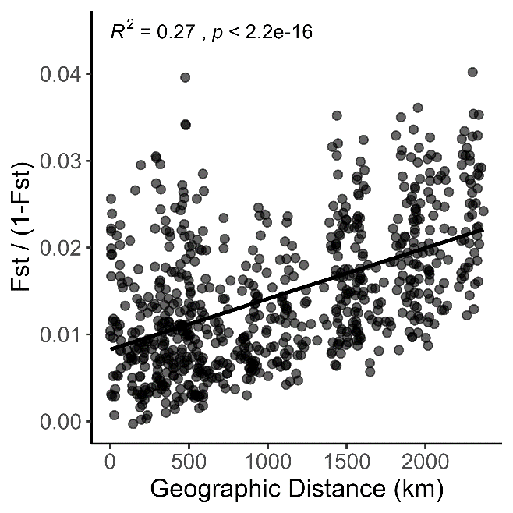
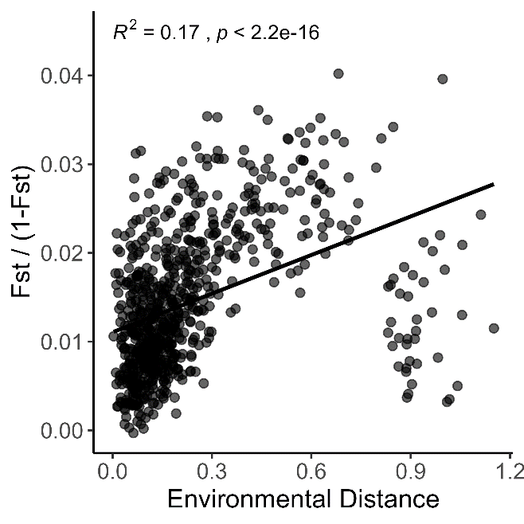
Fig S3. Results of the IBD and IBE analyses. (A) The Mantel test scatterplot of IBD shows a linearised measure of genetic distance (F_{ST} / (1 - F_{ST})) as a function of geographic distance (B). The Mantel test scatterplot of IBE shows linearised measure of genetic distance (F_{ST} / (1 - F_{ST})) as a function of environmental distance based on eight non-correlated variables.
A
B

Figure S4. Cross entropy between ten different runs for each K in LEA plotted vs. number of ancestral populations. The optimal number of clusters is detected by the first significant drop of cross entropy at K = 4, and the second drop is noted at K = 10.

Figure S5. The proportion of ancestry of each individual at 39 sites inferred using LEA for K 2-10. Different colours of the bars correspond to the inferred ancestry. The sites are ordered from north to south.
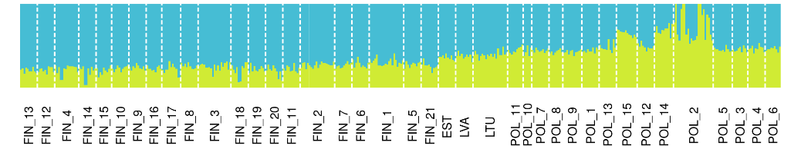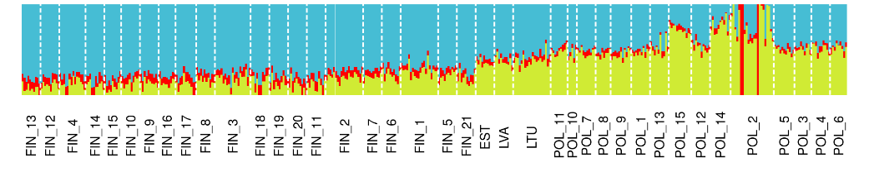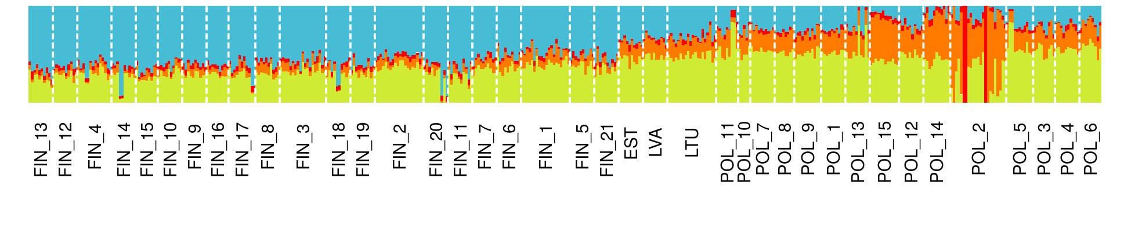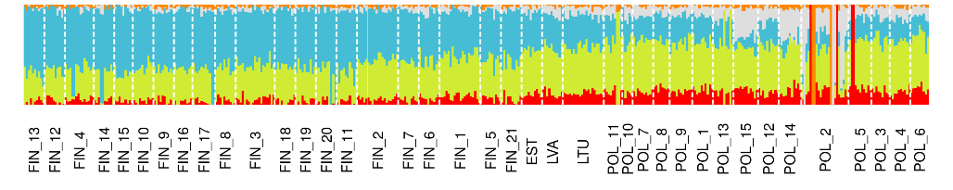
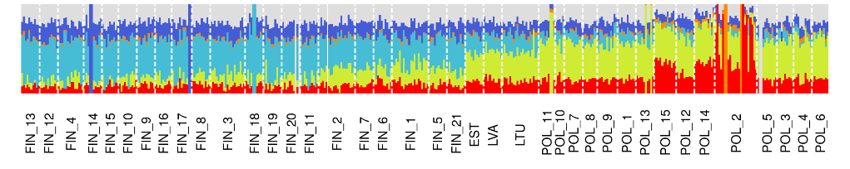
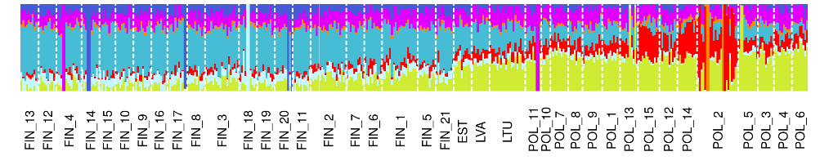
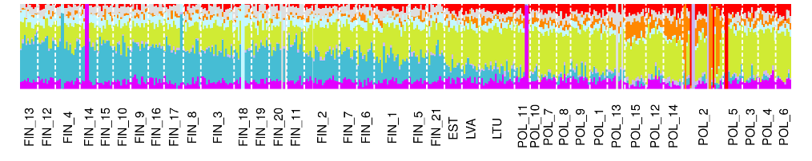
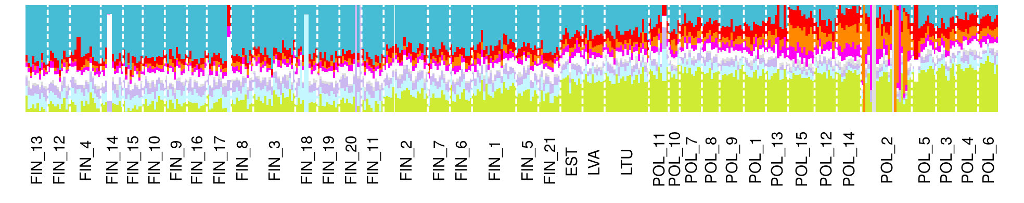
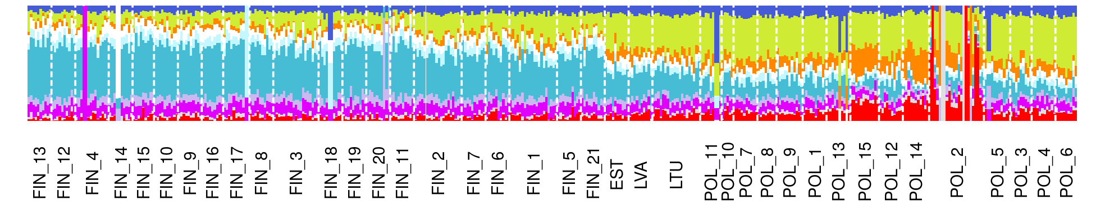
Figure S6. Principal component analysis (PCA) projections of P. sylvestris on a regional scale. (A) PCA for populations from Finland. Individuals are assigned to the northern and southern group, based on the ordination in environmental space as in Fig S1. (B) PCA for populations from Poland. Individuals from Stołowe Mountain. region were assigned to one group, and all the other populations were grouped together, based on the results of LEA analysis and ordination in environmental space in as Fig S1.
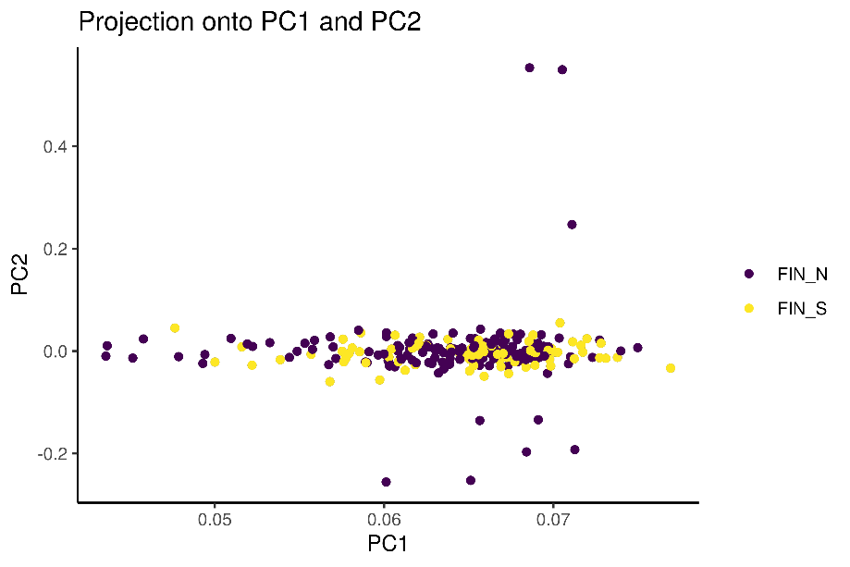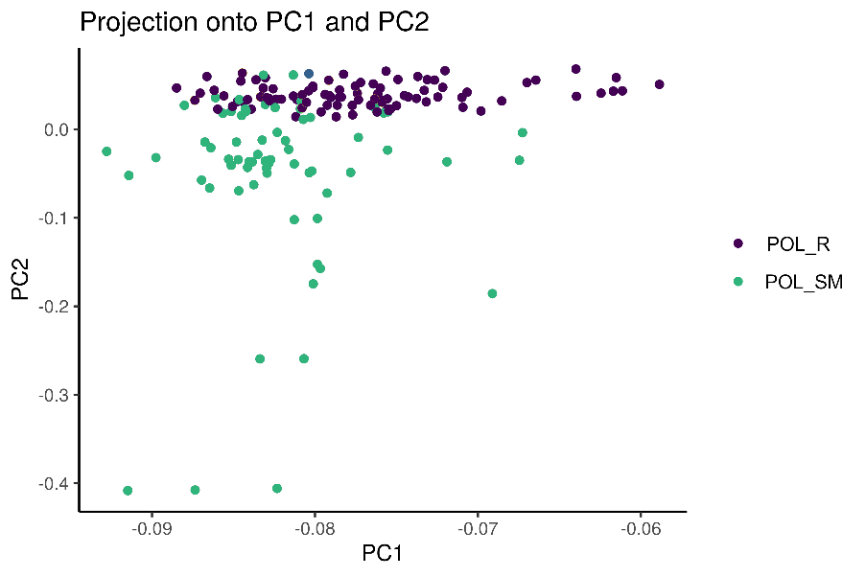
B
A

Figure S7. Comparison of PCA based on different numbers of SNPs included. (A) PCA based on all 440 samples and all SNPs (identical to the PCA in Fig. 2C). (B). PCA based on putatively neutral SNPs, without outlier SNPs. (C) PCA based only on outlier SNPs. All individuals are colour-coded as in Fig.2 (D) Correlation between PC scores from PCA with all SNPs and with a outlier SNPs only with 1:1 identity line. Due to the PC scores being centred, this method can estimate how similar are two different PCA runs. The correlation was rather weak, but statistically significant, with R² = 0.221. We used permutation test based on random resampling of 16 SNPs from the whole dataset 10,000 times and calculated correlation for each resampling. The p value based on the permutation test was 0.0274, since randomly selected SNPs do not explain observed population structure.
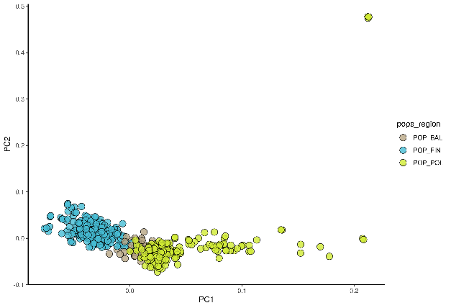
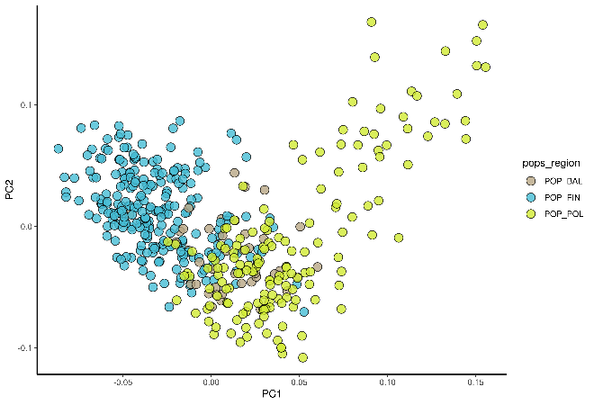
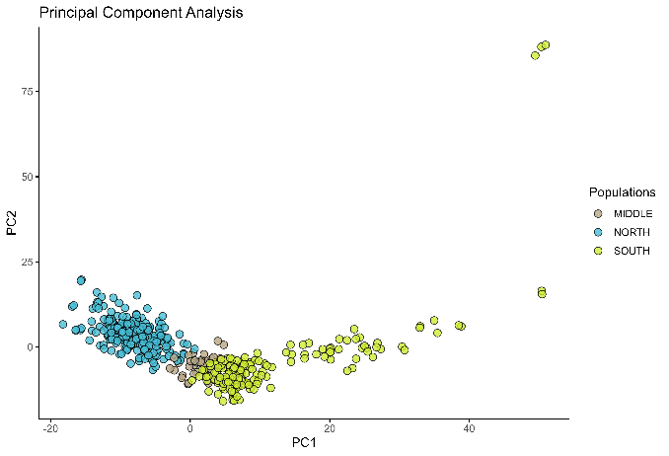
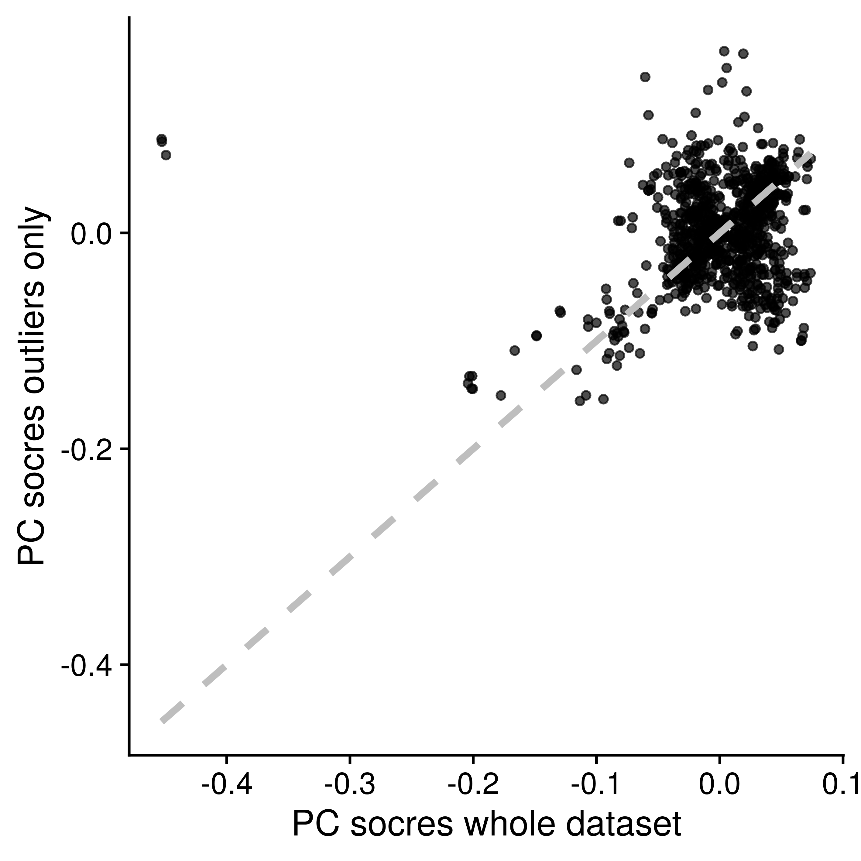
B
A
C
D

Figure S8. Venn diagram with the number of SNPs detected as outlier using only genomic outliers scans, separately in both regions. (A) Outliers SNPs detected in Finland. (B) Outliers SNPs detected in Poland.
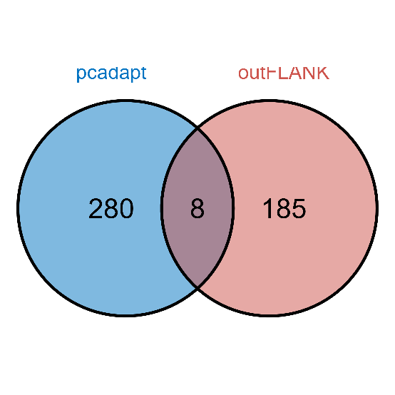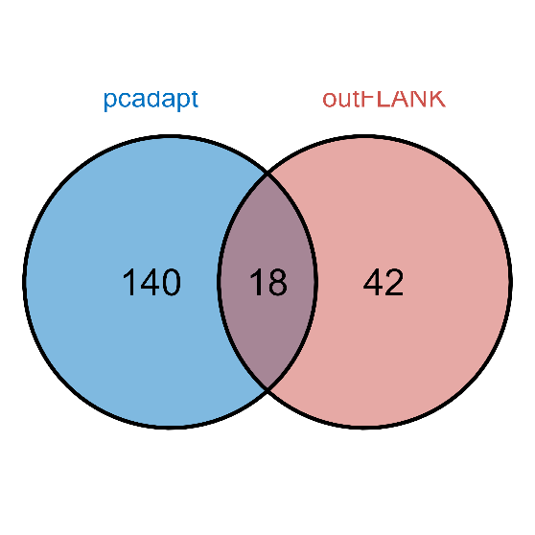
B
A
Figure S9. (A) Correlations between the environmental variables selected for redundancy analysis. (B) The results of RDA analysis on the ordination plot of the first two RDA axes. The points represent the populations colour coded as in Fig. 2, while the blue arrows represent the environmental predictors. The relative arrangement of the points and arrows on the plot represents their relationship to the RDA ordination axes. (C) Histograms of 39 SNPs detected by RDA and their correlations with the associated environmental variables. The vertical black line denotes a cutoff point of low correlation strength (none of the SNPs were found to be below that threshold).
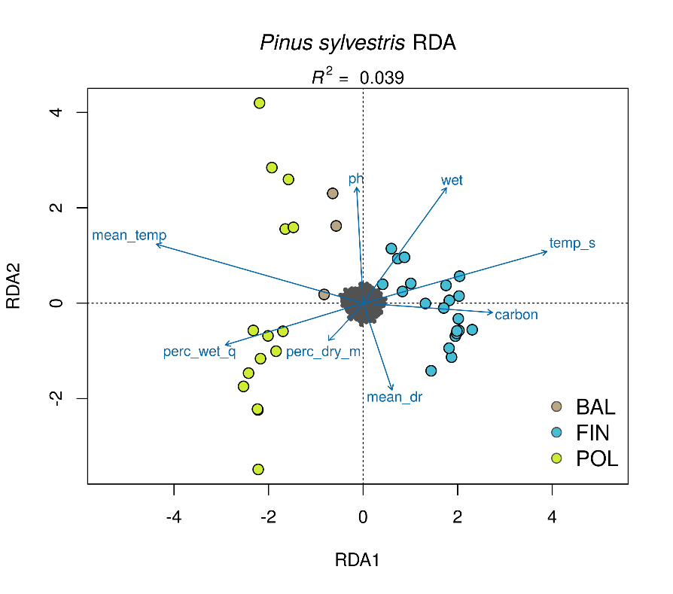
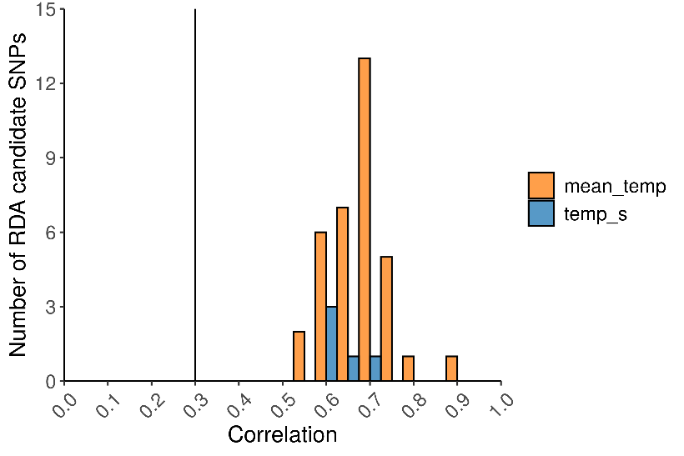
C
B
A
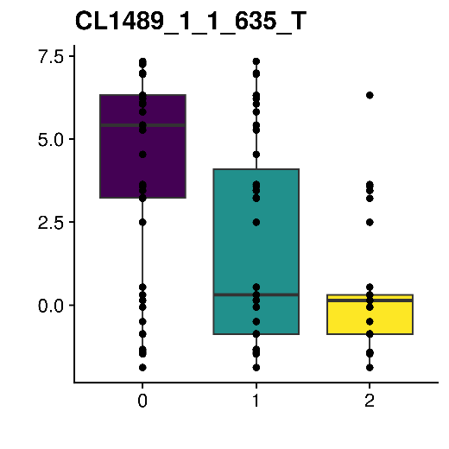
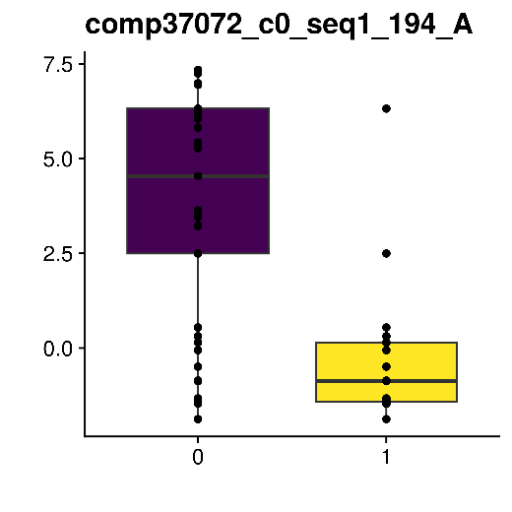
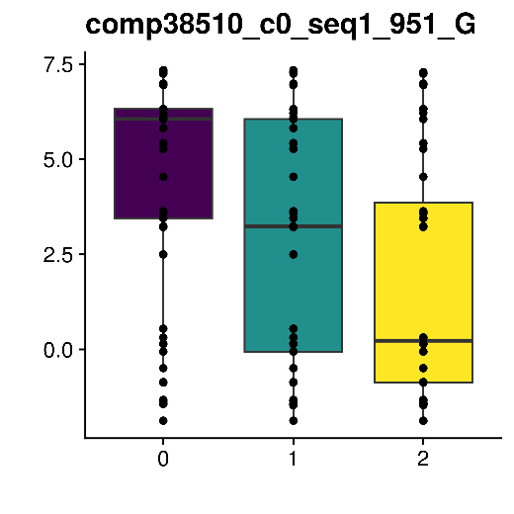
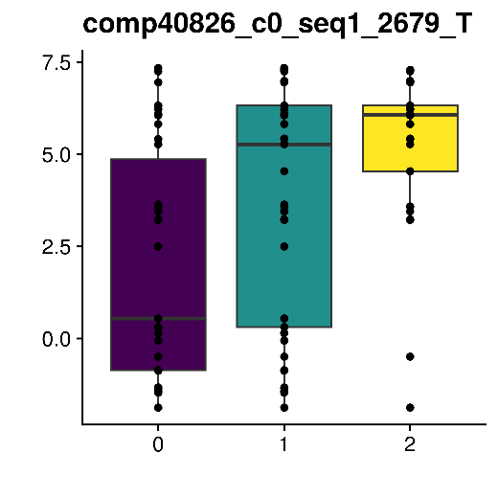
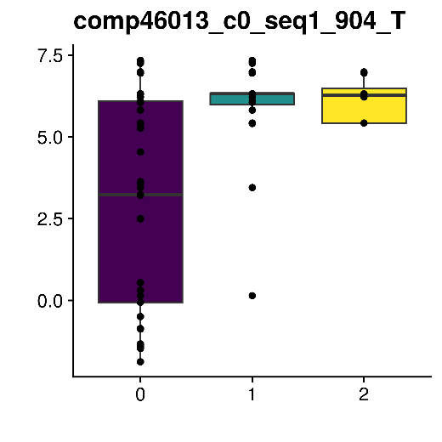
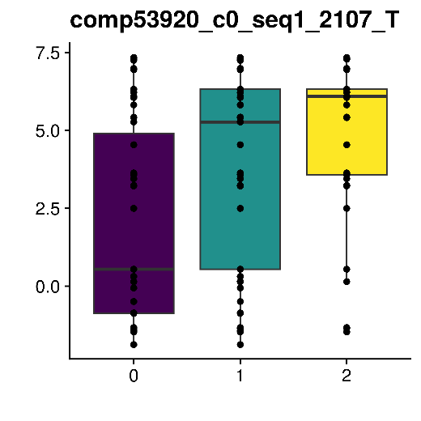
Figure S10. Correlation between genotype and mean temperature using a generalised linear model (GLM) with a binomial error.

Figure S11. Predicted shifts in allele frequencies under three RCP scenarios. (A) RCP2.6; (B) RCP4.5; (C) RCP8.5. (D) The results of the genomic vulnerability assessment under three climate scenarios. The GV score is reflecting the mean amount of allelic shift based on all the outlier SNPs.
D
C
B
A
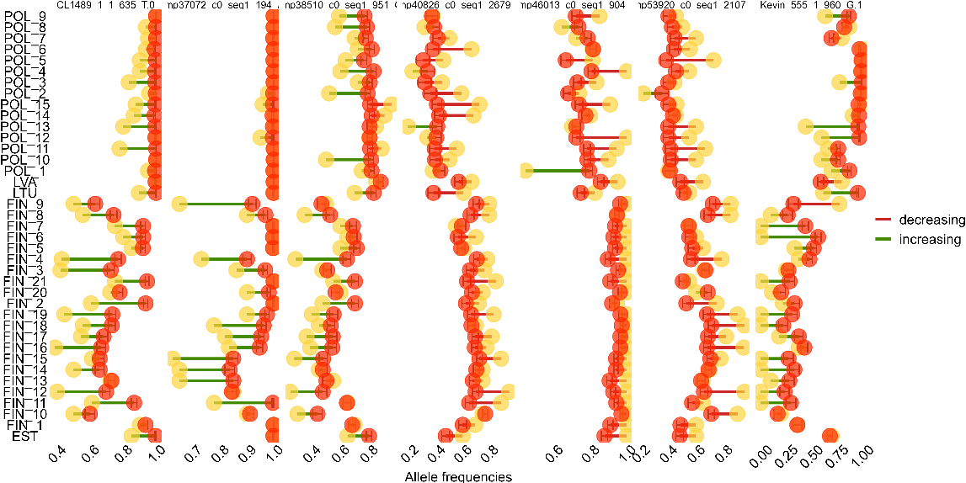
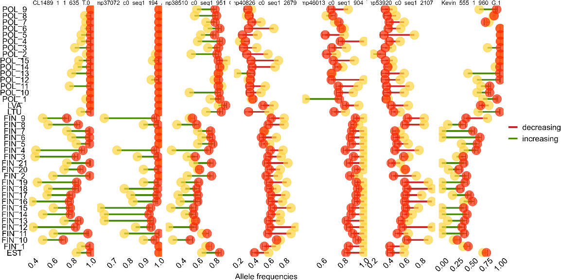
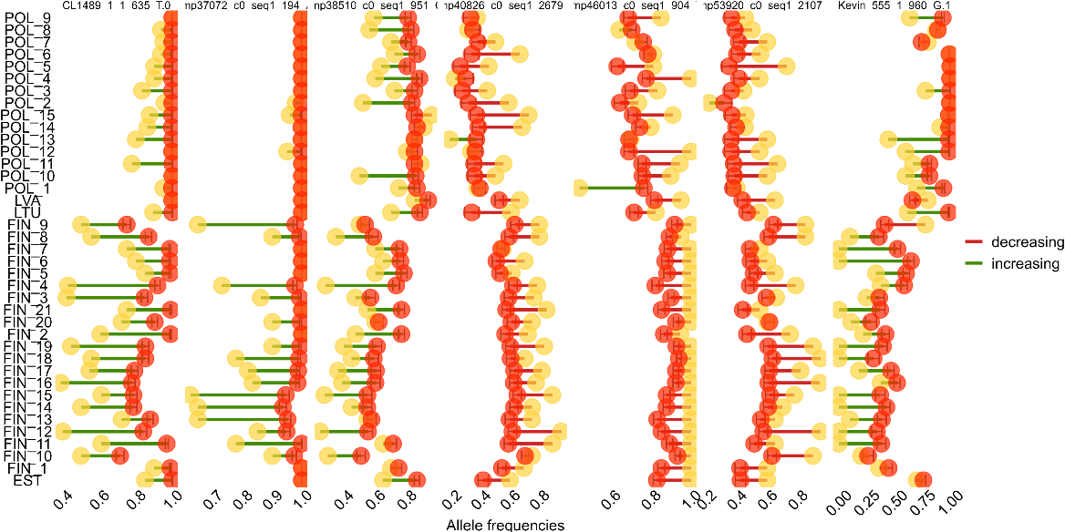
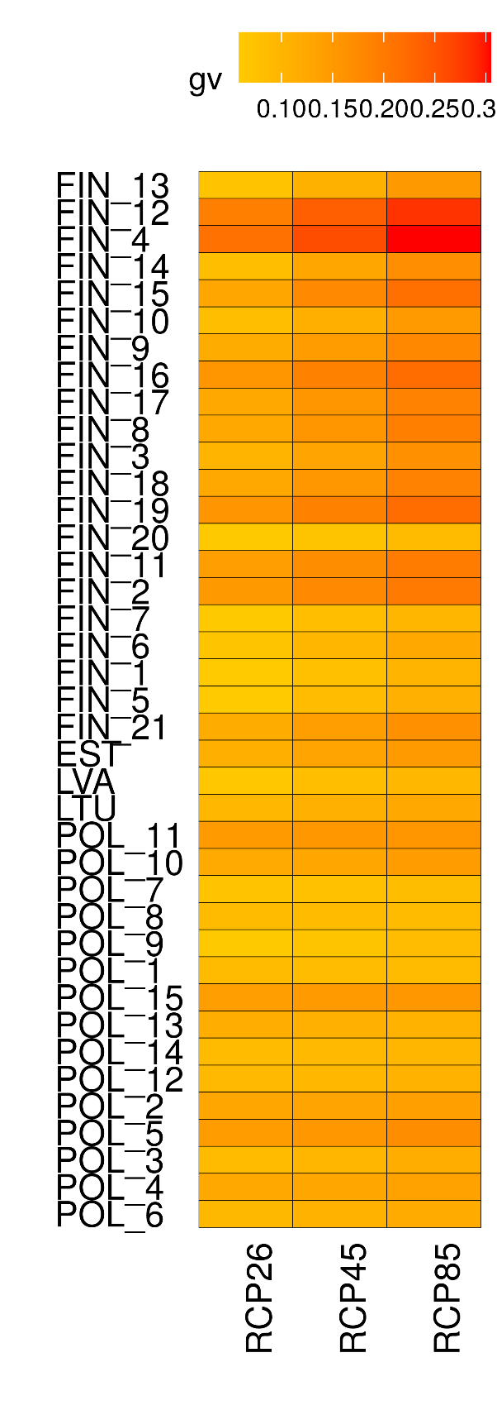
Figure S12. Number of generations required for the shift in allele frequency under selection starting from different initial allele frequencies. The frequency change equal to the maximum value (A) and minimum value (B) of GV (0.09 and 0.3, respectively) was simulated under different selection coefficients (s in range 0.1-0.9) starting from different initial frequencies (0.01 – 0.9) with an increment of 0.01. Left: boxplot of the mean number of generations required for the shift at different values of s. Right – relationship between starting allele frequency and number of generations to shift allele frequency under different selection coefficients.
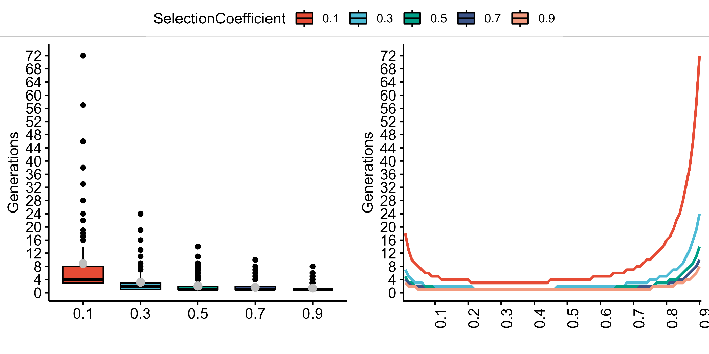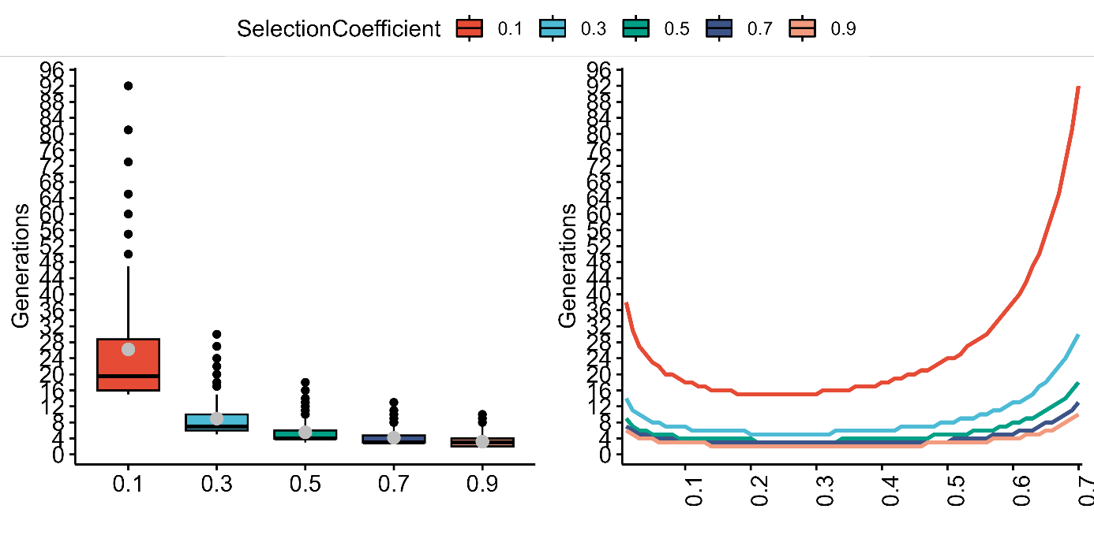
B
A

