A Self-Powered Enzymatic Glucose Sensor Utilizing Bimetallic Nanoparticle Composites Modified Pencil Graphite Electrodes as Cathode
Gamze Emir^{a*}, Yusuf Dilginª, Samet Sahin^{b,c}, Cahit Akgül^{a*}
ªChemistry Department, Faculty of Science, Çanakkale Onsekiz Mart University, Çanakkale, Turkiye
^{b}School of Engineering, Lancaster University, Lancaster, United Kingdom
^{c}Bioengineering Department, Faculty of Engineering, Bilecik Şeyh Edebali University, Bilecik, Turkiye
*e-mail: gamze.emir@comu.edu.tr, cahitakgul@comu.edu.tr

Fig. S1. CVs recorded for the electrochemical deposition of A) Pt-Nps, B) Pd-Nps, and C) Pt-Pd-Nps onto the PGE surface.

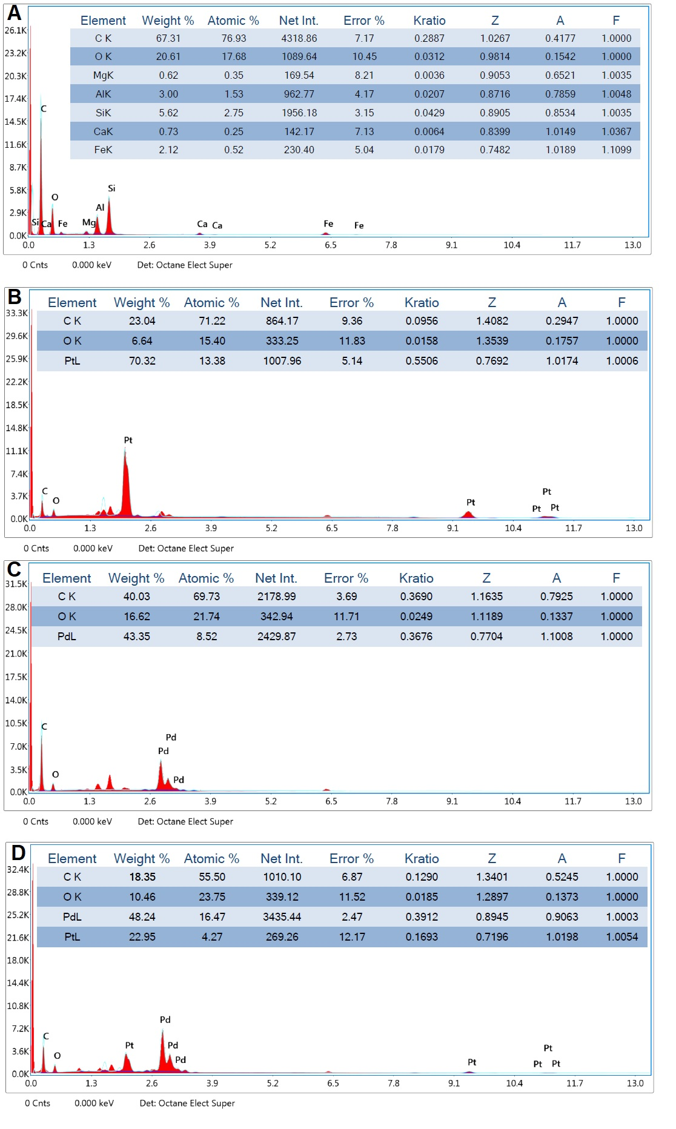
Fig. S2. EDX spectras of of A) unmodified PGE, B) Pt/KGE C) Pd/KGE and D) PtPd/KGE electrodes

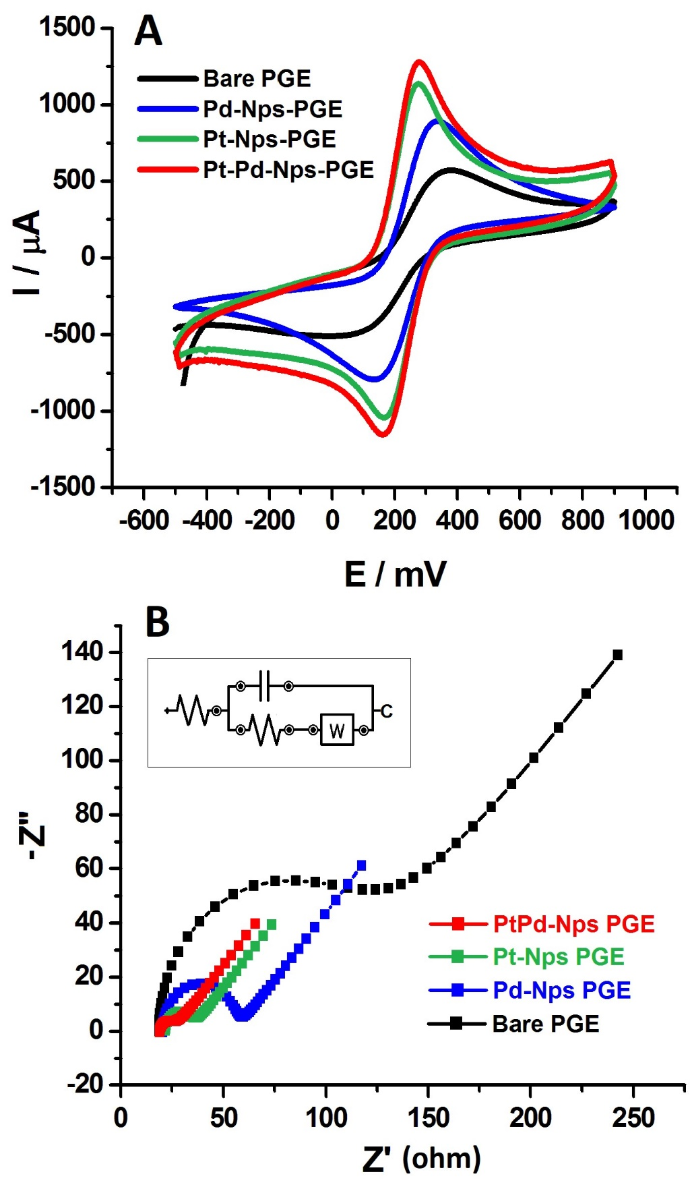

Fig. S3. A) CV and B) EIS of the unmodified PGE, Pt-Nps/PGE, Pd-Nps/PGE and Pt-Pd-Nps/PGE in 5.0 mM Fe(CN)₆^{3-/4-} containing 0.10 M KCl. The frequency range was fixed as 100000 to 0.1 Hz; potential 0.18 V, and sinusoidal signal 5.0 mV for EIS and a scan rate of 20 mV/s was used for CVs.
Fig. S4. Optimization curves of A) MWCNT, B) Fc and C) Gox concentrations obtained from CVs of each electrode prepared under the conditions of studied optimization parameter in 0.10 M pH 7.0 PBS containing 0.1 M KCl and 5.0 mM glucose.

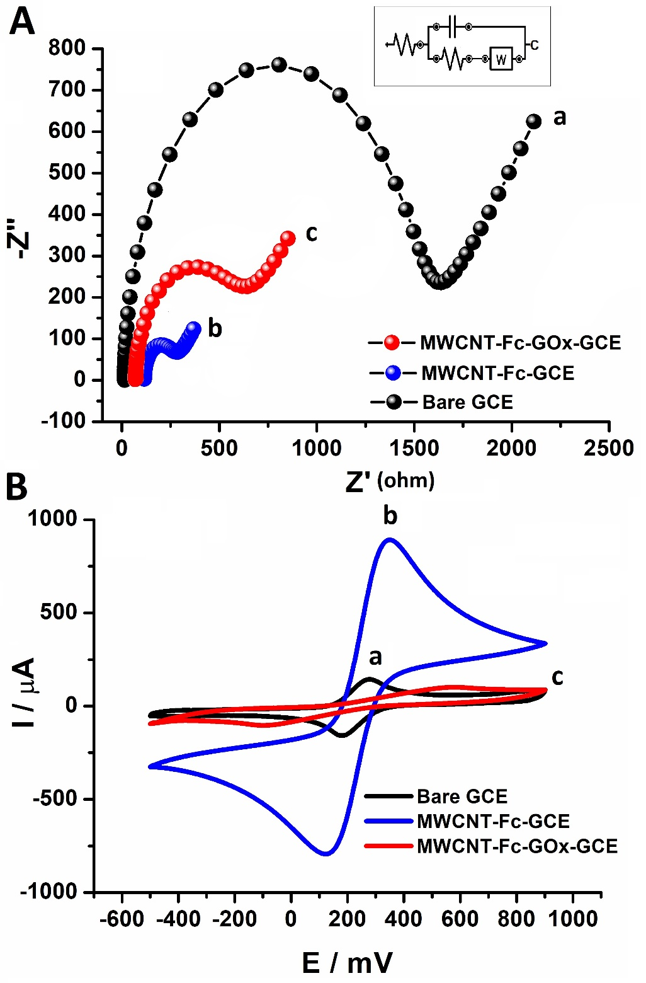

Fig. S5 A) CVs and B) EIS of the (a) unmodified GCE, (b) MWCNT-Fc-GCE, and (c) MWCNT-Fc-GOx-GCE electrode in 5.0 mM Fe(CN)₆^{3-/4-} containing 0.10 M KCl. The frequency range was fixed as 100000 to 0.1 Hz; potential 0.18 V, sinusoidal signal 5.0 mV for EIS, and a scan rate of 20 mV/s was used for CVs.
.
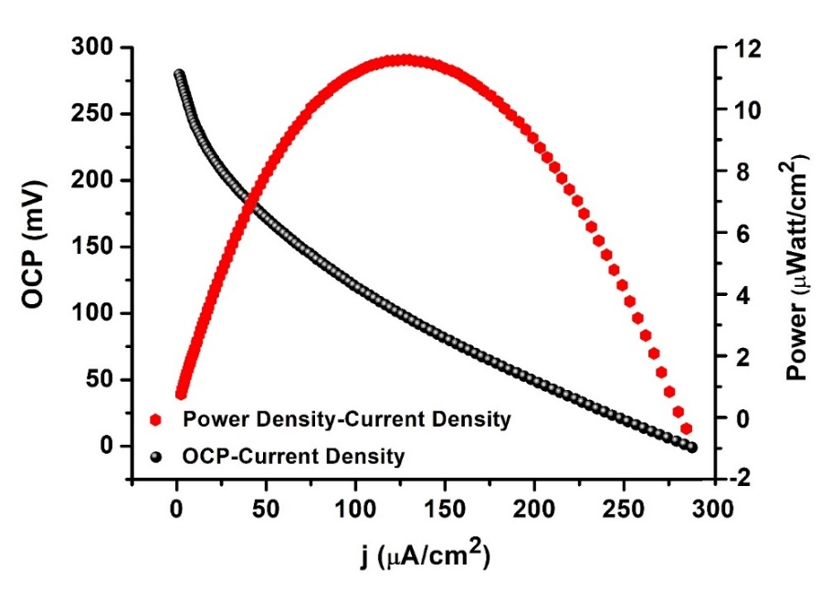
Figure S6. Power and current density curves with designed EBFC under optimized conditions. (0.1 M solution of PBS containing 0.1 M KCl at pH 7.0, 15 min oxygen saturated)

Table S1. The results obtained from the study of interference and interference elimination (using NaBiO₃) for the anode electrode.
Molecules | Analyte: Interference  Concentration | Without  NaBiO₃ | With  NaBiO₃
Glucose
(Analyte)
Fructose | 1:1  Glucose:Fructose | 0.45±0.026 | -
Sucrose | 1:1  Glucose:Sucrose | 0.89±0.068 | -
Maltose | 1:1  Glucose:Maltose | 0.21±0.032 | -
Mannose | 1:1  Glucose:Mannose | 0.15±0.047 | -
Galactose | 1:1  Glucose:Galactose | 0.55±0.086 | -
Glutamic Acid | 1:1  Glucose:Glutamic Acid | 0.96±0.063 | -
Lactose | 1:1  Glucose:Lactose | 1.86±0.074 | -
Sodium Lactate | 1:1  Glucose:Lactate | 1.23±0.019 | -
Uric Acid | 1:1  Glucose:Uric Acid | +82.1±0.096 | +7.3±0.041
Dopamine | 1:1  Glucose:Dopamine | +238.7±0.083 | +6.4±0.037
L-Ascorbic Acid | 1:1  Glucose:Ascorbic Acid | +78.4±0.071 | +0.9±0.078

