Multifunctional nanocomposite assessment using carbon nanotube fiber sensors
Hassaan A. Butt ^{a*}, Dmitry V. Krasnikov ª, Vladislav A. Kondrashov ª,
Boris V. Voloskov ª, Stepan D. Konev ª, Anna I. Vershinina ^{b}, Sergey D. Shandakov ^{b}, Zeyu Wang ^{c}, Alexander M. Korsunsky ^{d}, Ivan V. Sergeichev ª, Albert G. Nasibulin ª*
ª Skolkovo Institute of Science and Technology, Nobel 3, 121205, Moscow, Russia
^{b} Kemerovo State University, Krasnaya 6, 650043, Kemerovo, Russia
^{c} School of Material Science and Engineering, Jiangsu University, 301 Xuefu Road, Zhenjiang, 212013, China
^{d} Fellow Emeritus, Trinity College, Broad Street, Oxford OX1 3BH, UK

*corresponding authors: a.nasibulin@skol.tech, hassaan.butt@skoltech.ru
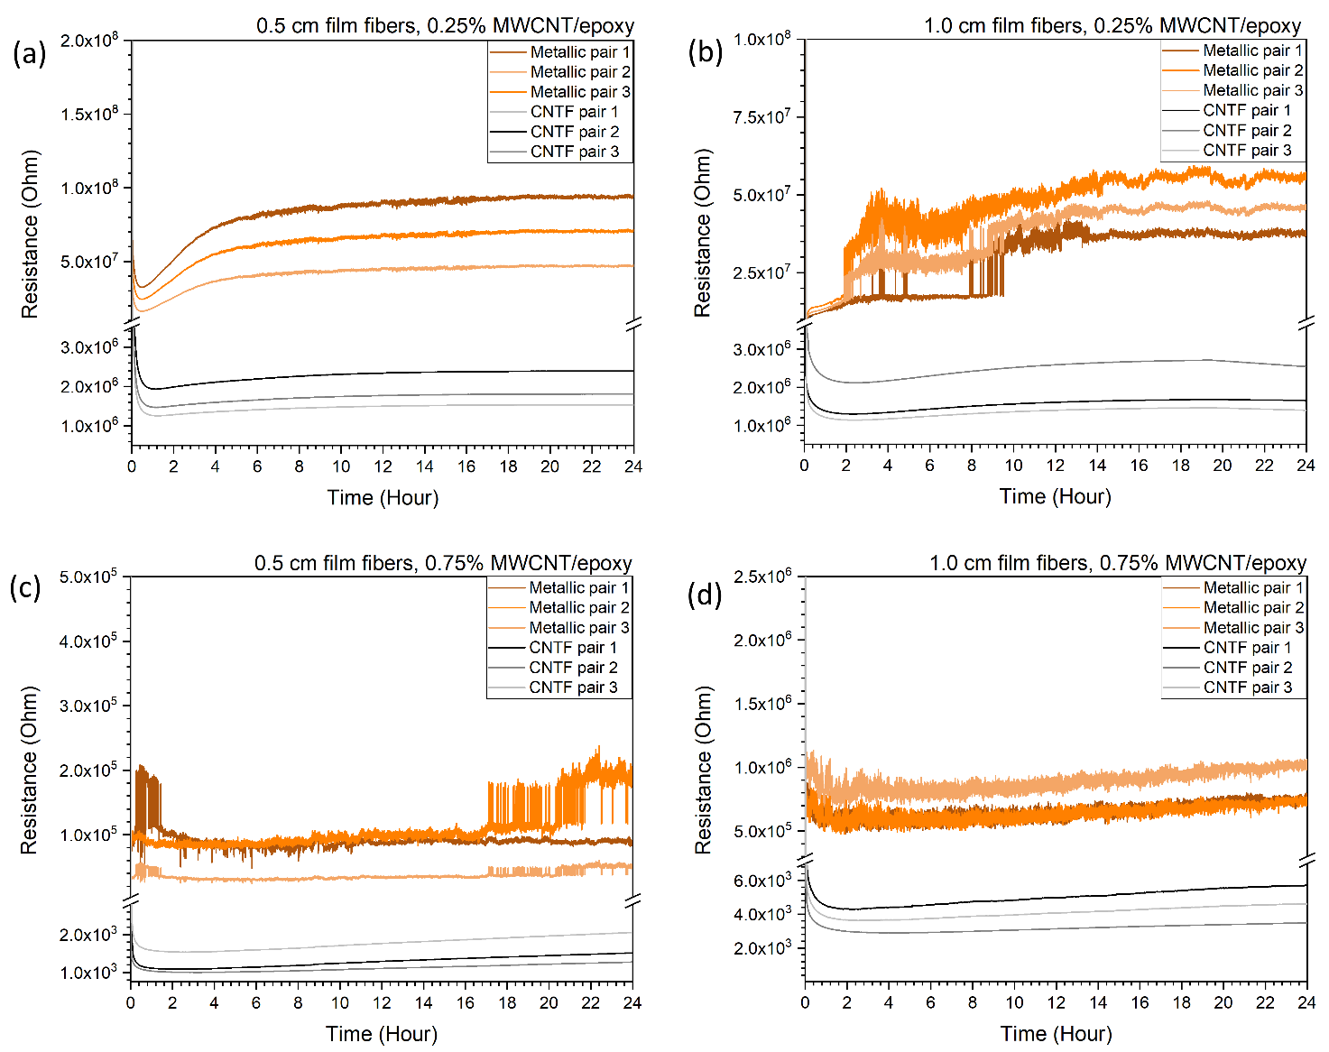
Fig. SI 1 2-point electrical measurements for the MWCNT nanocomposite matrices with (a, c) 0.5 cm and (b, d) 1.0 cm film fibers. Pair = 2 electrodes
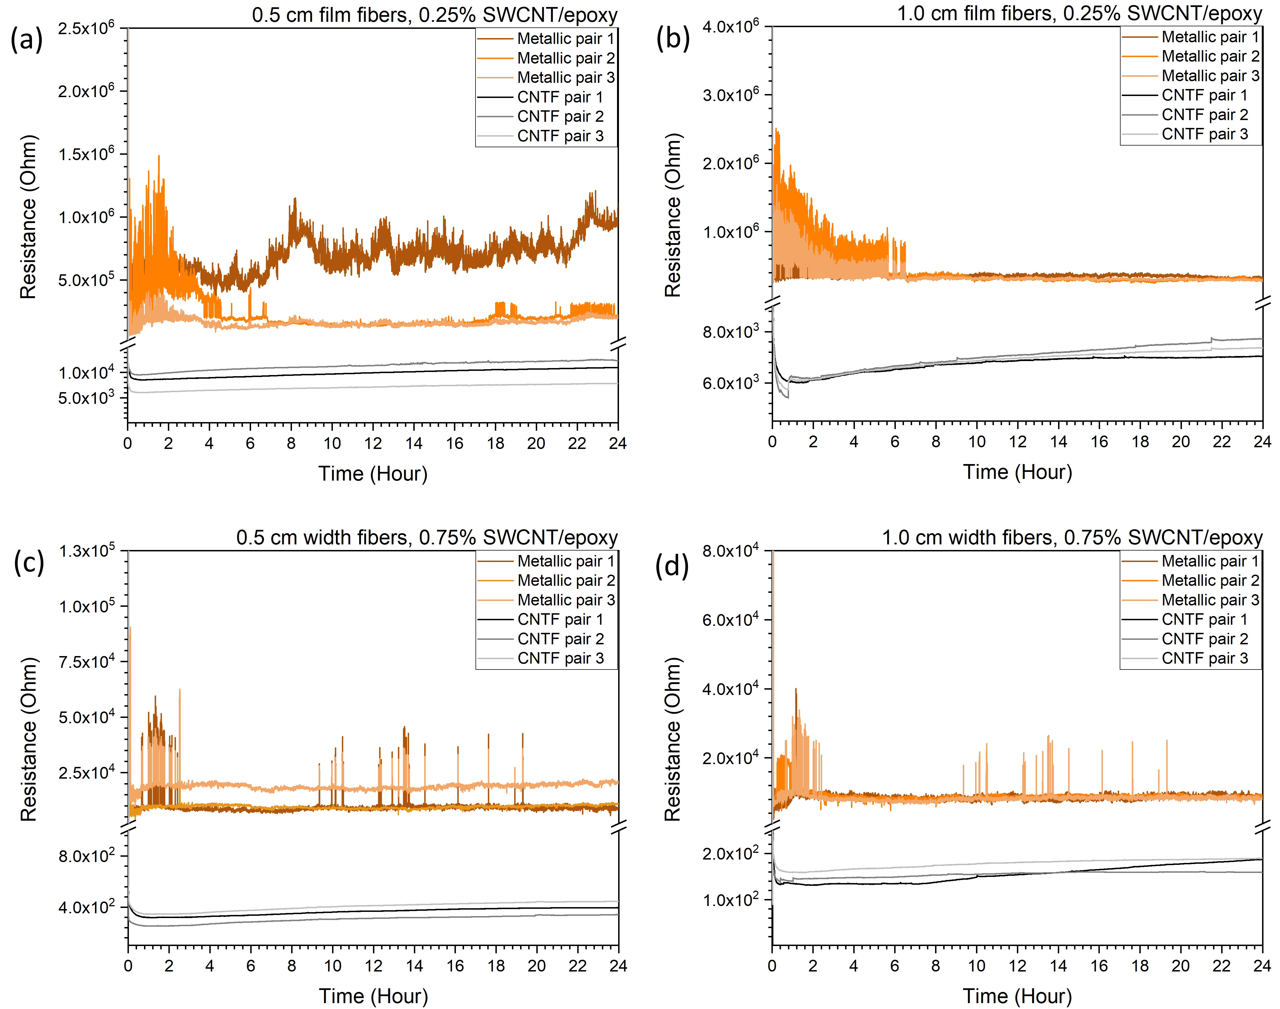
Fig. SI 2 2-point electrical measurements for the SWCNT nanocomposite matrices with (a, c) 0.5 cm and (b, d) 1.0 cm film fibers. Pair = 2 electrodes
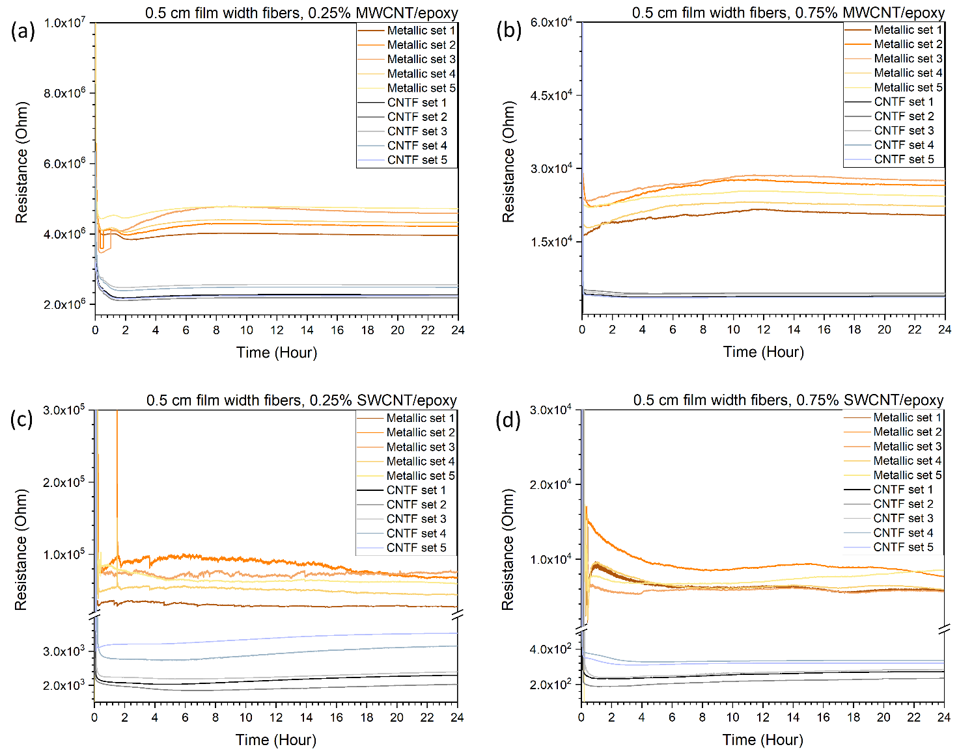
Fig. SI 3 4-point electrical measurements for the nanocomposite matrices with (a, c) MWCNTS and (b, d) SWCNTs. Set = 4 electrodes
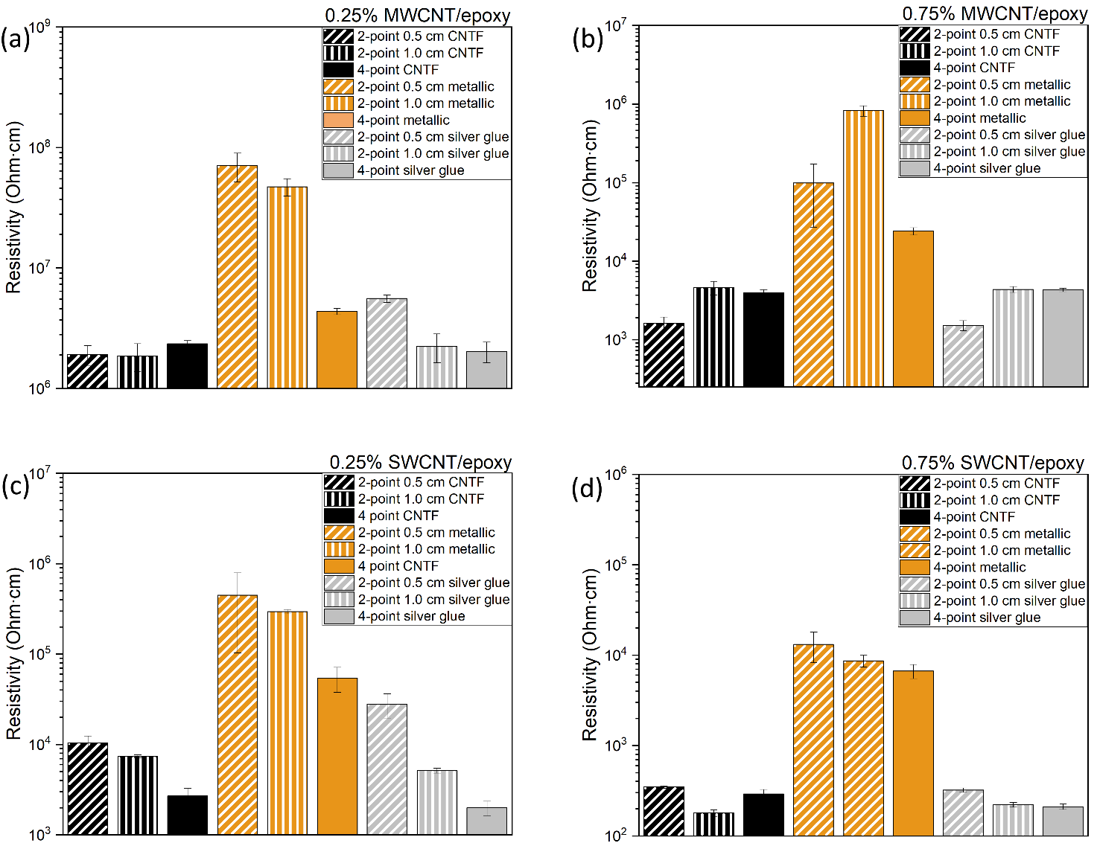
Fig. SI 4 Electrical resistivity measured using the different electrodes and schemes for (a, b) MWCNT and (c, d) SWCNT nanocomposites
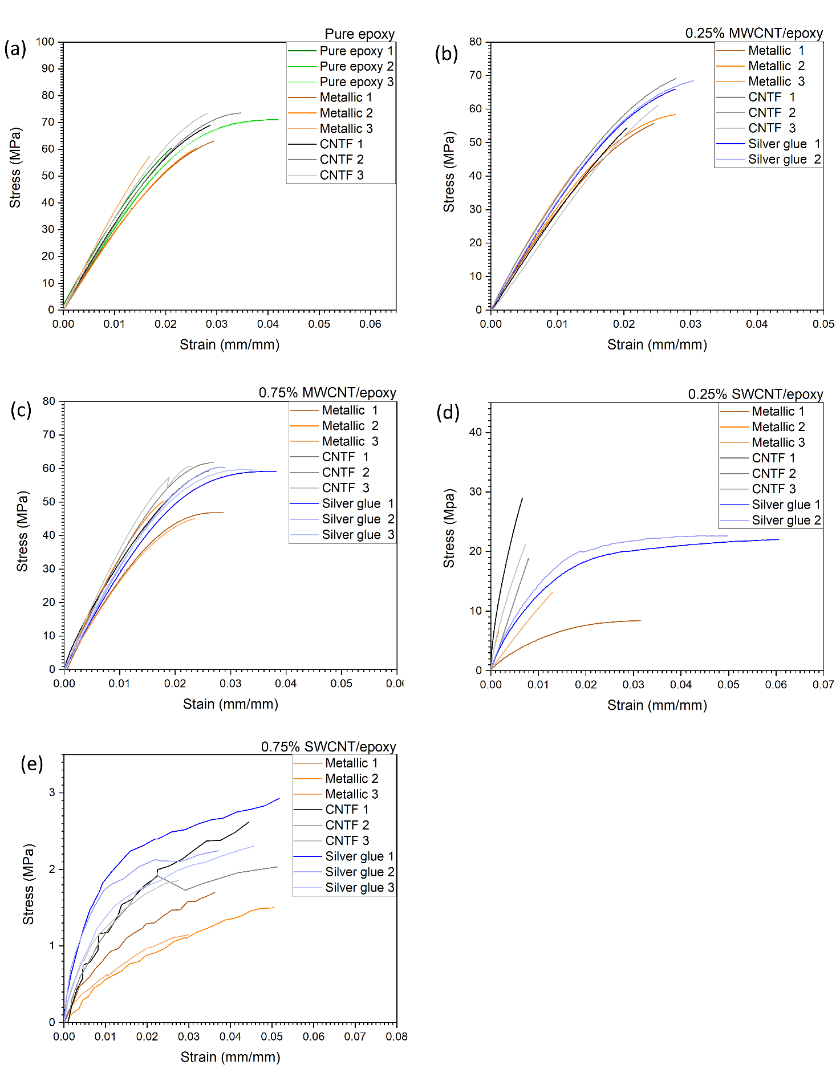
Fig. SI 5 Tensile testing curves for the various electrode systems for (a) pure epoxy and embedded electrodes, (b, c) MWCNT and (d, e) SWCNT nanocomposites

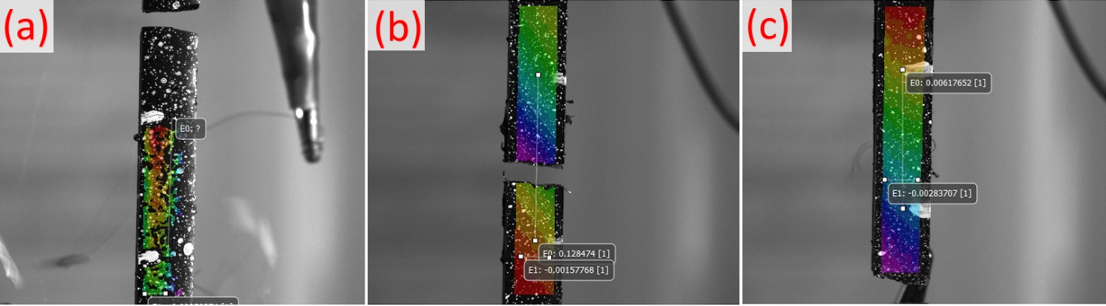
Fig. SI 6 Digital image correlation frames showing (a) detaching of silver-glue electrodes during fracture, (b) fracture taking place along an embedded metallic electrode and (c) CNTF electrodes outside fracture region. Digital extensometers may be ignored
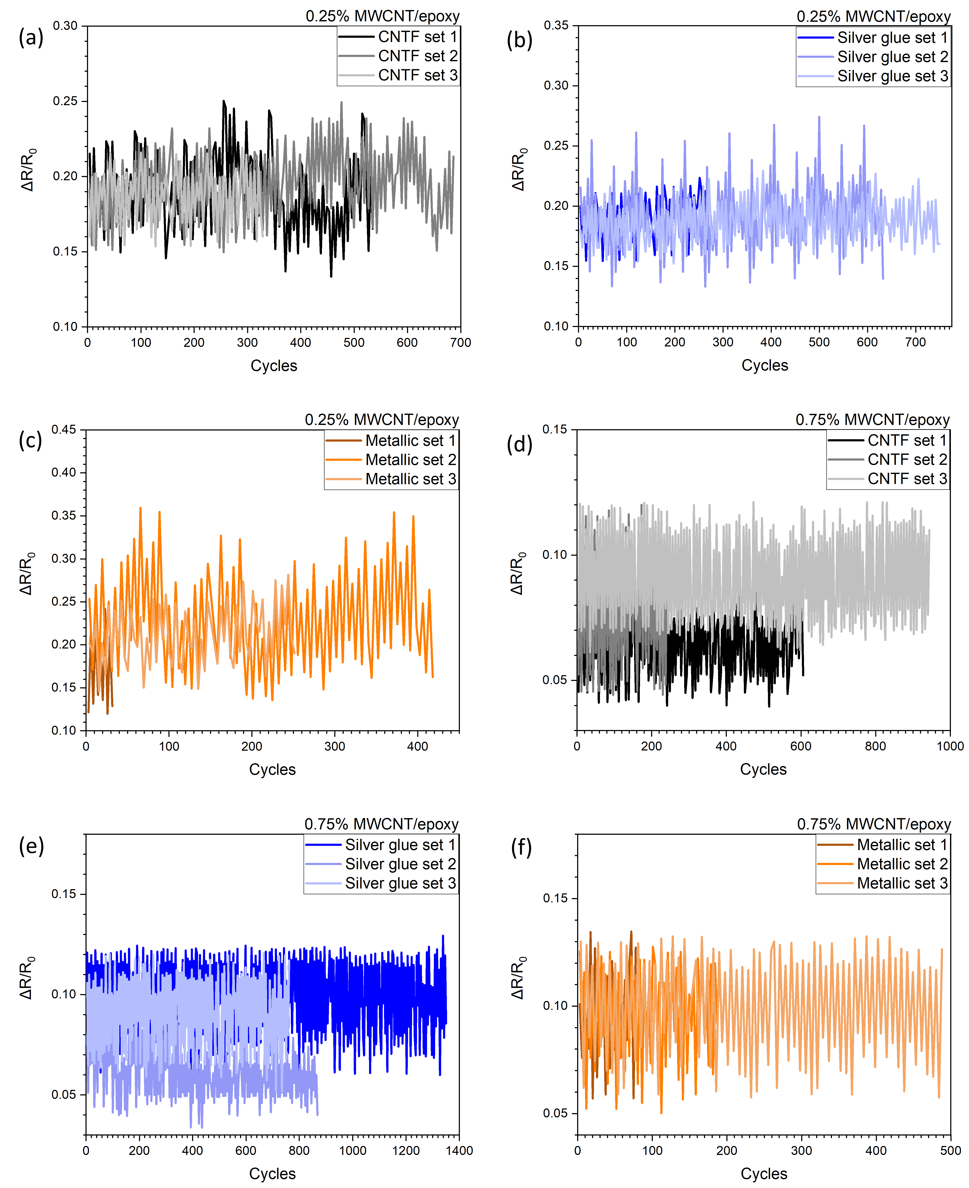
Fig. SI 7 Cyclic response curves for the various electrodes for MWCNT nanocomposites
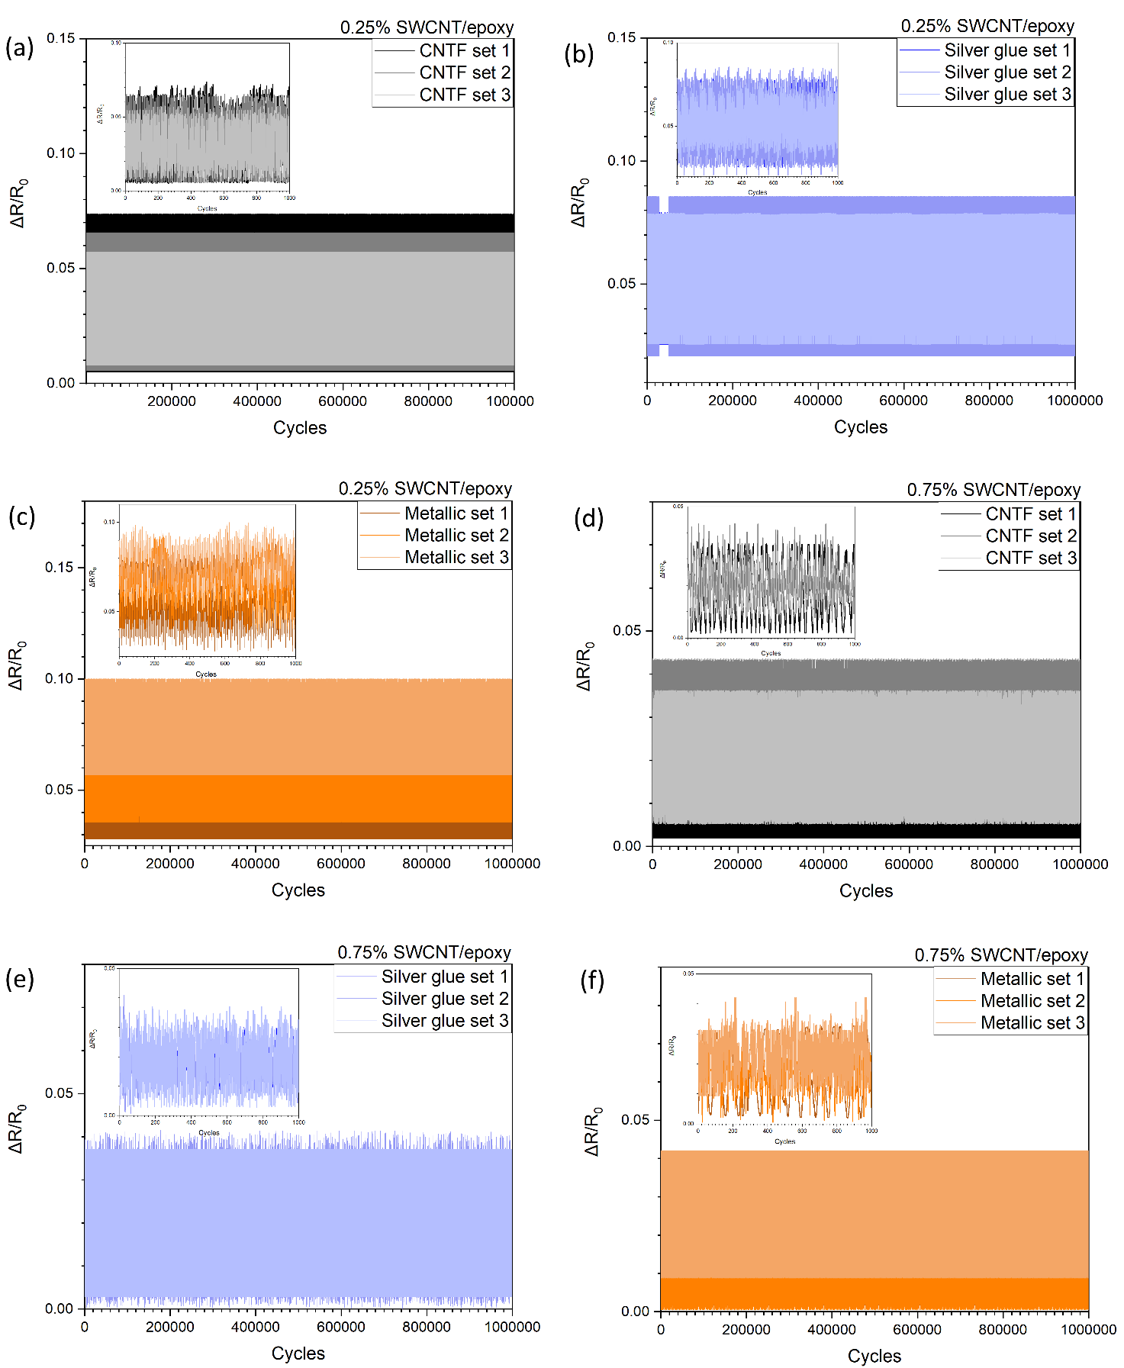
Fig. SI 8 Cyclic response curves for the various electrodes for SWCNT nanocomposites

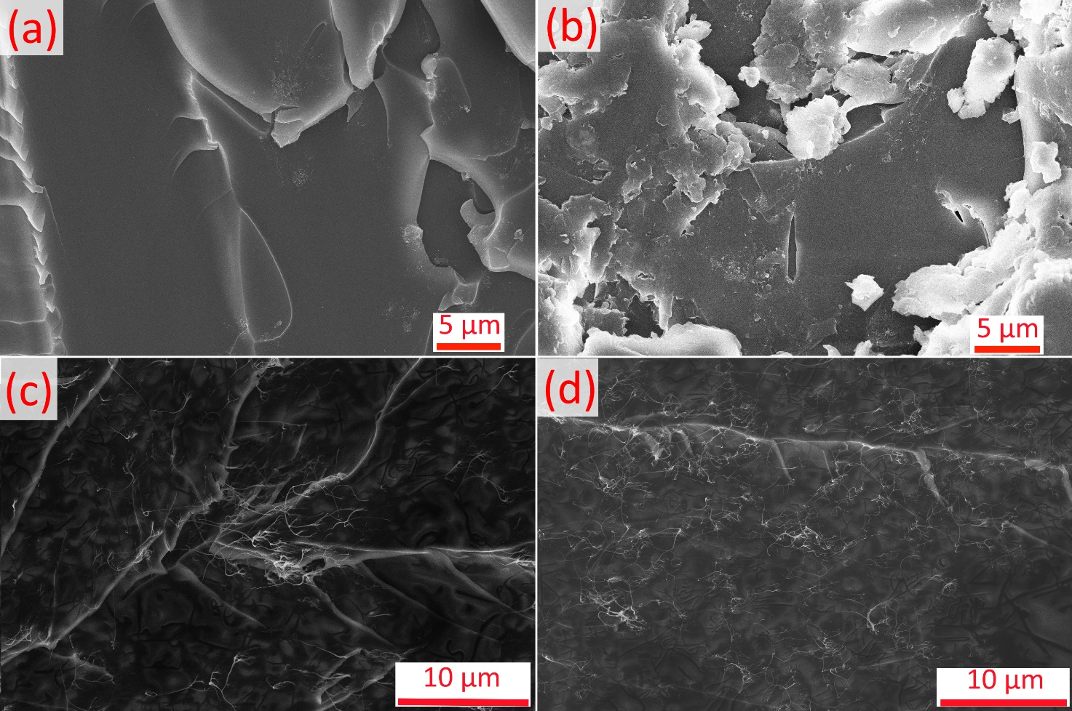
Fig. SI 9 SEM images of matrices with (a) 0.25% MWCNTs, (b) 0.75% MWCNTs, (c) 0.25% SWCNTs and (d) 0.75% SWCNTs
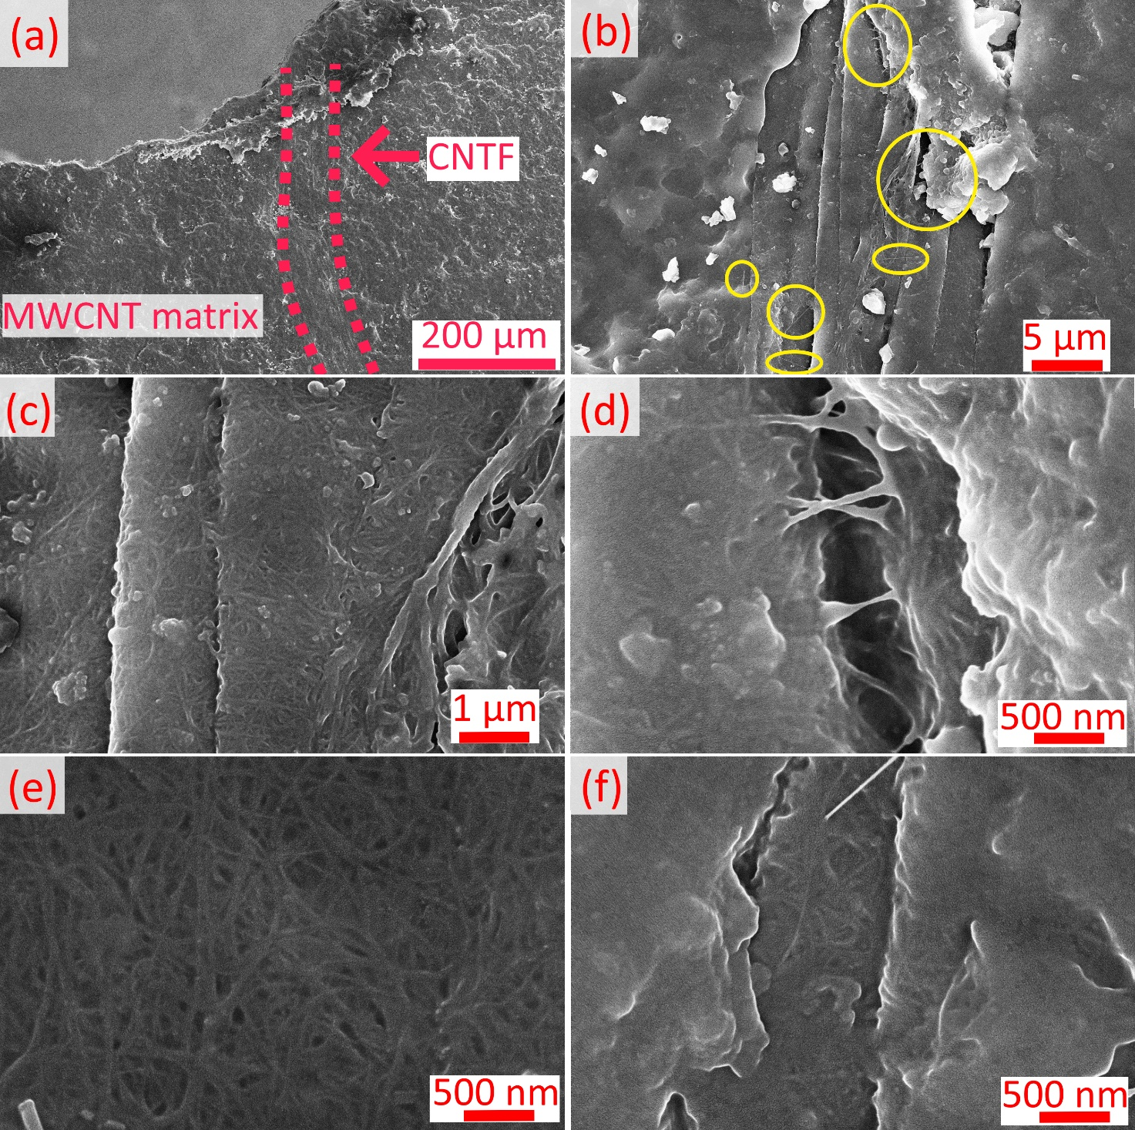
Fig SI 10 SEM images showing (a) complete impregnation of CNTF with nanocomposite matrix, (b) CNT bridging between matrix and fiber, (c) impregnated surface of CNTF with matrix, (d) CNT bridging, (e) surface porosity of CNTF and (f) impregnated surface porosity with CNT bridging

