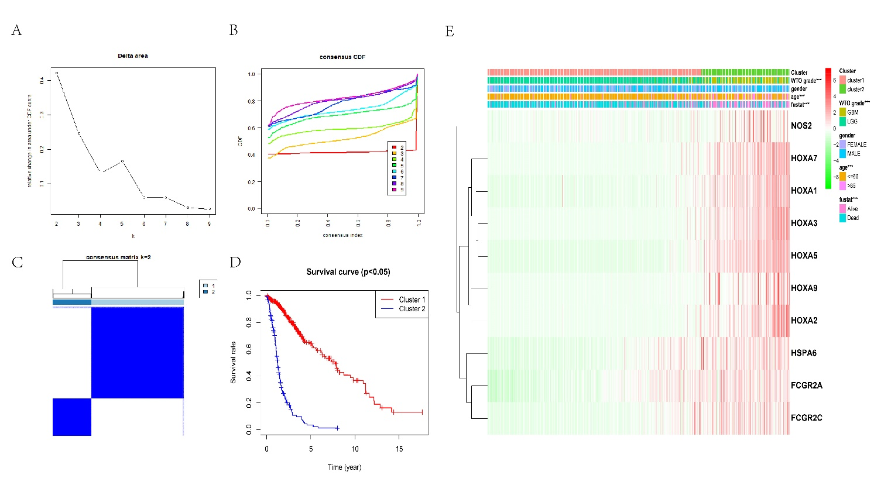
Fig. S1 The prognosis and clinical features of samples in the validation subtype. A relative variation in the CDF curve's area under k = 2-9. B CDF curve for k = 2-9. C Mapping of consensus clustering for k = 2. D The cluster 1 OS was much shorter than cluster 2. E Clinicopathologic characteristics and a heatmap of the two subtypes based on the expression of SEs. ***p < 0.001
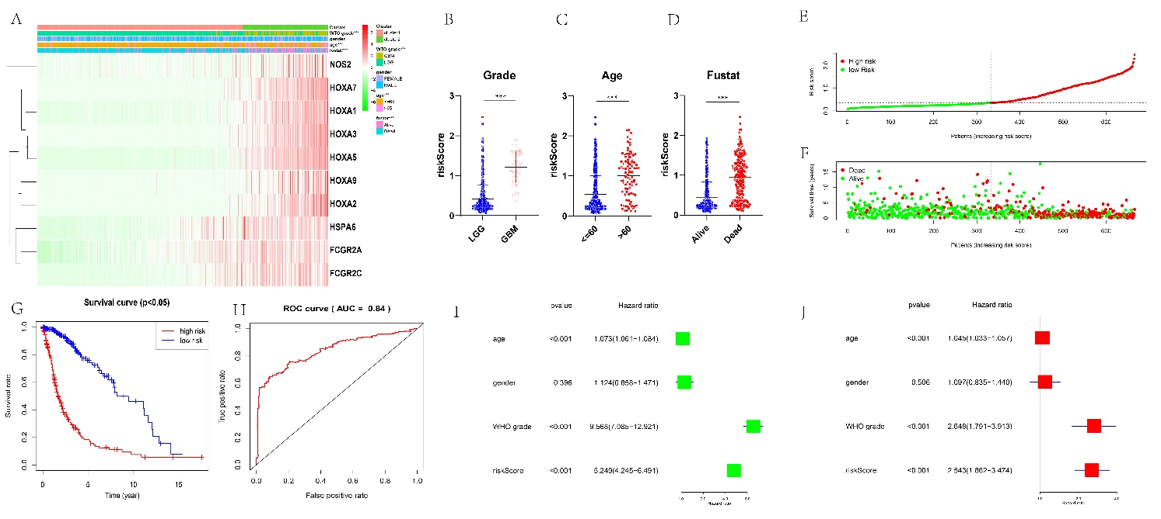
Fig. S2 Verifying the risk model in the TCGA subtype. A 10 SE-associated gene expression levels and the distribution of clinicopathological traits. B–D Various risk degrees for glioma patients clarified by WHO grade, age, survival status. E-F The validation subtype's risk score and survival status distribution plots. G–H The calibration curve predicted OS and AUC values. I-J Univariate and Multivariate Cox regression algorithm of clinicopathological feature difference. ***p < 0.001
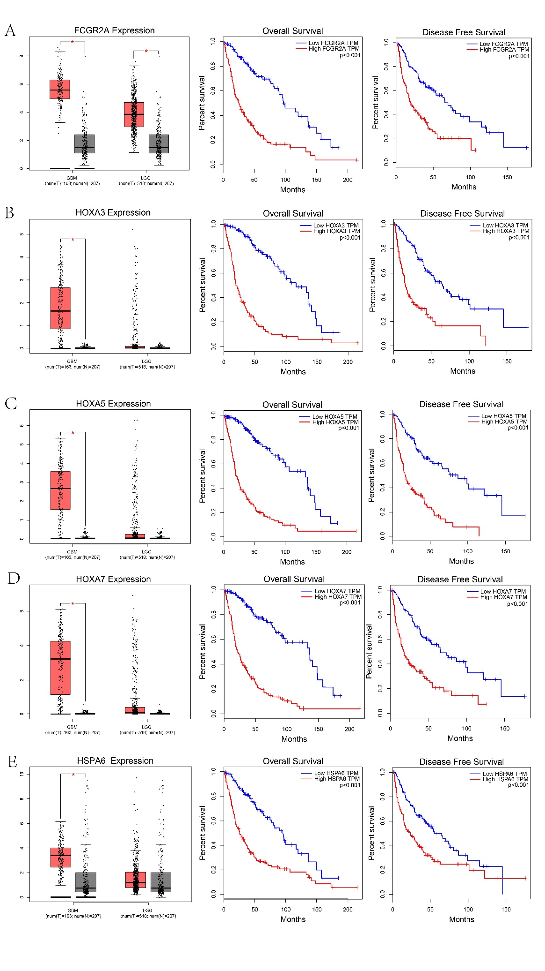
Fig. S3 Prognosis and expression for SE-associated genes. A-E Expression difference and survival prognosis of SE-associated gene FCGR2A (A), HOXA3 (B), HOXA5 (C), HOXA7 (D), HSPA6 (E) among the Normal, LGG and GBM from the GTEX and TCGA databases. *p < 0.05

