Study protocol
Comparison of Low-Pressure and Standard-Pressure Pneumoperitoneum Laparoscopic Cholecystectomy in Patients with Cardiopulmonary Comorbidities: A Double Blinded Randomized Clinical Trial
Principal investigator:
Feng Tian, MD
Department of General Surgery, Peking Union Medical College Hospital, Chinese Academy of Medical Sciences and Peking Union Medical College, Beijing 100730, China. E-mail: andytianfeng@126.com
Fellow investigators:
Xiaowei Sun, MD, ² Yang Yu, MD, ³ Ning Zhang, MD,¹ Tao Hong, MD,¹ Lu Liang, MD, ³ Bihui Yao, MD, ³ Lei Song, MD, ³ Changhong Pei, MD, ² Yu Wang, MD, ² Wenlong Lu, MD, ² Qiang Qu, MD, ¹ Junchao Guo, MD, ¹ Taiping Zhang, MD,¹ Xiaodong, He, MD ¹
¹Department of General Surgery, Peking Union Medical College Hospital, Chinese Academy of Medical Sciences and Peking Union Medical College, State Key Laboratory of Complex Severe and Rare Diseases, Beijing 100730, China. E-mail: andytianfeng@126.com
² Department of General Surgery, Baoquanling Hospital of Beidahuang Group，Heilongjiang 154211, China.
³ Department of General Surgery, Baotou Central Hospital, Baotou, Inner Mongolia Autonomous Region 014040, China
Trial Registration: ClinicalTrials.gov [NCT04670952].
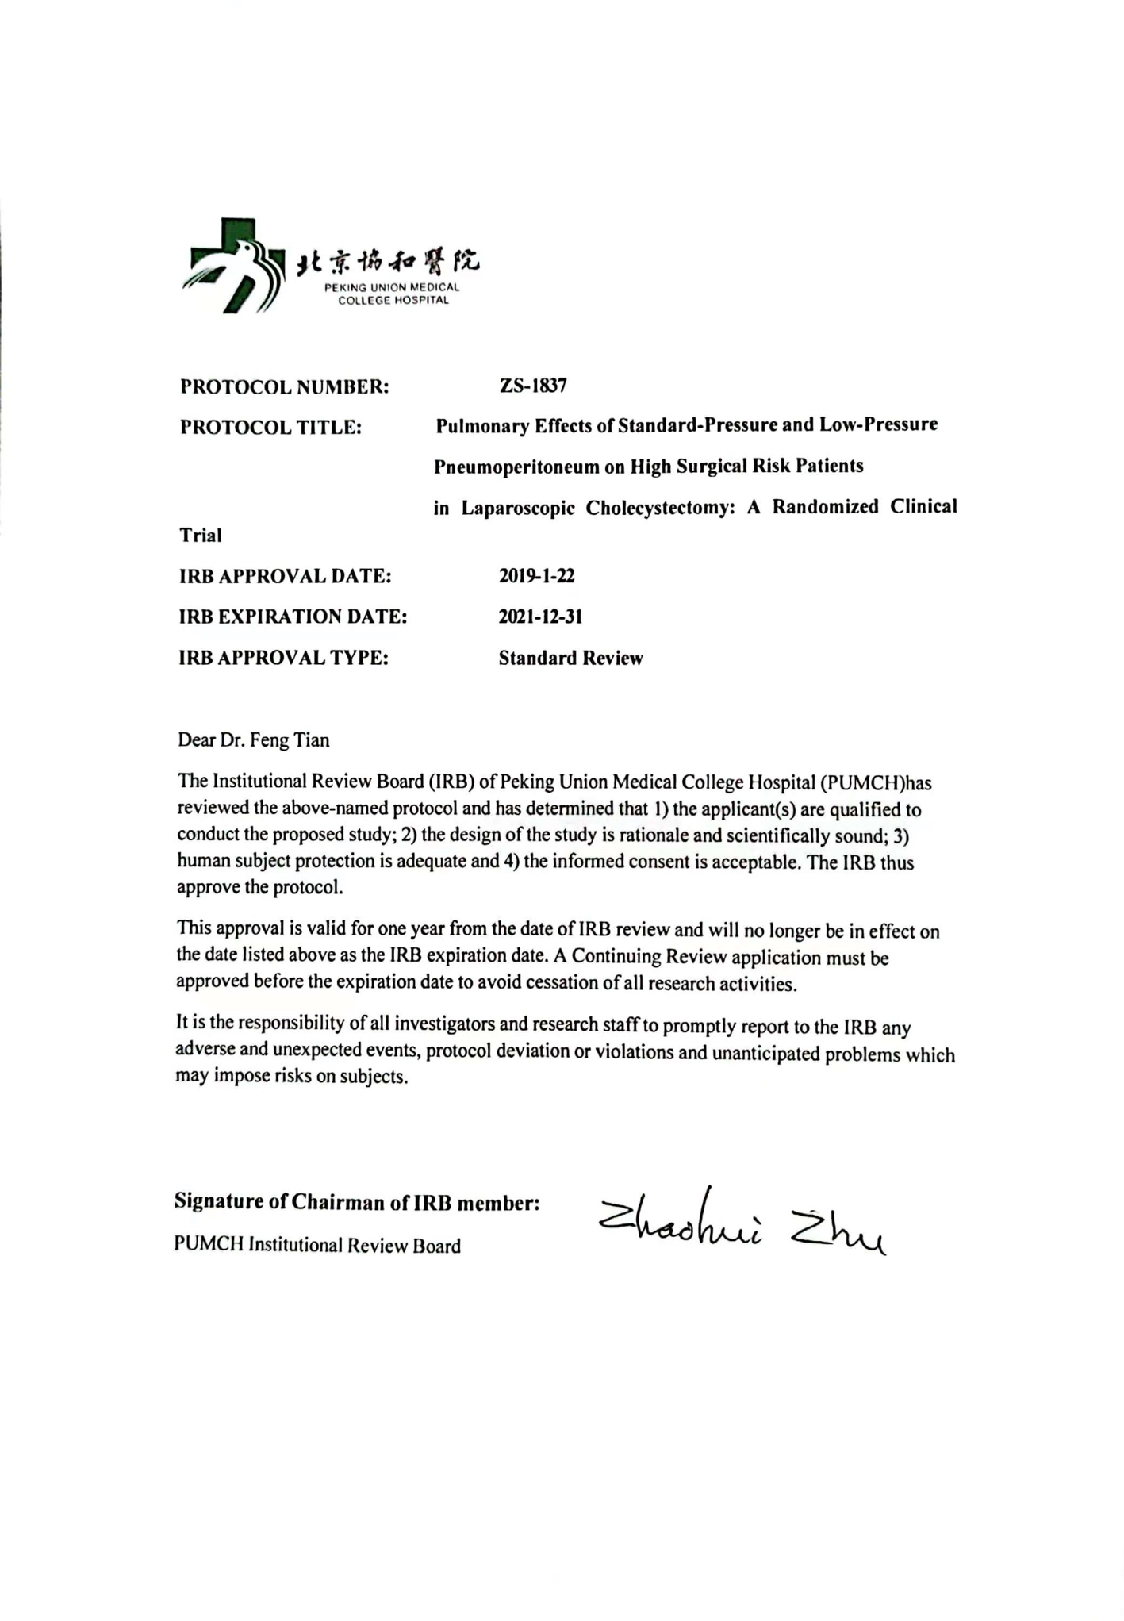
Abstract
Background
Laparoscopic cholecystectomy (LC) reduces complication rates and enhances patient recovery when com paring traditional open cholecystectomy. For decades, LC has been the standard procedure for symptomatic gallstones or high-risk gallbladder polyps. However, CO₂ inflation causes surgical stress and changes in blood circulation and pulmonary compliance. To minimize the effect of pneumoperitoneum, the concept of low-pressure pneumoperitoneum was introduced.
Existing studies have reported that low-pressure laparoscopic cholecystectomy (LPLC) potentially minimizes postoperative pain and improves other physiological functions. However, most studies on LPLC enroll patients with low anesthetic risk. The role of LPLC in high-risk population or patients with cardiopulmonary comorbidities is unclear, and high-quality evidence currently lacking. LPLC might benefit pulmonary parameters. Identification of an optimal maintenance pressure to minimize the impact of pneumoperitoneum while providing an adequate surgical working space is important.
Prospective randomized controlled trials (RCTs) comparing LPLC and standard-pressure laparoscopic cholecystectomy (SPLC) are required. Thus, we begin an RCT to assess and compare the safety and potential benefits of LPLC (10 mmHg) with those of SPLC (14 mmHg) in elderly patients and patients with cardiopulmonary disorders.
Methods: This is a randomized, multi-center clinical trial. All included participants are adults with gallbladder stones or polypoid lesions, in whom LC procedures are planned. Included in this trial are at least 140 patients meeting the criteria. The primary outcome is the rate of Level 3 surgeon comfort during operation. Secondary outcomes include other arterial blood gas parameters, any postoperative 30-day morbidity and mortality, and postoperative recovery variables.
Discussion: Although LPLC might reduce postoperative pain as reported in most previous studies. However, the role of LPLC in elderly patients or patients with cardiopulmonary disorders, is unclear. One of the reasons is the lack of RCTs focusing on the high risky population and pulmonary effects due to CO₂ pneumoperitoneum. To evaluate the potential benefit of LPLC in patients with cardiopulmonary comorbidities, we therefore undertake this RCT. The obtained results will be meaningful for figuring out the role of LPLC and its adaptive expansion for these patients.
Keywords: Laparoscopic cholecystectomy; Low-pressure pneumoperitoneum; Standard-pressure pneumoperitoneum; cardiopulmonary comorbidities; PaCO₂.

Backgrounds
For decades, laparoscopic cholecystectomy (LC) has been considered the standard procedure for symptomatic gallstones or risky polyps of the gallbladder. LC procedures are generally performed by inflating the abdomen with carbon dioxide (CO₂) gas to create surgical working space. A pneumoperitoneum pressure of 12 to 16 mm Hg is generally thought to be standard and has been proven to be safe ¹. However, LC could cause 15-35% pulmonary atelectasis on postoperative day one based on chest images. ²⁻³ To minimize the effect of pneumoperitoneum, the concept of low-pressure pneumoperitoneum (in the range of 7–10 mm Hg) was introduced ⁴.
Previous retrospective and randomized studies have claimed that low pressure laparoscopic cholecystectomy (LPLC) improves post-operative pain, and other physiological functions ⁴⁻⁶. Previously in 2014, a detailed Cochrane systematic review concluded that the safety of LPLC has not been completely established because the overall quality of existing evidence was estimated as low or very low ¹. The reasons for this may be as the follows. First, most of the trials reviewing LPLC enrolled low anesthetic risk participants undergoing elective laparoscopic cholecystectomy. Evidence focusing on high-risk patients with cardiopulmonary co-morbidities, who are less well tolerated to pneumoperitoneum, lacks. Second, primary outcomes of most studies focused on post-operative pain and analgesia requirements, rare studies paid attention to estimate of the CO₂ pneumoperitoneum impact on homeostasis such as cardiopulmonary parameters ⁷. Third, the definitions of “low” (from 6-10 mmHg) or “standard” (from 10-16 mmHg) pressure varies in the literature and no universal definition is available. Extreme lower pressure may limit and working space, possibly resulting in deputy injury to the adjacent organs. Thus, it’s important to identify an optimal maintenance pressure to minimize the impact of pneumoperitoneum while providing adequate surgical working space. Fourth，for short-period procedure like LC, it is difficult to select proper respiratory parameters at proper time-point because there are too many perioperative factors affecting respiratory function. More measurable parameters are needed to precisely reflect the outcome caused by different pneumoperitoneum pressure.
Hence, high-quality and powered evidence is required to clarify the role of LPLC in elderly or patients with cardiopulmonary comorbidities ¹. The present randomized controlled trial (RCT) compares the safety and potential benefits of LPLC (10 mmHg) and standard pressure laparoscopic cholecystectomy (SPLC, 14mmHg) for high surgical risk patients.
METHODS
Study objectives
This RCT aims to demonstrate the safety and potential benefits of LPLC (10mmHg) over SPLC (14mmHg) for patients with cardiopulmonary comorbidities.
Study setting
Multicenter, parallel, double-blind, randomized controlled trial.
Outcomes and definitions
The primary outcome measure is the Level 3 surgeon comfort during operation.
Surgeon comfort (combined perception of intraoperative visibility and working space) was assessed by interview and scored after surgery using a Likert scale as follows: Level 1, indicates unsatisfied with intraoperative visibility or working space, need to increase pneumoperitoneum pressure; Level 2, nearly excellent, but did not affect operation and there was no need to increase pneumoperitoneum pressure; Level 3, excellent, adequate view and working space. In cases involving poor comfort, the surgeon could request an increase in pneumoperitoneal pressure.
Secondary outcomes include arterial blood gas (ABG) parameters, postoperative 30-day morbidity and mortality, and postoperative recovery.
Other ABG parameters included pH, bicarbonate [HCO₃]⁻, lactate, base excess (BE), and derivative parameters such as pH post/pH pre, pCO₂ post/pCO₂ pre, HCO₃⁻ post/HCO₃⁻ pre, BE post/BE pre, lactate post/lactate pre, and pHpost-pHpre.
Mortality was defined as all-cause death within 30 days of surgery. Intraoperative complications were unexpected adverse events during surgery, such as iatrogenic bile duct injury, bowel or other organ injuries, hemorrhage, intraoperative bile spillage, and conversion to open surgery. Postoperative complications were adverse events within 30 days after surgery, including surgery-related complications, such as bile leakage, subcutaneous emphysema, and delayed wound healing; cardiopulmonary events, such as angina pectoris, myocardial infarction, arrhythmia, heart failure, hypoxemia, atelectasis, pulmonary infection, pulmonary embolism.
Baseline characteristics, the American Society of Anesthesiologists (ASA) classification, the intra-abdominal operative time (start of CO₂ inflation to end of CO₂ release), anesthetic duration (patient asleep to patient awake), intraoperative estimated blood loss (EBL), blood transfusion, drainage placement, and other adverse events within 30 days after surgery are recorded. Complications are graded according to the Clavien–Dindo classification.⁸
Perioperative pain is assessed using a visual analog scale (VAS) from 0 (no pain) to 10 (worst pain ever felt). All surgery-related pain sources, including visceral, incisional, and shoulder-related, are assessed. The VAS score is recorded for the worst pain source before surgery, immediately after the patient returned to the ward, and 6, 9, 12, 18, and 24 h thereafter, excluding sleep time.
Sample size
A “noninferiority test” is used to estimate the sample size based on previous studies, we estimated that 140 participants (1:1 match; 70 in each group) would be required to detect a 10% change in Level 3 surgeon comfort, with a 5% α error and 80% power.
Eligibility criteria for participants
Patients scheduled for elective LC are candidates for recruiting. Patients undergo abdominal ultrasonography and/or computed tomography (CT) scan to affiliate the diagnosis and surgical plan.
Inclusion criteria
- Hypertension
- Diabetes mellitus
- Coronary heart disease
- Arrhythmia
- Chronic bronchitis
- Chronic emphysema
- History of cardiac, lung, or mediastinal surgery
- History of asthma.
Exclusion criteria
- Participants with contraindications to laparoscopic surgery
- Having a history of major upper abdominal surgeries
- Participants requiring surgery more extensive than LC
- Participants refusing to participate in the trial.
Eligibility criteria for centers and surgeons
To minimize surgeon-related bias, participating surgeons satisfy the following criteria.
Only centers with annual volume of more than 100 LCs are considered eligible to participate the trial.
Surgeon experience of more than 50 LC procedures is eligible for patient management.
Before working, all participating surgeons attend workshops and learn instructions oriented by the principal investigator (FT, XWS, and YY) of each center.
Randomization, concealment and masking
Random numbers are pre-generated using SPSS®, and grouping information is kept in opaque, consecutively numbered envelopes. Enrolled participants are randomized to undergo either LPLC or SPLC. At the beginning of surgery, a coinvestigator not involved in the surgery or data collection and analysis consecutively opens the envelopes and set the assigned pressure on the pneumoperitoneum machine, which is covered with an opaque card to ensure blinding of the operators for both groups.
The participants and surgical team (including operators, assistants, and care providers in the surgical ward) are blinded to the intervention during the entire perioperative care process.
Data collection and statistics
Data is collected and recorded prospectively for all participants including medical history, physical examination, laboratory data, pathologic examination, surgeons’ comfort during operations, morbidity and mortality occurring within 30 days after surgery. Data is collected on case report form (CRF). All handling cases are managed by hospital identification code. Documents with anonymizing code and names are kept in a lockable document storage at PUMCH. All statistical analyses were performed using SPSS® version 23.0 (IBM). Continuous variables are expressed as mean (SD) or median (range). Categorical variables are shown as frequencies and percentages
Anesthesia induction and surgical procedures
Participants are randomized before general anesthesia induction. A standard anesthesia protocol is used for all participants, who are premedicated with dexamethasone 5 mg and midazolam 1 mg 2 min before anesthesia induction. Anesthesia is induced using 2 mg/kg propofol and 1–2 μg/kg fentanyl. Tracheal intubation is accomplished with 0.8 mg/kg rocuronium bromide. Anesthesia is maintained with 2 μg/kg/h remifentanil, sevoflurane (minimum alveolar concentration, 0.9–1.0), and 50% air in 50% oxygen through a breathing circuit. An incremental fentanyl dose is used to maintain intraoperative analgesia.
LC in both groups is performed using a three-port technique with a Karl–Storz laparoscope. After the CO₂ pneumoperitoneum is established via a Verres needle, a 10 mm umbilical trocar was placed. Two more trocars (10 mm trocar at the supraxiphoid and 5 mm trocar at the upper right quadrant) are placed after laparoscopic exploration. Calot’s triangle is dissected to achieve the critical view of safety. After identification, the cystic duct and cystic arteries are clipped and cut. Finally, the gallbladder is separated from the liver bed and removed.
Abdominal drainage is implemented only for patients with a high risk of hemorrhage or bile leakage, which is decided by the surgeon based on intraoperative factors. At the end of the surgery, port site infiltration for analgesia is not performed.
Follow-up
All participants are followed up for 30 days after surgery, which is performed by the treating physician in the outpatient clinic or via phone calls. Evaluation of chief postoperative complaints focus on cardiopulmonary events, abdominal physical examinations focus on wound healing, and routine blood and liver function tests when required are the main follow-up contents. Given the ethical constraints, chest X-rays or computed tomography scans were not routinely obtained unless symptoms pertaining to the chest or abdomen, such as chest pain, panic, dyspnea, and abdominal pain, were reported by the patients.
DISCUSSION
Previous studies comparing LPLC and SPLC have demonstrated that LPLC significantly decreases postoperative pain during the early recovery phase^{1,4}. Nonetheless, previous studies mainly enrolled low-risk patients who can tolerate pneumoperitoneum. Rare studies have focused on patients with cardiopulmonary comorbidities. Thus, the safety and efficacy of LPLC for patients with cardiopulmonary comorbidities remain unknown. Therefore, we proceed a prospective RCT to verify the feasibility of LPLC in these population. The results of our study will be meaningful for interpreting the role of LPLC for patients with cardiopulmonary comorbidities, and exploring the indication of LPLC.
This study has several limitations. First, all participating surgeons are experienced specialists, whereas LCs are usually performed by general surgeons with lesser experience. This may limit the generalizability of LC under a 10-mmHg pneumoperitoneum pressure.
Trial status
It was registered on the trial registration: ClinicalTrials.gov [NCT04670952]. The trial is open for recruitment from January, 2019.
Abbreviations
LC: Laparoscopic cholecystectomy (LC), LPLC: low-pressure laparoscopic cholecystectomy, SPLC: standard-pressure laparoscopic cholecystectomy, RCT: randomized controlled trial, DSMB: data and safety monitoring board.
Declarations
Acknowledgements
Not applicable.
Funding
This study was supported by the Bethune Charitable Foundation (Identifier: FW-HXKT2019013000198). The funders play no role in the study design, statistical analysis, and manuscript drafting.
Availability of data and materials
Data sharing is not applicable as no datasets are generated or analyzed at the current status.
Authors’ contributions
FT, XWS, YY, JCG, and XDH designed the protocol and drafted the manuscript. FT, XWS, YY performed the statistical analysis. FT wrote the manuscript, XWS and YY further aided in assessment and revision of the protocol. All authors read and approved the final version of the protocol.
Ethics approval and consent to participate
The study is conducted in accordance with the Declaration of Helsinki. WMUH Institutional Review Board approved the final version of the protocol (version 1.0) prior to the start of the study (approval number: 2283). This study was registered on the University Hospital Medical Information Network Clinical Trials Registry (UMIN000031536). We will obtain informed consent from all participants in the study.
Consent for publication
Not applicable.
Conflicts of Interest
The authors have no conflicts of interest to disclose.

References
1. Gurusamy KS, Vaughan J, Davidson BR. Low pressure versus standard pressure pneumoperitoneum in laparoscopic cholecystectomy. Cochrane Database Syst Rev 2014(3):CD006930.
5. Mohammadzade AR, Esmaili F. Comparing Hemodynamic Symptoms and the Level of Abdominal Pain in High- Versus Low-Pressure Carbon Dioxide in Patients Undergoing Laparoscopic Cholecystectomy. Indian J Surg 2018; 80(1):30-35.
6. Shoar S, Naderan M, Ebrahimpour H, et al. A prospective double-blinded randomized controlled trial comparing systemic stress response in Laparoascopic cholecystectomy between low-pressure and standard-pressure pneumoperitoneum. Int J Surg 2016; 28:28-33.
2. Torrington KG, Bilello JF, Hopkins TK, et al. Postoperative pulmonary changes after laparoscopic cholecystectomy. South Med J 1996; 89(7):675-678.
3. Ravimohan SM, Kaman L, Jindal R, et al. Postoperative pulmonary function in laparoscopic versus open cholecystectomy: prospective, comparative study. Indian J Gastroenterol 2005; 24(1):6-8.
4. Hua J, Gong J, Yao L, et al. Low-pressure versus standard-pressure pneumoperitoneum for laparoscopic cholecystectomy: a systematic review and meta-analysis. Am J Surg 2014; 208(1):143-150.
7. Gerntke IC, Eliseeva MY, Kosmas IP, et al. Low and standard pressure pneumoperitoneum effects during laparoscopic procedures: Problems of study design, analysis and presentation of results. Int J Surg 2016; 30:45-47.
8. Dindo D, Demartines N, Clavien PA. Classification of surgical complications: a new proposal with evaluation in a cohort of 6336 patients and results of a survey. Ann Surg 2004; 240(2):205-213.
9. Goel A, Gupta S, Bhagat TS, Garg P. Comparative analysis of hemodynamic changes and shoulder tip pain under standard pressure versus low-pressure pneumoperitoneum in laparoscopic cholecystectomy. Euroasian J Hepatogastroenterol. 2019;9(1):5-8.
10. Blackwelder WC. "Proving the null hypothesis" in clinical trials. Control Clin Trials 1982; 3(4):345-353.

