SUPPLEMENTARY INFORMATION
Synergistic effect of noble metal Pt and Zn_{0.25}Cd_{0.75}S QDs on ZnO: Broad spectral response and its outstanding photocatalytic performance
Yating Liuª Xiaodan Zhaoª Tianyu Hu^{c*} Yingru Sunª Siyu Li^{b}
Siqi Ding^{b} Yan Yu ^{a, b} Li Li^{a, b*}
ªCollege of Chemistry and Chemical Engineering, Qiqihar University, Qiqihar 161006, PR China
^{b}College of Materials Science and Engineering, Qiqihar University, Qiqihar 161006, PR China
^{c}College of Chemical Engineering, Zhejiang University of Technology, Hangzhou 310014, PR China

Experimental sections
Materials
Zinc ethanoate (Zn(CH₃COOH)₂·2H₂O, AR grade, ≥99.5%); Cadmium acetate (Cd(CH₃COOH)₂·2H₂O, AR grade, ≥99.5%); Sodium sulfide (Na₂S·9H₂O, AR grade, ≥98.0%); Sodium hydroxide (NaOH, AR grade, ≥96%); Chloroplatinic acid hydrate hexahydrate (H₂PtCl₆·6H₂O, AR grade, ≥37.5%); Methanol (CH₃OH, AR grade, ≥99.5%); Ethanol (C₂H₅OH, AR grade, ≥99.7%); Methyl orange (MO) (C₁₄H₁₄N₃NaO₃S, AR grade); Para-benzoquinone (BQ) (C₆H₄O₂, AR grade); Disodium ethylenediaminetetraacetic acid (EDTA-2Na) (C₁₀H₁₄N₂Na₂O₈, AR grade); Isopropyl alcohol (IPA) (C3H8O, AR grade, ≥99.7%); The water used in the experiments was deionized water.
Preparation of Pt/Zn_{0.75}Cd_{0.25}S QDs/ZnO
(a) Preparation of Zn_{0.75}Cd_{0.25}S QDs
A mixture of 1.5 mmol of cadmium acetate (Cd(Ac)₂·2H₂O), 2.5 mmol of sodium sulfide (Na₂S·9H₂O), and 0.5 mmol of zinc acetate (Zn(Ac)₂·2H₂O) was dissolved in 20 mL of deionized water. After ultrasound stirring, the above solution was transferred to a high-pressure reactor and the temperature was programmed to rise to 160 °C and held for 12 hours. After the reaction completed, the solid obtained was washed and dried at 60 °C for 12 h to obtain the solid Zn_{0.25}Cd_{0.75}S.
(b) Preparation of Zn_{0.75}Cd_{0.25}S QDs/ZnO
30 mL of zinc acetate solution at a concentration of 0.1 mol·L⁻¹ and 30 mL of sodium hydroxide (NaOH) at a concentration of 0.15 mol·L⁻¹ were mixed well. Then 0.1 g of Zn_{0.25}Cd_{0.75}S was added to the mixed solution, sonicated and stirred well to obtain a suspension. Finally, the above suspension was transferred to a three-necked flask and reacted in a water bath at 100 ℃ for 6 h. The product was centrifuged, washed and dried to obtain Zn_{0.25}Cd_{0.75}S/ZnO composites.
Characterization
The samples were analyzed by XRD using a Bruker-AXS (D8) X-ray powder diffractometer from Germany. The radiation source was Cu Kα line filtered by a graphite monochromator. The accelerating voltage and current were 60 kV and 80 mA, and the scanning range was 10° to 90°. The XPS spectra of the samples were measured by a VG-ADES400 X-ray photoelectron spectrometer from USA (the residual pressure of the Mg K-ADES source was less than 10⁻⁸ Pa). The UV–vis diffuse reflectance absorption spectra (UV–vis/DRS) of the solid samples were measured using the TU-1901 UV–vis spectrophotometer produced by Beijing Puxi General Company. The photoluminescence (PL) spectra were measured by the F-7000 fluorescence spectrophotometer of Hitachi High-Tech Scientific Naka Works, Japan. Electrochemical impedance tests and transient photocurrent response tests were carried out using a photoelectrochemical test system of PEC-1000 model manufactured by Beijing Perfect Light company. The SEM of the samples was analyzed by a S-4700 scanning electron microscope from Hitachi, Japan, and the working voltage was 5 kV. The samples were analyzed by TEM using a H-7650 transmission electron microscope from Hitachi, Japan, and the accelerating voltage was 100 kV. The HR-TEM of the samples was analyzed using a JEM-2100F transmission electron microscope with an accelerating voltage of 200 kV. The specific surface area and pore diameter of the samples were measured by a 3H-2000 specific surface area and pore diameter analyzer of Beijing Best Instrument Technology Co., Ltd., and the measurement temperature was 77 K. The absorbance values of the sample solutions at λ_{max} were measured with a TU-1901 UV–vis spectrophotometer produced by Beijing Puxi General Company. The experimental studies of photocatalytic hydrogen production were carried out in the photocatalytic hydrogen production system (Labsolar-ⅲ(AG), Beijing Aurora Technology Co., Ltd.).
Photocatalytic experiments
The photocatalytic experimental setup consists of a cylindrical quartz outer tube and a built-in light source surrounded by a quartz jacket, in which the visible light source is a 400 W Xe lamp (the main emission line is larger than 410 nm); and the UV light source is a 125 W high-pressure Hg lamp (the wavelength of the main emission line is about 313.2 nm). The simulated sunlight photocatalytic reaction is constituted by a BL-GHX-V photocatalytic reactor, the light source is a 1000 W external Xe lamp (the main emission line is close to the sunlight spectrum), and the distance between the lamp and the reaction solution is about 8.5 cm, and the temperature of the reaction system is kept constant by a thermostatic ethanol cycle.
The photocatalytic experiment process is as follows. 0.15 g of catalyst was added to 90 mL of methyl orange solution with a concentration of 50 mg/L. The mixture was sonicated for 10 min and stirred in the dark for 30 min to reach the adsorption–desorption equilibrium. The suspension was placed in a photocatalytic reactor for photocatalytic experiments, where the solution was cooled by circulating water to maintain the solution temperature at (30±2℃). 5 mL of suspension was taken in turn for a certain time interval and then centrifuged to remove the solid photocatalyst particles. The absorbance values of methyl orange were measured at λ_{max} using a UV–vis dual beam spectrophotometer (TU-1901).
In addition, p-benzoquinone (BQ), isopropanol (IPA), and disodium ethylenediaminetetraacetic acid (EDTA-2Na) were used as scavengers to capture the active species in the reaction process to determine the possible reaction mechanism during the reaction process. The light source for the capture experiment was a 125W high-pressure Hg lamp (the wavelength of the main emission line is about 313.2 nm), and the reaction time was 120 min.
Photocatalytic hydrogen evolution experiment
The photocatalytic hydrogen production experiments were carried out in a vacuum reactor connected to a closed loop system (labsolar-III AG system). 0.1 g of the photocatalyst was dispersed in 50 mL of distilled water, with 3.0 g Na₂S·6H₂O and 2.2 g Na₂SO₃ adding as sacrificial agents. Under the condition of vacuum degassing and constant stirring, the experiment of hydrogen production by photolysis of water started. A 300 W Xe lamp was used as the light source and fixed at 10 cm from the reaction solution; high-purity nitrogen was used as the carrier gas with a flow rate of 0.5 mL·s⁻¹; the output pressure was 0.4~0.5 MPa, and the working voltage and current were about 20 mV and 50 mA, respectively. During the reaction, circulating cooling water kept the reactor's temperature at about 5 °C. Hydrogen production was analyzed by online gas chromatography, and the gas was collected for a certain irradiation time; the reaction was carried out for 8 h. The column was a 0.5 nm molecular sieve column, and the detector was a thermal conductivity detector (TCD). Based on the peak areas at different reaction times, the hydrogen production was calculated from the equation x mmol/g = peak area/(22.4*hydrogen standard curve*y) (where 22.4 L/mol is the molar volume constant for the gas standard and y is the catalyst mass of 0.1 g) and the activity of the photocatalyst was measured by the total hydrogen production for 8 h.
Formula part
Formula S1. The band gap of the sample was calculated by the following formula:
$$\begin{aligned}{\left(\text{αhv}\right)}^{\text{n}}\text{=k}\left(\text{hv-Eg}\right)\#\left(\text{1}\right)\end{aligned}$$
Among them, α represents the absorption coefficient, h represents the optical frequency, A represents the proportionality constant, since ZnO, Zn_{0.25}Cd_{0.75}S QDs, Zn_{0.25}Cd_{0.75}S QDs/ZnO, Pt/Zn_{0.25}Cd_{0.75}S QDs/ZnO are all indirect semiconductors, so n=2. The results are shown in Table S1.

Formula S2. The conduction band (CB) and valence band (VB) were calculated by the following formula:

$$\begin{aligned}{\text{E}}_{\text{VB}}\text{=χ-}{\text{E}}_{\text{C}\text{B}}\text{+0.5}{\text{E}}_{\text{g}}\#\text{(}\text{2)}\end{aligned}$$
$$\begin{aligned}{\text{E}}_{\text{CB}}\text{=}{\text{E}}_{\text{VB}}\text{-}{\text{E}}_{\text{g}}\#\text{(3)}\end{aligned}$$
The conduction band edge potential (E_{CB}) and valence band edge potential (E_{VB}) of Zn_{0.25}Cd_{0.75}S QDs and ZnO were calculated by equations (2) and (3). Among them, E_{CB} is the band gap edge of CB, χ is the geometric average of the electronegativity of each atom constituting the semiconductor system, and the E_{e} value is about 4.5 eV. The results are shown in Table S4.

Table S1 Band gap energies of ZnO, Zn0_{.25}Cd_{0.75}S QDs, Zn_{0.25}Cd_{0.75}S QDs/ZnO, and Pt/Zn_{0.25}Cd_{0.75}S QDs/ZnO.
Sample | Eg/eV
ZnO | 3.20
Zn_{0.25}Cd_{0.75}S QDs | 2.46
Zn_{0.25}Cd_{0.75}S QDs/ZnO | 2.75
Pt/Zn_{0.25}Cd_{0.75}S QDs/ZnO | 2.67

Table S2 Specific surface area (S_{BET}), pore volume (V_{total}), and average pore size (D) of ZnO, Zn_{0.25}Cd_{0.75}S QDs/ZnO, and Pt/Zn_{0.25}Cd_{0.75}S QDs/ZnO.
Sample | S_{BET}(m²·g⁻¹) | V_{total}(cm³·g⁻¹) | D(nm)
ZnO | 12.50 | 0.0508 | 16.22
Zn_{0.25}Cd_{0.75}S QDs/ZnO | 58.52 | 0.3233 | 20.51
Pt/Zn_{0.25}Cd_{0.75}S QDs/ZnO | 58.83 | 0.3718 | 24.19

Table S3 Reaction kinetic constants for the degradation of methyl orange in each sample
under UV light irradiation.
Sample | k/min⁻¹
Direct photolysis | 0.0010
ZnO | 0.0031
Zn_{0.25}Cd_{0.75}S QDs | 0.0053
Zn_{0.25}Cd_{0.75}S QDs/ZnO | 0.0104
Pt/Zn_{0.25}Cd_{0.75}S QDs/ZnO | 0.0146

Table S4 Absolute electronegativity (χ), band gap energy value (Eg), conduction band value (E_{CB}), valence band value (E_{VB}) of ZnO and Zn_{0.25}Cd_{0.75}S QDs.
Sample | χ/eV | Eg/eV | E_{CB}/eV | E_{VB}/eV
ZnO | 5.79 | 3.20 | -0.31 | 2.89
Zn_{0.25}Cd_{0.75}S QDs | 5.32 | 2.46 | -0.41 | 2.05

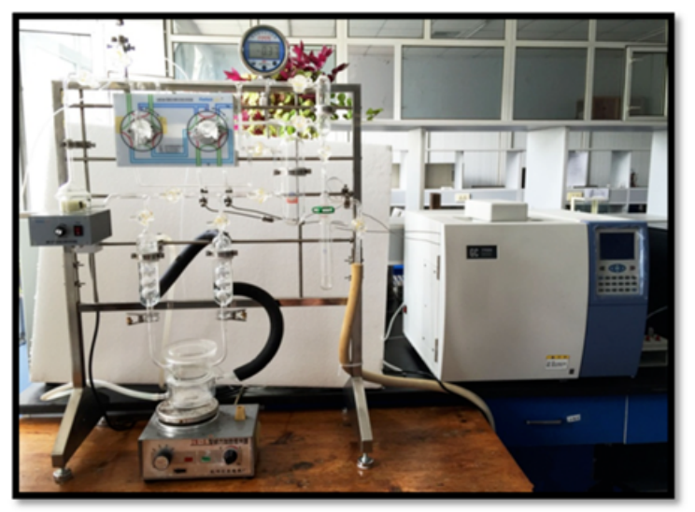
Fig.S1 The photolysis of water for hydrogen production device.

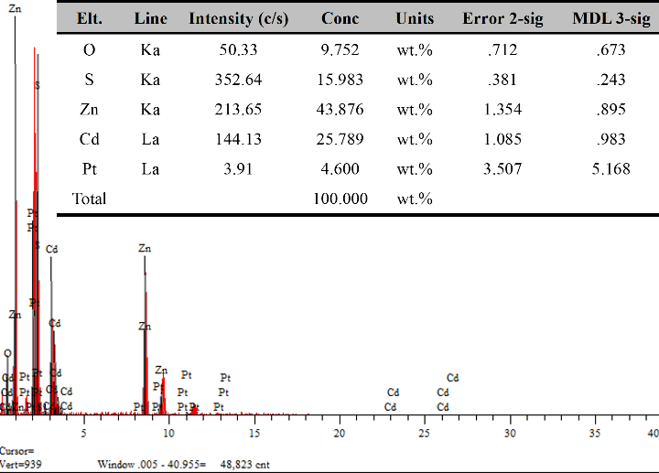
Fig.S2 EDS results of distribution of the content of each element in Pt/Zn_{0.25}Cd_{0.75}S QDs/ZnO.

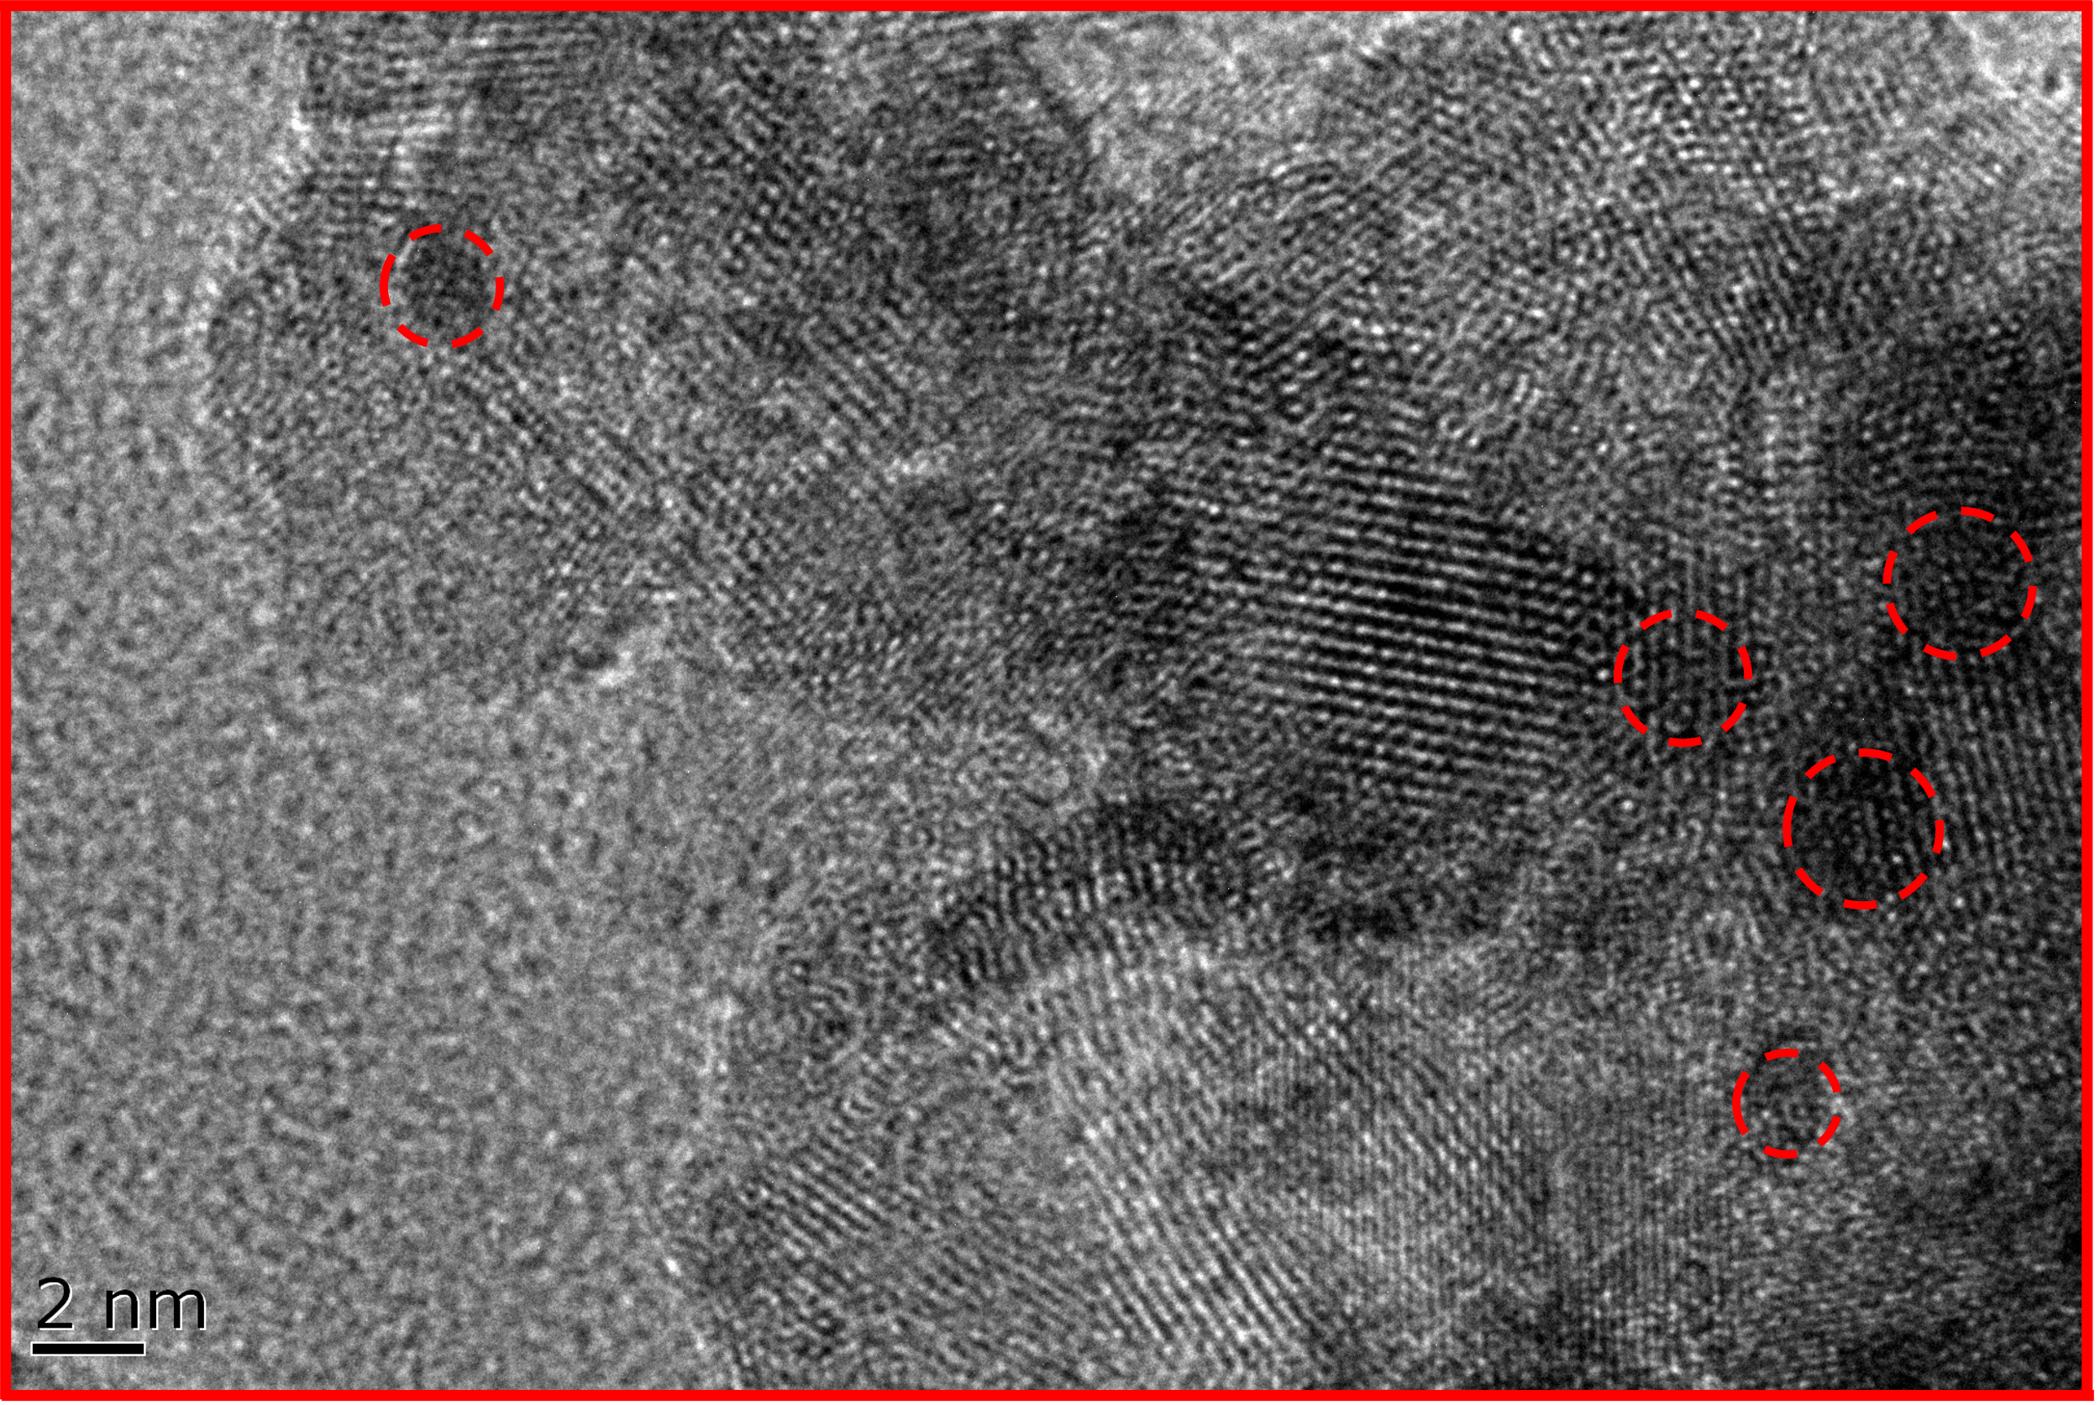
Fig.S3 HR-TEM map of Pt/Zn_{0.25}Cd_{0.75}S QDs/ZnO
(Among them, the marks in the figure are Zn_{0.25}Cd_{0.75}S QDs).

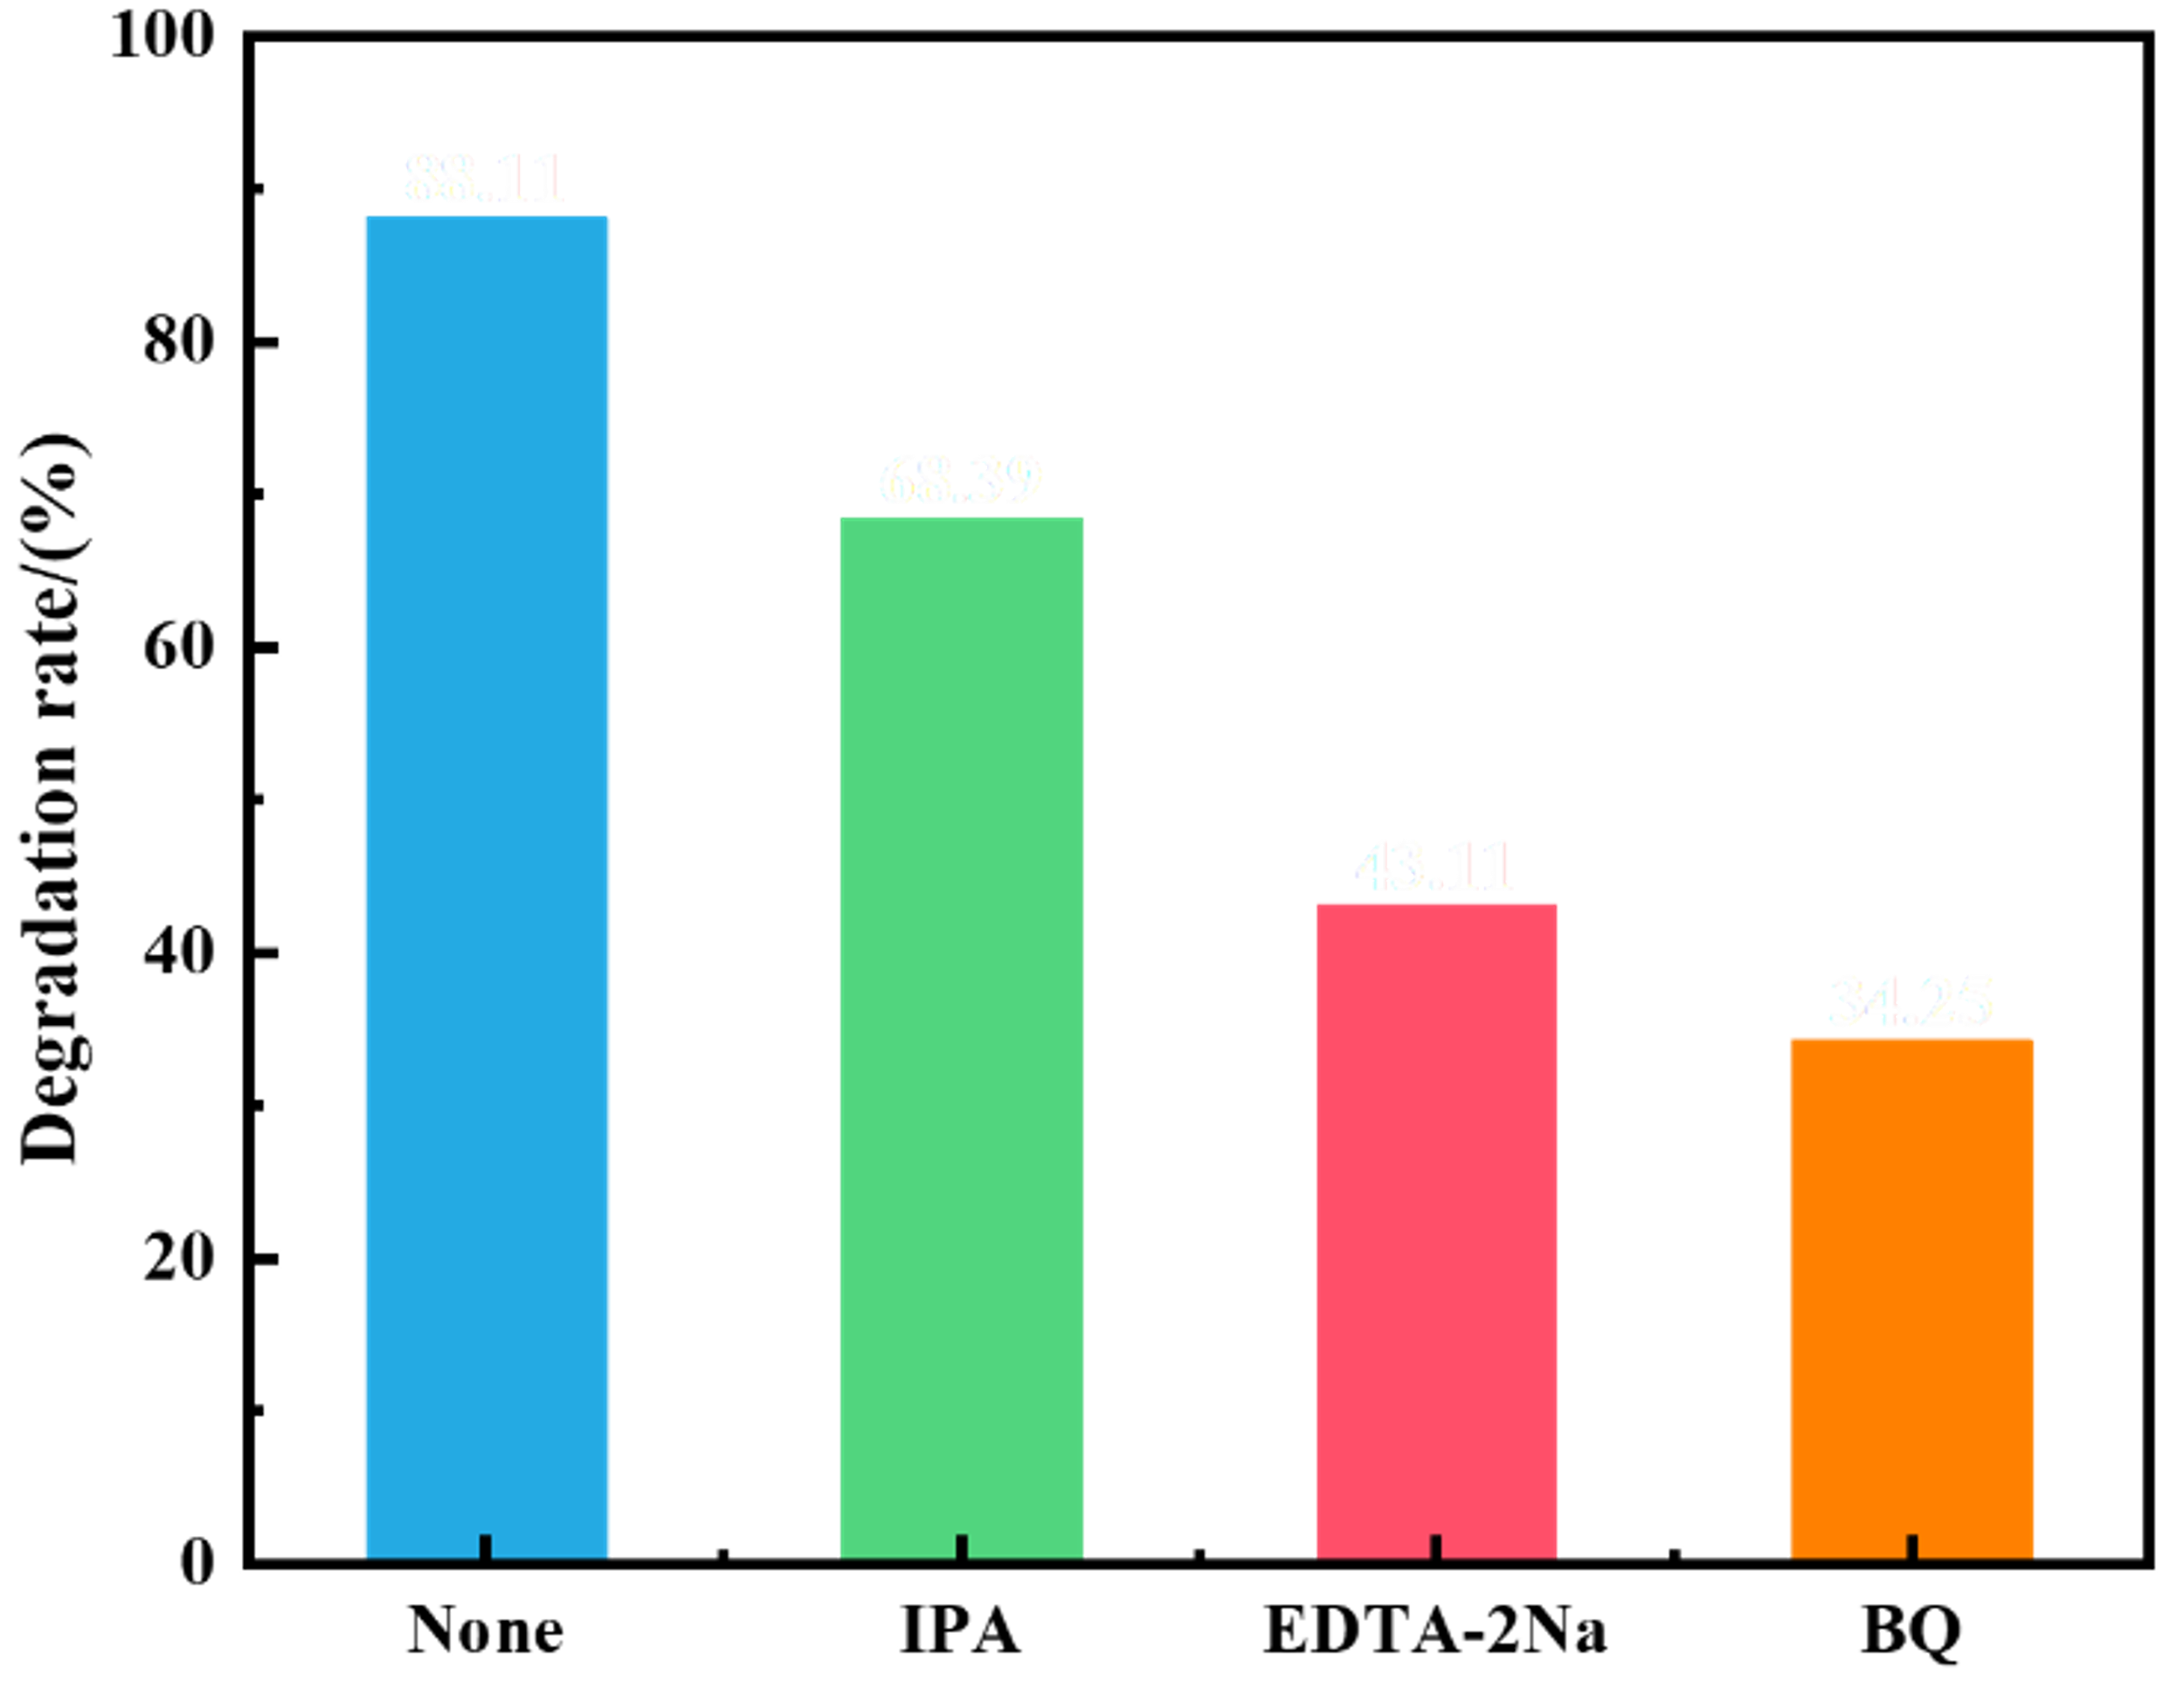
Fig. S4 Experimental results of the trapping of Pt/Zn_{0.25}Cd_{0.75}S QDs/ZnO under the conditions of UV irradiation (125 W high-pressure Hg lamp, t=120 min).

*Corresponding author: Li Li, Female, Ph.D., Professor, Doctoral tutor, mainly engaged in the preparation and photocatalytic properties of nanocomposites. E-mail: qqhrll@163.com; qqhrlili@126.com (L. Li). **Corresponding author: Tianyu Hu, female, Ph.D., E-mail: hutianyu@zjut.edu.cn.

