Supporting Information
M2 Macrophage-Polarized Anti-inflammatory Microneedle Patch for Accelerating Biofilm-Infected Diabetic Wound Healing via modulating insulin pathways
Yushan Yang^{1a}, Limin Fan^{1a}, Jingsi Jiang^{1b}, Jiuyuan Sunª, Liangyi Xueª, Xiaoyi Maª, Le Kuai^{c,d}, Bin Li ^{*b}, Yongyong Li^{*a}
ª Shanghai Skin Disease Hospital of Tongji University, The Institute for Biomedical Engineering & Nano Science, School of Medicine, Tongji University, Shanghai 200092, China.
^{b} Shanghai Skin Disease Hospital of Tongji University, Shanghai, 200443, China
^{c} Department of Dermatology, Yueyang Hospital of Integrated Traditional Chinese and Western Medicine, Shanghai University of Traditional Chinese Medicine, Shanghai 200437, China.
^{d} Institute of Dermatology, Shanghai Academy of Traditional Chinese Medicine, Shanghai 201203, China.
¹These authors contributed equally: Yushan Yang, Limin Fan, Jingsi Jiang.
Email: lib@shskin.com, yongyong_li@tongji.edu.cn;

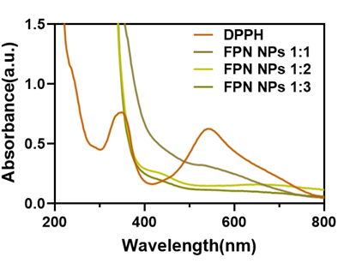
Figure S1. UV-Vis absorbance spectra of NPF nanoparticles at different proportions after incubation with DPPH.

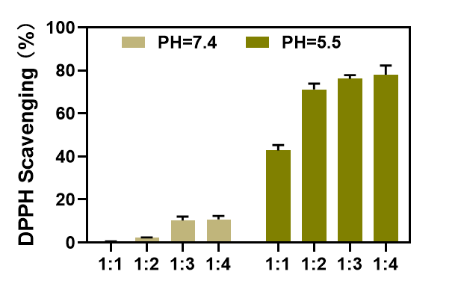
Figure S2. Clearance of DPPH by NPF with different proportions at pH7.4 and pH5.5.

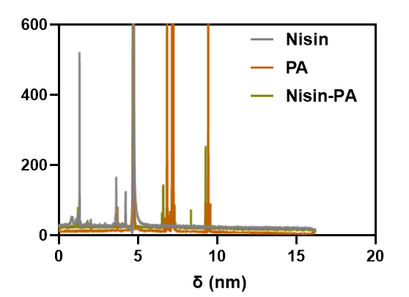
Figure S3. ¹H NMR spectrum of Nisin, PA and Nisin-PA in D₂O.

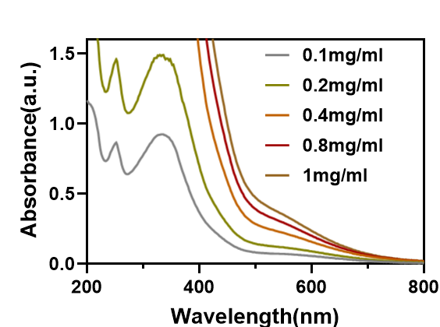

Figure S4. UV-Vis absorbance spectra of NPF solution.

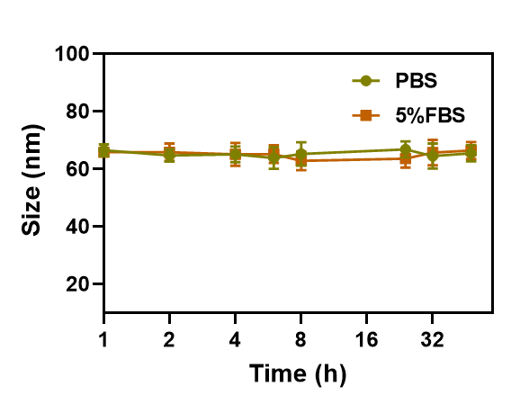
Figure S5. Size stability of NPF in PBS and PBS containing 5%FBS for 48h.

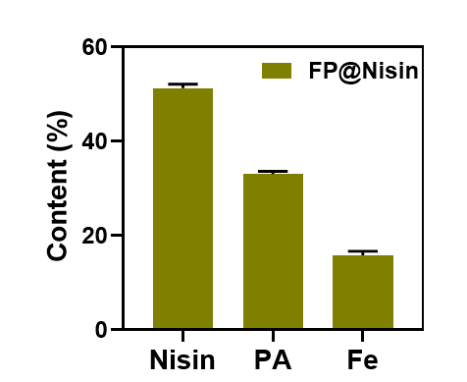.
Figure S6. NPF nanoparticle composition content

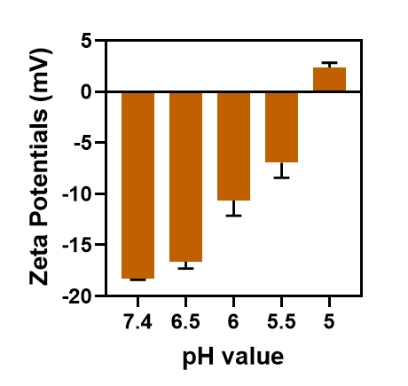
Figure S7. Zeta potential of NPF at different pH conditions

FigureS8. Calibration curve of Nisin.

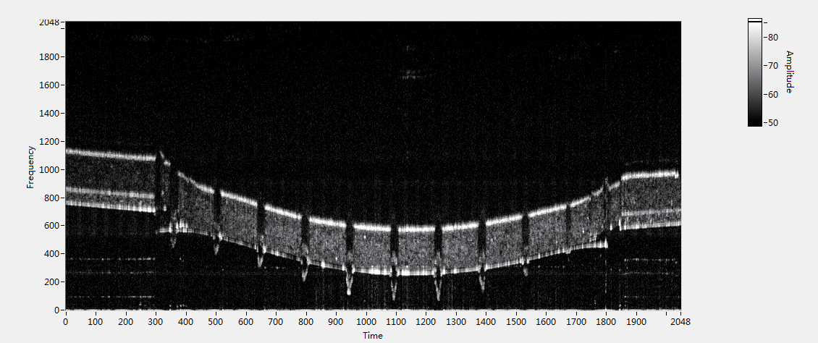
Figure S9. Microneedle OCT optical coherence test

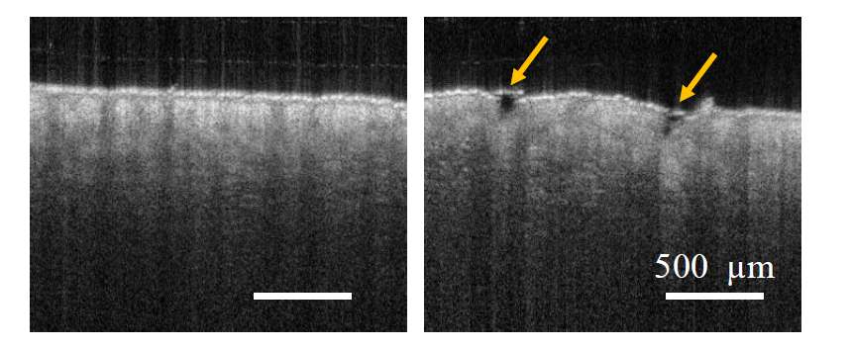
Figure S10. OCT images of microlesions and microchannels produced by microneedles piercing the skin

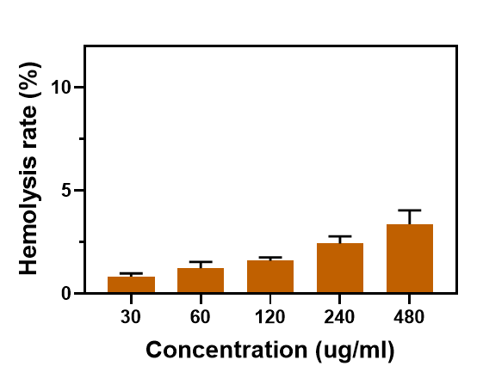
Figure S11. Hemolytic properties of NPF

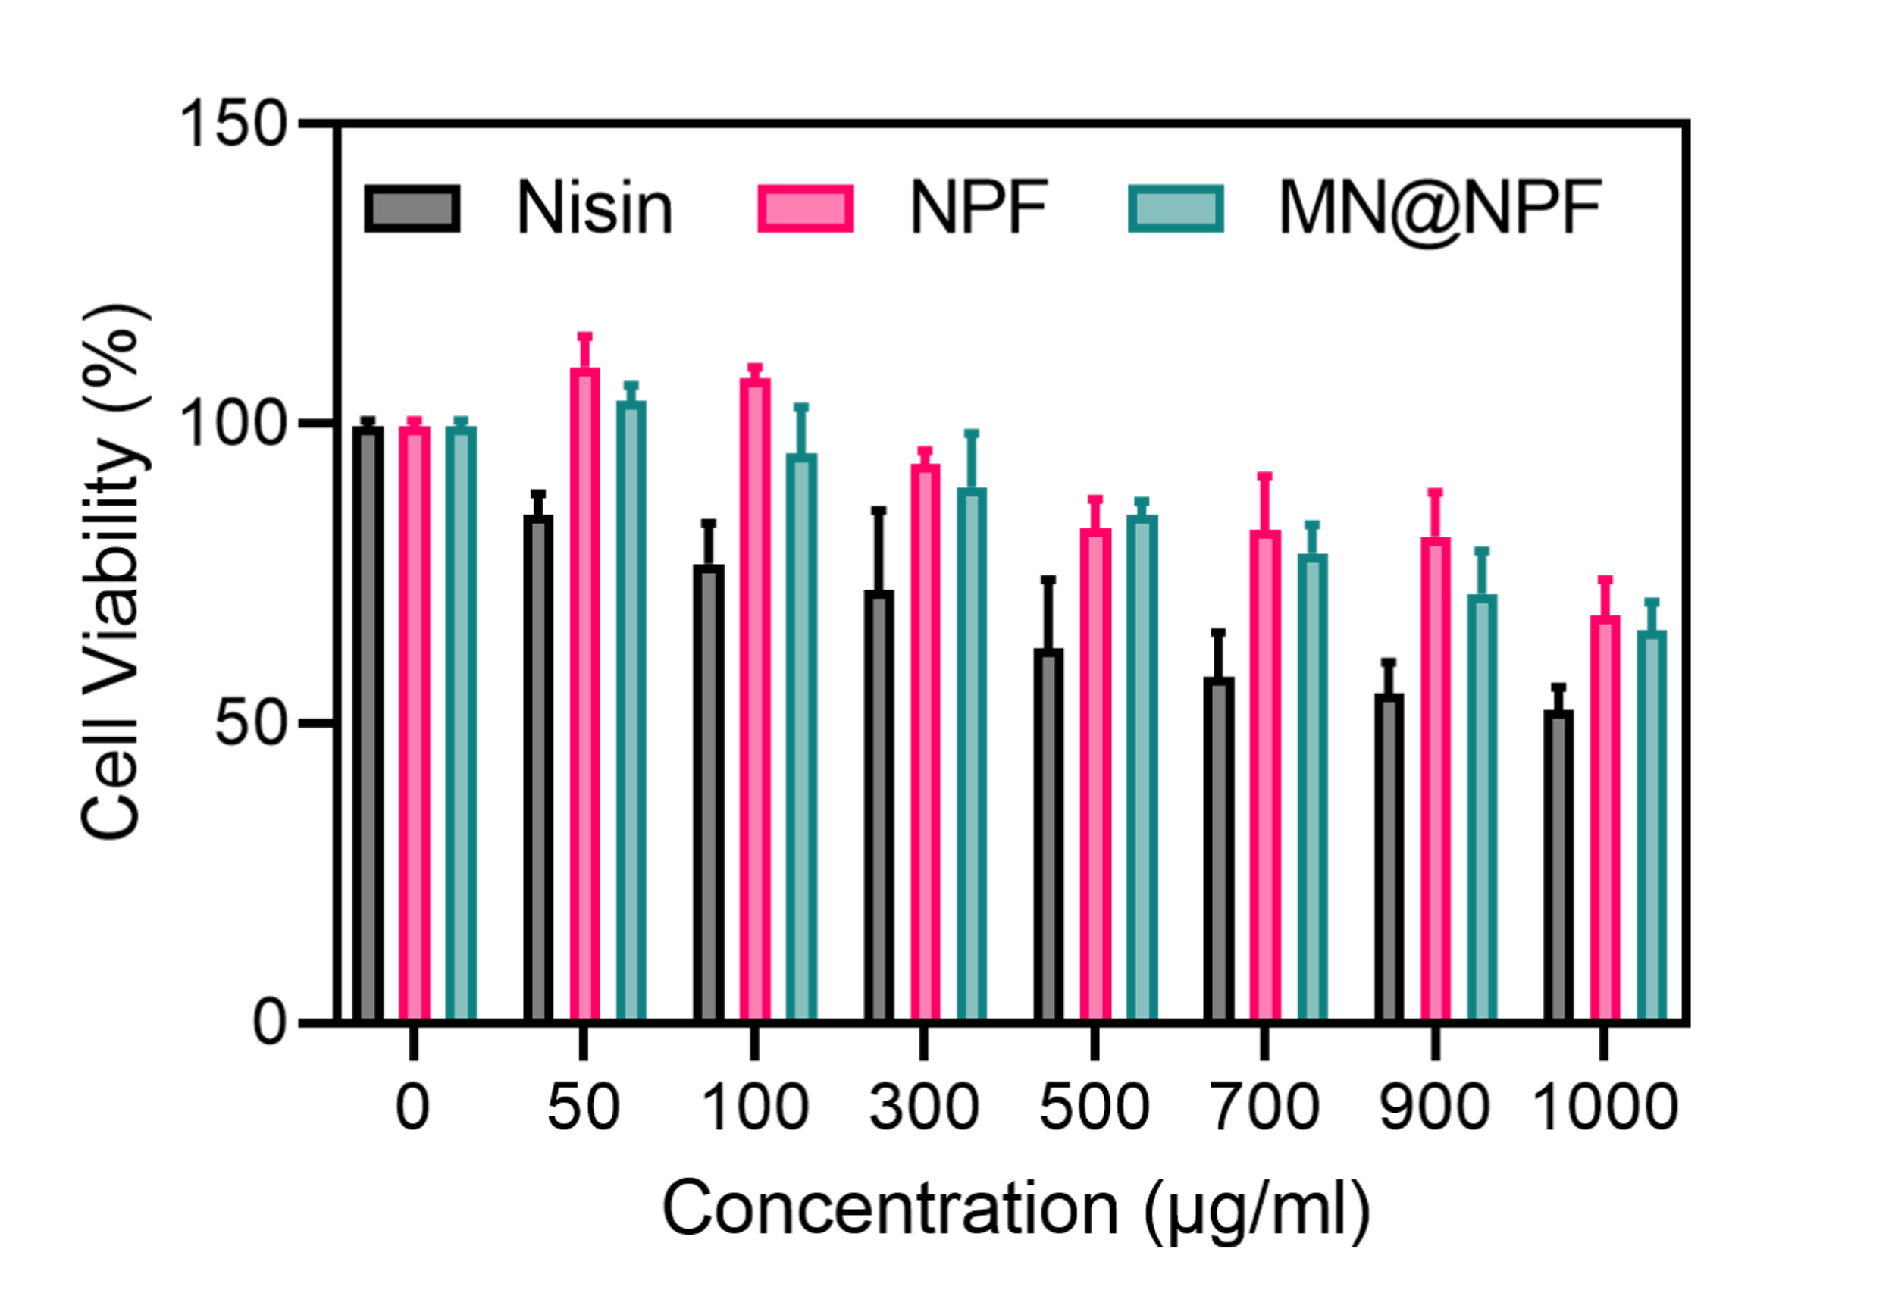
Figure S12. Cell viability of human dermal fibroblasts treated with Nisin, NPF and NPF@MN (50-1000 μg/mL) for 24 h and then incubated with 3 mM H₂O₂ for 30 minutes. 293T cells incubated in normal cell culture medium were applied as the control group. n=3 samples/group.

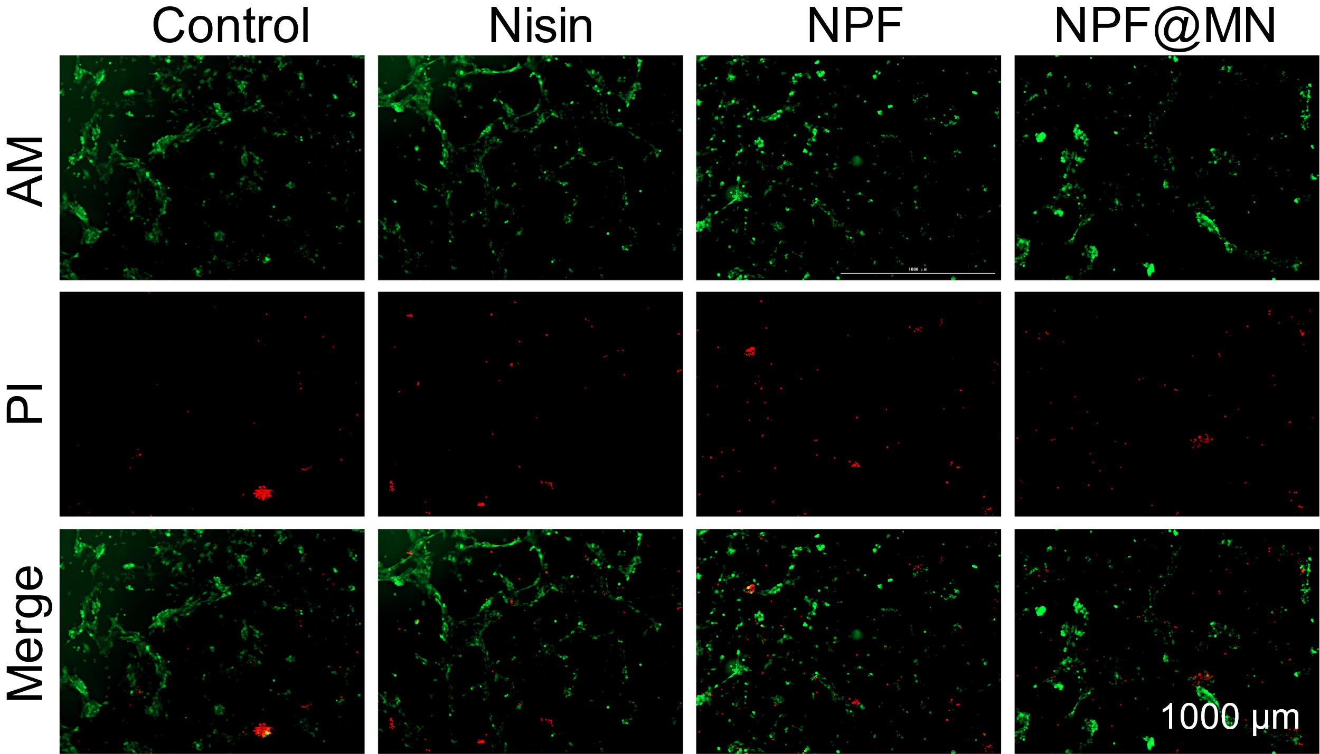
Figure S13. The fluorescent photograph of 293T cells co-cultured with Nisin, NPF and NPF@MN for 24h. Bar=1000μm. n=3 samples/group.

Figure S14. Quantification of the CD206⁺of RAW264.7 cells intensity.

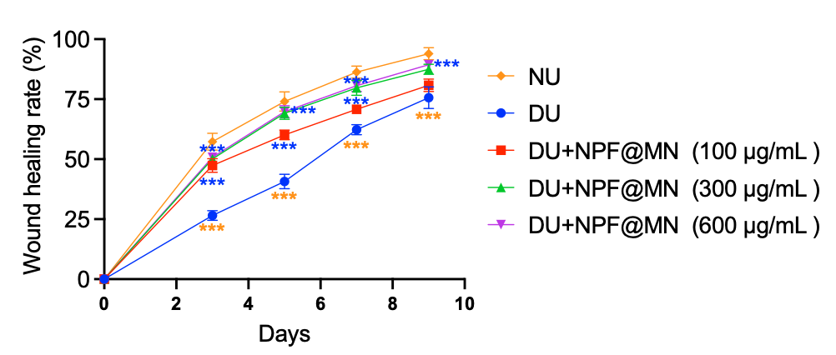
Figure S15. The healing rate of wounds treated with different concentration of NPF@MN. ***P<0.001.

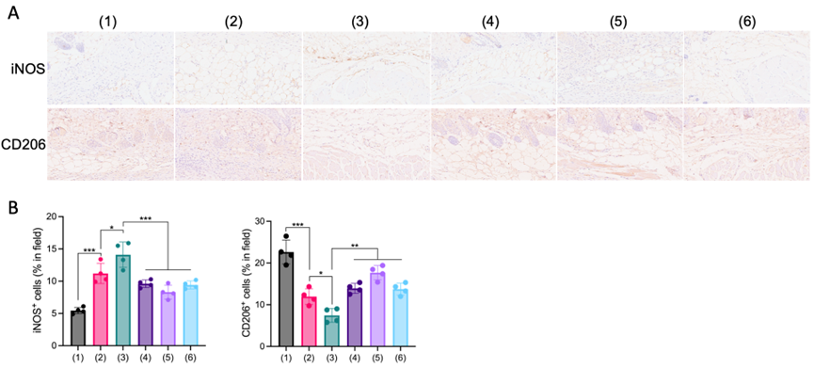
Figure S16.A-B. IHC staining of iNOS⁺ and CD206⁺ cells and the corresponding quantifications. Scale bar = 100 μm, n = 4 samples/group.

Figure S17. The H&E staining of liver, kidney and spleen from different groups. Scale bar = 250 μm.

Table S1. Primers for qPCR
Gene | Forward primer | Reverse primer
IL-1β | ACCTGAGCTCGCCAGTGAAA | GTAGTGGTGGTCGGAGATTCG
IL-6 | TGCAATAACCACCCCTGACC | GTGCCCATGCTACATTTGCC
β-ACTIN | GTCATTCCAAATATGAGATGCGT | TGTGGACTTGGGAGAGGACT

