Supplement
S1 Confirmatory Factor Analysis for the General Positive Youth Development Qualities (GPYDQ) Scale
Table S1 The General Positive Youth Development Qualities (GPYDQ) Scale
Dimensions | Items
Healthy Bonding | Items: 1,2,3,4,5,6
Resilience | Items: 7,8,9,10,11,12
Interpersonal Competence | Items: 13,14,15,16,17,18,19
Recognition of positive behavior | Items: 20,21,22,23
Emotional control and expression | Items: 24,25,26,27,28,29
Discrimination | Items: 42,43,44,45,46,47
Sense of self efficacy | Items: 53,54,55,56,57,58,59
Spiritual qualities | Items: 84,85,86,87,88,89,90
Table S2 The CFA results for the GPYDQ
Indicators | Composite Reliability | Average Variance Extracted | Cronbach's alpha
Healthy bonding | 0.882 | 0.557 | 0.866
Resilience | 0.900 | 0.602 | 0.874
Interpersonal Competence | 0.861 | 0.472 | 0.845
Recognition of positive behavior | 0.809 | 0.515 | 0.799
Emotional control and expression | 0.874 | 0.539 | 0.865
Discrimination | 0.823 | 0.439 | 0.792
Sense of self efficacy | 0.679 | 0.493 | 0.635
Spiritual qualities | 0.897 | 0.563 | 0.911

S2 Confirmatory Factor Analysis for the Modified Version of Internet Addiction Test (IAT)
The modified IAT scale adopted dimensions classification method in Table S3 and carried out corresponding confirmatory factor analysis (Figure S1). The goodness of fit indexes of CFA model was basically fine, and the coefficients of each evaluation index were CFI=0.878, TLI=0.863, NNFI=0.863, GFI=0.857, SRMR=0.047, RMSEA=0.080 ( 95%CI: 0.079-0.082) respectively. The Average Variance Extracted (AVE) and Composite Reliability (CR) were seen in Table S4.
Table S3 The modified Chinese version of Young's IAT
Items | Contents
1 | Do you find that you stay online longer than you intended?
2 | Do you neglect household chores to spend more time online?
3 | Do you prefer the excitement of the Internet to intimacy with your partner?
4 | Do you form new relationships with fellow online users?
5 | Do others in your life complain to you about the amount of time you spend online?
6 | Do your grades or schoolwork suffer because of the amount of time you spend online?
7 | Do you check your email before something else that you need to do? (*)
8 | Does your job performance or productivity suffer because of the internet?
9 | How often do you become defensive or secretive when anyone asks you what you do online?
10 | Do you block out disturbing thoughts about your life with soothing thoughts of the internet?
11 | Do you find that you find yourself anticipating when you will go online again? (*)
12 | Do you think about surfing the Internet all the time? (*)
13 | Do you fear that life without the Internet would be boring, empty or joyless?
14 | Do you snap, yell or act annoyed if someone bothers you while you are online?
15 | Do you lose sleep due to late night log-ins?
16 | Do you need to have longer and longer time online to get satisfaction? (*)
17 | Do you feel preoccupied with the Internet when offline, or fantasize about being online?
18 | Do you find yourself saying “just a few more minutes” when online?
19 | Do you try to cut down the amount of time you spend online?
20 | Do you try to hide how long you’ve been online?
21 | Do you choose to spend more time online over going out with others?
22 | Do you feel depressed, moody or nervous when you are offline, which goes away when you are back online?
23 | Even if you have to pay a very high Internet access fee, will you still continue to surf the Internet? (*)
Dimensions
Withdrawal and Social Problems |  | Items: 3,4,5,9,14,17,20,21,22
Time Management and Performance |  | Items: 1,2,6,8,18,19
Reality Substitute |  | Items: 10,13,15

Table S4 The CFA results for the modified version of IAT
Indicators | Composite Reliability | Average Variance Extracted | Cronbach's alpha
Withdrawal and Social Problems | 0.875 | 0.445 | 0.856
Time Management and Performance | 0.877 | 0.548 | 0.859
Reality Substitute | 0.799 | 0.579 | 0.730

Figure S1 The Structure diagram of CFA for the modified version of IAT
Note: * P < .01.

S3 Confirmatory Factor Analysis for the Screen for Child Anxiety Related Disorders (SCARED)
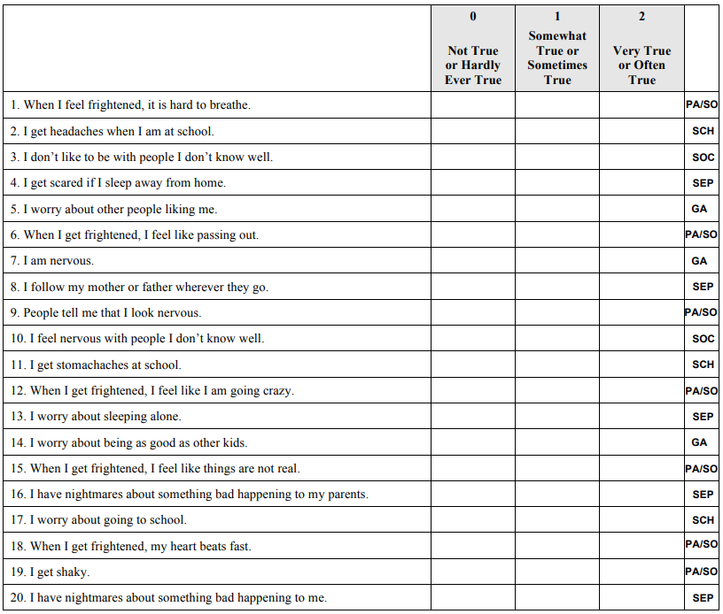
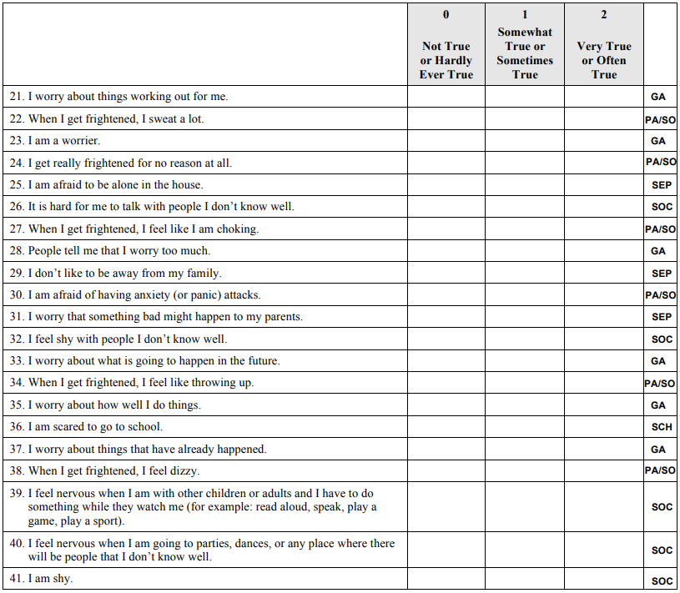
Table S5 The Screen for Child Anxiety Related Disorders (SCARED)
Dimensions | Items
Somatic / panic | Items: 1,6,9,12,15,18,19,22,24,27,30,34,38
Generalized anxiety | Items: 5,7,14,21,23,28,33,35,37
Separation anxiety | Items: 4,8,13,16,20,25,29,31
Social phobia | Items: 3,10,26,32,39,40,41
School phobia | Items: 2,11,17,36
Table S6 The CFA results for the SCARED
Indicators | Composite Reliability | Average Variance Extracted | Cronbach's alpha
Somatic / panic | 0.979 | 0.783 | 0.903
Generalized anxiety | 0.973 | 0.801 | 0.885
Separation anxiety | 0.942 | 0.680 | 0.784
Social phobia | 0.954 | 0.748 | 0.858
School phobia | 0.925 | 0.763 | 0.713
Figure S2 The Structure diagram of CFA for the screen for child anxiety related disorders
Note: * P < .01.

S4 Confirmatory Factor Analysis for the Center for Epidemiological Studies Depression Scale for Children (CES-DC)
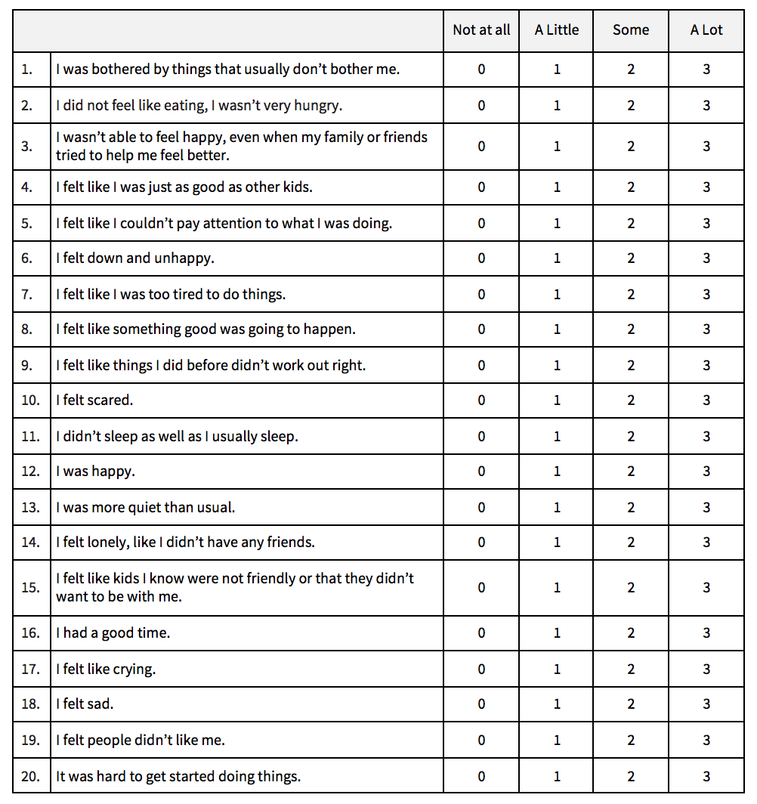
Table S7 The Center for Epidemiological Studies Depression Scale for Children
Dimensions | Items
Depressed affect | Items: 13,14,15,17,18,19
Positive affect | Items: 4,8,12,16
Somatic complaints | Items: 1,2,3,5,6,7,9,10,11,20
Note:Item 4, 8, 12, 16 calculates the score in reverse.
Table S8 The CFA results for the CES-DC
Indicators | Composite Reliability | Average Variance Extracted | Cronbach's alpha
Depressed affect | 0.942 | 0.733 | 0.872
Positive affect | 0.848 | 0.593 | 0.790
Somatic complaints | 0.957 | 0.691 | 0.905
Figure S3 The Structure diagram of CFA for the CES-DC
Note: * P < .01.

S5 Confirmatory Factor Analysis for the Children's Revised Impact of Event Scale (CRIES-13) with COVID-19
Table S9 The Children's Revised Impact of Event Scale (CRIES-13) with COVID-19
Dimensions | Items
CRIES-13 | Items: 1,2,3,4,5,6,7,8,9,10,11,12,13
Table S10 The CFA results for the CRIES-13 with COVID-19
Indicators | Composite Reliability | Average Variance Extracted | Cronbach's alpha
CRIES-13 | 0.899 | 0.413 | 0.895
Figure S4 The Structure diagram of CFA for the CRIES-13 after COVID-19 pandemic
Note: * P < .01.

