Supporting Information
Development of Ir-cR8-albumin nanomedicine toward the interventional treatment of liver cancer

1. Experimental section
1.1Materials
1 M Tris-HCl buffer, chlorpromazine and cell freezing medium were purchased from BiyunTian Biotechnology Co., Ltd. Irodium standard was purchased from National Standard Testing and Certification Co., Ltd. [Ir(ppy)2(H2O)2]OTf was purchased from Suzhou Nakai Technology Co., Ltd. The cRn peptide was purchased from Shanghai Gill Biochemical Co., Ltd. The 3% phosphotungstic acid staining solution was purchased from Beijing Zhongjing Science Instrument Co., Ltd. Bosentan and thiazole blue (MTT) were purchased from Shanghai Titan Scientific Co., Ltd. Ibuprofen was purchased from MedChemExpress. Digitalis glycoside and polyethylene glycol 8000 (PEG 8000) were purchased from Shanghai Macklin Biochemical Co., Ltd. Bovine serum albumin (BSA) powder was purchased from Shanghai Sangon Biotech Co., Ltd. CCK-8, propidium iodide (PI), cell relaxin D, streptomycin and 20× PBS buffer were purchased from Dalian Meilun Biotechnology Co., Ltd. Fetal bovine serum, RPMI 1640 medium and DMEM were purchased from Gibco Company, USA. 100× antibiotics (penicillin-streptomycin mixed solution) and 0.25% trypsin digestion solution were purchased from American HyClone Company. The lysosome fluorescent probe dye LysoTracker Red DND-99 was purchased from Invitrogen Company, USA. Mice were obtained from Suzhou Jingweiyu Biotechnology Co., Ltd. Oxaliplatin was purchased from Sain Chemical Technology (Shanghai) Co., Ltd. Red blood cell lysis buffer and neutral 4% paraformaldehyde fixative were purchased from Wuhan Servicebio Technology Co., Ltd. Mouse macrophage colony-stimulating factor (M-CSF), interleukin-4 (IL-4) and mouse granulocyte-macrophage colony-stimulating factor (GM-CSF) were purchased from Pepro Tech Biotechnology Co., Ltd. New Zealand White rabbits were obtained from Suzhou Gaoxin District Zhenhu Experimental Animal Co., Ltd. D-luciferin sodium salt was purchased from J&K Scientific Co., Ltd. Hydrochloric acid, nitric acid, alcohol and perchloric acid were purchased from China National Pharmaceutical Group Chemical Co., Ltd. Standard matrix gel was purchased from Shanghai NovaPharm Pharmaceutical Technology Co., Ltd.
1.2 Preparation of Ir-cR8-BSA-NP
(1) Standard curve generation: 1000 μM Ir-cR8 was diluted in 1× pH 7.4 PBS buffer to concentrations of 0.625, 1.25, 2.5, 5, 10 and 20 μM. Fluorescence emission intensity was measured at 520 nm after excitation at 328 nm to generate a standard curve at 520 nm.
(2) Mixture preparation: Bovine serum albumin (BSA) powder was weighed and dissolved in sterile ultrapure water to prepare a 1000 μM solution. The Ir-cR8 stock solution was diluted to 1000 μM. Equal volumes of BSA solution and Ir-cR8 solution were mixed in an EP tube in a 1:1 molar ratio and allowed to stand for 2 hours at room temperature.
(3) Ultrafiltration: The prepared Ir-cR8-BSA-NP were diluted to 10 μM in 1× PBS buffer (pH 7.4). The mixture was loaded into a 10 kDa ultrafiltration centrifuge tube and centrifuged (6000 rpm, 10 min).
(4) Detection: The emission intensity of Ir-cR8 in the liquid was measured after ultrafiltration using a fluorescence spectrophotometer. Finally, the drug loading rate of bovine serum albumin was calculated from the standard curve.
2. Cellular experiments
2.1 The ζ (zeta) potential of cells
Cells in the logarithmic growth phase, such as H22 cells or induced BMDCs and BMDMs, were resuspended in 1× pH 7.4 PBS buffer. After counting, the cell density was adjusted to 10^5 cells/ml and the zeta potential (ζ) of these three cell types was measured.
2.2 The cellular uptake pathway of Ir-cR8-BSA-NP
(1) To generate a standard curve, 500 μM Ir-cR8-BSA-NP was diluted in 1640 base medium to concentrations of 0.78125, 1.5625, 3.125, 6.25, 12.5 and 25 μM. The fluorescence emission intensity at 520 nm was scanned with excitation at 328 nm for each solution and the concentration was determined using the Em520 nm standard curve equation.
(2) For cell seeding, H22 cells in the logarithmic growth phase were digested, centrifuged and resuspended in 1640 base medium. The H22 cell density was adjusted to 10^5 cells/ml. Three millilitres of the H22 cell suspension was added uniformly to each well of a 6-well cell culture plate to ensure a cell number of 3 × 10^5 cells in each well. Three parallel groups were used for the control group, the endocytosis pathway inhibition group and the energy inhibition group.
(3) Pre-incubation with endocytosis inhibitors: Inhibitors of specific endocytic pathways, including filipin (NY, working concentration 9 μg/mL) for caveolin-mediated endocytosis, chlorpromazine (CPZ, working concentration 2.5 μg/mL) for clathrin-mediated endocytosis, and cytochalasin D (CytoD, working concentration 2.5 μg/mL) for macropinocytosis, were added to each endocytosis inhibition group. Cells were incubated in a cell culture incubator at 37°C and 5% CO2 for 1 hour.
(4) Ir-cR8-BSA-NP incubation: After pre-incubation, Ir-cR8-BSA-NP was added directly to reach a working concentration of 5 μM. The cells in the endocytosis inhibition group and the control group were incubated at 37°C in 5% CO2 for 2 hours, and the cells in the energy inhibition group were incubated at 4°C in a refrigerator for 2 hours.
2.3 The intracellular distribution of Ir-cR8-BSA-NP
(1) For cell seeding, H22 cells in logarithmic growth phase were digested, centrifuged and resuspended in complete culture medium (RPMI 1640 + 10% FBS + 1% antibiotics). The H22 cell density was adjusted to 4 × 10^5 cells/mL, 1 mL of H22 cell suspension was added to a 20 mm diameter glass bottom dish, and the mixture was incubated at 37°C in a 5% CO2 incubator for 24 hours.
(2) Ir-cR8-BSA-NP preincubation: After discarding the supernatant, the cells were gently washed once with 1× PBS buffer (pH 7.4). Ten μM Ir-cR8-BSA-NP (diluted in 1640 base culture medium) was added and incubated for 1 hour in a 37°C, 5% CO2 incubator.
(3) Lysosome staining incubation: After discarding the supernatant, the cells were gently rinsed twice with 1× pH 7.4 PBS buffer. The lysosome fluorescent probe dye LysoTracker Red DND-99 was diluted to 200 nM in 1640 base culture medium and incubated at 37°C and 5% CO2 for 15 minutes.
(4) For confocal microscopy, the medium was removed in the dark and the cells were gently rinsed three times with 1× pH 7.4 PBS buffer after the supernatant was discarded. Finally, the colocalisation of Ir-cR8-BSA-NP with lysosomes was observed by laser confocal microscopy.
3. Tumor models
3.1 In vivo pharmacokinetics of Ir-cR8-BSA-NP
(1) For serum preparation, 100 μL of 1× pH 7.4 PBS buffer, Ir-cR8 (500 μM) or Ir-cR8-BSA-NP (500 μM) was added by tail vein injection to 6- to 8-week-old BALB/c mice. For the Ir-cR8 group, blood was collected from the eye at 0.017, 1.5, 4, 8, 24 and 48 hours post injection. For the Ir-cR8-BSA-NP group, blood was collected at 1.5, 4, 8, 24 and 48 hours post injection. Three mice were collected at each time point. Serum was collected after centrifugation (10,000 rpm, 8 min).
(2) For serum sample processing, 100 μL of the supernatant was collected, to which 1 mL of perchloric acid and 4 mL of aqua regia (hydrochloric acid: nitric acid = 3:1, v/v) were added sequentially. The mixture was heated to 260 ℃ until digestion was complete and the liquid residue was approximately 1 mL. Sterile ultrapure water was added to bring the total volume to 10 mL.
(3) Standard curve preparation and detection: The 1000 ppm standard solution was diluted with sterile ultrapure water to concentrations of 0.78125, 1.5625, 3.125, 6.25, 12.5, 25, 50 and 100 ppb, after which the standard curve equation was obtained. Finally, the iridium content in each group was measured by ICP-MS.
3.2 Arterial infusion dosage of Ir-cR8-BSA-NP/oxaliplatin
According to the body surface area conversion formula, Dose(b) = Dose(a) × (kb/ka) × (Wb/Wa)^(2/3), the dosage for the arterial infusion treatment of Ir-cR8-BSA-NP and oxaliplatin was calculated. Where Dose(a) is the known dose for animal a (mg/m2); Dose(b) is the desired dose for animal b (mg/m2); ka and kb are body surface area coefficients as shown in Table 1; and Wa and Wb are the weights of the animals in kilograms.
Table 1: Body surface area coefficients (k) for different animals.
Animals (standard weight). | Mouse | Hamster | Rat | Guinea pig | Rabbit | Cat | Dog | Monkey | Human
body surface area coefficient | 0.0899 | 0.0862 | 0.086 | 0.092 | 0.1014 | 0.1086 | 0.1077 | 0.118 | 0.10
3.3 Arterial infusion treatment of VX2 orthotopic tumors with Ir-cR8-BSA-NP/oxaliplatin
Rabbits were anesthetized intravenously with 3% pentobarbital sodium (30 mg·kg^-1) via the marginal ear vein. The dose was maintained at 0.5 mL/30 min. The right inguinal area was prepared, disinfected, and draped. After identifying the femoral artery pulse, an incision was made along its course following longitudinal skin cutting. The femoral artery sheath was exposed by separating the subcutaneous and muscle tissues. Using a small vascular stripper, the femoral artery sheath was removed, exposing around 2 cm of the femoral artery. The near and far ends of the artery were then threaded with surgical sutures, and the near-end suture was tightened to temporarily block blood flow. Following successful puncture with an 18G needle, the needle core was removed, and a 2.6 F microcatheter was inserted into the sheath. Abdominal angiography was performed at the T12-L1 level to confirm the opening of the hepatic artery. Selective catheterization was then carried out on the proper hepatic artery/left hepatic artery. Following confirmation of adequate tumor imaging through digital subtraction angiography (DSA), PBS, Ir-cR8-BSA-NP, and oxaliplatin were injected through the catheter. Following the procedure, the microcatheter and sheath were removed, and the femoral artery was ligated and sutured layer by layer. Postoperatively, penicillin sodium (40 WU/d) was administered intramuscularly for three consecutive days to prevent infection.
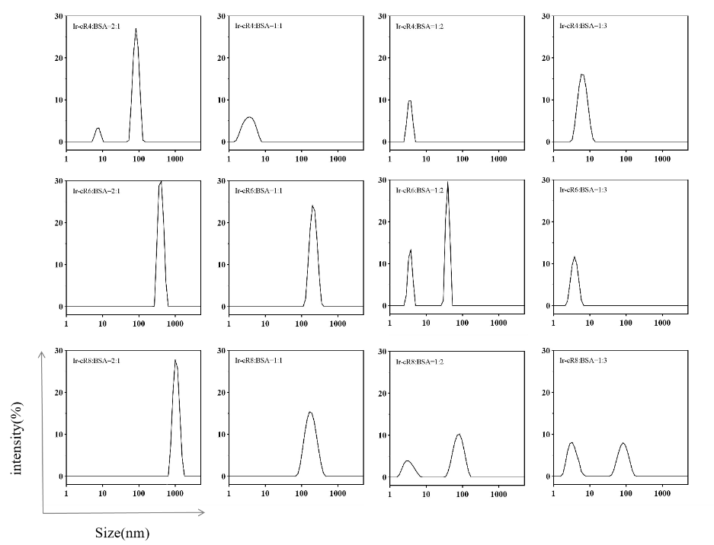
Appendix Figure:
Figure S1. Particle size distributions of peptides with different charges mixed with bovine serum albumin (BSA) at different molar ratios. The peak at approximately 100 nm is observed only when Ir-cR4 is mixed with albumin at a 2:1 ratio. Ir-cR6 and Ir-cR8 have average particle sizes of 224 nm and 170 nm, respectively, when mixed with albumin at a molar ratio of 1:1. Ir-cR8 was selected for further study due to its advantageous nanoparticle size range of 50 nm to 200 nm, which allows for accumulation at the tumor site.
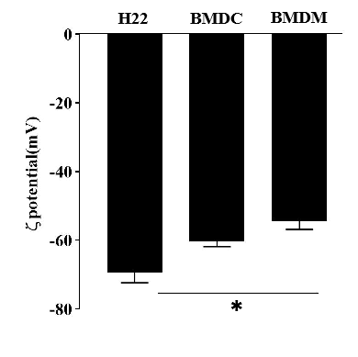

Figure S2. Zeta potential values are currently being assessed for the H22, BMDC, and BMDM cell lines.
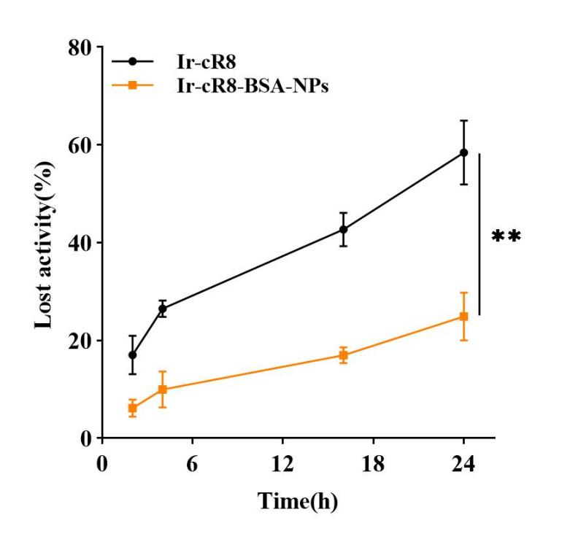

Figure S3. After incubation with serum for 2, 4, 16, or 24 hours, Ir-cR8-BSA-NP showed significantly less loss of cell-killing ability compared to Ir-cR8 alone. Following 24 hours of serum exposure, Ir-cR8-BSA-NP exhibited a 24.87±4.02% decrease in cell-killing ability, while Ir-cR8 alone caused a 58.42±5.32% decrease in cell-killing ability. These results suggest that bovine serum albumin can protect the peptide Ir-cR8 from enzymatic hydrolysis, enhancing its stability in serum.
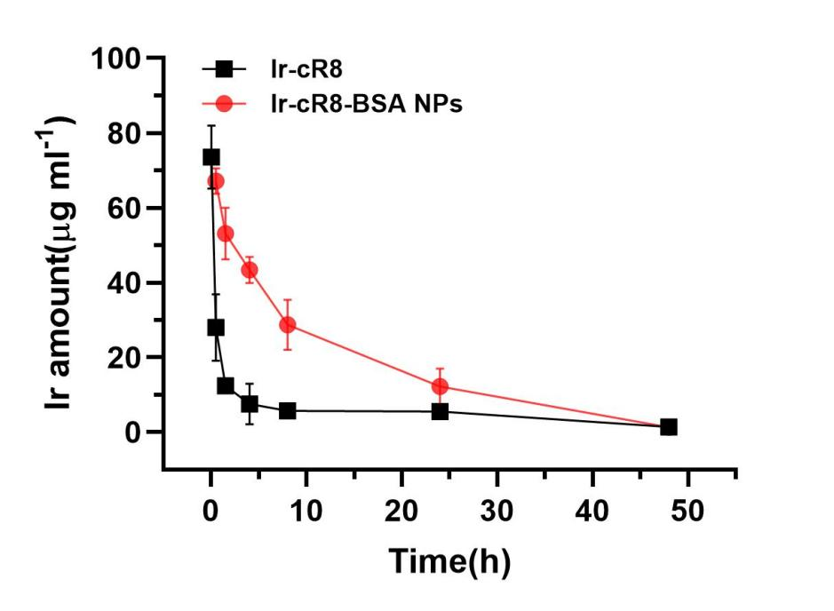
Figure S4. The pharmacokinetics of Ir-cR8 and Ir-cR8-BSA-NPs were studied. After approximately 30 minutes, the concentration of Ir-cR8 in the blood decreased by more than half, while the half-life of Ir-cR8-BSA-NP was found to be 9.8 hours. This suggests that the formation of albumin nanoparticles significantly prolongs the retention time of peptide drugs in systemic circulation.
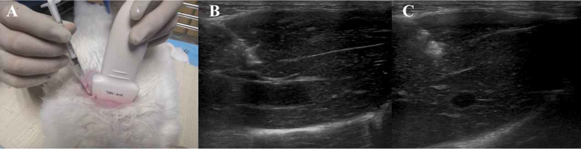
Figure S5. Ultrasound guidance was successfully used for tumor loading in a rabbit model of liver cancer(A). The images clearly demonstrate the precise placement of the puncture needle (B) and tissue block during the procedure (C).

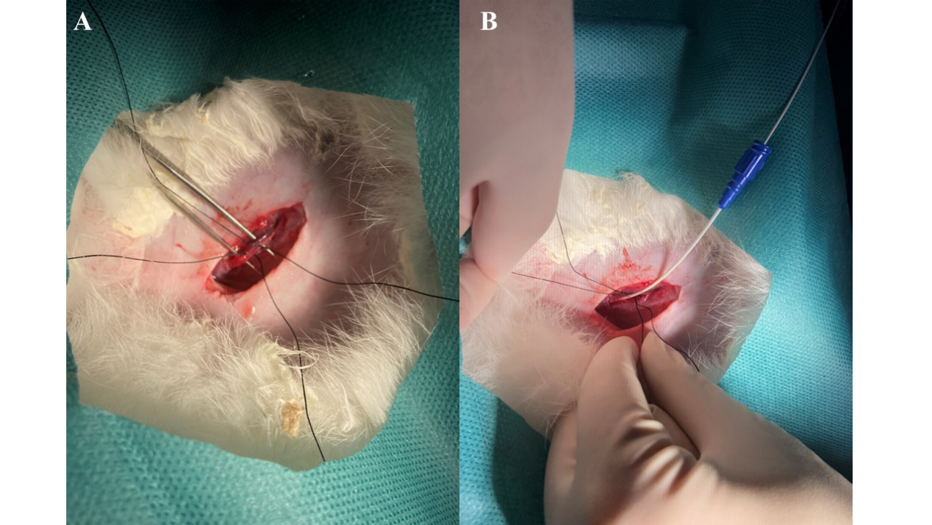
Figure S6. Isolate the femoral artery (A) and introduce a microcatheter by puncturing the artery (B).

