Tables:
Table 1 General summary of the impact of BD settlement on the PV module performance worldwide
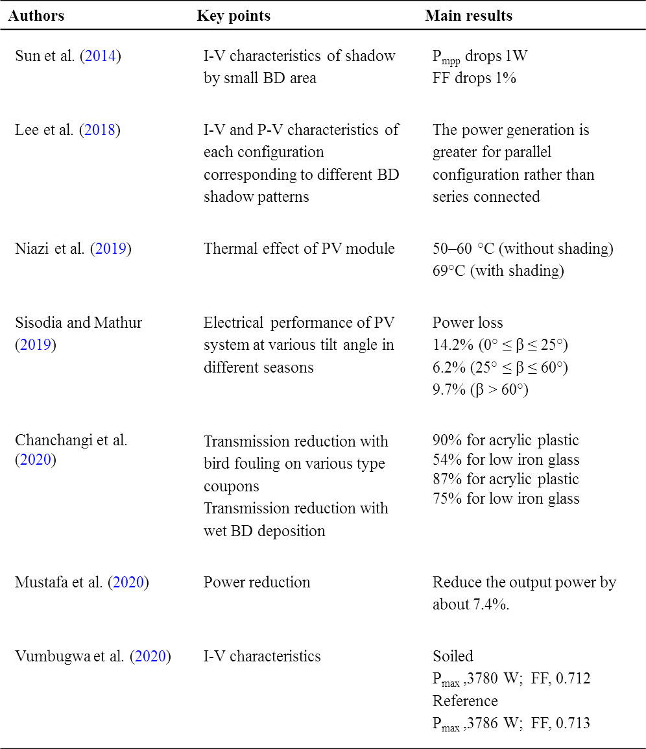

Table 2 Evaluation of some common different kinds of bird repelling or deterrents systems
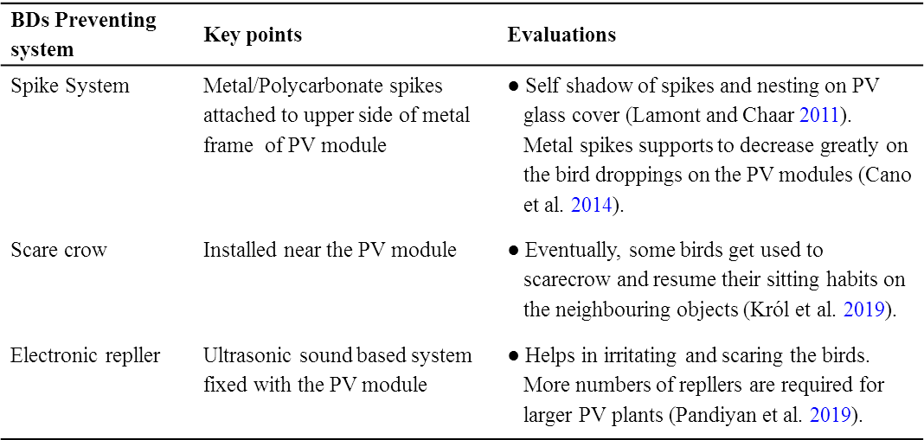

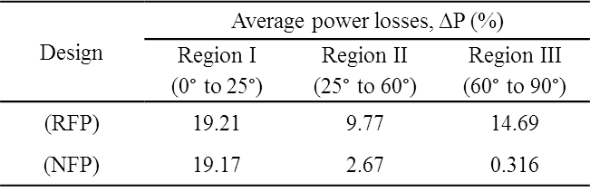
Table 3 Average power reduction (%) of RFP and NFP design structure at different TRs.

Table 4 Monthly optimum tilt-angle (β°) for Jodhpur (WR) /INDIA (Yadav and Chandel 2018)
