Supporting Information (SI)

A 2D Zn-MOF with Oxygen Functional Sites as An Efficient Luminescent Sensor for Detecting Cr₂O₇²⁻ in Water Media and HEPES Biological Buffer Solution

Xue-Li Niu^{1,2} Qian Wu,¹ Hua Yang,^{1,}* Lingqian Kong,¹ Jian-Min Dou¹

¹ Shandong Provincial Key Laboratory of Chemical Energy Storage and Novel Cell Technology, and School of Chemistry and Chemical Engineering, Liaocheng University, Liaocheng 252000, Shandong, P. R. China.
² Department of Chemical Engineering, Jincheng Institute of Technology, Jincheng 048026, Shanxi, P. R. China.

* E-mail address: dougroup@163.com (H. Yang).

Experimental Section
Materials and Methods
All chemicals were obtained commercially and used as received. Powder X-ray diffraction (PXRD) were performed on a D/MAX-rA (Rigaku) diffractometer with Cu Kα radiation (λ = 1.542 Å) with a scan rate of 4 ◦/min at 36 kV and 20 mA. X-ray photoelectron spectrums (XPS) were performed on ESCALAB Xi+. FT-IR spectra were conducted with a NICOLET iS50 FT-IR spectrometer. UV-vis measurements were carried out by a UV-3600 Plus spectrophotometer. Fluorescence sensing properties were performed on the Hitachi F-7000 fluorescence spectrophotometer.
X-ray Crystallography
Single crystal X-ray diffraction measurement was carried out on a Rigaku SCX-mini diffractometer and determined at 298(2) K with Mo-Kα radiation (λ = 0.71073 Å). The crystal data were solved by direct methods and refined by a full-matrix least-square method on F² using the SHELXL-97 crystallographic software packages. Zn atoms in Zn-MOF were found from E-maps and other non-hydrogen atoms were located in successive difference Fourier syntheses. The final refinement was performed by full matrix least-squares methods with anisotropic thermal parameters for non-hydrogen atoms on F². The hydrogen atoms of organic ligands were added theoretically, riding on the concerned atoms and refined with fixed thermal factors. The hydrogen atoms of free H₂O were added by successive difference Fourier syntheses. During the refinement of the compound, the command “dfix” was used to eliminate short link error caused by hydrogen bonding. In addition, the "omit -1 50.04" command is used in the refinement process to limit some non-regular atoms. Further details of crystal data and structure refinement for Zn-MOF were summarized as follows in Table S1. Selected bond lengths of Zn-MOF were given in Table S2. Full crystallographic data for Zn-MOF have been deposited with the CCDC (No.: 2346290). These data can be obtained free of charge from The Cambridge Crystallographic Data Centre via www.ccdc.cam.ac.uk/data_request/cif.
The Detailed Sensing Procedure of Anions
Typically experiments, 2 mg of crystal Zn-MOF dispersed in 4 mL H₂O aqueous/HEPES solutions containing 10⁻³ M anions (SO₄²⁻, OH⁻, CO₃²⁻, C₂O₄²⁻, NO₃⁻, SO₃²⁻, Cl⁻, Br⁻, I⁻, F⁻, SCN⁻, PO₄³⁻, Cr₂O₇²⁻). The mixture was further scattered by sonication 30 minutes to obtain uniform suspensions and directly used for sensing.

Table S1 Crystal data and structure refinement parameters for Zn-MOF.

Name |  | Zn-MOF
Formula | C₁₇H₁₆Zn₂N₃O₈P | γ [°] | 90
F_{w} | 552.11 | V (Å³) | 1883.9(3)
λ/Å | 0.71073 | Z | 4
T/K | 298(2) | Dc/M_{g}/m³ | 1.946
Crystal system | Monoclinic | F(000) | 1112
Space group | P2(1)/c | Reflections collected/unique | 9113/3304
a [Å] | 14.7678(13) | Rint | 0.019
b [Å] | 9.5870(9) | Data/Restraints/Parameters | 3304/3/286
c [Å] | 14.6712(14) | R1/wR₂ [I>2σ(I)]ª | 0.0377/0.0987
α[°] | 90 | R1/wR₂ [(all data)]^{b} | 0.0498/0.1048
β[°] | 114.907(5) | GOF on F² | 1.056
ªR₁ = Σ(||F₀| – |F_{C}||)/Σ|F₀|; ^{b}wR₂ = [Σw(|F₀|² – |F_{C}|²)²/(Σw|F₀|²)²]^{1/2}.

Table S2 The selected bond lengths [Å] and angles [º] of Zn-MOF.

O(4)-Zn(2)#1 | 2.115(3) | Zn(2)-O(7) | 1.952(3)
O(6)-Zn(1)#2 | 1.943(3) | Zn(2)-O(1)#2 | 1.993(3)
Zn(1)-O(6)#3 | 1.943(3) | Zn(2)-N(2) | 2.084(4)
Zn(1)-O(5) | 1.976(3) | Zn(2)-O(4)#4 | 2.115(3)
Zn(1)-O(3) | 2.003(3) | Zn(2)-N(3) | 2.169(4)
Zn(1)-O(1) | 2.057(3) | O(1)-Zn(2)#3 | 1.993(3)
Zn(1)-N(1) | 2.215(3)
O(6)#3-Zn(1)-O(5) | 105.93(11) | O(7)-Zn(2)-O(1)#2 | 99.87(12)
O(6)#3-Zn(1)-O(3) | 98.66(12) | O(7)-Zn(2)-N(2) | 125.58(13)
O(5)-Zn(1)-O(3) | 112.69(13) | O(1)#2-Zn(2)-N(2) | 133.99(13)
O(6)#3-Zn(1)-O(1) | 94.57(11) | O(7)-Zn(2)-O(4)#4 | 94.21(12)
O(5)-Zn(1)-O(1) | 110.53(12) | O(1)#2-Zn(2)-O(4)#4 | 95.39(11)
O(3)-Zn(1)-O(1) | 128.83(12) | N(2)-Zn(2)-O(4)#4 | 88.63(13)
O(6)#3-Zn(1)-N(1) | 166.49(11) | O(1)#2-Zn(2)-N(3) | 90.39(13)
O(5)-Zn(1)-N(1) | 86.78(11) | O(7)-Zn(2)-N(3) | 98.04(13)
O(3)-Zn(1)-N(1) | 80.08(12) | N(2)-Zn(2)-N(3) | 77.74(14)
O(1)-Zn(1)-N(1) | 76.31(11) | O(4)#4-Zn(2)-N(3) | 165.36(12)

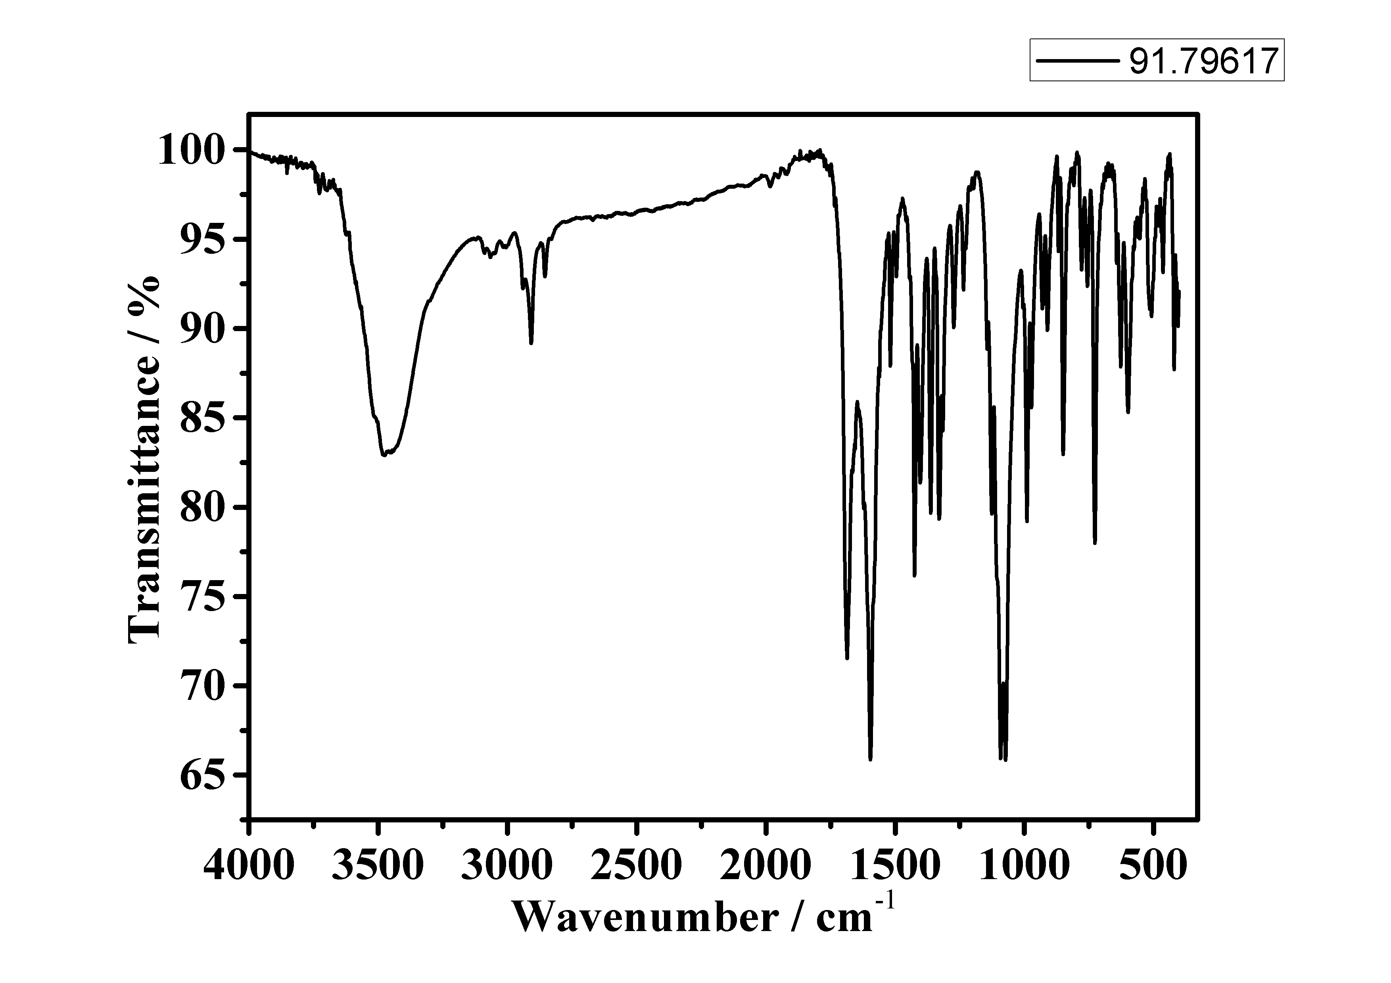
Fig. S1. IR spectrum of as-synthesized Zn-MOF.

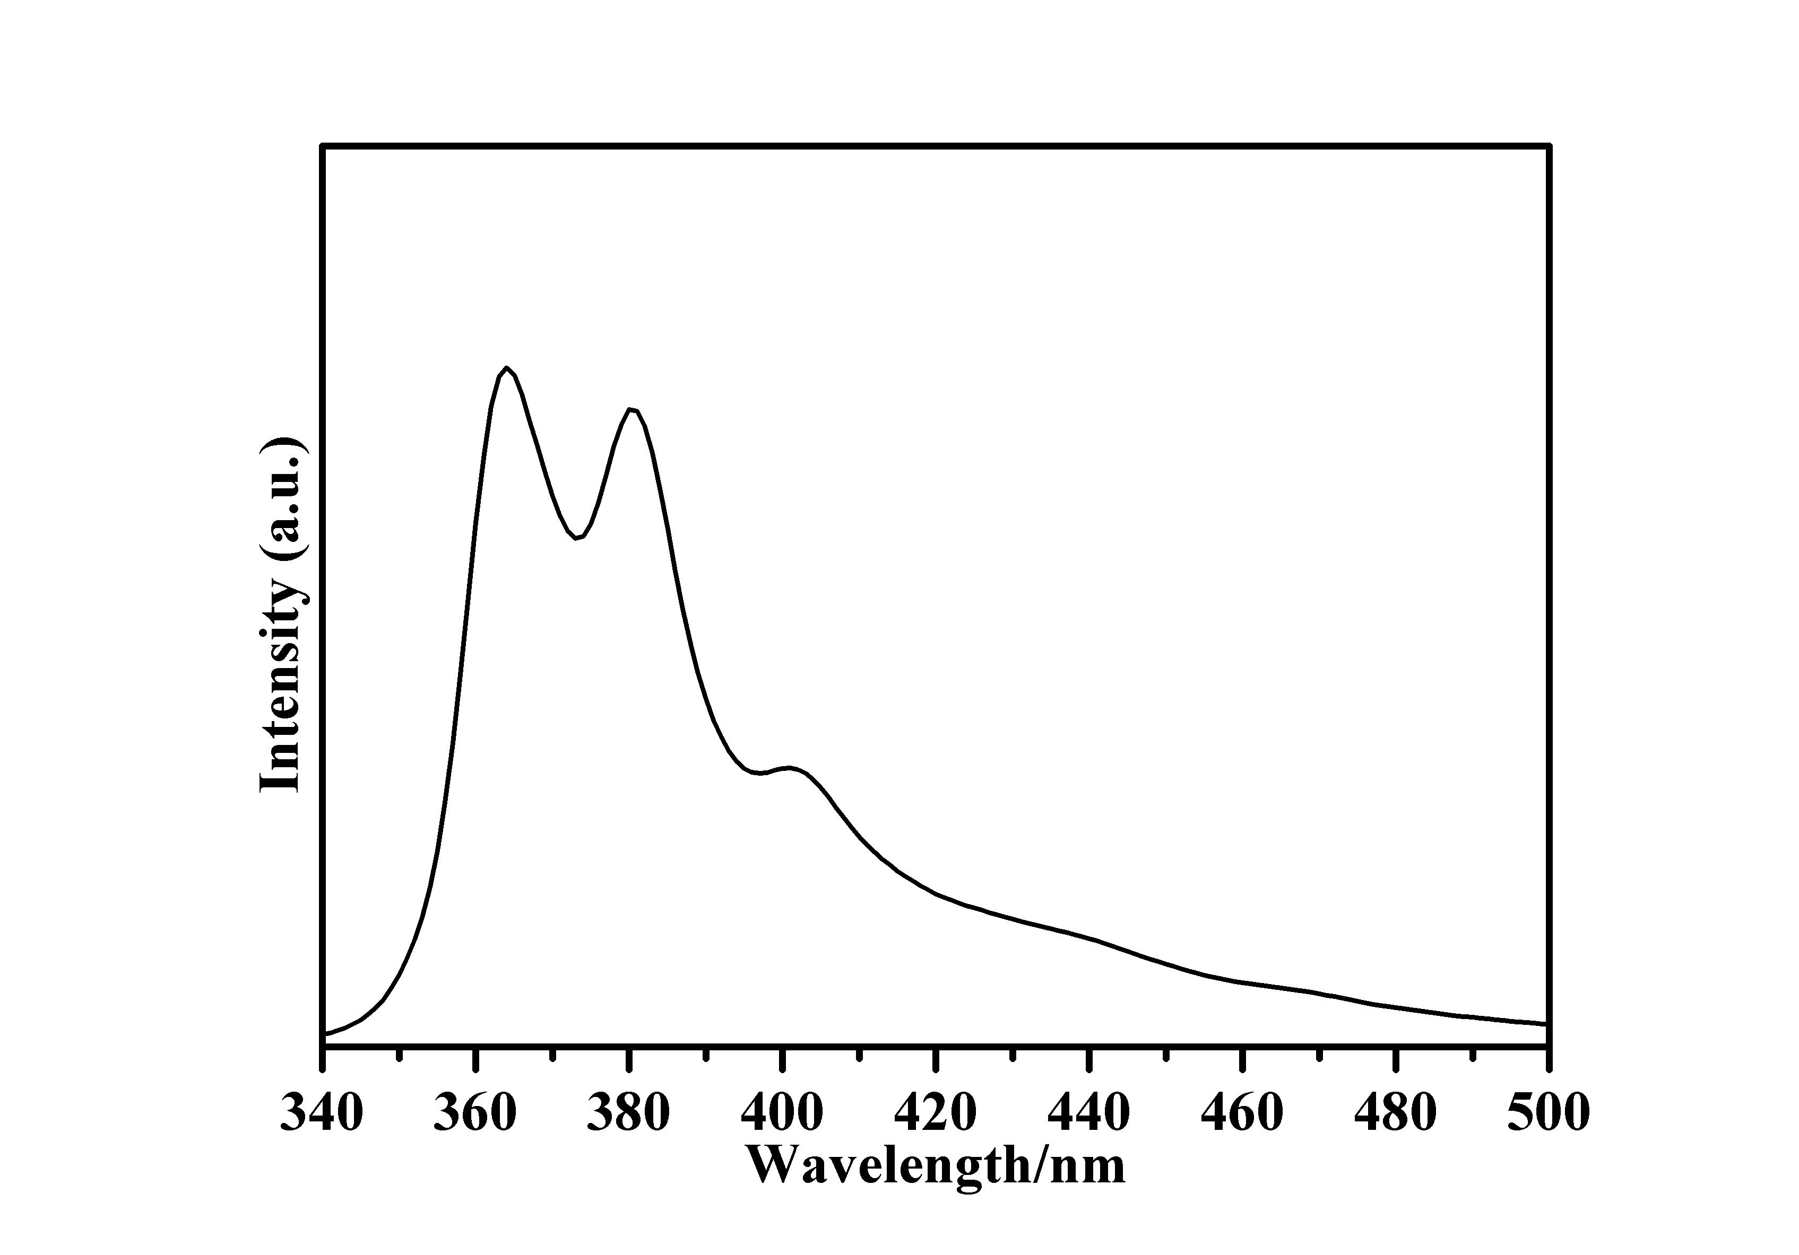

Fig. S2. The luminescence emission spectrum of 1,10-phen ligands in the solid state at room temperature excited at 281 nm.

Table S3 The K_{sv} values and LODs comparison for sensing Cr₂O₇²⁻.

Cr₂O₇²⁻
MOFs | K_{SV}/M⁻¹ | LODs  /μM | Medium used | Refs.
Zn-MOF | 4.84×10³ | 1.21 | H₂O | This work
Zn-MOF | 4.44×10³ | 4.56 | HEPES | This work
[Zn(IPA)(L)]_{n} | 1.37 × 10³ | 12.02 | H₂O | S1
[Tb(HL)(H₂O)₂(NO₃)]·NO₃ | 4.99×10⁴ | 25 | H₂O | S2
[Tb(ppda)(bdc)_{0.5}(C₂H₅OH)(H₂O)]_{n} | 4.03×10³ | 50 | DMF | S3
{[Cd(L1)(BPDC)]·2H₂O}_{n} | 6.40×10³ | 37.6 | H₂O | S4
{[Cd(L1)(SDBA)(H₂O)]·0.5H₂O}_{n} | 4.97×10³ | 48.6 | H₂O | S4
{[Cd(L)(4,4'-bpy)]·DMF·H₂O} | 2.83×10³ | 7.10 | DMF | S5
[Zn(OBA)₂(L1)·2DMA]_{n} | 1.89×10⁴ | 2.37 | H₂O | S6
[Zn₂(tpeb)(bpdc)₂] | 1.122×10⁴ | 1.04 | H₂O | S7
[Zn₃(dpcp)₂(1,4'-bmib)₂]_{n} | 5.32×10⁴ | 0.71 | H₂O | S8
NU-1000 | 1.34×10⁵ | 1.8 | H₂O | S9
BUT-28 | 1.02×10⁵ | 0.12 | H₂O | S10
BUT-39 | 1.57×10⁴ | 1.5 | H₂O | S11
{[Eu(L2)(H₂O)(DMF)]_{n} | 1.06×10⁵ | 0.32 | H₂O | S12
[Cd₃(cpota)₂(phen)₃]_{n}·5nH₂O | 1.21×10³ | 0.37 | H₂O | S13
[Zn₂(TzTz)₂(BDC)₂]⋅2DMF | 9×10⁷ | 4 | H₂O | S14
[Eu₂L_{1.5}(H₂O)₂EtOH]·DMF}_{n} | 1.526×10³ | ~10 | DMF | S15
References
S1. B. Parmar, Y. Rachuri, K. K. Bisht, R. Laiya, and E. Suresh (2017). Mechanochemical and conventional synthesis of Zn(II)/Cd(II) luminescent coordination polymers: dual sensing probe for selective detection of chromate anions and TNP in aqueous phase. Inorg. Chem. 56, 2627–2638.
S2. W. Gao, F. Liu, B. Y. Zhang, X. M. Zhang J. P. Liu, E. Q. Gao, and Q. Y. Gao (2017). 2D carboxylate-bridged Ln^{III} coordination polymers: displaying slow magnetic relaxation and luminescence properties in the detection of Fe³⁺, Cr₂O₇²⁻ and nitrobenzene. Dalton Trans. 46, 13878−13887.
S3. X. L. Zhang, Z. Y. Zhan, X. Y. Liang, C. Chen, X. L. Liu, Y. J. Jia, and M. Hu (2018). Lanthanide-MOFs constructed from mixed dicarboxylate ligands as selective multi-responsive luminescent sensors. Dalton Trans. 47, 3272–3282.
S4. S. G. Chen, Z. Z. Shi, L. Qin, H. L. Jia, and H. G. Zheng (2017). Two new luminescent Cd(II)-metal–organic frameworks as bifunctional chemosensors for detection of cations Fe³⁺, anions CrO₄^{2–}, and Cr₂O₇^{2–} in aqueous solution. Cryst. Growth Des. 17, 67–72.
S5. Z. W. Chen, X. N. Mi, J. Lu, S. N. Wang, Y. W. Li, J. M. Dou, and D. C. Li (2018). From 2D→3D interpenetration to packing: N coligand-driven structural assembly and tuning of luminescent sensing activities towards Fe³⁺ and Cr₂O₇²⁻ ions. Dalton Trans. 47, 6240–6249.
S6. B. W. Qin, X. Y. Zhang, J. J. Qiu, G. Gahungu, H. Y. Yuan, and J. P. Zhang (2021). Water-robust zinc–organic framework with mixed nodes and its handy mixed-matrix membrane for highly effective luminescent detection of Fe³⁺, CrO₄^{2–}, and Cr₂O₇^{2–} in aqueous solution. Inorg. Chem. 60, 1716–1725.
S7. B. B. Rath, and J. J. Vittal (2020). Water stable Zn(II) metal–organic framework as a selective and sensitive luminescent probe for Fe(III) and chromate ions. Inorg. Chem. 59, 8818–8826.
S8. W. B. Liu, N. N. Li, X. Zhang, Y. Zhao, Z. Zong, R. X. Wu, J. P. Tong, C. F. Bi, F. Shao, and Y. H. Fan (2021). Four Zn(II)-MOFs as highly sensitive chemical sensor for the rapid detection of tetracycline, o-nitro phenol, Cr₂O₇^{2–}/PO₄^{3–}, Fe³⁺/Al³⁺ in water environment. Cryst. Growth Des. 21, 5558–5572.
S9. Z. J. Lin, H. Q. Zheng, H. Y. Zheng, L. P. Lin, Q. Xin, and R. Cao (2017). Efficient capture and effective sensing of Cr₂O₇^{2–} from water using a zirconium metal–organic framework. Inorg. Chem. 56, 14178–14188.
S10. M. M. Xu, X. J. Kong, T. He, X. Q. Wu, L. H. Xie, and J. R. Li (2018). A stable Zr(IV)-based metal-organic framework constructed from C=C bridged di-isophthalate ligand for sensitive detection of Cr₂O₇^{2–} in water. Inorg. Chem. 57, 14260–14268.
S11. T. He, Y. Z. Zhang, X. J. Kong, J. M. Yu, X. L. Lv, Y. F. Wu, Z. J. Guo, and J. R. Li (2018). Zr(IV)-based metal-organic framework with T-shaped ligand: unique structure, high stability, selective detection, and rapid adsorption of Cr₂O₇^{2–} in water. ACS Appl. Mater. Interfaces 10, 16650–16659.
S12. X. N. Mi, D. F. Sheng, Y. E. Yu, Y. H. Wang, L. M. Zhao, J. Lu, Y. W. Li, D. C. Li, J. M. Dou, J. G. Duan, and S. N. Wang (2019). Tunable light emission and multiresponsive luminescent sensitivities in aqueous solutions of two series of lanthanide metal–organic frameworks based on structurally related ligands. ACS. Appl. Mater. Interfaces 11, 7914–7926.
S13. S. D. Li, L. P. Lu, M. L. Zhu, C. X. Yuan, and S. S. Fen (2018). A bifunctional chemosensor for detection of volatile ketone or hexavalent chromate anions in aqueous solution based on a Cd(II) metal–organic framework. Sensor Actuat. B Chem. 258, 970−980.
S14. S. Safaei, J. Wang, amd P. C. Junk (2021). Incorporation of thiazolothiazole fluorophores into a MOF structure: A highly luminescent Zn(II)-based MOF as a selective and reversible sensor for Cr₂O₇²⁻ and MnO₄⁻ anions. J. Solid State Chem. 294, 121762.
S15. W. Liu, X. Huang, C. Xu, C. Y. Chen, L. Z. Yang, W. Dou, W. M. Chen, H. Yang, and W. S. Liu (2016). A multi-responsive regenerable europium–organic framework luminescent sensor for Fe³⁺, Cr^{VI} Anions, and Picric Acid. Chem. Eur. J. 22, 18769–18776.

