Supporting Information for
Fluorescence visualization of endoplasmic reticulum Carboxylesterase in living cells with a small-molecule probe

Zha^{a,†}, Nanqian Xiong^{b†}, Meixia Wangª, Lanfang Chenª, Jun Liu^{c,*},Ganhua You^{d}

a School of Ethnic-Minority Medicine, Guizhou Minzu University, Guiyang, 550025, China
b School of Biological Sciences, Guizhou Education University, Guizhou 550003, China
c College of Chemistry and Chemical Engineering, Hexi University, Zhangye City 734000, China
d The Second People’s Hospital of Guizhou Province, Guiyang, 550002,China

*Corresponding Author; Email: liujun3622849@163.com

Table of contents
- Synthesis of fluorescent probes (PCeEr)
- Mass spectra and NMR characterizations of synthesized compounds (S1‒S3)
- Supplementary data (S4‒S6).

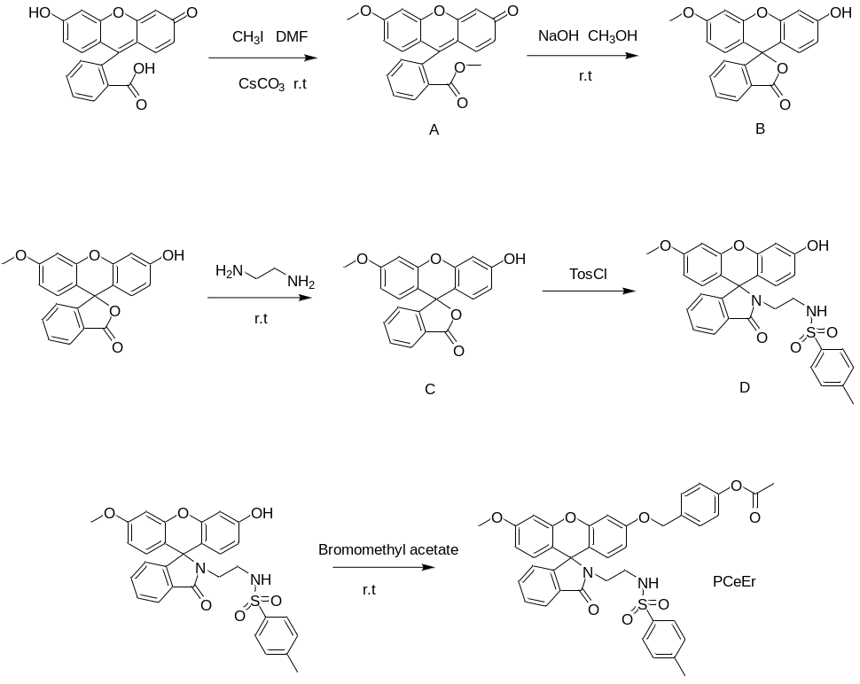
Scheme S1. Synthesis of PCeEr

Synthesis of A, B
The synthesisof the intermediates A and B was conducted according to the reported article [1].
Synthesis of C, D
Compound A and B were synthesized according to literature procedures.^{[1]} Preparation of C: A mixture of ethanediamine (0.1276 g, 2.1 mmol) in C₂H₅OH (50 mL) was refluxed under argon for 8 h. After cooling, the mixture was poured into water, resulting in yellow precipitate. The precipitates were washed with distilled water several times and dried.
Preparation of D: To triethylamine solution (0.5 mL) was added C (0.1983 g) at 25℃. After the reaction mixture was stirred for 20 min, toluenesulfonyl chloride (0.3821 g) and 50 mL of CH₂Cl₂ were added though syringe. After that, the reaction solution was stirred at 0℃ for 2.5 h. The solvent removal under reduced pressure. The residue was purified by silica column dichloromethane/ 0-15% methanol to obtain 0.27 g compound as the faint yellow oil in 40.3% yield.
Synthesis of PCeEr
A mixture of D (0.2122 g), K₂CO₃ (0.1235 mg), and bromomethyl acetate (0.3883 g) were dissolved in dry DMF (20 mL), and the reaction mixture was stirred for 15 h under nitrogen at room temperature. Then, the reaction solution was extracted with CH₂Cl₂/ NaHCO₃, and the combined organic phase was dried with Na₂SO₄. The organic phase was concentrated under reduced pressure. The residue was purified by silica column ethyl acetate: dichloromethane=1:10 to obtain PCeEr (0.14 g) as pale-yellow powder in 31.2% yield. ¹H NMR (400 MHz, DMSO) δ 10.24 (s, 2H), 8.06 (s, 1H), 8.04 (s, 1H), 7.83 (s, 1H), 7.76 (s, 1H), 7.37 (s, 1H), 6.98 (d, J = 2.3 Hz, 2H), 6.87 (s, 1H), 6.71 (s, 2H), 6.55 (d, J = 1.3 Hz, 1H), 6.43 (s, 2H), 6.21 (d, J = 1.3 Hz, 1H), 3.83 (s, 2H), 3.81 (s, 2H), 3.09 (s, 2H), 3.08 (d, J = 1.7 Hz, 2H), 3.06 (s, 2H), 3.04 (s, 2H), 1.20 (d, 6H). ESI-MS: m/z calcd for [C₃₈H₃₈N₄O₈]⁺, 690.20; found, 691.2 (M)⁺.

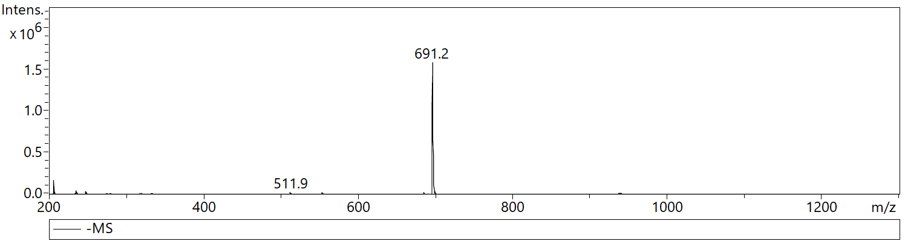
Figure S2. Mass spectrum of compound PCeEr.

Figure S3. ¹H NMR of compound PCeEr.

Figure S4. Plots of fluorescent intensity of PCeEr as a function of CEs concentrations.

Figure S5. Fluorescence intensity (λ_{em} = 522 nm) of 3 μM PCeEr toward various the putative interferants.

Figure S6. Cell viability of PCeEr (1.0 μM) at different times in A549 Cells.

Reference
[1] L. Wu, S.-H. Yang, H. Xiong, J.-Q. Yang, J. Guo, W.-C. Yang, et al. Anal Chem, 2017, 89, 3687-3693.

