Supplementary material

Increased biocrust cover and activity in the highlands of Iceland after five growing seasons of experimental warming

Alejandro Salazar¹, Eyrún G. Gunnlaugsdóttir², Ingibjörg S. Jónsdóttir³, Ian Klupar³,
Ruth-Phoebe T. Wandji¹, Ólafur Arnalds¹, Ólafur Andrésson³

Affiliations
1 Faculty of Environmental and Forest Sciences, Agricultural University of Iceland, Reykjavík, Iceland
2 Institute for Atmospheric and Earth System Research / Physics, Faculty of Science, University of Helsinki, Finland
3 Faculty of Life and Environmental Sciences, University of Iceland, Reykjavık, Iceland.

Corresponding author: Alejandro Salazar, alejandro@lbhi.is, ORCID: 0000-0002-0798-882X

Supplementary figures

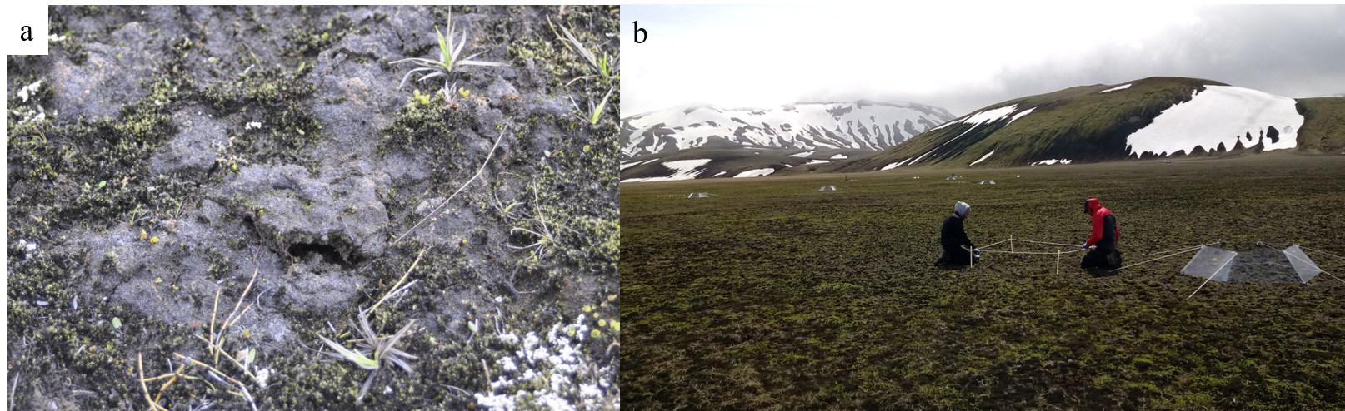
Figure S1. a) Anthelia jurkatzkana biocrust (grayish surface), surrounded primarily by mosses and vascular plants. b) Picture from June 2018, during the establishment of the Climate Research Unit at Subarctic Temperatures (CRUST) experiment in the highlands of Iceland.

Figure S2. Example of the visual estimation of surface cover using the quadrat method. Photo from control plot in July 2018.

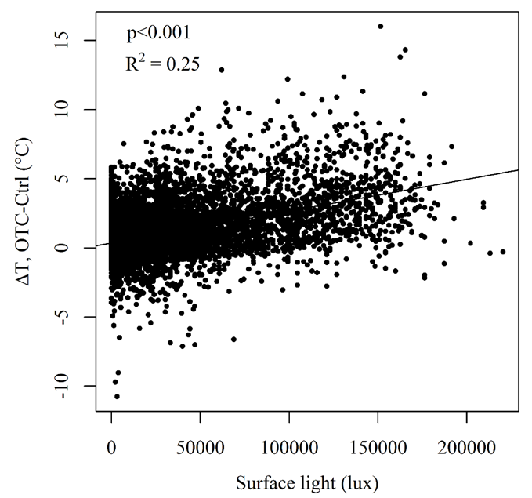
Figure S3. Positive correlation between surface light and the temperature difference (ΔT) between OTCs and controls (i.e. OTC-warming). ΔT = 0.4 + (2.3 x 10⁻⁵)*(Surface light) (Table S2).

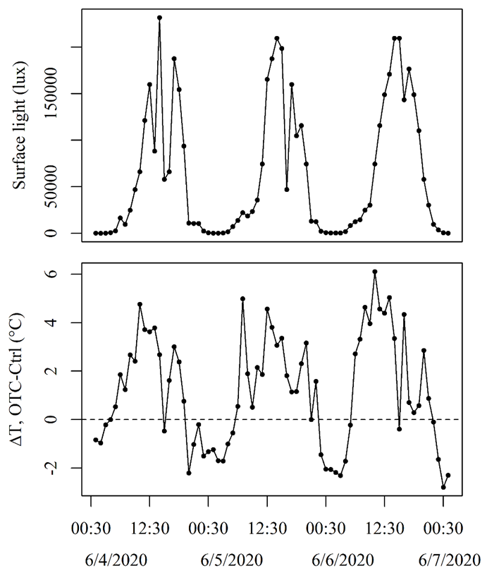
Figure S4. Segment of surface light and ΔT data, showing that surface temperature was lower in an OTC than in its paired control (i.e. negative ΔT) during the darkest part of the night.

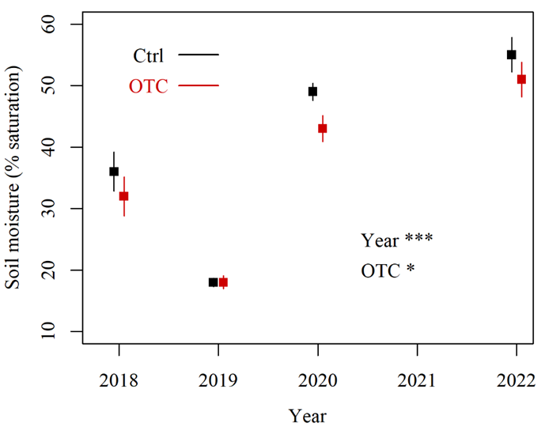

Figure S5. Soil moisture (2-3 cm depth) in control (black lines) and OTCs (red lines) between 2018 and 2022. Break points in 06/23/2018, 06/13/2019, 07/28/2020 and 09/13/2022 are mean values (n=8) and error bars are standard errors. Significance codes: * P < 0.05, *** P < 0.001 (anova results in Table S3). Overall, the OTC treatment decreased soil moisture (P < 0.05), but differences between control and OTC plots at individual years were not significant (Table S4).

Figure S6. Litter cover (%) in control and OTC plots on August 10th, 2022. Significance code: *** P < 0.001 (anova results in Table S7). Grey and red symbols are raw data points.

Figure S7. Number of vascular plant and moss species in control and OTC plots on August 10th, 2022. n=8. Grey and red symbols are raw data points.

Fig S8. Decomposition rates (k) and stabilization factor (S) in control (black) and OTC (red) plots, at 2 cm (open symbols) and 8 cm (solid symbols) depth, in 2018-2019 (left) and 2021-2022 (right). Mean values and standard errors Notice differences in axes values between years. n=8 (2018-2019), n=6 (2021-2022). Significance codes: n.s.: non-significant, * P < 0.05, ** P < 0.01, *** P < 0.001.
Figure S9. NDVI measurements in control and OTC plots on August 10th, 2022. n=8. Grey and red symbols are raw data points. White symbols are outliers.

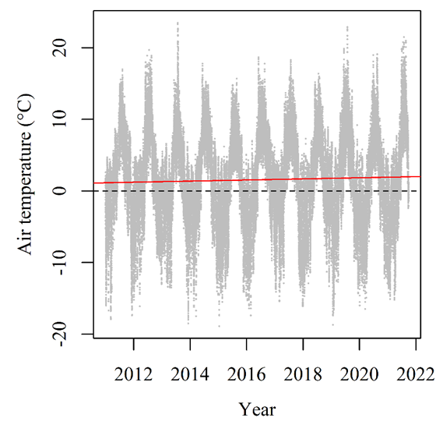
Figure S10. Air temperature (2 m height) at the IMO Vatnsfell station (64°11.736' N, 19°2.802' W), 20 km northeast from our study site. Measurements were taken hourly (gray dots) according to the guidelines of the World Meteorological Organization (WMO, M., 2021). Red solid line: linear regression (Table S1) showing an increase (P < 0.001) in air temperature at a rate of 0.8 °C per decade. Air temperature = 1.14 + (8.83 x 10⁻⁶)*(hour). For illustration purposes, we added a black dashed line showing air temperature 0 °C across years.

Supplementary tables

Table S1. Linear regression of air temperature (2 m height) at the Vatnsfell station, near our study site, as a function of time (hourly measurements), between 2011 and 2021.
Factor | Estimate | Standard error | t value | P value | Significance code
Intercept | 1.144 | 0.039 | 28.97 | <0.001 | ***
Time | 8.834 x 10⁻⁶ | 7.318 x 10⁻⁶ | 12.07 | <0.001 | ***

Table S2. Linear regression of the temperature difference (ΔT) between OTC and control plots at the CRUST experiment, as a function of surface light (lux).
Factor | Estimate | Standard error | t value | P value | Significance code
Intercept | 0.343 | 0.007 | 52.70 | <0.001 | ***
Time | 2.304 x 10⁻⁵ | 2.379 x 10⁻⁷ | 96.87 | <0.001 | ***

Table S3. Anova results of soil moisture (2-3 cm depth) as a function of year (2018, 2019, 2020 and 2022) and treatment (control and OTC).
Factor | Df | Sum of squares | Mean Square | F value | P value | Significance code
Treatment | 1 | 229 | 229 | 5.347 | 0.025 | *
Year | 3 | 10989 | 3663 | 85.618 | <0.001 | ***
Treatment:Year | 3 | 68 | 23 | 0.527 | 0.665
Residuals | 56 | 2396 | 43

Table S4. Tukey Honest Significant Differences of soil moisture (2-3 cm depth) as a function of year (2018, 2019, 2020 and 2022) and treatment (control and OTC).
Ctrl-OTC, Year | Difference | Lower bound | Upper bound | P value
2018 | -4.250 | -14.546 | 6.046 | 0.895
2019 | -0.625 | -10.921 | 9.671 | 0.999
2020 | -6.375 | -16.671 | 3.921 | 0.524
2022 | -3.875 | -14.171 | 6.421 | 0.932

Table S5. anova results for surface cover of biocrust, moss and vascular plants at the CRUST experiment between 2018 and 2022.
Cover type | Factor | Df | Sum of squares | Mean Square | F value | P value | Significance code
Biocrust | Year | 3 | 530 | 176.8 | 1.5 | 0.234
Biocrust | Treatment | 1 | 517 | 516.9 | 4.3 | 0.043 | *
Biocrust | Year:  Treatment | 3 | 65 | 21.6 | 0.2 | 0.910
Biocrust | Residual | 56 | 6756 | 120.6
Moss | Year | 3 | 637 | 212.3 | 1.7 | 0.168
Moss | Treatment | 1 | 349 | 349.2 | 2.9 | 0.096 | +
Moss | Year:  Treatment | 3 | 133 | 44.4 | 0.4 | 0.778
Moss | Residual | 56 | 6815 | 121.7
Vascular plants | Year | 3 | 475.7 | 158.6 | 21.5 | 2.4 x 10⁻⁹ | ***
Vascular plants | Treatment | 1 | 211.2 | 211.2 | 28.7 | 1.7 x 10⁻⁶ | ***
Vascular plants | Year:  Treatment | 3 | 215.5 | 71.8 | 9.8 | 2.8 x 10⁻⁵ | ***
Vascular plants | Residual | 56 | 412.3 | 7.4

Table S6. Tukey HSD analysis of biocrust, moss and vascular plant cover at the CRUST experiment between 2018 and 2022.
Cover type | Year | Treatment | Difference | Lower bound | Upper bound | P value | Significance code
Biocrust | 2018 | Ctrl-OTC | 3.195 | -14.095 | 20.486 | 0.999
Biocrust | 2019 | Ctrl-OTC | 4.219 | -13.072 | 21.509 | 0.991
Biocrust | 2021 | Ctrl-OTC | 7.570 | -9.720 | 24.861 | 0.863
Biocrust | 2022 | Ctrl-OTC | 7.750 | -9.540 | 25.040 | 0.848
Moss | 2018 | Ctrl-OTC | -0.547 | -17.912 | 16.819 | 1.000
Moss | 2019 | Ctrl-OTC | -8.711 | -26.077 | 8.655 | 0.760
Moss | 2021 | Ctrl-OTC | -4.680 | -22.046 | 12.686 | 0.989
Moss | 2022 | Ctrl-OTC | -4.750 | -22.116 | 12.616 | 0.988
Vascular plants | 2018 | Ctrl-OTC | -2.766 | -7.037 | 1.505 | 0.466
Vascular plants | 2019 | Ctrl-OTC | 1.641 | -2.630 | 5.912 | 0.926
Vascular plants | 2021 | Ctrl-OTC | -4.906 | -9.177 | -0.635 | 0.014 | *
Vascular plants | 2022 | Ctrl-OTC | -8.500 | -12.771 | -4.229 | <0.001 | ***
Vascular plants | 2018-2019 | Ctrl | -8.367 | -12.638 | -4.096 | <0.001 | ***
Vascular plants | 2019-2021 | Ctrl | 2.352 | -1.920 | 6.623 | 0.666
Vascular plants | 2021-2022 | Ctrl | 4.719 | 0.448 | 8.990 | 0.021 | *
Vascular plants | 2018-2019 | OTC | -3.961 | -8.232 | 0.310 | 0.088 | +
Vascular plants | 2019-2021 | OTC | -4.195 | -8.466 | 0.076 | 0.058 | +
Vascular plants | 2021-2022 | OTC | 1.125 | -3.146 | 5.396 | 0.991

Table S7. anova results of litter cover (%) responses to the OTC treatment.
Factor | Df | Sum of squares | Mean Square | F value | P value | Significance code
Treatment | 1 | 105.06 | 105.06 | 18.41 | <0.001 | ***
Residuals | 14 | 79.88 | 5.71

Table S8. Percentage mass loss. Best model identified with the glmulti function: Percentage mass loss ~ Treatment + Year + Tea type + Year:Tea type. Results from the mixed effect models (BIC 657), including the random effects of blocks, are biologically equivalent to those from an anova (BIC 654), but the latter had a better goodness-of-fit (i.e. lower BIC) and therefore those are the results that we report in this table.
Factor | Df | Sum of squares | Mean Square | F value | P value | Significance code
Treatment | 1 | 143 | 143 | 7.130 | 0.009 | **
Year | 1 | 975 | 975 | 48.667 | <0.001 | ***
Tea type | 1 | 48132 | 48132 | 2403.423 | <0.001 | ***
Year:Tea type | 1 | 105 | 105 | 5.229 | 0.024 | *
Residual | 103 | 2063 | 20

Table S9. Stabilization factor (S). Best model identified with the glmulti function: S ~ Treatment + Year + Depth + Year:Depth. Results from the mixed effect models including the random effects of blocks, are biologically equivalent to those from an anova, and both had the same goodness-of-fit (BIC -226). For practical reasons in the table below we present the anova results.
Factor | Df | Sum of squares | Mean Square | F value | P value | Significance code
Treatment | 1 | 0.040 | 0.040 | 13.137 | <0.001 | ***
Year | 1 | 0.453 | 0.453 | 147.857 | <0.001 | ***
Depth | 1 | 0.006 | 0.006 | 1.838 | 0.179
Year:Depth | 1 | 0.028 | 0.028 | 9.1 | 0.003 | **
Residual | 79 | 0.242 | 0.003

Table S10. Tukey HSD analysis of stabilization factor at the CRUST experiment at 2 cm and 8 cm depths and in the 2018-2019 and 2021-2022 periods.
Yearª | Depth (cm) | Difference | Lower bound | Upper bound | P value | Significance code
2019 | 2-8 | -0.033 | -0.070 | 0.003 | 0.087 | +
2022 | 2-8 | 0.051 | -0.013 | 0.114 | 0.161
2019-2022 | 2 | 0.129 | 0.078 | 0.180 | <0.001 | ***
2019-2022 | 8 | 0.213 | 0.160 | 0.266 | <0.001 | ***
ªFor practical reasons, in this table “Year” makes reference to the last year of the incubation period. i.e. 2019 and 2022: last years of the 2018-2019 and 2021-2022 periods, respectively.

Table S10. Decomposition rates (k). Best model identified with the glmulti function: k ~ Year + Depth. Results from the mixed effect models (BIC -959), including the random effects of blocks, are biologically equivalent to those from an anova (BIC -962), but the latter had a better goodness-of-fit (i.e. lower BIC) and therefore those are the results that we report in this table.
Factor | Df | Sum of squares | Mean Square | F value | P value | Significance code
Year | 1 | 5.5 x 10⁻⁵ | 5.5 x 10⁻⁵ | 106.227 | <0.001 | ***
Depth | 1 | 2.4 x 10⁻⁶ | 2.4 x 10⁻⁶ | 4.614 | 0.035 | *
Residual | 80 | 4.2 x 10⁻⁵ | 5.2 x 10⁻⁷

Table S11. Tukey HSD analysis of k at the CRUST experiment at 2 cm and 8 cm depths and in the 2018-2019 and 2021-2022 periods.
Yearª | Depth (cm) | Difference | Lower bound | Upper bound | P value | Significance code
2019 | 2-8 | -5.6 x 10⁻⁴ | -0.001 | -7.8 x 10⁻⁵ | 0.016 | *
2022 | 2-8 | 1.3 x 10⁻⁴ | -7.0 x 10⁻⁴ | 9.6 x 10⁻⁴ | 0.974
2019-2022 | 2 | -0.002 | -0.003 | -1.5 x 10⁻³ | <0.001 | ***
2019-2022 | 8 | -0.002 | -0.002 | -8.3 x 10⁻³ | <0.001 | ***
ªFor practical reasons, in this table “Year” makes reference to the last year of the incubation period. i.e. 2019 and 2022: last years of the 2018-2019 and 2021-2022 periods, respectively.

Table S13. Biocrust respiration (R_{B}). Best model identified with the glmulti function: R_{B} ~ Year + Month + Year:Month (BIC = -72).
Factor | Df | Sum of squares | Mean Square | F value | P value | Significance code
Year | 2 | 5.487 | 2.743 | 142.001 | <0.001 | ***
Month | 2 | 3.002 | 1.501 | 77.705 | <0.001 | ***
Year:Month | 1 | 0.103 | 0.103 | 5.336 | 0.023 | *
Residuals | 82 | 1.584 | 0.019

Table S14. Biocrust respiration (R_{B}) as a function of treatment, year, month and the interaction between year and month. Best model identified with the glmulti function: R_{B} ~ Year + Month + Year:Month (BIC = -72; Table S14). With the OTC treatment (R_{B} ~ Treatment + Year + Month + Year:Month) the model has a similar performance (BIC = -68), and indicates a marginally significant and positive effect of warming on R_{B}.
Factor | Df | Sum of squares | Mean Square | F value | P value | Significance code
Treatment | 1 | 0.009 | 0.009 | 0.449 | 0.504 | +
Year | 2 | 5.487 | 2.743 | 141.058 | <0.001 | ***
Month | 2 | 3.002 | 1.501 | 77.189 | <0.001 | ***
Year:Month | 1 | 0.103 | 0.103 | 5.307 | 0.024 | *
Residuals | 81 | 1.575 | 0.019

Table S15. anova results of NDVI analysis.
Factor | Df | Sum of squares | Mean Square | F value | P value
Treatment | 1 | 0.002 | 0.002 | 0.633 | 0.439
Residuals | 14 | 0.038 | 0.003

