Appendix
Figure 1: Difficult Airway Alert Documentation Revised Implementation
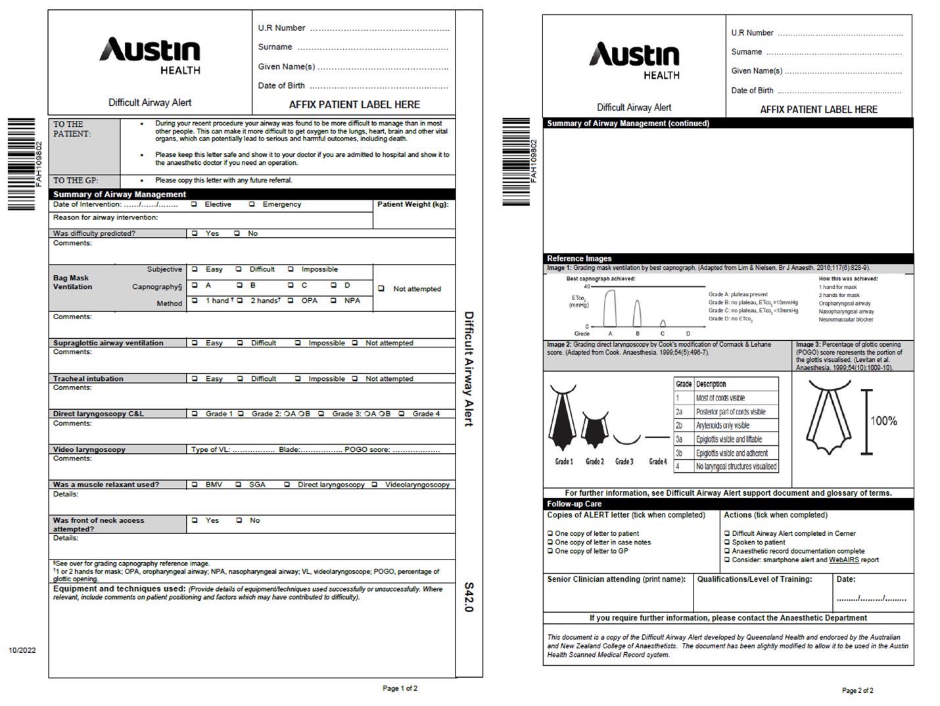

Local adaptation and implementation of the Queensland Health Difficult Airway Alert

Table 1: Inclusion / Exclusion Alerts
Any alert containing “intubation” OR “airway” OR “fibreoptic” OR “laryngoscopy” OR “ventilation” or “CICO” (case insensitive).

Included | Excluded
- DIFFICULT INTUBATION  - DIFFICULT AIRWAY INTUBATION  - UNEXPECTED DIFFICULT INTUBATION  - FAILED INTUBATION  - Difficult intubation, but easy BVM  - FAILED OR DIFFICULT INTUBATION  - EXPECTED DIFFICULT INTUBATION  - MEDICAL - DIFFICULT AIRWAY  - DIFFICULT AIRWAY  - DIFFICULT AIRWAY INTUBATION  - Anaesthetic - Difficult Airway  - Difficult airway, Grade 4 larynx  - Difficult Airway - grade 4 laryngoscopy, requires AFOI)  - Lumps in throat that block airway. Had tracheostomy for 9 mths. Requires HDU post procedure. | - COAD - CHRONIC OBSTRUCTIVE AIRWAYS DISEASE  - CHRONIC OBSTRUCTIVE AIRWAY DISEASE  - ACUTE EXACERBATION OF CHRONIC OBSTRUCTIVE AIRWAYS DISEASE  - RESUS PLAN - RESPOND / CODE BLUE FOR INTUBATION ONLY, NO CPR  - RESPIRATORY AIRWAY  - CPAP (CONTINUOUS POSITIVE AIRWAY PRESSURE) VENTILATION WEANING PROTOCOL  - CPAP (CONTINUOUS POSITIVE AIRWAY PRESSURE) AT HOME  - 5. ? Airways disease  - INTUBATION  - AIRWAY CONSTRICTION  - AIRWAYS OBSTRUCTION REVERSIBLE  - AIRWAY  - AIRWAY EVENT  - CHRONIC OBSTRUCTIVE AIRWAY DISEASE WITH ASTHMA  - AIRWAY CARE MANAGEMENT  - AIRWAY PATENT  - AIRWAY PROCEDURE  - OBSTRUCTION OF AIRWAY BY FOOD  - DEPENDENCE ON BIPHASIC POSITIVE AIRWAY PRESSURE (BIPAP) VENTILATION  - NASAL AIRWAY OBSTRUCTION  - AIRWAY HYPERREACTIVITY  - AIRWAY HAEMORRHAGE  - CHRONIC AIRWAY DISEASE  - BIPAP - BIPHASIC PRESSURE AIRWAY SUPPORT  - NASAL AIRWAY OBSTRUCTION  - CPAP - CONTINUOUS POSITIVE AIRWAYS PRESSURE  - AIRWAY CONDUCTANCE (G>AW<), FUNCTION  - AIRWAY MANAGEMENT  - Airways disease  - CPAP - CONTINUOUS POSITIVE AIRWAYS PRESSURE  - CHRONIC AIRWAY DISEASE  - ACUTE INFECTIVE EXACERBATION OF CHRONIC OBSTRUCTIVE AIRWAYS DISEASE  - NASAL AIRWAY  - INTUBATION OF TRACHEA  - NASAL AIRWAY OBSTRUCTION  - AIRWAY CLOSING VOLUME  - RESUS PLAN - MET CALL ONLY - NON-INVASIVE VENTILATION OFFERED  - RESUS PLAN - MET CALL ONLY - NON-INVASIVE VENTILATION NOT OFFERED, WARD MANAGEMENT ONLY  - Obesity hypoventilation syndrome  - NONINVASIVE VENTILATION  - Chronic nocturnal hypoventilation on nocturnal NIV  - nocturnal hypoventilation  - EXTREME OBESITY WITH ALVEOLAR HYPOVENTILATION  - Obesity hypoventilation  - HYPERVENTILATION  - HYPOVENTILATION  - CPAP (CONTINUOUS POSITIVE AIRWAY PRESSURE) VENTILATION WEANING PROTOCOL  - BILATERAL CHRONIC OTITIS MEDIA OF EARS FOLLOWING INSERTION OF TYMPANIC VENTILATION TUBE  - Not for CPR, is for non-invasive ventilation and inotropes & MET calls  - DEPENDENCE ON BIPHASIC POSITIVE AIRWAY PRESSURE (BIPAP) VENTILATION  - Obesity hypoventilation syndrome on nocturnal NIV  - PULMONARY HYPERTENSION ASSOCIATED WITH CHRONIC UNDERVENTILATION  - WEANING FROM MECHANICALLY ASSISTED VENTILATION  - VENTILATION STATUS  - WEANING FROM MECHANICALLY ASSISTED VENTILATION CONTINUED  - INTERMITTENT HYPERVENTILATION  - MECHANICALLY ASSISTED VENTILATION  - CONTROLLED MECHANICAL VENTILATION  - Chronic hypoventilation - ? central cause  - Likely obesity hypoventilation syndrome  - VENTILATION, FUNCTION  - DIRECT LARYNGOSCOPY  - CPAP (CONTINUOUS POSITIVE AIRWAY PRESSURE) TITRATION  - ENDOTRACHEAL INTUBATION

