Exploring putative drug properties associated with TNF-alpha inhibition and identification of potential targets in cardiovascular disease using Machine Learning-Assisted QSAR Modeling and Virtual Reverse Pharmacology approach
Manisha Shah¹, Sivakumar A¹*
*Correspondence: siva_kumar.a@vit.ac.in
1 Department of Bio-sciences, School of Biosciences and Technology, Vellore Institute of Technology, Vellore, Tamil Nadu, 632014, India

Supplementary Materials

3.3.1 Mechanistic interpretation of important features
a. PubChem fingerprint and its association with bioactivity
The first top-ranking feature of the PubChem fingerprint indicates the presence of "1 saturated or aromatic carbon only ring-sized 7" (PubFP214). After associating the identified compound (CHEMBL4648362) from our study with the given fingerprint, the aromatic carbon with a ring size of 7 is absent, indicating that the presence of single bond saturation imparts the increased pIC50 value, this suggests an increase in its activity. The second top-ranking feature is "4 aromatic rings" (PubFP261). Aromatic rings are extremely potent drug discovery motifs because they provide a variety of distinct and powerful modes of interaction with a target protein, such as the traditional arene-arene (p stacking) interaction and arene—H bonding (1), presence of this feature improve its interaction with target protein (TNF-alpha) and results in perfect binding. The third top-ranking feature is "any ring size 5" (PubFP150). This implies that the compound has five members and contains two heteroatoms at either size of the compound, at least one of which should be nitrogen, increasing the biological application of the compound. N-heterocyclic frameworks provide a substantial amount of structural variety. -lactam, pyrazole, imidazole, 1,2,4-triazole, pyrimidine, quinoline, and quinazoline derivatives are nitrogen-based heterocyclic molecules with highly promising biological properties, including antitubercular, antidiabetic, anticancer, antibacterial, anti-inflammation, anti-HIV, antifungal, antioxidant and other therapeutic properties (2). The fourth-ranked feature is "any ring size 6" (PubFP206). The fourth feature states the presence of a six-membered ring in a compound, especially when the compound is attached to a halogen ion (chlorine), which gives it a high binding affinity because every available Lewis base in the binding pocket can create halogen bonds with a halogenated ligand (3). The fifth and sixth-ranked features are "C (#C) (-C) (PubFP427) and ‘C-C-C#C’ (PubChemFP460),
The seventh important feature is the presence of "Cl-C-C-N-C" (PubFP609); the presence of this fingerprint ensures excellent cellular potency and metabolic stability (4). The eighth important feature is "2 saturated or aromatic nitrogen-containing ring size 5," which indicates that the presence of either of these features increases the activity of the compound. In the above explanation, the presence of N-heterocyclic compounds increases the biological application of the compound (2). "C(C) (C) (C) (N)" (PubChemFP336) and "C=C" (PubChemFP461) are the ninth and tenth most important features. Presence of any one or more than one of the aforementioned features in a compound can directly impact its activity against TNF-alpha
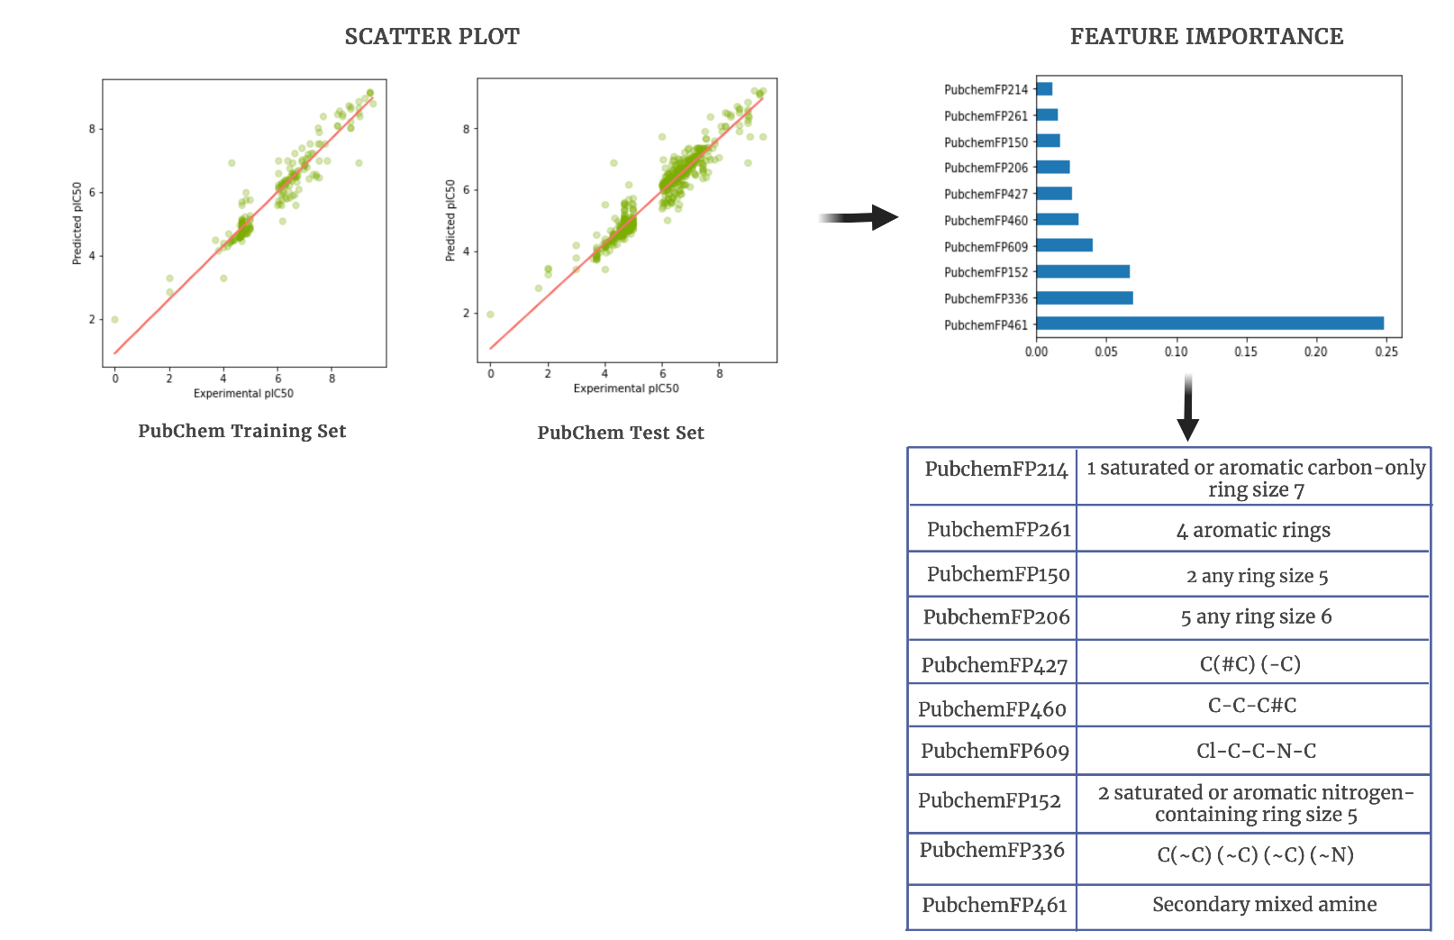

Figure 1: Graphical representation of QSAR model using PubChem fingerprint. The first two panels represent a regression plot for the ML-QSAR predictive model. The second represents the VIP (blue color) plot, which showcases the top ten most critical features based on the PubChem fingerprint.

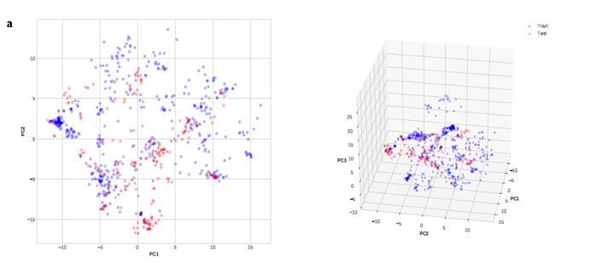
3.4 Applicability Domain
Figure 2: 2D and 3D plot for Applicability domain analysis for PubChem as deduced from the PCA scores plot of training (blue) and test (red) sets constituting 70% and 30% of the data set, respectively.
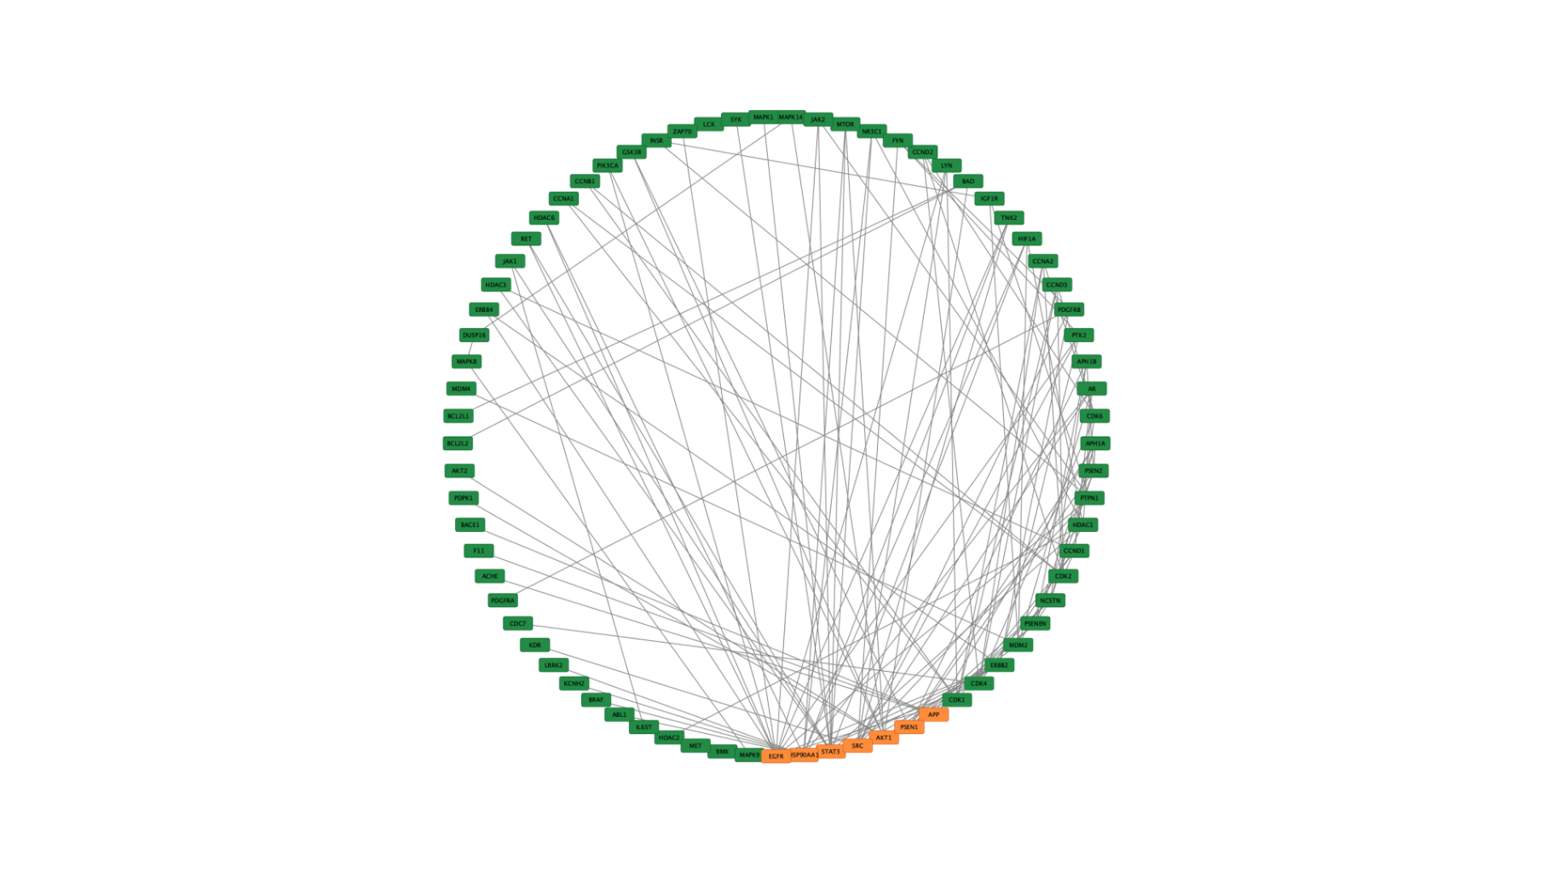
Figure 3: Represent network gene with the most interactive gene emphasized in orange color
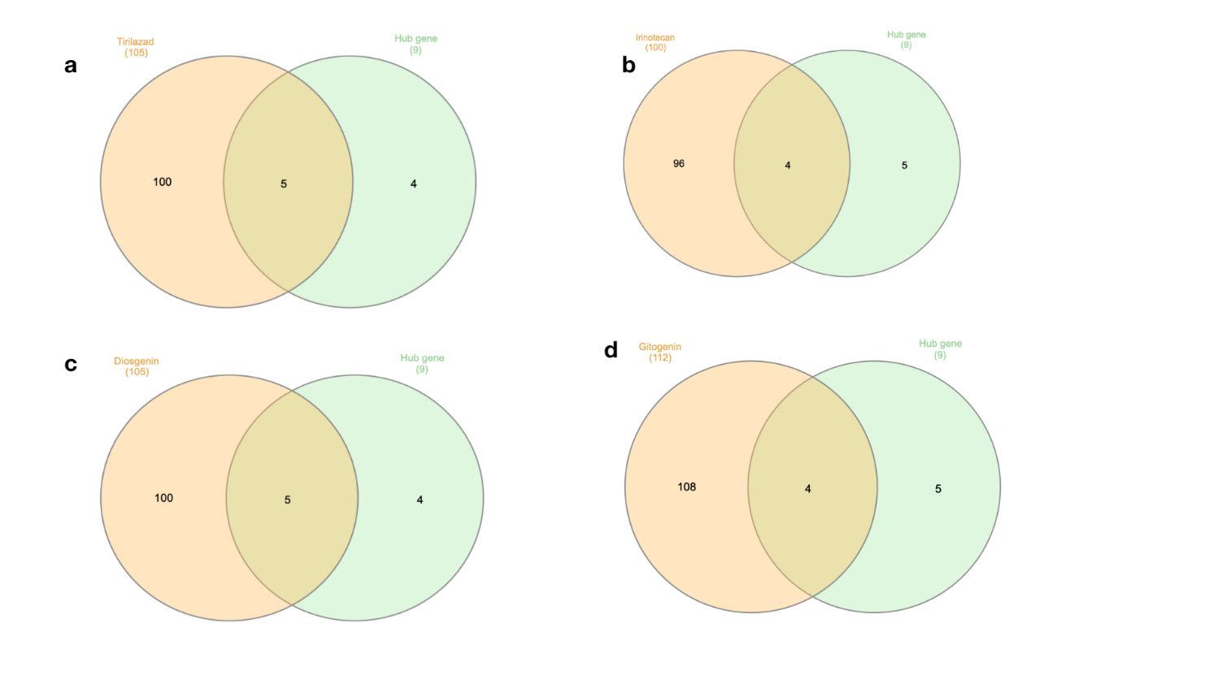

Figure 4: Represent the common genes between scaffolds and hub gene

References
1. Meyer EA, Castellano RK, Diederich F. Interactions with Aromatic Rings in Chemical and Biological Recognition. Angew Chem Int Ed. 2003 Mar 17;42(11):1210–50.
2. Kerru N, Gummidi L, Maddila S, Gangu KK, Jonnalagadda SB. A Review on Recent Advances in Nitrogen-Containing Molecules and Their Biological Applications. Molecules. 2020 Apr 20;25(8):1909.
3. Parisini E, Metrangolo P, Pilati T, Resnati G, Terraneo G. Halogen bonding in halocarbon–protein complexes: a structural survey. Chem Soc Rev. 2011;40(5):2267.
4. Xiao HY, Li N, Duan JJW, Jiang B, Lu Z, Ngu K, et al. Biologic-like In Vivo Efficacy with Small Molecule Inhibitors of TNFα Identified Using Scaffold Hopping and Structure-Based Drug Design Approaches. J Med Chem. 2020 Dec 10;63(23):15050–71.

