Supplemental data

Flutamide exacerbates steatosis and promotes early hepatocarcinogenesis in high-fat diet-fed non-obese steatotic rats: Insights from clustering analysis of mitophagy regulators AMBRA1 and LC3

Emika Hara¹, Kanami Ohshima¹, Wen Zhen¹, Suzuka Uomoto¹, Mio Kobayashi^{1,2}, Makoto Shibutani¹,
Toshinori Yoshida^{1*}

¹ Laboratory of Veterinary Pathology, Cooperative Department of Veterinary Medicine, Tokyo University of Agriculture and Technology, 3-5-8 Saiwai-cho, Fuchu-shi, Tokyo 183-8509, Japan
² Cooperative Division of Veterinary Sciences, Tokyo University of Agriculture and Technology, 3-5-8 Saiwai-cho, Fuchu-shi, Tokyo 183-8509, Japan

*Corresponding author: Toshinori Yoshida, D.V.M., Ph.D., Laboratory of Veterinary Pathology, Tokyo University of Agriculture and Technology, 3-5-8 Saiwai-cho, Fuchu-shi, Tokyo 183-8509, Japan. E-mail: yoshida7@cc.tuat.ac.jp; Tel +81-42-367-5874; Fax: +81-42-367-5771

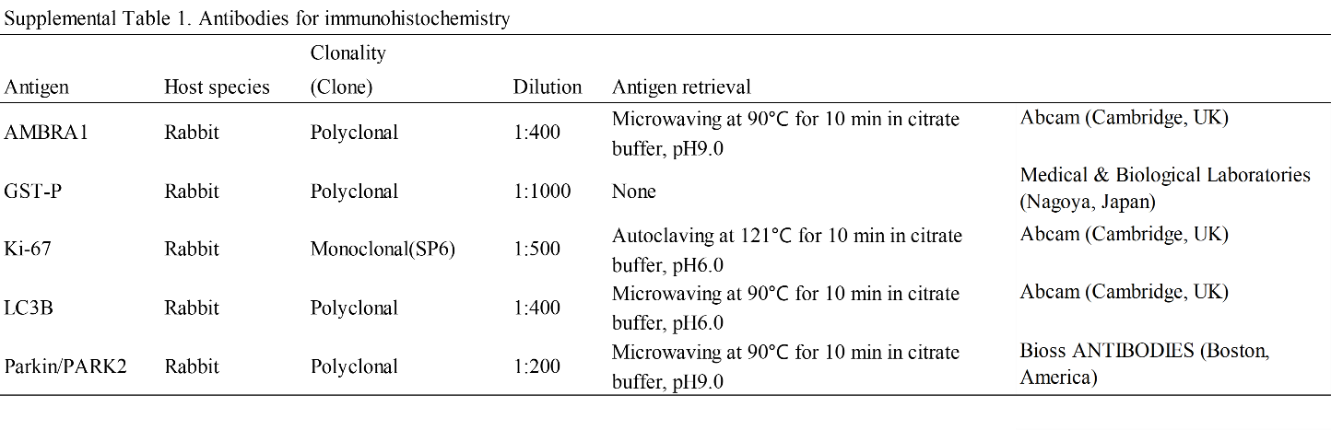

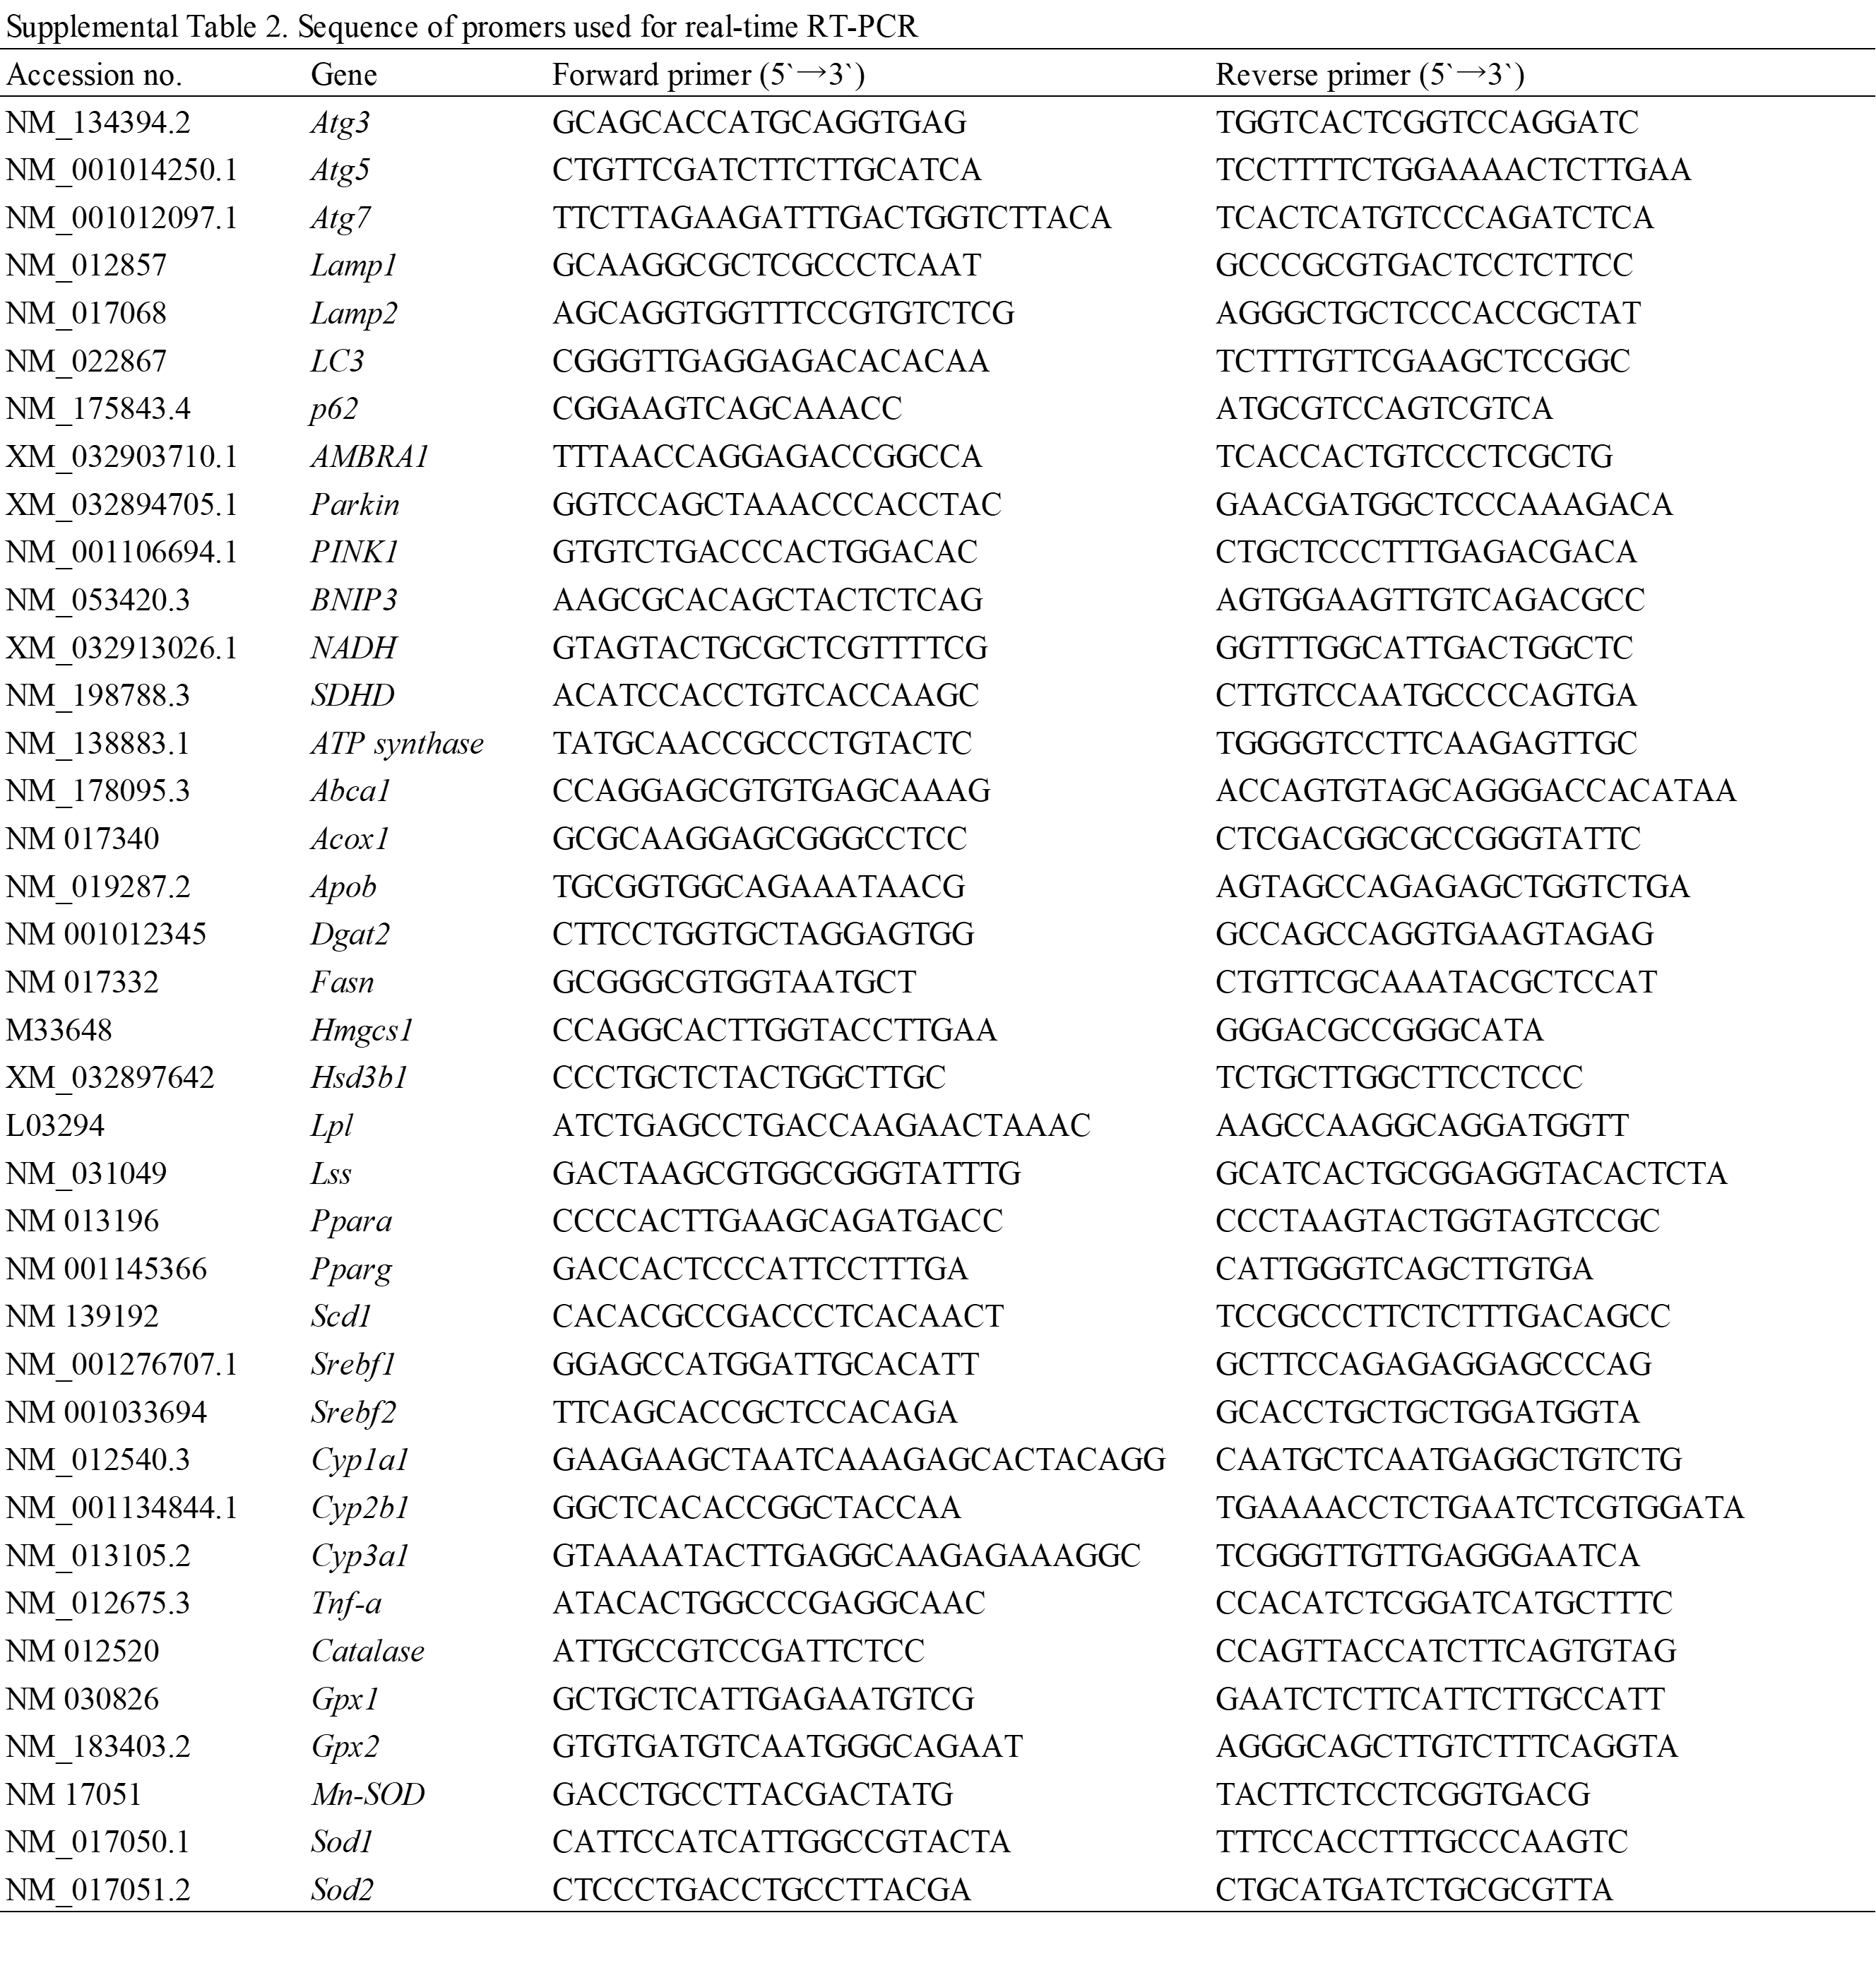

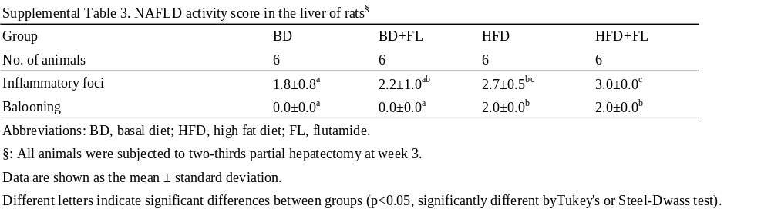

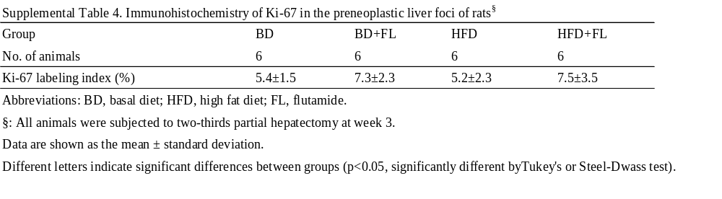

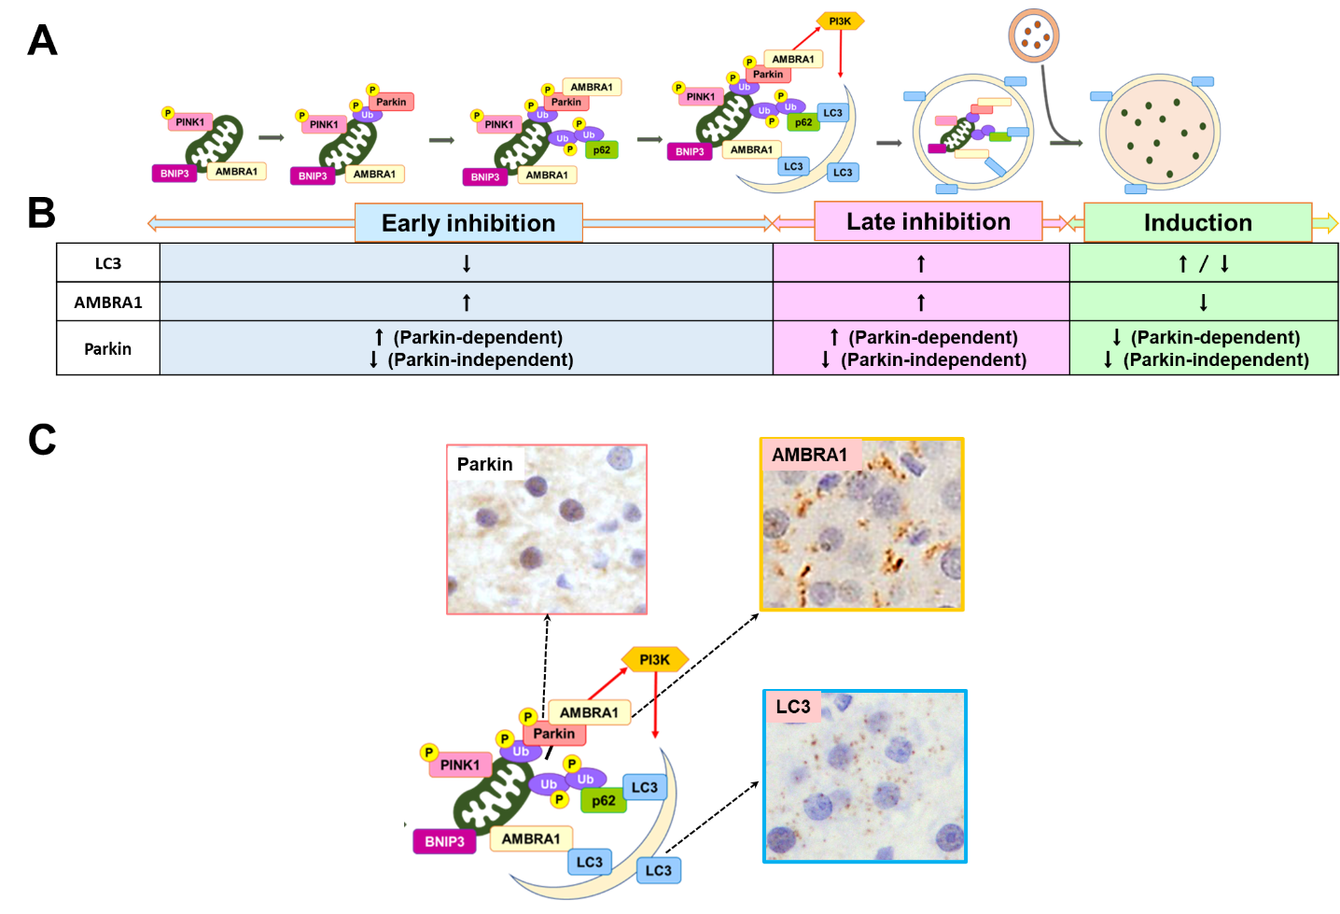

Supplemental Fig. 1. Hypothetical expression of mitophagy markers during autophagic flux. (A) Mitochondrial priming is mediated by Parkin-dependent or -independent mechanisms. Abnormal mitochondria constitutively express non-degraded PINK1 on the outer mitochondrial membrane, leading to the phosphorylation of parkin and ubiquitin. Phosphorylated PARKIN- and ubiquitin-tagged mitochondria are sequestered by LC3, along with the mitophagy-related receptors p62 and BNIP3 to form autophagosomes, which in turn fuse with lysosomes to form autolysosomes. In Parkin-dependent mitophagy, activated Parkin interacts with AMBRA1 on the outer mitochondrial membrane, promoting mitophagy. AMBRA1 directly binds to LC3 and promotes autophagosome formation. (B) Autophagic flux consists of three stages: early inhibition, late inhibition, and induction. Early inhibition involves low LC3 expression and a high AMBRA1 expression; high Parkin levels indicate Parkin-dependent mitophagy, whereas a low Parkin levels imply Parkin-independent mitophagy. Late inhibition involves high expression of both LC3 and AMBRA1, with high Parkin expression indicating Parkin-dependent pathway, and low Parkin expression indicating Parkin-independent pathway. The induction of autophagy is defined by low or high LC3 expression levels and low AMBRA1 expression, where low Parkin expression signifies Parkin-dependent or -independent pathway. (C) Immunohistochemical expression of Parkin, AMBRA1, and LC3 during mitophagy. Abbreviations: AMBRA1 autophagy and Beclin 1 regulator 1, BNIP3 = BCL2/adenovirus E1B-interacting protein 3, LC3 = microtubule-associated protein 1A/1B-light chain 3, PINK1 = phosphatase and tensin homolog (PTEN)-induced kinase 1.

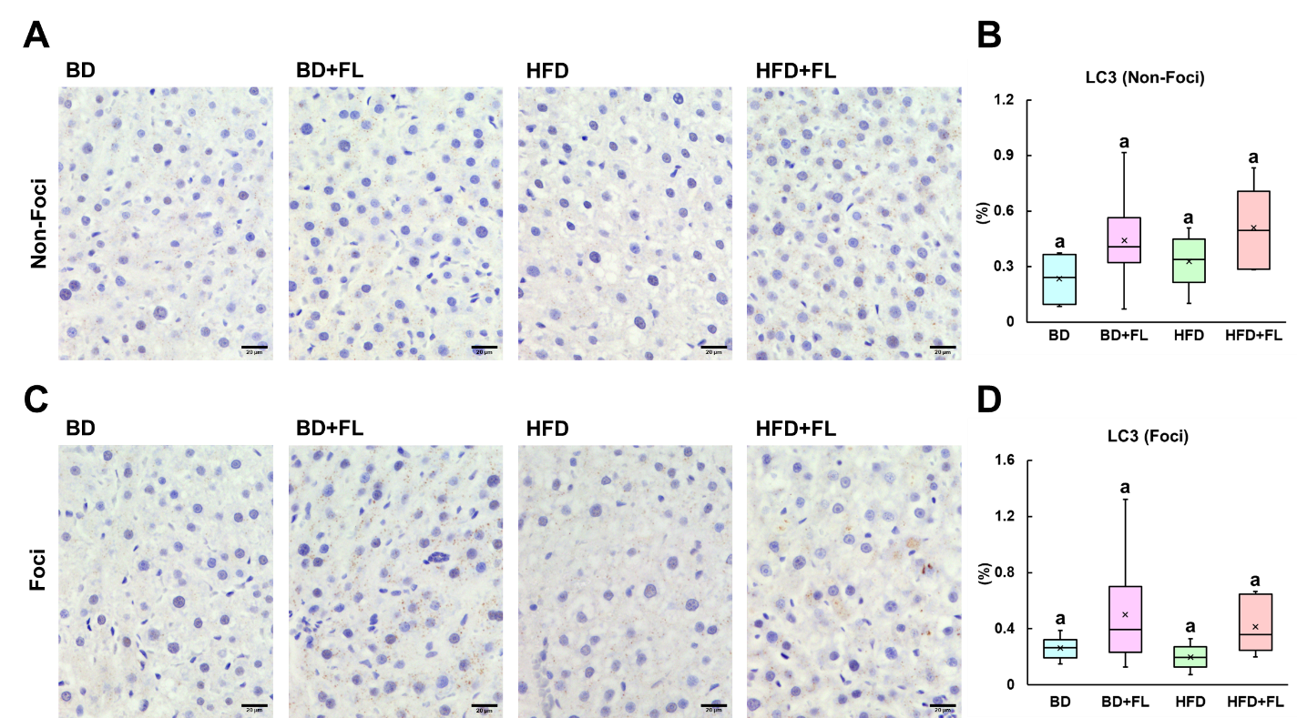

Supplemental Fig. 2. Representative images and quantitative analysis of LC3-positive granules in background hepatocytes and preneoplastic lesions. (A, B) Representative images and box plots illustrating LC3-positive granules in background hepatocytes (nonfoci). (C, D) Representative images and box plots depicting LC3-positive granules in preneoplastic lesions. Different letters indicate significant intergroup differences (p < 0.05, Tukey’s test or Steel–Dwass test). BD = basal diet; f=foci; FL = flutamide; HFD = high-fat diet.

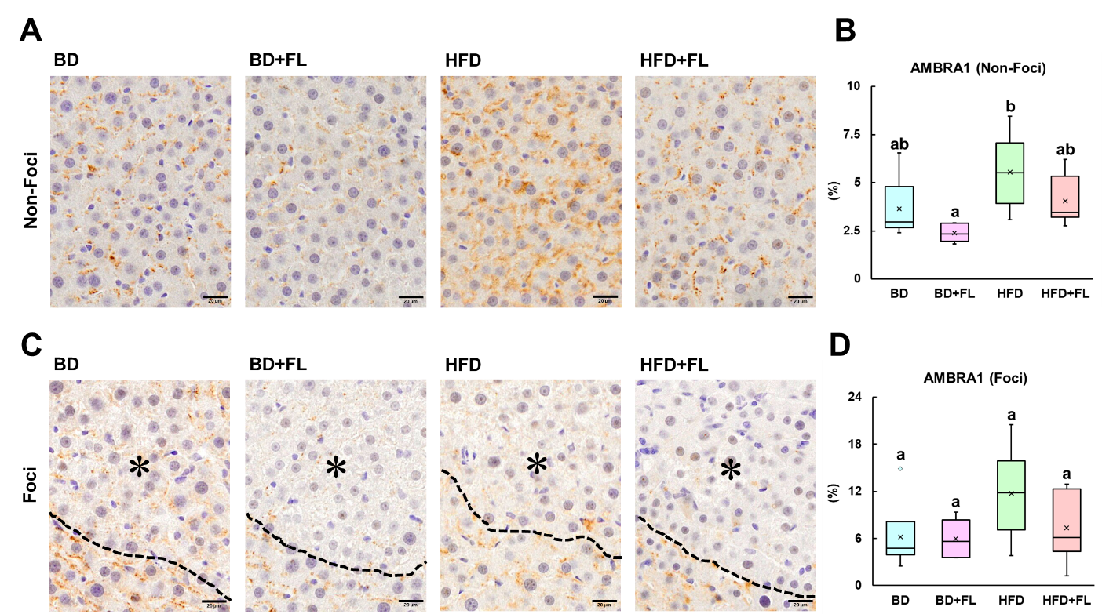

Supplemental Fig. 3. Representative images and quantitative analysis of AMBRA1-positive granules in background hepatocytes and preneoplastic lesions. (A, B) Representative images and box plots illustrating AMBRA1-positive granules in background hepatocytes (nonfoci). (C, D) Representative images and box plots depicting AMBRA1-positive granules in preneoplastic lesions (* = foci). Different letters indicate significant intergroup differences (p < 0.05, Tukey’s test or Steel-Dwass test). BD, basal diet; F, foci; FL, flutamide; GST-P, placental glutathione S-transferase; HFD, high-fat diet.

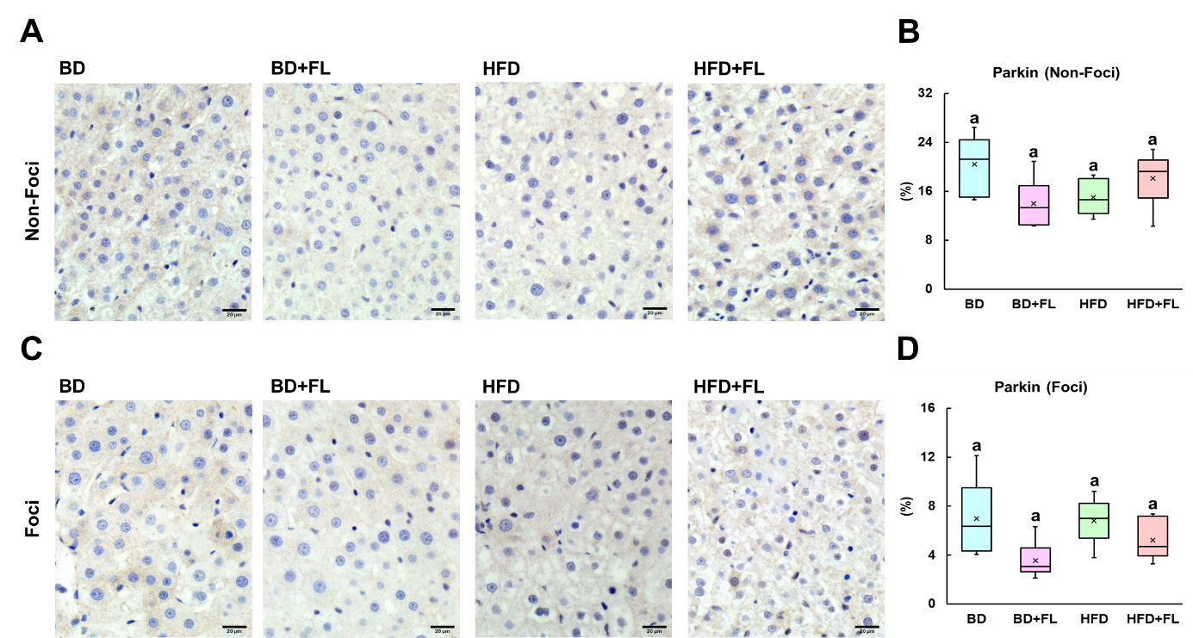

Supplemental Fig. 4. Representative images and quantitative analysis of Parkin-positive granules in background hepatocytes and preneoplastic lesions. (A, B) Representative images and box plots illustrating Parkin-positive granules in background hepatocytes (non-foci). (C, D) Representative images and box plots depicting Parkin-positive granules in preneoplastic lesions. Different letters indicate significant intergroup differences (p < 0.05, Tukey’s test or Steel–Dwass test). BD = basal diet; f=foci; FL = flutamide; HFD = high-fat diet.

