Connecting human wellbeing, urban trees and greenspace in Singapore: Alternative novel approaches.

Supplemental Material

Table S1a Top 10 parks (September 2019)
Park Name | Park Area | Park Income | Total Visit | Returner | Explorer | Park Returner | Park Explorer | Max Displacement | Mean Displacement | Median Displacement
Central Catchment Nature Reserve | Others | NaN | 32,330 | 22,438 | 9,892 | 13,334 | 18,996 | 22.8669 | 9.9625 | 10.9623
War Memorial Park | Downtown Core | High | 27,663 | 15,788 | 11,875 | 14,096 | 13,567 | 23.9686 | 2.2328 | 0.8481
Fort Canning Park | Others | NaN | 2,689 | 1,308 | 1,381 | 1,650 | 1,039 | 22.0374 | 3.3192 | 2.0245
Gardens by the Bay | Others | NaN | 1,639 | 781 | 858 | 1,076 | 563 | 24.2380 | 3.9853 | 2.6960
Raffles Place Park | Downtown Core | High | 1,518 | 812 | 706 | 1,010 | 508 | 22.3720 | 2.4410 | 1.2863
Bedok Town Park | Bedok | Medium | 1,247 | 650 | 597 | 662 | 585 | 22.2461 | 7.6832 | 8.8195
Dhoby Ghaut Green | Others | NaN | 1,182 | 595 | 587 | 836 | 346 | 21.9695 | 3.0675 | 2.4039
Tanjong Pagar Park | Downtown Core | High | 1,132 | 552 | 580 | 745 | 387 | 20.9134 | 2.4361 | 1.0704
Singapore Botanic Gardens | Tanglin | High | 1,052 | 555 | 497 | 709 | 343 | 19.6677 | 5.0114 | 5.0506
Bishan-Ang Mo Kio Park | Bishan | Medium | 956 | 461 | 495 | 649 | 307 | 19.9325 | 8.3266 | 8.7702

Table S1b Top 10 parks (September 2019 weekdays)
Park Name | Park Area | Park Income | Total Visit | Returner | Explorer | Park Returner | Park Explorer | Max Displacement | Mean Displacement | Median Displacement
Central Catchment Nature Reserve | Others | NaN | 23,406 | 16,069 | 6,977 | 10,455 | 12,591 | 22.7359 | 9.6787 | 10.9617
War Memorial Park | Downtown Core | High | 19,125 | 11,037 | 8,807 | 10,405 | 8,719 | 23.9686 | 2.2029 | 0.8478
Fort Canning Park | Others | NaN | 1,867 | 961 | 906 | 1,203 | 664 | 20.2933 | 3.3293 | 2.0109
Raffles Place Park | Downtown Core | High | 1,222 | 704 | 518 | 835 | 387 | 22.3720 | 2.3375 | 1.1418
Gardens by the Bay | Others | NaN | 1,141 | 552 | 589 | 762 | 379 | 23.8771 | 4.1788 | 2.4340
Bedok Town Park | Bedok | Medium | 899 | 473 | 426 | 491 | 408 | 28.5189 | 7.3715 | 8.5383
Tanjong Pagar Park | Downtown Core | High | 876 | 479 | 397 | 594 | 282 | 20.9134 | 2.3012 | 0.8461
Dhoby Ghaut Green | Others | NaN | 860 | 459 | 401 | 622 | 238 | 21.1387 | 2.9476 | 2.2622
Singapore Botanic Gardens | Tanglin | High | 720 | 392 | 334 | 473 | 253 | 18.7164 | 4.8015 | 4.8489
Bishan-Ang Mo Kio Park | Bishan | Medium | 701 | 366 | 335 | 485 | 216 | 19.9325 | 8.0095 | 8.4754

Table S1c Top 10 parks (September 2019 weekends)
Park Name | Park Area | Park Income | Total Visit | Returner | Explorer | Park Returner | Park Explorer | Max Displacement | Mean Displacement | Median Displacement
Central Catchment Nature Reserve | Others | NaN | 8,240 | 5,945 | 2,295 | 5,094 | 3,146 | 22.7734 | 9.5165 | 10.9605
War Memorial Park | Downtown Core | High | 6,567 | 4,011 | 2,556 | 4,586 | 1,981 | 23.9408 | 2.8412 | 0.8474
Fort Canning Park | Others | NaN | 705 | 379 | 326 | 556 | 149 | 22.0344 | 3.8005 | 2.1382
Gardens by the Bay | Others | NaN | 421 | 200 | 221 | 339 | 82 | 23.1513 | 5.0118 | 3.6573
Bedok Town Park | Bedok | Medium | 319 | 171 | 148 | 229 | 90 | 22.0713 | 6.5454 | 7.3637
East Coast Park (Zone E) | Bedok | Medium | 303 | 152 | 151 | 259 | 44 | 31.3064 | 10.1745 | 9.6573
East Coast Park (Zone C) | Marine Parade | High | 298 | 168 | 130 | 255 | 43 | 24.9116 | 7.6145 | 6.7511
Singapore Botanic Gardens | Tanglin | High | 286 | 156 | 130 | 227 | 59 | 18.2804 | 5.0645 | 4.8059
Dhoby Ghaut Green | Others | NaN | 276 | 118 | 158 | 247 | 29 | 18.6552 | 3.9292 | 2.4811
Chinese Garden | Jurong East | Low | 251 | 116 | 135 | 216 | 35 | 22.0545 | 10.6714 | 11.7996

Table S1d Top 10 parks (September 2020)
Park Name | Park Area | Park Income | Total Visit | Returner | Explorer | Park Returner | Park Explorer | Max Displacement | Mean Displacement | Median Displacement
War Memorial Park | Downtown Core | High | 26,089 | 15,905 | 10,184 | 22,398 | 3,691 | 23.9305 | 6.4104 | 5.3043
Whampoa Park | Novena | High | 6,472 | 3,348 | 3,124 | 5,530 | 942 | 23.9119 | 5.7226 | 3.5336
Central Catchment Nature Reserve | Others | NaN | 2,708 | 1,884 | 824 | 2,057 | 651 | 21.6871 | 9.2175 | 10.1809
Fort Canning Park | Others | NaN | 2,285 | 1,044 | 1,241 | 1,401 | 884 | 21.5579 | 2.8633 | 1.5192
Woodlands Neighbourhood Park | Woodlands | Low | 1,628 | 1,179 | 449 | 1,468 | 160 | 23.8612 | 13.8976 | 16.1432
Gardens by the Bay | Others | NaN | 1,102 | 514 | 588 | 829 | 273 | 24.6516 | 3.2746 | 1.2871
Bedok Town Park | Bedok | Medium | 890 | 496 | 394 | 450 | 440 | 28.0877 | 4.9843 | 2.7673
Aroozoo Aevnue Playground | Hougang | Low | 700 | 390 | 310 | 441 | 259 | 21.5001 | 7.2318 | 7.7185
Pasir Ris Park | Pasir Ris | Medium | 626 | 341 | 285 | 409 | 217 | 30.0345 | 11.3187 | 14.0443
Domain of the Istana | Others | NaN | 600 | 325 | 275 | 486 | 114 | 21.3436 | 3.5217 | 2.2034

Table S1e Top 10 parks (September 2020 weekdays)
Park Name | Park Area | Park Income | Total Visit | Returner | Explorer | Park Returner | Park Explorer | Max Displacement | Mean Displacement | Median Displacement
War Memorial Park | Downtown Core | High | 17,621 | 11,292 | 6,329 | 15,616 | 2,005 | 23.9305 | 6.8549 | 5.5958
Whampoa Park | Novena | High | 4,258 | 2,451 | 1,807 | 3,740 | 518 | 23.8748 | 6.1779 | 3.7679
Central Catchment Nature Reserve | Others | NaN | 1,849 | 1,333 | 516 | 1,421 | 428 | 21.6871 | 9.0322 | 10.1809
Fort Canning Park | Others | NaN | 1,486 | 735 | 751 | 940 | 526 | 21.5579 | 3.0892 | 1.5854
Woodlands Neighbourhood Park | Woodlands | Low | 1,059 | 733 | 326 | 981 | 78 | 23.8612 | 13.4946 | 15.2628
Gardens by the Bay | Others | NaN | 708 | 368 | 340 | 553 | 155 | 24.6302 | 3.3907 | 1.3287
Bedok Town Park | Bedok | Medium | 565 | 353 | 212 | 336 | 229 | 26.0764 | 5.0581 | 2.7724
Pasir Ris Park | Pasir Ris | Medium | 471 | 224 | 247 | 299 | 172 | 30.0345 | 11.6761 | 14.9458
Aroozoo Aevnue Playground | Hougang | Low | 457 | 248 | 209 | 286 | 171 | 25.6293 | 6.8031 | 7.6760
Bishan-Ang Mo Kio Park | Bishan | Medium | 412 | 253 | 159 | 304 | 108 | 22.4333 | 6.5434 | 7.4649

Table S1f Top 10 parks (September 2020 weekends)
Park Name | Park Area | Park Income | Total Visit | Returner | Explorer | Park Returner | Park Explorer | Max Displacement | Mean Displacement | Median Displacement
War Memorial Park | Downtown Core | High | 9,391 | 6,372 | 3,019 | 8,745 | 646 | 24.0752 | 7.8255 | 6.9014
Whampoa Park | Novena | High | 1,964 | 1,247 | 717 | 1,775 | 189 | 23.3439 | 6.8788 | 4.1931
Central Catchment Nature Reserve | Others | NaN | 775 | 605 | 170 | 648 | 127 | 19.9877 | 9.1592 | 10.1809
Fort Canning Park | Others | NaN | 657 | 327 | 330 | 502 | 155 | 22.2630 | 3.0868 | 1.4685
Woodlands Neighbourhood Park | Woodlands | Low | 644 | 459 | 185 | 620 | 24 | 22.5406 | 12.0007 | 12.7725
Gardens by the Bay | Others | NaN | 250 | 152 | 98 | 206 | 44 | 23.5868 | 4.9495 | 2.0659
Bedok Town Park | Bedok | Medium | 245 | 200 | 45 | 210 | 35 | 24.2383 | 4.2280 | 2.0124
Aroozoo Aevnue Playground | Hougang | Low | 221 | 137 | 84 | 159 | 62 | 21.5260 | 6.8687 | 7.6696
Domain of the Istana | Others | NaN | 217 | 113 | 104 | 197 | 20 | 16.8219 | 4.1401 | 2.4061
Bishan-Ang Mo Kio Park | Bishan | Medium | 155 | 82 | 73 | 122 | 33 | 17.5965 | 6.5362 | 6.9983

Table S1g Top 10 parks (June 2022)
Park Name | Park Area | Park Income | Total Visit | Returner | Explorer | Park Returner | Park Explorer | Max Displacement | Mean Displacement | Median Displacement
Interim Park at Lengkong Enam | Bedok | Medium | 25,091 | 14,134 | 10,957 | 11,411 | 13,680 | 34.8521 | 5.0243 | 4.3574
Telok Kurau Park | Bedok | Medium | 22,753 | 13,217 | 9,526 | 10,067 | 12,686 | 32.1462 | 4.0568 | 2.8774
Central Catchment Nature Reserve | Others | NaN | 19,109 | 13,734 | 5,375 | 10,948 | 8,161 | 27.1230 | 7.0614 | 8.4061
Singapore Botanic Gardens | Tanglin | High | 14,451 | 8,857 | 5,594 | 7,822 | 6,629 | 24.1940 | 4.0677 | 3.9011
Chartwell Drive Park | Serangoon | Medium | 9,352 | 5,416 | 3,936 | 5,277 | 4,075 | 30.8091 | 6.6792 | 6.3079
Bedok Town Park | Bedok | Medium | 7,272 | 4,315 | 2,957 | 3,995 | 3,277 | 36.3663 | 8.0251 | 8.5432
Rifle Range Nature Park | Bukit Panjang/ Bukit Timah | Low/ High | 3,989 | 2,619 | 1,370 | 2,442 | 1,547 | 25.1134 | 7.2741 | 8.4696
Nee Soon Central Community Park | Yishun | Low | 2,850 | 1,780 | 1,070 | 1,316 | 1,534 | 27.3459 | 11.5225 | 13.0578
Domain of the Istana | Others | NaN | 2,821 | 1,527 | 1,294 | 1,515 | 1,306 | 23.9974 | 2.9228 | 2.1936
Bukit Batok Town Park | Bukit Batok | Medium | 2,580 | 1,446 | 1,134 | 1,217 | 1,363 | 20.7004 | 9.6748 | 11.7866

Table S1h Top 10 parks (June 2022 weekdays)
Park Name | Park Area | Park Income | Total Visit | Returner | Explorer | Park Returner | Park Explorer | Max Displacement | Mean Displacement | Median Displacement
Interim Park at Lengkong Enam | Bedok | Medium | 18,125 | 10,336 | 7,789 | 8,722 | 9,403 | 34.8444 | 4.7978 | 3.7250
Telok Kurau Park | Bedok | Medium | 16,479 | 9,608 | 6,871 | 7,816 | 8,663 | 32.1462 | 3.9285 | 2.5758
Central Catchment Nature Reserve | Others | NaN | 14,978 | 10,881 | 4,097 | 9,055 | 5,923 | 27.1230 | 6.9269 | 8.0101
Singapore Botanic Gardens | Tanglin | High | 10,712 | 6,678 | 4,034 | 6,102 | 4,610 | 24.1230 | 2.0130 | 3.8686
Chartwell Drive Park | Serangoon | Medium | 7,065 | 4,161 | 2,904 | 4,148 | 2,917 | 30.8091 | 6.6986 | 6.3078
Bedok Town Park | Bedok | Medium | 5,267 | 3,270 | 2,997 | 3,154 | 2,113 | 26.3398 | 7.8821 | 8.5418
Rifle Range Nature Park | Bukit Panjang/ Bukit Timah | Low/ High | 2,985 | 1,946 | 1,039 | 1,880 | 1,105 | 23.6987 | 7.1437 | 8.3449
Domain of the Istana | Others | NaN | 2,153 | 1,222 | 931 | 1,226 | 927 | 23.9974 | 2.7392 | 2.1710
Nee Soon Central Community Park | Yishun | Low | 2,065 | 1,313 | 752 | 1,013 | 1,052 | 27.3459 | 11.2178 | 12.4013
Bukit Batok Town Park | Bukit Batok | Medium | 1,885 | 1,096 | 789 | 954 | 931 | 26.0169 | 9.5296 | 11.7812

Table S1i Top 10 parks (June 2022 weekends)
Park Name | Park Area | Park Income | Total Visit | Returner | Explorer | Park Returner | Park Explorer | Max Displacement | Mean Displacement | Median Displacement
Interim Park at Lengkong Enam | Bedok | Medium | 6,168 | 3,987 | 2,181 | 3,769 | 2,399 | 34.6846 | 4.1084 | 1.9829
Telok Kurau Park | Bedok | Medium | 4,978 | 3,208 | 1,770 | 3,199 | 1,779 | 22.7833 | 3.2124 | 1.3142
Central Catchment Nature Reserve | Others | NaN | 3,049 | 2,329 | 720 | 2,505 | 544 | 25.6796 | 7.1750 | 7.7579
Singapore Botanic Gardens | Tanglin | High | 2,962 | 1,927 | 1,035 | 2,093 | 869 | 23.9476 | 3.8758 | 3.5853
Chartwell Drive Park | Serangoon | Medium | 2,081 | 1,379 | 702 | 1,493 | 588 | 28.1007 | 6.4455 | 6.3061
Bedok Town Park | Bedok | Medium | 1,724 | 1,143 | 581 | 1,217 | 507 | 36.1875 | 7.1936 | 7.9043
Rifle Range Nature Park | Bukit Panjang/ Bukit Timah | Low/ High | 813 | 538 | 275 | 593 | 220 | 23.8475 | 6.6704 | 7.3273
Nee Soon Central Community Park | Yishun | Low | 681 | 467 | 220 | 477 | 210 | 23.8719 | 9.9725 | 10.4978
Bukit Batok Town Park | Bukit Batok | Medium | 598 | 419 | 179 | 427 | 171 | 19.3175 | 8.3291 | 10.1412
Domain of the Istana | Others | NaN | 538 | 353 | 186 | 393 | 145 | 23.4666 | 2.7571 | 2.1751

Table S2: Planning area greenery
Planning Area | 2019 Tree Cover (%) | 2019 Street Tree Cover (%) | 2020 Tree Cover (%) | 2020 Street Tree Cover (%) | 2021 Tree Cover (%) | 2021 Street Tree Cover (%)
ANG MO KIO | 21.50 | 1.46 | 20.55 | 0.93 | 21.92 | 1.38
BEDOK | 2.85 | 0.40 | 5.16 | 0.78 | 6.29 | 0.97
BISHAN | 12.24 | 0.90 | 10.72 | 0.48 | 13.70 | 0.83
BUKIT BATOK | 30.88 | 1.98 | 31.80 | 2.04 | 29.38 | 1.94
BUKIT MERAH | 17.19 | 3.98 | 17.20 | 3.46 | 17.86 | 3.42
BUKIT PANJANG | 44.16 | 4.62 | 42.07 | 3.28 | 43.31 | 4.11
BUKIT TIMAH | 23.06 | 2.40 | 18.87 | 1.36 | 21.25 | 1.79
CHOA CHU KANG | 5.72 | 1.44 | 3.83 | 0.87 | 4.38 | 0.51
CLEMENTI | 8.13 | 0.69 | 6.12 | 0.58 | 8.38 | 0.92
DOWNTOWN CORE | 1.40 | 0.40 | 0.85 | 0.21 | 1.46 | 0.24
GEYLANG | 1.03 | 0.29 | 0.60 | 0.18 | 1.89 | 0.35
HOUGANG | 3.29 | 0.12 | 4.09 | 0.13 | 4.34 | 0.23
JURONG EAST | 4.20 | 1.15 | 2.07 | 0.46 | 3.41 | 0.54
JURONG WEST | 5.51 | 1.27 | 4.33 | 0.97 | 5.63 | 1.38
KALLANG | 2.68 | 0.37 | 2.10 | 0.42 | 2.78 | 0.58
MARINE PARADE | 15.48 | 2.05 | 14.02 | 1.78 | 13.27 | 1.29
NOVENA | 25.80 | 2.83 | 29.70 | 3.75 | 25.34 | 2.28
OUTRAM | 11.06 | 1.08 | 2.90 | 0.18 | 7.07 | 0.57
PASIR RIS | 12.18 | 0.29 | 14.59 | 0.29 | 13.57 | 0.28
PUNGGOL | 13.07 | 0.73 | 13.69 | 0.19 | 14.36 | 0.65
QUEENSTOWN | 10.65 | 1.73 | 11.01 | 1.99 | 14.99 | 2.76
RIVER VALLEY | 12.21 | 2.11 | 12.43 | 2.13 | 8.41 | 1.89
SEMBAWANG | 6.30 | 1.17 | 4.98 | 0.68 | 5.81 | 0.83
SENGKANG | 7.82 | 0.11 | 8.88 | 0.31 | 11.20 | 0.81
SERANGOON | 1.33 | 0.17 | 1.47 | 0.14 | 2.78 | 0.33
TAMPINES | 1.68 | 0.16 | 3.18 | 0.41 | 4.45 | 0.53
TANGLIN | 26.43 | 4.37 | 30.18 | 6.08 | 23.56 | 3.75
TOA PAYOH | 4.11 | 0.84 | 5.18 | 1.06 | 6.85 | 1.17
WOODLANDS | 10.65 | 1.44 | 11.54 | 0.82 | 10.70 | 0.85
YISHUN | 18.48 | 0.84 | 20.01 | 1.26 | 17.11 | 0.87

 | Overall | Lower income areas | Higher income areas
Mean NDVI | 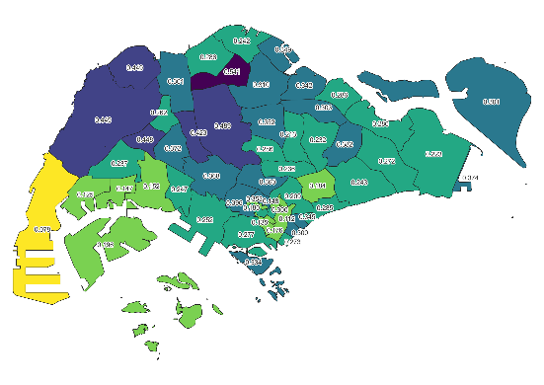 | 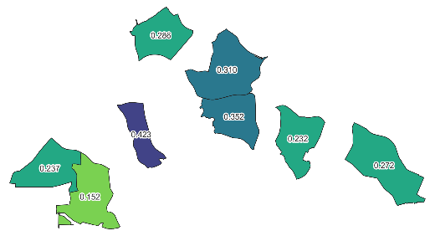 | 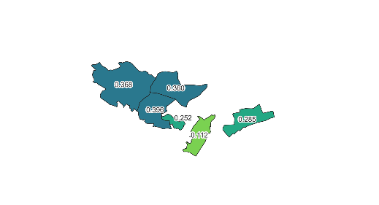 | 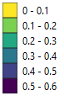
TreesSG density (trees / sq m) | 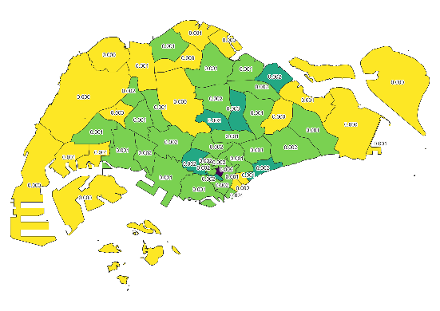 | 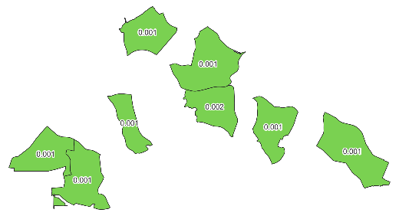 | 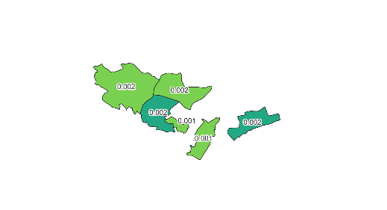 | 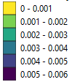
Tree cover proportion (% area) | 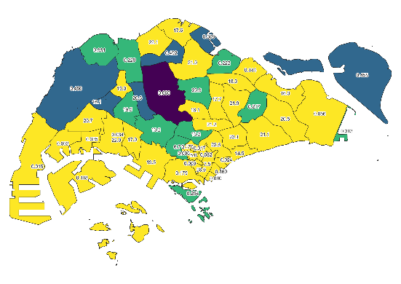 | 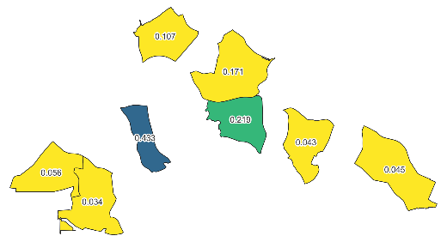 | 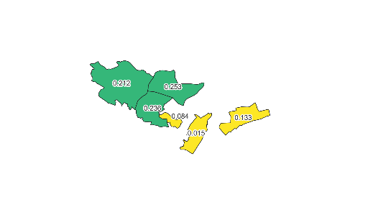 | 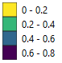
Street tree cover proportion (% area) | 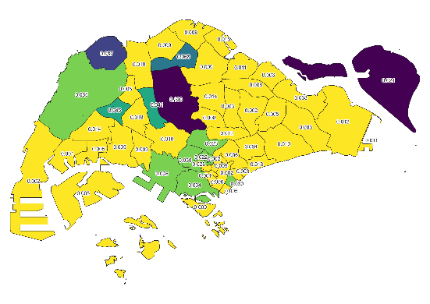 | 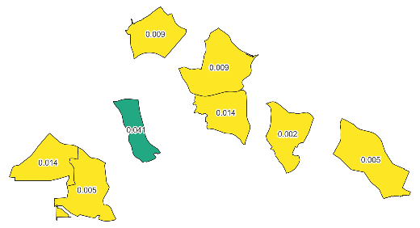 | 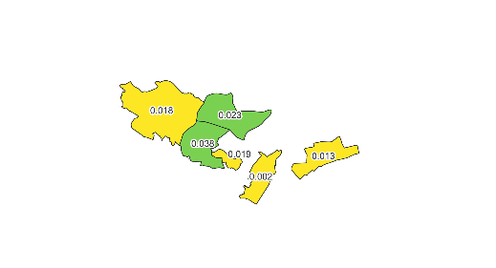 | 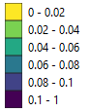
TreesSG provision (trees / pax) | 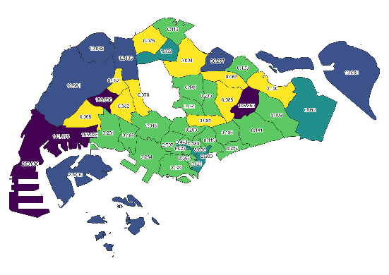 | 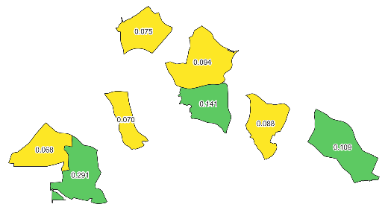 | 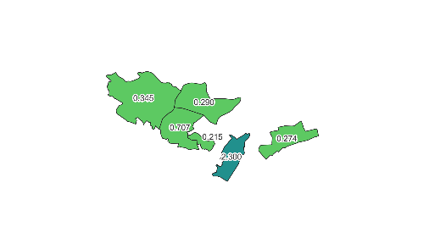 | 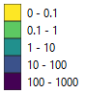
Tree cover provision (sq m / pax) | 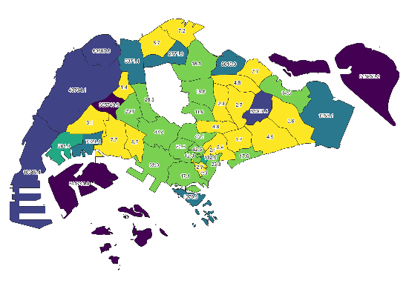 | 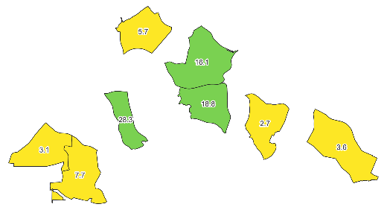 | 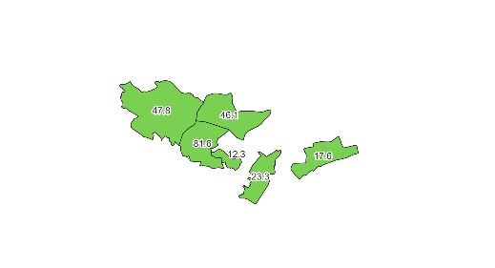 | 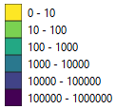
Street tree cover provision (sq m / pax) | 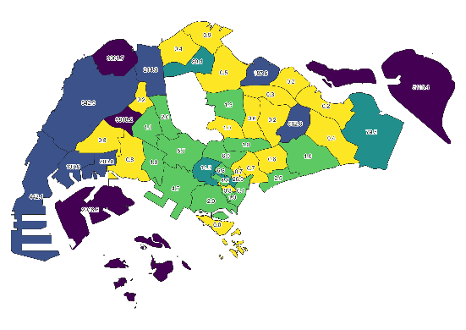 | 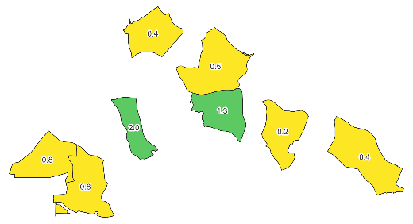 | 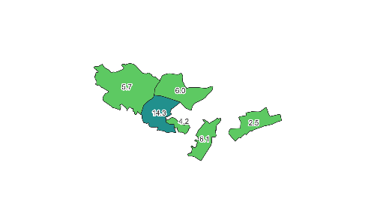 | 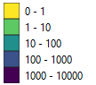
TreesSG mean girth (m) | 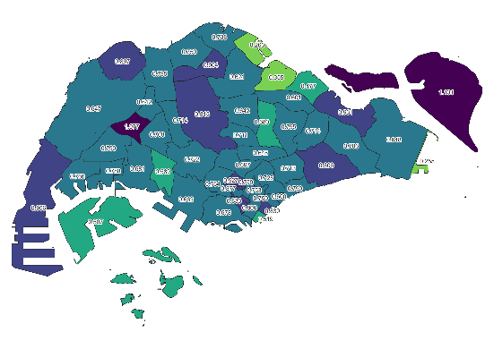 | 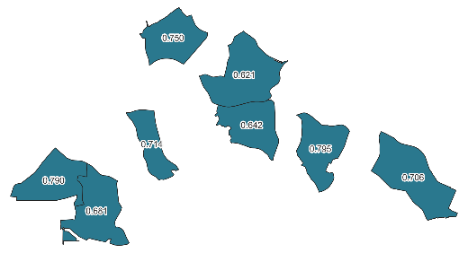 | 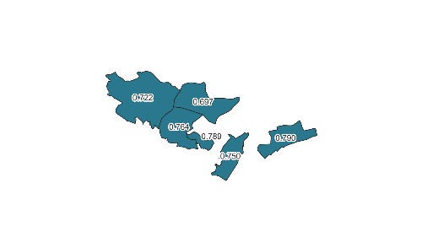 | 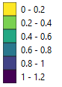
TreesSG mean height (m) | 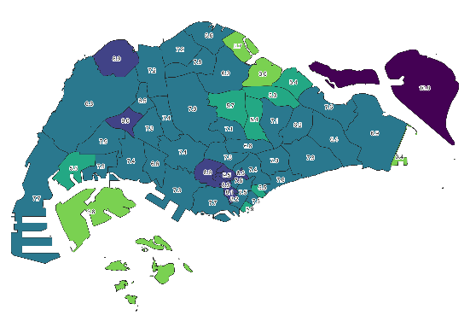 | 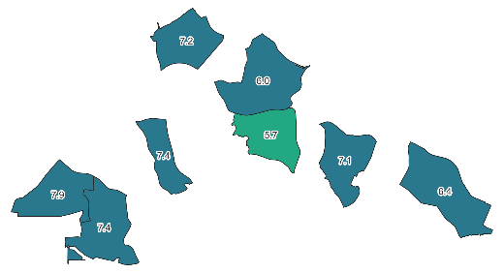 | 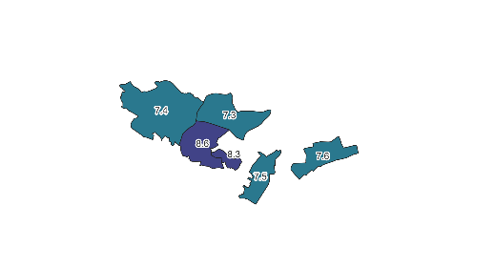 | 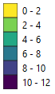
TreesSG mean age (m) | 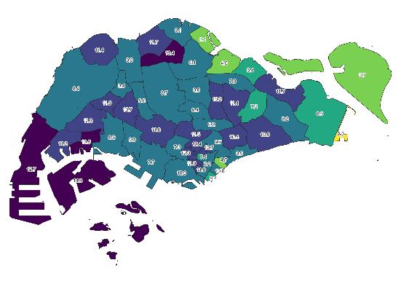 | 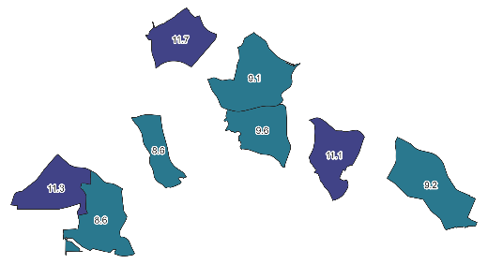 | 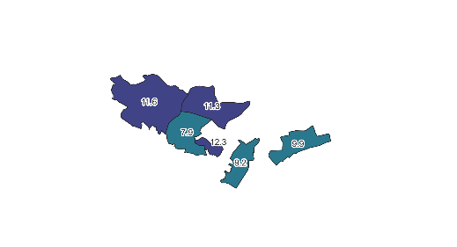 | 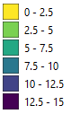

Figure S1 – Quantification of Greenery via Satellite Imagery and TreeSG.

Table S3: Greenery attributes and their descriptions.
Greenery Attribute | Description
Mean NDVI
TreesSG density (trees / sq m)
Tree cover proportion (% area)
Street tree cover proportion (% area)
TreesSG provision (trees / pax)
Tree cover provision (sq m / pax)
Street tree cover provision (sq m / pax)
TreesSG mean girth (m)
TreesSG mean height (m)
TreesSG mean age (m)

Table S4: Summary of number of trees and species included in the TreesSG dataset.
Total number of trees | 728365
Number of tree species | 2256

Table S5: Top 15 tree species in the TreesSG dataset by count.
Tree Species | Counts
Samanea saman | 48338
Peltophorum pterocarpum | 29455
Planchonella obovate | 28365
Xanthostemon chrysanthus | 26462
Hopea odorata | 23086
Syzgium myrtifolium | 17253
Swietenia macrophylla | 15392
Tabebuia rosea | 15315
Neolitsea cassia | 14584
Sterculia parviflora | 12766
Syzygium grande | 11175
Lagerstroemia floribunda | 10692
Khaya senegalensis | 10027
Cratoxylum cochinchinense | 9731
Mimusops elengi | 8760

Table S6: Trees' Parameters
 | Girth (meters) |  |  | Height (meters)
Tree Species | Mean | Mode | Max | Mean | Mode | Max
Samanea saman | 1.62 | 1.0 | 8.5 | 11.47 | 12 | 24
Peltophorum  pterocarpum | 1.42 | 1.2 | 6.3 | 11.93 | 12 | 24
Hopea odorata | 0.63 | 0.3 | 4 | 9.29 | 6 | 24
Khaya senegalensis | 2.71 | 1.8 | 6.2 | 16.95 | 15 | 24

Figure S2: Singapore Planning Areas
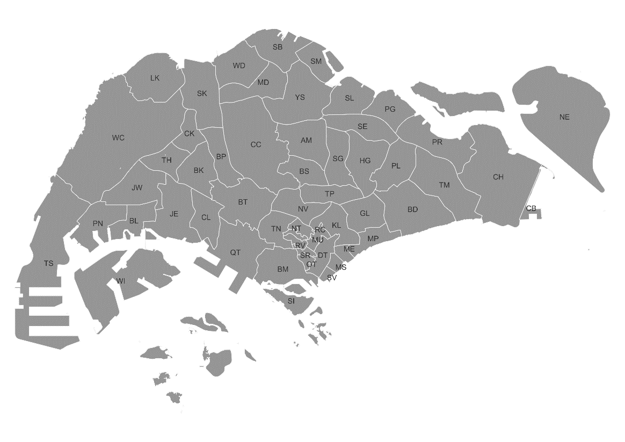

AM – Ang Mo Kio,
BD – Bedok,
BK – Bukit Batok,
BL – Boon Lay,
BM – Bukit Merah,
BP – Bukit Panjang,
BS – Bishan,
BT – Bukit Timah,
CB – Changi Bay,
CC – Central Water Catchment,
CH – Changi,
CK – Choa Chu Kang,
CL – Clementi,
DT – Downtown Core,
GL – Geylang,
HG – Hougang,
JE – Jurong East,
JW – Jurong West,
KL – Kallang,
LK – Lim Chu Kang,
MD – Mandai,
ME – Marina East,
MP – Marine Parade,
MS – Marina South,
MU – Museum,
NE – North Eastern Islands,
NT – Newton,
NV – Novena,
OR – Orchard,
OT – Outram,
PG – Punggol,
PL – Paya Lebar,
PN – Pioneer,
PR – Pasir Ris,
QT – Queenstown,
RC – Rochor,
RV – River Valley,
SB – Sembawang,
SE – Sengkang,
SG – Serangoon,
SI – Southern Islands,
SK – Sungei Kadut,
SL – Seletar,
SM – Simpang,
SR – Singapore River,
SV – Straits View,
TH – Tengah,
TM – Tampines,
TN – Tanglin,
TP – Toa Payoh,
TS – Tuas,
WC – Western Water Catchment,
WD – Woodlands,
WI – Western Islands,
YS – Yishun

Table S7: Open Street Map Data
Data | Properties | Description
Building | PK | - An Identifier (PRIMARY KEY)  - Type: Integer
Building | THE_GEOM | - building’s geometry (POLYGON or MULTIPOLYGON)  - Type: Geometry
Building | HEIGHT | - building’s height (in meters)  - Type: Double
Roads | PK | - An Identifier (PRIMARY KEY)  - Type: Integer
Roads | THE_GEOM | - Geometry of the roads (LINESTRING or MULTILINESTRING)  - Type: Geometry
Roads | LV_D | - Hourly average light vehicle count (day, evening and night)  - Type: Double
Roads | LV_E
Roads | LV_N
Roads | HGV_D | - Hourly average heavy duty vehicle (day, evening and night)  - Type: Double
Roads | HGV_E
Roads | HGV_N
Roads | LV_SPD_D | - Hourly average light vehicle speed (km/h)  - Type: Double
Roads | LV_SPD_E | - Hourly average light vehicle speed (km/h)  - Type: Double
Roads | LV_SPD_N | - Hourly average light vehicle speed (km/h)  - Type: Double
Roads | HGV_SPD_D | - Hourly average heavy duty vehicles speed (km/h)  - Type: Double
Roads | HGV_SPD_E
Roads | HGV_SPD_N

