Supplementary file for characterization of extracts synthesized with silver nanoparticles

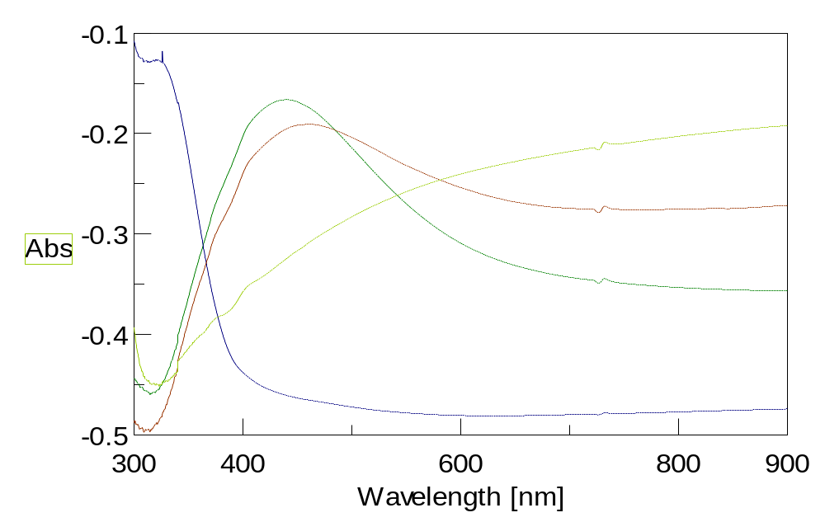
Supplementary figure 1. UV-Vis spectra.
OM extract

OM-Ag-NPs 2mg

AgNO₃ 2mM

OM-Ag-NPs 1mg

Figure S1. UV-Vis spectra of silver nanoparticles synthesized using OM extract.

The reduction of silver ions (Ag⁺) to silver nanoparticles (Ag⁰) occurs during synthesis processes, and sample colors change owing to surface plasmon resonance during interaction with the components in the extract leading to the formation of silver nanoparticles, as confirmed by UV–vis. Figure S1 shows the UV-vis absorption spectra of the OM extract, AgNO₃, and OM-Ag-NPs with different extract concentrations 1 and 2 mg/ml. Increasing the concentration of the extract from 1 to 2 mg/ml led to increased absorption bands at 440 nm. The supporting point there is no other peak observed in the whole spectrum which means OM-Ag-NPs 2 mg/ml have successfully formed.
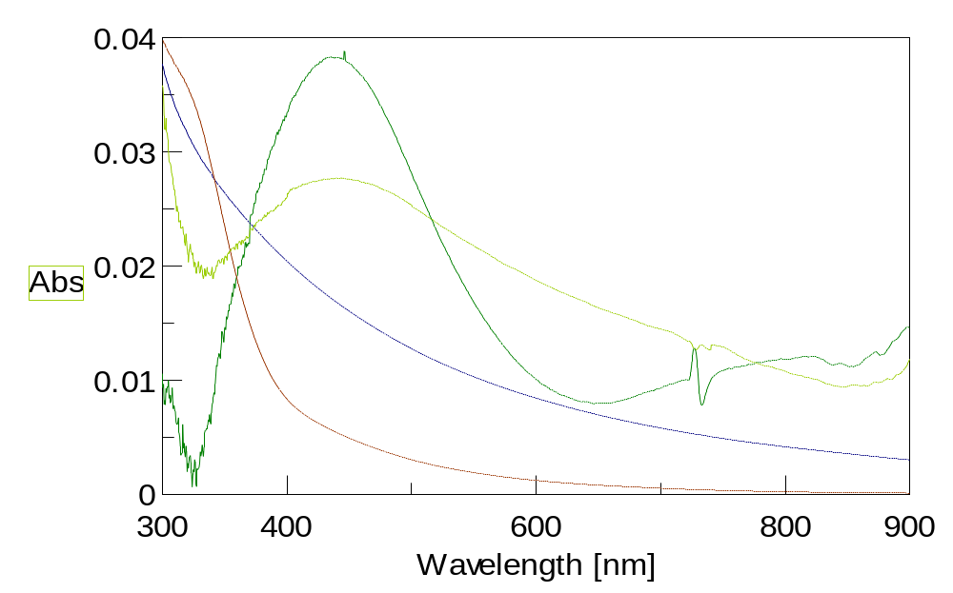
MP extract

MP-Ag-NPs 2mg

AgNO₃ 2mM

MP-Ag-NPs 1mg
Figure S2. UV-Vis spectra of silver nanoparticles synthesized using MP extract.

Similar to Figure S1, Figure S2 presents the UV–vis absorption spectrum for the nanoparticles synthesized from MP extract. The distinct peak centered around 430 nm is specific for MP-Ag-NPs 2 mg/ml indicating the presence of silver-nanoparticle biosynthesis.
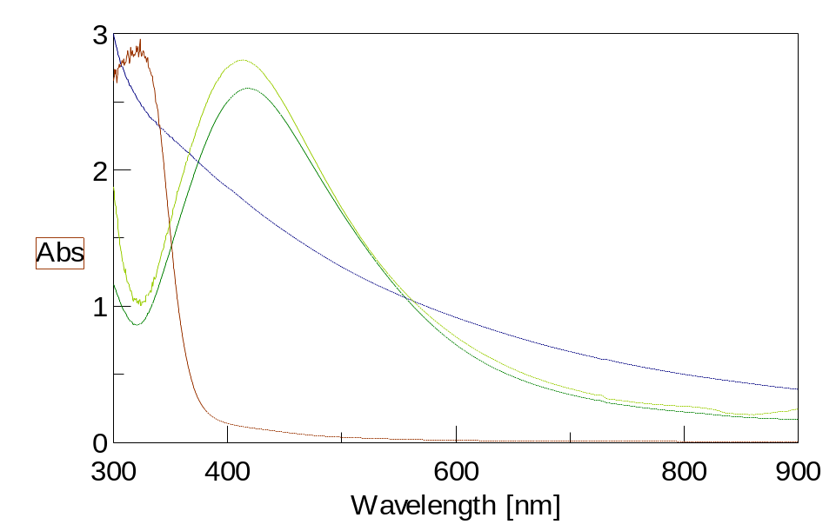
ML extract

ML-Ag-NPs 2mg

AgNO₃ 2mM

ML-Ag-NPs 1mg
Figure S3. UV-Vis spectra of silver nanoparticles synthesized using ML extract.
Figure S3 shows the UV–vis spectra of AgNO₃ synthesized from ML extract with different concentrations. The spectrum reveals a characteristic absorption peak of ML-Ag-NPs 1 mg/ml at a wavelength of 420 nm. This sample differed from the other samples, insofar as the lower concentration of the extract had the highest peak.
Supplementary figure 2. Fourier transform infrared (FT-IR) spectrometer
With our samples, we carried out FT-IR measurements to identify the possible biomolecules responsible for capping leading to efficient stabilization of the silver nanoparticles. As shown in Figures S4 and S5, we specifically compared the FT-IR spectra of AgNO₃ at 2 mM, the OM extract, the MP extract, the ML extract, the OM-Ag-NPs (at 1 and 2 mg/ml), the MP-Ag-NPs (at 1 and 2 mg/ml), and the ML-Ag-NPs (at 1 and 2 mg/ml).
a)AgNO₃2mM b) OM extract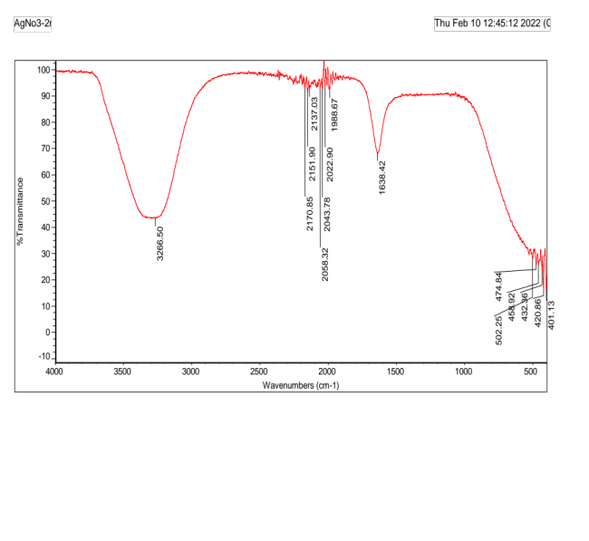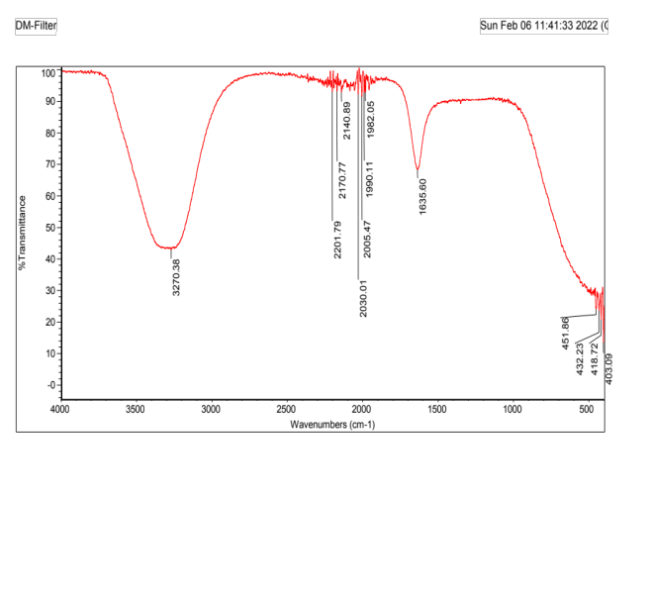c) ML extract d) MP extract 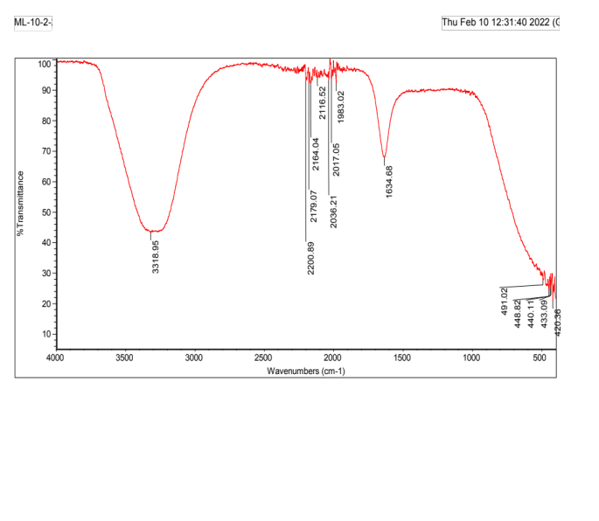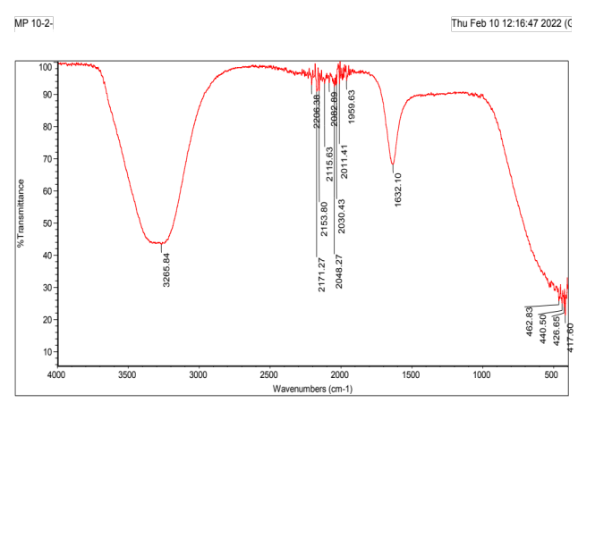
Figure S4. FT-IR spectra of AgNo₃ 2mM, OM extract, ML extract, MP extract.
As shown in Figure S4 the FT-IR spectrum of AgNO₃ 2mM exhibit several absorption peaks at different locations including at 3266 cm⁻¹ (O-H stretch), 2170 cm⁻¹ to 2022 cm⁻¹ (C≡C stretch), 1638 cm⁻¹ (C=O stretch). Regarding the OM extract, we observed absorption peaks at the following at 3270 cm⁻¹ corresponding to O-H stretching H-bonded alcohols and phenols indicating the presence of hydroxyl groups in the reducing agent, 2005 cm⁻¹ to 2201 cm⁻¹ (C≡C stretch) indicating the presence of alkyne groups ,1635 cm⁻¹ (C=O stretch) indicating the presence of carbonyl group. Regarding the ML extract, we observed absorption peaks at 3318 cm⁻¹ (O-H stretch), 2200 cm⁻¹ to 2017 cm⁻¹ (C≡C stretch), 1634 cm⁻¹ (C=O stretch). Regarding the MP extract, we observed absorption peaks at 3265 cm⁻¹ (O-H stretch), 2206 cm⁻¹ to 2011 cm⁻¹ (C≡C stretch), 1632 cm⁻¹ (C=O stretch).
a) OM-Ag-NPs 1mg 2mg
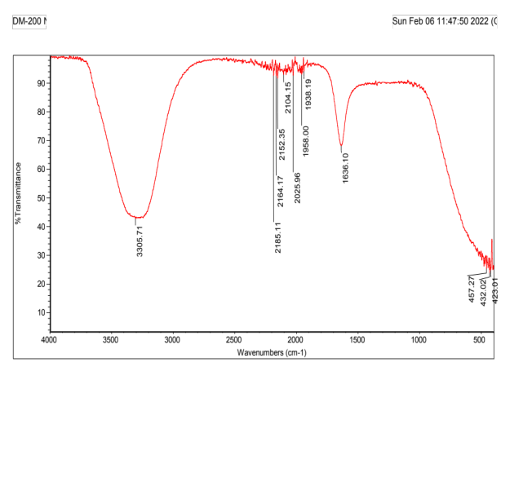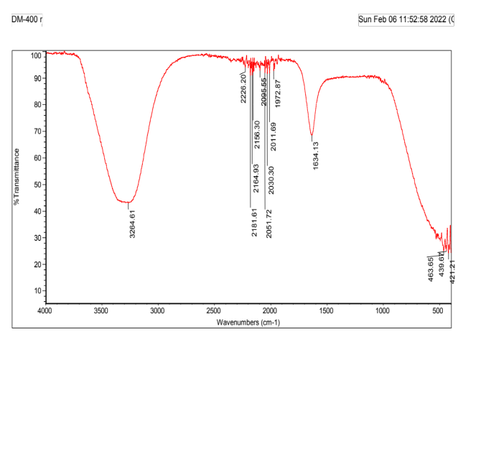
b) ML-Ag-NPs 1mg 2mg
c) MP-Ag-NPs 1mg 2mg
Figure S5. FT-IR spectra of OM-Ag-NPs (1and 2 mg/ml), ML-Ag-NPs (1and 2 mg/ml ), MP-Ag-NPs (1and 2 mg/ml )
As shown in Figure S5 we found that the difference in concentrations does not differ much in the absorption values. The peaks appeared at ; 3305 cm⁻¹ (OM-Ag-NPs 1 mg/ml), 3264cm⁻¹ (OM-Ag-NPs 2 mg/ml), 3292cm⁻¹ (ML-Ag-NPs 1 mg/ml) , 3268cm⁻¹ (ML-Ag-NPs 2 mg/ml), 3255cm⁻¹ (MP-Ag-NPs 1 mg/ml), 3274cm⁻¹ (MP-Ag-NPs 2 mg/ml). These peaks could be due to the O-H stretching vibrations of flavonoid and phenolic groups, indicating the presence of aromatic groups along with the Ag-NPs. The results of our FT-IR analysis demonstrated the presence of functional bioactive-compound groups that play the role of capping agents facilitating the formation of nanoparticles. We then completed our analyses of the OM-Ag-NPs, MP-Ag-NPs, and ML-Ag-NPs at the 1 and 2 mg/ml concentrations.

Supplementary figure 3. Scanning electron microscope (SEM)
Scanning electron microscopy (SEM) serves mainly to determine the size and shape of nanoparticles and gives high-resolution images of the surface of a given sample. As shown in Figure S6, our analysis of the OM-Ag-NPs, ML-Ag-NPs, and MP-Ag-NPs (at the 1 and 2 mg/ml) shows that these nanoparticles had a spherical shape and that their diameters were less than 100 nm, generally in the range of 15 to 31 nm. Furthermore, in the samples for the OM-Ag-NPs 1,2 mg/ml and MP-Ag-NPs 1,2 mg/ml we found that an increase in the concentration of the plant extract reduced the size of the nanoparticles. In the case of ML-Ag-NPs, the size of the nanoparticles increased when the concentration level increased from 1 to 2 mg/ml.

a)OM-Ag-NPs 1mg 2mg
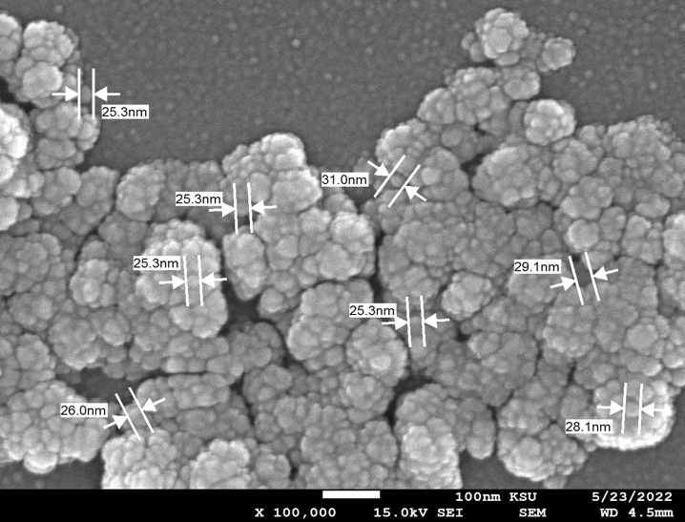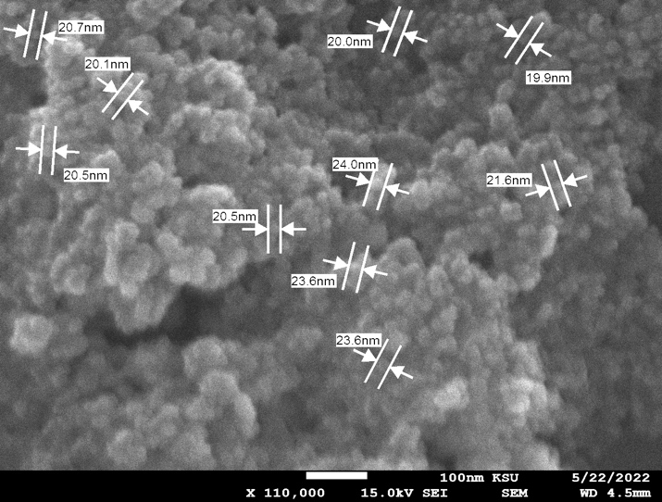
b)ML-Ag-NPs 1mg 2mg
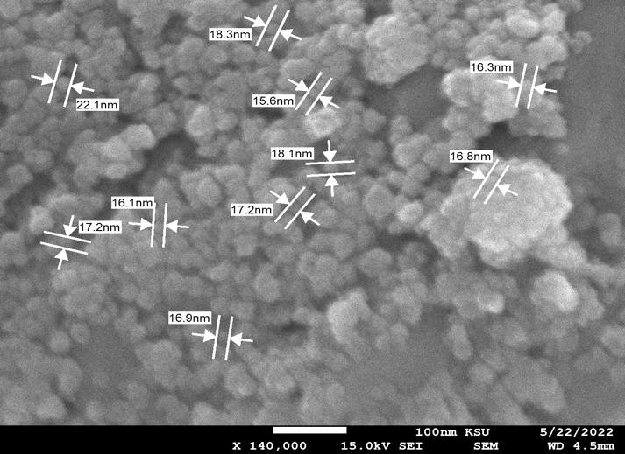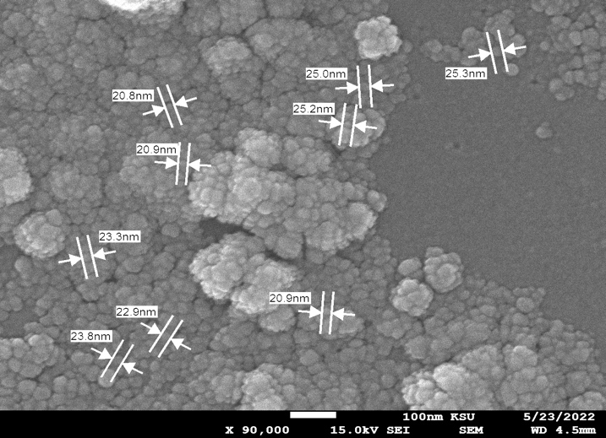
c)MP-Ag-NPs 1mg 2mg
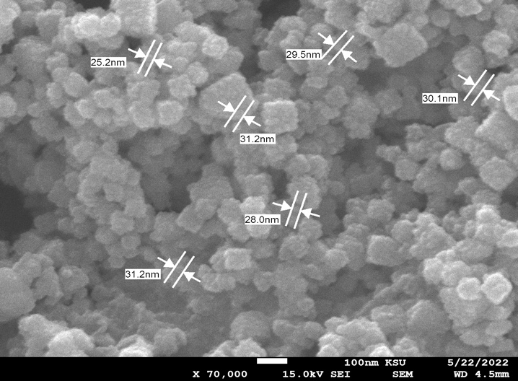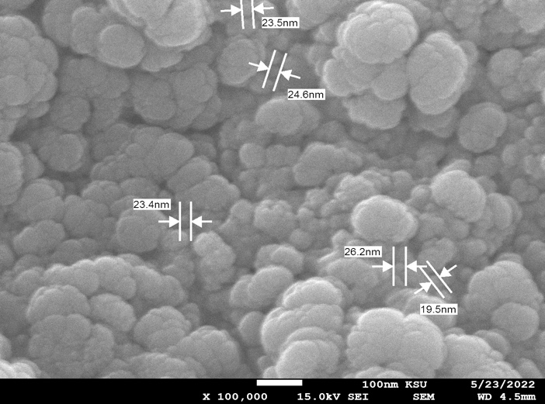
Figure S6. SEM images of OM-Ag-NPs (1 and 2 mg/ml), ML-Ag-NPs (1 and 2 mg/ml), MP-Ag-NPs (1 and 2 mg/ml )
Supplementary figure 4. Zetasizer
Regarding our application of the PDI to the present study, Figure S7 shows that the corresponding values ranged between 0.2 and 0.5, suggesting that we were dealing with a moderate polydisperse distribution with multiple particle-size populations. We observed a clear trend in which values decreased with an upward shift in concentration from 1 to 2 mg/ml for both OM-Ag-NPs and MP-Ag-NPs. However, we observed an increase in the PDI values (which ranged between 0.2 and 0.4) for the ML-Ag-NPs when the concentration level increased from 1 to 2 mg/ml. This observation may indicate that particle growth was not restricted, resulting in an increase in dispersion.

- OM-Ag-NPs 1mg 2mg
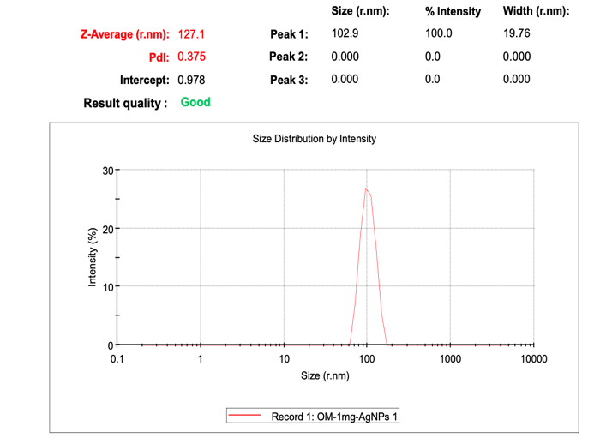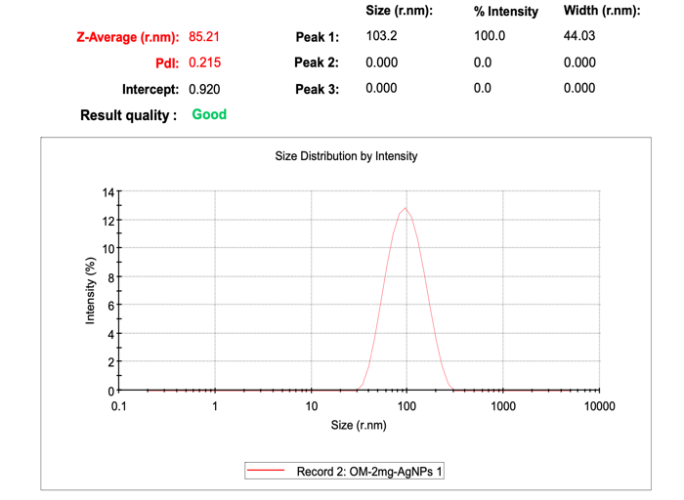
b) ML-Ag-NPs 1mg 2mg
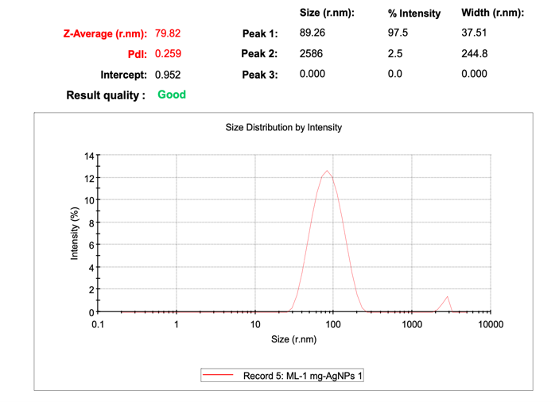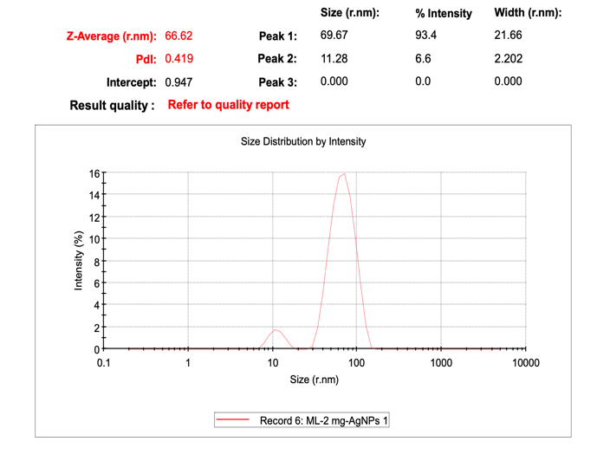

c) MP-Ag-NPs 1mg 2mg
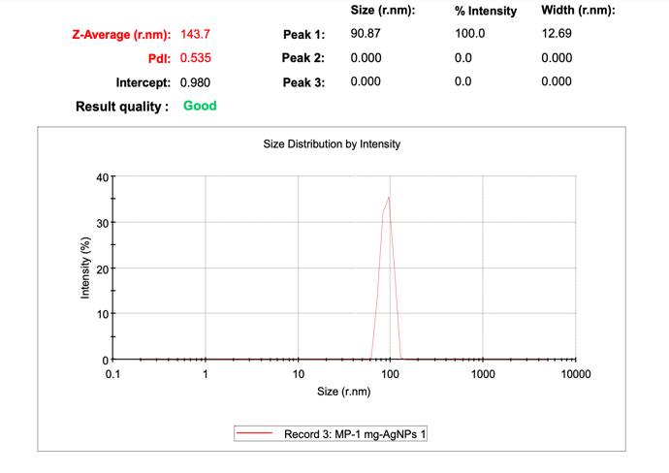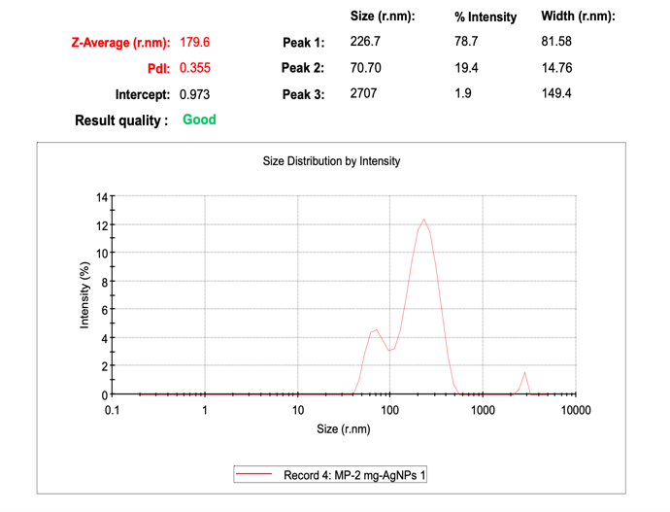
Figure S7. Size distribution by intensity of OM-Ag-NPs (1and 2 mg/ml), ML-Ag-NPs (1 and 2 mg/ml), MP-Ag-NPs (1 and 2 mg/ml )
According to our results and comparison we excluded the ML-Ag-NPs at the 1 and 2 mg/ml concentrations after our UV–vis, SEM, and PDI analyses revealed that the increase in concentration led to (1) the lowest peak of all the samples, (2) increased dispersion, and (3) increased particle size. These results are inconsistent with the typical behavior that one would expect to observe in the green synthesis of nanoparticle. Interestingly, the OM-Ag-NPs at the 2 mg/ml concentration exhibited better dispersion and stability than the other samples after the concentration increased from 1 to 2 mg/ml. The reason for the better dispersion and stability may concern differences among the plants regarding their antioxidant and polyphenol levels: such differences can significantly affect metal-ion levels, in turn affecting the production of nanoparticles during biosynthesis, and can also increase the stability of nanoparticles.

