Supplement Table1. Baseline characteristics of the study participants according to WWI quartile at baseline
Characteristics |  | WWI |  |  |  | All | F/H值 | p
Characteristics |  | Q1(n=2549) | Q2(n=2551) | Q3(n=2527) | Q4(n=2573) | All | F/H值 | p
No. of subjects |  | 2549 | 2551 | 2527 | 2573 | 10200
age | mean ± SD | 64.87±8.35 | 65.66±8.91 | 67.34±9.25 | 71.84±10.02 | 67.43±9.55 | 282.662 | 0.000**
education level, n (%) | junior middle school | 2170(85.13) | 2225(87.22) | 2284(90.38) | 2466(95.84) | 9145(89.66) | 5.653 | 0.134
education level, n (%) | High school | 326(12.79) | 280(10.98) | 222(8.79) | 88(3.42) | 916(8.98) | 5.653 | 0.134
education level, n (%) | College or above | 53(2.08) | 46(1.80) | 21(0.83) | 19(0.74) | 139(1.36) | 5.653 | 0.134
place of residence, n (%) | Urban | 414(16.24) | 463(18.18) | 462(18.30) | 375(14.59) | 1714(16.82) | 2.081 | 0.111
place of residence, n (%) | Rural | 2135(83.76) | 2084(81.82) | 2063(81.70) | 2196(85.41) | 8478(83.18)
Drinking, n (%) | yes | 1144(44.88) | 1007(39.47) | 792(31.34) | 520(20.21) | 3463(33.95) | 394.818 | 0.000**
Smoking, n (%) | yes | 1176(46.35) | 936(36.73) | 681(27.03) | 403(15.71) | 3196(31.43) | 612.483 | 0.000**
Chronic diseases history
Hypertension, n (%) | yes | 340(13.42) | 486(19.11) | 584(23.26) | 767(29.94) | 2177(21.45) | 219.713 | 0.000**
Diabetes , n (%) | yes | 59(2.32) | 107(4.22) | 143(5.71) | 182(7.11) | 491(4.85) | 69.772 | 0.000**
Dyslipidemia, n (%) | yes | 117(4.66) | 153(6.12) | 196(7.88) | 219(8.66) | 685(6.83) | 38.073 | 0.000**
psyche, n (%) | yes | 25(0.98) | 30(1.18) | 32(1.27) | 27(1.05) | 114(1.12) | 1.123 | 0.772
BMI | mean ±SD | 21.76±2.90 | 23.18±3.17 | 23.96±3.56 | 24.27±3.96 | 23.29±3.55 | 273.117 | 0.000**
UA | M (IQR) | 4.27(3.5,5.0) | 4.35(3.6,5.3) | 4.286(3.6,5.2) | 4.168(3.5,5.0) | 4.27(3.55, 5.12) | 20.309 | 0.000**
Total cholesterol | M (IQR) | 182.4(160.8,206.8) | 188.6(165.5,211.1) | 192.91(170.1,217.3) | 196.39(171.7,223.8) | 190.59(167.01,214.95) | 148.135 | 0.000**
HDL | M (IQR) | 52.5(43.7,63.0) | 49.87(40.6,60.3) | 48.32(39.4,58.4) | 47.98(39.8,58.0) | 49.48(40.59,59.92) | 111.903 | 0.000**
LDL | M (IQR) | 109.0(90.5,128.4) | 112.50(91.2,134.2) | 116.36(94.7,140.3) | 119.07(95.9,143.8) | 114.04 (93.17,136.85) | 92.002 | 0.000**
Blood glucose (mg /dl) | M (IQR) | 99.7(92.5,108.5) | 102.06(94.0,112.1) | 103.50(95.2,115.4) | 103.50(95.6,116.6) | 102.24 (94.14,112.86) | 109.088 | 0.000**
Note：Male: Q1(≤10.36), Q2(10.36-10.80), Q3(10.80-11.26), Q4(>11.26); Female: Q1(≤10.85), Q2(10.85-11.42), Q3(11.42-12.00), Q4(>12.00).
BMI: body mass index; UA: uric acid; HDL: high density lipoprotein; LDL: Low density lipoprotein;Continuous variables are expressed as mean±standard; deviation, or as median (interquartile range). Categorical variables are expressed as frequency (percent).
* P<0.05 ** P<0.001

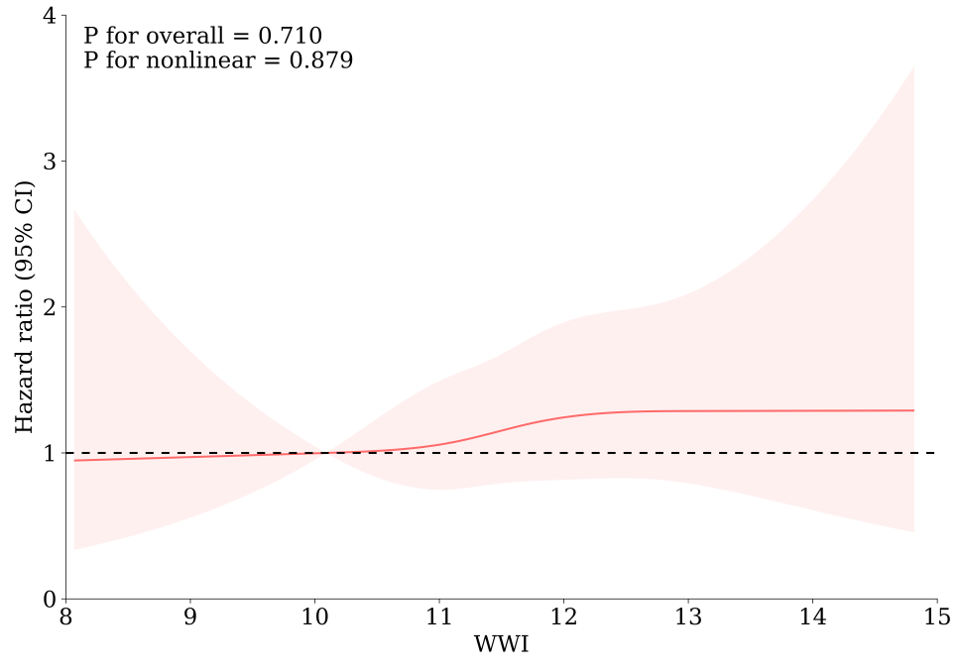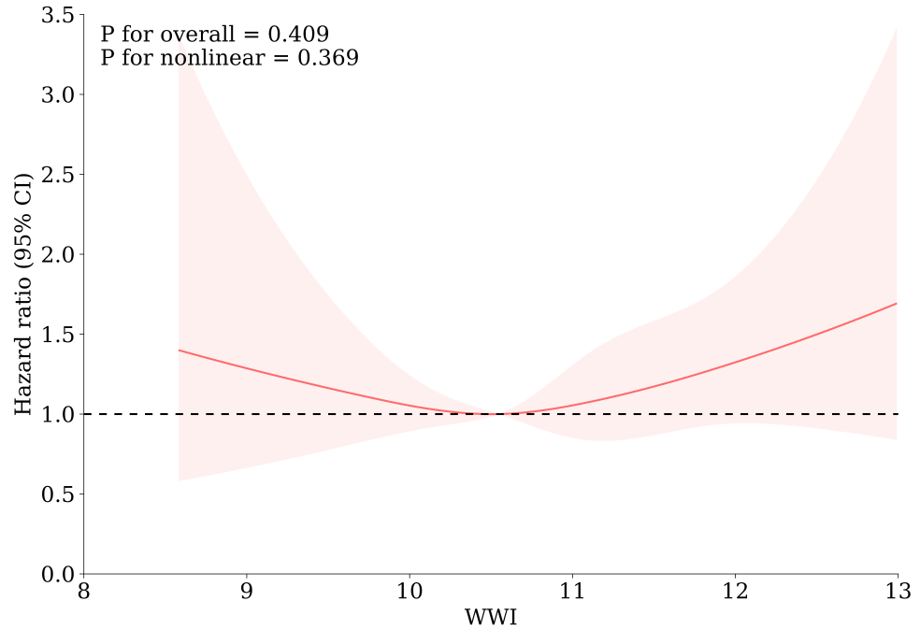
- Male （2）Female

Supplement Fig1. Analyzing the relationship between WWI and CKD using non restrictive cubic splines

