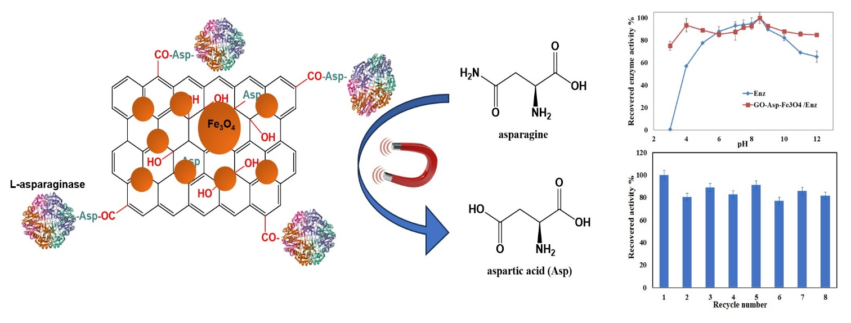
Enhanced Stability and Reusability of Immobilized L-Asparaginase on biofunctionalized Magnetic Graphene Oxide Nanocomposite

