ROS-Resistant Redox Mediator in Lithium-Oxygen Batteries
Hyun-Wook Lee^{1,†}, Jiwon Hwang^{2,†}, Ja-Yeong Kim^{1,2,†}, Gabriel N. Morais³, Katie S. Tang³, Myungsoo Choi⁴, Haeun Choi², Hong-Bin Youn^{1,5}, Seoung-Tae Kim⁶, Jeeho Ha¹, Seok Ju Kang¹, Shuming Chen^{*3}, Sung-Eun Suh^{*4,5}, and Won-Jin Kwak^{*1}
¹School of Energy and Chemical Engineering, Ulsan National Institute of Science and Technology, Ulsan, Republic of Korea
²Department of Energy Systems Research, Ajou University, Suwon, Republic of Korea
³Department of Chemistry and Biochemistry, Oberlin College, Oberlin, Ohio, USA
⁴Ajou Energy Science Research Center, Ajou University, Suwon, Republic of Korea
⁵Department of Chemistry, Ajou University, Suwon, Republic of Korea
⁶Department of Chemistry, Massachusetts Institute of Technology, Cambridge, Massachusetts, USA
e-mail: shuming.chen@oberlin.edu; sesuh@ajou.ac.kr; wjkwak@unist.ac.kr

Table of Contents:
1. General Information S2
2. Comparison of Calculated Radical Geometries S3
3. Calculated Free Energy Diagrams and Molecular Geometries S4
4. Experimental Procedures for Synthesis of RMs S10
5. Comparative Experiments and Results on RMs with Reactive Oxygen Spieces S16
6. Electrochemical Behavior of RMs in LOBs S20
7. Results of DEMS Experiments S21
8. DFT Calculation S22
9. NMR Spectra of Characterized Compounds. S51
10. Supplementary References S56

1. General Information
Materials and Spectroscopic Methods. The following commercially obtained reagents were used without further purification: trans-4-aminocyclohexanol (>98.0% purity, TCI), benzyl chloroformate (95% purity, stabilized with ca. 0.1% sodium carbonate, Alfa Aesar), para-toluenesulfonyl chloride (99% purity, TCI), potassium tert-butoxide (97.0% purity, Alfa Aesar), palladium (10% on activated carbon, Strem), sodium hypochlorite (11–15% available chlorine, Alfa Aesar), tert-butyllithium solution (1.7 M in pentane, Sigma Aldrich), hydrazine monohydrate (98.0% purity, Kanto), succinic anhydride (99.0% purity, Samchun), lithium aluminium hydride (powder, >95.0% purity, TCI), piperidine (>98.0% purity, Kanto), silver nitrate (99.8% purity, Samchun), sodium persulfate (98.0% purity, Samchun). All the other general reagents (i.e. sodium hydroxide, pyridine, acetic acid, etc) were sourced from Samchun. Anhydrous solvents were purified via passage through a Chembly solvent purification system (Product No. SPS4-H) using argon as the working gas: solvent water content of tetrahydrofuran (THF) and N,N-dimethylformamide (DMF) were under 10 parts per million (ppm) and 30 ppm respectively. The silica gel (particle size 600–200 µm, 70–230 mesh) that was used for flash column chromatography was purchased from Intertec and thin layer chromatography plates (TLC silica gel 60 F₂₅₄, particle size 10–12 μm, thickness 250 µm, 20 x 20 cm) were purchased from Sigma Aldrich. CDCl₃ (stabilized with Ag foil) containing 0.03% (v/v) tetramethylsilane (TMS) was purchased from ZEOtope. The ¹H NMR spectra were recorded on a JEOL Resonance ECZ600R (600 MHz) spectrometer. Chemical shifts were reported in delta (δ) units, ppm relative to the center of a peak at TMS (0.00 ppm). Spectra were recorded at 23 °C. The purification was performed on Agilent 1260 Infinity II LC system coupled with an Agilent C-18 prep column (Product No. 410910-702, 250 x 21.2 mm, particle size 10 μm). Distillation was carried out using a Büchi B-585 Kugelrohr apparatus. meso-tetraphenylporphine (TPP, Alfa Aesar) was used as purchased and stored in Argon filled glove box. Tetraethylene glycol dimethyl ether (TEGDME, 99%, Acros Organics) and N,N-dimethylaceamide (DMAc, thermos scientific, 99%) was dried with activated molecular sieve for 3 days before used. Dimethyl sulfoxide (DMSO, 99.9%, Sigma Aldrich), α-Al₂O₃ (250–450 nm, Alfa Aesar), LiOH·H₂O (Samchun), Nafion D520 (5 wt.% in mixture of lower aliphatic alcohols and water, contains 45% water, Sigma Aldrich) were used to pretreat the lithium metal to eliminate potential side reactions on lithium metal. Lithium metal foils were obtained from Honjo Metal and stored in Ar filled glove box. Lithium bis(trifluoromethanesulfonyl)imide (LiTFSI, 99%, Samchun), glass fibers (GF/C, Whatman) and gas diffusion layer (GDL, Sigracet 39 BB, Fuel Cell Store) were dried for 3 days in vacuum oven at 120 °C before used. 18-Crown-6 ether (Daejung) and potassium superoxide (KO₂, Acros Organics) were used as purchased.

2. Comparison of Calculated Radical Geometries
In Supplementary Figure 1, we compare the geometry parameters of the RM-derived radicals IV against two simpler model radicals. Both model radicals (shown on top) have essentially perfectly planar geometries around the carbon radical centers, allowing for delocalization and stabilization of the unpaired electron. In the BP55- and BP66-derived radicals, the carbon radical centers are mostly planar as well. In the BAC-derived radical, planarization is energetically extremely costly for the bridgehead carbon, so the carbon radical center is much more nonplanar. This leads to poor delocalization of the unpaired electron and higher energies.

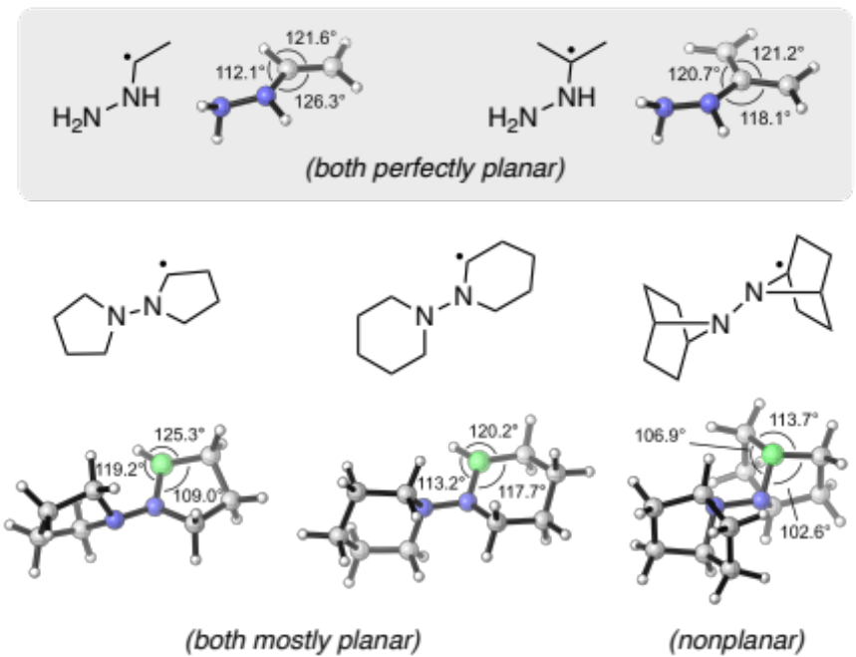
Supplementary Figure 1. Calculated geometries of carbon-centered radicals after Cα hydrogen abstraction.

3. Calculated Free Energy Diagrams and Molecular Geometries
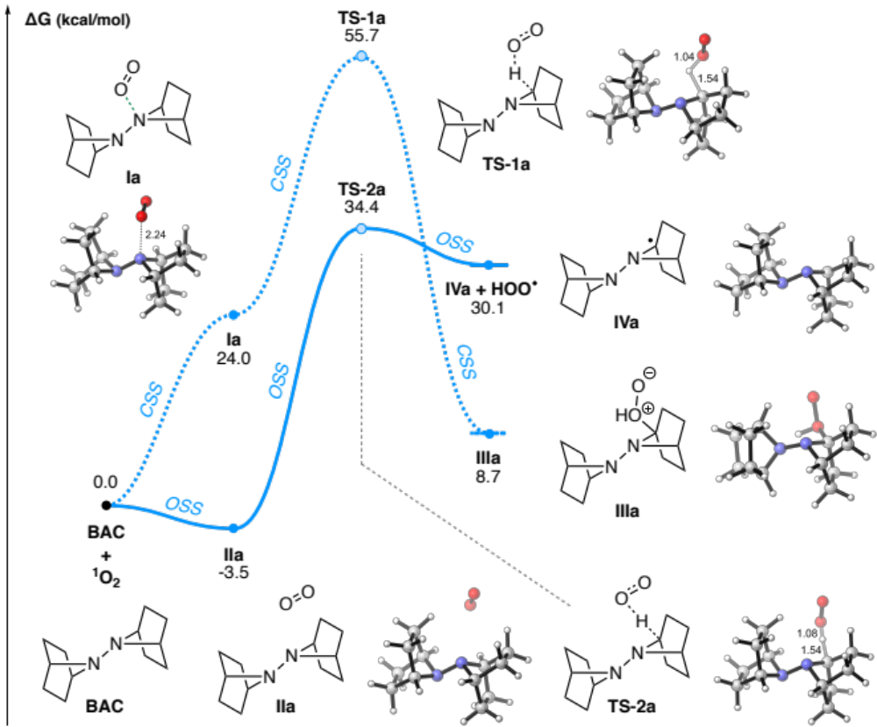
Supplementary Figure 2. Calculated free energy diagram for the oxidation of BAC by singlet oxygen through the two Cα hydrogen abstraction pathways. CSS = closed-shell singlet, OSS = open-shell singlet. Interatomic distances are in Å.

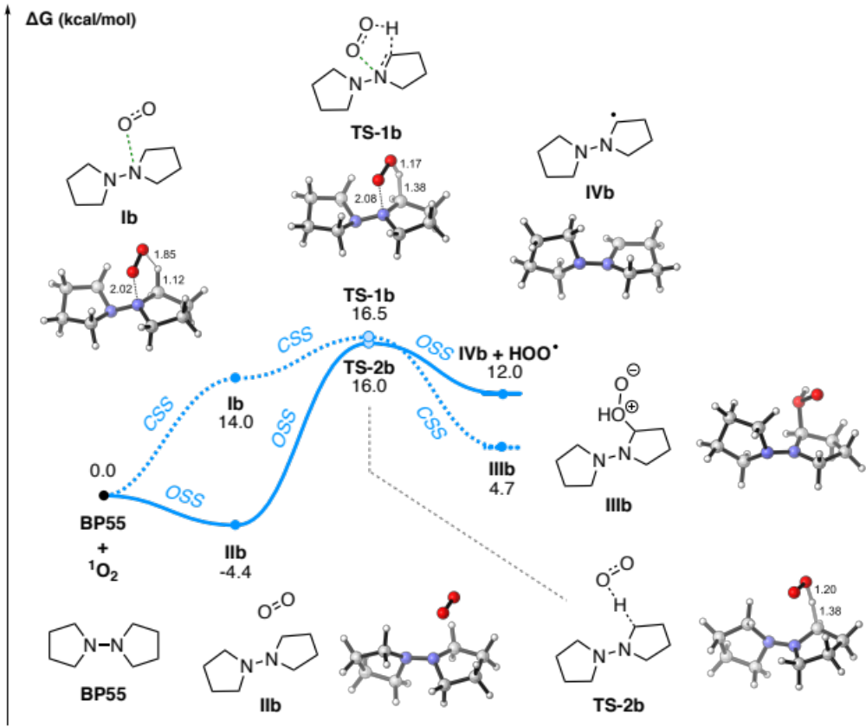
Supplementary Figure 3. Calculated free energy diagram for the oxidation of BP55 by singlet oxygen through the two Cα hydrogen abstraction pathways. CSS = closed-shell singlet, OSS = open-shell singlet. Interatomic distances are in Å.

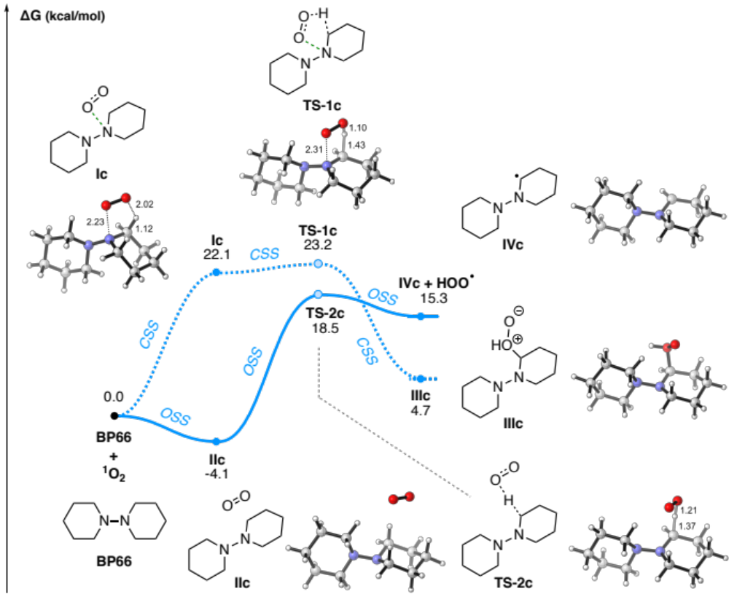
Supplementary Figure 4. Calculated free energy diagram for the oxidation of BP66 by singlet oxygen through the two Cα hydrogen abstraction pathways. CSS = closed-shell singlet, OSS = open-shell singlet. Interatomic distances are in Å.

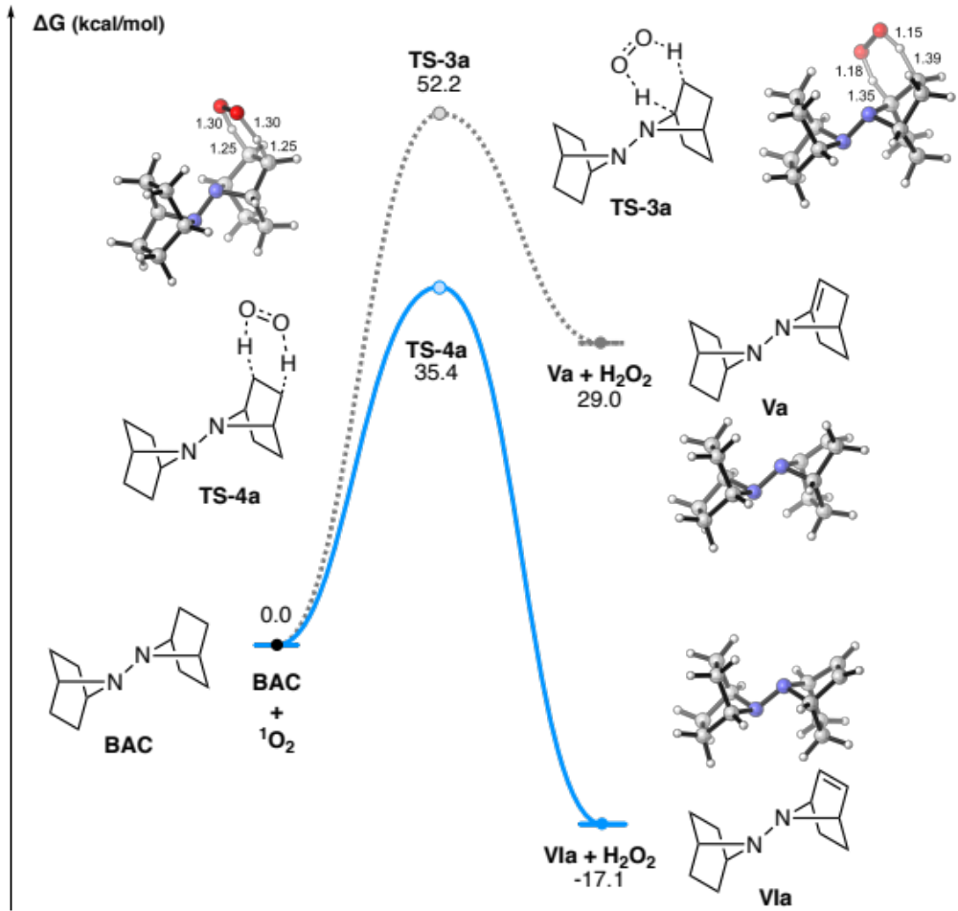
Supplementary Figure 5. Calculated free energy diagram for the oxidation of BAC by singlet oxygen through concerted H₂ abstraction pathways. CSS = closed-shell singlet, OSS = open-shell singlet. Interatomic distances are in Å.

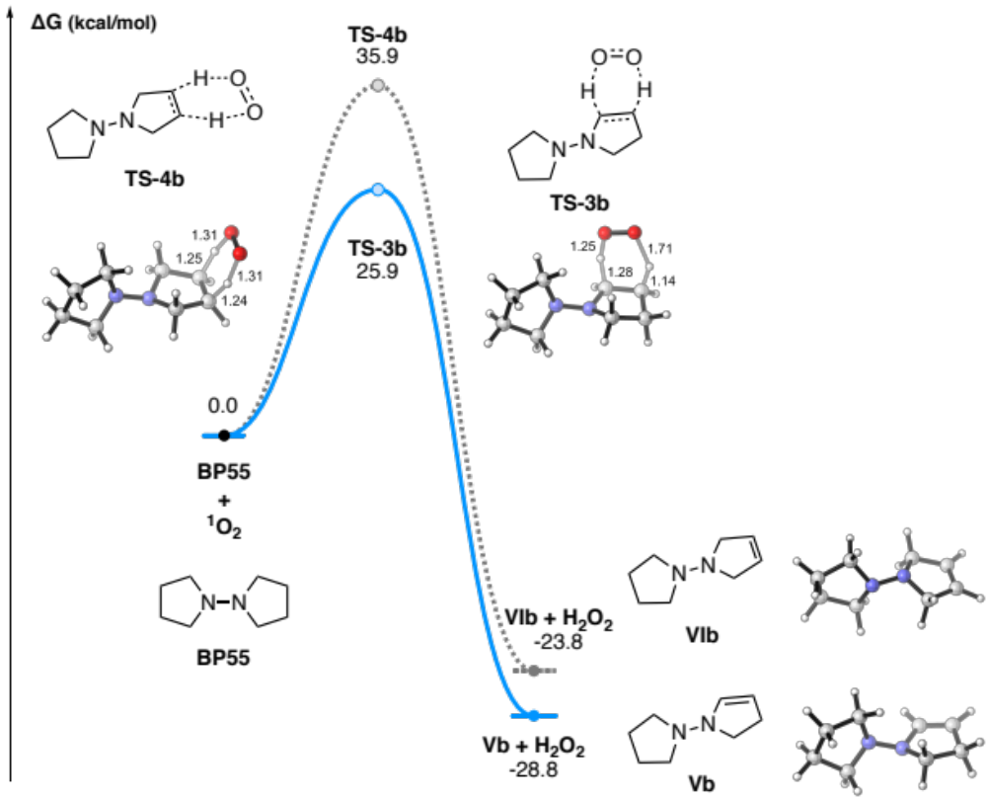
Supplementary Figure 6. Calculated free energy diagram for the oxidation of BP55 by singlet oxygen through concerted H₂ abstraction pathways. CSS = closed-shell singlet, OSS = open-shell singlet. Interatomic distances are in Å.

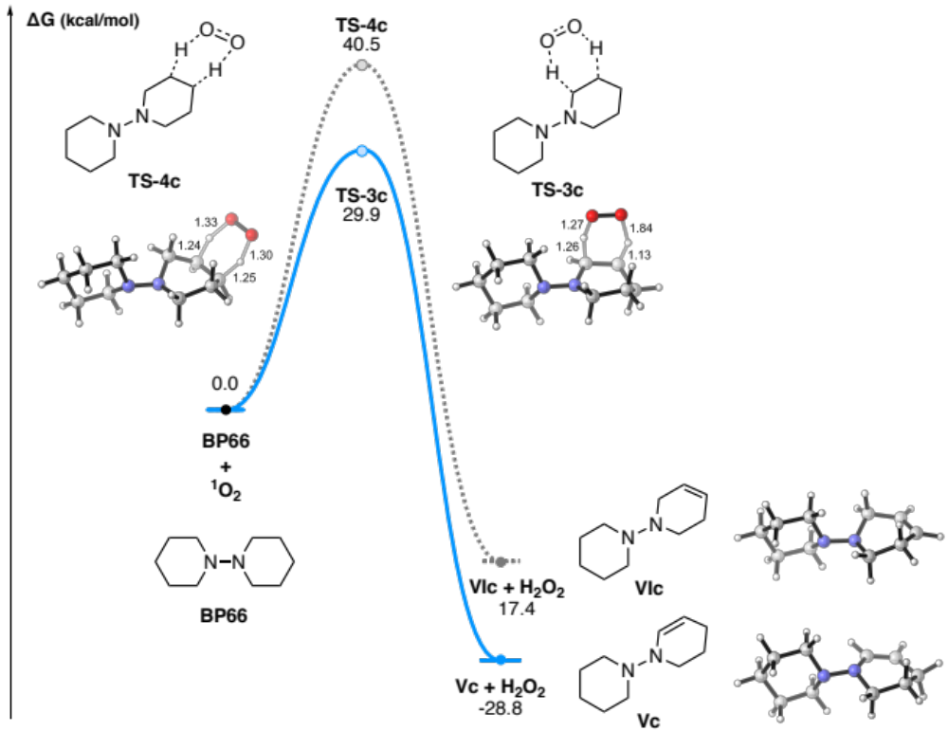
Supplementary Figure 7. Calculated free energy diagram for the oxidation of BP66 by singlet oxygen through concerted H₂ abstraction pathways. CSS = closed-shell singlet, OSS = open-shell singlet. Interatomic distances are in Å.

4. Experimental Procedures for Synthesis of RMs (1,1'-Bipyrrolidine (BP55), 1,1'-Bipiperidine (BP66), and 7,7'-Bi-7-azabicyclo[2.2.1]heptane (BAC))
Experimental Procedures for Synthesis of 1,1'-Bipyrrolidine (BP55)

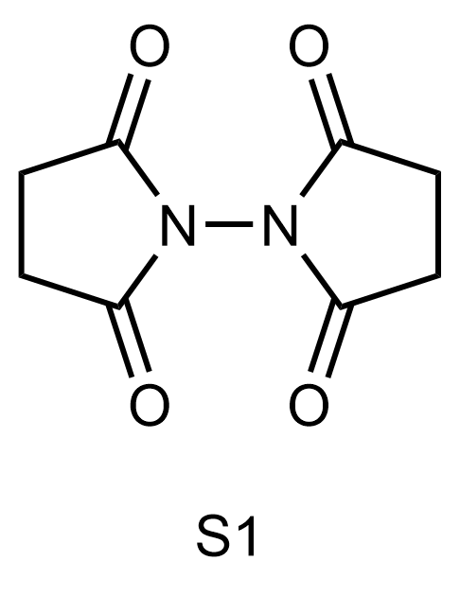
Preparation of [1,1'-Bipyrrolidine]-2,2',5,5'-tetraone (S1)
Prepared modifying the literature procedure. A dried 40 mL vial was charged with a magnetic stir bar, succinic anhydride (1.01 g,10.0 mmol) and 1.0 M acetic acid (5.0 mL). The vial was cooled to 0 °C and hydrazine monohydrate (64-65% hydrazine, 0.25 g, 5.0 mmol) was added to the reaction mixture. The reaction vial was moved to heat block and heated to 140 °C. After vigorous stirring for two hours, the resulting solution was cooled to 23 °C. The crude solution was washed with saturated aqueous solution of sodium bicarbonate (15 mL x 3) and extracted with dichloromethane (30 mL x 3). The organic layer was washed with brine solution (30 mL), dried over sodium sulfate. The organic solvent was evaporated to give 358 mg (1.83 mmol) of S1. ¹H NMR spectrum of S1 was matched with the literature¹.
Yield: 51%
Physical Property: White solid.
¹H NMR (600 MHz, CDCl₃ containing 0.03% (v/v) TMS): δ 2.95 (s, 8H)

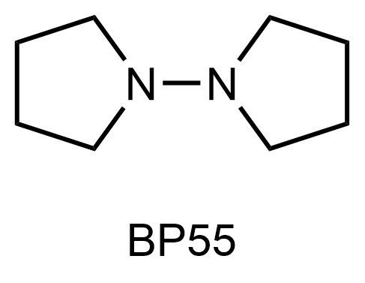
Preparation of BP55
Prepared modifying the literature procedure¹. A dried 100 mL round-bottom flask was charged with a magnetic stir bar outside a glovebox. The flask was moved into the glovebox and underwent three cycles of vacuum-argon-backfill over 30 minutes. The flask was charged with lithium aluminum hydride (1.25 g, 32.9 mmol) and capped with Suba-Seal® septum. After removing the flask from the glovebox, to the flask was added a solution of S1 (1.00 g, 5.10 mmol) in 0.2 M anhydrous THF (26 mL) at –50 °C. After an hour of stirring at –50 °C the reaction mixture was slowly heated to 70 °C and stirred for 14 hours under reflux. To quench the reaction, 15 mL of a 15 wt.% sodium hydroxide solution was added portionwise to the reaction mixture at 0 °C (5 mL per portion), which was then washed with saturated sodium bicarbonate (15 mL x 3). The organic layer was separated from the extraction with dichloromethane (50 mL x 3), washed with brine solution (50 mL x 3) and dried in vacuo. Kugelrohr distillation (8 Torr, 110 °C) gave 92 mg (0.66 mmol) of BP55. ¹H NMR spectrum of BP55 was matched with the literature¹.
Yield: 13%
Physical Property: Colorless oil.
¹H NMR (600 MHz, CDCl₃ containing 0.03% (v/v) TMS): δ 2.81–2.76 (m, 1H), 1.82–1.78 (m, 1H)

Experimental Procedure for Synthesis of 1,1'-Bipiperidine (BP66)

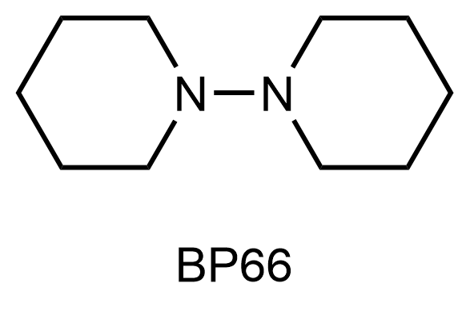
Preparation of BP66
Prepared according to the literature procedure¹. A dried 100 mL round-bottom flask was charged with a magnetic stir bar, piperidine (2.55 g, 30.0 mmol), silver nitrate (255 mg, 1.50 mmol) and an aqueous solution of 4.0 M sodium hydroxide (15 mL) at 0 °C. After stirring for 15 minutes, an aqueous solution of 1.5 M sodium persulfate (20 mL) was added to the reaction mixture and stirred for four hours at 23 °C. The organic layer was separated from extraction extracted with ethyl acetate (50 mL x 3). The crude mixture was purified by flash chromatography (ethyl acetate: hexane = 1:4) to afford 847 mg (5.03 mmol) of BP66. ¹H NMR spectrum of BP66 was matched with the literature¹.
Yield: 34%
Physical Property: Yellow oil.
TLC: R_{f} = 0.30 (silica gel, ethyl acetate/hexane = 1:2)
¹H NMR (600 MHz, CDCl₃ containing 0.03% (v/v) TMS): δ 2.69–2.64 (br, 8H), 1.64–1.55 (m, 8H), 1.35 (br, 4H).

Experimental Procedures for Synthesis of 7,7'-Bi-7-azabicyclo[2.2.1]heptane (BAC)

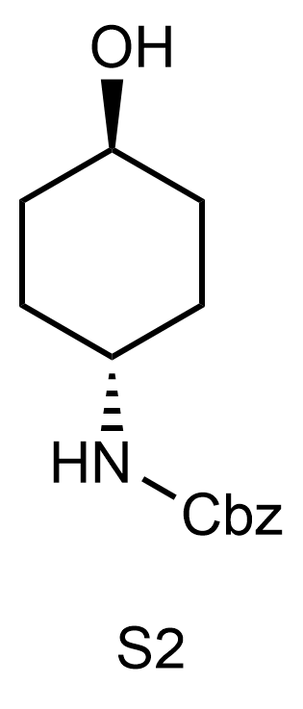
Preparation of trans-4-Carbobenzoxyaminocyclohexanol (S2)
Prepared according to the literature procedure. A dried 250 mL round-bottom flask was charged with a magnetic stir bar, trans-4-aminocyclohexanol (11.5 g, 0.100 mol) in 80 mL of water, an aqueous solution of 3.0 M sodium hydroxide (35.0 mL). The flask was cooled to 0 °C and benzyl chloroformate (17.4 g, 0.102 mol) was dropwise added to the reaction mixture. Before the addition of tap water, the mixture was stirred for two hours at 0 °C. After the extraction of the reaction mixture with dichloromethane, the organic layer was separated and concentrated in vacuo. The resulting brownish crude solid was washed with hexane (50 ml x 3) to afford 18.6 g (0.075 mol) of S2. ¹H NMR spectrum of S2 was matched with the literature².
Isolated Yield: 75%
Physical Property: Cotton-like white solid.
TLC: R_{f} = 0.33 (silica gel, ethyl acetate/hexane = 2:1)
¹H NMR (600 MHz, CDCl₃ containing 0.03% (v/v) TMS): δ 7.39–7.27 (m, 5H), 5.08 (s, 2H), 4.63 (brs, 1H), 3.63–3.56 (brs, 1H), 3.50 (brs, 1H), 2.02 (m, 2H), 1.98–1.93 (m, 2H), 1.41–1.34 (m, 2H), 1.19 (m, 2H).

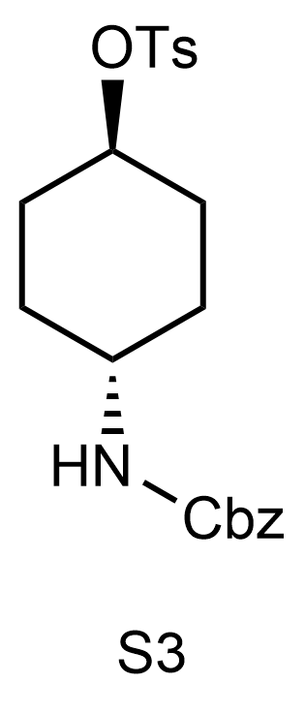
Preparation of trans-4-Carbobenzoxyaminocyclohexyl p-toluenesulfonate (S3)
Prepared according to the literature procedure². A dried 100 mL round-bottom flask was charged with a magnetic stir bar, S2 (11.2 g, 44.8 mmol) in pyridine (0.84 M, 53.3 mL) and para-toluenesulfonyl chloride (11.1 g, 58.2 mmol) at 0 °C. Reaction mixture was stirred for five hours at 0 °C and then for 15 hours at 23 °C. Dichloromethane (50 mL x 3) was added to it, then washed with 1.0 M aqueous hydrogen chloride (50 mL x 3) and brine solution (50 mL x 3), dried over sodium sulfate. The organic solvent was evaporated to give 18.1 g (44.8 mmol) of S3. ¹H NMR spectrum of S3 was matched with the literature².
Isolated Yield: 100%
Physical Property: Pale brown solid.
TLC: R_{f} = 0.33 (silica gel, ethyl acetate/hexane = 1:2)
¹H NMR (600 MHz, CDCl₃ containing 0.03% (v/v) TMS): δ 7.80–7.75 (d, J = 8.2 Hz, 2H), 7.37–7.27 (m, 5H), 5.05 (s, 2H), 4.66 (brs, 1H), 4.41 (m, 1H), 3.54–3.40 (brs, 1H), 2.44 (s, 3H), 2.02–1.87 (m, 4H), 1.63–1.53 (m, 2H), 1.19 (m, 2H).

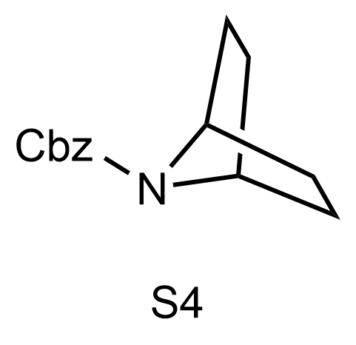
Preparation of Benzyl-7-azabicyclo[2.2.1]heptane-7-carboxylate (S4)
Prepared modifying the literature procedure. To a solution of S3 (5.00 g, 12.4 mmol) in a mixture of DMF and THF (20 mM, 600 mL, 1:1 v/v) was added potassium tert-butoxide (2.09 g, 18.6 mmol) at 0 °C. After stirring four hours at 23 ℃, the resulting solution was quenched with ammonium chloride (100 mL). The organic layer was separated from extraction with diethyl ether (500 mL x 4), washed with brine solution (500 mL x 4), and dried over sodium sulfate. The crude mixture was purified by flash column chromatography (ethyl acetate: hexane = 1:20) to afford 2.32 g (10.0 mmol) of S4. ¹H NMR spectrum of S4 was matched with the literature³.
Isolated Yield: 81%
Physical Property: Pale yellow oil.
TLC: R_{f} = 0.25 (silica gel, ethyl acetate/hexane = 1:15)
¹H NMR (600 MHz, CDCl₃ containing 0.03% (v/v) TMS): δ 7.41–7.28 (m, 5H), 5.11 (s, 2H), 4.30 (s, 2H), 1.77 (d, J = 8.1 Hz, 4H), 1.42 (d, J = 7.5 Hz, 4H).

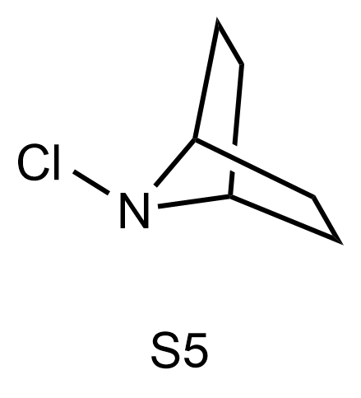
Preparation of 7-Chloro-7-azabicyclo[2.2.1]heptane (S5)
A 100 mL round-bottom flask was charged with a magnetic stir bar, S4 (849 mg, 3.67 mmol) in methanol (0.22 M, 16.5 mL). 2.5 mol% Pd/C (10 wt.%, 97.5 mg, 91.6 µmol) was added to the solution. The flask was evacuated and purged hydrogen gas three times at 0 ℃. The mixture was stirred under hydrogen gas contained in a double-layered balloon at 23 ℃. After vigorous stirring for 4 hours, the catalyst was filtered out through Celite pad on a fritted funnel, and the Celite pad was washed with methanol (10 mL x 3). The solvent in the filtrate was evaporated at 23 ℃ to afford 241 mg (2.48 mmol) of 7-azabicyclo[2.2.1]heptane as yellow oil. Due to the instability of 7-azabicyclo[2.2.1]heptane, N-chlorination was promptly conducted with modifications to the established literature procedure. A 100 mL round-bottom flask was charged with a magnetic stir bar, 7-azabicyclo[2.2.1]heptane (240 mg, 2.47 mmol) in water (70 mM, 35.3 mL), and 1.66 M sodium hypochlorite (23.8 mL, 39.5 mmol) and stirred at 23 ℃ for an hour. The resulting solution was extracted into dichloromethane (60 mL x 3) and combined organic layer was dried over magnesium sulfate, filtered, and evaporated at 23 ℃ to afford 218 mg (1.66 mmol) of S5. ¹H NMR spectrum of S5 was matched with the literature.
Isolated Yield: 45% (2 steps)
Physical Property: Yellow oil.
¹H NMR (600 MHz, CDCl₃ containing 0.03% (v/v) TMS stabilized with Ag foil): δ 3.64 (m, 2H), 2.20–2.14 (m, 2H), 1.79–1.73 (m, 2H), 1.54–1.48 (m, 2H), 1.39–1.34 (m, 2H).
Note: (1) After Cbz deprotection, the structure of 7-azabicyclo[2.2.1]heptane was determined by ¹H NMR (600 MHz) experiment: δ 4.18 (br, 1H), 2.19 (d, J = 9.1 Hz, 2H), 1.63 (d, J = 8.0 Hz, 2H) in CDCl₃ containing 0.03% (v/v) TMS. However, gradual decomposition of the free amine form was shown for longer experiment. (2) Prior to commencing experiments, sodium hypochlorite was routinely subjected to titration analysis. (3) 7-Chloro-7-azabicyclo[2.2.1]heptane was so unstable that it decomposed within a day and thus was used for the next step immediately after the removal of solvent. (4) The N-chlorination exhibited almost quantitative conversion and produced S5 with a negligible amount of unidentified byproducts (see the crude ¹H NMR spectrum in Supplementary Figure 14). However, due to its instability upon complete solvent removal, the exact measurement of the isolated yield of S5 was not accurate. The coupling reaction in the next step was performed according to the amount of 7-azabicyclo[2.2.1]heptane assuming the conversion of 7-azabicyclo[2.2.1]heptane into S5 was quantitative.

5. Comparative Experiments and Results on RMs with Reactive Oxygen Spieces
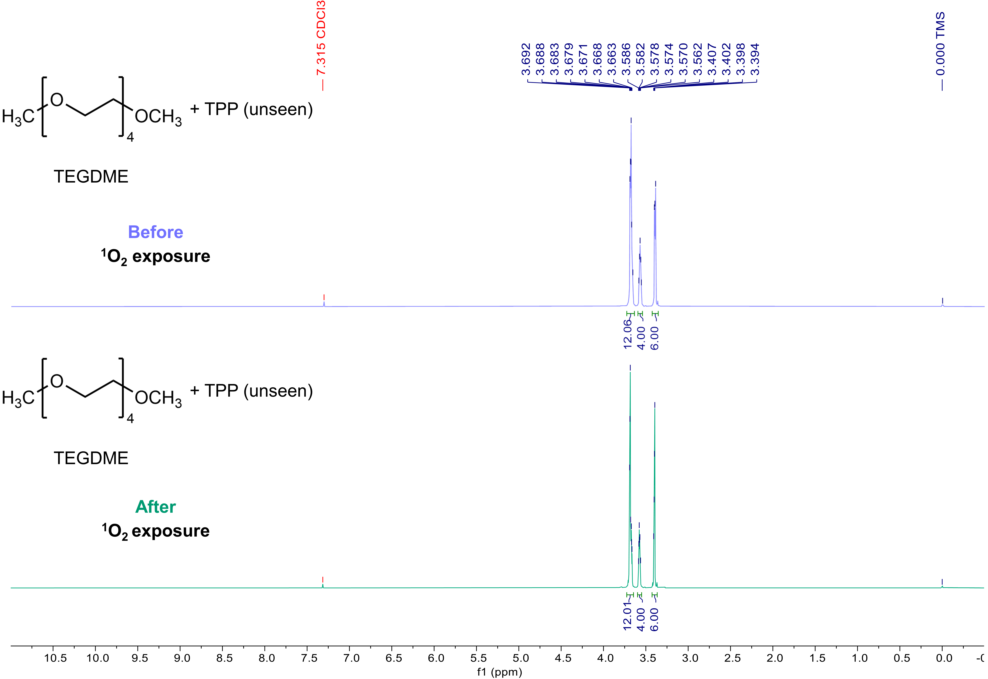
Supplementary Figure 8. Comparison of electrochemical stability of electrolyte before & after exposure to ¹O₂. Overlaid ¹H NMR spectra of a set of tetraethylene glycol dimethyl ether (TEGDME) and tetraphenylporphyrin (TPP) before and after exposure to ¹O₂ in CDCl₃ containing 0.03% (v/v) TMS (600 MHz). Due to the presence of TPP in trace amount in TEGDME, it remains undetectable in NMR spectra.

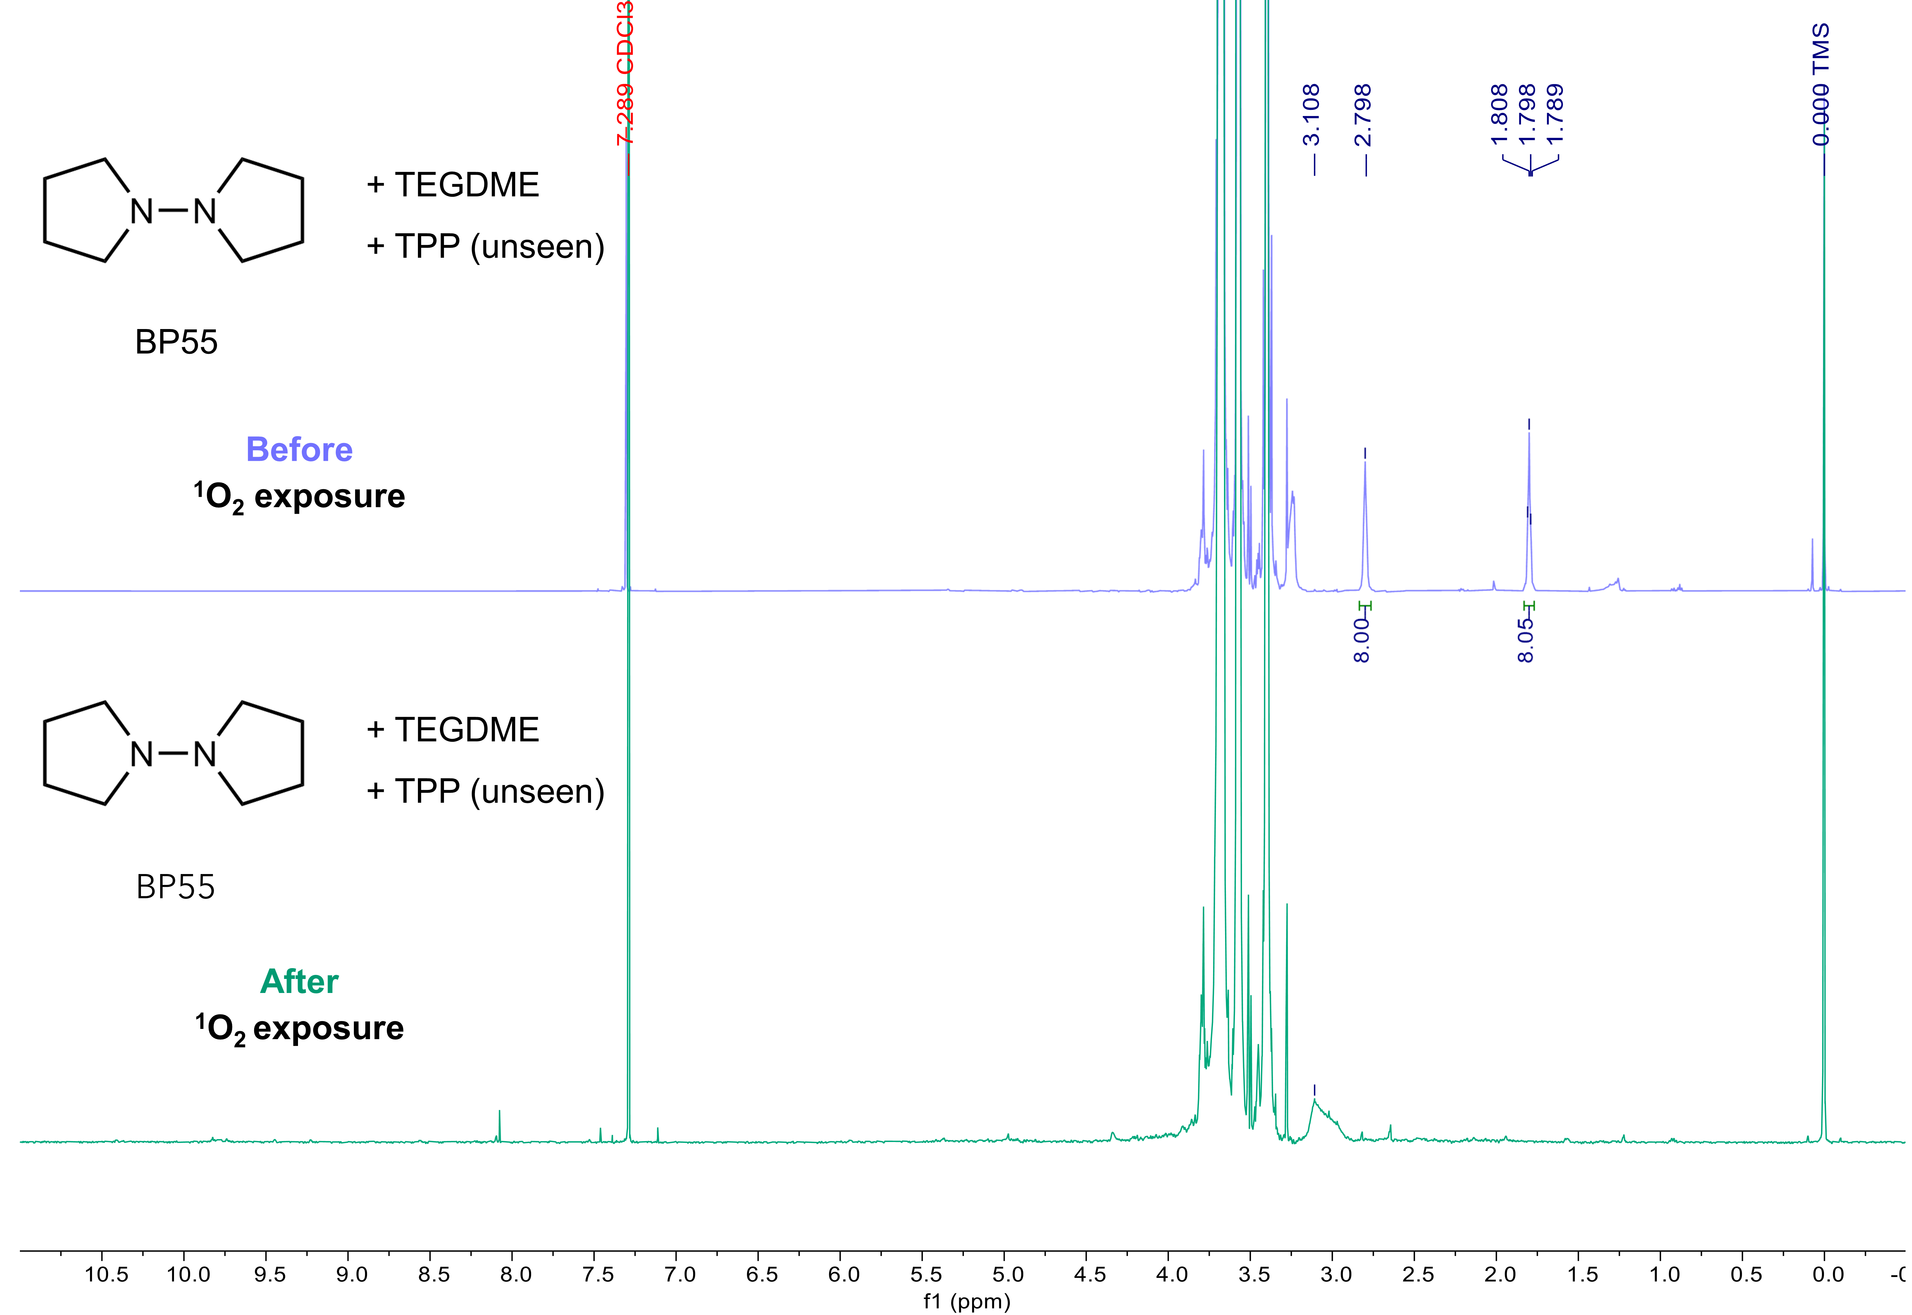
Supplementary Figure 9. Comparison of electrochemical stability of BP55 before & after exposure to ¹O₂. Overlaid ¹H NMR spectra of BP55 with a set of TEGDME and TPP before and after exposure to ¹O₂ in CDCl₃ containing 0.03% (v/v) TMS (600 MHz). Due to the presence of TPP in trace amount in TEGDME, it remains undetectable in NMR spectra.

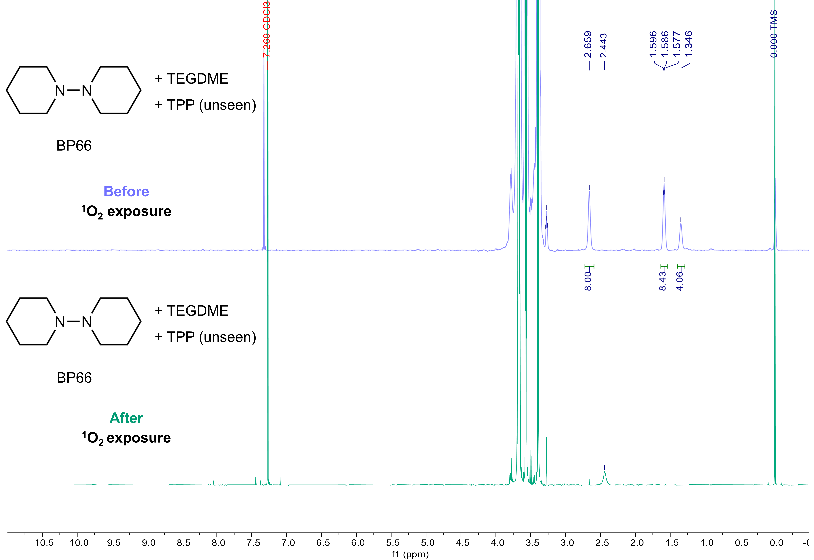
Supplementary Figure 10. Comparison of electrochemical stability of BP66 before & after exposure to ¹O₂. Overlaid ¹H NMR spectra of BP66 with a set of TEGDME and TPP before and after exposure to ¹O₂ in CDCl₃ containing 0.03% (v/v) TMS (600 MHz). Due to the presence of TPP in trace amount in TEGDME, it remains undetectable in NMR spectra.

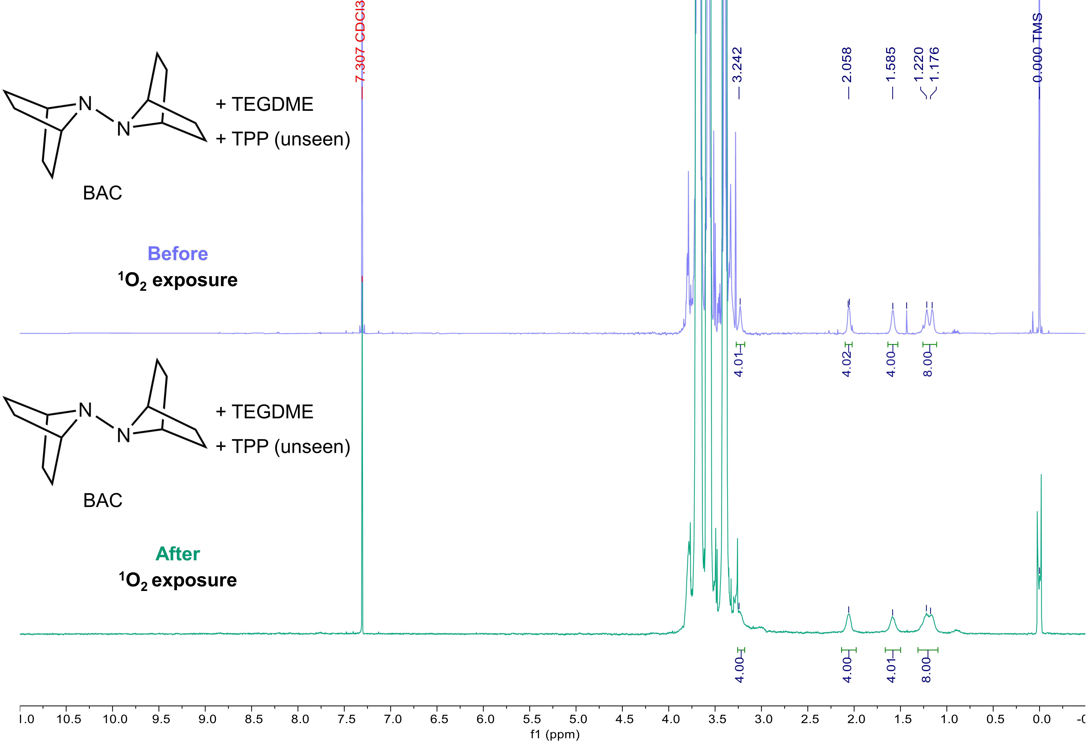
Supplementary Figure 11. Comparison of electrochemical stability of BAC before & after exposure to ¹O₂. Overlaid ¹H NMR spectra of BAC with a set of TEGDME and TPP before and after exposure to ¹O₂ in CDCl₃ containing 0.03% (v/v) TMS (600 MHz). Due to the presence of TPP in trace amount in TEGDME, it remains undetectable in NMR spectra.

Supplementary Figure 12. Comparison of electrochemical activity of alkylamine-type RMs changed by O₂^{•−}. Cyclic voltammetry (CV) profiles of a, BP55 (after O₂^{•−} exposure), b, BP66 (after O₂^{•−} exposure), c, BAC (after O₂^{•−} exposure) at different scan rates.

6. Electrochemical behavior of RMs in LOBs.
Supplementary Figure 13. Charge/discharge profiles of a, BP55, b, BP66, c, BAC at 0.1 mA cm⁻² for 5 hours for 10 cycles. d, Summarized terminal charging and discharge potential of cells with each RM. The dashed line indicates the typically observed charging potential of LOBs without RM.

Supplementary Figure 14. Comparison of electrochemical activity of alkylamine-type RMs in different environment. Cyclic voltammetry (CV) profiles of a, BP55, b, BP66, c, BAC in N,N-dimethylacetamide at different scan rates. Electrochemical behavior of RMs has little difference compared to ether-based electrolyte.

7. Results of DEMS Experiments
Supplementary Figure 15. Gas evolution rate of each additive during DEMS measurement. Accumulated gas evolution rate recalculated based on the Fig. 8.

Supplementary Table 1. Accumulated gas evolution rate for each additive measured via DEMS.ª
¹O₂ exposure | Redox mediator | O₂ (%) | H₂ (%) | CO₂ (%)
before | BP55 | 47 | 11 | 42
after | BP55 | 12 | 14 | 74
before | BP66 | 44 | 16 | 40
after | BP66 | 20 | 13 | 67
before | BAC | 82 | 3 | 15
after | BAC | 79 | 10 | 11
ªThe evolution amount of O₂, H₂ and CO₂ presented in the relative percentage.

8. DFT Calculation
Computed Energies
Supplementary Table 2. Calculated energies in Hartrees.
Structure | ΔG [ωB97X-D/def2-SVP] (298K) | E [(ωB97X-D/def2-TZVPP, SMD(TEGDME)] | G ( = ΔG + E ) (298K) | Imaginary Frequency (cm⁻¹)
³O₂ | -0.015904 | -150.340080 | -150.355984 | -
OOH· | -0.007540 | -150.930546 | -150.938086 | -
H₂O₂ | 0.004894 | -151.575444 | -151.570550 | -
BAC | 0.277048 | -578.822289 | -578.545241 | -
Ia | 0.280631 | -729.107809 | -728.827178 | -
IIa | 0.274139 | -729.145004 | -728.870865 | -
IIIa | 0.282652 | -729.134165 | -728.851513 | -
IVa | 0.262791 | -578.142183 | -577.879392 | -
TS-1a | 0.275580 | -729.052192 | -728.776612 | -1141.07
TS-2a | 0.271182 | -729.081755 | -728.810573 | -655.90
TS-3a | 0.270099 | -729.052217 | -728.782118 | -1355.90
TS-4a | 0.272304 | -729.081196 | -728.808892 | -1254.14
Va | 0.251543 | -577.500082 | -577.248539 | -
VIa | 0.252774 | -577.574768 | -577.321994 | -
BP55 | 0.204189 | -423.974879 | -423.770690 | -
Ib | 0.209519 | -574.277995 | -574.068476 | -
IIb | 0.201658 | -574.299433 | -574.097775 | -
IIIb | 0.210818 | -574.294079 | -574.083261 | -
IVb | 0.189135 | -423.322792 | -423.133657 | -
TS-1b | 0.207139 | -574.271618 | -574.064479 | -696.54
TS-2b | 0.199725 | -574.264989 | -574.065264 | -1429.66
TS-3b | 0.202189 | -574.251746 | -574.049557 | -762.85
TS-4b | 0.199718 | -574.233264 | -574.033546 | -1222.98
Vb | 0.180988 | -422.747107 | -422.566119 | -
VIb | 0.180430 | -422.738672 | -422.558242 | -
BP66 | 0.262919 | -502.629016 | -502.366097 | -
Ic | 0.265534 | -652.916578 | -652.651044 | -
IIc | 0.259207 | -652.951945 | -652.692738 | -
IIIc | 0.269928 | -652.948608 | -652.678680 | -
IVc | 0.248608 | -501.972433 | -501.723825 | -
TS-1c | 0.263118 | -652.912342 | -652.649224 | -296.34
TS-2c | 0.257508 | -652.914336 | -652.656828 | -1486.80
TS-3c | 0.260100 | -652.898715 | -652.638615 | -601.51
TS-4c | 0.257371 | -652.878998 | -652.621627 | -1190.62
Vc | 0.238659 | -501.400274 | -501.161615 | -
VIc | 0.236947 | -501.380415 | -501.143468 | -

Cartesian Coordinates of Calculated Structures
³O₂
O | 0.000000 | 0.000000 | 0.595410
O | 0.000000 | 0.000000 | -0.595410
OOH·
O | 0.055123 | 0.705181 | 0.000000
O | 0.055123 | -0.596534 | 0.000000
H | -0.881976 | -0.869174 | 0.000000
H₂O₂
H | 1.019410 | 0.649995 | 0.434808
H | -1.019566 | -0.649884 | 0.434858
O | 0.698662 | -0.118558 | -0.054343
O | -0.698642 | 0.118544 | -0.054366
BAC
C | 1.892886 | 1.438182 | -0.774175
C | 1.509671 | -0.026520 | -1.087855
C | 1.509567 | -0.026580 | 1.087823
C | 1.892755 | 1.438158 | 0.774241
H | 2.865211 | 1.707679 | -1.211947
H | 1.135916 | 2.128355 | -1.168648
H | 2.864982 | 1.707706 | 1.212186
H | 1.135659 | 2.128268 | 1.168585
N | 0.590252 | -0.412051 | -0.000058
C | 2.693547 | -0.949927 | -0.775720
H | 2.515805 | -1.957395 | -1.176047
H | 3.629685 | -0.572369 | -1.211180
C | 2.693486 | -0.949968 | 0.775729
H | 2.515763 | -1.957465 | 1.175993
H | 3.629578 | -0.572397 | 1.211273
H | 1.081041 | -0.182525 | -2.086278
H | 1.080840 | -0.182642 | 2.086196
C | -1.509564 | 0.026596 | 1.087820
C | -2.693467 | 0.949997 | 0.775712
C | -2.693547 | 0.949910 | -0.775736
H | -3.629563 | 0.572467 | 1.211282
H | -2.515705 | 1.957502 | 1.175940
N | -0.590246 | 0.412043 | -0.000068
C | -1.892784 | -1.438141 | 0.774264
H | -1.080834 | 0.182665 | 2.086191
C | -1.509668 | 0.026497 | -1.087857
C | -1.892886 | -1.438200 | -0.774150
H | -1.081040 | 0.182487 | -2.086282
H | -3.629686 | 0.572326 | -1.211172
H | -2.515826 | 1.957368 | -1.176099
H | -1.135717 | -2.128263 | 1.168642
H | -2.865029 | -1.707649 | 1.212197
H | -1.135904 | -2.128378 | -1.168590
H | -2.865200 | -1.707711 | -1.211935
Ia
C | 1.478649 | -2.146748 | 0.448393
C | 1.375690 | -0.745574 | 1.094480
C | 1.428990 | -0.262074 | -1.041752
C | 1.499374 | -1.804468 | -1.065844
H | 2.381878 | -2.674065 | 0.786887
H | 0.606973 | -2.762758 | 0.702574
H | 2.407534 | -2.151668 | -1.578294
H | 0.630161 | -2.233053 | -1.580612
N | 0.553173 | 0.013427 | 0.120463
C | 2.721825 | -0.026482 | 0.967723
H | 2.731607 | 0.892920 | 1.564528
H | 3.545500 | -0.670942 | 1.305444
C | 2.772009 | 0.294293 | -0.547413
H | 2.841131 | 1.372460 | -0.733031
H | 3.607009 | -0.197508 | -1.065626
H | 0.949158 | -0.730526 | 2.104845
H | 1.063675 | 0.210878 | -1.962353
C | -1.597065 | 0.018242 | -1.064471
C | -2.785564 | -0.948310 | -0.952092
C | -2.836819 | -1.215375 | 0.577670
H | -3.709226 | -0.501570 | -1.345510
H | -2.589871 | -1.872692 | -1.512640
N | -0.725547 | -0.574461 | -0.033899
C | -2.008789 | 1.397194 | -0.502950
H | -1.133310 | 0.042135 | -2.058567
C | -1.659872 | -0.369627 | 1.087409
C | -2.037284 | 1.125919 | 1.022626
H | -1.254770 | -0.704285 | 2.050698
H | -3.785365 | -0.907697 | 1.039570
H | -2.679183 | -2.278860 | 0.803704
H | -1.271970 | 2.167080 | -0.762782
H | -2.983510 | 1.711834 | -0.903657
H | -1.290100 | 1.741237 | 1.537105
H | -3.019510 | 1.310749 | 1.481422
O | 0.821281 | 2.204094 | 0.483565
O | 0.935211 | 2.828609 | -0.561355
IIa
C | 1.345834 | -2.413903 | -0.435571
C | 1.137955 | -1.518527 | 0.807403
C | 1.514156 | -0.038629 | -0.742535
C | 1.620114 | -1.360884 | -1.537003
H | 2.172497 | -3.125061 | -0.292361
H | 0.436837 | -2.989627 | -0.656105
H | 2.605684 | -1.472474 | -2.012270
H | 0.852614 | -1.400937 | -2.320063
N | 0.487758 | -0.302302 | 0.286076
C | 2.483339 | -0.929814 | 1.251897
H | 2.392706 | -0.462652 | 2.242004
H | 3.263935 | -1.701694 | 1.311220
C | 2.748902 | 0.129472 | 0.149649
H | 2.787916 | 1.142912 | 0.571173
H | 3.681321 | -0.044077 | -0.406094
H | 0.576862 | -1.990004 | 1.624494
H | 1.282994 | 0.841350 | -1.356629
C | -1.494722 | 0.671424 | -0.636971
C | -2.804187 | 0.102454 | -1.194308
C | -3.014181 | -1.139297 | -0.287449
H | -3.625671 | 0.830313 | -1.133019
H | -2.684974 | -0.187079 | -2.247273
N | -0.779149 | -0.584170 | -0.335517
C | -1.753857 | 1.316086 | 0.745187
H | -0.948657 | 1.313213 | -1.340764
C | -1.781835 | -1.078077 | 0.625132
C | -1.945849 | 0.071287 | 1.645083
H | -1.516278 | -2.048105 | 1.064678
H | -3.948538 | -1.102985 | 0.290799
H | -3.015170 | -2.068017 | -0.874195
H | -0.884701 | 1.902344 | 1.066640
H | -2.630225 | 1.980483 | 0.725973
H | -1.166980 | 0.018658 | 2.417719
H | -2.924750 | 0.037385 | 2.145268
O | 1.208578 | 3.363203 | 0.401022
O | 0.916211 | 3.369523 | -0.753296
IIIa
C | -1.561088 | -1.747300 | 1.051703
C | -1.146948 | -1.466279 | -0.419197
C | -1.587142 | 0.520854 | 0.312236
C | -1.788208 | -0.315714 | 1.592261
H | -2.464652 | -2.371268 | 1.102471
H | -0.775105 | -2.276056 | 1.607544
H | -2.777436 | -0.155362 | 2.040350
H | -1.028124 | -0.041179 | 2.339375
N | -0.500584 | -0.150987 | -0.406731
C | -2.413940 | -1.063980 | -1.209894
H | -2.189452 | -1.028366 | -2.283410
H | -3.232810 | -1.779379 | -1.052194
C | -2.735213 | 0.357454 | -0.659700
H | -2.637696 | 1.145753 | -1.414877
H | -3.715150 | 0.428256 | -0.169588
H | -0.556435 | -2.254401 | -0.898727
H | -0.224510 | 1.650033 | 0.882643
C | 1.681659 | 0.764121 | -0.750985
C | 2.809127 | 1.165756 | 0.207477
C | 2.748447 | 0.040957 | 1.280760
H | 3.780572 | 1.218734 | -0.303368
H | 2.610224 | 2.153071 | 0.646890
N | 0.722645 | 0.173674 | 0.213735
C | 2.108307 | -0.448095 | -1.594839
H | 1.199077 | 1.586802 | -1.291629
C | 1.637506 | -0.865187 | 0.732737
C | 2.167975 | -1.579526 | -0.535025
H | 1.179896 | -1.519849 | 1.483397
H | 3.695913 | -0.503630 | 1.396706
H | 2.467518 | 0.440563 | 2.265362
H | 1.340710 | -0.654656 | -2.353991
H | 3.063655 | -0.285796 | -2.113212
H | 1.545048 | -2.440769 | -0.812686
H | 3.185507 | -1.963493 | -0.372862
O | -1.020292 | 2.698643 | -0.555498
O | -1.172716 | 1.840585 | 0.631445
IVa
C | -1.927505 | 1.454057 | 0.718390
C | -1.572949 | -0.013727 | 1.084570
C | -1.484006 | -0.038858 | -1.039833
C | -1.820068 | 1.432192 | -0.841810
H | -2.928560 | 1.735252 | 1.077210
H | -1.196758 | 2.148375 | 1.152285
H | -2.752995 | 1.713437 | -1.349270
H | -1.017073 | 2.095226 | -1.189046
N | -0.600590 | -0.416502 | 0.037798
C | -2.739109 | -0.949806 | 0.724614
H | -2.576800 | -1.952106 | 1.143608
H | -3.699429 | -0.571018 | 1.102072
C | -2.660428 | -0.960803 | -0.838036
H | -2.455364 | -1.970335 | -1.220922
H | -3.572810 | -0.584441 | -1.320311
H | -1.189619 | -0.148591 | 2.105449
C | 1.454940 | 0.116758 | -1.073948
C | 2.645194 | 1.016489 | -0.720141
C | 2.698546 | 0.877545 | 0.825992
H | 3.567869 | 0.686190 | -1.218072
H | 2.450471 | 2.054869 | -1.021452
N | 0.576174 | 0.400397 | 0.076002
C | 1.855607 | -1.367079 | -0.900914
H | 0.974799 | 0.350365 | -2.033641
C | 1.527861 | -0.076916 | 1.096066
C | 1.904871 | -1.505077 | 0.640551
H | 1.126365 | -0.013257 | 2.116396
H | 3.650368 | 0.468292 | 1.193377
H | 2.532812 | 1.844908 | 1.319646
H | 1.091631 | -2.025817 | -1.333885
H | 2.815067 | -1.588406 | -1.390790
H | 1.162223 | -2.231299 | 0.995515
H | 2.890992 | -1.807549 | 1.022231
TS-1a
C | 1.378955 | -2.181532 | -0.750560
C | 1.090813 | -1.631549 | 0.682622
C | 1.424012 | 0.109350 | -0.455348
C | 1.528285 | -0.876041 | -1.605499
H | 2.283250 | -2.806489 | -0.772169
H | 0.533129 | -2.780311 | -1.109245
H | 2.488204 | -0.794788 | -2.129802
H | 0.710204 | -0.780230 | -2.329925
N | 0.379573 | -0.352328 | 0.422760
C | 2.368943 | -1.078941 | 1.326217
H | 2.189222 | -0.805603 | 2.374315
H | 3.196015 | -1.801064 | 1.291479
C | 2.621346 | 0.164328 | 0.430505
H | 2.590180 | 1.126845 | 0.983285
H | 3.554751 | 0.120732 | -0.144951
H | 0.510821 | -2.314503 | 1.317268
H | 0.762534 | 1.462070 | -0.795127
C | -1.489400 | 0.643041 | -0.754412
C | -2.843384 | 0.087165 | -1.214215
C | -3.148893 | -0.964797 | -0.115418
H | -3.599765 | 0.881254 | -1.281091
H | -2.754939 | -0.381079 | -2.203962
N | -0.875555 | -0.594108 | -0.225617
C | -1.680973 | 1.546354 | 0.485719
H | -0.918218 | 1.092823 | -1.580122
C | -1.923410 | -0.828073 | 0.793549
C | -2.000079 | 0.499325 | 1.581826
H | -1.720904 | -1.714267 | 1.409488
H | -4.082593 | -0.766264 | 0.428755
H | -3.210677 | -1.976940 | -0.537908
H | -0.765681 | 2.109107 | 0.721300
H | -2.489113 | 2.274449 | 0.327336
H | -1.243508 | 0.522601 | 2.376229
H | -2.988119 | 0.637814 | 2.043844
O | 1.602976 | 2.810148 | 0.314761
O | 1.455747 | 2.238240 | -0.839625
TS-2a
C | 1.369136 | -2.174744 | -0.897986
C | 1.081719 | -1.740615 | 0.567975
C | 1.460514 | 0.112142 | -0.397855
C | 1.593598 | -0.801961 | -1.613227
H | 2.242755 | -2.839405 | -0.963771
H | 0.504129 | -2.697606 | -1.324266
H | 2.578077 | -0.707422 | -2.090446
H | 0.815942 | -0.615538 | -2.364092
N | 0.404279 | -0.427013 | 0.414239
C | 2.376767 | -1.290080 | 1.257089
H | 2.214413 | -1.141436 | 2.332701
H | 3.186303 | -2.021651 | 1.127954
C | 2.657682 | 0.059159 | 0.529695
H | 2.647537 | 0.910211 | 1.224666
H | 3.605336 | 0.071653 | -0.025098
H | 0.490406 | -2.461241 | 1.147626
H | 1.315991 | 1.613232 | -0.718636
C | -1.444667 | 0.746035 | -0.593828
C | -2.767564 | 0.278410 | -1.212138
C | -3.098080 | -0.971764 | -0.353759
H | -3.537413 | 1.060639 | -1.156690
H | -2.630111 | 0.013188 | -2.269323
N | -0.831119 | -0.564884 | -0.294570
C | -1.705855 | 1.375940 | 0.792017
H | -0.835578 | 1.362002 | -1.266935
C | -1.908666 | -1.010652 | 0.612955
C | -2.038415 | 0.129233 | 1.648430
H | -1.718777 | -2.002325 | 1.044685
H | -4.054064 | -0.891497 | 0.182494
H | -3.129835 | -1.881884 | -0.968302
H | -0.806353 | 1.887164 | 1.158913
H | -2.521712 | 2.111803 | 0.753932
H | -1.308624 | 0.000973 | 2.458409
H | -3.043020 | 0.159501 | 2.094587
O | 1.406123 | 3.156199 | 0.390379
O | 1.283311 | 2.687087 | -0.796915
TS-3a
C | 1.178858 | -2.342913 | -0.546522
C | 0.963519 | -1.586479 | 0.810075
C | 1.379435 | -0.037280 | -0.585408
C | 1.331713 | -1.190907 | -1.600833
H | 2.058143 | -3.003936 | -0.515967
H | 0.295539 | -2.952851 | -0.773177
H | 2.248722 | -1.266716 | -2.198892
H | 0.460975 | -1.129240 | -2.263197
N | 0.337882 | -0.320687 | 0.393734
C | 2.274262 | -0.973199 | 1.354718
H | 2.086755 | -0.455947 | 2.306917
H | 3.088330 | -1.697438 | 1.500108
C | 2.579751 | -0.051335 | 0.171136
H | 2.623736 | 1.308302 | 0.470358
H | 3.520654 | -0.176241 | -0.376130
H | 0.380269 | -2.150950 | 1.550715
H | 1.318759 | 1.252355 | -0.969792
C | -1.490769 | 0.725749 | -0.769802
C | -2.868780 | 0.226305 | -1.219799
C | -3.227078 | -0.778156 | -0.091339
H | -3.587915 | 1.052235 | -1.311195
H | -2.802872 | -0.274933 | -2.195282
N | -0.941698 | -0.530854 | -0.216252
C | -1.642334 | 1.657814 | 0.452011
H | -0.877553 | 1.138385 | -1.581741
C | -1.990477 | -0.689896 | 0.811889
C | -1.995650 | 0.653014 | 1.575749
H | -1.836806 | -1.576126 | 1.442408
H | -4.145153 | -0.513146 | 0.451670
H | -3.349090 | -1.796195 | -0.486006
H | -0.696681 | 2.176739 | 0.650263
H | -2.420483 | 2.416378 | 0.284688
H | -1.229595 | 0.655129 | 2.362057
H | -2.970200 | 0.845934 | 2.047400
O | 2.394170 | 2.407518 | 0.246276
O | 1.494139 | 2.396575 | -0.722379
TS-4a
C | -1.001812 | -2.329116 | -0.772300
C | -1.055817 | -0.807684 | -1.087803
C | -1.055946 | -0.807494 | 1.087815
C | -1.001915 | -2.328986 | 0.772578
H | -1.847735 | -2.873134 | -1.216271
H | -0.070037 | -2.754579 | -1.166908
H | -1.847898 | -2.872923 | 1.216532
H | -0.070192 | -2.754381 | 1.167384
N | -0.296454 | -0.178362 | -0.000004
C | -2.446411 | -0.304797 | -0.723558
H | -2.448349 | 0.920102 | -0.984025
H | -3.318084 | -0.672952 | -1.277178
C | -2.446487 | -0.304683 | 0.723305
H | -2.448304 | 0.920406 | 0.983519
H | -3.318240 | -0.672609 | 1.276947
H | -0.709327 | -0.523882 | -2.088529
H | -0.709573 | -0.523528 | 2.088535
C | 1.807156 | 0.125286 | 1.088949
C | 3.243048 | -0.310334 | 0.775837
C | 3.243143 | -0.310523 | -0.775397
H | 3.978885 | 0.380130 | 1.211413
H | 3.441969 | -1.313892 | 1.176293
N | 1.084236 | -0.568609 | 0.000122
C | 1.629717 | 1.627880 | 0.774362
H | 1.464947 | -0.177127 | 2.087552
C | 1.807286 | 0.125010 | -1.088793
C | 1.629800 | 1.627682 | -0.774609
H | 1.465201 | -0.177660 | -2.087362
H | 3.979027 | 0.379841 | -1.211051
H | 3.442121 | -1.314176 | -1.175585
H | 0.670956 | 1.997545 | 1.160298
H | 2.437800 | 2.230967 | 1.213241
H | 0.671074 | 1.997241 | -1.160736
H | 2.437921 | 2.230667 | -1.213557
O | -2.426660 | 2.174366 | -0.641316
O | -2.426740 | 2.174297 | 0.640861
Va
C | -2.004367 | 1.222310 | 0.931735
C | -1.615159 | -0.307334 | 1.041817
C | -1.550800 | 0.132552 | -1.008636
C | -1.755651 | 1.585119 | -0.591345
H | -3.047983 | 1.409071 | 1.228382
H | -1.345084 | 1.811029 | 1.583228
H | -2.634562 | 2.044016 | -1.061788
H | -0.878672 | 2.231793 | -0.717813
N | -0.628003 | -0.448613 | -0.038519
C | -2.666370 | -1.268886 | 0.408882
H | -2.318327 | -2.312775 | 0.475992
H | -3.669435 | -1.203798 | 0.856329
C | -2.678247 | -0.613560 | -0.970122
H | -3.604484 | -0.289251 | -1.448859
H | -1.249970 | -0.601395 | 2.038846
C | 1.405591 | 0.347812 | -1.018359
C | 2.588072 | 1.165034 | -0.483824
C | 2.652876 | 0.697406 | 0.996204
H | 3.511091 | 0.960335 | -1.044642
H | 2.380986 | 2.241710 | -0.554205
N | 0.531863 | 0.364710 | 0.170568
C | 1.823276 | -1.132637 | -1.173728
H | 0.916654 | 0.778161 | -1.903036
C | 1.497478 | -0.310447 | 1.057519
C | 1.891577 | -1.599547 | 0.301008
H | 1.101565 | -0.476181 | 2.068612
H | 3.612699 | 0.233315 | 1.263873
H | 2.476187 | 1.533338 | 1.686811
H | 1.060605 | -1.691297 | -1.731349
H | 2.779502 | -1.229921 | -1.708179
H | 1.165607 | -2.399484 | 0.495092
H | 2.886947 | -1.958285 | 0.601464
VIa
C | -1.929083 | 1.376253 | 0.772536
C | -1.567364 | -0.113957 | 1.083228
C | -1.567192 | -0.113729 | -1.083532
C | -1.928963 | 1.376414 | -0.772583
H | -2.894064 | 1.659495 | 1.215213
H | -1.151236 | 2.043823 | 1.165135
H | -2.893874 | 1.659748 | -1.215352
H | -1.151054 | 2.044066 | -1.164920
N | -0.628729 | -0.476354 | -0.000115
C | -2.757719 | -0.947543 | 0.667302
H | -3.494509 | -1.377340 | 1.345871
C | -2.757610 | -0.947406 | -0.667971
H | -3.494290 | -1.377065 | -1.346747
H | -1.175772 | -0.299382 | 2.091215
H | -1.175440 | -0.298942 | -2.091495
C | 1.452618 | 0.023811 | -1.088122
C | 2.611027 | 0.979185 | -0.775623
C | 2.610880 | 0.979077 | 0.776220
H | 3.557106 | 0.627014 | -1.210782
H | 2.406456 | 1.981658 | -1.175715
N | 0.524254 | 0.385385 | 0.000060
C | 1.875247 | -1.429895 | -0.774218
H | 1.017807 | 0.168193 | -2.086018
C | 1.452411 | 0.023660 | 1.088368
C | 1.875100 | -1.430003 | 0.774343
H | 1.017411 | 0.167905 | 2.086201
H | 3.556876 | 0.626846 | 1.211510
H | 2.406232 | 1.981495 | 1.176412
H | 1.137286 | -2.140647 | -1.167778
H | 2.854727 | -1.672150 | -1.211952
H | 1.137062 | -2.140808 | 1.167664
H | 2.854495 | -1.672320 | 1.212232
BP55
H | 1.417468 | -0.220592 | -1.833514
N | 0.669312 | -0.413074 | 0.161637
C | 1.224307 | 0.696870 | 0.945491
C | 2.659193 | 0.857708 | 0.422788
C | 2.940912 | -0.464520 | -0.302862
C | 1.580680 | -0.800724 | -0.898020
H | 0.644285 | 1.629666 | 0.818606
H | 1.202652 | 0.455266 | 2.022921
H | 3.384476 | 1.078572 | 1.218673
H | 2.703760 | 1.687695 | -0.300406
H | 3.235313 | -1.244283 | 0.417200
H | 3.735325 | -0.380770 | -1.057857
H | 1.455519 | -1.866139 | -1.145477
H | -1.419361 | -0.229231 | 1.832352
N | -0.669305 | -0.411432 | -0.163134
C | -1.223164 | 0.704172 | -0.939641
C | -2.659745 | 0.859464 | -0.419585
C | -2.941011 | -0.466856 | 0.298866
C | -1.581190 | -0.804922 | 0.893839
H | -0.644619 | 1.636644 | -0.803531
H | -1.198021 | 0.471233 | -2.018877
H | -3.383477 | 1.082805 | -1.216186
H | -2.707821 | 1.685859 | 0.307457
H | -3.233732 | -1.243199 | -0.425543
H | -3.736439 | -0.387715 | 1.053291
H | -1.455269 | -1.871422 | 1.136119
Ib
H | -1.380422 | 1.438261 | 0.871964
N | -0.513622 | -0.261385 | 0.106520
C | -1.242116 | -1.306219 | -0.602169
C | -2.690003 | -0.864201 | -0.446657
C | -2.711883 | -0.310402 | 0.980511
C | -1.335777 | 0.343767 | 1.123292
H | -0.910877 | -1.358262 | -1.648240
H | -1.056867 | -2.282535 | -0.115485
H | -3.398884 | -1.687080 | -0.609143
H | -2.902513 | -0.065099 | -1.171171
H | -2.820135 | -1.132694 | 1.705850
H | -3.530604 | 0.400567 | 1.153667
H | -0.884257 | 0.230889 | 2.117904
H | 1.397454 | -0.578082 | -1.601730
N | 0.814107 | -0.532805 | 0.446087
C | 1.529832 | 0.656825 | 0.965721
C | 2.926727 | 0.592258 | 0.333388
C | 3.026774 | -0.839005 | -0.197704
C | 1.599661 | -1.102874 | -0.649417
H | 1.006273 | 1.581490 | 0.683998
H | 1.575579 | 0.602135 | 2.065198
H | 3.724314 | 0.849944 | 1.043513
H | 2.984220 | 1.301308 | -0.505759
H | 3.303045 | -1.539094 | 0.606388
H | 3.752709 | -0.952986 | -1.014239
H | 1.378326 | -2.172567 | -0.779414
O | -0.486635 | 1.219045 | -1.263810
O | -0.883371 | 2.268735 | -0.700359
IIb
H | -2.058848 | -1.592725 | 0.799940
N | -1.018589 | -0.047085 | -0.266787
C | -1.531494 | 1.091823 | 0.478597
C | -3.056694 | 1.024666 | 0.266406
C | -3.300583 | -0.319806 | -0.455914
C | -2.018075 | -1.102248 | -0.198161
H | -1.286127 | 1.015303 | 1.558807
H | -1.073502 | 2.021139 | 0.109069
H | -3.427028 | 1.871227 | -0.328169
H | -3.583001 | 1.056715 | 1.231367
H | -3.416309 | -0.157147 | -1.537369
H | -4.198115 | -0.842643 | -0.096682
H | -1.823094 | -1.884863 | -0.947879
N | 0.309666 | -0.348656 | -0.022932
C | 0.663444 | -1.196591 | 1.104538
C | 2.177721 | -1.293694 | 0.949674
C | 2.393361 | -1.301822 | -0.582050
C | 1.057263 | -0.816916 | -1.176234
H | 0.349084 | -0.742899 | 2.057350
H | 0.201814 | -2.207109 | 1.042593
H | 2.598149 | -2.179632 | 1.445887
H | 2.646617 | -0.405253 | 1.396477
H | 2.638838 | -2.309584 | -0.946664
H | 3.226280 | -0.644997 | -0.868824
H | 0.534537 | -1.650500 | -1.691565
H | 1.170087 | -0.001621 | -1.906623
O | 1.931528 | 2.191144 | 0.459162
O | 2.337649 | 2.172895 | -0.660515
IIIb
H | 1.272113 | 2.057249 | -1.307048
N | 0.384570 | -0.737712 | 0.039075
C | 1.334231 | -1.214150 | 1.037318
C | 2.700183 | -0.780868 | 0.489166
C | 2.418944 | -0.356101 | -0.960721
C | 0.953970 | 0.037782 | -0.950058
H | 1.130895 | -0.747659 | 2.013560
H | 1.233597 | -2.307177 | 1.149320
H | 3.452810 | -1.579012 | 0.548398
H | 3.049837 | 0.097549 | 1.042217
H | 2.537427 | -1.192335 | -1.667399
H | 3.068371 | 0.462833 | -1.301466
H | 0.430125 | -0.003773 | -1.920118
H | -0.669337 | 1.233382 | 1.175921
N | -0.953483 | -0.709529 | 0.360909
C | -1.874634 | -1.153729 | -0.677013
C | -3.162107 | -0.383908 | -0.380062
C | -2.636795 | 0.944313 | 0.174641
C | -1.472133 | 0.490115 | 1.050042
H | -1.509999 | -0.885360 | -1.690292
H | -2.010364 | -2.247587 | -0.663167
H | -3.749311 | -0.908382 | 0.391005
H | -3.800093 | -0.274400 | -1.268662
H | -3.396679 | 1.520428 | 0.721476
H | -2.262613 | 1.575736 | -0.648591
H | -1.836912 | 0.208740 | 2.054517
O | 1.393485 | 1.910807 | 0.626118
O | 0.790586 | 1.541660 | -0.642298
IVb
N | 0.688284 | -0.164272 | -0.260229
C | 1.574978 | 0.779617 | -0.919867
C | 2.956115 | 0.232947 | -0.563621
C | 2.759707 | -0.358057 | 0.849193
C | 1.294921 | -0.675001 | 0.889772
H | 1.369959 | 0.808205 | -1.999723
H | 1.434570 | 1.805323 | -0.521184
H | 3.742010 | 0.999347 | -0.610436
H | 3.223627 | -0.569167 | -1.268541
H | 3.032176 | 0.387504 | 1.621468
H | 3.403680 | -1.234347 | 1.027761
H | 0.849944 | -1.539844 | 1.386591
H | -1.320222 | -1.844422 | 0.259368
N | -0.671034 | 0.094938 | -0.336112
C | -1.265467 | 0.847052 | 0.765123
C | -2.760954 | 0.779514 | 0.446931
C | -2.927352 | -0.515722 | -0.390963
C | -1.508209 | -1.079192 | -0.524329
H | -1.041071 | 0.371353 | 1.742446
H | -0.868633 | 1.873055 | 0.795965
H | -3.068835 | 1.656578 | -0.139536
H | -3.368338 | 0.770636 | 1.362815
H | -3.344194 | -0.281892 | -1.380590
H | -3.604173 | -1.239542 | 0.083966
H | -1.303698 | -1.544388 | -1.499420
TS-1b
H | -1.309029 | 1.581326 | 0.215556
N | -0.506632 | -0.302784 | 0.220368
C | -1.246425 | -1.384269 | -0.432615
C | -2.683117 | -0.883141 | -0.365688
C | -2.714923 | -0.106090 | 0.955700
C | -1.310840 | 0.461006 | 1.019429
H | -0.883831 | -1.531831 | -1.456074
H | -1.095066 | -2.308639 | 0.154008
H | -3.413086 | -1.701696 | -0.413053
H | -2.857180 | -0.197905 | -1.206870
H | -2.899828 | -0.780896 | 1.810328
H | -3.489094 | 0.673354 | 0.972587
H | -0.883209 | 0.796074 | 1.967838
H | 1.346057 | -0.653463 | -1.540527
N | 0.831776 | -0.504015 | 0.511859
C | 1.528900 | 0.718847 | 0.960014
C | 2.902468 | 0.664403 | 0.279760
C | 3.030838 | -0.788375 | -0.181197
C | 1.599817 | -1.119857 | -0.572416
H | 0.969055 | 1.613719 | 0.650144
H | 1.608803 | 0.714760 | 2.059408
H | 3.716459 | 0.985295 | 0.943806
H | 2.897288 | 1.328195 | -0.596968
H | 3.358539 | -1.437251 | 0.646331
H | 3.731761 | -0.920166 | -1.016481
H | 1.406513 | -2.201527 | -0.625172
O | -0.405045 | 1.007518 | -1.398071
O | -0.985013 | 2.031619 | -0.810476
TS-2b
H | -2.007557 | -1.734615 | 0.708277
N | -1.007657 | -0.226124 | -0.440378
C | -1.384128 | 1.065600 | 0.165827
C | -2.871299 | 0.903490 | 0.509144
C | -3.315605 | -0.323377 | -0.298155
C | -2.072920 | -1.201709 | -0.264767
H | -0.766585 | 1.285420 | 1.052062
H | -1.201322 | 1.879377 | -0.553617
H | -3.459786 | 1.802785 | 0.281413
H | -2.990201 | 0.698817 | 1.584748
H | -3.542220 | -0.041843 | -1.338198
H | -4.201618 | -0.819840 | 0.121155
H | -2.042794 | -1.957770 | -1.064434
N | 0.266682 | -0.672775 | -0.216886
C | 0.728972 | -1.191673 | 1.067779
C | 2.254220 | -1.134182 | 0.936258
C | 2.503849 | -1.142197 | -0.582132
C | 1.293953 | -0.400000 | -1.111394
H | 0.350811 | -0.578261 | 1.901190
H | 0.360667 | -2.223677 | 1.212960
H | 2.754907 | -1.959732 | 1.459810
H | 2.611187 | -0.183979 | 1.356534
H | 2.527963 | -2.173389 | -0.977752
H | 3.453483 | -0.660777 | -0.854900
H | 1.005898 | -0.481265 | -2.169002
H | 1.594863 | 0.943272 | -0.970689
O | 1.652627 | 2.067174 | 0.651707
O | 1.836982 | 2.063083 | -0.612217
TS-3b
H | 1.334215 | 0.957188 | -0.897002
N | 0.132287 | -0.736541 | -0.287398
C | 0.633029 | -1.143142 | 1.028186
C | 2.001017 | -1.716570 | 0.663913
C | 2.451280 | -0.811907 | -0.494514
C | 1.189822 | -0.302761 | -1.080994
H | 0.737685 | -0.275814 | 1.707447
H | -0.045099 | -1.872992 | 1.493807
H | 1.888733 | -2.753633 | 0.310528
H | 2.701446 | -1.713581 | 1.508921
H | 3.136716 | -1.269378 | -1.219333
H | 2.991064 | 0.091298 | -0.060792
H | 1.002465 | -0.300955 | -2.163686
H | -2.188848 | -1.708928 | 0.539445
N | -1.102706 | -0.161165 | -0.462912
C | -1.382626 | 1.115334 | 0.224601
C | -2.850866 | 0.999457 | 0.651002
C | -3.413950 | -0.101437 | -0.255449
C | -2.238911 | -1.063709 | -0.363812
H | -0.707824 | 1.272838 | 1.080805
H | -1.213915 | 1.958150 | -0.464864
H | -3.394337 | 1.950558 | 0.566244
H | -2.914377 | 0.677348 | 1.702617
H | -3.657434 | 0.303996 | -1.250090
H | -4.318893 | -0.575701 | 0.148798
H | -2.288076 | -1.724960 | -1.242343
O | 2.722524 | 1.702289 | 0.436359
O | 1.702055 | 1.974826 | -0.279599
TS-4b
H | 0.797923 | 0.314324 | -1.663687
N | -0.165886 | -0.754582 | -0.081280
C | 0.541509 | -0.335456 | 1.128247
C | 1.957585 | -0.828480 | 0.867979
C | 2.095133 | -1.035566 | -0.555887
C | 0.759558 | -0.695397 | -1.203182
H | 0.542912 | 0.765110 | 1.270128
H | 0.095019 | -0.787077 | 2.027793
H | 2.390683 | -1.574350 | 1.545760
H | 2.716904 | 0.137652 | 1.067733
H | 2.638635 | -1.924007 | -0.899782
H | 2.893080 | -0.134912 | -0.875745
H | 0.467706 | -1.408376 | -1.988979
H | -2.396372 | -1.058922 | 1.408008
N | -1.427648 | -0.269135 | -0.329528
C | -1.675785 | 1.176461 | -0.365473
C | -3.123123 | 1.323625 | 0.127274
C | -3.716031 | -0.083624 | -0.019700
C | -2.524833 | -0.974028 | 0.306233
H | -0.976957 | 1.740158 | 0.278269
H | -1.545462 | 1.565396 | -1.390719
H | -3.685726 | 2.090061 | -0.423732
H | -3.129065 | 1.614801 | 1.189556
H | -4.038178 | -0.259925 | -1.058007
H | -4.578737 | -0.257790 | 0.638374
H | -2.611856 | -1.995045 | -0.095240
O | 3.422857 | 1.154896 | 0.639769
O | 3.538410 | 0.976818 | -0.623147
Vb
N | -0.723173 | 0.126574 | -0.424118
C | -1.327222 | 0.897254 | 0.672006
C | -2.835554 | 0.616380 | 0.525701
C | -2.850679 | -0.673890 | -0.265877
C | -1.633050 | -0.867286 | -0.788118
H | -0.961984 | 0.527326 | 1.650173
H | -1.072200 | 1.964614 | 0.599205
H | -3.329810 | 1.425977 | -0.041543
H | -3.344924 | 0.552933 | 1.499600
H | -3.738133 | -1.266779 | -0.478434
H | -1.287741 | -1.652535 | -1.461101
H | 1.337246 | 1.823909 | -0.271884
N | 0.618328 | -0.186546 | -0.412503
C | 1.174524 | -0.943292 | 0.717551
C | 2.594265 | -0.385969 | 0.888138
C | 2.883853 | 0.307270 | -0.449438
C | 1.520892 | 0.874799 | -0.821242
H | 0.578109 | -0.818336 | 1.638018
H | 1.177630 | -2.022430 | 0.485675
H | 3.330608 | -1.161034 | 1.142951
H | 2.610264 | 0.360499 | 1.698217
H | 3.199749 | -0.429261 | -1.204988
H | 3.665612 | 1.076181 | -0.376636
H | 1.407322 | 1.087155 | -1.895241
VIb
H | -1.352744 | -1.935859 | 0.163767
N | -0.745438 | 0.035846 | -0.420263
C | -1.337158 | 1.116609 | 0.364661
C | -2.784686 | 0.721370 | 0.412266
C | -2.957782 | -0.509128 | -0.070934
C | -1.649447 | -1.100450 | -0.507576
H | -0.920330 | 1.195960 | 1.392733
H | -1.179096 | 2.101586 | -0.112845
H | -3.568053 | 1.369595 | 0.808293
H | -3.907791 | -1.041475 | -0.136491
H | -1.681682 | -1.516579 | -1.531001
H | 1.378531 | 1.679738 | -0.782816
N | 0.592867 | -0.253601 | -0.302951
C | 1.148768 | -0.608538 | 1.006293
C | 2.614450 | -0.149224 | 0.936615
C | 2.864128 | 0.106559 | -0.556704
C | 1.506513 | 0.602689 | -1.033673
H | 0.617165 | -0.110627 | 1.838574
H | 1.059202 | -1.695570 | 1.179649
H | 3.312515 | -0.879103 | 1.370128
H | 2.738921 | 0.791422 | 1.495770
H | 3.115900 | -0.833303 | -1.072408
H | 3.677147 | 0.823411 | -0.738810
H | 1.349587 | 0.495767 | -2.117729
BP66
C | -3.535226 | 0.072167 | -0.206769
C | -2.708022 | -1.125620 | -0.670774
C | -1.264020 | -0.711311 | -0.937636
N | -0.694608 | -0.092544 | 0.249505
C | -1.412205 | 1.091651 | 0.680233
C | -2.866830 | 0.749230 | 0.988973
H | -4.561978 | -0.237014 | 0.043959
H | -3.617562 | 0.797779 | -1.036112
H | -3.140167 | -1.571070 | -1.580668
H | -2.712630 | -1.903597 | 0.110577
H | -0.657984 | -1.591639 | -1.202311
H | -1.243488 | -0.025321 | -1.815075
H | -0.899661 | 1.481934 | 1.570299
H | -1.386733 | 1.895730 | -0.092711
H | -3.409963 | 1.663834 | 1.274421
H | -2.890333 | 0.069538 | 1.857025
C | 3.535224 | -0.072122 | -0.206817
C | 2.707970 | 1.125673 | -0.670719
C | 2.866887 | -0.749274 | 0.988910
H | 4.561976 | 0.237078 | 0.043891
H | 3.617550 | -0.797682 | -1.036206
C | 1.263980 | 0.711336 | -0.937599
H | 3.140079 | 1.571206 | -1.580590
H | 2.712569 | 1.903596 | 0.110687
N | 0.694598 | 0.092491 | 0.249511
H | 0.657909 | 1.591656 | -1.202219
H | 1.243464 | 0.025391 | -1.815074
C | 1.412247 | -1.091688 | 0.680219
H | 0.899753 | -1.482005 | 1.570299
H | 1.386774 | -1.895774 | -0.092724
H | 3.410045 | -1.663885 | 1.274291
H | 2.890410 | -0.069629 | 1.856998
Ic
C | 2.801472 | -1.601201 | 0.137271
C | 1.824705 | -1.421168 | 1.298816
C | 1.179218 | -0.033828 | 1.235664
N | 0.570824 | 0.284588 | -0.053933
C | 1.404301 | 0.019597 | -1.199711
C | 2.099237 | -1.346730 | -1.195113
H | 3.248193 | -2.607126 | 0.155121
H | 3.632433 | -0.882587 | 0.250739
H | 2.344478 | -1.525866 | 2.264180
H | 1.054982 | -2.209010 | 1.266615
H | 0.423988 | 0.105581 | 2.021771
H | 1.966519 | 0.722212 | 1.403979
H | 0.782463 | 0.162865 | -2.092452
H | 2.189294 | 0.811958 | -1.206900
H | 2.818640 | -1.380838 | -2.027906
H | 1.361904 | -2.144784 | -1.385724
C | -3.629723 | -0.380860 | 0.155141
C | -3.064281 | 1.012366 | -0.106536
C | -2.709241 | -1.436786 | -0.450368
H | -4.648699 | -0.473079 | -0.251318
H | -3.706791 | -0.546355 | 1.244784
C | -1.620368 | 1.126497 | 0.371302
H | -3.671288 | 1.783438 | 0.392595
H | -3.093579 | 1.224658 | -1.188164
N | -0.802016 | 0.089558 | -0.242402
H | -1.201063 | 2.096618 | 0.085953
H | -1.596951 | 1.061902 | 1.482891
C | -1.278260 | -1.258867 | 0.045762
H | -0.616059 | -1.979105 | -0.454334
H | -1.242489 | -1.479670 | 1.136752
H | -3.055383 | -2.452507 | -0.203277
H | -2.714165 | -1.346627 | -1.549236
O | 2.173243 | 2.570824 | -0.209569
O | 0.989201 | 2.474823 | 0.081432
IIc
C | 3.771839 | 0.574448 | -0.179249
C | 2.653649 | 1.478445 | 0.337447
C | 1.294598 | 0.982628 | -0.146901
N | 1.095683 | -0.401163 | 0.255736
C | 2.098441 | -1.303255 | -0.276358
C | 3.490436 | -0.882436 | 0.186141
H | 4.747377 | 0.894724 | 0.218832
H | 3.833199 | 0.668029 | -1.278611
H | 2.807648 | 2.518402 | 0.009008
H | 2.656565 | 1.477622 | 1.440103
H | 0.488291 | 1.595930 | 0.283395
H | 1.240525 | 1.106092 | -1.252652
H | 1.852859 | -2.314430 | 0.076455
H | 2.081094 | -1.330949 | -1.391550
H | 4.245729 | -1.549776 | -0.257934
H | 3.547783 | -1.004659 | 1.280609
C | -3.062361 | -1.227690 | -0.079219
C | -2.129284 | -1.512138 | -1.255030
C | -2.320318 | -1.413758 | 1.243426
H | -3.952141 | -1.875099 | -0.121800
H | -3.424591 | -0.186380 | -0.148406
C | -0.862377 | -0.668713 | -1.151228
H | -2.632626 | -1.307725 | -2.213155
H | -1.845539 | -2.577672 | -1.253243
N | -0.205155 | -0.906352 | 0.125265
H | -0.163513 | -0.929727 | -1.961105
H | -1.132052 | 0.402588 | -1.286826
C | -1.037006 | -0.588814 | 1.270359
H | -0.448561 | -0.801398 | 2.173584
H | -2.959754 | -1.129885 | 2.093982
H | -2.057369 | -2.477103 | 1.371203
H | -1.305084 | 0.492661 | 1.300742
O | -1.852811 | 2.965341 | -0.414762
O | -2.797093 | 2.640792 | 0.234016
IIIc
C | -3.311528 | -0.416471 | -0.238995
C | -2.455627 | -1.486871 | -0.907834
C | -1.028422 | -0.988620 | -1.085255
N | -0.474211 | -0.535374 | 0.190658
C | -1.229198 | 0.266542 | 1.055296
C | -2.709283 | -0.059467 | 1.116065
H | -4.345420 | -0.768619 | -0.103044
H | -3.325888 | 0.490460 | -0.859712
H | -2.862700 | -1.756106 | -1.894151
H | -2.453309 | -2.405265 | -0.295006
H | -0.385154 | -1.804411 | -1.451953
H | -1.021229 | -0.170330 | -1.823228
H | -0.775276 | 0.248412 | 2.058953
H | -0.125736 | 1.899764 | 0.789608
H | -3.224944 | 0.793152 | 1.579876
H | -2.808994 | -0.913465 | 1.806333
C | 3.727779 | -0.008475 | -0.235377
C | 2.764918 | 1.119176 | -0.605695
C | 3.146725 | -0.862065 | 0.891605
H | 4.711297 | 0.394194 | 0.052219
H | 3.894242 | -0.644073 | -1.123371
C | 1.380055 | 0.564696 | -0.918115
H | 3.137161 | 1.683826 | -1.474228
H | 2.688725 | 1.832399 | 0.233414
N | 0.889127 | -0.202149 | 0.230069
H | 0.646717 | 1.357963 | -1.140909
H | 1.449520 | -0.074971 | -1.824442
C | 1.737610 | -1.340311 | 0.553427
H | 1.286910 | -1.865721 | 1.407318
H | 1.782521 | -2.061490 | -0.292862
H | 3.791184 | -1.730789 | 1.097351
H | 3.100003 | -0.265104 | 1.818026
O | -1.084193 | 1.735732 | 0.736312
O | -1.441084 | 2.038522 | -0.643314
IVc
C | 3.522966 | -0.157457 | -0.287208
C | 2.747778 | 1.124414 | -0.580881
C | 1.282367 | 0.809636 | -0.856246
N | 0.699668 | 0.057603 | 0.248818
C | 1.413373 | -1.032087 | 0.746185
C | 2.893726 | -0.881331 | 0.904937
H | 4.583168 | 0.064472 | -0.090240
H | 3.488531 | -0.812155 | -1.175258
H | 3.172158 | 1.656517 | -1.446361
H | 2.814237 | 1.804581 | 0.285413
H | 0.707222 | 1.738740 | -0.988855
H | 1.210173 | 0.238798 | -1.805268
H | 0.842076 | -1.629816 | 1.459797
H | 3.351930 | -1.872296 | 1.048856
H | 3.124853 | -0.300983 | 1.824922
C | -3.515273 | 0.053419 | -0.228581
C | -2.684607 | -1.143438 | -0.690192
C | -2.859728 | 0.726226 | 0.976972
H | -4.544093 | -0.256547 | 0.011968
H | -3.590553 | 0.782780 | -1.055328
C | -1.238431 | -0.730310 | -0.942269
H | -3.108544 | -1.584098 | -1.606102
H | -2.697424 | -1.925062 | 0.087231
N | -0.686175 | -0.108237 | 0.251841
H | -0.616220 | -1.605990 | -1.182785
H | -1.206777 | -0.045163 | -1.819845
C | -1.403885 | 1.076429 | 0.682192
H | -0.902297 | 1.463516 | 1.580530
H | -1.376994 | 1.883974 | -0.086107
H | -3.407821 | 1.637851 | 1.262022
H | -2.887796 | 0.042324 | 1.841337
TS-1c
C | 3.232309 | -0.800990 | 0.200506
C | 2.241226 | -1.319944 | 1.236410
C | 1.024102 | -0.408727 | 1.315949
N | 0.494277 | -0.047822 | -0.016667
C | 1.232611 | -0.111066 | -1.143934
C | 2.562836 | -0.821851 | -1.167443
H | 4.146884 | -1.411321 | 0.187235
H | 3.520514 | 0.234692 | 0.442864
H | 2.696791 | -1.371564 | 2.236399
H | 1.935685 | -2.346984 | 0.969505
H | 0.211630 | -0.896082 | 1.872705
H | 1.279196 | 0.534465 | 1.815953
H | 0.614223 | -0.126003 | -2.047378
H | 1.628113 | 1.260212 | -1.209311
H | 3.201188 | -0.362082 | -1.936486
H | 2.395274 | -1.868241 | -1.485467
C | -3.738804 | -0.282370 | 0.113464
C | -3.038506 | 1.074522 | 0.155252
C | -2.922153 | -1.272895 | -0.714118
H | -4.756673 | -0.186634 | -0.294766
H | -3.845920 | -0.670026 | 1.142525
C | -1.599415 | 0.942414 | 0.638556
H | -3.575746 | 1.772393 | 0.815347
H | -3.032333 | 1.521022 | -0.852702
N | -0.892890 | -0.011909 | -0.207161
H | -1.049935 | 1.889233 | 0.566742
H | -1.599030 | 0.617976 | 1.702753
C | -1.483424 | -1.345807 | -0.213498
H | -0.879430 | -1.988910 | -0.871978
H | -1.472185 | -1.805454 | 0.800317
H | -3.368512 | -2.278850 | -0.681490
H | -2.910760 | -0.952885 | -1.769060
O | 1.825884 | 2.193642 | -0.657669
O | 0.997443 | 2.173037 | 0.362199
TS-2c
C | -3.789856 | 0.085383 | 0.170195
C | -2.831667 | 1.275747 | 0.176676
C | -1.437056 | 0.845881 | 0.615495
N | -0.961225 | -0.229583 | -0.248382
C | -1.805812 | -1.414771 | -0.222358
C | -3.218992 | -1.055394 | -0.671187
H | -4.780550 | 0.383923 | -0.205733
H | -3.938402 | -0.266460 | 1.206982
H | -3.196473 | 2.069025 | 0.847019
H | -2.766283 | 1.707460 | -0.835578
H | -0.719204 | 1.675428 | 0.554532
H | -1.476731 | 0.523210 | 1.679848
H | -1.361086 | -2.162002 | -0.895450
H | -1.848209 | -1.867017 | 0.794815
H | -3.860537 | -1.948149 | -0.609845
H | -3.182668 | -0.750214 | -1.730039
C | 3.218361 | -0.858611 | 0.174173
C | 2.249953 | -1.544514 | 1.134382
C | 2.585040 | -0.751100 | -1.211273
H | 4.168474 | -1.410917 | 0.119931
H | 3.452392 | 0.152564 | 0.547449
C | 0.935185 | -0.777490 | 1.216257
H | 2.681161 | -1.620629 | 2.143992
H | 2.052081 | -2.573016 | 0.787157
N | 0.390091 | -0.531298 | -0.116078
H | 0.189682 | -1.350817 | 1.787216
H | 1.094068 | 0.183216 | 1.737493
C | 1.221268 | -0.092112 | -1.143380
H | 0.665069 | -0.031457 | -2.087988
H | 3.228384 | -0.177913 | -1.895884
H | 2.477787 | -1.762072 | -1.647527
H | 1.537591 | 1.226825 | -0.919961
O | 1.466181 | 2.538374 | 0.577852
O | 1.886676 | 2.342509 | -0.610489
TS-3c
C | -3.822879 | 0.426654 | -0.180436
C | -3.378801 | -1.027163 | -0.340004
C | -1.911630 | -1.109848 | -0.750362
N | -1.091876 | -0.379976 | 0.201399
C | -1.438919 | 1.032574 | 0.318903
C | -2.887429 | 1.173222 | 0.770162
H | -4.862185 | 0.475619 | 0.179014
H | -3.806971 | 0.922230 | -1.167767
H | -3.998828 | -1.546324 | -1.087161
H | -3.504802 | -1.558994 | 0.617500
H | -1.564922 | -2.153234 | -0.764113
H | -1.801295 | -0.710059 | -1.784792
H | -0.746726 | 1.500288 | 1.034346
H | -1.304667 | 1.564187 | -0.649822
H | -3.153438 | 2.239987 | 0.824308
H | -2.982741 | 0.758856 | 1.787382
C | 2.841127 | -1.510193 | -0.176270
C | 2.391911 | -0.457920 | -1.183821
C | 2.434433 | -1.031879 | 1.213949
H | 3.929762 | -1.651393 | -0.238499
H | 2.369700 | -2.482701 | -0.401700
C | 0.971338 | -0.037921 | -0.971931
H | 2.556225 | -0.751652 | -2.230327
H | 3.028415 | 0.455832 | -1.015282
N | 0.271090 | -0.630065 | 0.075270
H | 1.120637 | 1.185684 | -0.716336
H | 0.355473 | 0.038378 | -1.880057
C | 0.913619 | -0.967848 | 1.337020
H | 0.622325 | -0.229744 | 2.106209
H | 0.502062 | -1.938972 | 1.658621
H | 2.830860 | -1.685395 | 2.004331
H | 2.863531 | -0.027459 | 1.363724
O | 2.912463 | 2.012475 | -0.045308
O | 1.664595 | 2.203410 | -0.179632
TS-4c
C | 4.141909 | -0.632521 | 0.281099
C | 3.663225 | -0.130490 | -1.080338
C | 2.157187 | -0.320205 | -1.233520
N | 1.452111 | 0.314924 | -0.136169
C | 1.837186 | -0.187366 | 1.174017
C | 3.331663 | 0.016697 | 1.401872
H | 5.216759 | -0.433961 | 0.413381
H | 4.014955 | -1.729064 | 0.330123
H | 4.186019 | -0.653270 | -1.896396
H | 3.893532 | 0.943416 | -1.178469
H | 1.793211 | 0.132803 | -2.166160
H | 1.935166 | -1.411975 | -1.290018
H | 1.256207 | 0.351297 | 1.939554
H | 1.597797 | -1.269253 | 1.287139
H | 3.616304 | -0.396621 | 2.382036
H | 3.539343 | 1.099237 | 1.428847
C | -2.664229 | 0.715879 | -0.684009
C | -2.045054 | -0.578943 | -0.847721
C | -1.973129 | 1.617687 | 0.323496
H | -3.750750 | 0.411996 | -0.144087
H | -3.035162 | 1.193223 | -1.601425
C | -0.744356 | -0.747574 | -0.078738
H | -2.034113 | -0.969645 | -1.873840
H | -2.862862 | -1.335915 | -0.303105
N | 0.080378 | 0.421068 | -0.360633
H | -0.955745 | -0.897370 | 1.000626
H | -0.213337 | -1.645132 | -0.425524
C | -0.462636 | 1.703884 | 0.063119
H | 0.028257 | 2.057467 | 0.990415
H | -0.244871 | 2.457005 | -0.713399
H | -2.413072 | 2.624405 | 0.326823
H | -2.145013 | 1.201158 | 1.328621
O | -4.508853 | -0.404260 | 0.528504
O | -3.941226 | -1.548745 | 0.437347
Vc
C | -3.480768 | -0.263245 | -0.051521
C | -2.607042 | -0.894682 | 1.031482
C | -1.169528 | -1.043538 | 0.544656
N | -0.651533 | 0.245557 | 0.108416
C | -1.418206 | 0.853150 | -0.964925
C | -2.867495 | 1.051547 | -0.531658
H | -4.504572 | -0.101521 | 0.319916
H | -3.560788 | -0.960451 | -0.904977
H | -3.000604 | -1.879382 | 1.328268
H | -2.611360 | -0.255012 | 1.929673
H | -0.522620 | -1.419016 | 1.352100
H | -1.137784 | -1.797694 | -0.273793
H | -0.944299 | 1.813933 | -1.210936
H | -1.396439 | 0.230798 | -1.889391
H | -3.447750 | 1.472090 | -1.367724
H | -2.891155 | 1.789383 | 0.287528
C | 3.571090 | -0.326597 | 0.023098
C | 2.614437 | -0.954941 | -0.956107
C | 2.957791 | 0.938560 | 0.630967
H | 4.521715 | -0.077237 | -0.476439
H | 3.834400 | -1.043455 | 0.822538
C | 1.310167 | -0.633645 | -0.967870
H | 2.988837 | -1.661273 | -1.699499
N | 0.724743 | 0.285873 | -0.104435
H | 0.629038 | -1.067355 | -1.704724
C | 1.505291 | 0.710638 | 1.039514
H | 1.052447 | 1.632108 | 1.432268
H | 1.463685 | -0.048310 | 1.849678
H | 3.535050 | 1.277207 | 1.504466
H | 2.985307 | 1.751688 | -0.112630
VIc
C | -3.455227 | -0.018276 | -0.249998
C | -2.827111 | -0.783360 | 0.914083
C | -1.375834 | -1.143474 | 0.609715
N | -0.620904 | 0.045437 | 0.263687
C | -1.153595 | 0.762942 | -0.883327
C | -2.594732 | 1.189036 | -0.619408
H | -4.480771 | 0.296580 | -0.001513
H | -3.533844 | -0.688362 | -1.125190
H | -3.397962 | -1.699336 | 1.133313
H | -2.850743 | -0.156967 | 1.821372
H | -0.889084 | -1.601236 | 1.482122
H | -1.357996 | -1.899538 | -0.210478
H | -0.519412 | 1.645476 | -1.065581
H | -1.124122 | 0.144855 | -1.809803
H | -2.998978 | 1.701459 | -1.506600
H | -2.601146 | 1.914563 | 0.210956
C | 3.541883 | -0.214898 | 0.006355
C | 2.794567 | -1.104440 | -0.646876
C | 2.919486 | 1.088710 | 0.422659
H | 4.601616 | -0.397896 | 0.204111
C | 1.346357 | -0.788572 | -0.898458
H | 3.208351 | -2.047577 | -1.012772
N | 0.756857 | -0.153490 | 0.269821
H | 1.275897 | -0.164262 | -1.820047
H | 0.783880 | -1.711310 | -1.111158
C | 1.479699 | 0.922000 | 0.931828
H | 0.943220 | 1.880206 | 0.800614
H | 1.496430 | 0.724017 | 2.018164
H | 3.519045 | 1.595250 | 1.192696
H | 2.920991 | 1.762442 | -0.454211

9. NMR Spectra of Characterized Compounds
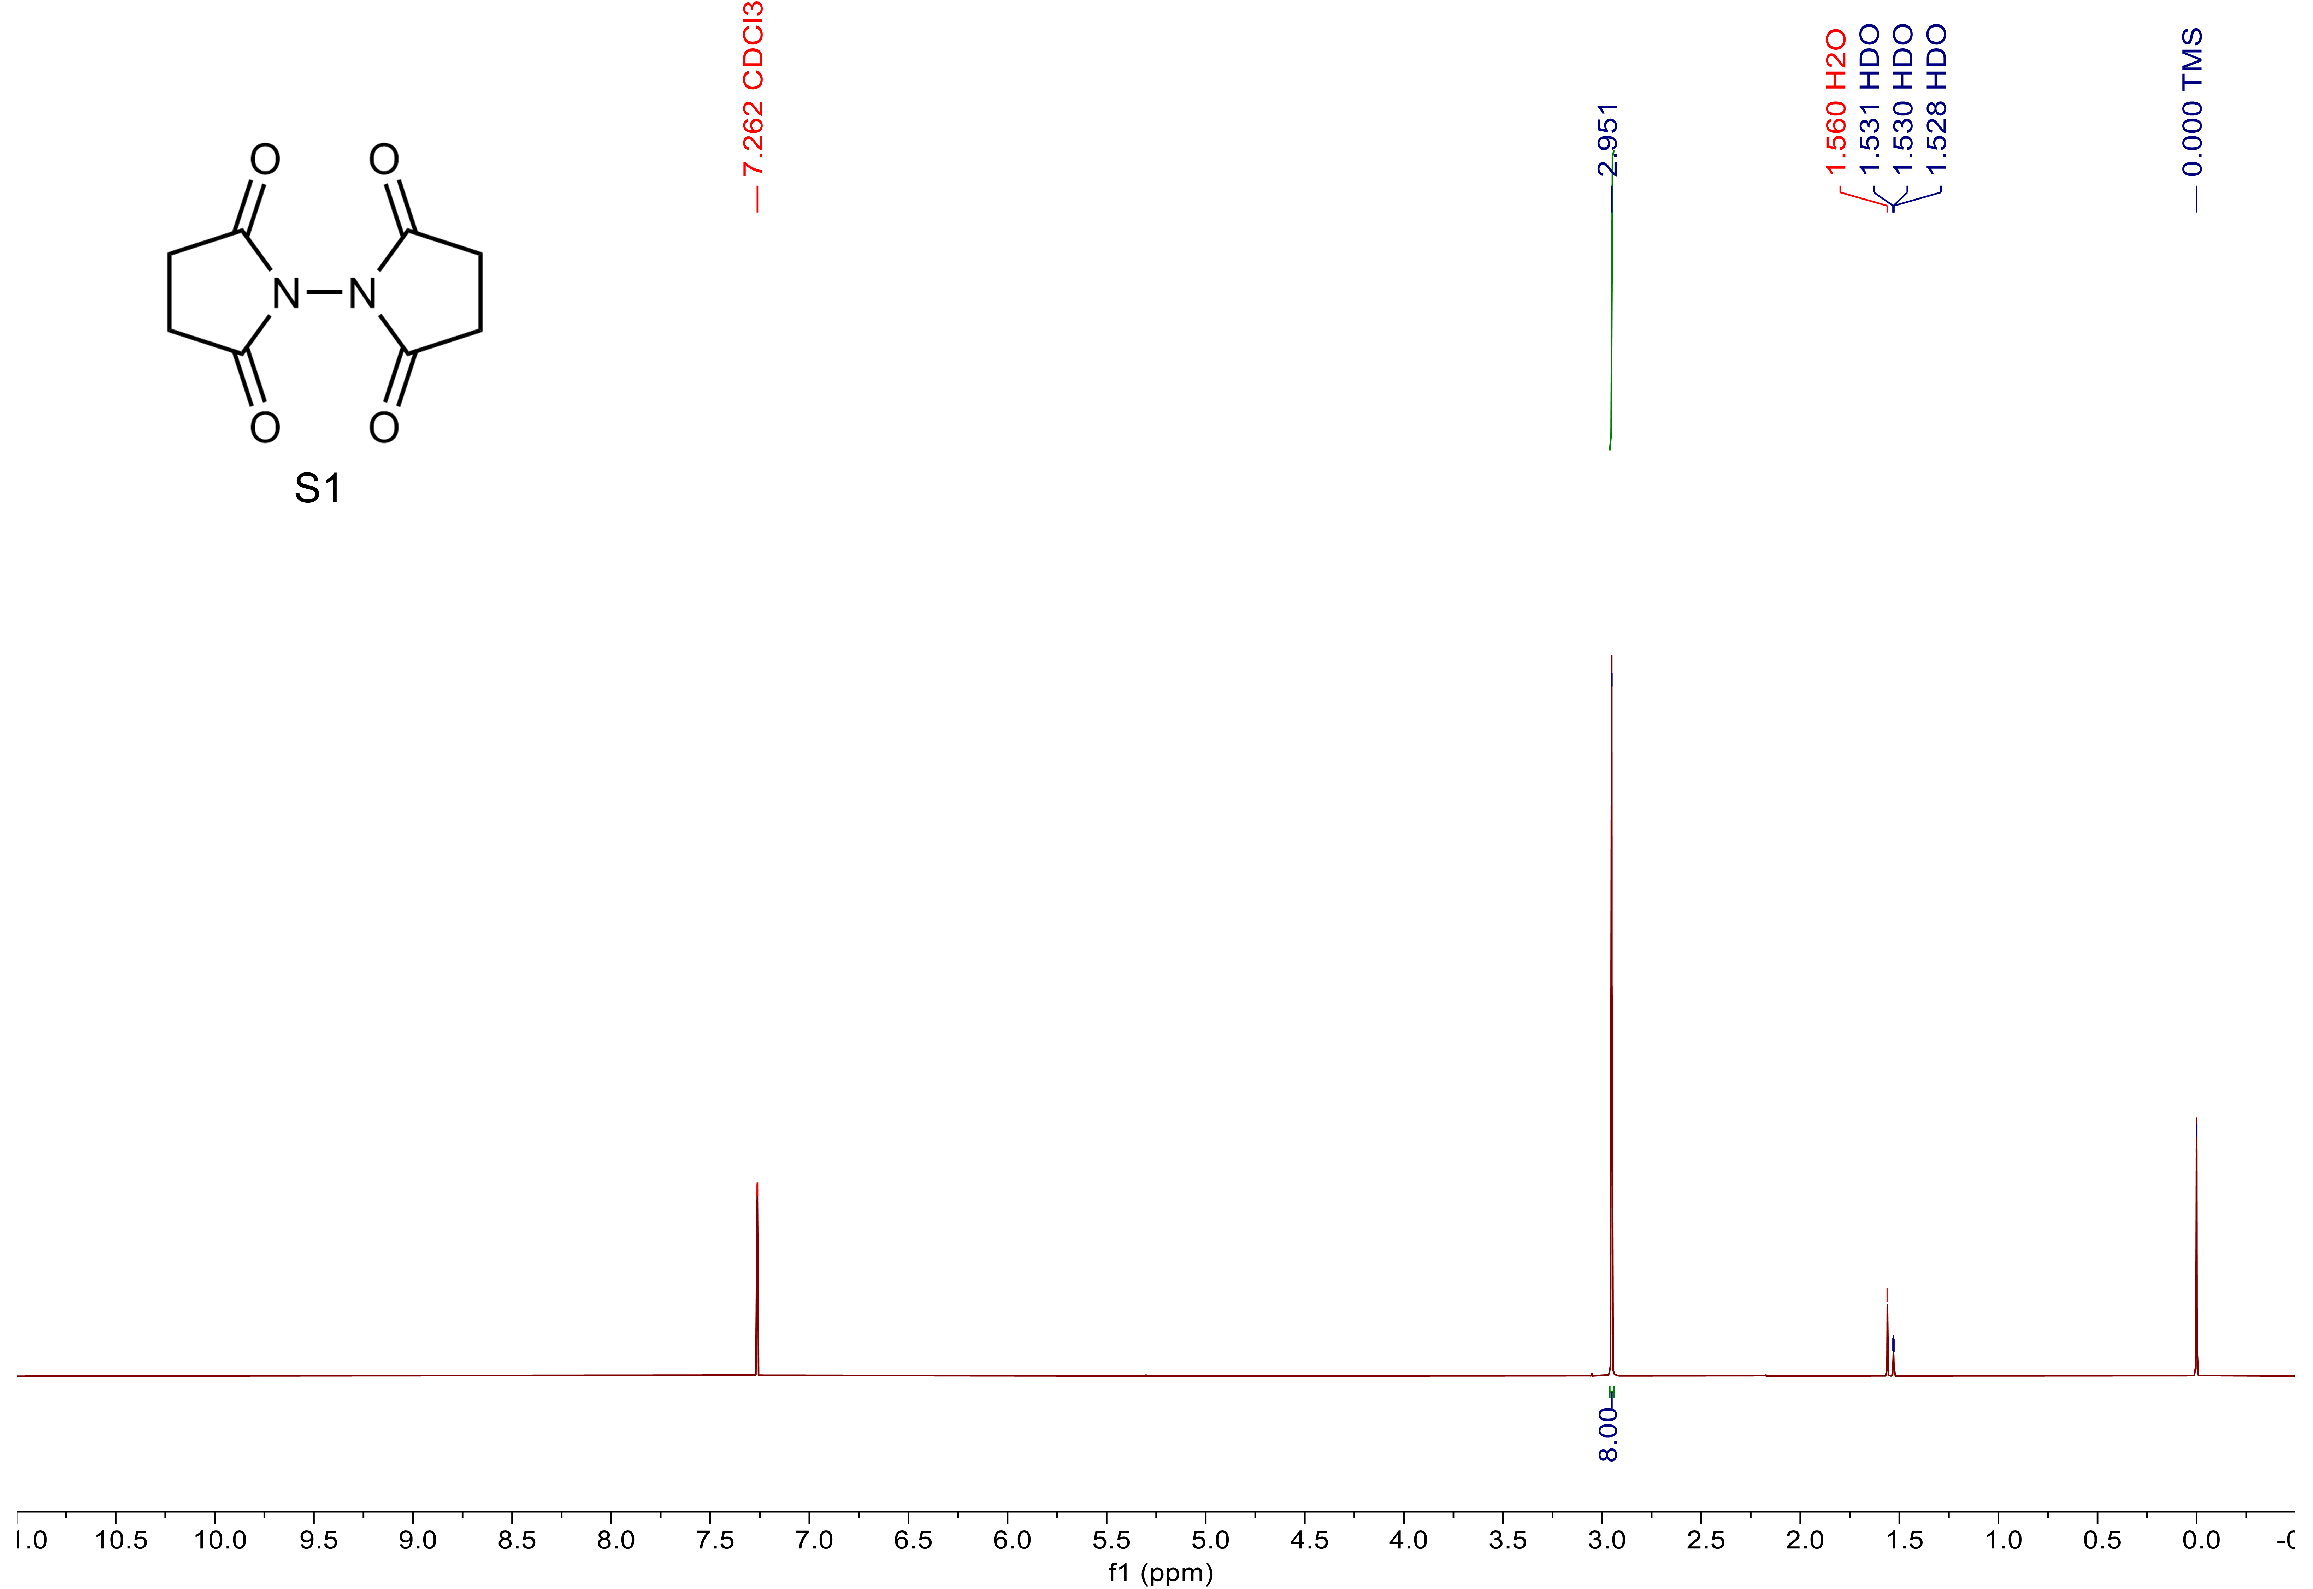
Supplementary Figure 16. ¹H NMR spectrum of S1 in CDCl₃ containing 0.03% (v/v) TMS (600 MHz).
Supplementary Figure 17. ¹H NMR spectrum of BP55 in CDCl₃ containing 0.03% (v/v) TMS (600 MHz).
Supplementary Figure 18. ¹H NMR spectrum of BP66 in CDCl₃ containing 0.03% (v/v) TMS (600 MHz).
Supplementary Figure 19. ¹H NMR spectrum of S2 in CDCl₃ containing 0.03% (v/v) TMS (600 MHz).
Supplementary Figure 20. ¹H NMR spectrum of S3 in CDCl₃ containing 0.03% (v/v) TMS (600 MHz).
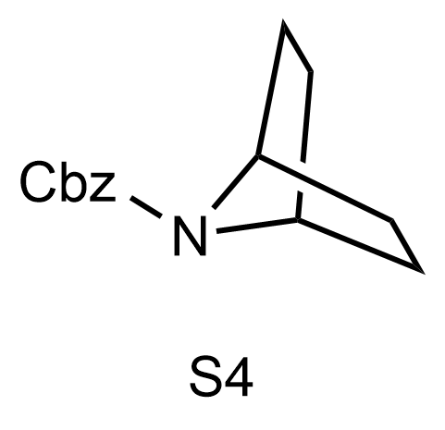
Supplementary Figure 21. ¹H NMR spectrum of S4 in CDCl₃ containing 0.03% (v/v) TMS (600 MHz).
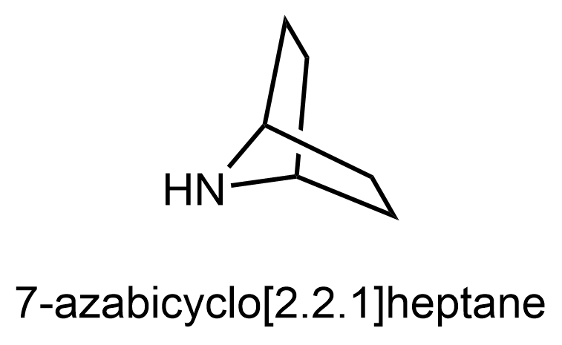
Supplementary Figure 22. ¹H NMR spectrum of 7-azabicyclo[2.2.1]heptane in CDCl₃ containing 0.03% (v/v) TMS (600 MHz).
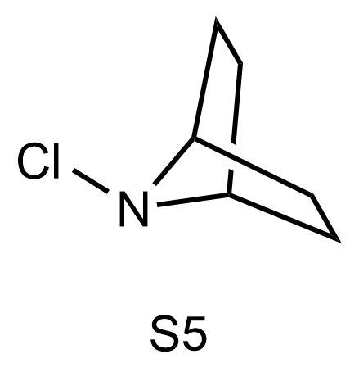
Supplementary Figure 23. Crude ¹H NMR spectrum of S5 in CDCl₃ containing 0.03% (v/v) TMS (600 MHz).
Supplementary Figure 24. ¹H NMR spectrum of BAC in CDCl₃ containing 0.03% (v/v) TMS (600 MHz).

10. Supplementary References

. Kwak, W.-J. et al. A dendrite- and oxygen-proof protective layer for lithium metal in lithium–oxygen batteries J. Mater. Chem. A 7, 3857–3862 (2019).
. Petit, Y. K. et al. Mechanism of mediated alkali peroxide oxidation and triplet versus singlet oxygen formation. Nat. Chem. 13, 465–471 (2021).
. Otani, Y. et al. An Evaluation of Amide Group Planarity in 7-Azabicyclo[2.2.1]heptane amides low amide bond rotation barrier in solution. J. Am. Chem. Soc. 125, 15191–15199 (2003).
. Olivo, H. F., Peeples, T. L., Ríos, M. Y., Velázquez, F., Kim, J. W., & Narang, S. Microbial. C. hydroxylation and β-4-O-methylglucosidation of methyl-benzamide 7-azanorbornane ethers with Beauveria bassiana. J. Mol. Catal. B Enzym. 21, 97–105 (2003).
. Naylor, A., Howarth, N. & Malpass, J. R. Synthetic Approaches to Nortropanes and Nortrop-6-enes; Intramolecular displacement by Nitrogen in 7-Membered Rings Tetrahedron. 49, 451–468 (1993).
. Nelsen, S. F. et al. Comparison of Free Energy Changes for Nitrogen Inversion and Electron Loss. 2. 8-Azabicyclo[3.2.1]octyl and 7-Azabicyclo[2.2.1]heptyl Systems. J. Am. Chem. Soc. 110, 6149–6153 (1988).

