Novel PVA nanocomposite films: Synthesis, structure, optical and photocatalytic properties evaluation.
Yamanappagouda Amaregouda and Kantharaju Kamanna*
School of Basic Sciences: Department of Chemistry, Rani Channamma University, Vidyasangama, P-B, NH-4, Belagavi -591156, Karnataka.
Tel: +91(0831)-2565203; Fax: +91-(0831)-2565240
*Corresponding author: E-mail: kk@rcub.ac.in

Supporting information
Experimental
Soil Burial Test
Soil buried test of the prepared films for the degradation studies carried out according to the previous reported with some modifications [1]. The film sample was cut into small pieces (2 × 3 cm), and dried at 60 °C for about 24 h, initial weight of the film was measured (Wo). The weighed film was buried in the soil (taken from botanical garden, Rani Channamma University Campus) at a depth of 10cm to have natural biodegradation environment and not modified soil microflora. Everyday about 10 mL of water was added to each sample up to 10 days. After 10 days, the films were removed, washed gently and dried in an oven and were taken degraded weight (Wf). The percent of degradation (WD) was calculated using Eq. (1).
$$WD=Wo-\frac{Wf}{Wo}×100-----1$$
Water vapor transmission rate (WVTR)
The water vapor transmission rate of the prepared films was assessed agreeing to the method depicted with slight alterations [2]. Briefly, 3 × 3 cm film sample was set on a circular mouth of a glass bottle containing 10 mL of twofold refined water and fixed with teflon tape. The starting weight of the bottle was measured (Wi) and put in an oven at 40 °C, after 24 h, the sample bottles were withdrawn from the oven and weighed again (Wf). The WVTR can be calculated using Eq. (2).
$$WVTR=Wi-\frac{Wf}{A}×100 \left(\frac{g}{m2h}\right)-----2$$
Where, A = area of the circular mouth of the bottle and T = 24 h, three replicate readings were taken and average value of WVTR was reported.
Moisture retention capability
Moisture retention capability (MRC) was calculated for the nanocomposite films of almost equal thickness of the film cut into pieces and weighed [3]. These films were put in an oven for 6 h at 40 °C. MRC was calculated by using following Eq. (3).
Moisture retention capability (%) = [Wt/Wi] ×100 -----3
Where, Wi is the initial weight before putting it in an oven and Wt is the final weight of the film after taken out from an oven.
Result and discussion
Soil degradation
The soil degradation of the packing material is the most important property for the eco-friendly application concern [4]. The soil degradation of the prepared films in 10 days experimental data was shown in Fig. S1. The degradation rate of the film F1 shows 25%. This degradation rate was increased after incorporation of the CuO NTs and Asp onto PVA. The percentage degradation of the prepared films in soil found to be 65.5% and 68%, for F2 and F3 respectively was shown in Fig. S2. The composite films F2 and F3 shows higher degradation (˃50%) than the film F1.
Water vapor transmission Rate (WVTR)
Water vapor transmission rate is the most important parameter for the food packaging materials. The WVTR of the prepared films were shown in Fig. S3, the composite films found to be decreased WVTR on incorporation of the CuO NTs and Asp compared to pure PVA (F1). The decreased WVTR value of the composite film indicates lesser permeability and a higher ability to keep dry products dry and moist product moist. Additionally, incorporation of the CuO NTs and Asp are more likely increased compactness of the films, thereby lowering the absorptivity as well as infusibility of the water vapor through the film as indicated by lowering WVTR [5].
Moisture retention capability of the nanocomposite films
Moisture retention capability determines loss of water vapors from the films. Controlling moisture migration is vital to maintain the texture, taste and overall quality of the packaged products. It usually depends on the food product; high or lower level of the moisture can be stabilized product quality and expedite shelf life [6]. The moisture retention capacity of the F1, F2 and F3 composite films are appended in Fig. S2. The results indicated high moisture retention capability for the prepared films. The F1 film shows 77.55% and significant differences shown by other two films 83.44% and 84.79% respectively, which indicated films have the similar moisture retention capability irrespective of their additives. The good moisture retention capability of the films was attributed to the hydrophilic character of the PVA, CuO NTs and Asp.
References
- S. Dutta, N. Karak, J.P. Saikia, B.K. Konwar, J Polym Environ. 18, 167–176, (2010)
- Y. Hu, V. Topolkaraev, A. Hiltner, E. Baer, J. Appl. Polym. Sci.. 81, 1624–1633, (2001)
- M.S. Sarwar, M.B.K. Niazi, Z. Jahan, T. Ahmad, A. Hussain, Carbohydr. Polym. 184, 453–464, (2018)
- K. Katerinopoulou, A. Giannakas, N.M. Barkoula, A. Ladavos, Starch/Staerke. 71. (2019)
- M. Zenkiewicz, J. Richert, Polym. Test. 27, 835–840, (2008)
- M.A. Bertuzzi, E.F. Castro Vidaurre, M. Armada, J.C. Gottifredi, J. Food Eng. 80, 972–978, (2007)

Figures

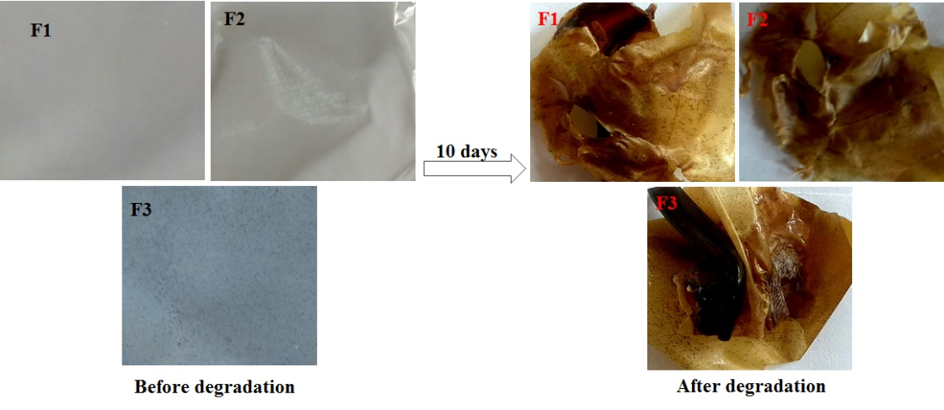
Fig. S1 Soil degradation of prepared films F1-F3

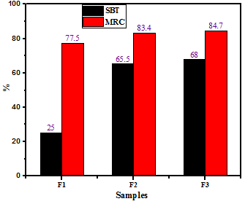
Fig. S2 Moisture retention capacity and soil burial test of the prepared films

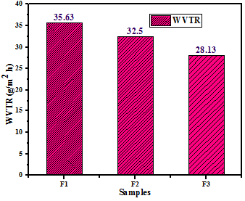
Fig. S3 Water vapor transmission rate of PVA composite films

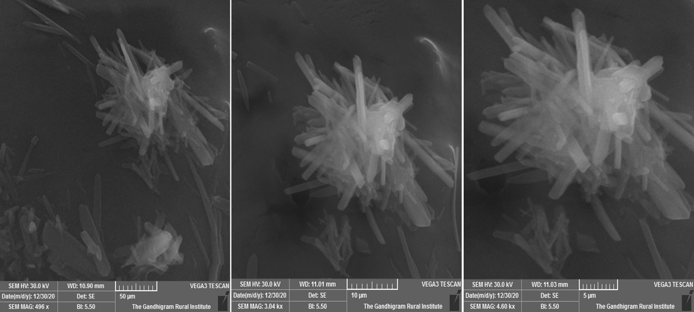
Fig. S4 CuO NTs SEM images

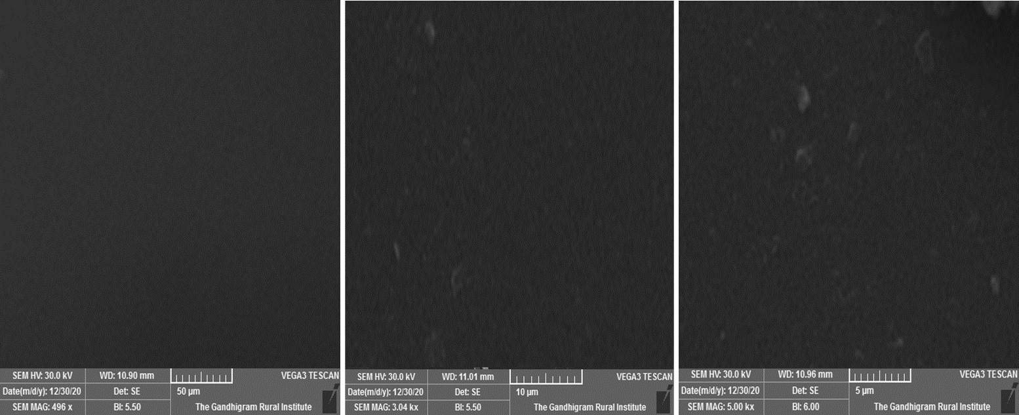
Fig. S5 F1 film SEM images

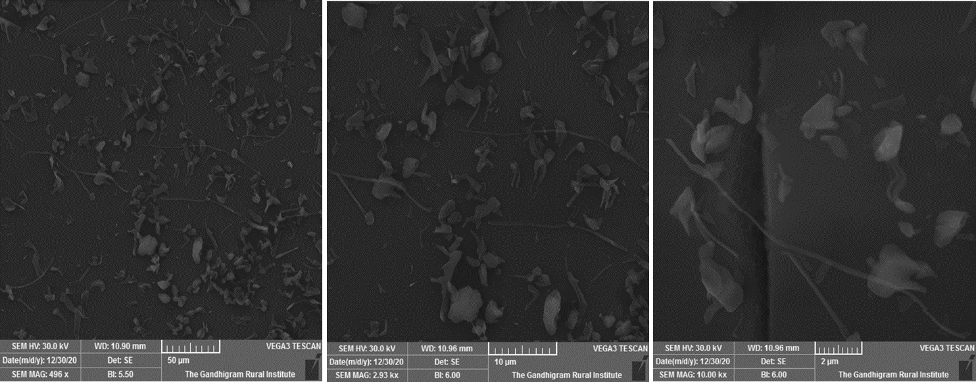
Fig. S6 F2 film SEM images

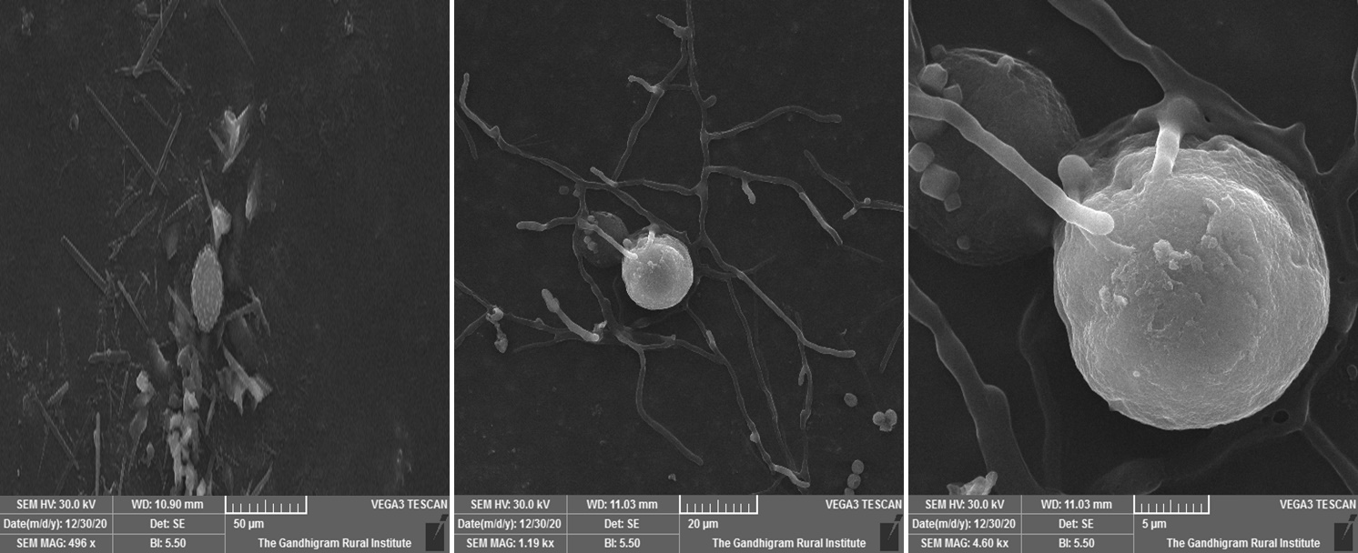
Fig. S7 F3 film SEM images

