Supplementary Information

Supplementary Information 1: Supplementary Figures

Table of contents
Supplementary Figure S1 Additional region of interests (ROIs) for CRISM spectral analysis.
Supplementary Figure S2 Mapping of sheet unit, ridge unit and pitted unit (A) and CRISM PFM browse product (B); CTX/HiRISE showing the sheet units (C, E) and overlapped on CRISM PFM browse product (D, F). The coverage of CRISM MTRDR datasets is indicated by white color.
Supplementary Figure S3 THEMIS image (A), CRISM MRDR mineral mapping MAF (B) and PFM (C) browse products; CRISM PFM browse product of Hargraves crater (D).

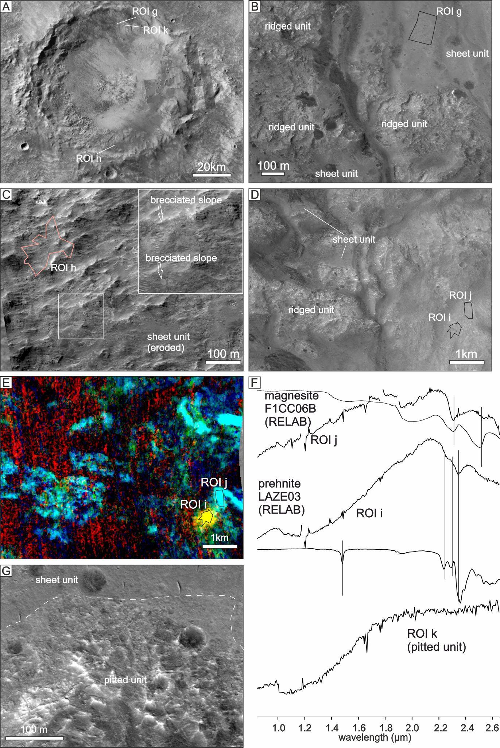

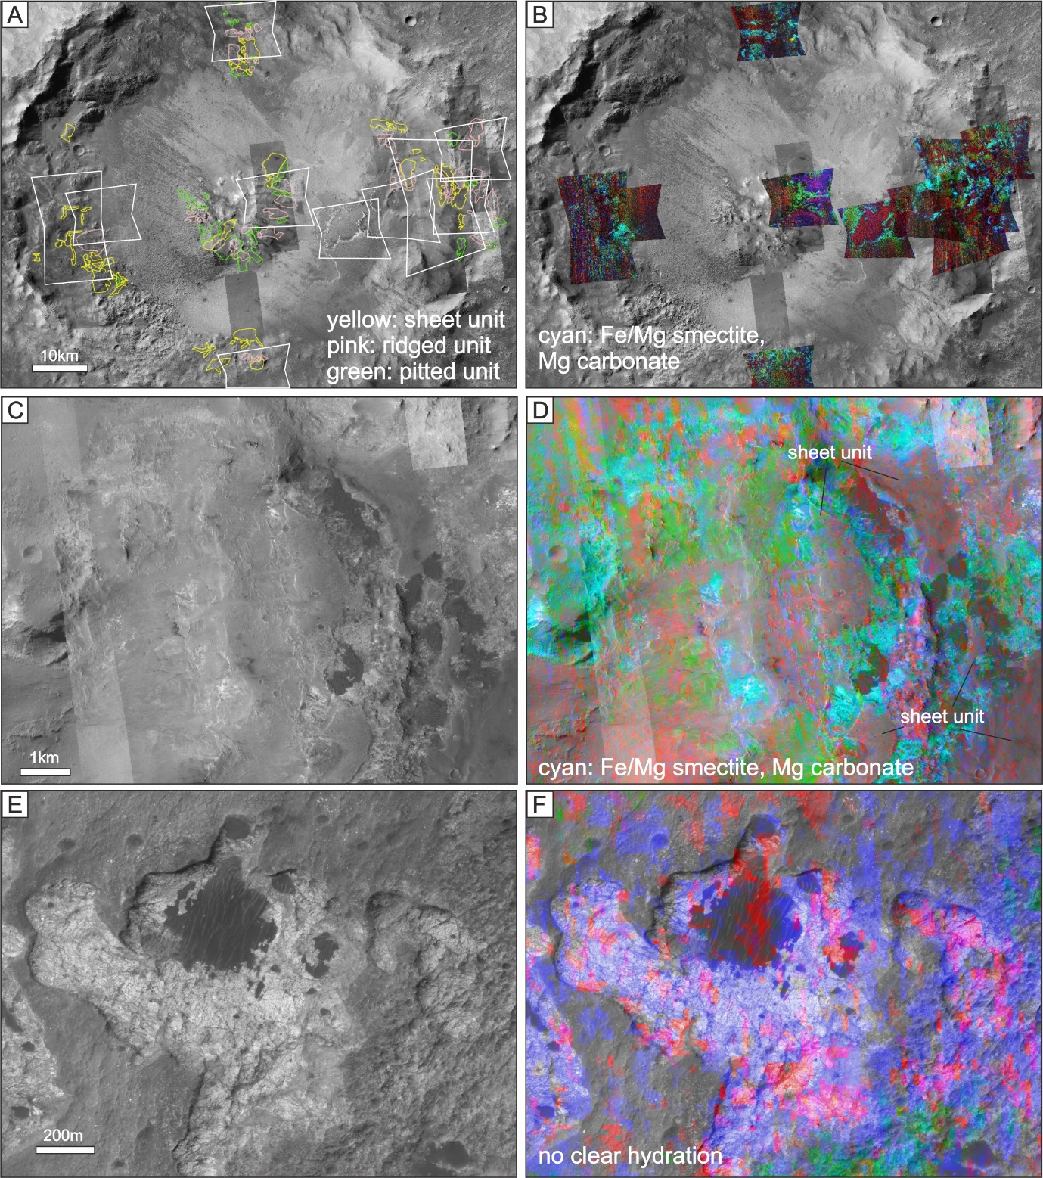

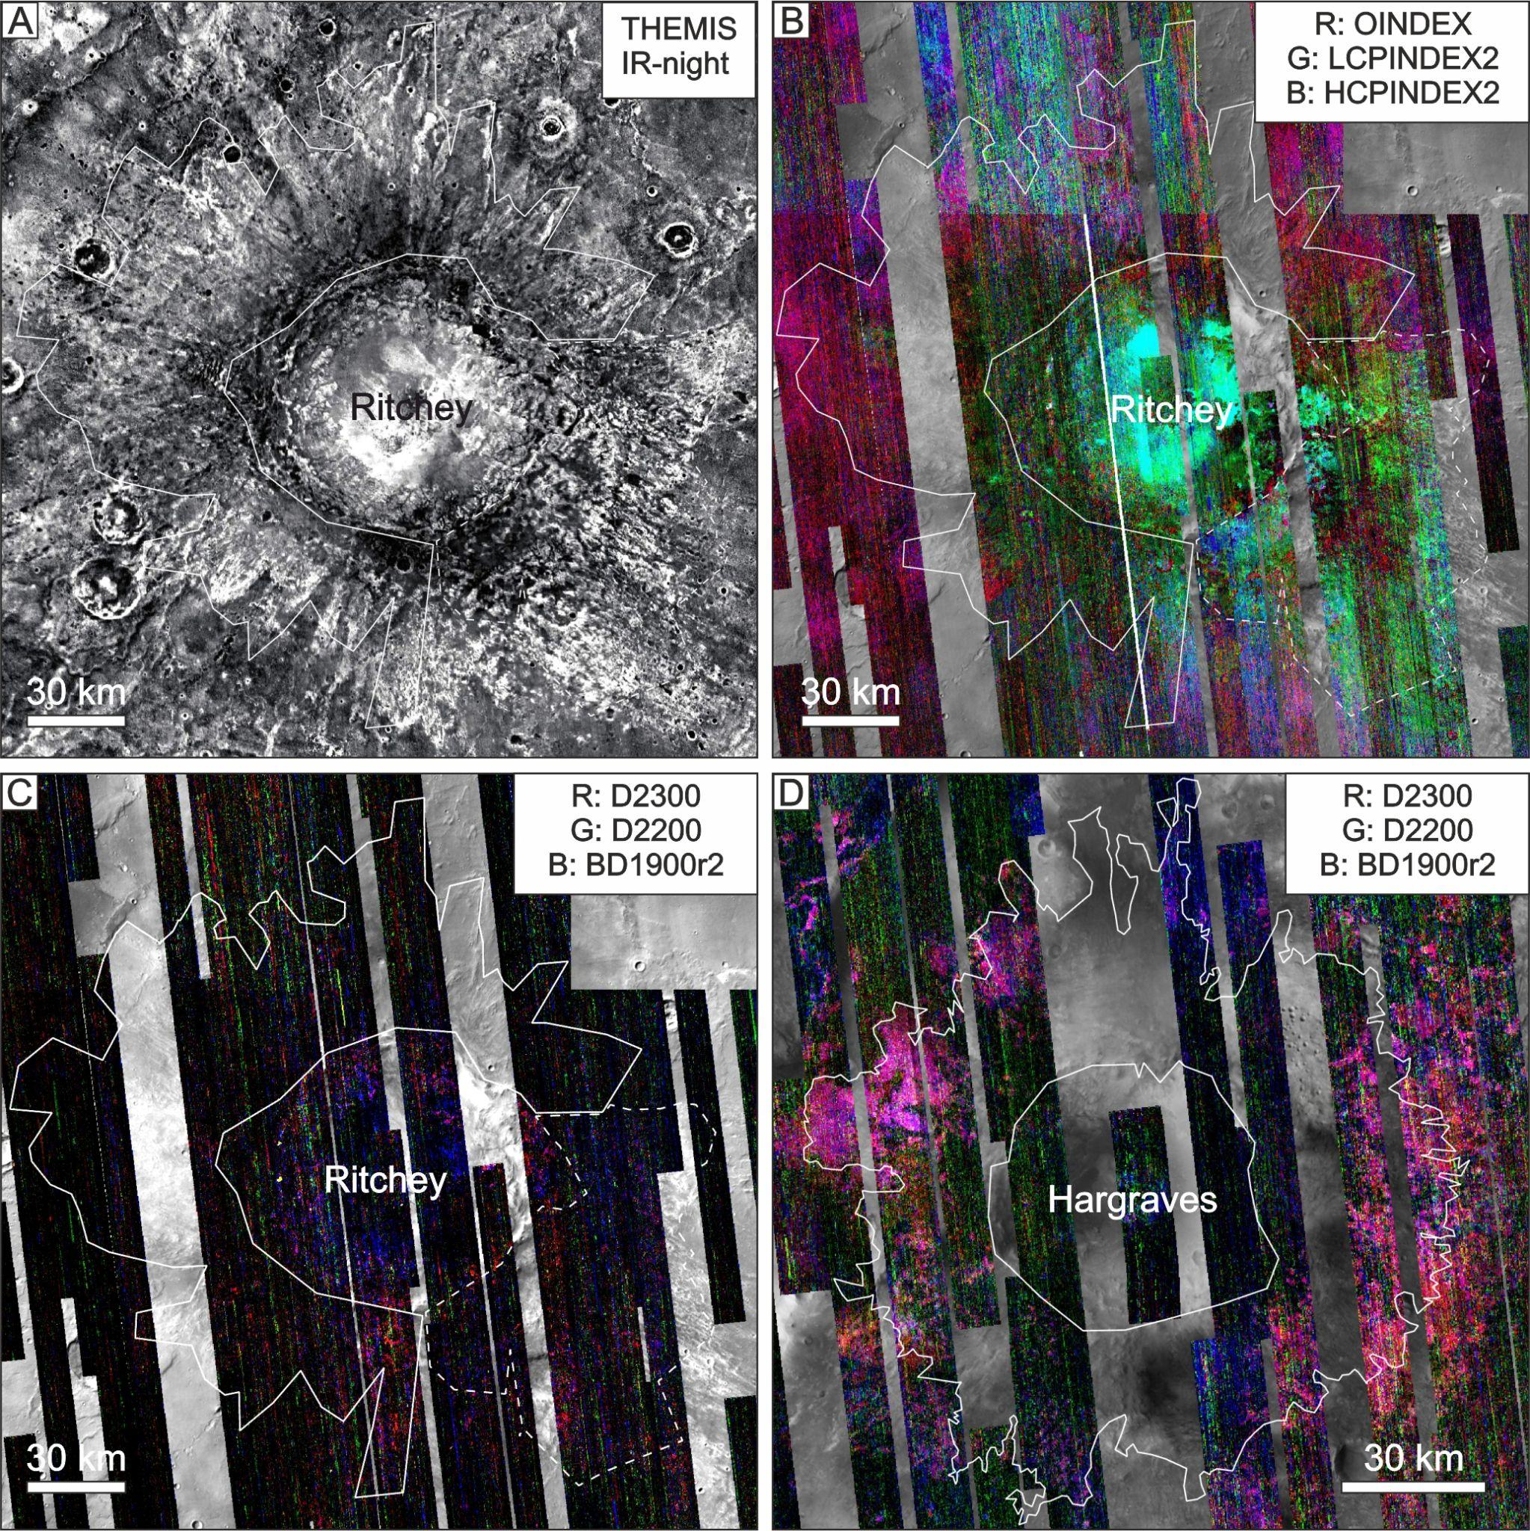

Supplementary Information 2

Supplementary Table S1 Spectra of region of interest (ROI), ratioed against to a spectral denominator that is a dusty, bland feature (see Table S3).
Supplementary Table S2 Spectra of standard samples for comparison.
Supplementary Table S3 Spectra of the bland features used for spectral denominators.

