Supplementary Information
High-Throughput Screening for Discovering Small Molecules Capable of Increasing the Wnt/β-Catenin Signaling Pathway to Promote Hair and Nail Growth
Supplementary Table 1. Primer sequences used for real-time quantitative reverse transcriptase polymerase chain reaction (qRT-PCR)
Gene | Forward Primer sequence (5′-3′) | Reverse Primer sequence (5′-3′)
RSPO3 | CCAGCAAAGAAATCCCAGAGC | ACAGTGCTGACTGATACCGAT
RSPO4 | CACAATGGAAAGACCTGCGGC | GTCCTTCCTGCCCTTCTTCTGG
WIF1 | GCACAACAGAGAATGCCAGC | GACGGTTGGATCTGCCATGA
DKK1 | CGGTCATCAGACTGTGCCTC | TGTATCCGGCAAGACAGACC
TCF7 | CTGCACATGCAGCTATACCCA | CCATCCTTGAGTTCTCTGGGC
SERPINB2 | TGATGCGATTTTGCAGGCAC | AAGCTCGCAGACTTCTCACC
RUNX1 | TTCCAGTCGACTCTCAACGG | GTGAAGGCGCCTGGATAGTG
RUNX2 | TTCCAGAATGCTTCCGCCAT | TTCCATCAGCGTCAACACCA
LEF1 | AGGCTGGTCTGCAAGAGACA | TTCTTGGACCTGTACCTGATGC
RGS2 | TCAACACGACTGCAGACCC | CTTTTCTCGCTTCTCCTCGC
ALPL | CATCCTGTATGGCAATGGGC | GACTGCGCCTGGTAGTTGT
NOG | AAACAGCGCCTGAGCAAGAAG | GAACACTTACACTCGGAAATGATGG
LGR4 | CATTTGCAGGGCAACCTGAC | TGCAGGACAGCTGTGTGATT
LGR5 | AGAATGGGGTTGGTTGCCAT | TTCACAGAGAACCCACGCTC
LGR6 | ACGCGTTCCAGAATCTCACC | GTGTCTCCAGATTGTGCAGC
BMP2 | GCCAAACACAAACAGCGGAA | GGGAGCCACAATCCAGTCAT
BMP4 | AGCGTAGCCCTAAGCATCAC | AGTCATTCCAGCCCACATCG
BMP5 | CGGAGCAACAACCGATTTGAA | AGACAAGCCAACCCACATCTA
BMP7 | ACGTTCCGGATCAGCGTTTA | TCGAGCAGGAAGAGATCCGA

Supplementary Figure 1.
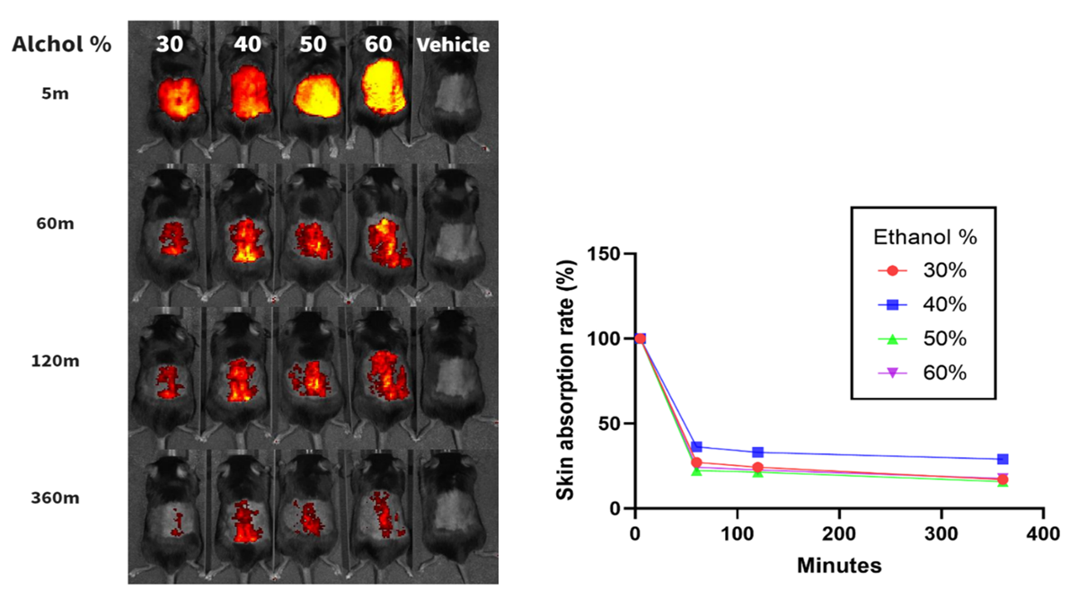
Figure 1. Aminoacridine fluorescence imaging analysis.

