Supplementary Information:

Herbicidal properties of antihypertensive drugs: Calcium channel blockers
Hannan Safiyyah Tan Sian Hui Abdullah¹, Chia Poh Wai¹, Dzolkhifli Omar², Chuah Tse Seng^{3*}

¹ Faculty of Science and Marine Environment, Universiti Malaysia Terengganu, Terengganu, Malaysia.
² Faculty of Agriculture, Universiti Putra Malaysia, Selangor, Malaysia.
³ Faculty of Plantation and Agrotechnology, Universiti Teknologi Mara, Arau, Malaysia.

*Corresponding author’s email: chuahts@uitm.edu.my

Table S1. List of the ten thiazolo[3,2-a]pyrimidine-6-carboxylate derivatives synthesized in the previous work³⁵.

Entry |  |  | Product |  |  | Name
 | 1 | 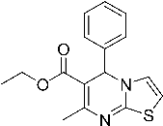 (a) |  | 7-Methyl-5-phenyl-5H-thiazolo[3,2-a]pyrimidine-6-carboxylic acid ethyl ester
 | 2 | 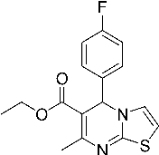 (b) |  |  | 5-(4-Fluoro-phenyl)-7-methyl-5H-thiazolo[3,2-a]pyrimidine-6-carboxylic acid ethyl ester
 | 3 | 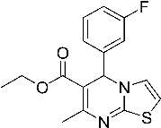 (c) |  | 5-(3-Fluoro-phenyl)-7-methyl-5H-thiazolo[3,2-a]pyrimidine-6-carboxylic acid ethyl ester
 | 4 | 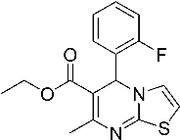 (d) |  | 5-(2-Fluoro-phenyl)-7-methyl-5H-thiazolo[3,2-a]pyrimidine-6-carboxylic acid ethyl ester
 | 5 | 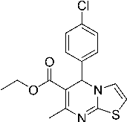 (e) |  | 5-(4-Chloro-phenyl)-7-methyl-5H-thiazolo[3,2-a]pyrimidine-6-carboxylic acid ethyl ester
 | 6 | 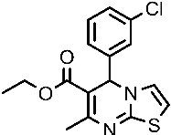 (f) |  | 5-(3-Chloro-phenyl)-7-methyl-5H-thiazolo[3,2-a]pyrimidine-6-carboxylic acid ethyl ester
 | 7 | 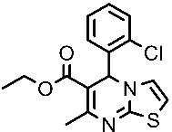 (g) |  | 5-(2-Chloro-phenyl)-7-methyl-5H-thiazolo[3,2-a]pyrimidine-6-carboxylic acid ethyl ester
 | 8 | 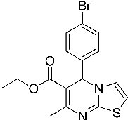 (h) |  | 5-(4-Bromo-phenyl)-7-methyl-5H-thiazolo[3,2-a]pyrimidine-6-carboxylic acid ethyl ester
 | 9 | 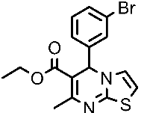 (i) |  | 5-(3-Bromo-phenyl)-7-methyl-5H-thiazolo[3,2-a]pyrimidine-6-carboxylic acid ethyl ester
 | 10 | 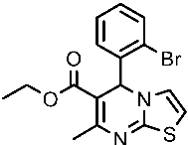 (j) |  | 5-(2-Bromo-phenyl)-7-methyl-5H-thiazolo[3,2-a]pyrimidine-6-carboxylic acid ethyl ester
Table S2. Visual assessment of leaf disc colour change.

Score | Colour | Leave disc appearance | Phytotoxic effect
1 | Green  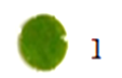 | The leaf disc surface is completely green | No
2 | Green brownish  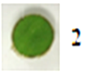 | 10 to 30% of the leaf disc surface is dark brown in colour | Weak
3 | Brown greenish  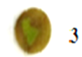 | 50 to 80% of the leaf disc surface is dark brown in colour | Moderate
4 | Dark brown  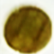 | More than 90% of the leaf disc surface, in aggregate, is dark brown | Strong

