SUPPLEMENTARY MATERIAL

EXPLORING THE BIOSORPTION OF NICKEL AND LEAD BY Fusarium sp. BIOMASS: KINETIC, ISOTHERM, AND THERMODYNAMIC ASSESSMENT

Daniele Moreira¹, Gabriela Souza Alves², João Marcos Madeira Rodrigues ³, Bianca Ramos Estevam⁴, Douglas Henrique Sales⁵, Juliana Heloisa Pinê Américo-Pinheiro⁶, Ana Flora Dalberto Vasconcelos³, Rosane Freire Boina^{3,5}

¹Department of Civil Engineering, School of Engineering, São Paulo State University (UNESP), 15385-000 Ilha Solteira, SP, Brazil
²Institute of Biology, University of Campinas (UNICAMP), 13083-970 Campinas, SP, Brazil
³Department of Chemistry and Biochemistry, School of Technology and Sciences, São Paulo State University (UNESP), 19060-900 Presidente Prudente, SP, Brazil
⁴Department of Process and Product Development, School of Chemical Engineering, University of Campinas (UNICAMP), 13083-852 Campinas, SP, Brazil
⁵Department of Physics, School of Technology and Sciences, São Paulo State University (UNESP), 19060- 900 Presidente Prudente, SP, Brazil
⁶Department of Forestry, Soil and Environmental Science, Faculty of Agricultural Sciences, School of Technology and Sciences UNESP, 18610-034 Botucatu, SP, Brazil

Corresponding author e-mail: daniele.moreira@unesp.br (18) 99713-8061

Table S1 presents the quality control analysis for atomic absorption spectrophotometry, as outlined in the equipment's manual, used to determine the concentrations of Ni²⁺ and Pb²⁺ in the aqueous solutions submitted to the biosorption treatment using inactivated dry Fusarium sp. biomass.

Table S1: Operating parameters of atomic absorption spectroscopy for measuring metallic ions
Metal ion | Wavelength (nm) | Variation of the linear curve (ppm) | Correlation coefficient
Ni²⁺ | 232.0 | 0.14 – 7.00 | 0.98 – 0.99
Pb²⁺ | 283.3 | 0.45 – 20.00 | 0.98 – 0.99

Figure S1 depicts the speciation of nickel and lead, as determined by the Hydra Medusa software®, assessing the presence of free ions and the potential for precipitate formation as a function of the pH. This analysis facilitates the prediction of pH conditions favorable for the biosorption of the metallic ions while minimizing the precipitate formation.

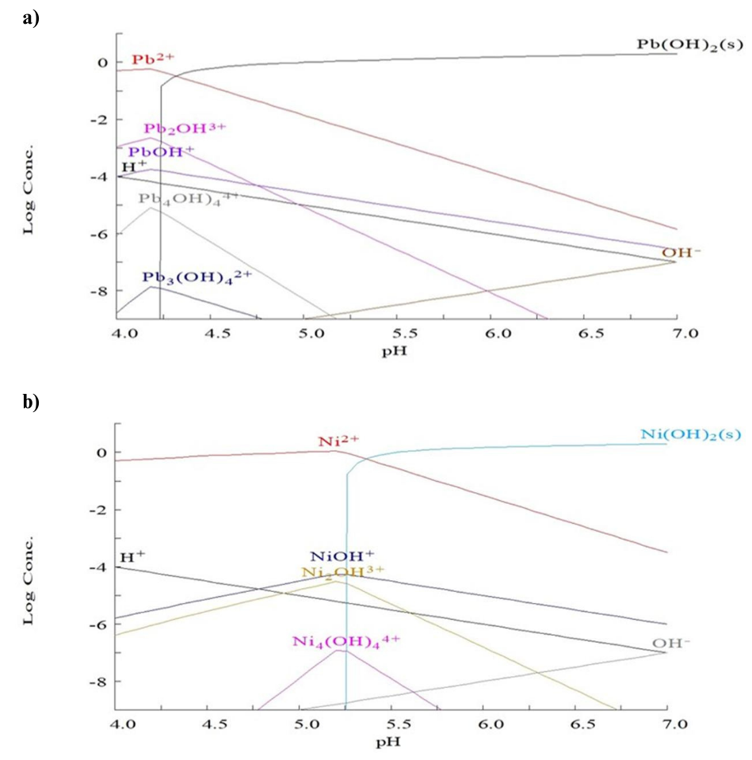
Fig. 1S.: Chemical speciation for Pb²⁺(a) and Ni²⁺ (b).

