Supplementary Material
Supplementary Table 1 - Meta-regression analysis for ALP, GGT and total bilirubin levels
Supplementary Figure 1. Critical appraisal of individual studies according to the Cochrane Collaboration’s tool for assessing risk of bias in randomized controlled trials
Supplementary Figure 2. AST level analysis comparing PPAR agonists and control groups
Supplementary Figure 3. ALT level analysis comparing PPAR agonists and control groups
Supplementary Figure 4. Normalization of ALP level analysis comparing PPAR agonists and control groups
Supplementary Figure 5. Incidence of abdominal pain analysis comparing PPAR agonists and control groups
Supplementary Figure 6. Incidence of laboratory abnormalities analysis comparing PPAR agonists and control groups
Supplementary Figure 7. Incidence of nausea analysis comparing PPAR agonists and control groups
Supplementary Figure 8. Incidence of headache analysis comparing PPAR agonists and control groups
Supplementary Figure 9. Incidence of fatigue analysis comparing PPAR agonists and control groups
Supplementary Figure 10. Incidence of myalgia analysis comparing PPAR agonists and control groups
Supplementary Figure 11. Incidence of diarrhea analysis comparing PPAR agonists and control groups
Supplementary Figure 12. Leave-one-out sensitivity analysis of the outcome of ALP levels
Supplementary Figure 13. Leave-one-out sensitivity analysis of the outcome of the outcome of GGT levels
Supplementary Figure 14. Leave-one-out sensitivity analysis of the outcome of total bilirubin levels
Supplementary Figure 15. Leave-one-out sensitivity analysis of the outcome of direct bilirubin levels
Supplementary Figure 16. Leave-one-out sensitivity analysis of the outcome of AST levels
Supplementary Figure 17. Leave-one-out sensitivity analysis of the outcome of ALT levels
Supplementary Figure 18. Leave-one-out sensitivity analysis of the outcome of headache
Supplementary Figure 19. Leave-one-out sensitivity analysis of the outcome of normalization or reduction of ALP levels
Supplementary Figure 20. Funnel plot with enhanced contour for the outcome of ALP levels
Supplementary Figure 21. Funnel plot with enhanced contour for the outcome of GGT levels
Supplementary Figure 22. Funnel plot with enhanced contour for the outcome of total bilirubin levels

Supplementary Table 1 - Meta-regression analysis for ALP, GGT and total bilirubin levels
Outcome/Predictor | b | LB | UB | K | QM | QMp | QE | QEp | I2 | R2
ALP
Follow-up | -0.0842 | -0.3806 | 0.2122 | 13 | 0.31 | 0.578 | 77.254 | <0.001 | 82.46 | 1.67
PPAR agonist dosage | -0.1095 | -0.2659 | 0.0469 | 13 | 1.883 | 0.17 | 76.569 | <0.001 | 78.88 | 15.76
Baseline ALP | -0.1111 | -0.3004 | 0.0782 | 13 | 1.324 | 0.25 | 68.295 | <0.001 | 81.14 | 15.71
GGT
Follow-up | 0.3788 | -0.8492 | 1.6067 | 10 | 0.365 | 0.545 | 132.697 | <0.001 | 90.6 | 5.96
PPAR agonist dosage | 0.0558 | -0.1905 | 0.302 | 10 | 0.197 | 0.657 | 137.464 | <0.001 | 90.48 | 0
Baseline ALP | 0.2335 | 0.001 | 0.466 | 10 | 3.874 | 0.049 | 149.41 | <0.001 | 89.53 | 23.8
Total Bilirubin
Follow-up | -0.0018 | -0.0034 | -0.0002 | 11 | 4.777 | 0.029 | 27.867 | 0.001 | 0.05 | 28.86
PPAR agonist dosage | -0.0005 | -0.0009 | -0.0001 | 11 | 6.913 | 0.009 | 25.723 | 0.002 | 0.12 | 0
Baseline ALP | -0.0004 | -0.0013 | 0.0005 | 11 | 0.698 | 0.403 | 32.38 | <0.001 | 17.94 | 0
ALP = alkaline phosphatase; GGT = gama glutamyl transferase; b = partial unstandardized regression coefficient for each predictor; LB = lower bound of the regression coefficient; UB = upper bound of the regression coefficient; K = number of included studies in the model; QM = statistic for testing the significance of the model; QMp = p-value for the test of significance of the model; QE = statistic for testing the existence of residual heterogeneity; QEp = p-value for the test of existence of residual heterogeneity; I2 = remaining heterogeneity not explained by the predictor; R2 = proportion of variance accounted for by the predictors;

Supplementary Table 2
Outcome | K | Intercept | LB | UB | t | p
ALP | 13 | -0.083 | -2.561 | 2.396 | -0.065 | 0.949
GGT | 10 | -3.324 | -6.386 | -0.263 | -2.128 | 0.066
Total  Bilirubin | 11 | -6.394 | -22.949 | 10.161 | -0.757 | 0.468
K = Number of studies; LB = lower bound of the intercept; UB = upper bound of the intercept; t = t-value of the Eggers Test; p = p-value of the Eggers Test

Supplementary Figure 1. Critical appraisal of individual studies according to the Cochrane Collaboration’s tool for assessing risk of bias in randomized-controlled trials

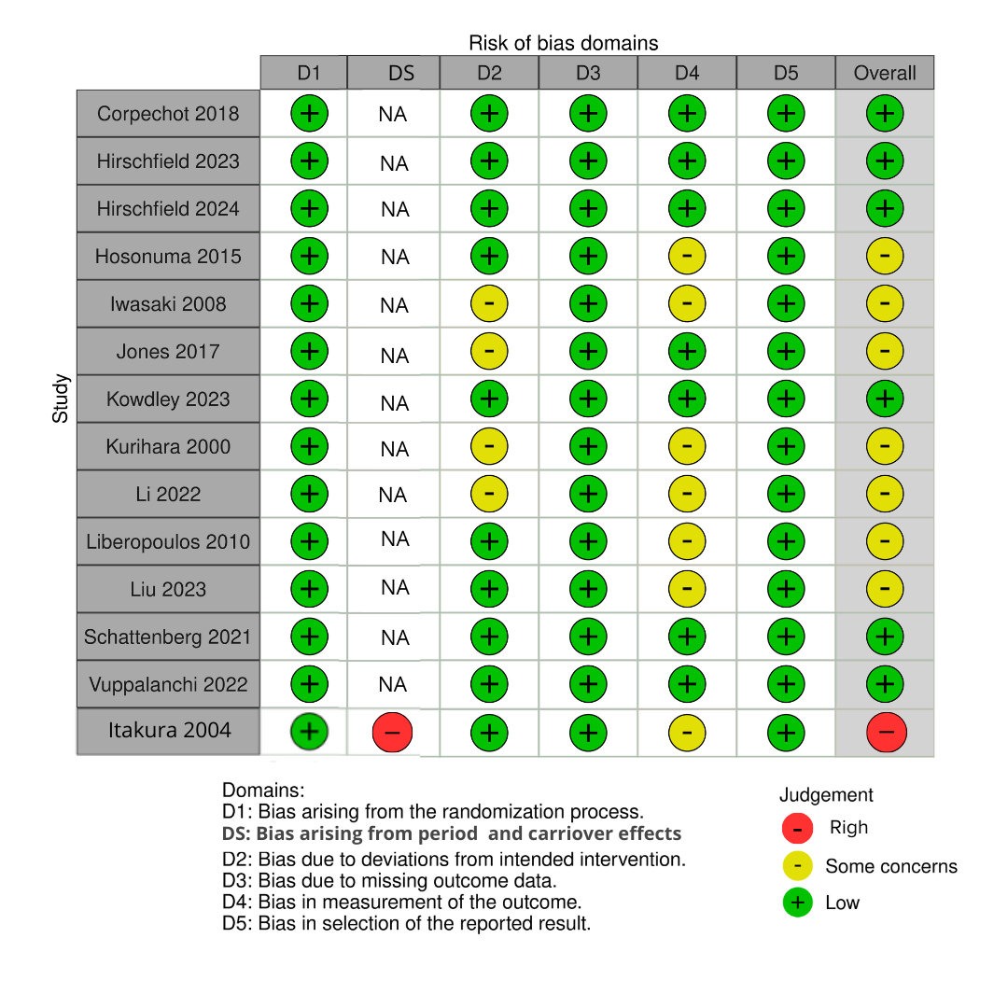

Supplementary Figure 2 - There was no statistically significant difference in terms of AST levels between groups
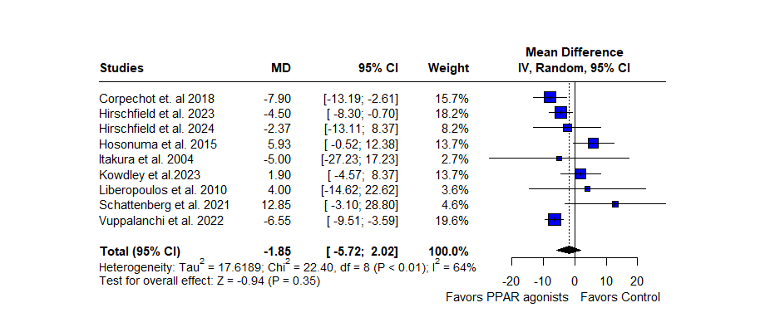

Supplementary Figure 3 - There was no statistically significant difference in terms of ALT levels between groups
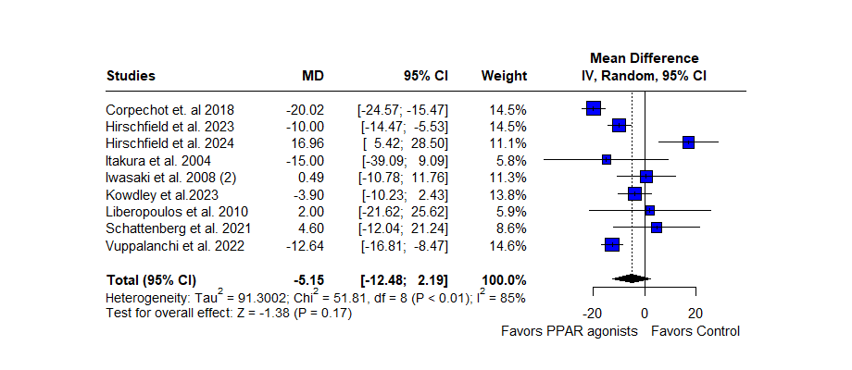

Supplementary Figure 4 - In those receiving PPAR agonists, the incidence of normalization or reduction of ALP levels was significantly higher when compared with the control group
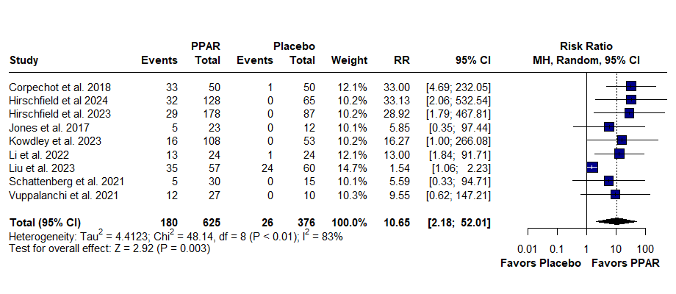

Supplementary Figure 5 - The incidence of abdominal pain was significantly higher in those receiving PPAR when compared to the control group.
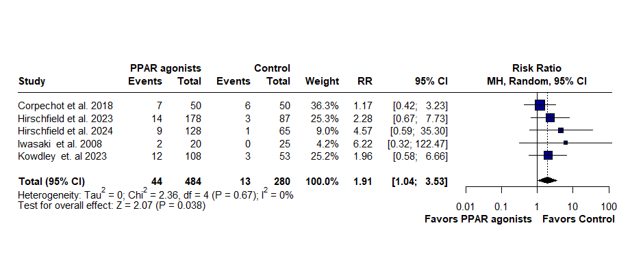

Supplementary Figure 6 - The incidence of laboratory abnormalities was significantly higher in those receiving PPAR when compared to the control group.
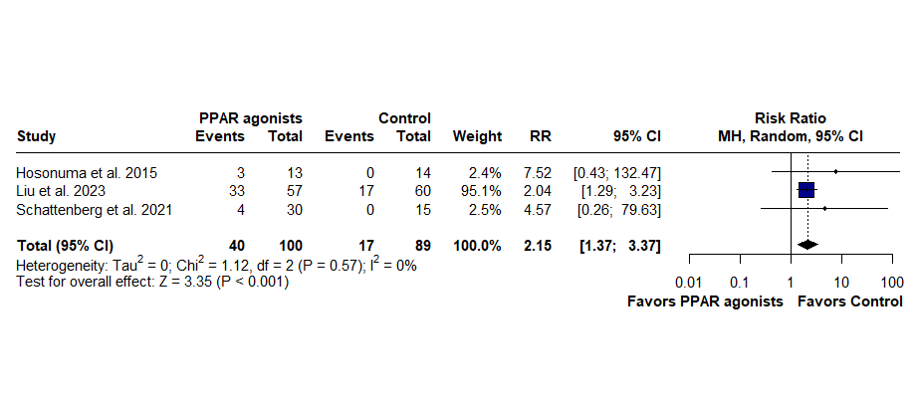

Supplementary Figure 7 - There was no statistically significant difference in terms of nausea between groups
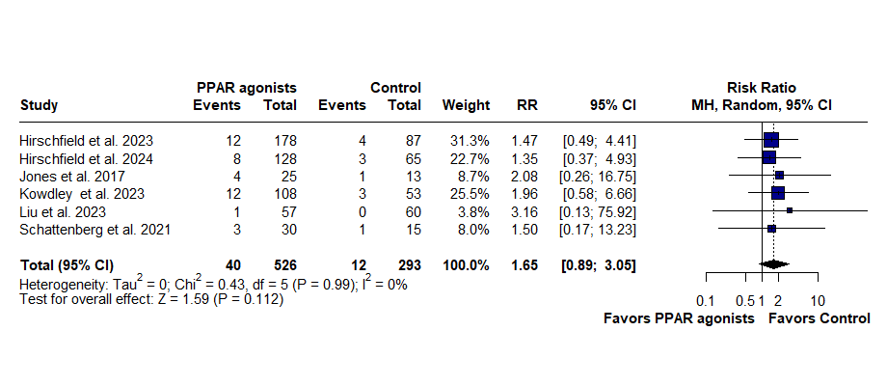

Supplementary Figure 8 - There was no statistically significant difference in terms of headache between groups
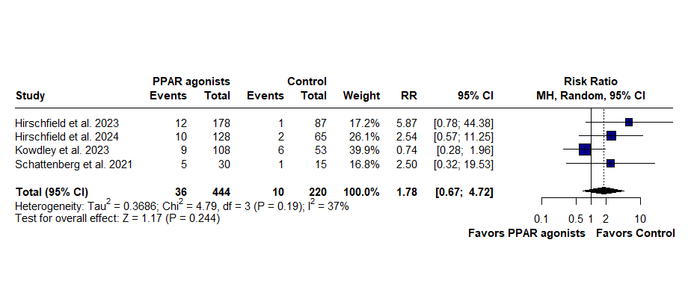

Supplementary Figure 9 - There was no statistically significant difference in terms of fatigue between groups
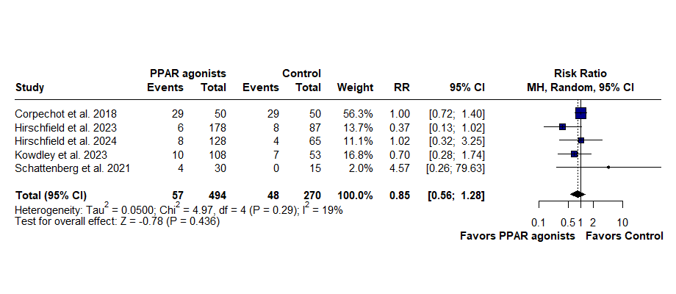

Supplementary Figure 10 - There was no statistically significant difference in terms of myalgia between groups
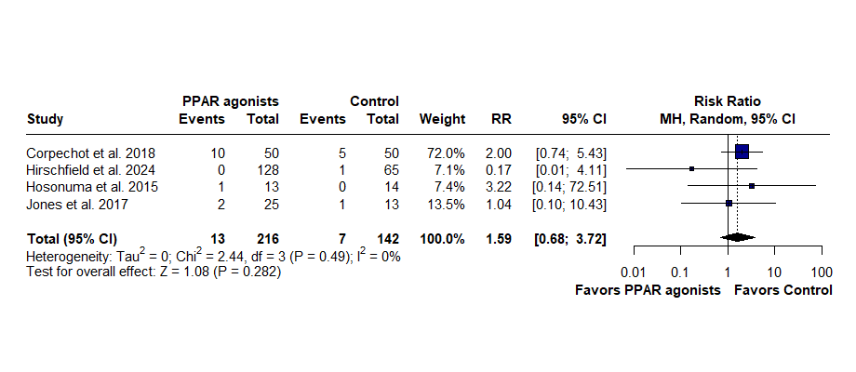

Supplementary Figure 11 - There was no statistically significant difference in terms of diarrhea between groups
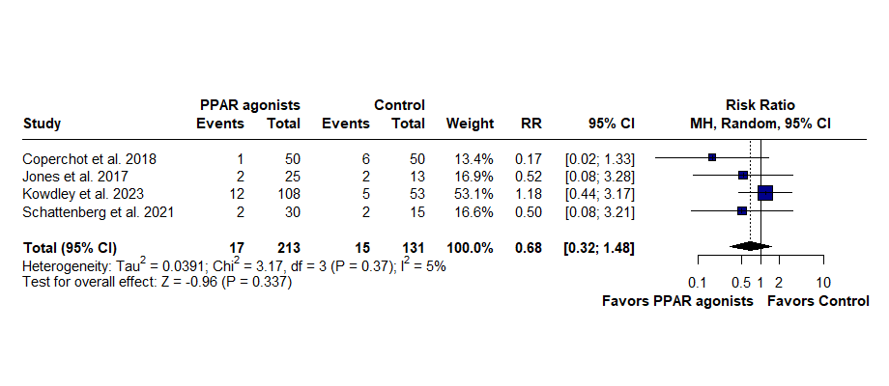

Supplementary Figure 12 - For the outcome of ALP levels, the removal of the study “Liu et al. 2023” rendered the lowest heterogeneity possible
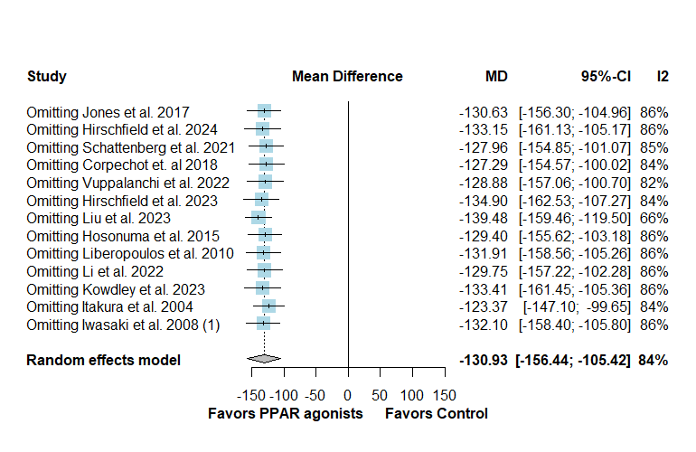

Supplementary Figure 13 - Leave-one-out sensitivity analysis of the outcome of the outcome of GGT levels
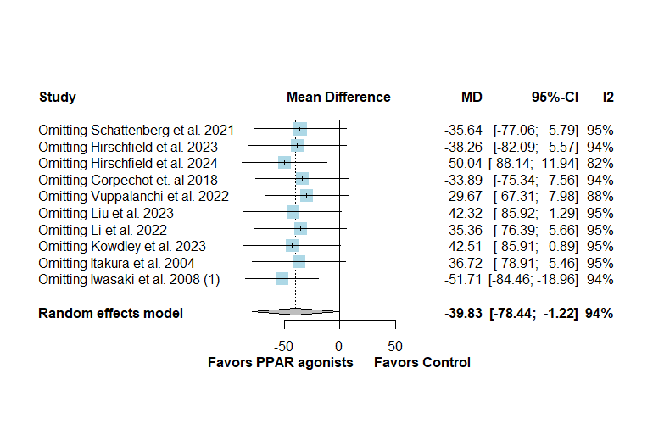

Supplementary Figure 14 - Leave-one-out sensitivity analysis of the outcome of total bilirubin levels
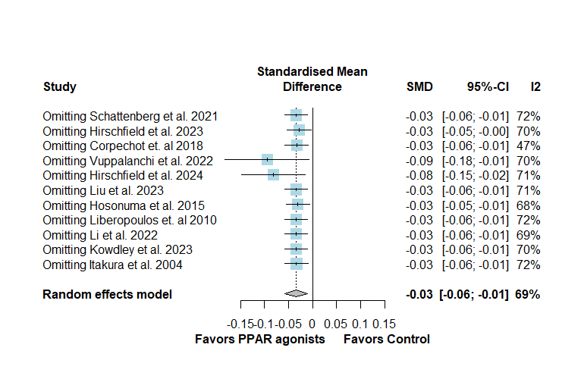

Supplementary Figure 15 - Leave-one-out sensitivity analysis of the outcome of total bilirubin levels
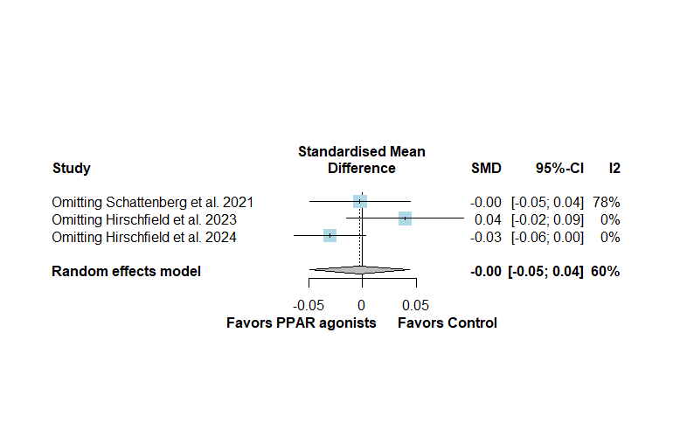

Supplementary Figure 16 - Leave-one-out sensitivity analysis of the outcome of AST levels
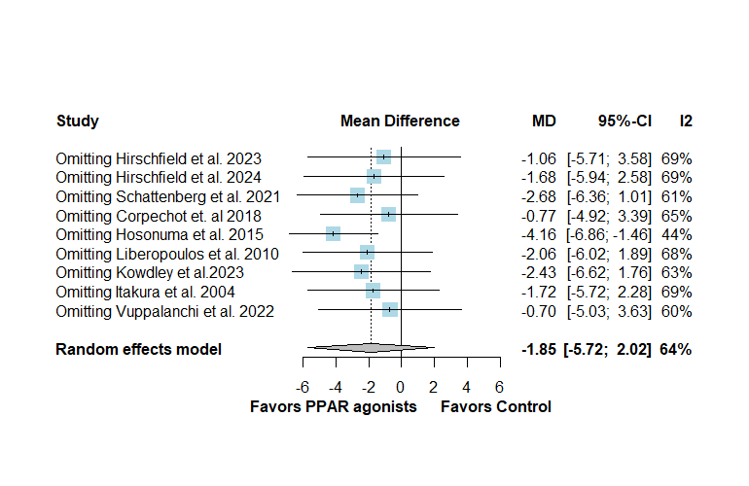

Supplementary Figure 17 - Leave-one-out sensitivity analysis of the outcome of ALT levels
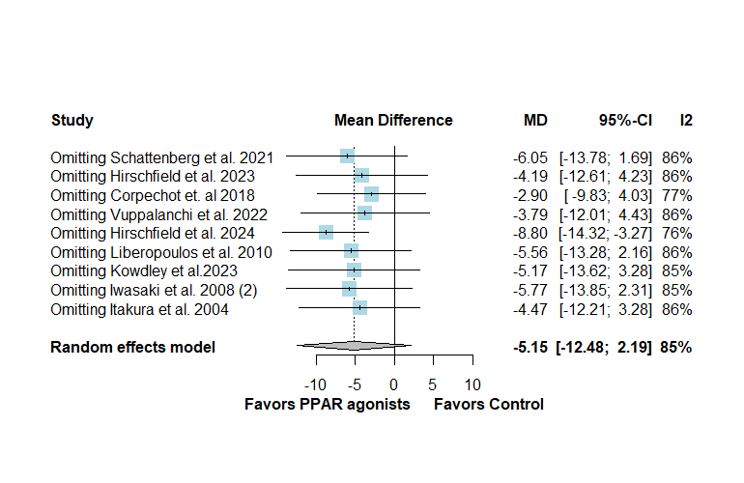

Supplementary Figure 18 - Leave-one-out sensitivity analysis of the outcome of headache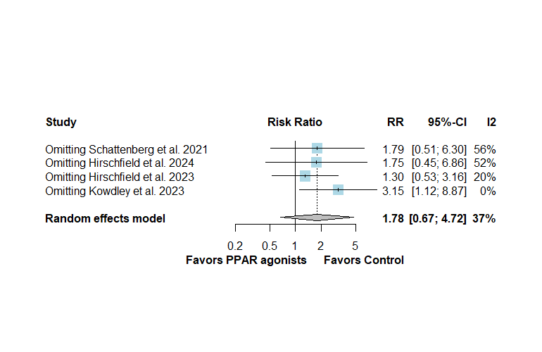

Supplementary Figure 19 - Leave-one-out sensitivity analysis of the outcome of normalization of ALT levels
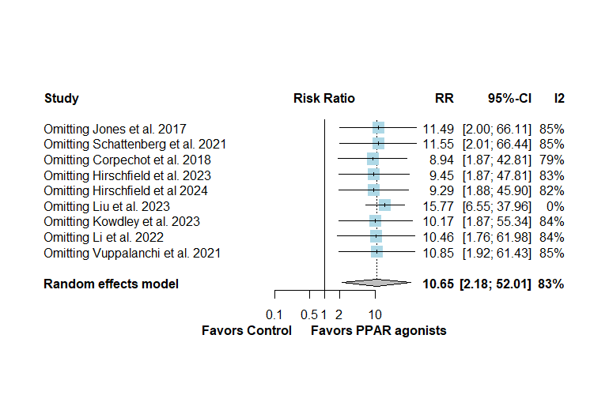

Supplementary Figure 20 - Funnel plot with enhanced contour for the outcome of ALP levels
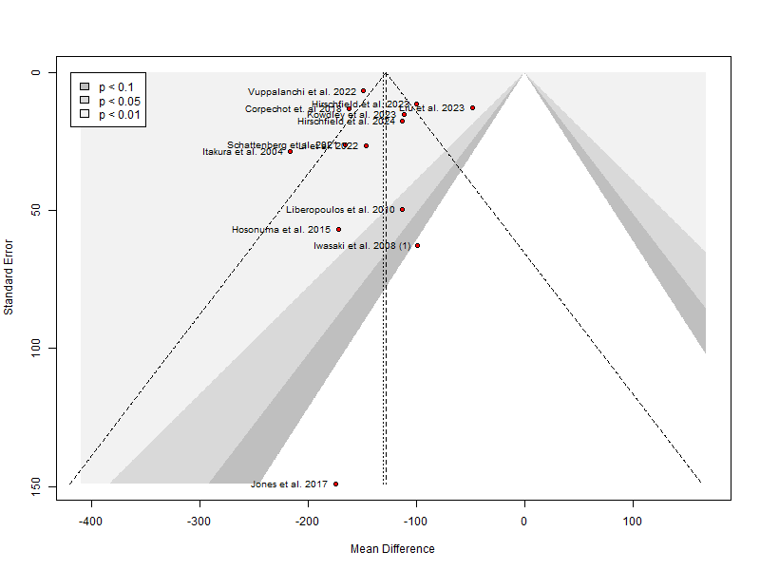

Supplementary Figure 21 - Funnel plot with enhanced contour for the outcome of GGT levels
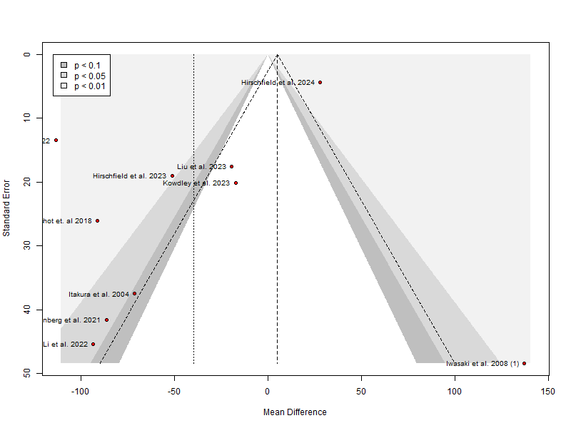

Supplementary Figure 22 - Funnel plot with enhanced contour for the outcome of total bilirubin levels
