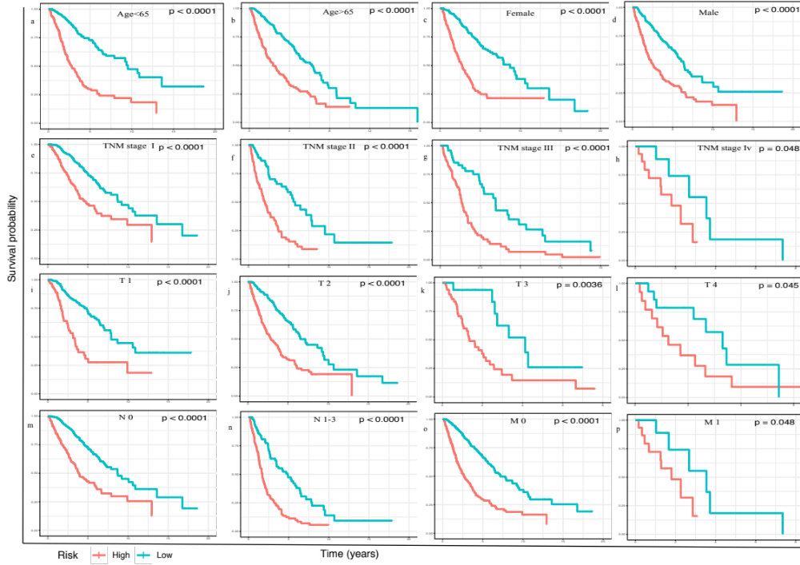
Fig. S1 Survival difference between high- and low- risk patients in different subgroup. (a) Age <65. (b) Age >65. (c) Female. (d) Male. (e) TNM grade I. (f) TNM grade II. (g) TNM grade III. (h) TNM grade IV. (i) T1. (j) T2. (k) T3. (l) T4. (m) Without lymph node metastasis. (n) With lymph node metastasis. (o) Without distance metastasis. (p) With distance metastasis.
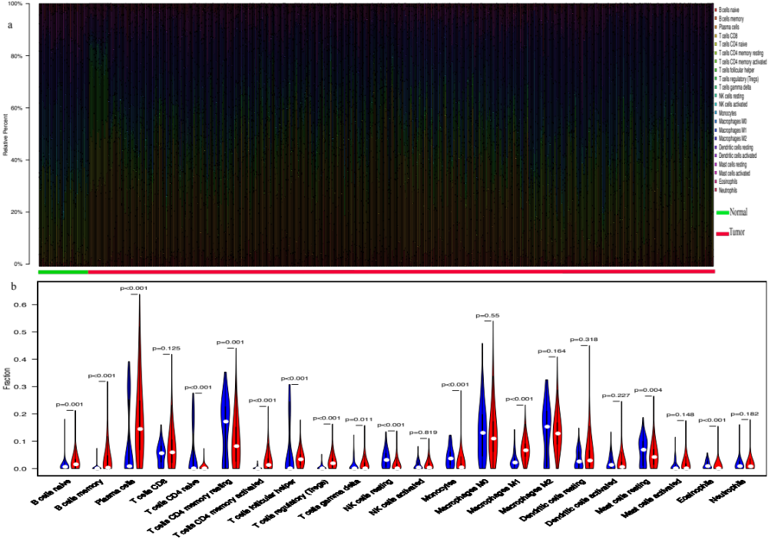
Fig. S2 (a) The proportions of 22 TIICs in 823 samples quantified by CIBERSORT. (b) The difference of 22 TIICs between normal and LUAD tissues.
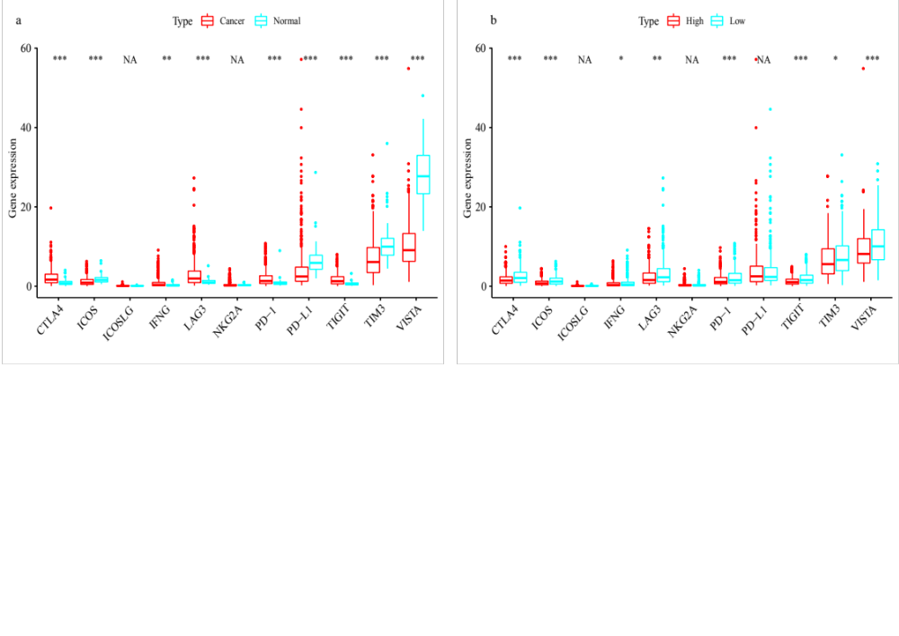
Fig. S3 The difference of distribution of 11 immunomodulators. (a) between normal and LUAD tissues. (b) between high- and low- risk LUAD patients. *P<0.05, ** P<0.01, ***P<0.001.

