Table 1

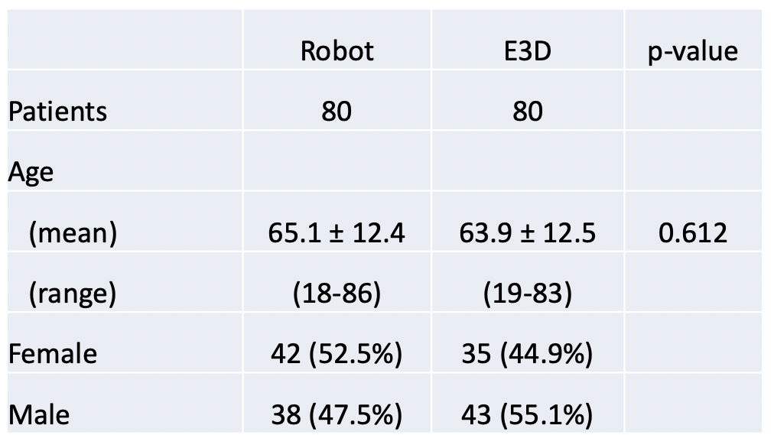
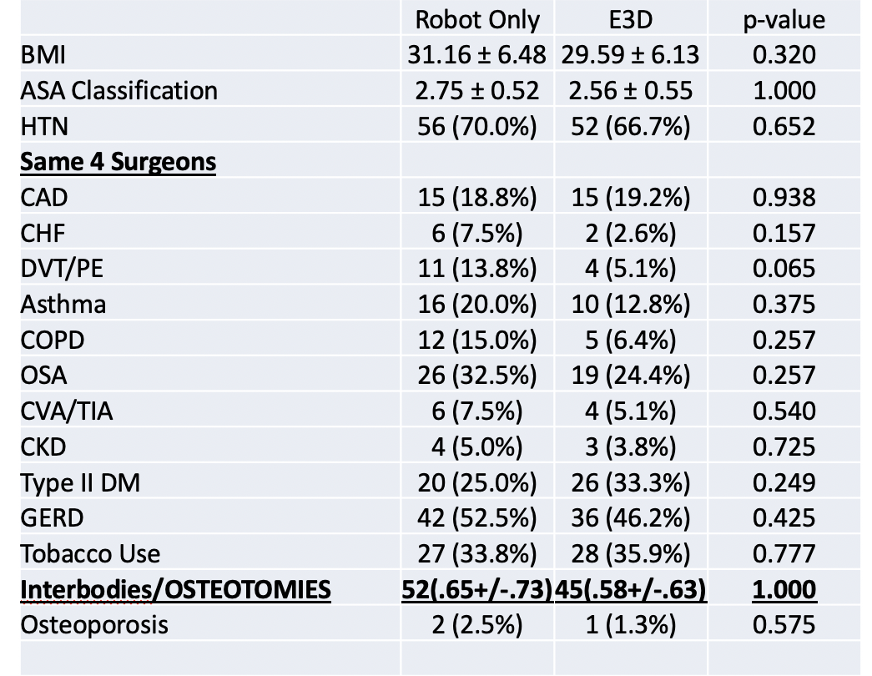

Table 1—The demographics between the two groups of 80 patients each demonstrate that the two populations of deformity spine patients undergoing robotic surgery were remarkably similar.
Table 2

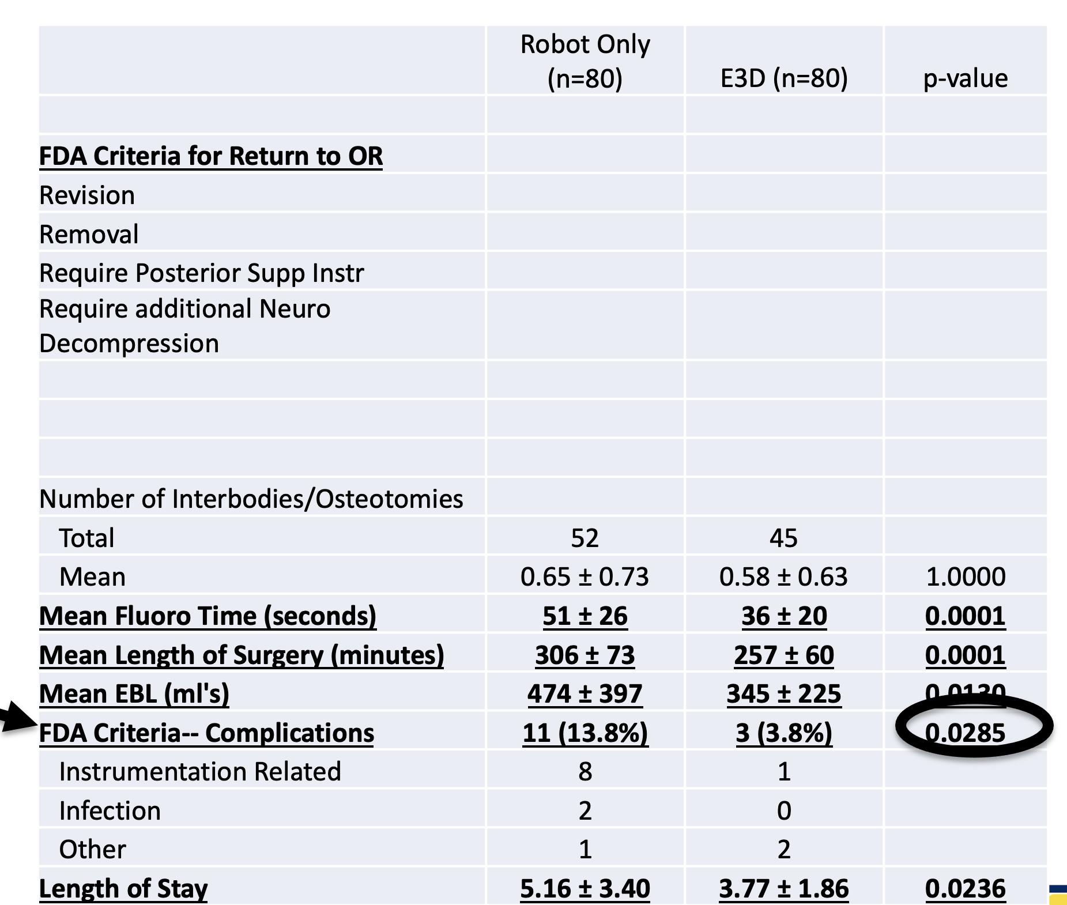

Table 2—The patients in Group 2, E3D had statistically fewer reoperations than the patients in Group 1, C-arm fluoroscopic registration (p = 0.0285). They also demonstrated significantly less radiation exposure, less mean blood loss, and had a shorter operative time. Perhaps the most important finding is the shorter length of hospital stay by more than a day for the E3D patients (p = 0.0236).

